PALMERSTON POST

15 February 2018

Week 2, Term 1

Board Chair: Julian Fior, Board Members: Parent Reps: Jesse Dang and George Villaflor

P&C President: Lisa Fior

Principal: Melissa Travers Deputy Principal: Kate Flynn

Executive Teachers: Haeley Simms, Kylie Moller, Jacqui Warden, Matt Gowan, Catherine Griffin (acting)

ASSEMBLY:
16 Feb | Senior - Yr 6
23 Feb | Junior - 2EG & 2LM
2 Mar | Senior - Yr 5
DATES TO REMEMBER:
22 Feb | Swimming Carnival -
 | Dickson pool
26-28 Mar | Yr5/6 Camp - Borambola

NOTES HOME:

Swimming Carnival reminder

P&C BOARD NEWS P&C: 19 February 2018

All P&C activities, meeting agendas and minutes are available from the School website at – Parent Corner

School Board Elections held in early 2018

DEPUTY PRINCIPAL’S MESSAGE

Dear parents and carers,

I would like to thank the community for attendance at the Parent Information Session on Tuesday night. We were pleased to see the number of families who came to hear about the teaching and learning programs that our staff will be facilitating this year. Term overviews were distributed at this time and, for families who could not make the session overviews were handed out the following day. I would like to take the time to thank the teachers for their collaborative planning and delivery of the sessions.

School Board Nominations 2018

School Board elections will be held in early 2018

Membership of the School Board is a wonderful opportunity for parents to participate in the ongoing management of the school and to contribute to the determination of the school’s future directions. The assistant returning officer would now like to extend the nomination period for another two weeks for one more position as a parent representative on the Palmerston District Primary School Board. The successful candidate will be announced by Monday 26 March 2018. If you are interested in being a member of the Palmerston District Primary School Board for 2018-2020 and would like more information about the roles and responsibilities of School Board members, please contact the Principal, Melissa Travers on 6142 1440. A copy of the School Board Manual is also available for perusal at the front office. Nomination forms are available from the school front office.

Together, we learn from each other

PALMERSTON POST Page 2

Swimming Carnival

We are looking forward to our Swimming carnival next Thursday 22 February 2018 at Dickson Aquatic Centre. I’d like to take the opportunity to remind families to ensure that their children arrive to school with sunscreen on. We will be reminding children throughout the day to reapply and we will be taking sunscreen to the pool for the children to access. We encourage all children to wear their swimming rash shirts as a layer of protection from the sun. Children must wear a shirt at all times to ensure appropriate sun protection.

Children turning 8 years or older this year have been offered the opportunity to participate in a variety of competitive races as well as participate in both structured water activities and dry events. Each activity will be run by teachers and will include both shallow water activities and games conducted on land. In line with ACT Education Directorate requirements, prior to participating in competitive races children will be required to partake in a Royal Life Saving Survival Challenge Proficiency Test. If they are deemed proficient, they will compete in the competitive races.

Students in Kindergarten to year 2, who are turning seven years or under this year (2018), do not participate in the competitive events but will participate in a variety of water sense activities as part of our Health and Physical Education curriculum. As above, these activities will include both structured water activities and dry events. Each activity will be run by teachers and will include both shallow water activities and games conducted on land.

Lifeguards will be on duty during the carnival and teachers will be supervising the structured activities/games. A reminder that the canteen will not be available on the day for Palmerston students.

PIPS

PIPS testing will commence in week 3 for all Kindergarten students. Information has been distributed to families to explain the processes involved in this online assessment. Families will receive individual reports later in the term that provide information regarding student performance in literacy and numeracy.

Camp

Our Year 5/6 children and staff are looking forward to attending school camp at Borambola Sport and Recreation Centre from Monday week 4. Borambola is located just this side of Wagga Wagga and for the 3 days the children will engage in a range of activities that may range from using low ropes, abseiling and archery.

SRC news

This year Kara Brailey will be working with our SRC students. At the moment Miss Brailey is working behind the scenes to prepare for the election of our SRC, school captains and vice captains. This week the year 6 students have indicated if they would like to take on the role of school captain. This is the same for the year 5 students in regard to the vice-captain role. A part of this process is to prepare a speech and present the speech to the senior school outlining why the students would like to take on a leadership role as captain or vice-captain. The presentation of these speeches will occur next Monday.
Car Parking and playground supervision

We understand that families may have concerns about parking. We have worked with the Board and

P&C to put into place the following initiatives:

The library is open for students from 8:30am as well as supervision on the playground from this time as well.

Together, we learn from each other

PALMERSTON POST Page 3

We have walked the local streets at pick up and drop off time to find possible parking places. We have noticed that the local shops appear to have spaces at these times as well as the community centre located next to the shops. There is a path that runs from the shops to the school. There are also parks available near the bus stop.

We are looking to open a new teacher carpark behind the preschool later in the year. This will free up more spaces in the main carpark

We have been promoting children to walk to school through our Walk to School program as well as adapting the bike racks to make it more appealing for children to ride their bikes to school.

In the afternoon, executive teachers are supervising the playground so if you have older children we suggest you arrive at the school a few minutes after the bell has gone.

Again, we thank you for your support at this time.

TWILIGHT FAIR REFUNDS

If you requested a refund (due the rides being cancelled) from the Twilight Fair, please collect it at the front office.
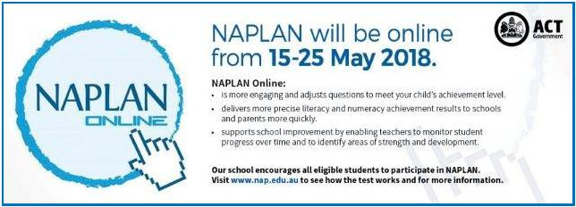

Together, we learn from each other

PALMERSTON POST Page 4

UPCOMING EVENTS

Swimming Carnival

Date: 22 February 2018

Locaton: Dickson Aquatic Centre

Yr 5/6 Camp - Borambola

Date: 26-28 February 2018

Location: Borambola, NSW Sport & Recreation

ASSEMBLIES

We look forward to running our assemblies each week. During this time a variety of performances are celebrated. All community members are invited to attend.

This year we are trialling a new model with our assemblies. We will host senior assemblies in the even weeks (with Year 6 hosting in week 2) and junior assemblies in the odd weeks. Please contact Kate Flynn if you have any questions.

RIDE OR WALK TO SCHOOL PROGRAM

Our school is pleased to be part of the Ride or Walk to School program, encouraging our students to ride, walk, scoot, skate board or even roller-skate to school!

Overwhelming evidence shows that kids who use active travel to get to school are more alert and ready to learn and it contributes to getting their recommended 60 minutes of daily physical activity. Another big bonus is it reduces the number of cars coming to school each day for pick up and drop off. Even if it’s only part way, we’d love to see lots of our students riding and walking each day.

Did you know we have an app you can download to keep you up to date with what is happening at Palmerston?

Together, we learn from each other

PALMERSTON POST Page 5

Think before you park…and keep our kids safe!

With school now back for the year we are encouraging all parents to make parking safety a priority!

This means:

- keep clear of ‘no stopping’ and ‘no parking’ zones

- don’t park in bus zones, on school crossings, across footpaths or driveways; and

- don’t double (or triple) park

Remember - it’s okay to park a little further away from the school and walk the rest of the way Consider - having a pre-determined meeting spot agreed with your kids. That way if you are a little late, they know where to wait.

Think – visibility around schools and if your car may be blocking the view of crossings for other motorists. Also be mindful when entering or leaving parking spots – look twice!

Be kind – to other road users and pedestrians and also if you see any parking officers in the area – they are doing their job and working to keep our kids safe!

Note - licence Plate Recognition (or electronic chalking) vans are now actively monitoring schools. Penalties range from $114 upwards to $600. Details at www.act.gov.au/accessCBR

SCHOOL BOARD NOMINATIONS 2018

School Board elections will be held in early 2018

Membership of the School Board is a wonderful opportunity for parents to participate in the ongoing management of the school and to contribute to the determination of the school’s future directions. There is one (1) vacancy for a parent representative on the Palmerston District Primary School Board for the period 1 April 2018 to 31 March 2020. Election of the parent representative will be undertaken in the first few weeks of the 2018 school year. Nomination period:

Closes – 11:00am on Monday 26 February 2018

Voting period (if election is required):

Opens – 11:00am on Monday 5 March 2018

Closes – 11:00am on Monday 19 March 2018

The position for election will be:

One (1) - Parent Representative Position. Elected positions run for a two (2) year term.

The successful candidate will be announced by Monday, 26 March 2018.

If you are interested in being a member of the Palmerston District Primary School Board for 2018-2020 and would like more information about the roles and responsibilities of School Board members, please contact the Principal, Melissa Travers on 6142 1440. A copy of the School Board Manual is also available for perusal at the front office. Nomination forms will be available from the school front office from Monday, 5 February 2018. If you would like to have a form before that date, please contact the school front office on 6142 1440.

Together, we learn from each other

PALMERSTON POST Page 6

P&C NEWS

P&C Meeting - SAVE THE DATE - Monday 19 February 7pm

Upcoming events:

P&C AGM and meeting Monday 19 February at 7pm (week 3) – we welcome new parents to join us at this meeting.

Welcome to Term 1 all families at Palmerston District Primary School, both new

and continuing. We commence the 2018 school year looking forward to being part of all that our wonderful school and teachers have been busy preparing for our children and school community.

I am the current P&C President and have thoroughly enjoyed being part of both the Palmerston School Community as well as the P&C for a number of years. I have had the privilege of getting to know many families at Palmerston through various connections. The P&C and all of its wonderful volunteers again co-ordinated many both enjoyable and successful events in 2017 and we look forward to the year ahead.

We welcome and warmly encourage new parents to the P&C. Being a member is a great way to contribute to and be part of your child’s schooling. Meetings are held in week 3 and 9 of each term. All positions on the committee will become vacant at our AGM on Monday 19 February.

2018 P&C Positions

President and Vice President

Secretary and Assistant Secretary

Treasurer and Assistant Treasurer

Fundraising Coordinator and assistants

If you can help in any of these roles or would like more information on them then please see one of the P&C executive or email palmpandc@hotmail.com.

Lisa Fior

P&C President

SCHOOL BANKING & BOOK CLUB

Hi Everyone,

My name is Edwina and I have 1 child at Palmerston, I also volunteer to organise both the School Book Club and School Banking.

School Banking:

Every Wednesday morning in the staff room. Bank books can be left at the front office by 9.30am. Joanne from Commonwealth Bank will be at school from 8.30am on Wed 7 March (Week 5) to assist with questions and information about School Banking. We will also be offering 2 account opening information sessions at preschool on Thursday 8 March (week 5) Tuesday 13 March (week 6)

If you would like to open a new account, a Youthsaver account can be opened online by all parents.Visit commbank.com.au/schoolbanking and click on the link to open the Youthsaver account. Parents will need their child’s birth certificate or similar identification as well as their own to complete the process and generate an account. Or you can visit any Commonwealth Bank branch with identification and open an account.

Together, we learn from each other

PALMERSTON POST Page 7

Book Club:

Hopefully everyone should have received issue 1 by now. The deadline for all orders is Friday 23 February.

There are 2 ways you can order from our Book Club Catalogues:

1: Pay Cash or Cheque.

If this is your preference, then please fill out the back page of the catalogue with all of your childs details, including the books required and total amounts.

Then place the completed back page of the catalogue with the correct amount of money (or cheque made payable to Scholastic Australia) into an envelope marked with “Book Club”. Then place this envelope into the ‘Boomerang Box” located in the front office foyer.

A receipt will be returned with the book once it arrives.

2: Order and pay Online

Please follow the steps using the LOOP method. This requires payment online.

If you order and pay via LOOP you DO NOT need to hand in any paperwork.

The books can take up to 2 weeks to be distributed after the deadline closes.

Remember that by participating in school banking and book club raises money for our school to use to purchase equipment.

If you have any questions, please contact me.

Thanks,

Edwina

0422 006 142

Together, we learn from each other

PALMERSTON POST Page 8
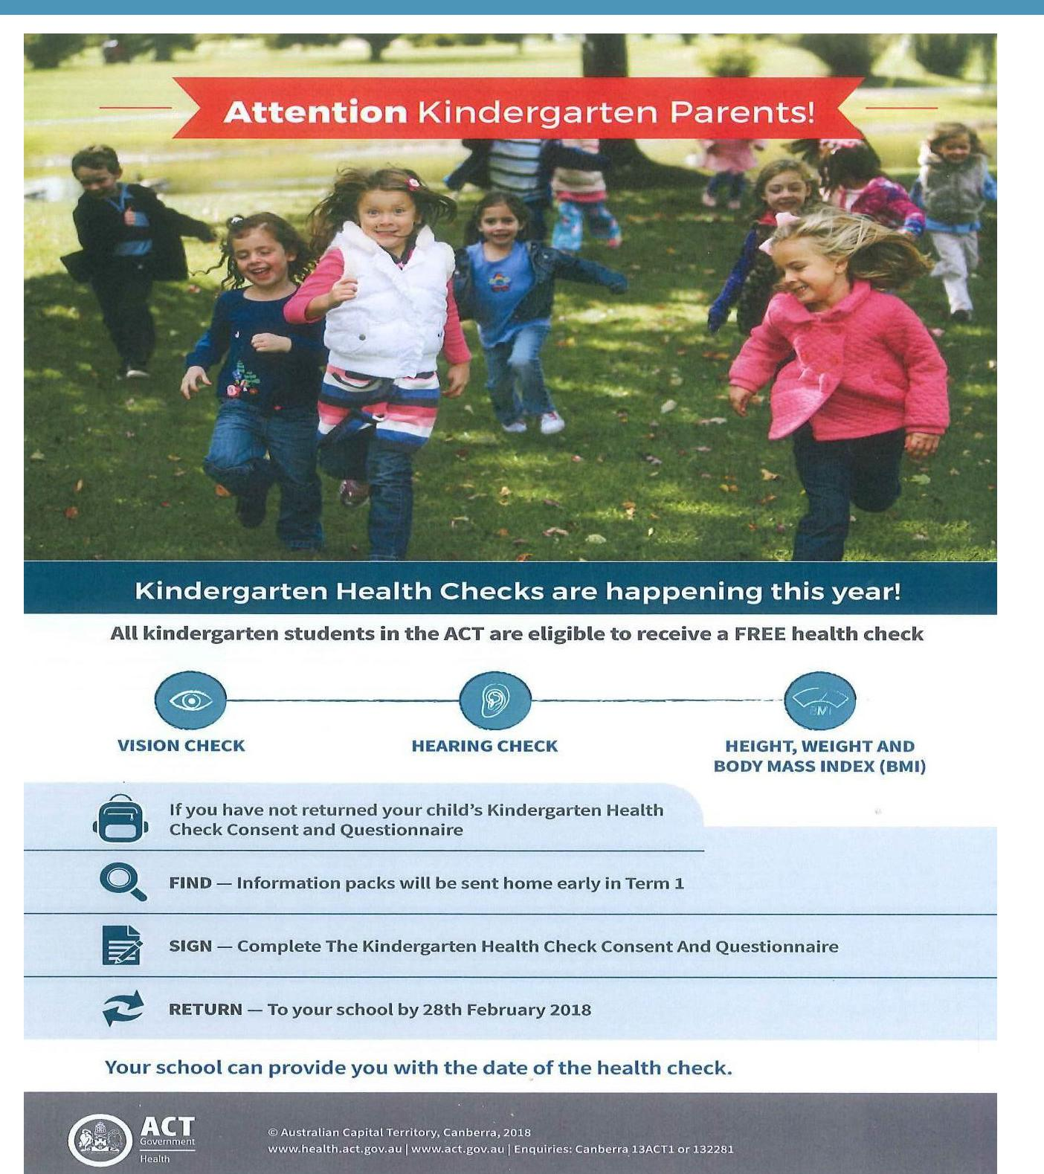

Together, we learn from each other

PALMERSTON POST Page 9

Together, we learn from each other

PALMERSTON POST Page 10
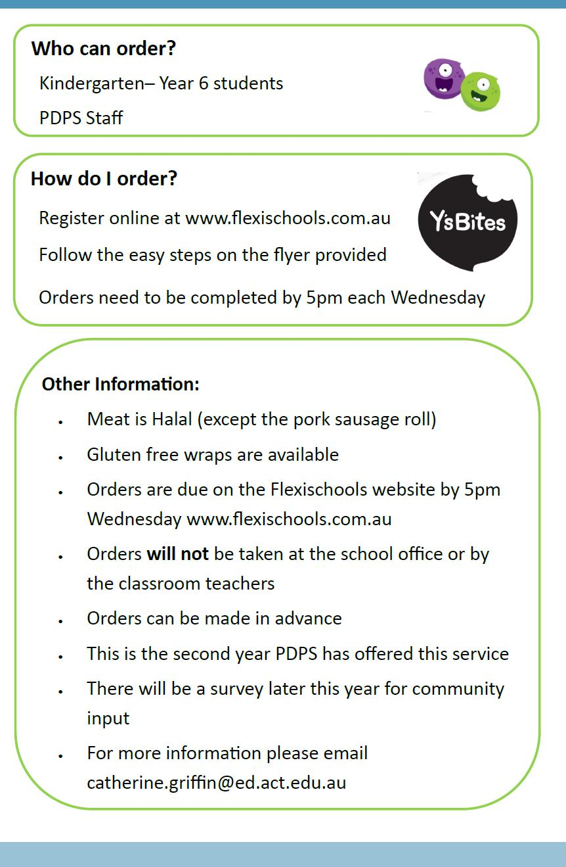

Together, we learn from each other

PALMERSTON POST Page 11
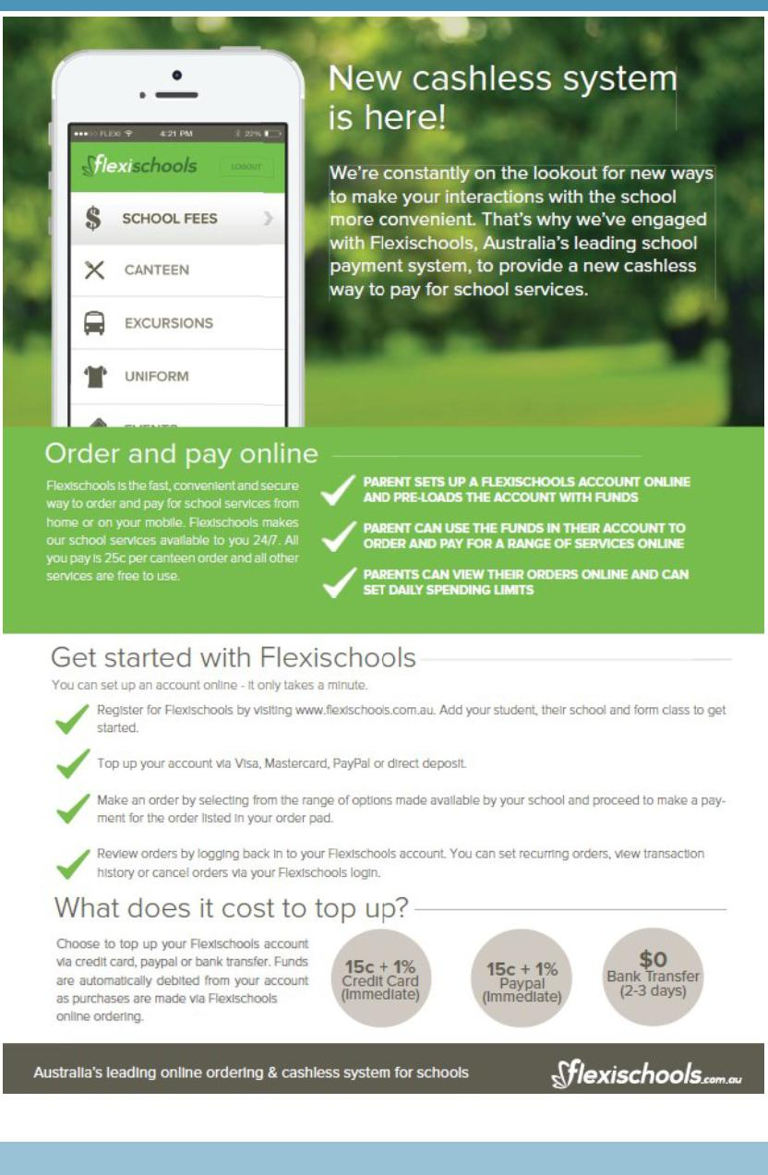

Together, we learn from each other

PALMERSTON POST Page 12

COMMUNITY NEWS
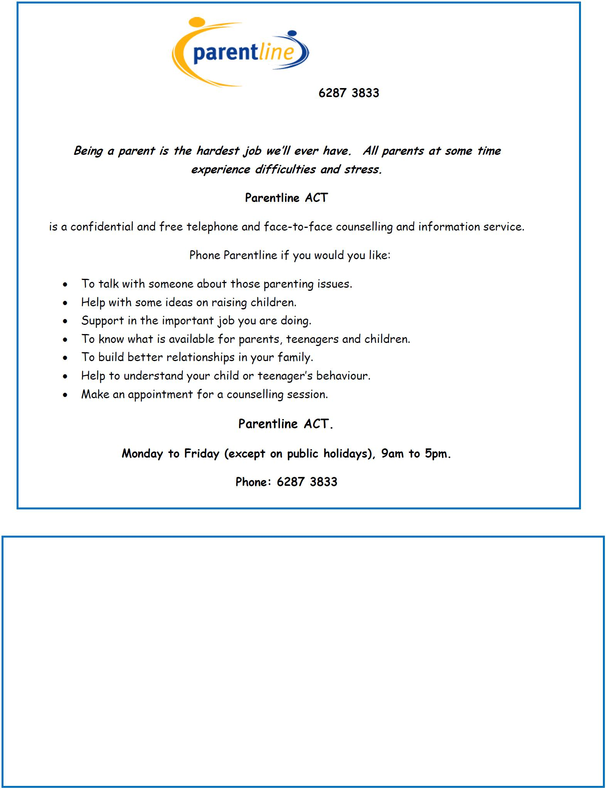

ROAD CLOSURES

Due to road closures to allow for the National Multicultural Festival, stops 3356 (London Circuit Legislative Assembly), 3003 (London Circuit Commonwealth Bank) and stop 3004 (London Circuit after Akuna Street) will be temporarily closed from 10:00 am on Friday 16 February until the first service on Monday 19 February.

Transport Canberra will be implementing diversions during this time, which may affect some afternoon bus routes on Friday 16 February. We encourage you to view this information now available on the Transport Canberra Website.

We would appreciate your assistance in circulating this information using your existing communications channels, such as school emails, newsletters or notices so students and parents can start planning their travel during this time.

Together, we learn from each other

