Palmerston Post

3 May 2018

Week 1, Term 2

Board Chair: Lisa Fior Board Members: Parent Reps: Jesse Dang and George Villaflor

Teacher Reps: Jessica Lago and Maxine Green

P&C President: Lisa Fior

Principal: Kate Flynn (acting) Deputy Principal: Haeley Simms (acting)

Executive Teachers: Kylie Moller, Jacqui Warden, Matt Gowan, Catherine Griffin (acting)

ASSEMBLY:
4 May | ANZAC assembly
11 May | Mother’s Day Concert
18 May | Junior - 1HD & 1AE
25 May | Senior - Yr5
DATES TO REMEMBER:
8 May | P/S Mother’s Day -
 | Stay & Play
11 May | P/S Mother’s Day -
 | Stay & Play
11 May | K-6 Mother’s Day
 | Concert & Stall
14-16 May | Yr5/6 Camp
16-17 May | NAPLAN
21-24 May | NAPLAN
25 May | Yr1 Canberra Theatre
 | Excursion
29 May | Yr1/2 Author Visit

NOTES HOME:

- Mother’s day notes (youngest)

P&C BOARD NEWS P&C: 7:30pm 8 May 2018

All P&C activities, meeting agendas and minutes are available from the School website at – Parent Corner

School Board: 7:30am 22 June 2018

PRINCIPAL’S MESSAGE

Welcome back to term 2. I hope you all had a great two weeks holiday. The students and teachers were every excited to be back. I know many teachers took the school holidays as an opportunity to continue with their professional learning and some had adventures away. We had teachers visit Queensland, country NSW, Cambodia, Thailand and more. The teachers undertaking professional learning specialised in Google classrooms.

Over the holidays I was asked by the Directorate to oversee Jervis Bay School while their principal is away.

This is short notice, but I know with Kate Flynn and the executive team to lead Palmerston, the school will be in fantastic hands. I look forward to seeing you again later in the term or early next term.

Melissa Travers

ACTING PRINCIPAL’S MESSAGE

Welcome back to term 2!

I hope that you had a wonderful term break. There was certainly a buzz on Monday morning when our community returned to school. I enjoyed the conversations that I had on the blacktop before 9am with families and children about their adventures during the break. Walking around the classrooms it is evident that the children have had the opportunity to re-energise and now reconnect with their learning.

I have welcomed the opportunity to step into the principal’s role for the term and to continue on with the wonderful work that Melissa carries out around our school.

Together, we learn from each other

Palmerston Post Page 2

Our Mother’s Day concert is fast approaching and I know that Miss Griffin has been supporting classes to prepare their performance item for next Friday morning. Thank you to all the families who have donated items for our Mother’s Day stall. We anticipate a wonderful morning and we hope as many mothers/grandmothers/special family members can attend our traditional Mother’s Day concert next Friday morning, straight after morning lines, in the hall.

Today the Suara Indonesia Dance company visited the school to demonstrate Indonesian dances for our years 3-6 children. This performance provided our students with the opportunity to experience firsthand the costumes and music associated with Indonesian dancing. The highlight of this was definitely the final performance of body percussion dances from North Sumatra. This was a wonderful way to support and enrich the Indonesian program running at the school. Thanks to Mr Susko for organising this event.

Included in the newsletter today is an advert reminding us that NAPALN will commence on the 15th of May 2018. Included in the advert is a web address: www.nap.edu.au This website will provide relevant information about NAPLAN.

Tomorrow morning we will be holding our annual ANZAC Commemorative assembly. This will commence after morning lines in the hall. Our Defence Transitions Officer Kristy Retzlaff has been working with some of our Defence children to prepare for this assembly and the children from 5DT and 3RC will be singing a special ANZAC song with Mr Shaw at this time. I look forward to this memorable event and thank Mrs Retzlaff and Mr Shaw for facilitating this day.

Enrolments into public schools for 2019 opened on 30 April. If you have or know of anyone who has a child who is eligible for preschool in 2019 please ask them to contact the front office on 6142 1440. Applications can be made online at www.education.act.gov.au. To be eligible for Palmerston preschool children must turn 4 years of age by 30 April 2019 and must reside in the Palmerston District Primary School priority enrolment area (this information can be gathered on the allhomes website: www.allhomes.com.au)

We are excited about the new bus service (morning and afternoon) that is now offered between Crace and Palmerston. Please see further in the newsletter for more information around this.

The flow of traffic in our carpark seems to be improving and we thank all families for working with us by driving slowly and parking in allocated spaces. We look forward to the car park near the preschool being completed shortly.

Wishing you all a lovely end of week and weekend.

Kate Flynn

(acting principal)

Together, we learn from each other

Palmerston Post Page 3

UPCOMING EVENTS

ANZAC Day Service

Date: Friday May 4 2018

Location: Palmerston District Primary School

Mother’s Day Celebrations

Date: Tuesday 8 May - Brave, Itchy & Noisy Bears

Friday 11 May - Cranky, Hungry & Sleepy, K-6

Location: Palmerston District Primary School

Year 5/6 Camp

Date: 14 - 16 May 2018

Location: Borambola, NSW

RAIL READY

Palmerston District Primary School was invited to the unveiling of Canberra’s new light rail safety campaign by ACT’s Minster for Transport Meegan Fitzharris. Our students engaged with senior

officials who are leading the project through the construction and roll out phase in a question and answer style panel. Dante, Isaac, Caitlin and Natasha will now become Palmerston Schools’ light rail

ambassadors for safety. They will be sharing the message of how to use and interact with the light rail vehicles safely and responsibly throughout the year.
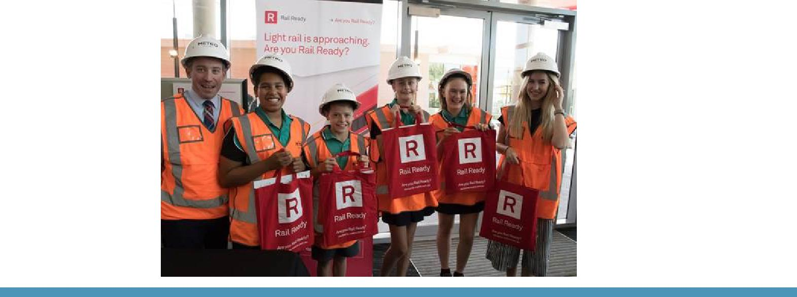

SEESAW

Seesaw is a digital portfolio that allows our students to develop critical 21st century skills. It builds a strong home/school partnership by providing parents with real time notifications of their child’s learning. During Term 1 the teachers and students have been busy learning how to use Seesaw and uploading work samples for their parents/carers to view. Yesterday we held a parent Seesaw

information session which outlined what Seesaw is and how parents can use Seesaw.

In order to ensure a successful transition to Seesaw we have decided to provide parent/carer access to Seesaw during week 4 and 5 of term 2. We look forward to sharing the fantastic work with you.

Please contact me via the front office if you have any questions or queries regarding Seesaw.

Haeley Simms

Together, we learn from each other

Palmerston Post Page 4

PRESCHOOL 2019 INFORMATION SESSION

An information session will be held for parents of preschool children entering preschool in 2019. The session will be held in the Library at Palmerston District Primary School on Wednesday 30 May 2018. After the session you will be welcome to walk through the preschool classrooms to see the learning spaces.

Children must turn four years old by 30 April 2019 to be eligible for enrolment into preschool for the 2019 school year.

To register your interest for the session please call 6142 1440.

Come and tour the preschool facilities of the school and speak with current staff. Tours will be conducted during May on Tuesdays and Fridays at 9.30 to 10.00am. Book a tour of the preschool by calling the school on 6142 1440.

VOLUNTEERS WANTED

If you can spare some time, the library staff would love your assistance. Please drop in the library anytime on Thursdays.

Thank you,

Noreen Pidgeon & Eleni Velanis

Together, we learn from each other

Palmerston Post Page 5
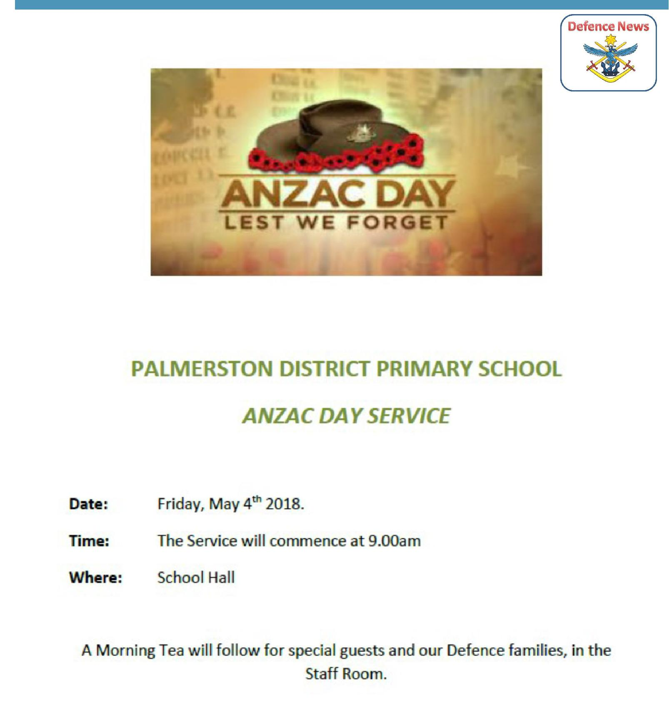

DSTA NEWS

Together, we learn from each other

Palmerston Post Page 6
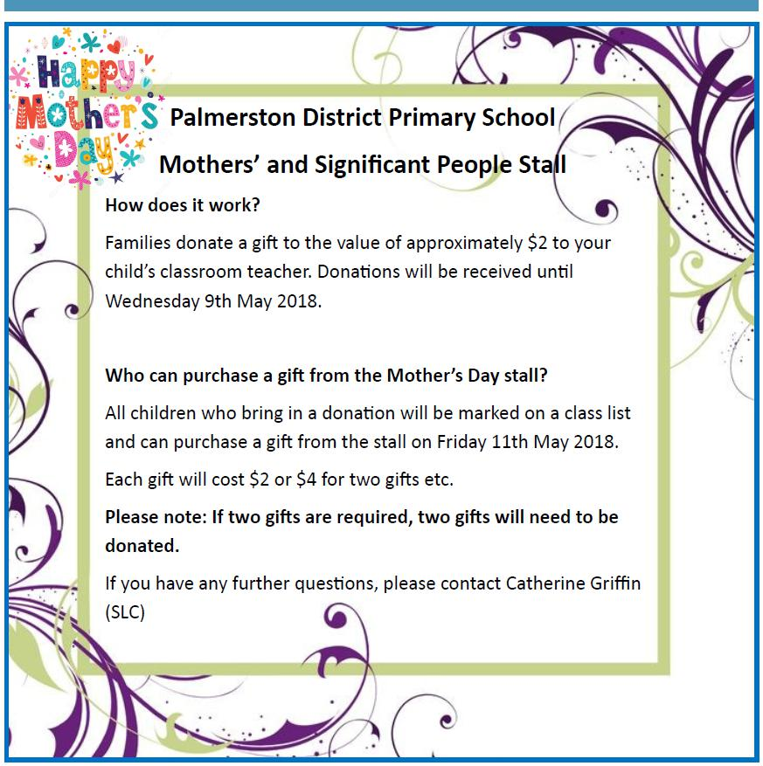

Together, we learn from each other

Palmerston Post Page 7

P&C NEWS

2nd Hand Uniform Shop

The 2nd hand uniform shop is open every Friday morning from 9:00am. To make an appointment outside the opening hours please contact the front office on 6142 1440.
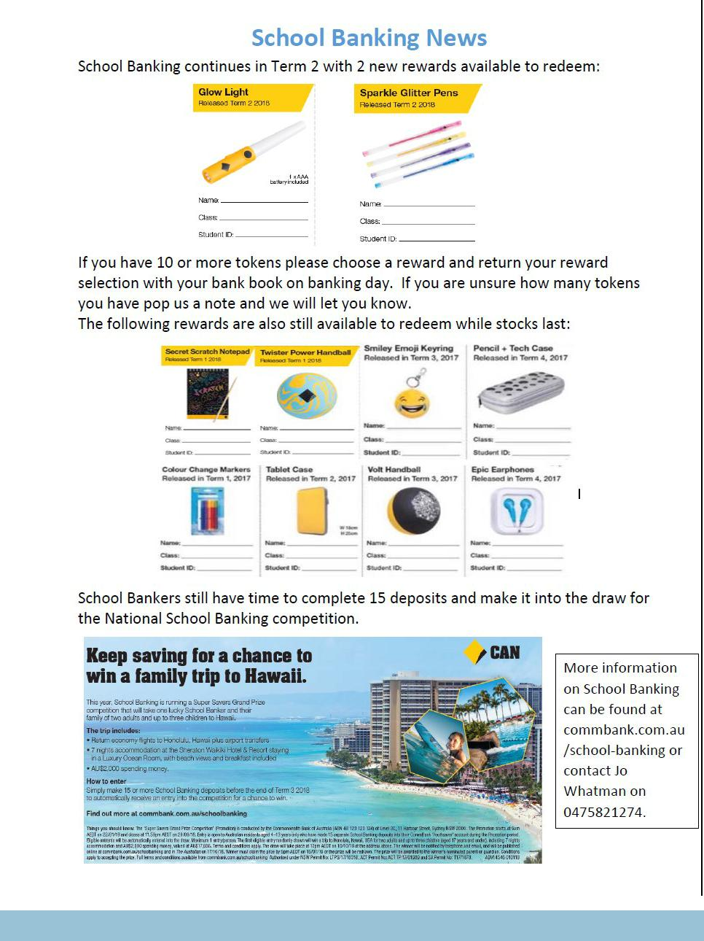

Together, we learn from each other

Palmerston Post Page 8
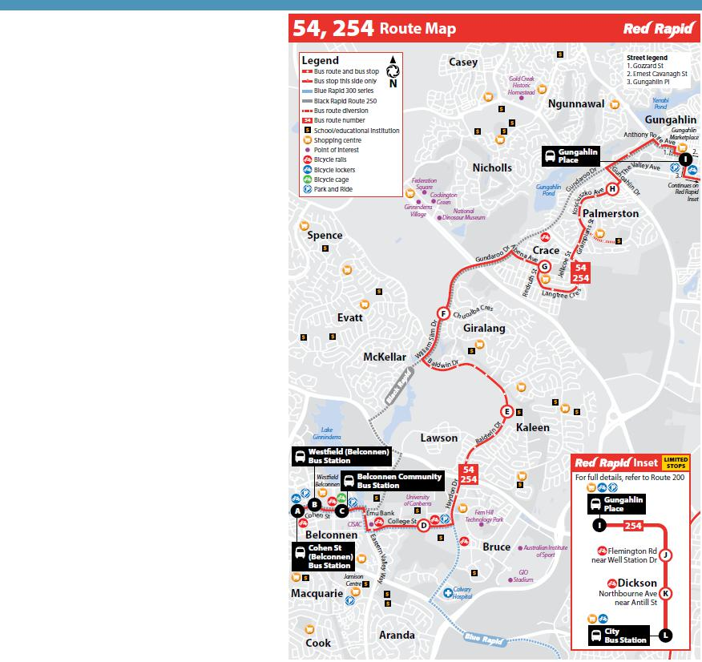

TRANSPORT AT PALMERSTON

Thank you to all of the parents and carers who have been parking in the legal spaces and utilising some of the suggested strategies such as parking at the shops or coming a little later. We have noticed an improvement in the flow of the car park. On this note we are excited that building works have commenced to provide additional car spaces. Thank you to the parents and carers who have provided suggestions in our car park suggestion box in the front foyer. This box is still available if you have any further suggestions.

We are excited to announce that two bus services from Crace (morning and afternoon) will now divert past Palmerston Primary. We have included the timetable of these buses in this newsletter as an attachment. If you would like to investigate using this transport option. We are still liaising with ACTION buses in regards to a designated school service. To achieve this, we require a large number of families who would like this service. There is an expression of interest in the front foyer which currently has just over 20

signatures. If you wish to express your interest please add your name.

Palmerston is participating in the Active Streets for Schools program. Riding, walking , scooting or skating are simple ways to incorporate physical activity into everyday lives and journeys. Active Streets makes it easier for children to ride or walk to school. The program has placed a blue stencil along popular walking paths around our school, these allow the students to travel on a safer route to school. These guide students to the two designated crossings we have at our school. I would like to remind parents to ensure they drive slowly and look out for students at these crossings.

Thank you to all the families who have assisted us to make improvements to various modes of transport around Palmerston. We will continue to work on ways to improve this.

Haeley Simms

Together, we learn from each other

Palmerston Post Page 9

Year 7 School Open Days 2019
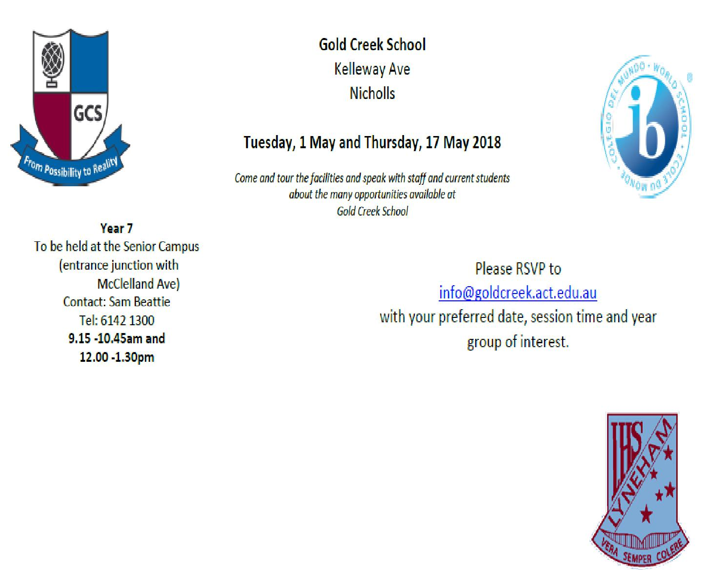

Lyneham High School

Tuesday 8 May 2018

Year 7 information session 6:30 - 8:30pm in Hall

Band Information Session 5:30 - 6:30pm in IPAC building

Wednesday 9 May

SEAL (Lyneham Enriched Academic Program) information session at 6:00pm in Library

LEAP (Sporting Excellence At Lyneham) information session at 7:00pm in Hall

For further details or information please contact Lyneham High School on 6142 1176 or email:LynehamHS@ed.act.edu.au

Kaleen High School

Tuesday 15 May 2018

6:00 – 8:00pm in the Library

On the evening of the 15th of May from 6-8pm we will be opening our school to the community for our annual Open Night. This is a fantastic evening for families to attend as they research which high school well best suit the needs of their child. The evening highlights the many wonderful opportunities on offer at UCHSK as well demonstrating exactly how we fulfil our mission of doing whatever it takes to ensure high levels of learning in every student.

Together, we learn from each other

Palmerston Post Page 10
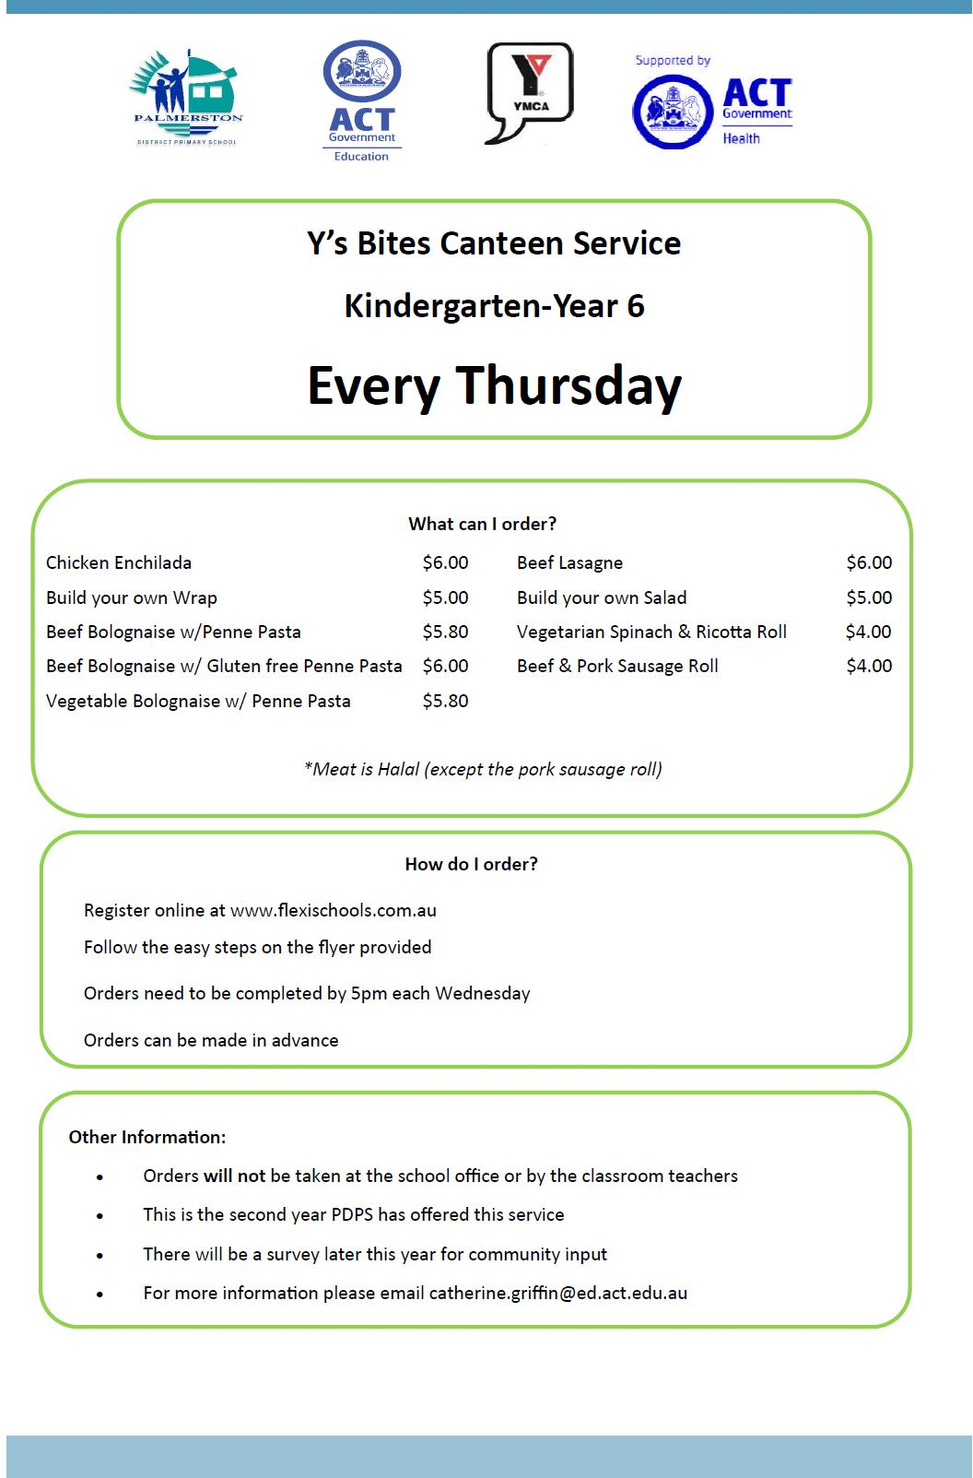

Together, we learn from each other

Palmerston Post Page 11

Together, we learn from each other

Palmerston Post Page 12

HIRERS
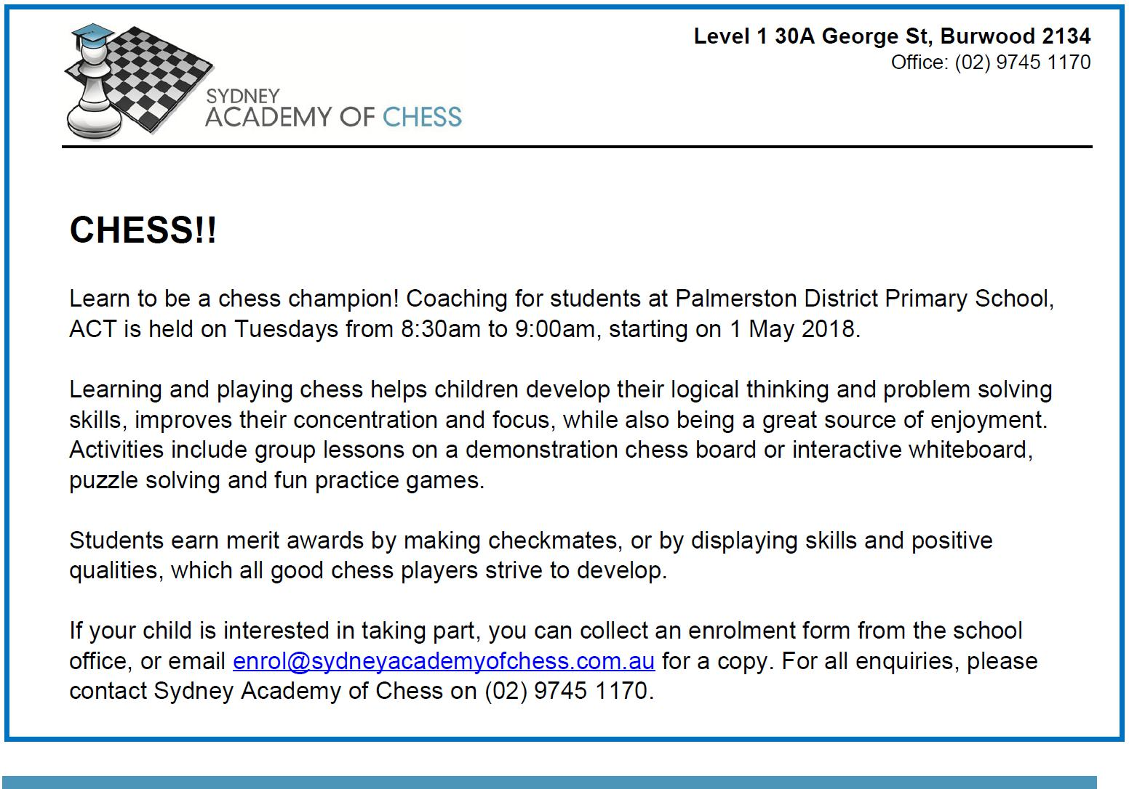

COMMUNITY NEWS

Winter Map Mates registrations is now open. After the success of the Summer series this fantastic team based competition, for children 7-13 years old, is on again! A free Map Mates Welcome event will be held on 19 May and is open to any child interested in orienteering. Map Mates is perfect for beginners with our Map Mates coaches teaching new orienteering skills each week. Map Mates is a team competition designed to teach map reading, build teamwork, enhance fitness, showcase Canberra’s beautiful parks and reserves, all while focusing on having fun! The Map Mates competition starts on 26 May and runs for four weeks, in conjunction with the ACT Saturday Series, and concludes with a presentation BBQ on 30 Jun. For more information and to register go to the Map Mates page on Orienteering ACT's website: http://act.orienteering.asn.au/juniors/blue-sparks/map-mates/

Together, we learn from each other

Palmerston Post Page 13
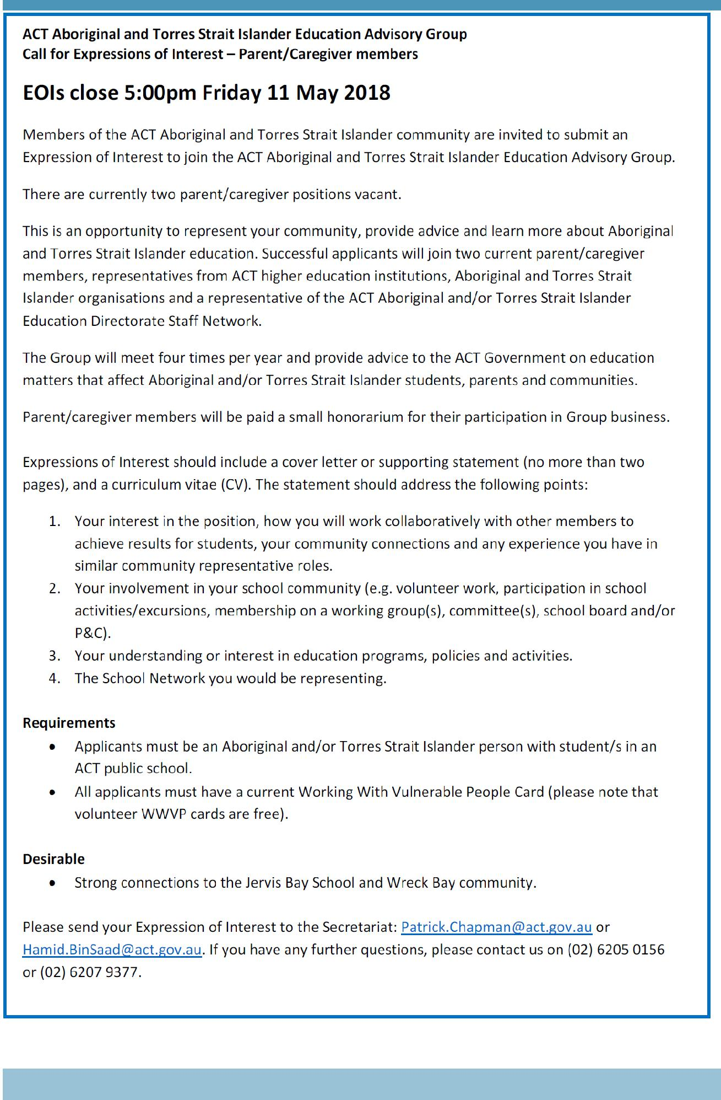

Together, we learn from each other

Palmerston Post Page 14
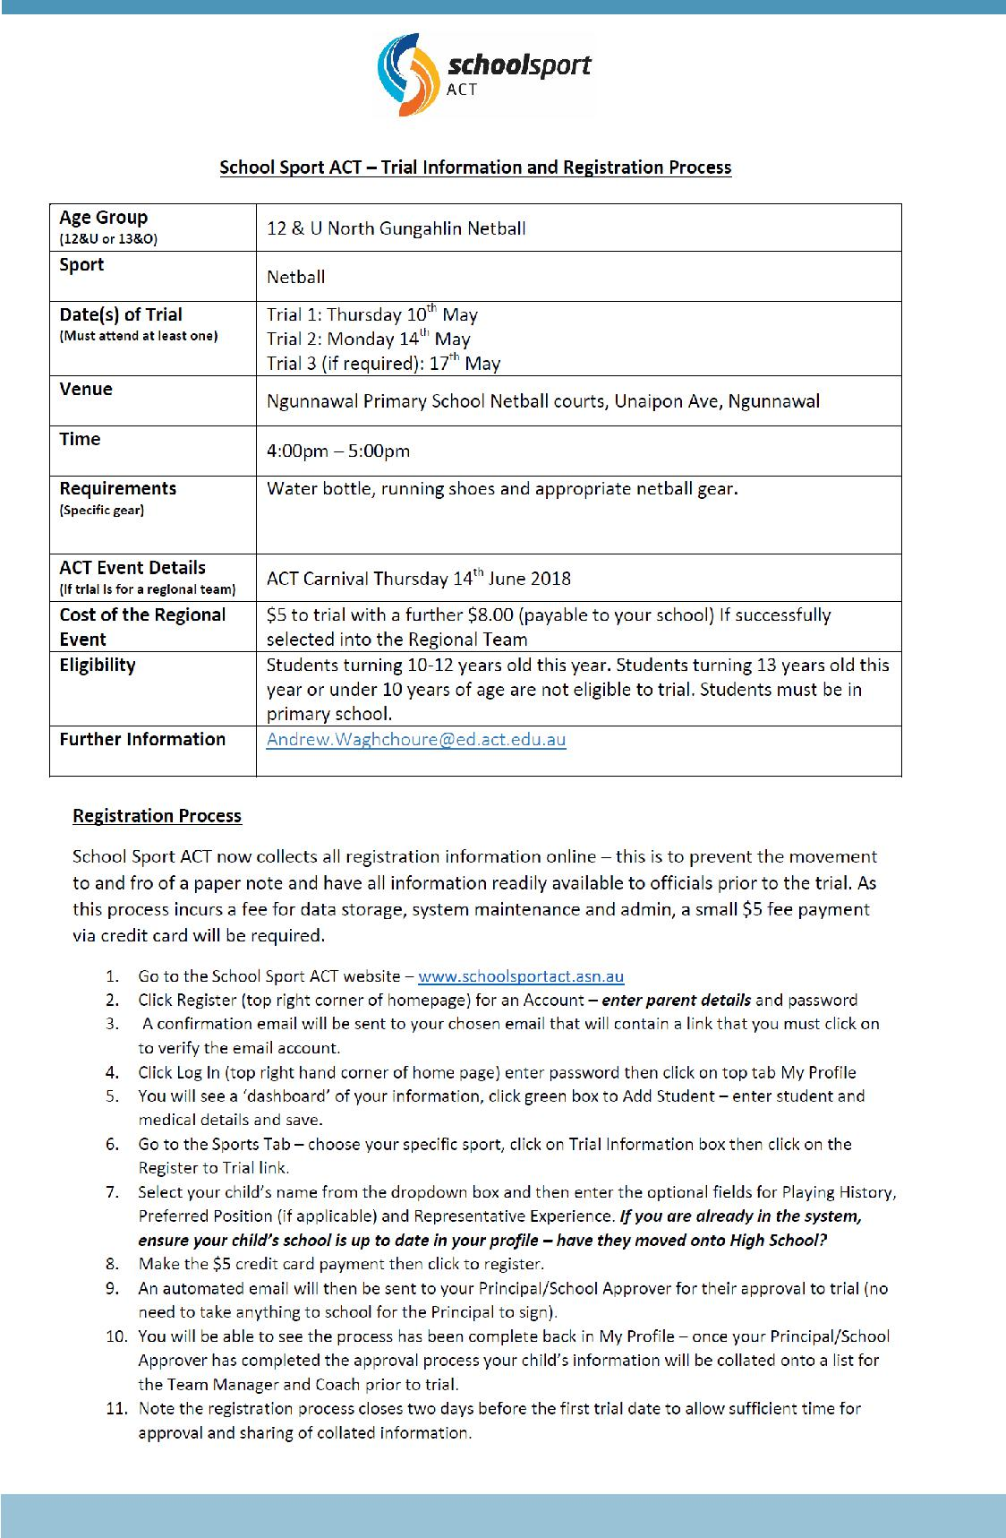

Together, we learn from each other

Palmerston Post Page 15
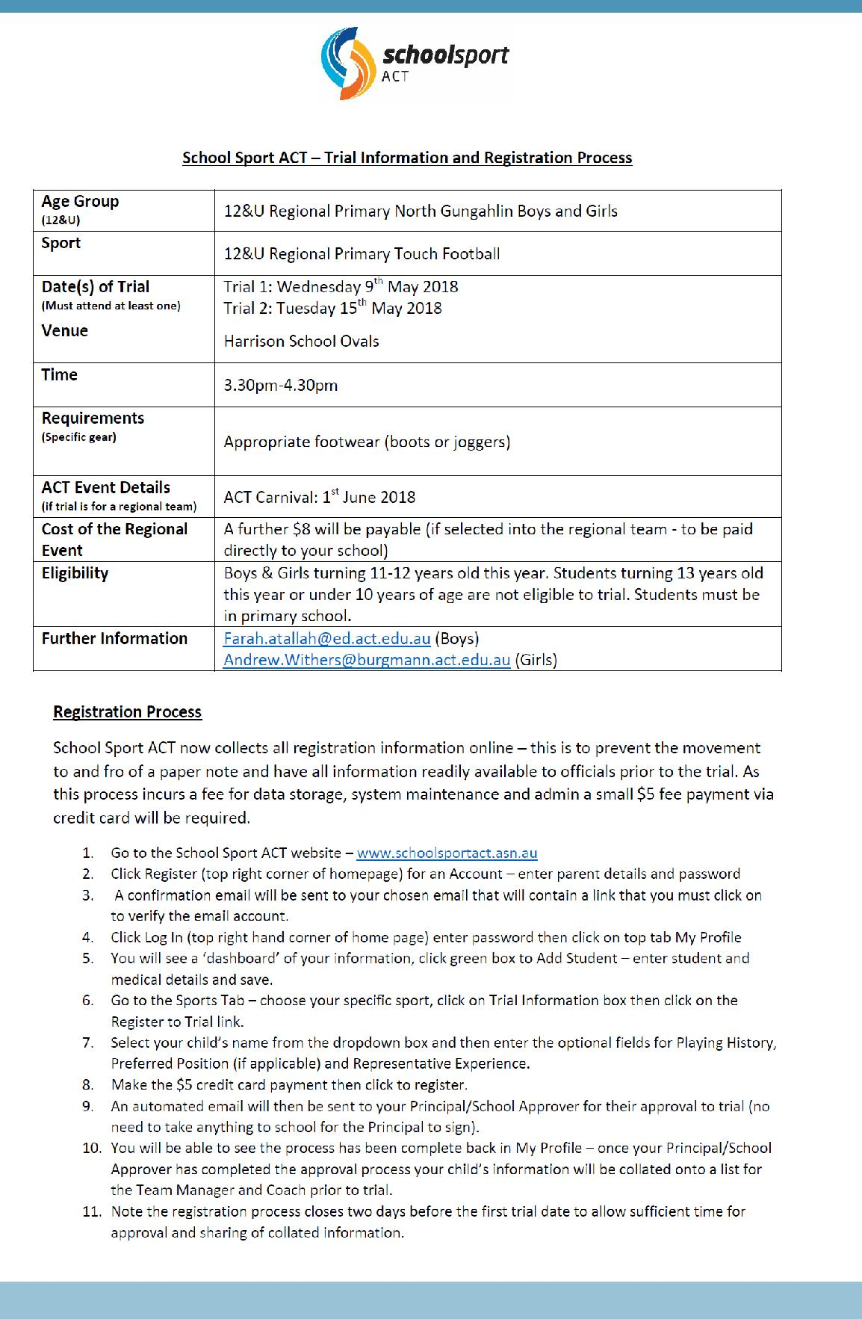

Together, we learn from each other

Palmerston Post Page 16
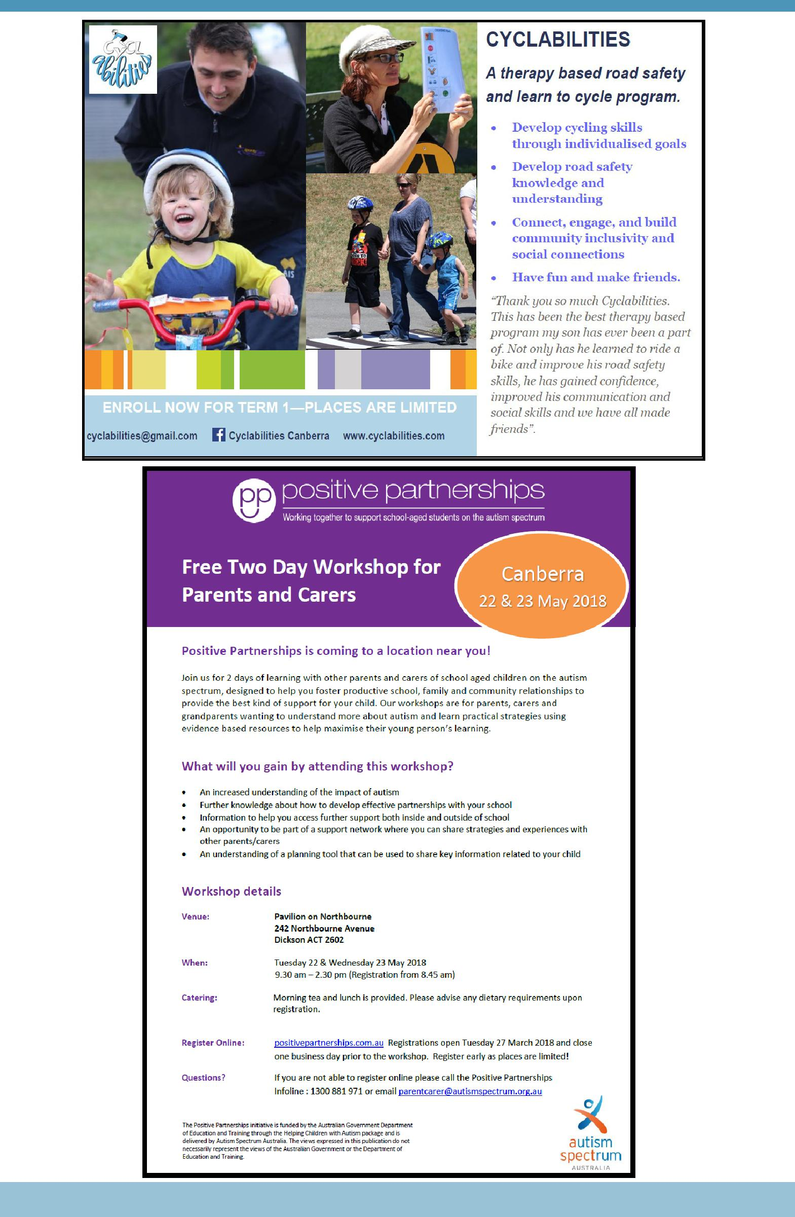

Together, we learn from each other

