Palmerston Post

7 June 2018

Week 6, Term 2

Board Chair: Lisa Fior Board Members: Parent Reps: Jesse Dang and George Villaflor

Teacher Reps: Jessica Lago and Maxine Green

P&C President: Lisa Fior

Principal: Kate Flynn (acting) Deputy Principal: Haeley Simms (acting)

Executive Teachers: Kylie Moller, Jacqui Warden, Matt Gowen, Catherine Griffin (acting)

ASSEMBLY:
8 Jun | Senior - Yr 4
15 Jun | Junior - K
DATES TO REMEMBER:
08 Jun | P/S Mini Athletics
 | Carnival (end)
08 Jun | Yr3-6 Orienteering
11 Jun | PH - Queen’s Birthday
12 Jun | P/S School Photos
12 Jun | Yr3-6 Orienteering
13 Jun | Christian Education
13 Jun | ICAS - Spelling
13 Jun | 5pm CAP evening
14 Jun | School Photos
14 Jun | ICAS - Writing
15 Jun | K-Yr2 Constable
 | Kenny
15 Jun | Yr3-6 Orienteering

NOTES HOME:

- Yr2-4 & IEC Canberra Theatre excursion

- CAP

- PBL Mascot Competition

P&C BOARD NEWS P&C: 7:00pm 25 June 2018

All P&C activities, meeting agendas and minutes are available from the school website at – Parent Corner

School Board: 7:30am 21 June 2018

DEPUTY PRINCIPAL’S MESSAGE

On Tuesday night I was fortunate to attend the 2018 Lions Club of Gungahlin Primary School Public Speaking Competition. Palmerston had two representatives. Vishal who presented a very knowledgeable speech on Volcanoes and Isabela who spoke beautifully about working dogs. Both of these students should be extremely proud of their efforts on the night.

Athletics Carnival

On Wednesday Palmerston held another very successful Athletics Carnival. The students enthusiastically cheered members of their house on and the junior school had a fantastic time participating in activity rotations. Thank you to Mr Susko and our athletics carnival committee for organising such a fantastic carnival.

NCCD

This week included in the newsletter is information about the Nationally Consistent Collection of Data (school students with a disability). This collection provides education authorities with a clear picture of the number of students receiving adjustments because of a disability. This year there has been a change in the guidelines for this process. Previously parents/carers could choose to opt out of this collection, however this year all students will be included. This information will not explicitly identify students. If you would like further information please read the attached information and/or contact our Disability Education Contact Officer Felicity McNeice. Here is the link to the NCCD document: https:// docs.education.gov.au/node/33415

Seesaw

Over the past two weeks all of the classes at Palmerston have been sending home parent/carer invitations for Seesaw. This allows our parents to view and participate in their child’s digital portfolio on Seesaw. To date we have had over 500 parents log on to Seesaw and have had some fantastic feedback.

Together, we learn from each other

Palmerston Post Page 2

Stranger Danger

There have been incidents reported last week involving strangers approaching students in the vicinity of schools. The Education Directorate is working with ACT Policing in relation to the reported incidents. These incidents are a good reminder to us all to help children understand the importance of stranger safety and the need to report any unusual incidents or approaches to staff immediately. Working to-gether is the best way to help keep children safe and I ask that you please have conversations with your children about moving safely on the way to and from school and what to do if they ever feel un-safe – the ParentLink website has some useful tips.

Preschool 2019

Please remember that we are enrolling for preschool 2019. If you know someone who has a preschool aged child for 2019, have them drop by the school or fill in an online enrolment form. This assists us in organising staffing for 2019.

Have a great week,

Haeley Simms

GUNGAHLIN PRIMARY SCHOOL PUBLIC SPEAKING COMPETITION

Congratulations to Isabela - 4VS and Vishal - 3DJ who did a wonderful job representing our school in the 2018 Lions Club of Gungahlin Primary School Public Speaking Competition on Tuesday the 5 June.
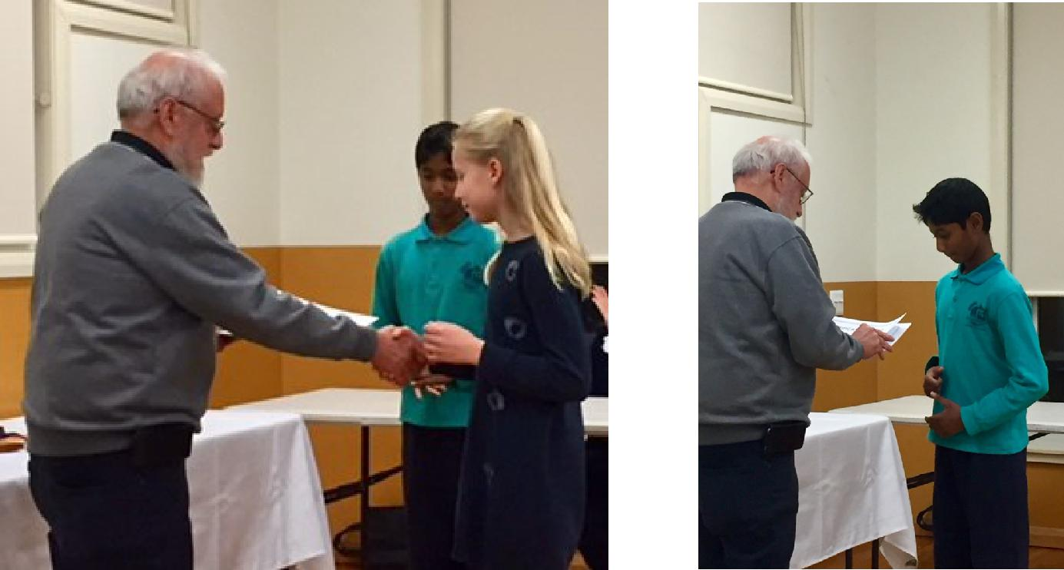

Together, we learn from each other

Palmerston Post Page 3

UPCOMING EVENTS

Preschool Mini Athletics Carnival

Date: Friday 8 June 2018

Location: Palmerston Preschool
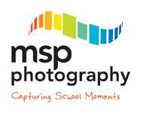

School Photos

Date: Tuesday 12 June 2018 - Preschool - Brave, Itchy & Noisy Bears

Date: Thursday 14 June 2018 - whole school (including remaining preschool classes)

Location: Palmerston District Primary School

If families require more than one set of photos they are able to place separate orders. Just complete a spare order form for your order, clearly marking mum or dad’s details. Or you can contact MSP Photography direct to place your order on 6255 9208. Sibling photo envelopes are available at the front office.

Christian Education

Date: Wednesday 13 June 2018

Location: Palmerston District Primary School

Our teaching theme for 2018 is HORRIBLE HISTORY - FANTASTIC FUTURE. We will learn about four people from Old Testament Bible history who had a ‘horrible’ time… but who God used to be heroes and leaders. We will teach the song ‘God’s Good All The Time’ by Colin Buchanan.

Term 2 will introduce the character of King David and trace his history to Jesus.

2019 CAP Program Information Session

Date: 5pm Wednesday 13 June 2018

Location: Palmerston District Primary School, library

K-Yr2 Constable Kenny

Date: Friday 15 June 2018

Location: Palmerston District Primary School

Yr3-6 Constable Kenny

Date: Friday 22 June 2018

Location: Palmerston District Primary School

Preschool - Sammy Seal Music (Cranky, Hungry & Sleepy Bears)

Date: Friday 22 June 2018

Location: Palmerston Preschool

Preschool - Sammy Seal Music (Brave, Itchy & Noisy Bears)

Date: Monday 25 June 2018

Location: Palmerston Preschool

Preschool - Hatching Chicks

Date: 25 June - 6 July 2018

Location: Palmerston Preschool

Together, we learn from each other

Palmerston Post Page 4

RECYLING PROGRAM

Want to raise money for the school and at the same time recycle items you normally throw away?

Palmerston Primary is registered to be part of a new recycling program. The school will be a collection point for oral care waste that we will send off to earn money for the school.

Al you have to do is bring your finished toothpaste tubes, toothbrushes, dental floss containers and packaging and place them in the box just outside the staffroom where the club board is. We will do the rest.
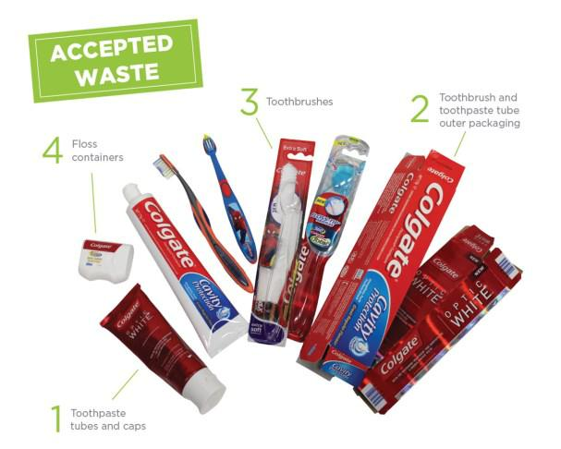
Just so you know… even though the collection box has pictures of Colgate products on it – ANY BRAND OF ORAL CARE PRODUCTS IS ACCEPTED!

The program will be officially launched on World Environment Day June 5 at morning lines. If you already have some products you would like to bring in before then please hand in to the front office or directly to Karon Campbell - Environmental Science Teacher.

Together, we learn from each other

Palmerston Post Page 5

CAP PROGRAM

This term we will begin the testing and identification process for our CAP program in 2019. The CAP program at Palmerston District Primary School is for children who are identified as gifted students. In line with school procedures, all students currently in year 2 will be tested for the program. If your child is in another year group at Palmerston and you would like to nominate them to be tested for next year’s program, nomination forms are available now at the front office. All nomination forms must be submitted by Friday 15 June 2018 (week 7).

If you are interested in hearing more about the program itself and/or more about the testing we use to identify gifted children, please come along to an information session on Wednesday 13 June 2018 at 5pm in the library.

Thank you,

Cheryl Cassella

PBL UPDATE

Thank you to all of the parents who attended our PBL information session on Wednesday evening. It was great to receive feedback on our Behaviour Expectation Matrix.

Raffle tickets started this week. Teachers have been on the look out to catch students making positive choices in the playground. The students have been very excited to see their houses collecting lots of tickets.

A mascot competition form is going home today to find our very own Palmerston PBL mascot. The PBL team are looking forward to receiving lots of entries!

BOOK CLUB NEWS

Hopefully everyone has received their issue 4 of the Book Club catalogue this week.

Please note the deadline for all orders is next Friday 15 June.

Reminder you can order online via LOOP or if you prefer to pay with correct cash/chq (made payable to Scholastic Australia) then place with the order into the Boomerang Box located in front office foyer.

Books can then take up to 2 weeks to be received and distributed.

Together, we learn from each other

Palmerston Post Page 6

REPORTING

Over the last few weeks teachers have been very busy collating and recording information in order to provide you with clear, accurate and objective information about the learning and development of your child, via the ACT Directorate reporting template. At Palmerston, we use a range of mechanisms to provide information - these include Learning Journeys, informal and formal interviews and end of semester reports.

For students in Kindergarten to Year 6, teachers report student achievement using the Australian Curriculum achievement standards for each learning area. The achievement standards describe the quality of learning comprising the extent of knowledge, the depth of understanding and sophistication of skills expected of students at the end of each reporting period.

In the areas of English and mathematics you will find comments relating to the strengths of each child and areas for development. Aligned with these strengths and areas for development you will find strategies to maintain and support the progression of learning. Reports will be sent home with children on Thursday 28 June, week 9.

A-E Reports

Preschool children will receive a developmental summary report. If your child is in Kindergarten you will receive the school report. Children in Years 1 - 6 will receive a copy of the school report and an A-E report. As parents/carers you have the option of withdrawing your child from the A-E reporting process. This means that your child will still be awarded an A-E grade in the key learning areas, and a copy of the A-E report will go onto their school file. However, an A-E report will not be sent home with your child. You will receive only the school report.

If you choose to withdraw your child from the A-E reporting process, please advise the school in writing by Friday 15 June, week 7.

Interviews

Teachers will be running interviews after reports go home, on Monday 2 - Thursday 5 July week 10. Preschool teachers will also offer interviews throughout week 10. Please call the front office on 6142 1440 to book in an interview time.

Request for duplicate reports – please return to the Front Office – Semester 1, 2018

Please indicate on the form attached if you require duplicate copies of your child’s report.

I will require a duplicate copy of my child/ren’s report. My child/ren’s name/s are:

class

class

class

Please address the duplicate report to: (please include name & address)

Together, we learn from each other

Palmerston Post Page 7
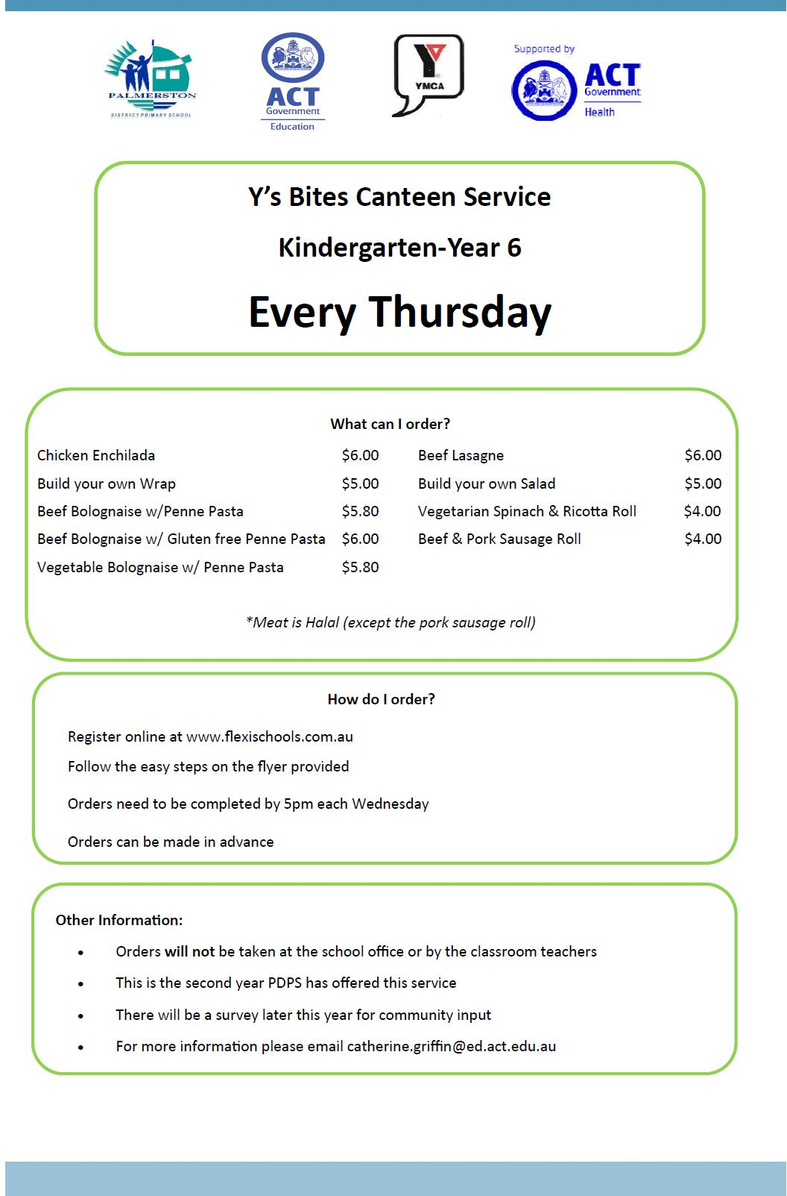

Together, we learn from each other

Palmerston Post Page 8
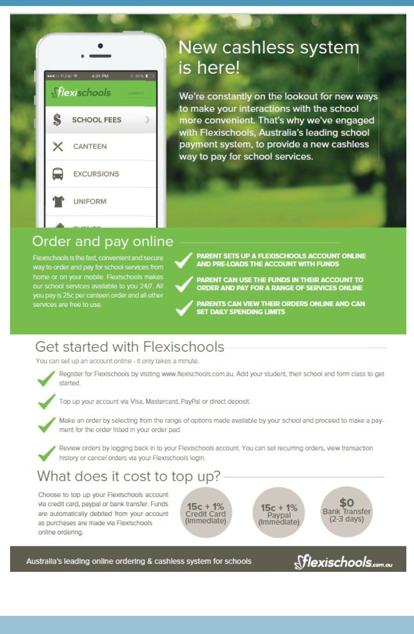

Together, we learn from each other

Palmerston Post Page 9
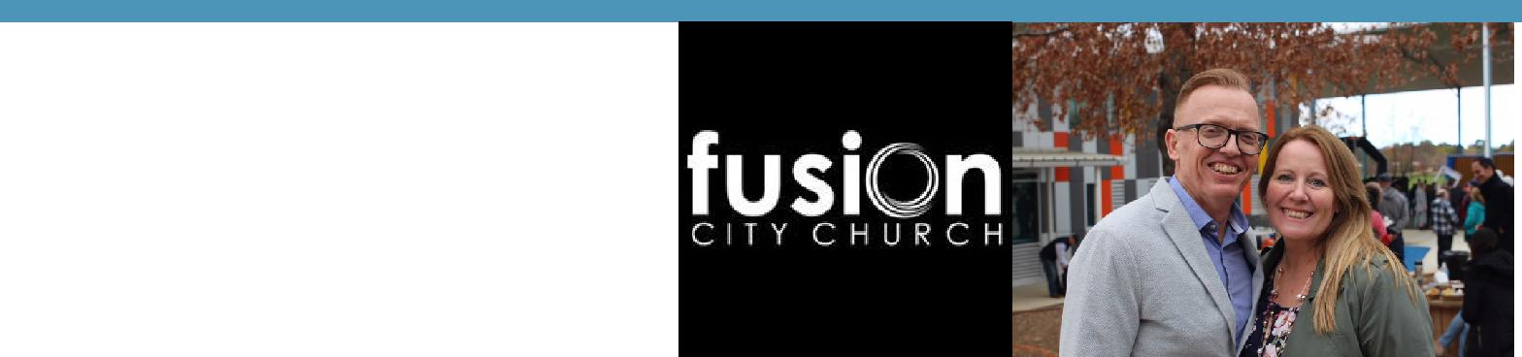

HIRER NEWS

Congratulations to Fusion City Church who celebrate their 10th birthday over the weekend.
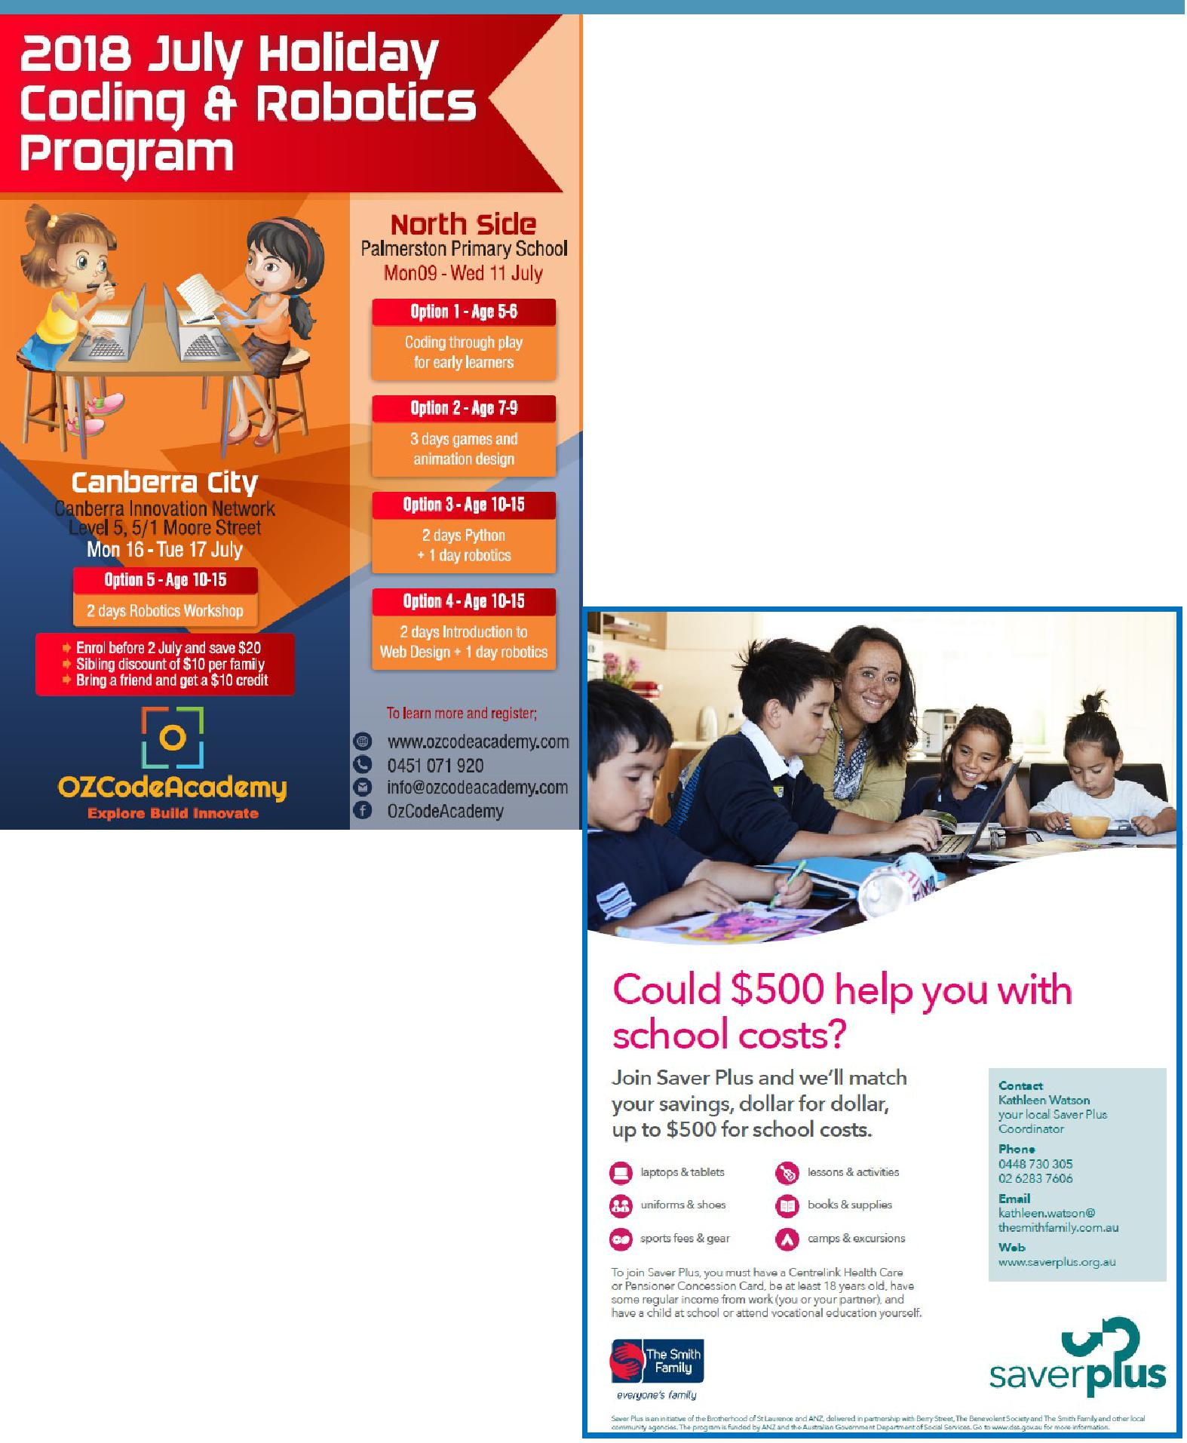

COMMUNITY NEWS

Together, we learn from each other

