What’s On

14 June 2018

Week 7, Term 2

ASSEMBLY:
15 | Jun |  | Junior - K
22 | Jun |  | Senior - Yr6
29 | Jun |  | Whole School -
 |  |  | Indonesian
DATES TO REMEMBER:
15 | Jun |  | K-Yr2 Constable Kenny
15 | Jun |  | Yr3-6 Orienteering
19 | Jun |  | P/S School Photos
22 | Jun |  | Yr3-6 Constable Kenny
22 Jun |  |  | P/S Sammy Seal
 |  |  | Music
25 | Jun - 6 Jul |  | P/S Hatching Chicks
25 Jun |  |  | P/S Sammy Seal
28 Jun |  |  | LSU - Magic Mania
28 Jun |  |  | Yr3/4 Children’s
 |  |  | Opera
29 | Jun |  | Yr2-4 & IEC Canberra
 |  |  | Theatre excursion
2-4 Jul |  |  | Kindy Health Checks
2-5 Jul |  |  | Parent Teacher
 |  |  | Interviews
3 Jul |  |  | P/S Fresh Food
 |  |  | Challenge
4 Jul |  |  | Transport & Parking
 |  |  | Parent Info Session
6 Jul |  |  | P/S Fresh Food
 |  |  | Challenge

NOTES HOME:

- Mrs Cassella leave - 4/5CC

- Mrs Saro leave - 4VS

P&C BOARD NEWS P&C: 7:00pm 25 June 2018

All P&C activities, meeting agendas and minutes are available from the school website at – Parent Corner

School Board: 7:30am 21 June 2018

PRINCIPAL’S MESSAGE

Rostrum

On Tuesday night Miss Brailey, Mrs Imhoff and I went along to the Quarter Final for the Rostrum Competition at Giralang Primary School. A number of students from neighbouring schools participated in this event. These included: Harrison, Kaleen Primary, Maribyrnong Primary, Mother Teresa, St Michael’s Primary, Sutton Public and Giralang Primary. We were exceptionally proud of our school finalist Caitlin - 6KB who presented a fantastic speech on ‘Breaking the Ice’.

Transport

As previously mentioned we are really happy with the new carpark at the preschool and the positive impact it has had on our parking processes. We have received a few e-mails from members of the community with further questions around our transport and parking processes. To assist with these questions a member of the ACT Directorate will be on site at Palmerston at 5pm on Wednesday 4 July. A flyer is coming home soon with the details of this event.
PBL

We have been receiving a steady stream of entries for our mascot competition since its launch last week. We certainly have a wide variety of ideas and responses and the PBL committee know that making the decision our on our mascot is going to be quite tricky. A reminder that we have asked for an illustration as well as a 50 word or less explanation on the entry, keeping in mind our PRIDE values, school motto “together we learn from each other” and the PBL values of Safe, Respectful, Learner. We thank all community members for supporting us with this initiative.

Reporting and interviews

Palmerston staff are currently working hard on our end of semester one reports which are due home on Thursday 28 June. Staff utilise the ACT Directorate template in order to provide you with a clear picture regarding the progress of your child in relation to their learning and development. Interviews will be held throughout week

- If you would like to book an appointment to see your child’s class teacher for an interview, please call the front office on 6142 1440.

Together, we learn from each other

What’s On Page 2

School photos

Master School Portraits were in the school today to take school photos. Unfortunately their photographer was unwell on Tuesday and had to postpone taking photos for the front end of the week preschool group and sibling photos. We apologise for this inconvenience and thank you for your understanding. These photos will now be taken on Tuesday 19 June.

CAP program

Thank you to all families who came to our CAP information session last night. The teachers ran an informative session around our program and answered questions. CAP testing will occur later in the term. Palmerston District Primary School utilises the CoGAT testing, in line with other Gungahlin schools. The tests are sent away to be marked and will be returned to us during next term.

Social Media

I would like to take the opportunity to mention Palmerston District Primary School’s commitment to respecting and adhering to parent/carers individual requests around privacy for children within the school. As such, I would ask that if you are taking photographs of your own children, to be mindful of other children within the photos and ensure only your own child is visible before choosing to upload to social media such has Facebook, Instagram, twitter and YouTube.

Have a great week and stay warm!!

Kate Flynn
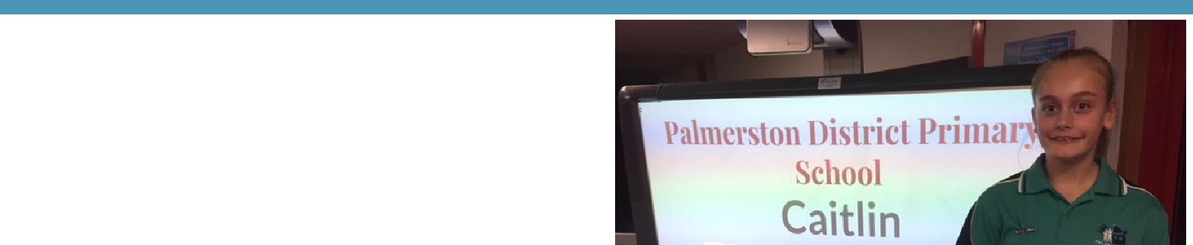

STUDENT ACHIEVEMENTS

Rostrum

Congratulations to Caitlin in 6KB who did a wonderful job representing our school at a Rostrum quarter final on Tuesday 12 June. The topic that she chose was ‘Breaking the Ice’.

ACT Cross Country results

Congratulations to the three students who competed at the ACT Cross Country Carnival. Amelia and Georgia both finished 31st and Toby finished an amazing 8th!

Together, we learn from each other

What’s On Page 3

UPCOMING EVENTS

K-Yr2 Constable Kenny

Date: Friday 15 June 2018

Location: Palmerston District Primary School
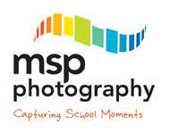

School Photos *change of date*

Date: Tuesday 19 June 2018 - Preschool - Brave, Itchy & Noisy Bears

Date: Location: Palmerston Preschool

If families require more than one set of photos they are able to place separate orders. Just complete a spare order form for your order, clearly marking mum or
dad’s details. Or you can contact MSP Photography direct to place your order on 6255 9208.

Sibling photo envelopes are available at the front office.

Yr3-6 Constable Kenny

Date: Friday 22 June 2018

Location: Palmerston District Primary School

Preschool - Sammy Seal Music (Cranky, Hungry & Sleepy Bears)

Date: Friday 22 June 2018

Location: Palmerston Preschool

Preschool - Sammy Seal Music (Brave, Itchy & Noisy Bears)

Date: Monday 25 June 2018

Location: Palmerston Preschool

Preschool - Hatching Chicks

Date: 25 June - 6 July 2018

Location: Palmerston Preschool

LSU - Magic Mania Show

Date: 28 June 2018

Location: Hellenic Club of Woden

Yr3/4 Children’s Opera

Date: 28 June 2018

Location: Palmerston District Primary School

Yr2-4 & IEC - George’s Marvellous Medicine show

Date: 29 June 2018

Location: Canberra Theatre

Together, we learn from each other

What’s On Page 4

RECYLING PROGRAM

Want to raise money for the school and at the same time recycle items you normally throw away?

Palmerston Primary is registered to be part of a new recycling program. The school will be a collection point for oral care waste that we will send off to earn money for the school.

Al you have to do is bring your finished toothpaste tubes, toothbrushes, dental floss containers and packaging and place them in the box just outside the staffroom where the club board is. We will do the rest.
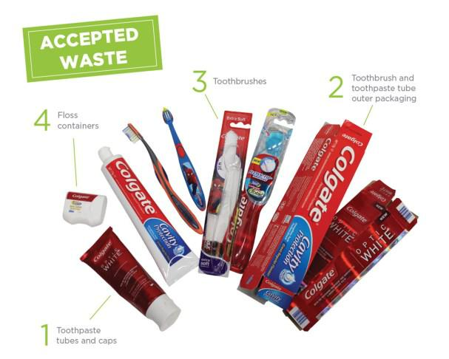
Just so you know… even though the collection box has pictures of Colgate products on it – ANY BRAND OF ORAL CARE PRODUCTS IS ACCEPTED!

The program will be officially launched on World Environment Day June 5 at morning lines. If you already have some products you would like to bring in before then please hand in to the front office or directly to Karon Campbell - Environmental Science Teacher.

CAP PROGRAM

This term we will begin the testing and identification process for our CAP program in 2019. The CAP program at Palmerston District Primary School is for children who are identified as gifted students. In line with school procedures, all students currently in year 2 will be tested for the program. If your child is in another year group at Palmerston and you would like to nominate them to be tested for next year’s program, nomination forms are available now at the front office. All nomination forms must be submitted by TOMORROW, Friday 15 June 2018 (week 7).

Thank you,

Cheryl Cassella

Together, we learn from each other

What’s On Page 5

REPORTING

Over the last few weeks teachers have been very busy collating and recording information in order to provide you with clear, accurate and objective information about the learning and development of your child, via the ACT Directorate reporting template. At Palmerston, we use a range of mechanisms to provide information - these include Learning Journeys, informal and formal interviews and end of semester reports.

For students in Kindergarten to Year 6, teachers report student achievement using the Australian Curriculum achievement standards for each learning area. The achievement standards describe the quality of learning comprising the extent of knowledge, the depth of understanding and sophistication of skills expected of students at the end of each reporting period.

In the areas of English and mathematics you will find comments relating to the strengths of each child and areas for development. Aligned with these strengths and areas for development you will find strategies to maintain and support the progression of learning. Reports will be sent home with children on Thursday 28 June, week 9.

A-E Reports

Preschool children will receive a developmental summary report. If your child is in Kindergarten you will receive the school report. Children in Years 1 - 6 will receive a copy of the school report and an A-E report. As parents/carers you have the option of withdrawing your child from the A-E reporting process. This means that your child will still be awarded an A-E grade in the key learning areas, and a copy of the A-E report will go onto their school file. However, an A-E report will not be sent home with your child. You will receive only the school report.

If you choose to withdraw your child from the A-E reporting process, please advise the school in writing by TOMORROW, Friday 15 June, week 7.

Interviews

Teachers will be running interviews after reports go home, on Monday 2 - Thursday 5 July week 10. Preschool teachers will also offer interviews throughout week 10. Please call the front office on 6142 1440 to book in an interview time.

Request for duplicate reports – please return to the Front Office – Semester 1, 2018

Please indicate on the form attached if you require duplicate copies of your child’s report.

I will require a duplicate copy of my child/ren’s report. My child/ren’s name/s are:

class

class

class

Please address the duplicate report to: (please include name & address)

Together, we learn from each other

What’s On Page 6
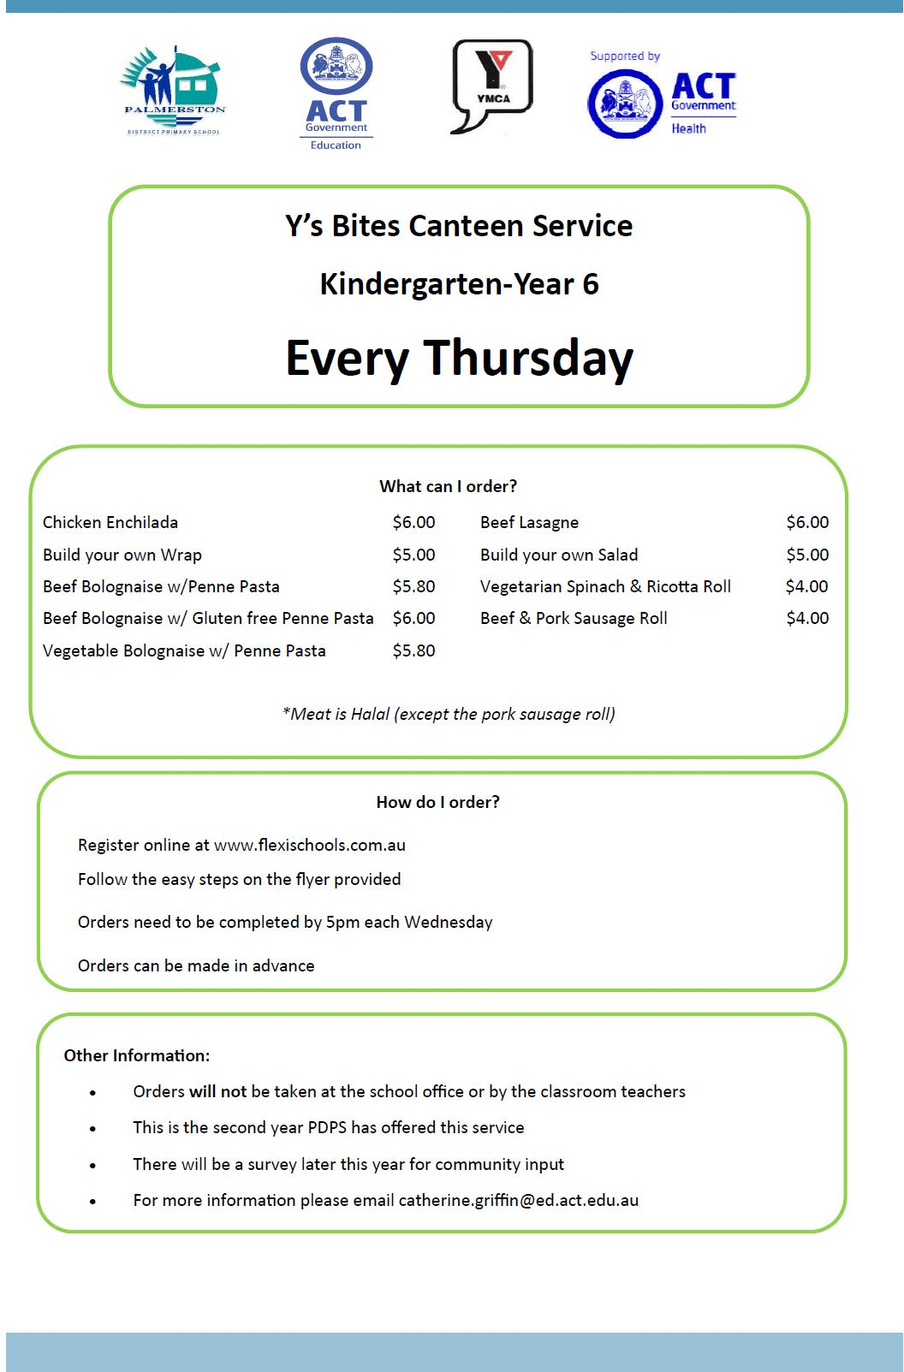

Together, we learn from each other

What’s On Page 7
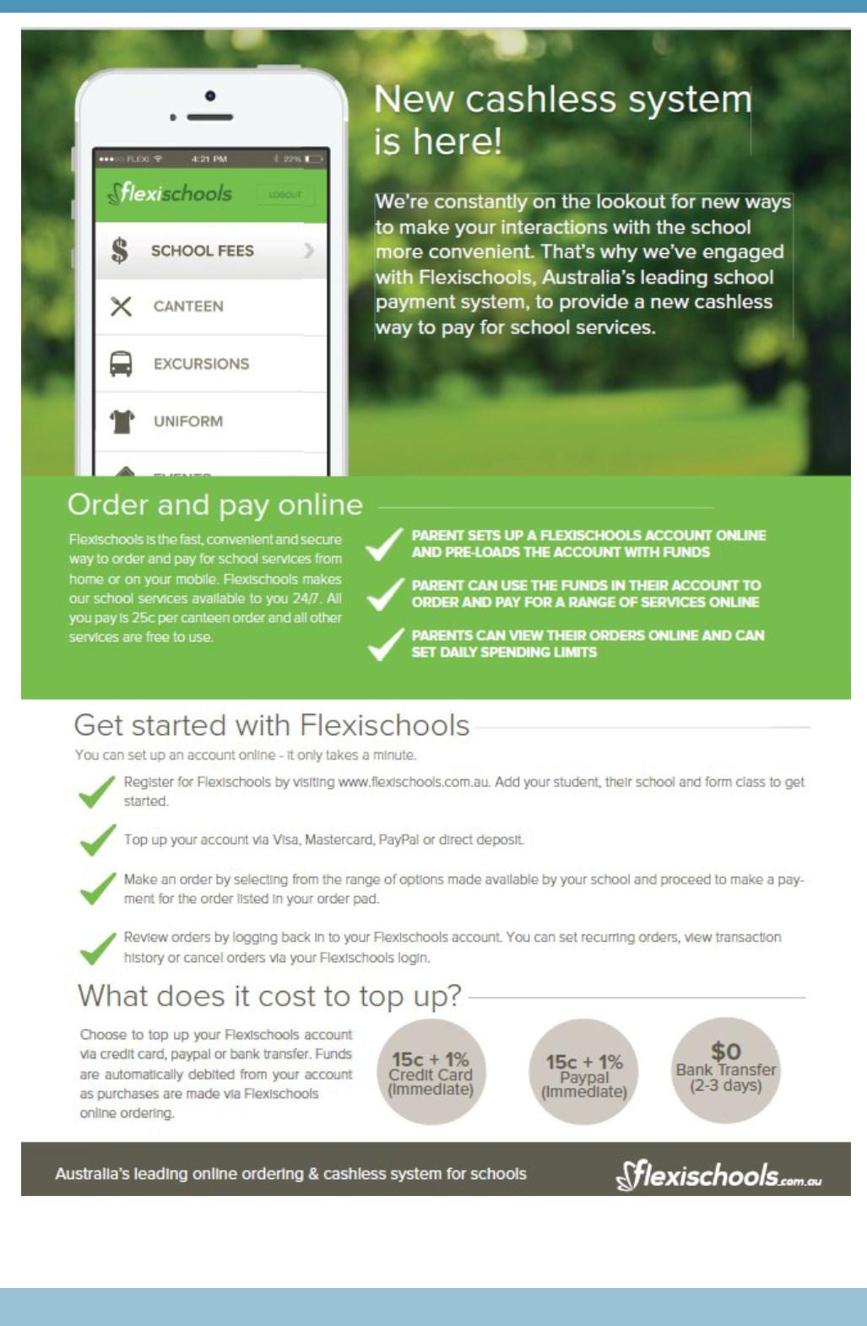

Together, we learn from each other

What’s On Page 8

HIRER NEWS
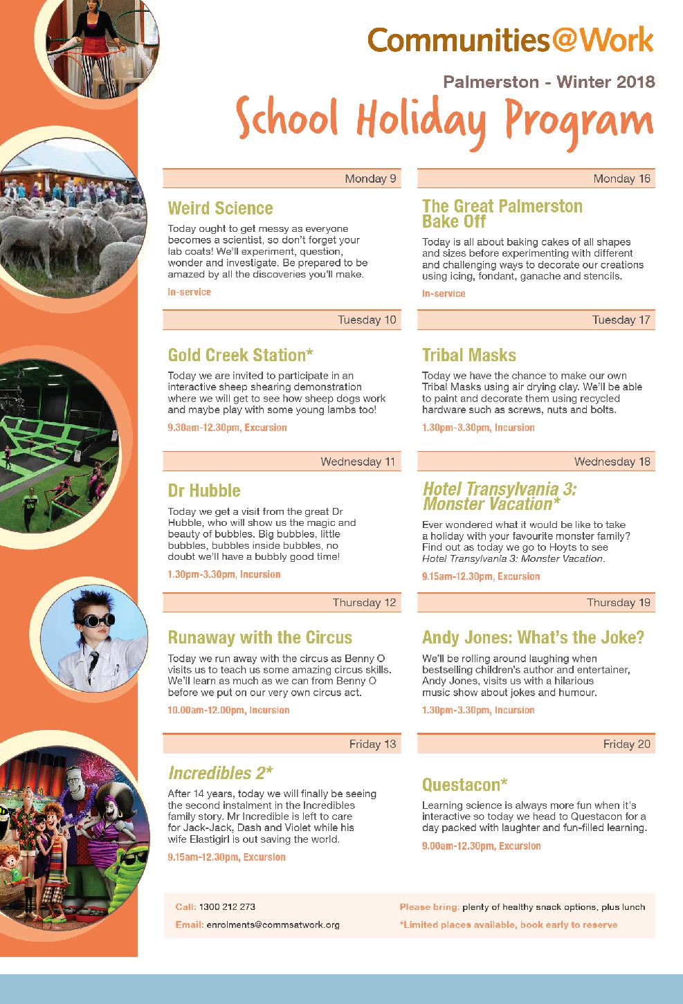

Together, we learn from each other

What’s On Page 9
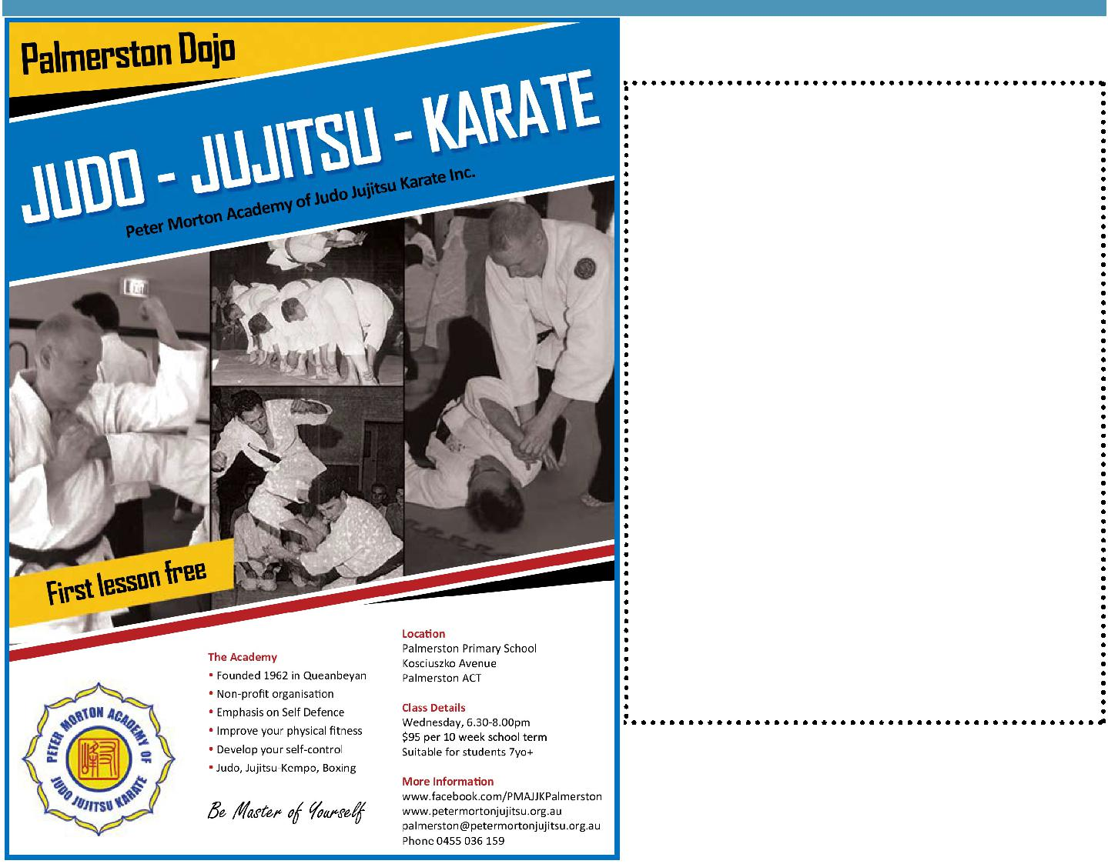

COMMUNITY NEWS

First Eucharist and Reconciliation Dates for 2018

(children in Year 3 or older)

Parent Information Session:
Tuesday 26 June at 1:00pm or 6:00pm

Commitment Mass followed by Enrol-ment:

Saturday 30 June at 6:00pm OR Sunday 1 July at 9:30am OR 5:30pm

Celebration of the Sacrament:
At Masses on weekends of

15-16 or 22-23 September

For more information please contact the Sac-

ramental Coordinator via email:

sacraments@holyspiritgungahlin.org.au

Holy Spirit Catholic Parish

2019 ACT Australian of the Year Awards – Be Great and Nominate

Play your part by giving our nation’s best the recognition they deserve. If you know a remarkable Canberran who inspires you, then nominate them for an Australian of the Year Award.

You can nominate an Australian of the Year, Senior Australian of the Year (65 years and over), Young Australian of the Year (16 to 30 years) or Australia’s Local Hero.

Nominations close on 31 July 2018.

Visit australianoftheyear.org.au to nominate today.

Together, we learn from each other

