Palmerston Post
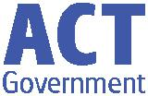

13 September 2018

Week 8, Term 3

Board Chair: Lisa Fior Board Members: Parent Reps: Jesse Dang and George Villaflor

Teacher Reps: Jessica Lago and Maxine Green

P&C President: Lisa Fior

Principal: Melissa Travers Deputy Principal: Kate Flynn

Executive Teachers: Kylie Moller, Jacqui Warden, Matt Gowen, Felicity McNeice, Catherine Griffin (acting)

ASSEMBLY:

14 Sep Whole school - Kindy

21 Sep Learning Journey - no assembly

28 Sep Senior - Yr4

DATES TO REMEMBER:

14 Sep P/S (end) - Yr6 Crazy

Hair day for Twilight

Fair

18 Sep 5:50pm Digital

Technology Info night

20 Sep Science Fair

21 Sep Learning Journey

21 Sep Walk-a-thon

25 Sep P/S Movie Dress up

day

27 Sep Market Day

27 Sep P/S Movie Dress up

day

28 Sep P/S, K & IEC -

Canberra Theatre

excursion

NOTES HOME:

- P&C Cookbook

P&C BOARD NEWS P&C: 7:00pm 17 Sep 2018

All P&C activities, meeting agendas and minutes are available from the school website at – Parent Corner

School Board: 7:30am 29 Oct 2018

DEPUTY PRINCIPAL’S MESSAGE

As I have been moving around the classes I have been taking the time to talk to the children about their purpose for attending school and receiving a quality education. Some of the comments I’ve received have included “we attend school so we can learn from each other” “we come to school so we learn more and our brains become more powerful” “we learn from our teachers- they help us to read, write and learn” “we learn new things” and “we come to school so we can learn more and help people”. I am really impressed with the depth of understanding around the purpose of school and the positive attitude of the students towards the importance of learning and learning time. Recently, we have noticed

that some children have been a little unsettled during learning time. Discussions have indicated that the outside use of social media, technology and technology games may have played a part in contributing to this as ideas/issues have filtered into the classroom and playtime. Some students are falling asleep in class due to staying up late playing computer games. Last week, the staff from ThinkUKnow provided great information on how to guide children to utilise social media in an age appropriate way. They provided useful tips to support children when using technology and reminded us that information around the content of and the recommended age guidelines of programs such as Fortnite, Snapchat and Instagram can be found on the e-safety commissioner website: https://www.esafety.gov.au/

This website may help you to work with your children so they are always ready to engage with learning here at school.

LEAVE

I will be taking long service leave for the last two weeks of term heading to warmer weather in northern NSW and Queensland with my family. During my absence Haeley Simms will be acting as the deputy. Wishing you all a great end of term - we certainly have fantastic events planned such as the Walkathon, the Science Fair and Learning Journey.
Kate Flynn

Together, we learn from each other

Palmerston Post

EXECUTIVE TEACHER’S MESSAGE

This week has seen the return of warm weather and with it a reminder to our students to ensure they have their broadbrim or legionnaire’s hat with them everyday to ensure they are sunsafe. We have had a fantastic week full of successes and learning. In particular it has been wonderful to see the improving writing of our students.

Maths Night

On Tuesday night we had many families attend our annual maths night. This is an interactive night where parents are given the opportunity to participate with their child in a variety of games that build students’ maths skills. The parents are then given a free maths pack to take home and play the games with their children. The feedback from the event was extremely positive with many parents remarking how effective and adaptable the resources were. Thank you to the numeracy committee for staying back late and hosting such a fantastic night.
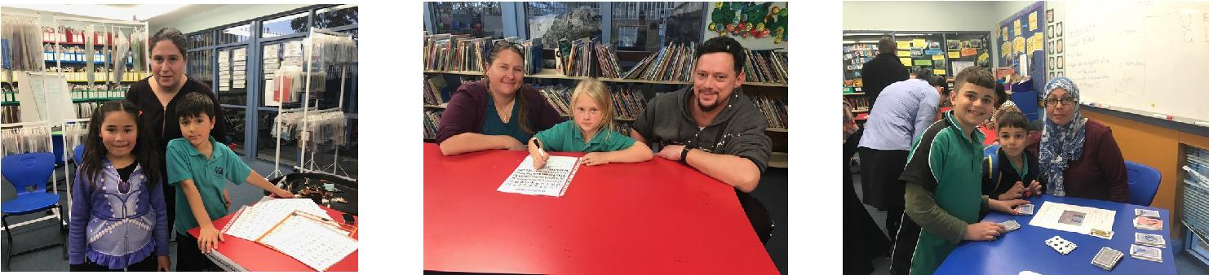

Digital Technologies evening

Next week we will be hosting a Digital Technologies evening. This evening will explore how students are using digital technology in the classroom from Seesaw to Chromebooks. We look forward to seeing many of you there.

Learning Journey

Next Friday is our Learning Journey, walkathon and Science Fair. This is an annual event for us and

we are very excited about next week and showcasing our students’ work. Preparations are going on all around us. I look forward to seeing you all next Friday morning. Have a great weekend and enjoy the warmer weather!
Haeley Simms

PBL UPDATE

The PBL team have taken another step in our PBL journey and starting from today you will notice updates in our newsletter every second week around what the focus for the next fortnight will be. The picture to look out for looks like this:
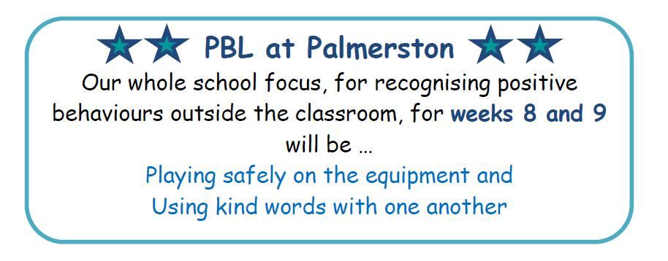

Once we have our mascot finalised it will also be added to the box above. We will also be reminding students about our fortnightly whole school focus at morning lines and via the app and Facebook.

Together, we learn from each other

Palmerston Post

UPCOMING EVENTS

Crazy Hair Day for Twilight Fair

Date: Tuesday 11 (Preschool beginning) & Friday 14 September 2018

Location: Palmerston District Primary
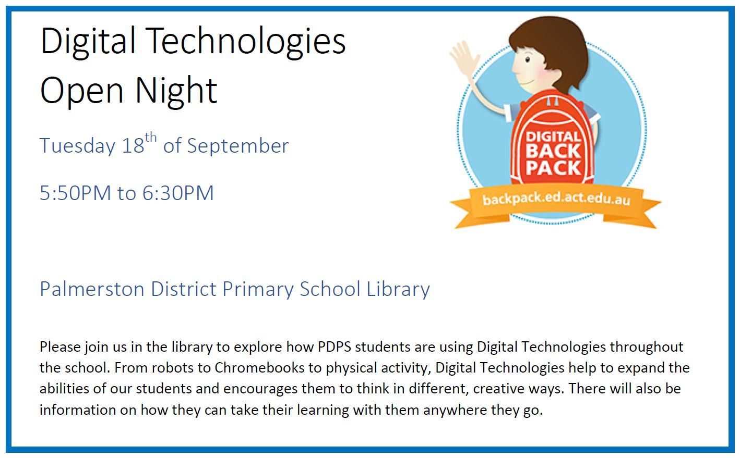

Preschool (beginning) Learning Journey

Date: Tuesday 18 September 2018

Location: Palmerston Preschool

Science Fair

Date: Thursday 20 & Friday 21 September 2018

Location: Library, Palmerston District Primary

Preschool (end) & K-Yr6 Learning Journey

Date: Friday 21 September 2018

Location: Palmerston Preschool

Walk-a-thon

Date: Friday 21 September 2018

Location: Palmerston District Primary

Preschool (beginning) Movie Dress Up Day

Date: Tuesday 25 September 2018

Location: Palmerston Preschool

Preschool (end) Movie Dress Up Day

Date: Thursday 27 September 2018

Location: Palmerston Preschool

Market Day

Date: Thursday 27 September 2018

Location: Black top, Palmerston District Primary

Preschool (end), Kindy & IEC - Canberra Theatre excursion ‘Josephine wants to dance’ Date: Friday 28 September 2018

Location: Canberra Theatre

Together, we learn from each other

Palmerston Post

P&C NEWS

Disco

"The P&C would like to thank the volunteers and parent helpers who contributed to making the school disco a raging success!"
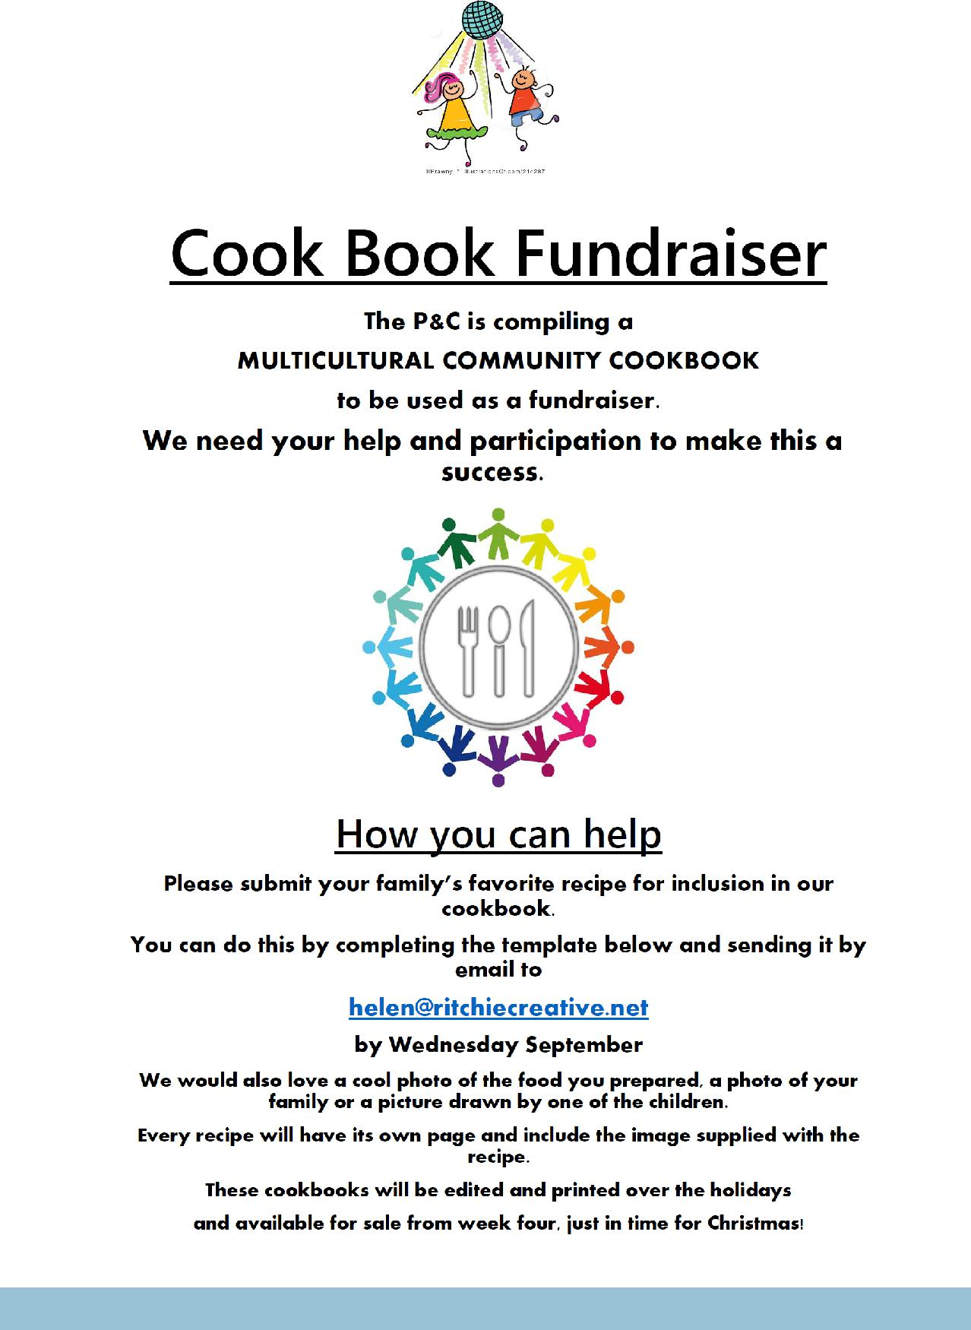

Together, we learn from each other

Palmerston Post

Name of Recipe

_______________________________________________________________________________________________

Number of Serves: Preparation Time: Cooking Time:

Difficulty (circle) : Kids Beginners OK for most Advanced

Category: Vegan Vegetarian Halal Gluten Free Dairy Free Other:

Culture (eg Asian, British, African):

Ingredients – 1 per box

Method:

Tips:

Together, we learn from each other

Palmerston Post

SCHOOL INTENTIONS 2019

School Leavers 2019

We have now reached the time in the year when we begin to look at our school numbers and staffing arrangements for 2019. If your circumstances have changed and your child/ren will not be attending Palmerston District Primary School in 2019 can you please let the front office staff know as soon as possible.

My child/ren will not be returning to Palmerston in 2019.

Name Class

Last day at Palmerston:

My child/ren will be attending:

Another government school in the ACT:

A non-government school in the ACT:

Moving out of the ACT

Forwarding Address:

Phone number:

Parent’s name:

Together, we learn from each other

Palmerston Post
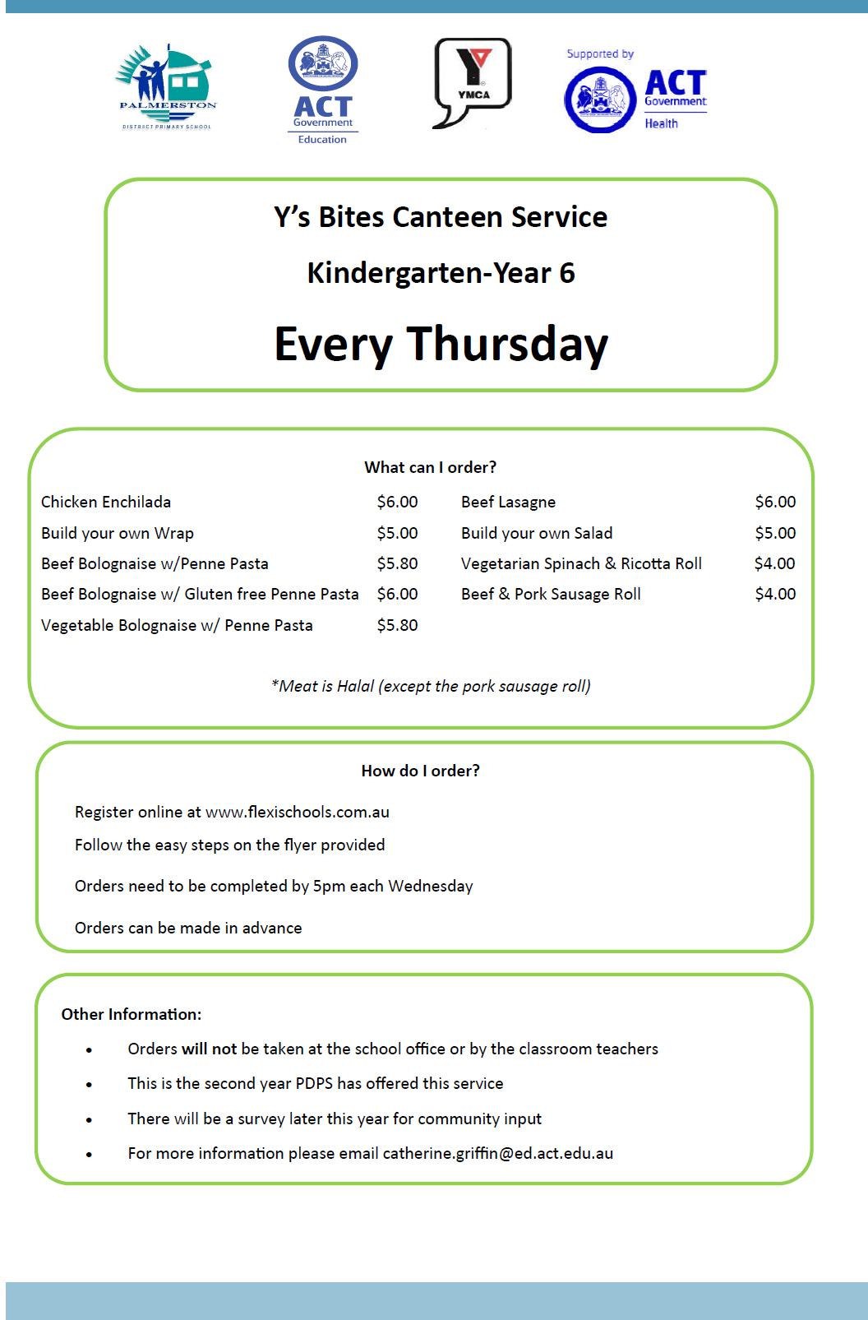

Together, we learn from each other

Palmerston Post
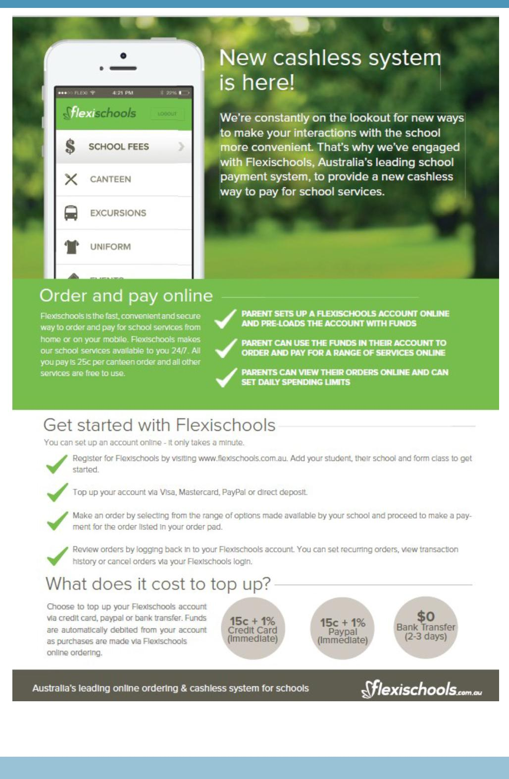

Together, we learn from each other

Palmerston Post
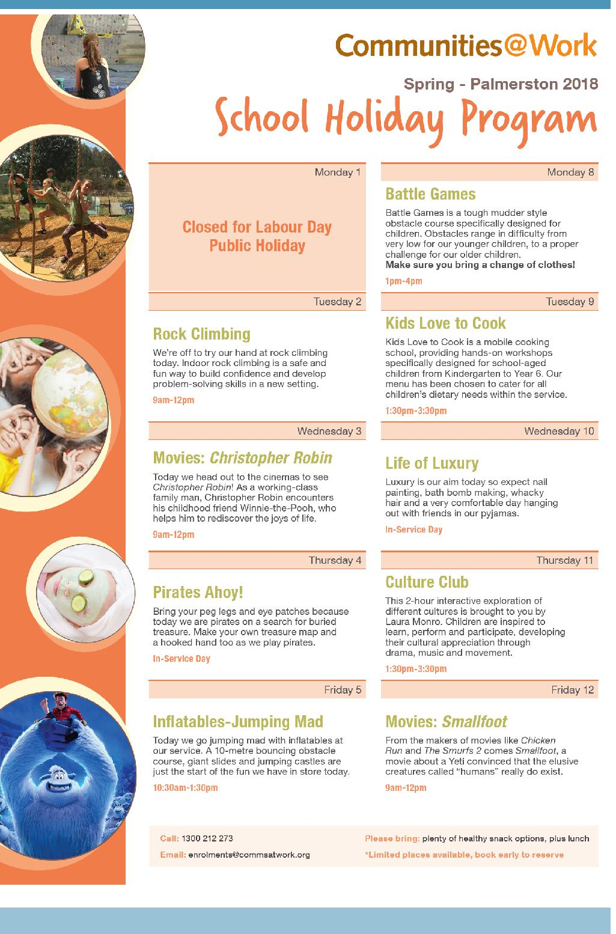

Together, we learn from each other

Palmerston Post

INSTRUMENTAL MUSIC PROGRAM EXTENSION ENSEMBLES FOR 2019

Applications for auditions are now open

Current year 3 – 5 students are eligible to apply for -

Primary Concert Choir – Singers in years 4-6 in 2019 in ACT public schools

Current year 6 students who will be attending a public high school in 2018 are eligible to apply for auditions for the following IMP ensembles.

Junior Concert Band – Brass, woodwind and percussion players in years 7 & 8 in 2019 in ACT public schools

Percussion Ensemble – Percussion players in years 7 - 12 in 2019 in ACT public schools

Senior Concert Choir – Singers in years 7 – 12 in 2019 in ACT public schools

Website link - http://www.imp.act.edu.au/our_ensembles/auditions
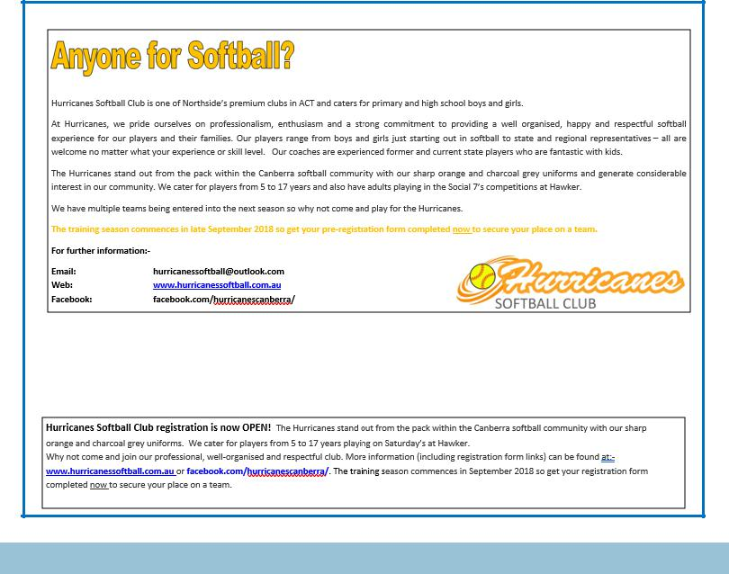

Together, we learn from each other

Palmerston Post
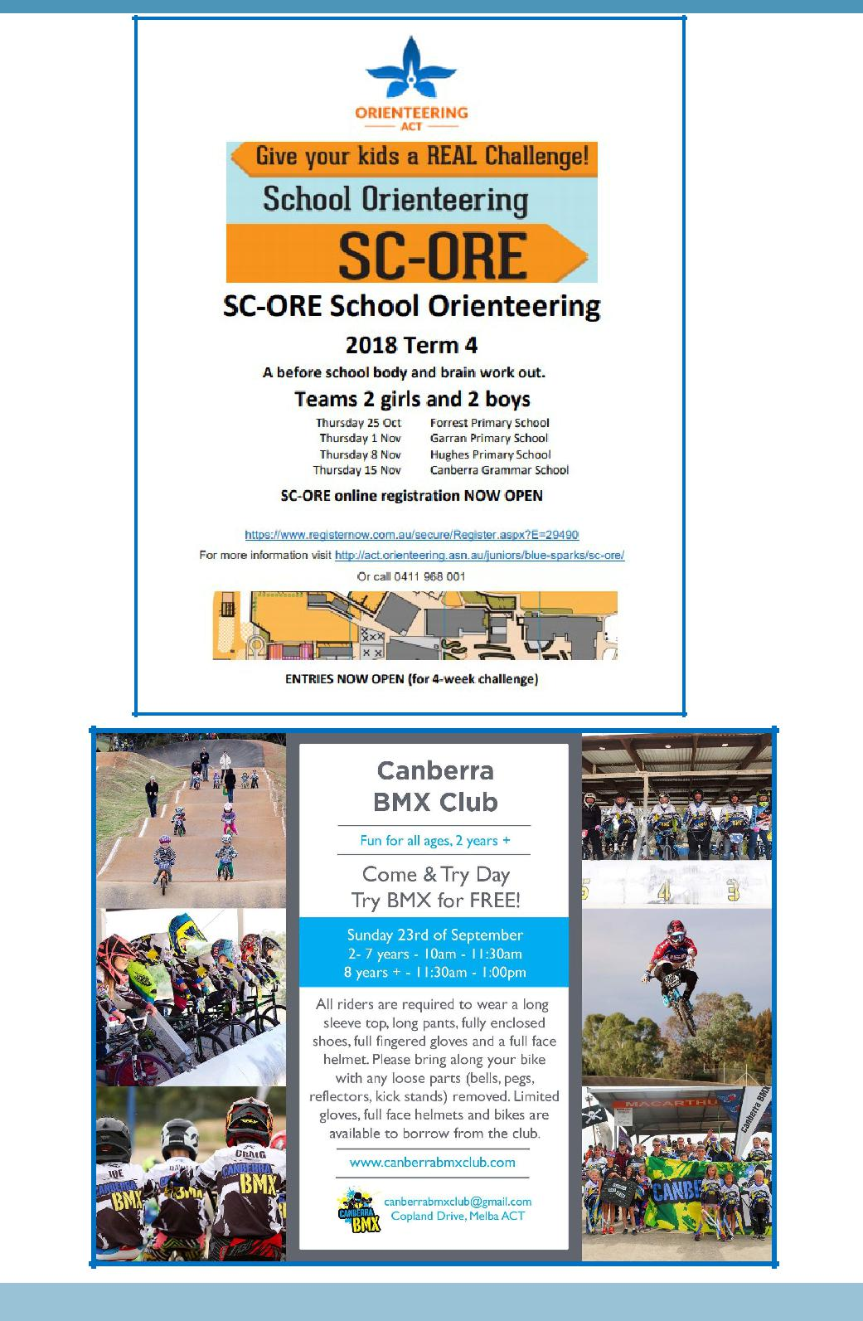

Together, we learn from each other

