Palmerston Post

14 February 2019

Week 2, Term 1
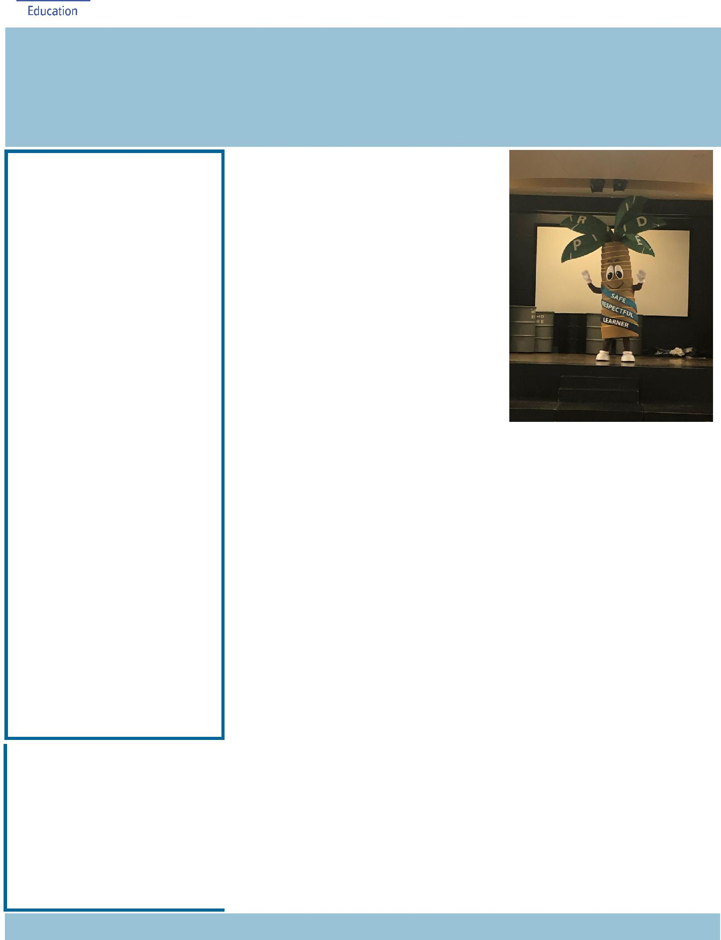

Board Chair: Lisa Fior

Teacher Reps: Jessica Lago and Maxine Green

P&C President: Lisa Fior

Principal: Melissa Travers Deputy Principals: Haeley Simms (acting) & Kylie Moller (acting)

Executive Teachers: Matt Gowen, Felicity McNeice, Catherine Griffin (acting)

ASSEMBLY:

15 Feb |  | Junior - 2MO & 2AF
22 Feb |  | No assembly
1 Mar |  | No assembly
DATES TO REMEMBER:
20 | Feb | Swimming Carnival
25 | Feb | Canberra Raiders Cyber
 |  | Safety
01 Mar |  | 5pm Billy Tea Bush
 |  | Dance
11 | Mar | Canberra Day - public
 |  | holiday
13 Mar |  | K-Yr2 Questacon
 |  | incursion
15 Mar |  | Yr3-6 Questacon
 |  | incursion
19 | Mar | Yr3-6 Author visit -
 |  | Katrina Nannestad
20 | Mar | Christian Education

NOTES:

- Billy Tea Bush Dance - youngest

- Kindy Heath Checks

P&C BOARD NEWS P&C: 18 March 2019

All P&C activities, meeting agendas and minutes are available from the school website at – Parent Corner

School Board:

DEPUTY PRINCIPAL’S MESSAGE

Thank you to all of the parents/carers who came out last night for our Parent Information Night. It was great to see so many familiar faces and some new ones as well. Thank you to our wonderful staff for staying back late to meet with families. It has been a fantastic start to the year.

This year marks our second year of Positive Behaviours for Learning (PBL). Our Palmerston Expectations are Be

safe, Be respectful and Be a learner. Last Friday we were very excited to meet our mascot designed by one of our year six students ‘Palmy’ the friendly palm tree. The children were ecstatic to finally meet him. Palmy also popped in for a visit last night at the information session. This year PBL will continue to focus on outside of the classroom and will start to look at expectations inside as well. Keep a look out for Palmy at future events. Our school has an inclusive, safe, respectful and supportive environment. If you have any issue or concern regarding your child’s welfare we encourage you to contact your child’s teacher or the school leadership team.

Thank you for your patience over the last few weeks as our car park is always busier than normal at the start of the year. Some tips to assist you with the carpark are: picking your child up at 3:10pm, walk or ride to school or parking at the shops. You are also able to park in the side streets around Palmerston. Please keep in mind that a parking infringement van often patrols the streets and unfortunately we have no control over this. For the safety of all of our students and community please make sure you park in designated areas only and not on the verge. At the front of the school there is a designated “Kiss and Drop” section, this zone is just for drop off and pick up and you must remain with your vehicle at all times.

Together, we learn from each other

Palmerston Post

Thank you again for your ongoing patience and support.

Next week on Wednesday will be our annual swimming carnival at Dickson Aquatic Centre. It is al-ways a fantastic day. A reminder that children are unable to access the canteen on the day so please ensure your child has enough food and drink to last the day. Parents please ensure that you apply sunscreen at home prior to arriving at the carnival. Students will need a sunsmart hat, rashie or long sleeve t-shirt. Sunscreen will be available at the carnival for students to reapply throughout the day. Thank you to our swimming carnival committee who have put in considerable effort into making sure this event runs smoothly.

Have a great week,

Haeley Simms and Kylie Moller

NAPLAN Online will occur in our school between 14 and 24 May 2019.

NAPLAN Online is a more engaging assessment that adjusts questions to each student’s achieve-ment level. It also delivers more precise results to schools and parents more quickly.

NAPLAN provides valuable information to schools and parents about literacy and numeracy achieve-ment. It supports school improvement processes by enabling teachers to monitor student progress over time and to identify areas of strength and development.

All eligible students are encouraged and supported to participate in NAPLAN testing. Visit www.nap.edu.au to see interactive versions of the test and for more information.

Together, we learn from each other

Palmerston Post

UPCOMING EVENTS

K-Yr6 Swimming Carnival

Date: Wednesday 20 February 2019

Location: Dickson Aquatic Centre

Canberra Raiders Cyber Safety

Date: Monday 25 February 2019

Location: PDPS, hall

Billy Bush Tea Dance

Date: 5-7pm Friday 1 March 2019

Location: PDPS, hall

CAMPS

Year 3/4 camp to Birrigai - Term 2 - Friday 14 June

Year 5/6 camp to Cooba - Term 4, Wednesday 30 October - Friday 1 November
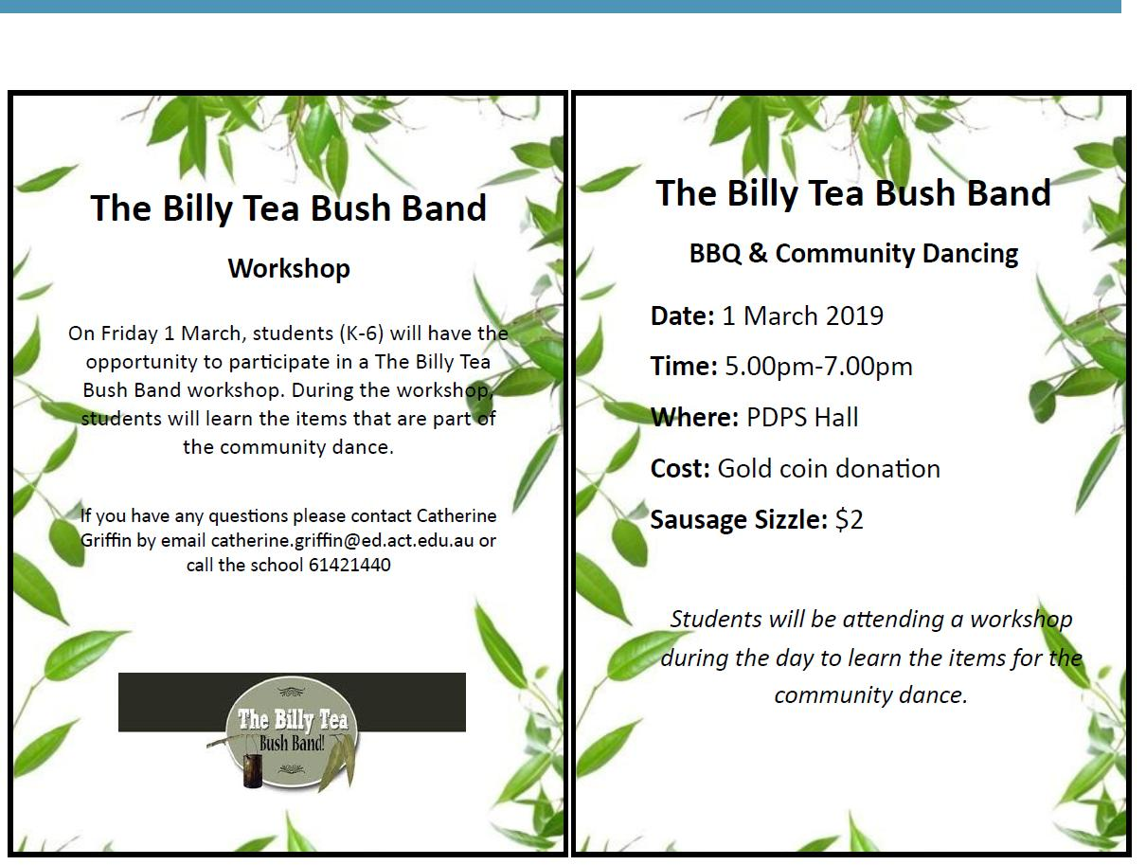

Together, we learn from each other

Palmerston Post

SCHOOL BOARD NOMINATIONS 2019

School Board elections will be held in early 2019

Membership of the School Board is a wonderful opportunity for parents to participate in the ongoing management of the school and to contribute to the determination of the school’s future directions. There are two (2) vacancies for parent representatives on the Palmerston District Primary School Board for the period 1 April 2019 to 31 March 2021. Election of the parent representative will be undertaken in the first few weeks of the 2019 school year. Nomination period:

Opens – 11:00am on Thursday 14 February 2019

Closes – 11:00am on Thursday 28 February 2019

Voting period (if election is required):

Opens – 11:00am on Tuesday 12 February 2019

Closes – 11:00am on Tuesday 19 March 2019

The positions for election will be:

Two (2) - Parent Representative Position. Elected positions run for a two (2) year term.

The successful candidates will be announced by Monday, 25 March 2019.

If you are interested in being a member of the Palmerston District Primary School Board for 2019-2021 and would like more information about the roles and responsibilities of School Board members, please contact the Principal, Melissa Travers on 6142 1440. A copy of the School Board Manual is also available for perusal at the front office. Nomination forms will be available from the school front office. If you would like to have a form before that date, please contact the school front office on 6142 1440.

CANTEEN UPDATE 2019

As mentioned last year, PDPS would like to thank Y’s Bites for providing the school with the Thursday canteen service over the past two years. We would also like to thank the P&C for supporting this initiative and assisting with the sorting and delivery of the lunches each Thursday.

Unfortunately, the food service will not be provided in 2019 due to the conclusion of grant funding with the YMCA, they are no longer able to provide the school the current service. We are currently looking into an alternate lunch option with more information available in early 2019.

ART SUPPLIES

If you have any unwanted wool, fabric or ribbon the school would love them for art projects. Please drop them off at the front office.

Together, we learn from each other

Palmerston Post

Our school is again participating in Scholastic Book Club this year. Twice a term, during the school year, I will send home a Club catalogue with a different selection of books offered for all ages.

You’ll find award-winning books and bestsellers, as well as old and new favourites. The books span a wide range of children’s reading levels and interests and they are inexpensive (some books cost as little as $2).

It is easy to order. The Book Club LOOP platform for parents allows you to pay by credit card.

Your child’s order is submitted directly to school safe and sound and the books will be delivered

to class approximately 2 scholastic.com.au/LOOP or Google Play.

weeks after the deadline closes. You can place your child’s order at or using the LOOP app, which can be downloaded from the App Store

Or

If you wish to order and pay with cash, then complete the order form on the back of the brochure and place into an envelope with the correct money and then place into the ‘Boomerang’ Box located in the front office foyer by the order deadline.

Each order helps earn free books and teaching materials for our school, however there is never any obligation to order.

My name is Edwina and I am a volunteer at the school, I look after the Scholastic Book Club.

Issue 1 of the Book Club Catalogues have been sent out this week.

All Orders are due by Friday 22 Feb (Week 3).

If you have any questions regarding Book Club, then please don’t hesitate to contact me via the front office.

Edwina

Book Club Coordinator

Together, we learn from each other

Palmerston Post

Enforcement around schools
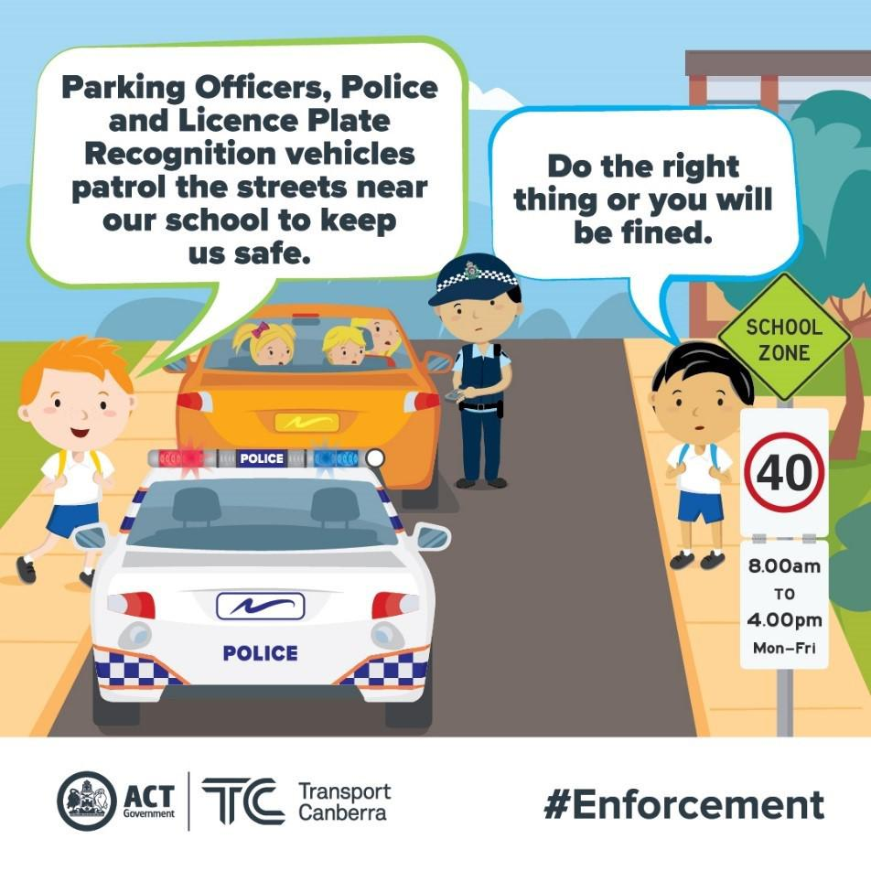

Parking Operations use a Licence Plate Recognition vehicle (or electronic chalking), which regularly patrols school environments to increase safety for children. Motorists that commit an offence will receive their infringement notice in the mail (rather than on their windscreen) 5-7 days after the offence.

While the school can become congested during the peak times, illegal parking should be avoided at all times as it creates an unsafe environment for children and local residents. Parents are welcome to park on side streets around the school, but please remember to park legally. Infringements for parking on nature strips,
footpaths, verges, street corners and near children’s

crossings start from $114.

More information is available on the Transport Canberra website to promote safe behaviours around schools. Please help to make our school community safe.

Safe parking behaviours
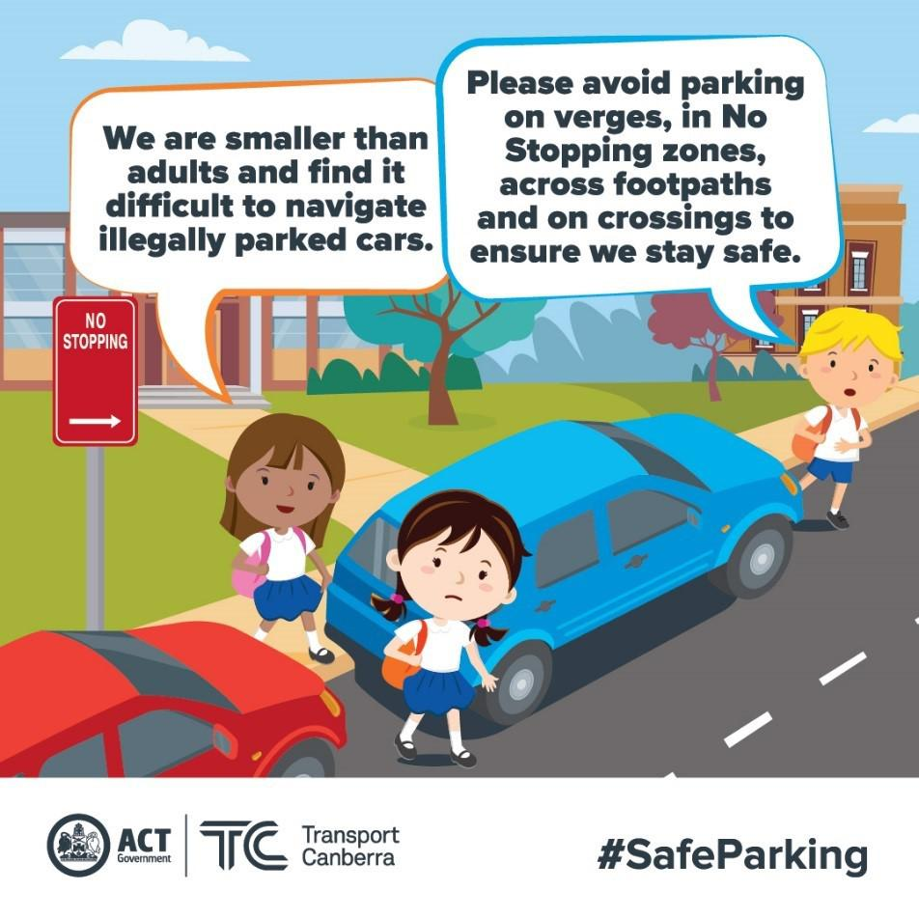

Unsafe driving and parking behaviours increase the potential road safety risk for children around schools. Road safety is a shared responsibility, it is important the road rules are followed near our school to ensure the entire school community feels safe.

Please remember children are more at risk than adults around schools because they are smaller and less visible to drivers. They are also less predictable and less experienced, which makes them more likely to make errors of judgement.

Failing to follow simple road rules like parking on the verge, in no stopping zones, in bus stops, near children’s crossings, on footpaths or across

driveways increases the risk to children around schools. Please do the right thing to create a safe environment around our school.

Together, we learn from each other

Palmerston Post
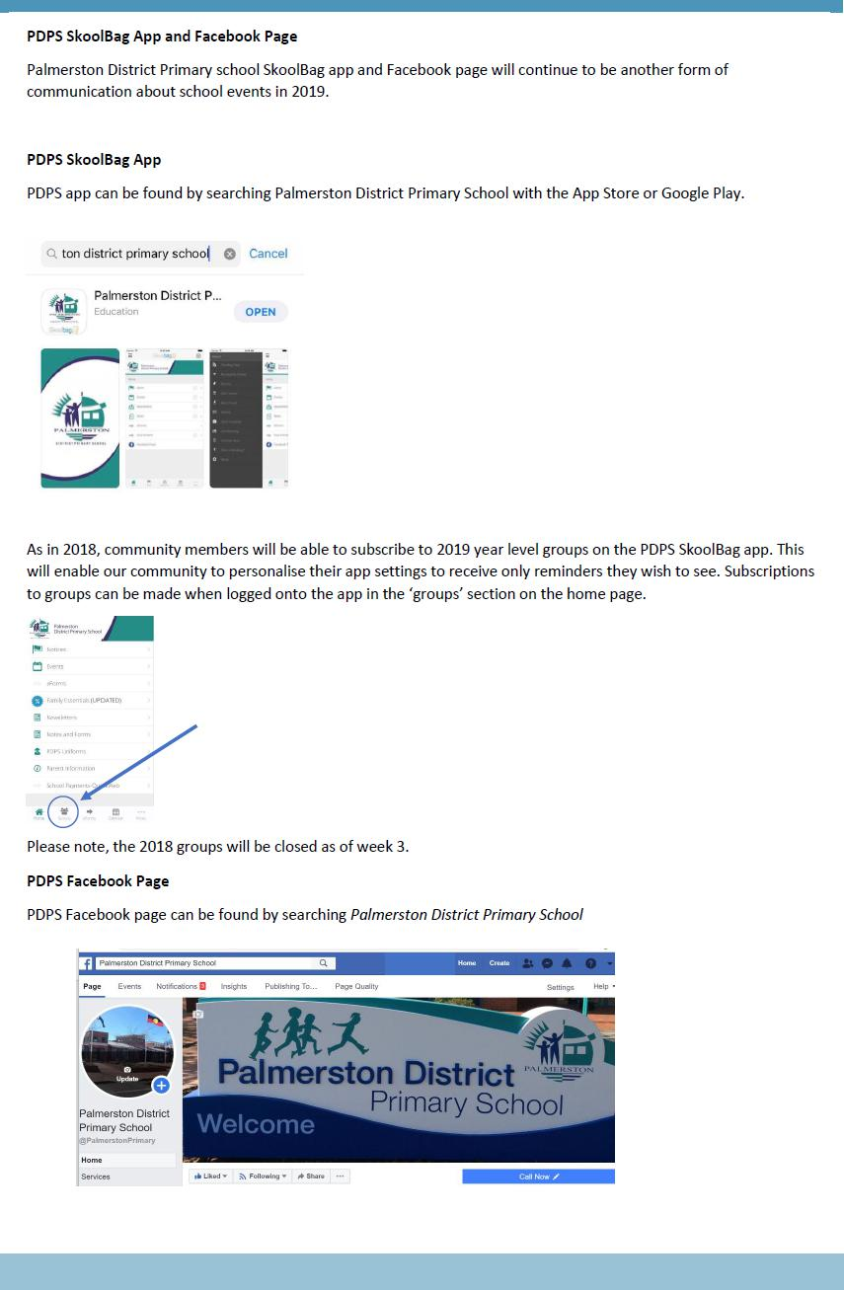

Together, we learn from each other

Palmerston Post

COMMUNITY NEWS
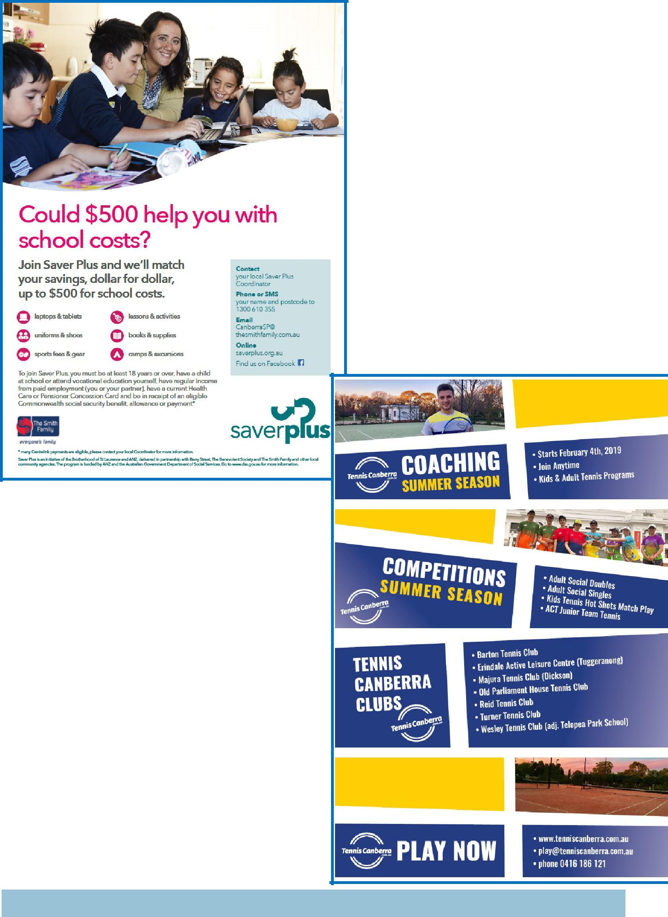

Together, we learn from each other

