Palmerston Post
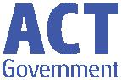

28 February 2019

Week 4, Term 1
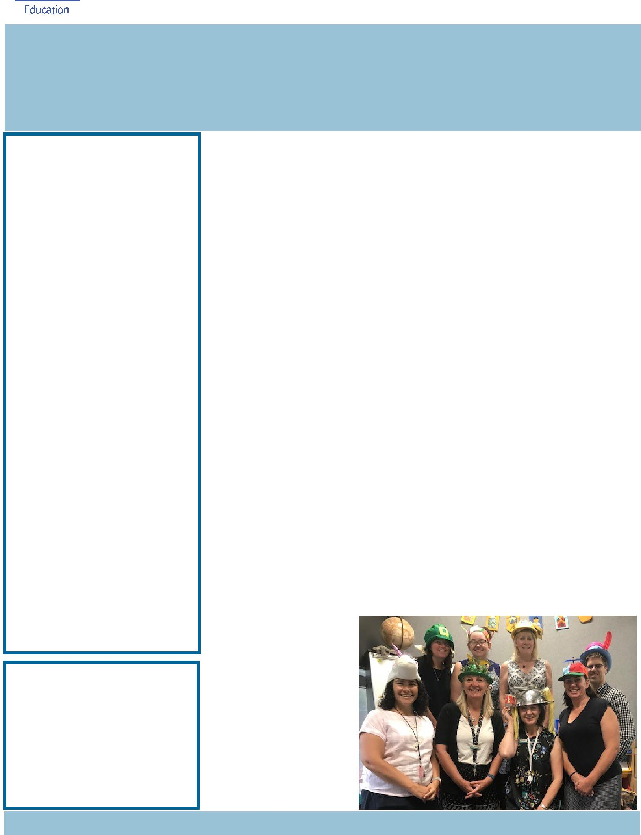

Board Chair: Lisa Fior

Teacher Reps: Jessica Lago and Maxine Green

P&C President: Lisa Fior

Principal: Melissa Travers Deputy Principals: Haeley Simms (acting) & Kylie Moller (acting)

Executive Teachers: Matt Gowen, Felicity McNeice, Catherine Griffin (acting)

ASSEMBLY:

1 Mar | No assembly
8 Mar | Senior - Year 4
DATES TO REMEMBER:
1 Mar | 5pm Billy Tea Bush
 | Dance
5 Mar | Parent Reading
 | Workshop
11 Mar | Canberra Day - public
 | holiday
13 Mar | K-Yr2 Questacon
 | incursion
15 Mar | Yr3-6 Questacon
 | incursion
19 Mar | Yr3-6 Author visit -
 | Katrina Nannestad
20 Mar | Christian Education

NOTES:

- Music Viva -

- Yr 4 Ukulele Band expression of interest

- Yr 5 2019 Band

- Yr 6 2019 Band

P&C BOARD NEWS P&C: 18 March 2019

All P&C activities, meeting agendas and minutes are available from the school website at – Parent Corner

School Board:

PRINCIPAL’S MESSAGE

Thank you to the families who attended Parent Teacher Evening in Week 2. At the start of the evening we met in the school hall and spoke about the School Plan and our Action Plan for 2019, introduced teaching staff and the year ahead for the Palmerston School Community.

At the evening, I announced my upcoming retirement. I will retire by the end of the term. I arrived at Palmerston in 2009 and I have had ten wonderful years as the principal of this school. I have enjoyed working with all of you, community, staff and students. The School Board and the Director of School Improvement will be involved with the selection of the new principal.

Please come up and see me when you are walking through the school. I would love to have the opportunity to personally say good bye to you all. I will be working closely with all staff over the next few weeks to ensure a smooth transition for the newly appointed principal. Thanks again for being such a great community.

See you at the bush dancing on Friday evening,

Melissa Travers

P.S We are having a special farewell assembly for Melissa at 9am on Wednesday

- March. Haeley & Kylie

Staff supporting Rare Disease Day

Together, we learn from each other

Palmerston Post

RECIPES & NEWS FROM MRS CAMPBELL

Scones

Ingredients

- cups of self-raising flour ½ teaspoon salt

- tablespoons butter ½ -1 cup milk

Method

Preheat oven to 200 degrees

Put flour and salt in a bowl – mix

Melt butter and add to flour mix

Add milk and mix

Turn out onto floured board and knead

Press out to about 2cm thick

Cut with a round cutter

Place on a baking tray in a ring (use baking paper so they don’t stick)

Brush with thin layer of milk

Bake for about 10 mins or until brown
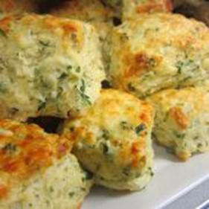

Herb Scones

For a variation add chopped fresh herbs and cheese.

Add extra flour to the mix if too sticky. Add extra milk if too dry.

The IEC class planted some veggies and herbs today.
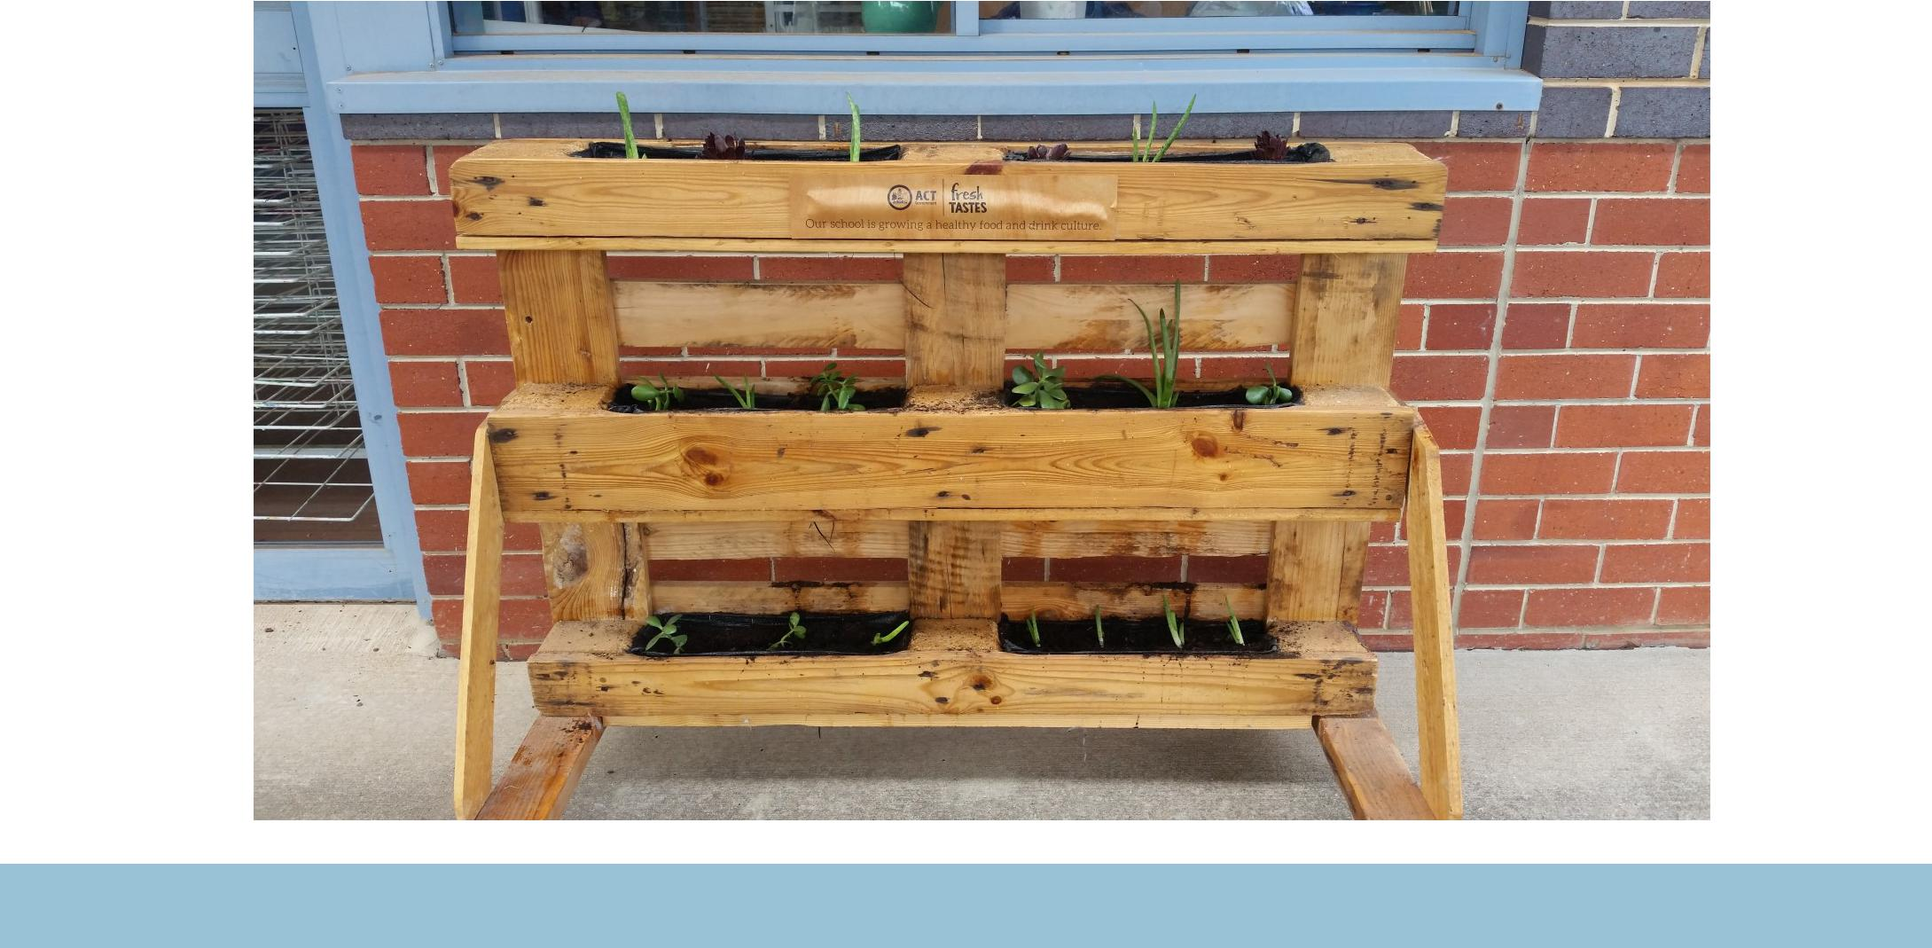

Together, we learn from each other

Palmerston Post

P&C NEWS

The P&C AGM was held on Monday 18 February and we are pleased to report that we have a new P&C executive in place for 2019. A big thank you to everyone who has volunteered to take on the executive roles and assistants positions.

2019 P&C Executive Positions are held by the following:

President Lisa Fior

Vice President Lina Haines

Secretary Emma Davidson

Assistant secretary Kate Baron

Treasurer Jenni Palombi

Assistant Treasurer Helen Ritchie

Fundraising Officer Helen Ritchie

2019 Assistants:
Public Officer |  | Mandy Judson
Assistant Returns Officer |  | Sonya Campbell
Fundraising team members (x2) |  | Janelle Hunter & Calli Bowyer
Second Hand Clothing Shop Coordinator |  | Kate Baron
Second Hand Clothing Shop Assistant |  | Franki Gugliotta
Student Banking Coordinators |  | Vanessa Chapman, Janelle Hunter and Lea Perrott
Book Club Coordinator |  | Edwina Samuelson

As the continuing P&C President I look forward to spending time getting to know many more families at Palmerston Primary School. The P&C and all of its volunteers have various events planned in 2019 and we look forward to the year ahead.

We welcome and warmly encourage new parents to the P&C. Being a member is a great way to contribute to and be part of your child’s schooling. Meetings are held in week 3 and 9 of each term. Please come along and find out what the P&C is all about.

If you can help in any way or would like more information on them then please see one of the P&C executive or email palmpandc@hotmail.com.

Lisa Fior

P&C President

Together, we learn from each other

Palmerston Post

UPCOMING EVENTS

Yr1-6 Tennis Clinics

Date: Weeks 2-5

Location: PDPS, blacktop

Run by Tennis Canberra, funded by Sporting School’s grant

Billy Bush Tea Dance

Date: 5-7pm Friday 1 March 2019

Location: PDPS, hall

Questacon incursion

Date: K-Yr2 , Wednesday 13 March 2019

Yr3-6 Friday 15 March 2019

Location: PDPS

P/S - Yr1 Parent Reading Workshops

Date: 9:00am or 5:00pm Tuesday 5 March 2019

9:00am Thursday 7 March 2019

Location: PDPS, library

* Just a reminder, Kindy Health Check envelopes are due. Please return them to school.
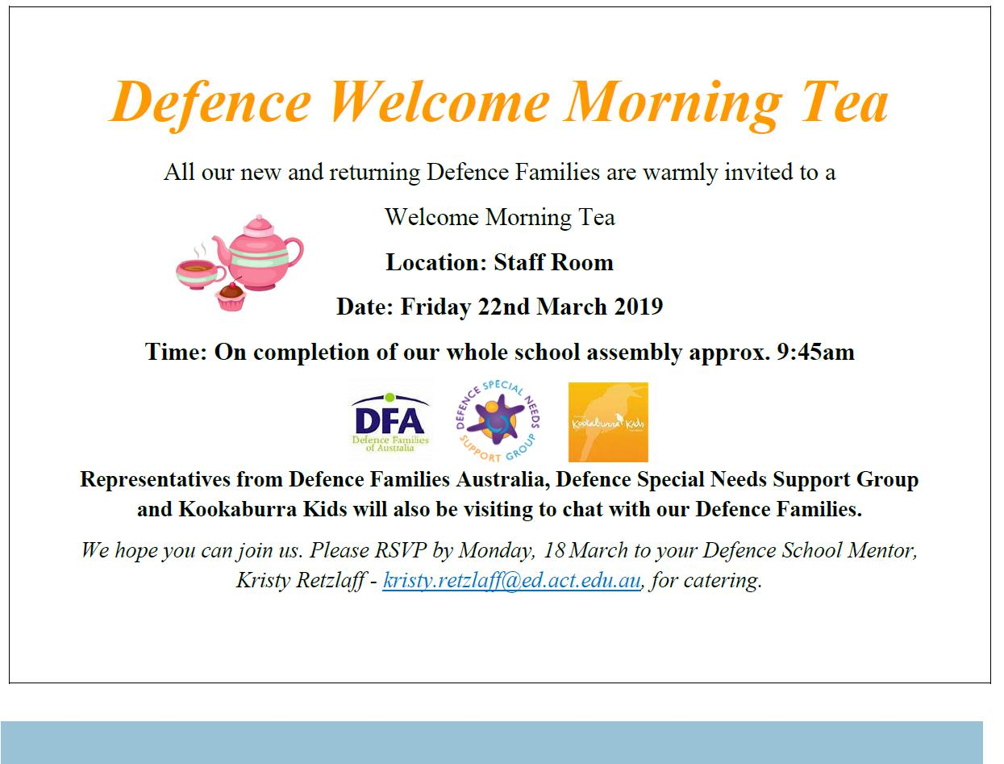

Together, we learn from each other

Palmerston Post

SCHOOL BOARD NOMINATIONS 2019

Nominations have now closed. Please see next week’s newsletter for more information.

RILEY’S STAR
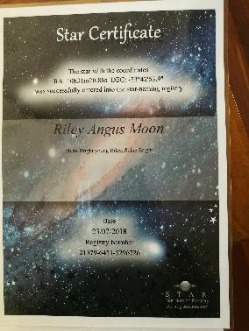

Last week on Friday lunch we had a memorial to remember Riley. At the memorial his family shared the coordinates for Riley’s star.
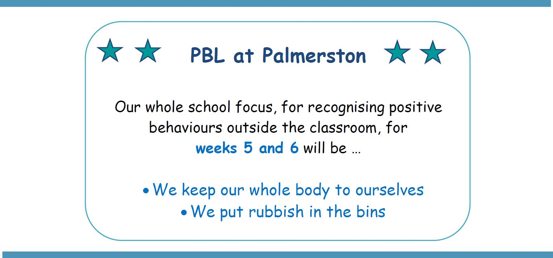

ART SUPPLIES

If you have any unwanted wool, fabric or ribbon the school would love them for art projects. Please drop them off at the front office.

Together, we learn from each other

Palmerston Post
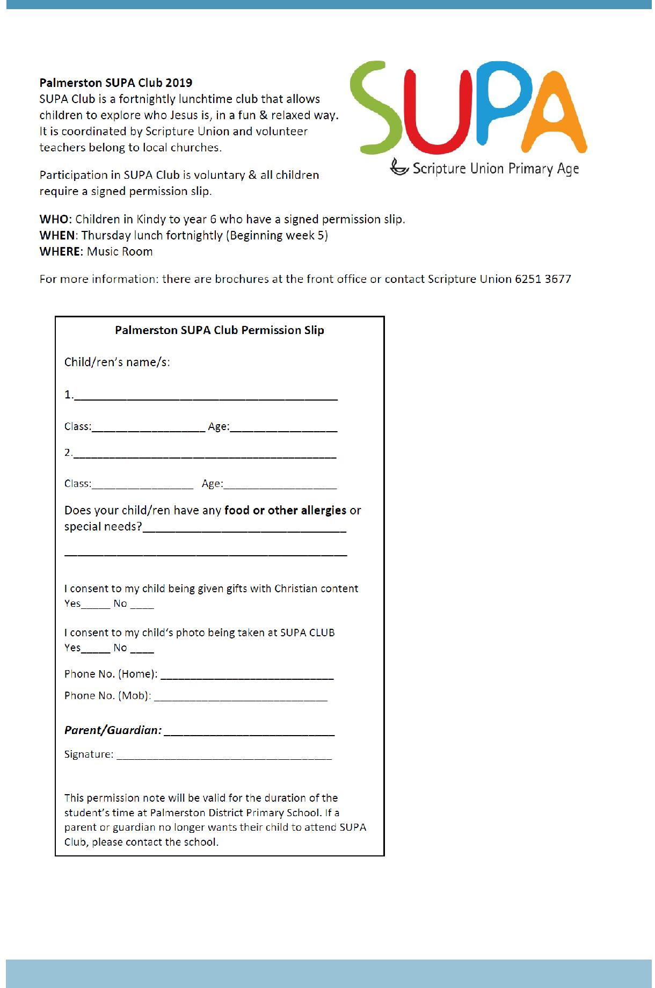

Together, we learn from each other

Palmerston Post
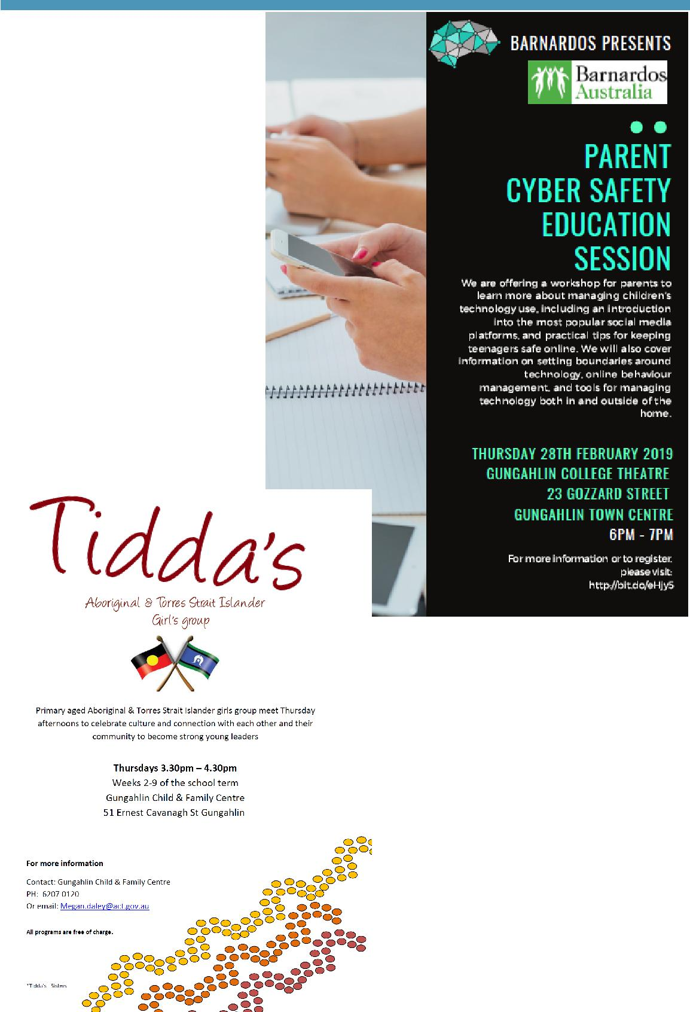

COMMUNITY NEWS

Together, we learn from each other

Palmerston Post
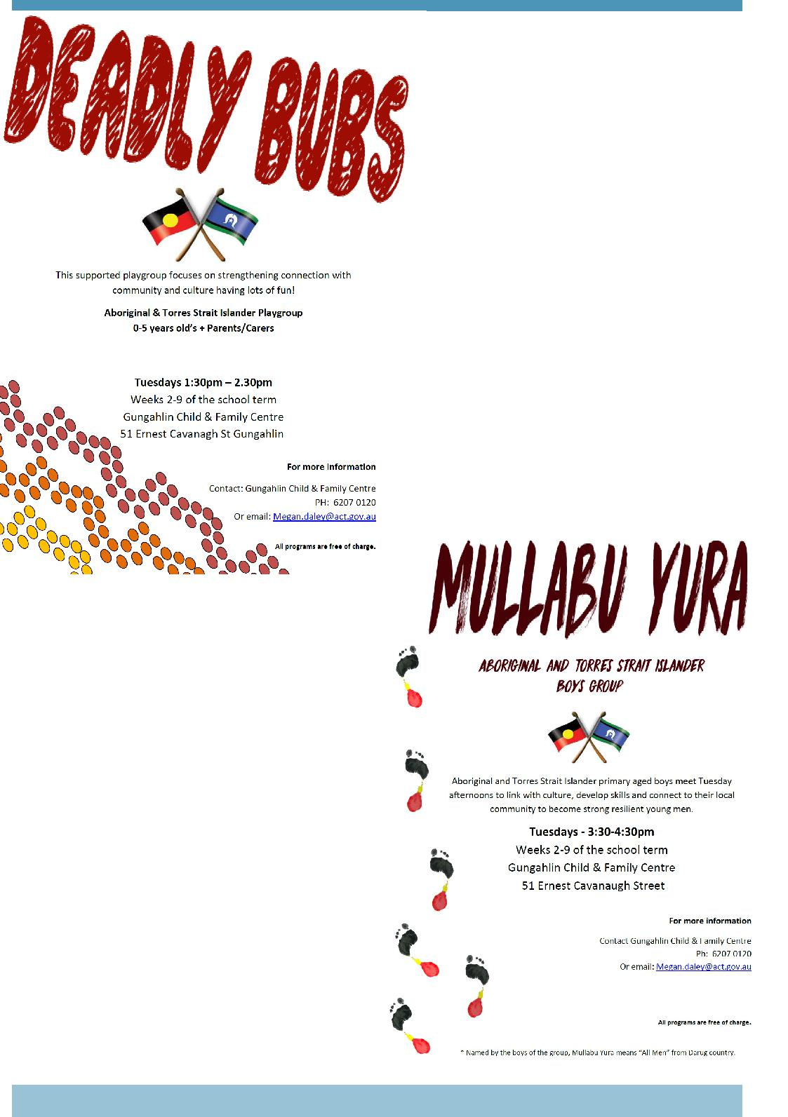

Together, we learn from each other

Palmerston Post
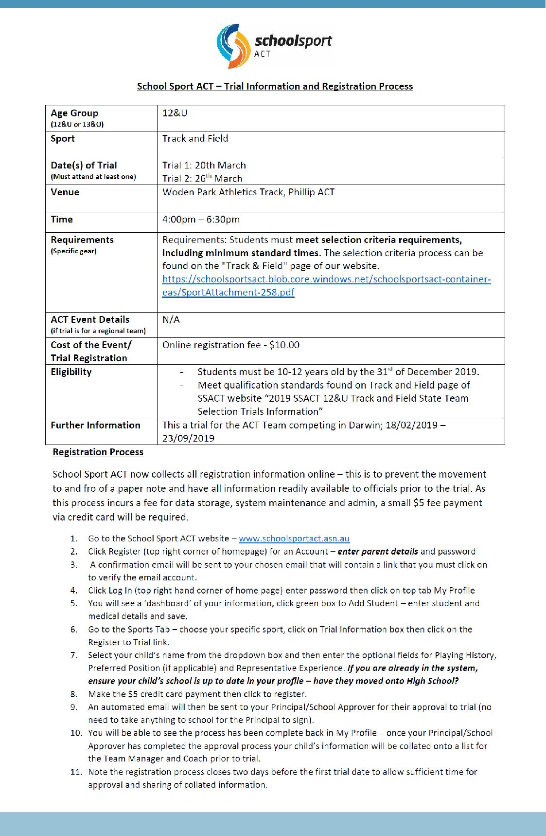

Together, we learn from each other

