What’s On
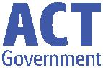

13 June 2019

Week 7, Term 2

ASSEMBLY:

14 June Whole school - 5/6CW & 5/6KB

21 June Junior - KGM, KMC & KGS

28 June Senior - 3AP & 3AJ

DATES TO REMEMBER:

14 June Year 3/4 Birrigai Camp

14 June Whole School Assembly

17 June Preschool Photos (beginning)

20 June Whole School Photos 21June Year 3/4 Indonesian Arts

Workshop

24 June Hatching Chicks (Preschool)

- &

- June Kindergarten Health Checks

NOTES:

School Photos - Sibling photo and spare envelopes are available in the front office

Year 2 Theatre Excursion Revolting Rhymes

P&C BOARD NEWS P&C: 24 June 2019

All P&C activities, meeting agendas and minutes are available from the school website at – Parent Corner

School Board: 24 June 2019

DEPUTY PRINCIPAL’S MESSAGE

Dear Parents and Carers,

Tomorrow is an exciting day for the IEC and year 3/4 team; they are heading to Birrigai for the day to engage in an ‘Early Settlers Simulation’, a campfire damper bake and an indigenous walk around Tidbinbilla. We look forward to hearing all about their learning once they are back at school.

Teachers have been working extremely hard on writing mid-year reports. We are trialling a new reporting format, which will be rolled out across all ACT schools. Reports will be emailed to families at the end of week 9. If you don’t have access to email, please contact the front office to organise a printed copy for you. We thank Matt Gowen for his hard work in getting the online reporting system up and running and for his leadership in this area. If you have any questions, please don’t hesitate to contact us. Parent teacher interviews will be held in week 10. Please look out for more information about how to book in with your child’s teacher in the next week or so.

You will notice some exciting new signs around our school. The posters feature ‘Palmy’ our Positive Behaviours for Leaning (PBL) mascot. These posters focus on the behaviours students will need to display in certain areas of the school so they are being safe, respectful and a learner. We have also installed a screen outside the library which will give live updates on PBL, focusing on student achievements and information on how students can display safe, respectful, learner behaviours to optimise their time at school. Stop by and have a look next time you are in the school.

A reminder that next week is school photo week. Please ensure your child is in full school uniform for photos. Photo notes have gone out to families and are due back on photo day. Preschool photos will be on Monday 17 June and Thursday 20 June, and K-6 photos will be taken on Thursday 20 June. Get those haircuts and smiles ready!

We hope you have a wonderful week in your households.

Kylie Moller and Haeley Simms

Together, we learn from each other

What’s On

PALMERSTON PRIDE AWARDS
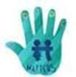

Congratulations to the following students who received a PRIDE Award at assembly on 24 May 2019.

PARTICIPATION – becoming involved, “having a go” and cooperating with others

Naeva - 2MO | Alina - KGS | Rishva - 2MO | Hannah - KGS
Blossom - 2RC | Joanna - 1DE
RESPECT – having respect for self, others and their property
Adam - 2RC | Tristram - 2MO | Seanna - 2RC | Hannah - 1DE

INTEGRITY – being honest, fair, responsible and loyal

Naeva - 2MO

DETERMINATION - being persistent and resilient

Milla - KKA Manav - KGS Olivia - 2RC

EMPATHY - understanding and supporting others regardless of our differences Toby - KGS

PBL
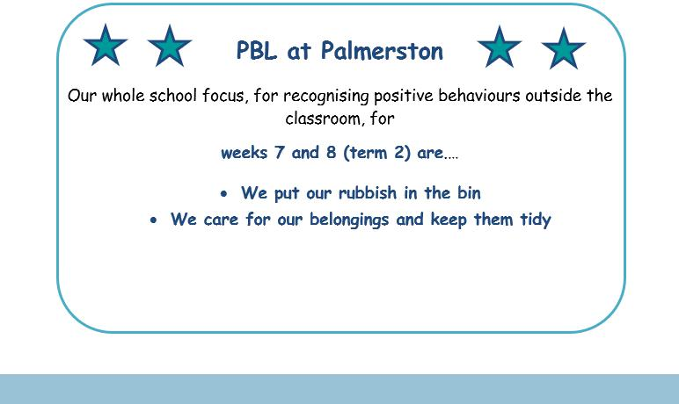

Together, we learn from each other

What’s On

DEFENCE NEWS
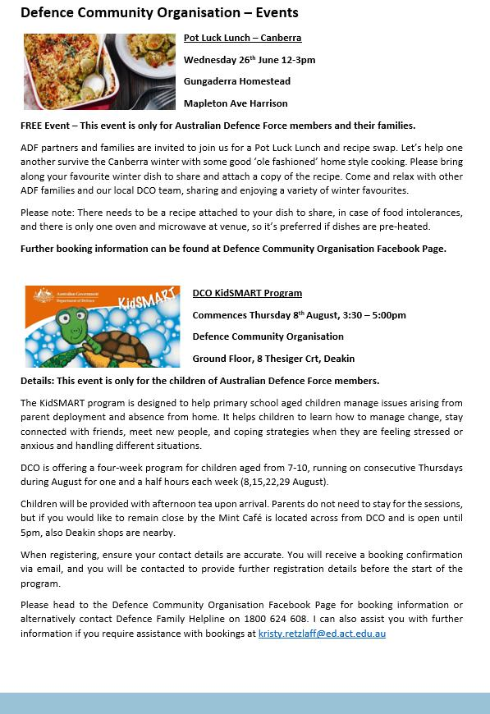

Together, we learn from each other

What’s On

DEFENCE NEWS
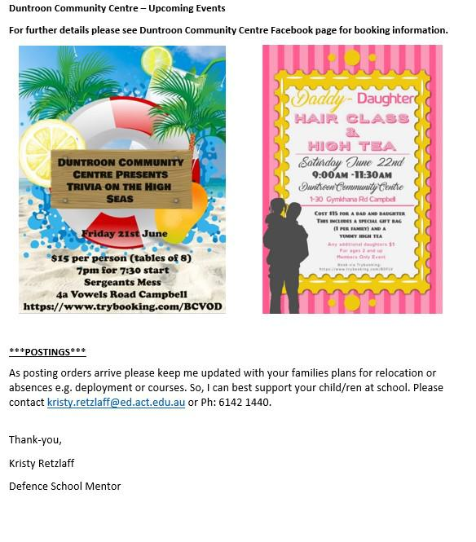

Together, we learn from each other

What’s On

UPCOMING EVENTS

Year 3/4 Day Camp

Date: Friday 14 June 2019

Location: Birrigai

Preschool (beginning) - School Photos

Date: Monday 17 June 2019

Location: PDPS

Whole School Photos (including end of week Preschool)

Date: Thursday 20 June 2019

Location: PDPS

Preschool Hatching Chicks Program

Date: Monday 24 June 2019

Location: Palmerston Preschool

Kindergarten Health Checks

Date: Wednesday 26 June & Thursday 27 June 2019

Location: PDPS

Year 2 Theatre Excursion

Date: Thursday 4 July 2019

Location: Canberra Theatre

Protect yourself and your family from the flu

Getting vaccinated is the best way to prevent your family getting the flu this winter. The flu vaccine can save a child’s life.

The vaccine is safe, and everyone 6 months of age and over, including pregnant women and young children, should get the vaccination.

Children are more likely to contract the flu, spread it around, and are at a higher risk of serious complications if they get sick. The flu is highly contagious and is spread easily through childcare centres and schools.

The flu vaccine is free in the ACT for:

- children aged 6 months to under 5 years

- pregnant women

- people 65 years of age and older

- all Aboriginal and Torres Strait Islander people aged 6 months and older, and

- people aged 6 months and older with some medical conditions such as severe asthma, heart or lung disease, diabetes or weakened immune systems.

Where to get your flu vaccination

Everyone can get a flu vaccine from their GP or immunisation provider.

People over 16 years of age can also get a vaccine at some pharmacies.

ACT Government Early Childhood Immunisation Clinics provide a free flu vaccination for children aged 6 months to under 5 years. To book an appointment, call Community Health Intake on 02 5124 9977.

Learn more about influenza and where to get your vaccination at health.act.gov.au/flu

Together, we learn from each other

What’s On

P&C NEWS
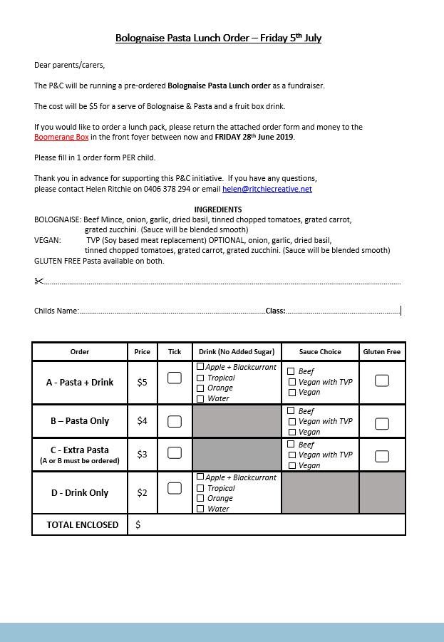

Together, we learn from each other

What’s On

P&C NEWS
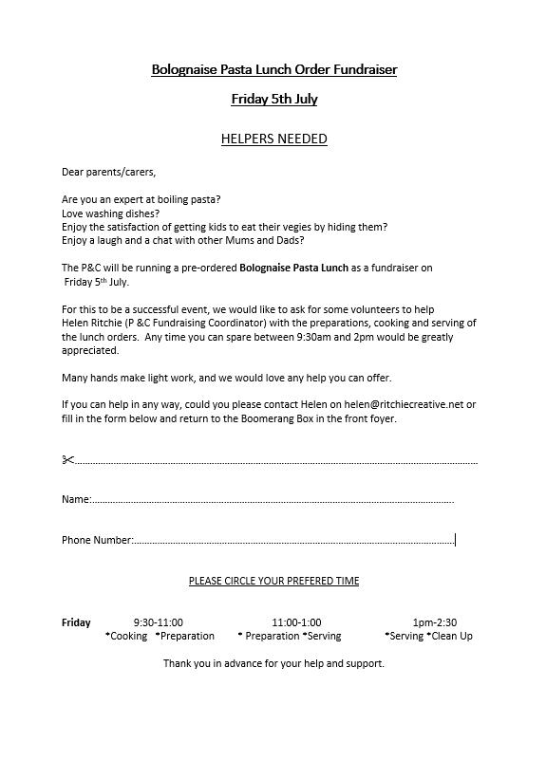

Together, we learn from each other

What’s On

With winter upon us, it’s important to remember that Canberra has lots of health options that don’t involve a trip to a hospital emergency department. Many of these are free and available after hours.

Walk-in Centres provide free, one-off treatment of minor injury and illness, including colds and flu. They’re a great choice for children over 2 years of age – children under 2 should see their GP.

Walk-in Centres are open from 7.30am to 10pm, every day of the year. They are staffed by highly skilled nurses who can provide you with a sick certificate and in some cases, medication, saving you time and money.

The service is free and no appointments are necessary.

Walk-in Centres are located in Tuggeranong, Belconnen and Gungahlin.

To find out more about getting the right health care for your symptoms, visit

www.act.gov.au/yourhealthoptions
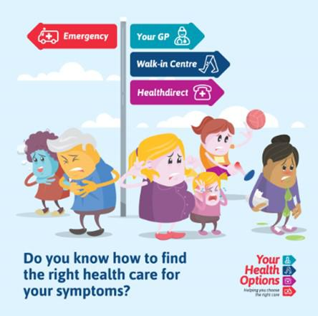

Together, we learn from each other

What’s On
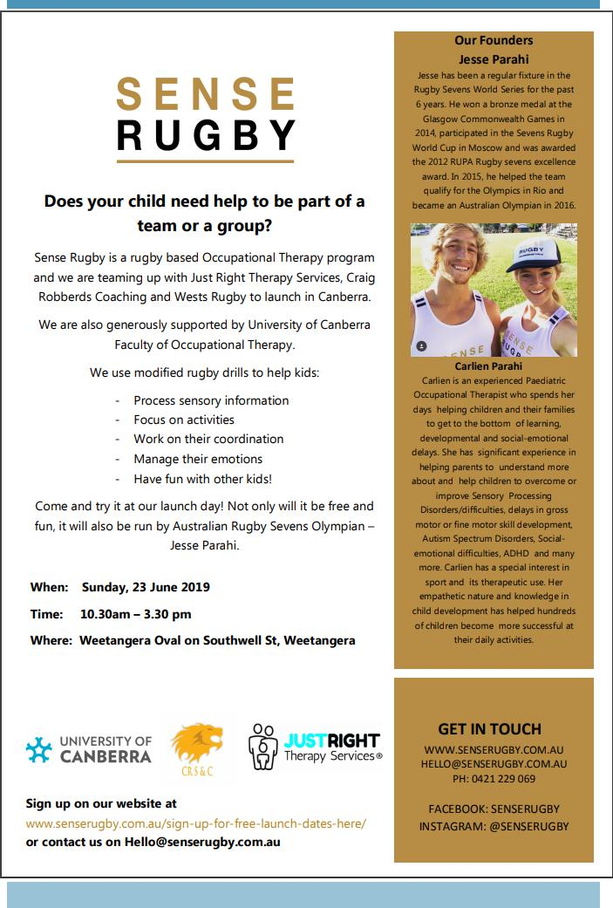

Together, we learn from each other

What’s On
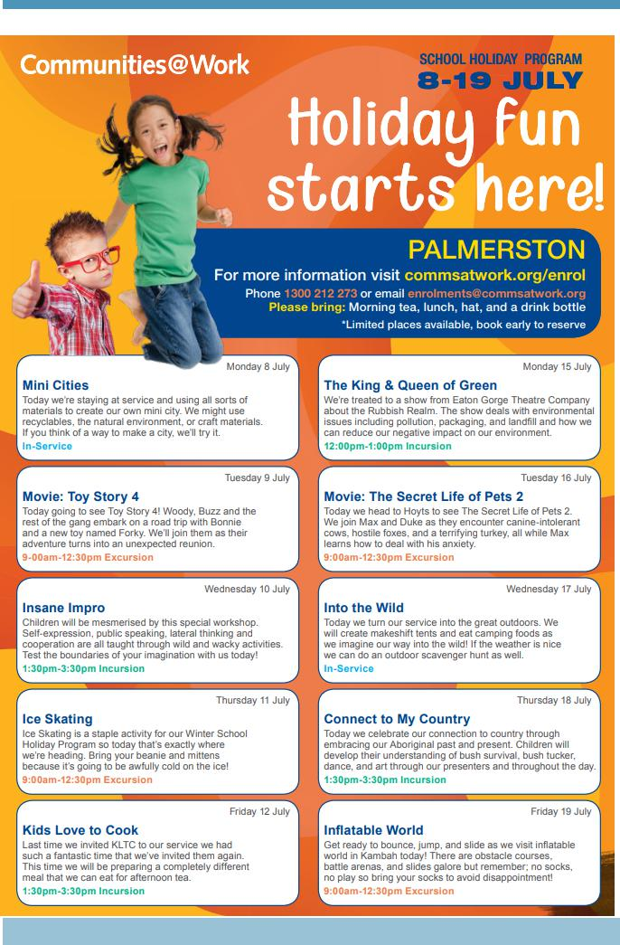

Together, we learn from each other

What’s On
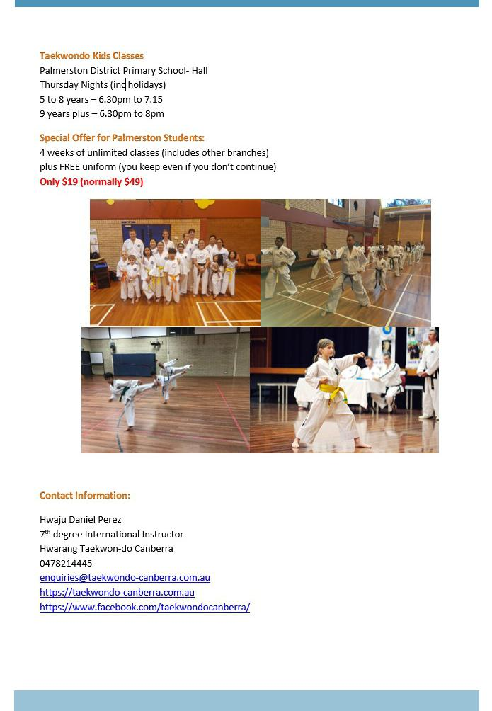

Together, we learn from each other

What’s On
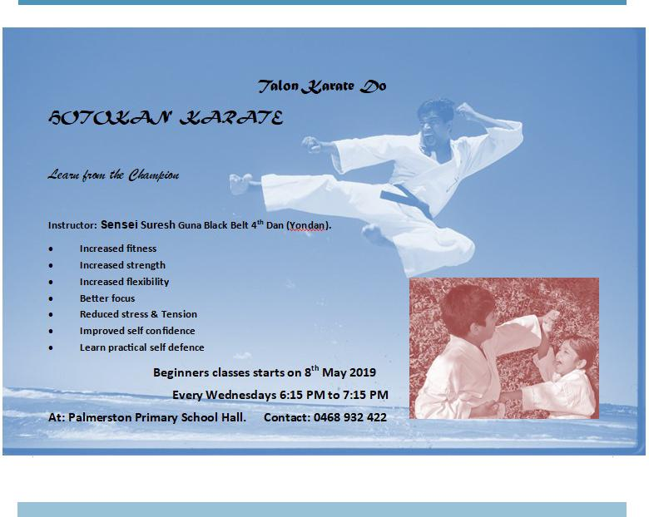

Together, we learn from each other

What’s On

Community News

ParentLink

ParentLink provides parenting education to the community, from birth to teenage years. It is available for parents, carers, kin, teachers, and the broader community, providing information and
links to local resources and services.

The ParentLink website provides links to all ParentLink guides including a variety of topics - Start-ing School, More than Reading and Writing, Optimism and Cyber Safety.

The ParentLink suite of resources includes guides specifically for Aboriginal and Torres Strait Islander families, and access to resources for diverse cultural groups.

ParentLink guides are available to view and order via the website at,

https://www.parentlink.act.gov.au/

PARKING AROUND SCHOOLS

As we drive and park our cars around schools we all need to ensure the safety of school students is our priority. Parking illegally and unsafely across pedestrian crossings, corners and verges puts children at risk. We all need to help keep our children safe. Here is a short video demonstra-tion: https://youtu.be/AslMVXpA9Zc

Access Canberra inspectors will be patrolling our school zones to help us ensure drivers do the right thing.
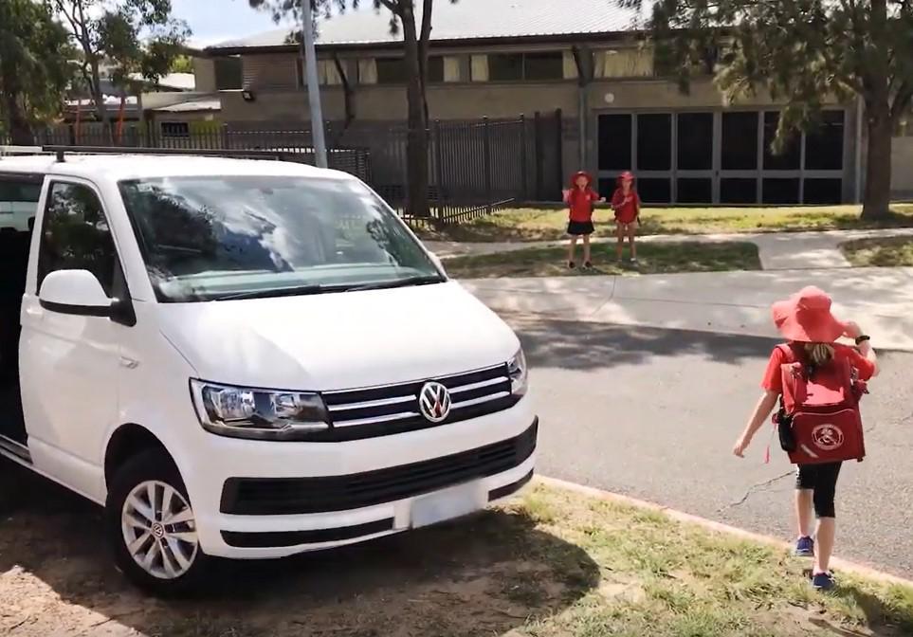

Together, we learn from each other

