Palmerston District Primary School acknowledges

the Ngunnawal People,

the traditional owners and custodians of this land.

Palmerston Post

PRINCIPAL’S MESSAGE

“The moment you realise how important time is, your entire perspective will change”. How true is this? The most precious resource we have is time. Time at night to listen to your child read. Time in the morning to wake up in time to be ready and on time for school. Time to complete the book that you have just become obsessed with. Time to have notes returned o school within the deadline. Time to give positive feedback to your child’s teacher, or drop a comment on our FB page. Time to listen to your heart and feel that today is going to be a great day.

We all have the same amount of time, it is how we man-age that time that makes us different. I would like to share with you some things happening at school that I am very thankful for. We have the front office staff who make the time to support new families to the school, to provide vital information and make them feel welcome. Thank you. We have support staff who make time to check in with students who they see may have had a tough day the day before or who are struggling with their learning. Mr Phil makes time every day to check and ensure our playground is safe. Our teachers value the time it takes to check in with their students, allocate appropriate amounts of time for students to complete their work and ensure a bit of time is spent in connecting and building a sense of belonging. Our executive staff are dedicating time to now invest in what 2020 is going to look like, how we are going to operate, what little tweaks we are making to launch into the new year with gust.

We all have completing priorities and managing time is a skill for life. I have heard of the incredible Science Fair that occurs each year. This will be testament to the time students have dedicated a home to complete their projects and display them with pride in the Library next week. I am eagerly looking forward to spending time

with families next week in Learning Journeys, as you dedicate time to come and see the progress your child/ ren are making with their learning. Please ensure you make time on the day to provide feedback acknowledging the awesome work your child has showcased. At the moment, I am designating my time during lunches on Wednesdays to learn drumming – this has now become a sacred part of my week – not to mention the time we have sanctioned for our new Performance Choir on Friday lunchtimes. Our school provides many wonderful learning opportunities for our students. We believe in them and want to stretch their learning in as many ways as possible. We align time with these activities because we believe they are important when educating the whole child.

Thank you to the 336 responders to our recent annual School Satisfaction Survey. This was incredible and very soon, I will receive the data back whereby I will commit time to analyse and begin to make plans for areas to focus on moving forwards. This was a wonderful result for us. Thank you to the P&C for donating their time organising the disco tonight – I am really looking forward to having a boogie!

Until next time, don’t forget to have a good time.

Kate Smith

DEPUTY PRINCIPAL MESSAGE

Gifted and talented students are entitled to rigorous, rele-vant and engaging learning opportunities drawn from the Australian Curriculum and aligned with their individual learning needs, strengths, interests and goals. Teachers use the flexible design of the Australian Curriculum to meet the individual learning needs of gifted and talented students and make necessary adjustments to meet their individual learning needs.

Gifted and talented students vary in terms of the nature and level of their abilities; there is no single homogeneous group of gifted and talented students. Gifted and talented students:

- vary in abilities and aptitudes — they may demonstrate gifts and/or talents in a single area or across a variety of domains; they may also have a disability

- vary in their level of giftedness — this means that two students who have gifts in the same field will not nec-essarily have the same abilities in that field

- vary in achievement — while having gifts is often asso-ciated with high achievement, achievement can and does vary across high-potential students and over time, and some gifted students underachieve and experience difficulty translating their gifts into talents

- are not always visible and easy to identify, and their visibility can be impacted by cultural and linguistic background, gender, language and learning difficulties, socio-economic circumstance, location, and lack of en-gagement in curriculum that is not matched to their abilities

- exhibit an almost unlimited range of personal charac-teristics in temperament, personality, motivation and behaviour — no standard pattern of talent exists among gifted individuals

- come from diverse backgrounds and are found in all cultures, socio-economic levels and geographic loca-tions.

2

Gagné’s model: a shared understanding of giftedness is important in order to address their needs. In Australia today, Gagné’s model provides the most generally accepted definition of both giftedness and talent and underpins the ACT Education Directorate’s Gifted and Talented Policy: https://www.education.act.gov.au/ support-for-our-students/g-and-talented-education

Gagné’s Differentiated Model of Giftedness and Talent (2008) provides research-based definitions of giftedness and talent that are directly and logically connected to teaching and learning. According to Gagné, gifted students are those whose potential is distinctly above average in one or more of the following domains of human ability: intellectual, creative, social, physical.

Talented students are those whose skills are distinctly above average in one or more areas of human perfor-mance. Talent emerges from giftedness through a complex developmental process and via a number of influences, including the teaching

and learning opportunities. Gagné’s model recognises that giftedness is a broad concept that encompasses a range of abilities; it also recognises that giftedness is only potential and that it must go through a transformative process in order to become a talent. As such, Gagné makes it clear that adequate school support over time is necessary if students are to develop their gifts or high abilities into talents or high achievements.
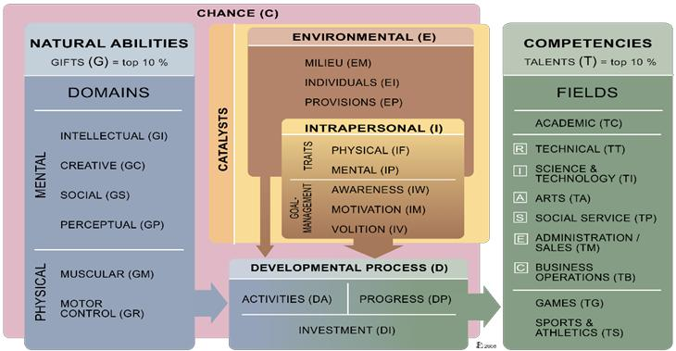

Gagne’s Model of Giftedness and Talent (DMGT) (2008) (v.2.0)

Helen Cox

Achievement and Potential

DEPUTY PRINCIPAL MESSAGE

When I think back on my primary school years I think of Mrs Papendrea.

Mrs Papendrea was my Year Five teacher. She was also one of the most memorable teachers I had. Mrs Papendrea was a petite woman and was always immaculately dressed. Every day, even on a ‘sports’ day, she would come to school in beautiful high heeled shoes, her hair was always styled to perfection, her face perfectly made up. While I always admired her style from a far, this is not the reason she was my favourite teacher. Mrs Papendrea knew her students. She had clear, explicit expectations and believed in all of the little people in her care. Mrs Papendrea was firm (often throwing those beautiful high heels at students misbehaving), but fair. We all knew the consequences of our actions and were eager to receive her praises after doing the right thing. Mrs Papendrea was encouraging, understanding and interested in us, what we did on the weekend and supporting us to overcome adversity and show some grit! Looking back now I realise that what Mrs Papendrea was great at is building relationships and I often think of her when I am trying to do the same (minus the throwing of my shoes).

Relationships is a word we often use, but often take for granted. Human beings are wired for social interactions, and without them we can become lost in this big old world. Building and maintaining positive relationships can also be hard work. We need to trust, invest time, effort and commitment to others to make relationships work. What I have come to learn is that positive connections are integral to teaching and learning and are the foundation of any positive school culture.

This week our staff have spent some time exploring the idea of positive relationships and how integral they to student learning. When students have a strong, positive, focus driven relationship with their teachers they are more likely to engage in the learning and environment and excel in reaching their goals. Through positive relationships and role modelling students become more aware of their own emotions and how to regulate these in order to stay focused on building connection with their peers and others in the school community.

I have also spent some time self-reflecting on some simple ways I can improve my relationships with parents/carers, students and staff in the hopes of inspiring others;

- Share a smile – you never know who needs one.

- Make a phone call to parents/carers to celebrate all the positive contributions are students are making to our school.

- Tell someone they are doing a great job!
- Be open to listening and give everyone the opportunity to have a voice.
- Treat everyone with respect – the same respect I would like to be shown.

This last point makes me think of Mrs Papenrea. She was always using her words to embed a positive classroom culture. A simple thank you to the BSO, a few words with a parent helper telling them she appreciated their time and commitment, an encouraging word or acknowledgement for a fellow student was always there. I guess her greatest lesson to me was that a little kindness and respect certainly goes a long way.

Marijana Pasalic

Diversity, Inclusion and Wellbeing

DATES TO REMEMBER

Please see page 15

Principal:

Kate Smith

Deputy Principals:

Marijana Pasalic Helen Cox

Executive Teachers:

Felicity McNiece Kylie Moller Haeley Simms Kristina Collins

Business Manager:

Sonya Campbell

Office Manager:

Kirsty Brown

Board Chair:

Lisa Fior

P & C President:

Lisa Fior

On Thursday 12 September 2019 Mrs Cox and Miss Pasalic attended the Australian Council for Educational Leaders (ACEL) Annual branch awards ceremony where Mrs Smith was honoured with an award recognising her leadership in ACT Public Schools. Mrs Smith received the ACEL ACT Excellence in Leadership Award for her contribution as principal of ACT primary schools and her role as Director of School Improvement in Tuggeranong. Mrs Smith has always demonstrated exemplary leadership qualities and has achieved great outcomes for schools and school communities. We are so proud of Mrs Smith. Congratulations!
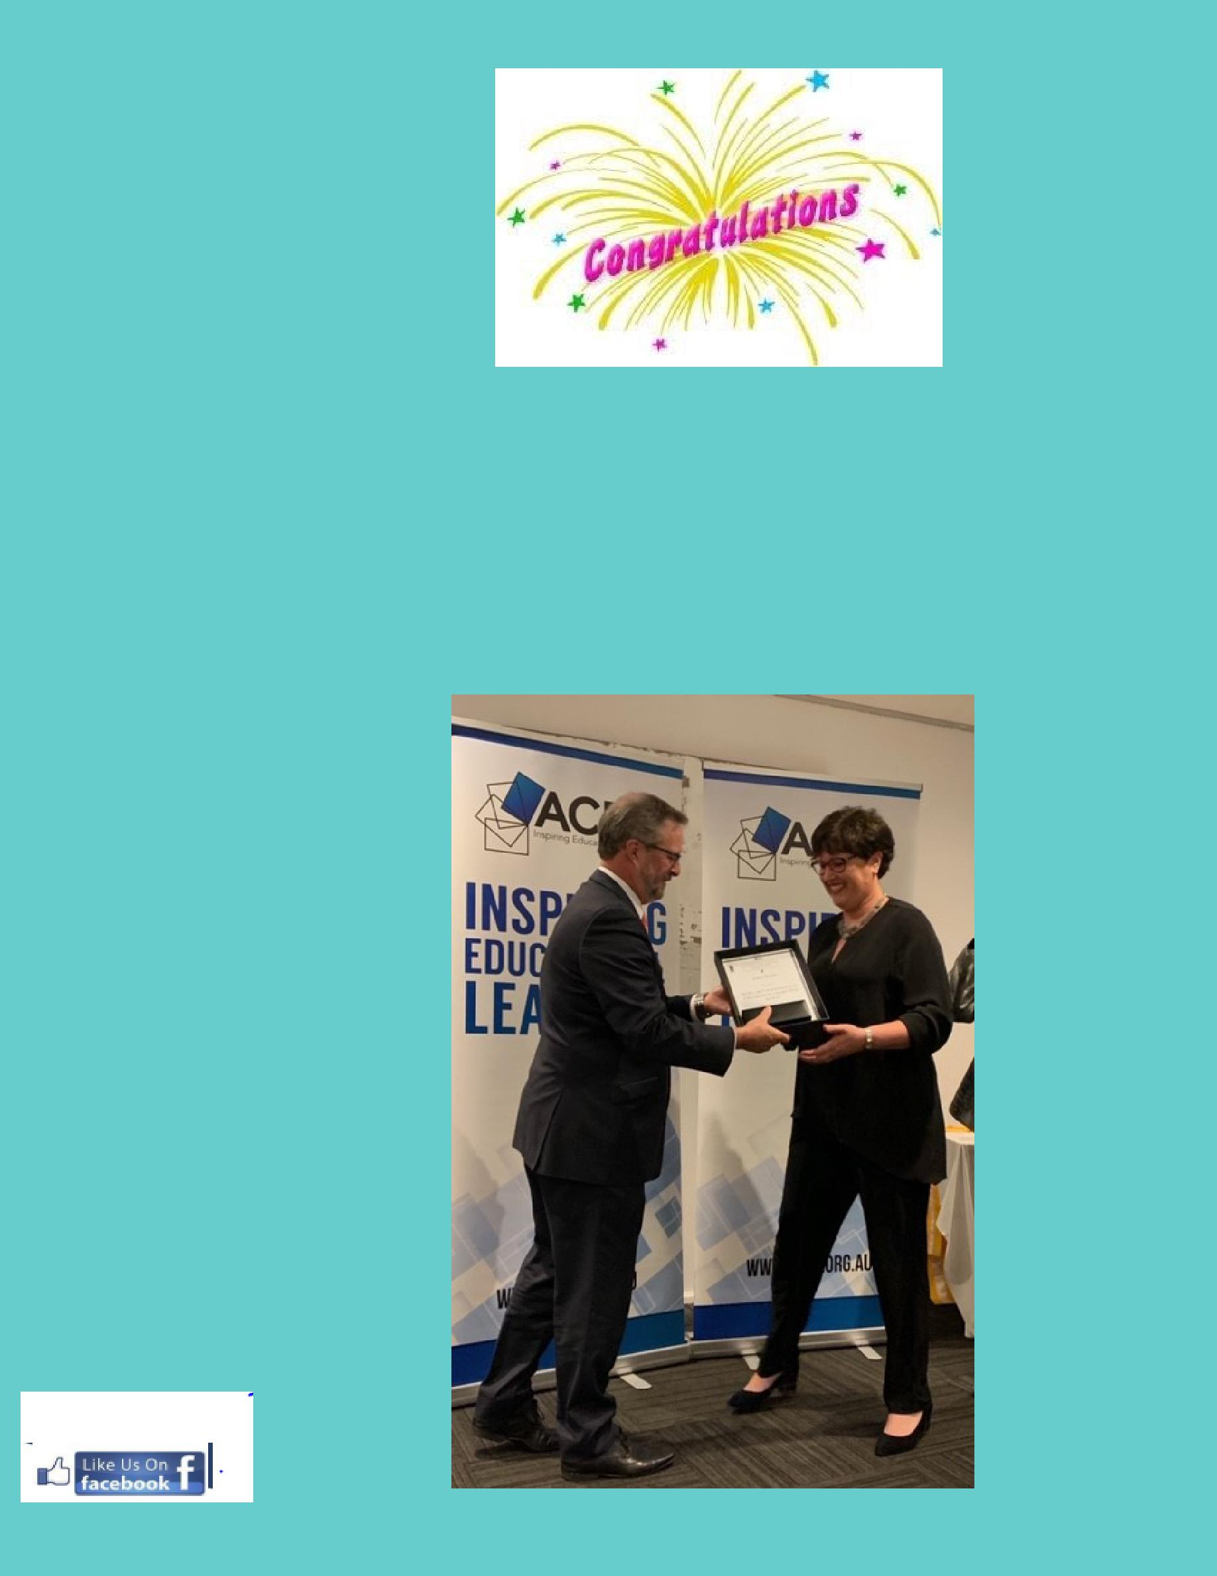

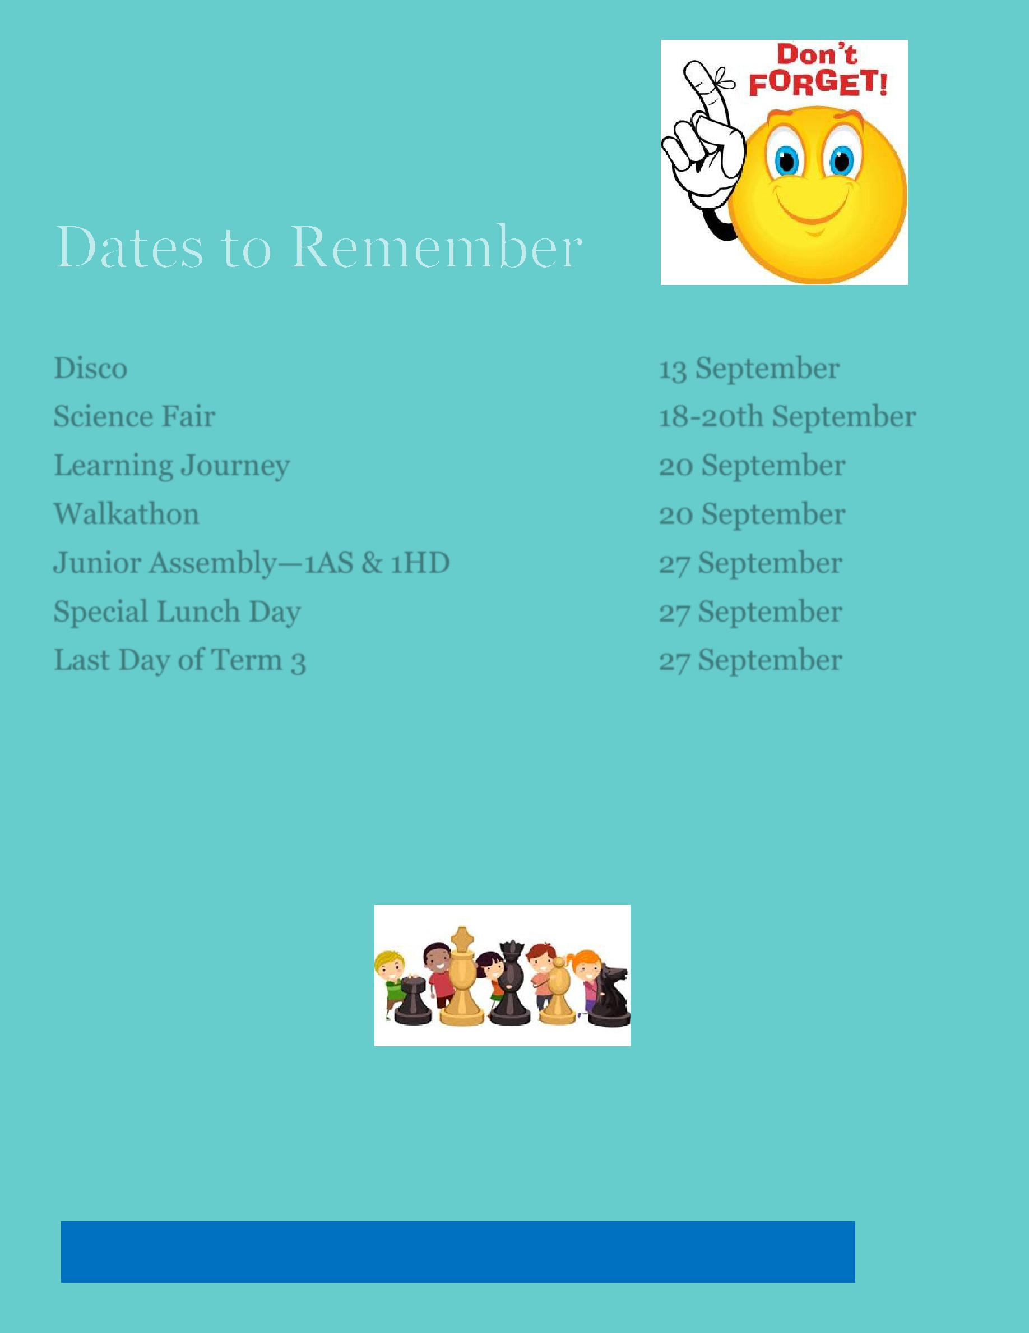

Disco 13 September

Science Fair 18-20th September

Learning Journey 20 September

Walkathon 20 September

Junior Assembly—1AS & 1HD 27 September

Special Lunch Day 27 September

Last Day of Term 3 27 September

Chess Tutors Needed

Chess is hugely popular at lunchtime in the Library but we really could use some help to learn to play properly. Do you know someone who might have time once or twice a week at lunchtime to teach small groups to play chess? We’d love to hear from you!

Together WeTogether We Learn From Each Other

5

All P&C activities, meeting agendas and minutes are available from the school website at – Parent Corner

P & C/BOARD NEWS

The P&C are fundraising with the Entertainment book. The Entertainment™ Book is a local restaurant and activity guide which provides hundreds of up to 50% off and 2-for-1 offers from the finest restaurants, cafes, attractions, activities, retailers and hotel accommodation. The Membership entitles buyers to exclusive offers that are virtually restriction-free, and is valid through to 1 June 2020!

The Entertainment™ Digital Membership (app) puts all of the value of the Entertainment ™ Book into the customer's smartphone. With 'near me' technology and the ability to show and save using a phone, this is perfect for the person on-the-go, with no card or voucher to present.

You can purchase a book through the front office or download the app via this link

https://www.entertainmentbook.com.au/orderbooks/2487s6

6

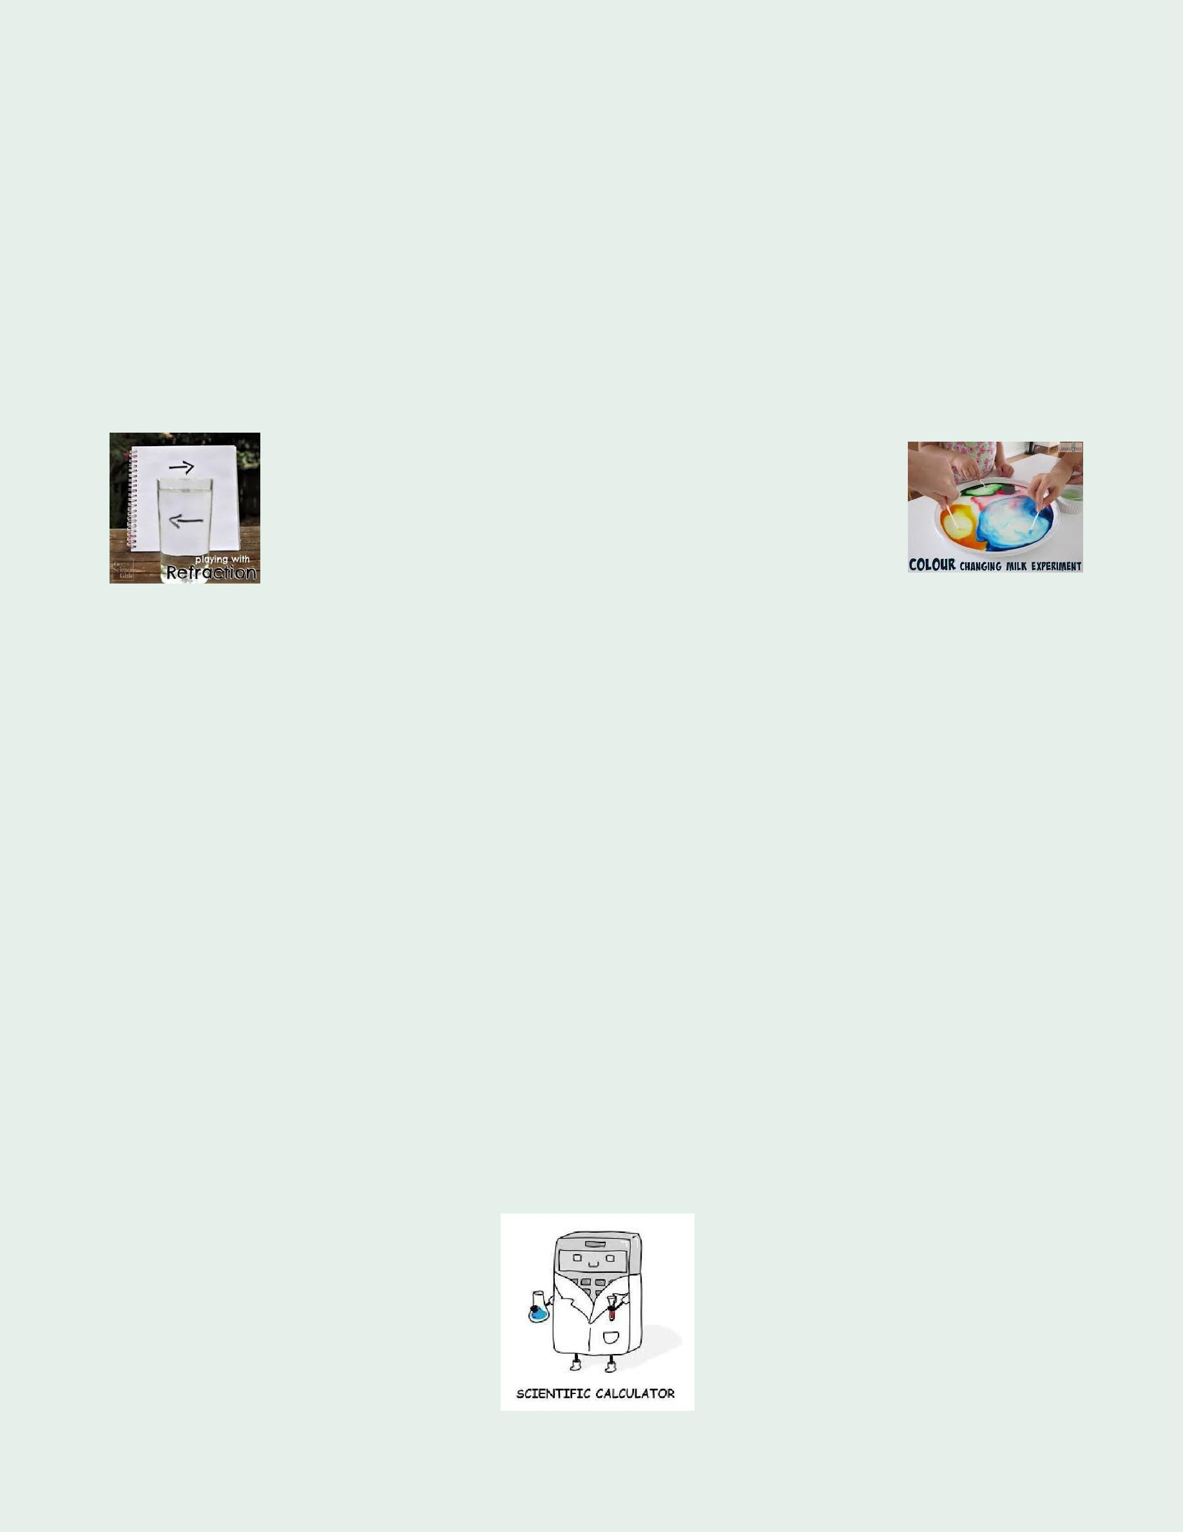
Palmerston District Primary
School Science Fair

September 18-20
2019

SCIENCE IS FUN!

Ask a Question…
What do you wonder about?

The Science Fair is an annual event for Palmerston District Primary students. The idea is for students to have a fun and safe experience conducting a science experiment or researching the answer to a Science question at home. Then showcase their results at the Science Fair Wednesday 18 September - Friday 20 September in the school library.

This year display boards will be a $2 payment for all students who want to participate in the Science Fair. Money will be place in the money spinner as students collect their Science boards next week Tuesday 20 August, Wednesday 21 August and Thursday 22 August afternoons between 3:00 – 3:15pm from the library.

On Friday 20 September students and their families are invited to come and see the projects as part of the learning journey. But you can come anytime between Wednesday 18 September - Friday 20 September.

People’s Choice Award for junior (K-2), middle (3-4) and senior (5-6) students.

Looking forward to seeing lots of entries this year.

Karon Campbell
karon.campbell@ed.act.edu.au

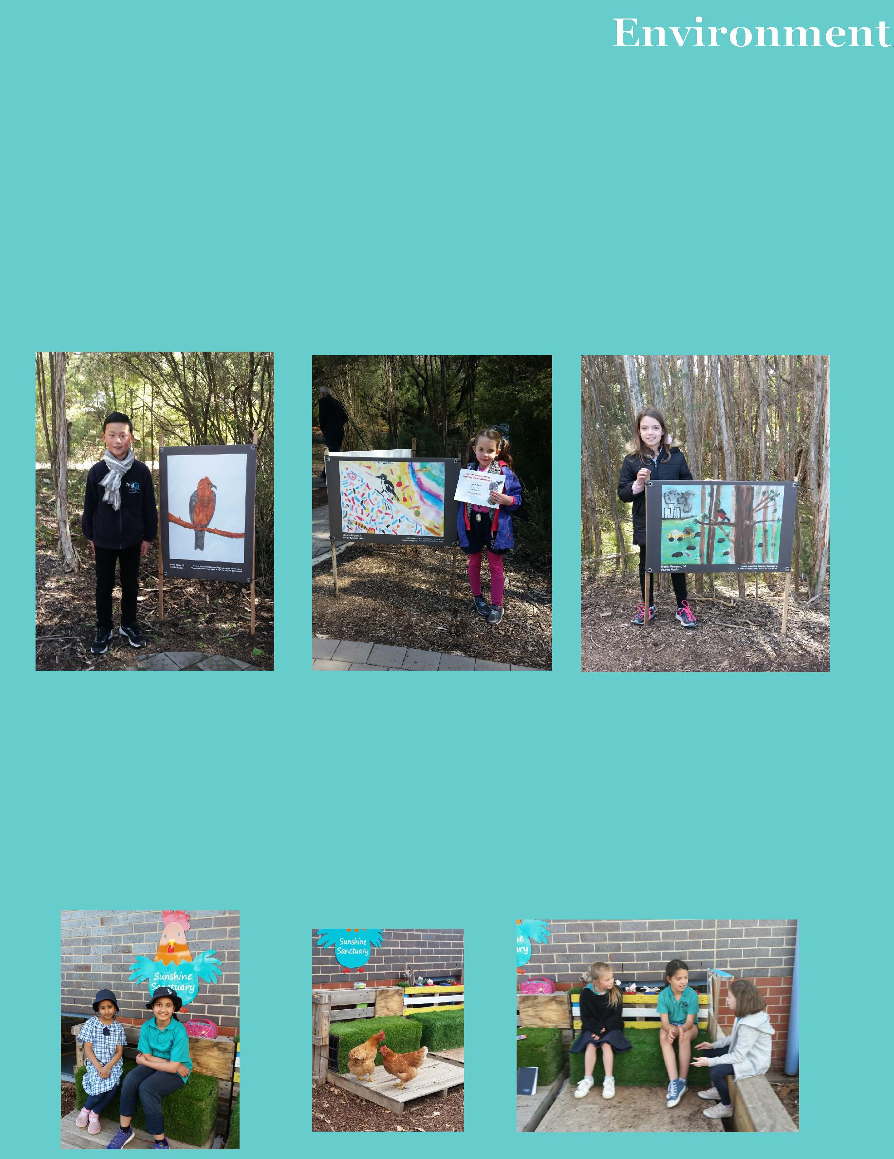
Threatened Species Art Competition

Australian Association of Environmental Education (AAEE)

On Saturday September 7, three of our Palmerston students attended a presentation ceremony for the Threatened Species Art Competition at the Australian National Botanic Gardens at Black Mountain.

All three students were finalists in the competition and have had their artwork reproduced and are currently part of an outdoor exhibition at the Botanic Gardens. You will find the exhibition on the pathway to the children’s playground. I encourage the community to look at this fabulous display.

Sienna from 3JL and Mollie and Paul from 3/4DJ proudly represented Palmerston Primary. Apart from having artworks reproduced; prizes for these students included book prizes, book vouchers and art materials.

Donation of art installation seating from Wellspring Environmental Art & Design

In the Sunshine Sanctuary there has been the welcome addition of seating that was previously part of an art installation in city communities.

Students have enjoyed sitting and chatting in this space. Even the chickens have checked it out. What a wonderful permanent sustainable use of a temporary art installation!

Thanks to Wellspring Environmental Art & Design for this donation.

Science Fair – YAY!

Science Fair entries are due Tuesday 17 September. Please deliver your entries to the library. The display will be set up Tuesday afternoon ready for viewing Wednesday 18 September – Friday 20 September. The Science Fair will be viewed as part of the school Learning Journey.

Please remember to come and collect your entry on Friday 20 September in the afternoon to take home.

I will be on leave for weeks 9-10 and I am very disappointed that I will miss the Science Fair. However, all entries will be photographed so that I will be able to view each and every entry upon my return. Thank you, Palmerston, for all your enthusiasm around Science Fair. Looking forward to seeing all the fabulous displays.

Karon Campbell

Hooray Hooray

It’s Market Day!

Students in Year 5/6 have been using their mathematical skills and knowledge in real life situations to develop Market Day stalls.

This year, Market Day will be held on Wednesday 25 September 2019 (Week 10)

from 11:30am – 1:00pm. All activities will be run by Year 5/6 students and the money raised will go toward the Year 6 graduation.

All students from across the school will be able to participate in games and purchase yummy treats and miscellaneous goods from stalls. The 5/6 students are excitedly preparing for Market Day and can’t wait to show the school community what we have planned for this year.

9

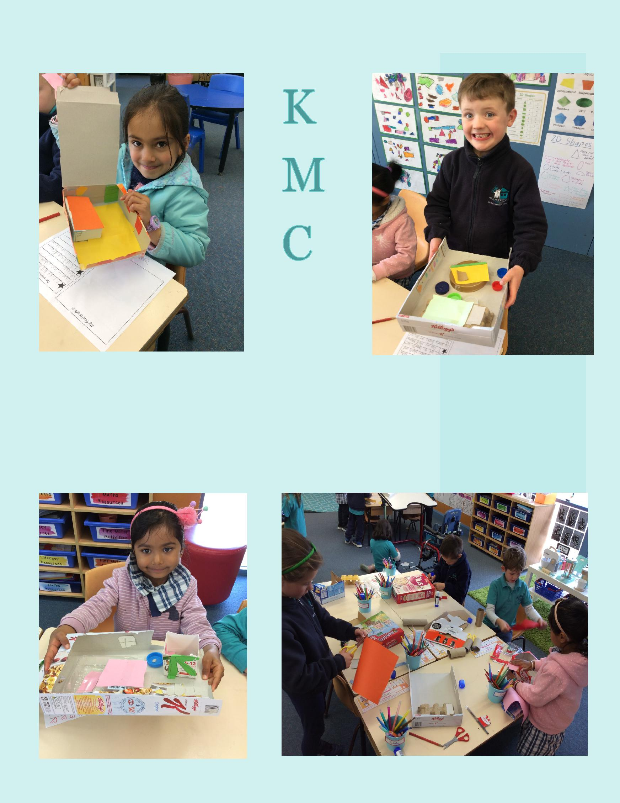
CLASSROOM CONNECTIONS

Following our geography unit on special places, students of KMC have designed and made a

model of their bedroom. We have collected recyclable resources and planned our

designs. Students have been asked to include, walls, a window, a door, a bed and something

special to them, in their designs and models. We had such rich conversations and creative
thinking skills happening in our classroom during this process.

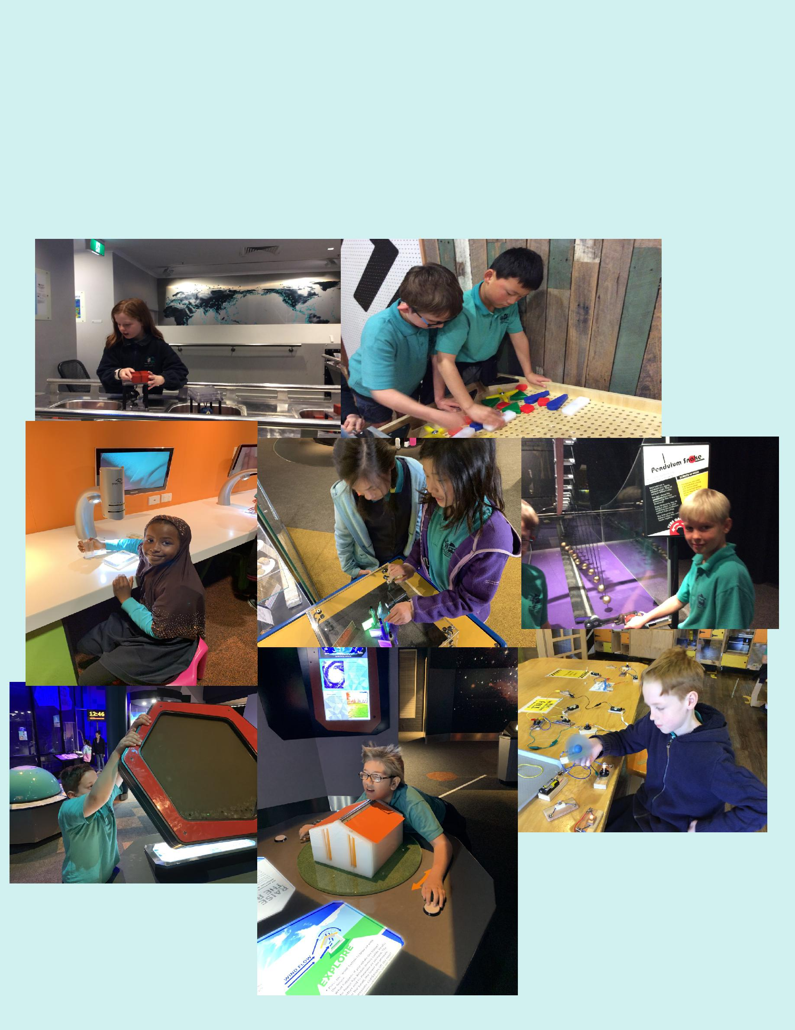
YEAR 4 QUESTACON EXCURSION

Year 4 students went to Questacon on 2nd September to consolidate their understanding of Natural Disasters. Students built homes to withstand earthquakes and explored the importance of having shock absorbers.

Students also explored how the wind speed and wind direction affects houses during cyclones. They looked at the viscosity of lava and the layers of Earth.

11

PALMERSTON PRIDE

Congratulations to the following students who received a PRIDE Award at assembly.

PARTICIPATION – becoming involved, “having a go” and cooperating with others

Stanley—KMC | Rocky—KMC | Nick—KMC | Andy—1HD
Leo—KMC | Jewel—KMC | Dora—2AF | Noelle— 2SH
Arnav—2SH | Elliott—2SH | Savleen—2SH | Imogen—KGM
Jake - KGM | Mohamed—KGM | Wilbur—2MO | Madeline— 2MO
Binyak—KFD | Chanyai— 1KW | Carter—1KW | Hussain— 1KW
Flynn—1KW | Yashvir—KFD | Hunter— KGS | Eric—KGS
Haiqa—KGS | Haren—KGS | Yicheng—KGS | Gus—2DK
Olivia—2DK | Thomas—2DK | Lincoln— 1AS | Emma—1AS
Lani—KGM
RESPECT – having respect for self, others and their property
Adelle— 2SH | Lilly— 2MO | Antoinette— 2DK
INTEGRITY – being honest, fair, responsible and loyal
Elijah—2 AF | Elijah—2AF | Nabeel—2MO
DETERMINATION - being persistent and resilient
Sophia—2AF | Devine—2AF | Tevita—KGM | Alex M - KFD
Rhoweinaa—KKA | Kevin—KKA | Jerry—KKA | Joanna—1DE
Nicholas— 1DE | Harshini— KGS | Dominic—1AS | Huzaifa– 1AS

EMPATHY - understanding and supporting others regardless of our differences

Ellie— 2SH Lucia—1KW

Junior Artist of the Month

Maryam—1AS

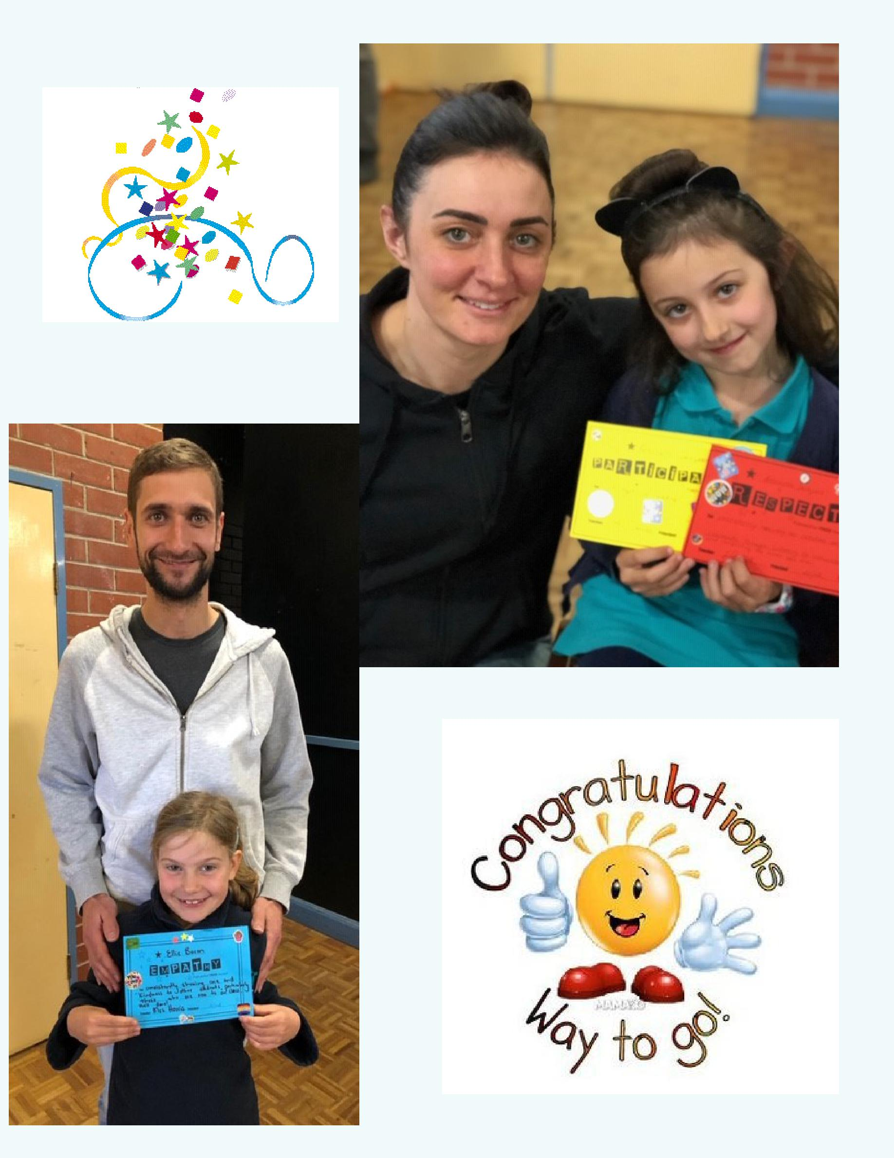

DEFENCE NEWS

An ADF Family Event: Teen SMART (Ages 11-14), Canberra

Date: Thursday 3rd Oct and Friday 4th October

Time: 12:00pm to 2:30pm, both days.

Where: Defence Community Organisation,
Thesiger Crt, Deakin, ACT 2600

Register: https://www.eventbrite.com.au/e/an-adf-families-event-teensmart-11-14-years-canberra -tickets-69252360675

NOTE: This event is only for Australian Defence Force members and their families. This school holidays, teens of ADF members aged between 11 and 14 are invited to participate in a two-day ‘TeenSMART’ mini-workshop designed to provide teens with skills to manage life within a military family. The workshop will focus on positive self -image, maintaining a peer support network, parental absence, self-care and goal setting. Come along and share ideas, experiences and pizza!

When registering, ensure your email address is accurate as you will receive a booking confirmation and further information via email.

Defence Community Organisation – Coffee Connections - Northside

Location: Café Injoy, 39 O’Hanlon Place Nicholls, ACT
Date: Tuesday, 1st Oct, 2019
Time: 10:00am – 11:30am

NOTE: This event is only for Australian Defence Force members, partners and their families.

ADF members,partners and families in Canberra are invited to join us at our regular Northside coffee group. Come along to this child-friendly café, relax with other ADF families and meet DCO staff.

Kids welcome, but please reserve a ticket for them so we know how many people are coming. When registering, ensure your email address is accurate as you will receive a booking confirmation and further information via email.

Tickets available Eventbrite to RSVP on Canberra Defence Community Organisation Facebook Page.

14

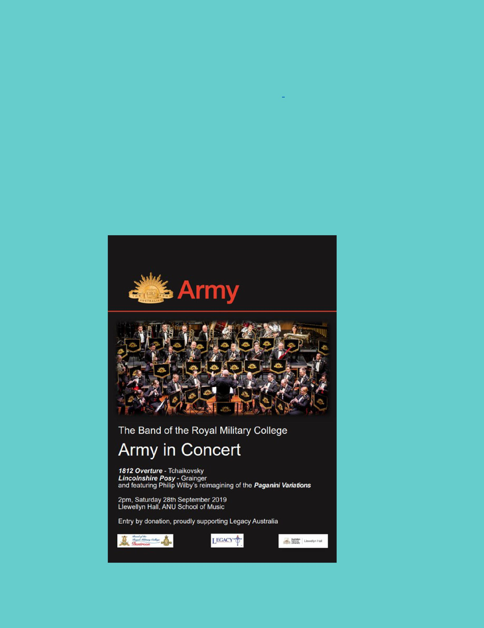
Postings

Are you posting this year or early next year? I would love to know where you are heading for 2019/2020 so I can support your child, if your family are moving into another locality or school. You can contact me via email kristy.retzlaff@ed.act.edu.au or 6142 1440.

Thank you,

Kristy Retzlaff

Defence School Mentor

COMMUNITY CONNECTIONS
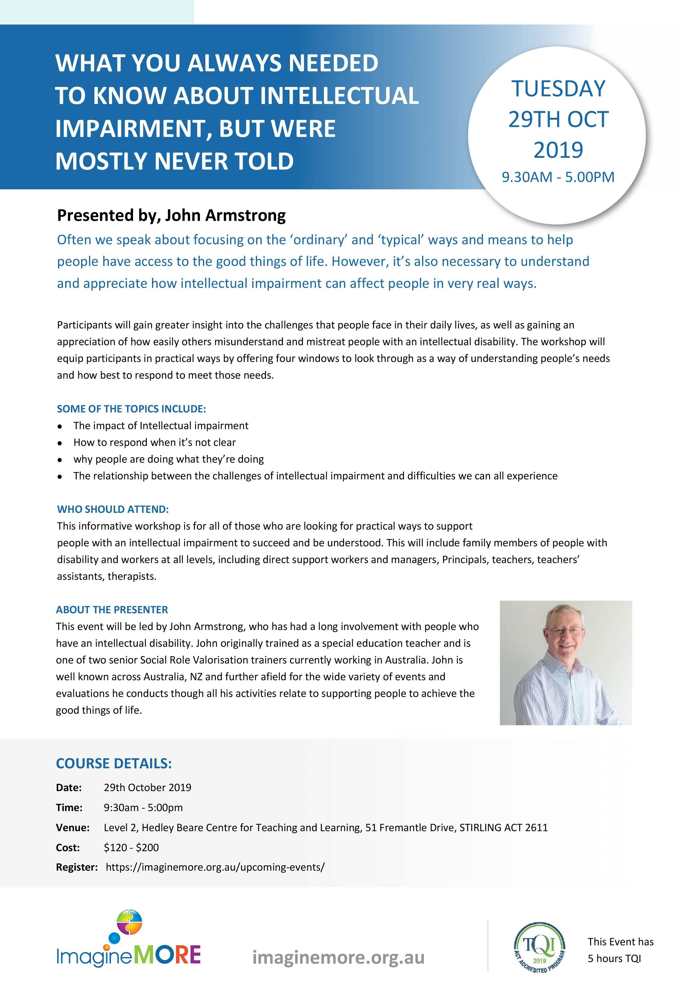

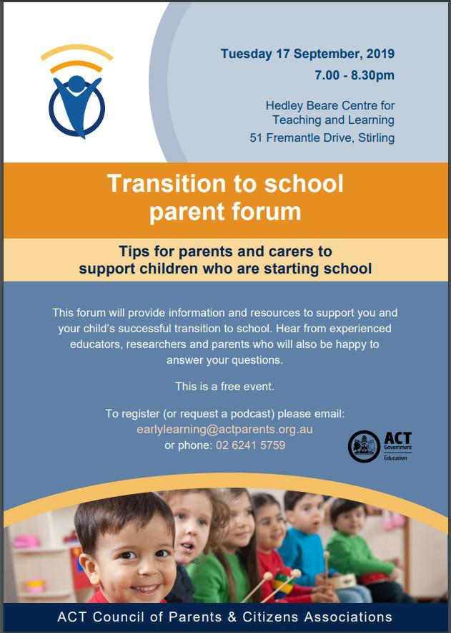

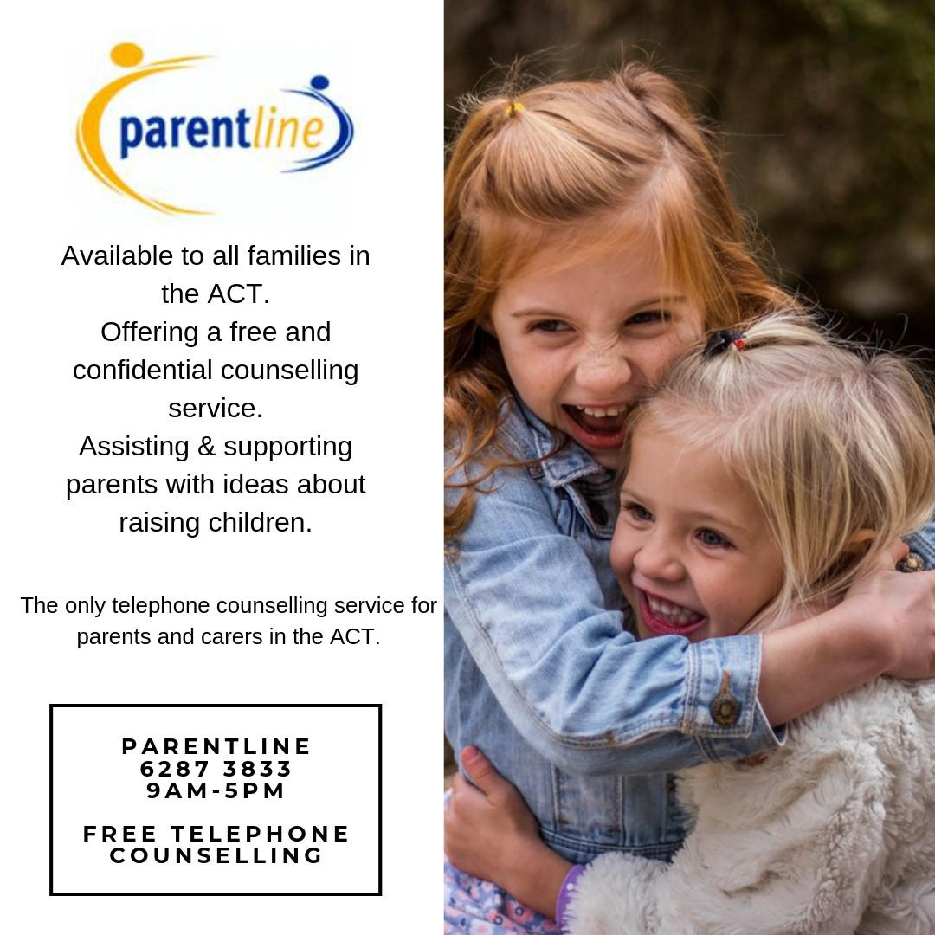

Together WeTogether We Learn From Each Other

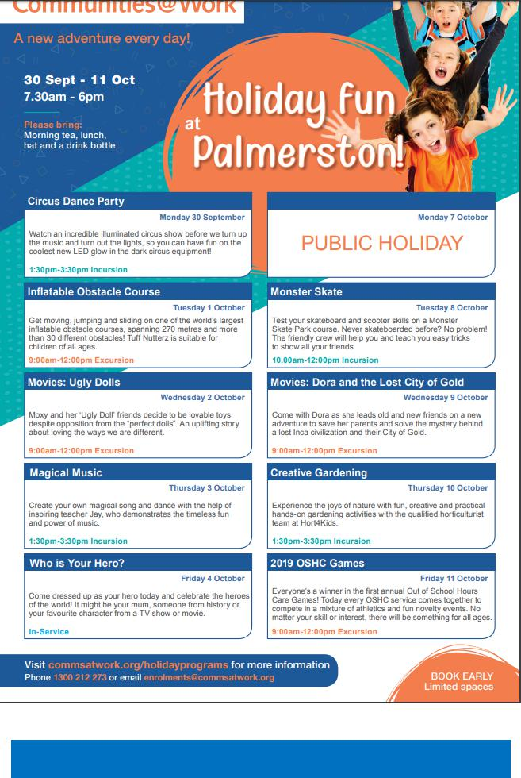

Together WeTogether We Learn From Each Other

