Palmerston Post

21 June 2018

Week 8, Term 2

ASSEMBLY:
22 | Jun |  | Senior - Music
29 | Jun |  | Whole School -
 |  |  | Indonesian
DATES TO REMEMBER:
22 | Jun |  | Yr3-6 Constable Kenny
22 Jun |  |  | P/S Sammy Seal
 |  |  | Music
25 | Jun - 6 Jul |  | P/S Hatching Chicks
25 Jun |  |  | P/S Sammy Seal
28 Jun |  |  | LSU - Magic Mania
28 Jun |  |  | Yr3/4 Children’s
 |  |  | Opera
29 | Jun |  | Yr2-4 & IEC Canberra
 |  |  | Theatre excursion
2-4 Jul |  |  | Kindy Health Checks
2-5 Jul |  |  | Parent Teacher
 |  |  | Interviews
3 Jul |  |  | P/S Fresh Food
 |  |  | Challenge
4 Jul |  |  | Transport & Parking
 |  |  | Parent Info Session
6 Jul |  |  | P/S Fresh Food
 |  |  | Challenge

NOTES HOME:

- Transport & Parking Parent Info Session

P&C BOARD NEWS P&C: 7:00pm 25 June 2018

All P&C activities, meeting agendas and minutes are available from the school website at – Parent Corner

DEPUTY PRINCIPAL’S MESSAGE

This week I have been reading the student’s reports before they are ready to go home to parents next week. While reading the reports it has again highlighted to me the wonderful work the teachers at Palmerston do. I know that teachers put hours of work into these reports to ensure they are detailed and accurate. The depth of knowledge of each and every individual child and the growth that the students have shown is wonderful to see. This growth is also evident when I walk around the classrooms, I have seen many students this week showing me their writing that they have been working hard on. I have also seen lots of progress with the students’ reading. A reminder that reports will be going home next week and you are able to book an interview with your child’s teacher for week 10 via the front office.

This week teachers have been meeting in teams to plan for term

- Some of the students in year 2,3 & 4 have been reading

George’s Marvellous Medicine in preparation for their visit to

Canberra Theatre next Friday. The year two students in particular are getting very excited!

Next week Wayfarers Australia will be coming to Palmerston to present the children’s opera Heavenly Grandfather’s Banquet, which one of our talented students, Annabella, will be performing in. We can’t wait to see the show.

Please remember that we are enrolling for preschool 2019. If you have a child going into preschool or know of someone who does, have them fill in the online enrolment form. Later in this newsletter we have a slip for you to fill in if you think you will be leaving Palmerston in 2019. This information assists the school with staffing requirements for 2019.

As always if you would like to discuss an area of concern or have a question please do not hesitate to contact your child’s teacher or one of the members of the executive team. We are always happy to help and enjoy getting to know the families in the community.

Have a great week,

Haeley Simms

Together, we learn from each other

Palmerston Post Page 2

YEAR 2 NEWS - KENNY KOALA VISIT

On Friday 15 June, year two had a visit from Constable Kenny Koala. Kenny Koala came to teach us about how to be safe in our community. He talked to us about road safety.
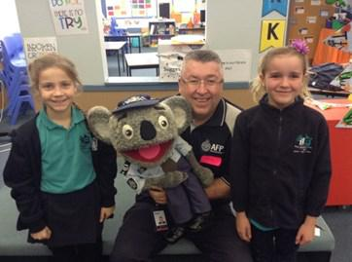

Kenny Koala also talked to us about stranger danger. He gave us

strategies we could use if we were ever approached by somebody we didn’t know. He explained that if we were to yell out “help, I don’t know this person” it immediately alerts people around us that we

need help as an unknown person is near us. Kenny also explained that we could seek safety from a family nearby with other small children or if we’re at the shops, a shop keeper. He told us that we can identify a shop keeper by looking at their uniform.
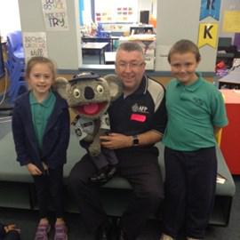
Year two thoroughly enjoyed our engaging visit from Constable Kenny Koala and the messages he shared about being safe.

Extra, extra! Read all about it!

“I enjoyed when we practised walking across the road.” – Elijah

“You need to put your seat belt on and hold an adult’s hand while crossing the road.” – Lacey

“You have to wear a helmet when riding a bike, skateboard or scooter to protect yourself.” – Reign

“The red light is for stop and the green light is for go.” – Eluney
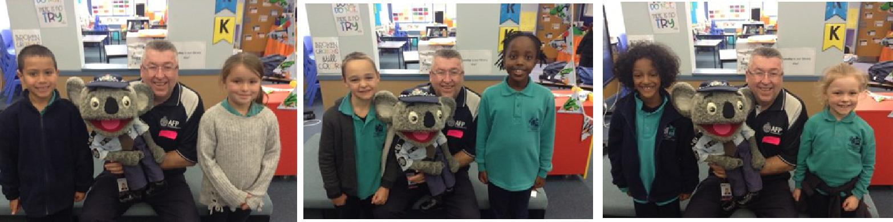

Together, we learn from each other

Palmerston Post Page 3

UPCOMING EVENTS

Yr3-6 Constable Kenny

Date: Friday 22 June 2018

Location: Palmerston District Primary School

Preschool - Sammy Seal Music

Date: Friday 22 June 2018 & Monday 25 June 2018

Location: Palmerston Preschool

Preschool - Hatching Chicks
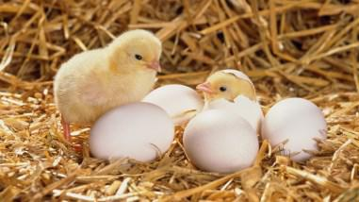

Date: 25 June - 6 July 2018

Location: Palmerston Preschool

LSU - Magic Mania Show

Date: 28 June 2018

Location: Hellenic Club of Woden

Yr3/4 Children’s Opera

Date: 28 June 2018

Location: Palmerston District Primary School
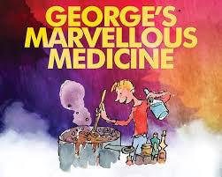

Yr2-4 & IEC - George’s Marvellous Medicine show

Date: 29 June 2018

Location: Canberra Theatre

Kindy Health Checks

Date: 2-4 July 2018

Location: Palmerston Primary District School

Parent / Teacher Interviews

Date: 2-5 July 2018

Location: Palmerston Primary District School

BOOK CLUB

Issue 4 has now closed and I am expecting the books will be distributed to all students in week 9. However, I have 1 child who placed their order into the Boomerang box and paid with cash and ordered “100 Deadliest things on the Planet” ($12). The form did not have any name or contact details. If this was you, please contact me to advise the student name and class for delivery.

A reminder to all parents to please check the orders if your child is completing the form. Please make sure the form is completed correctly, with the books required marked, the correct amount of money is included if paying cash (with no foreign currency) and their name and class is clearly visible on top of the order form.

Thanks,

Edwina

0422 006 142

Together, we learn from each other

Palmerston Post Page 4
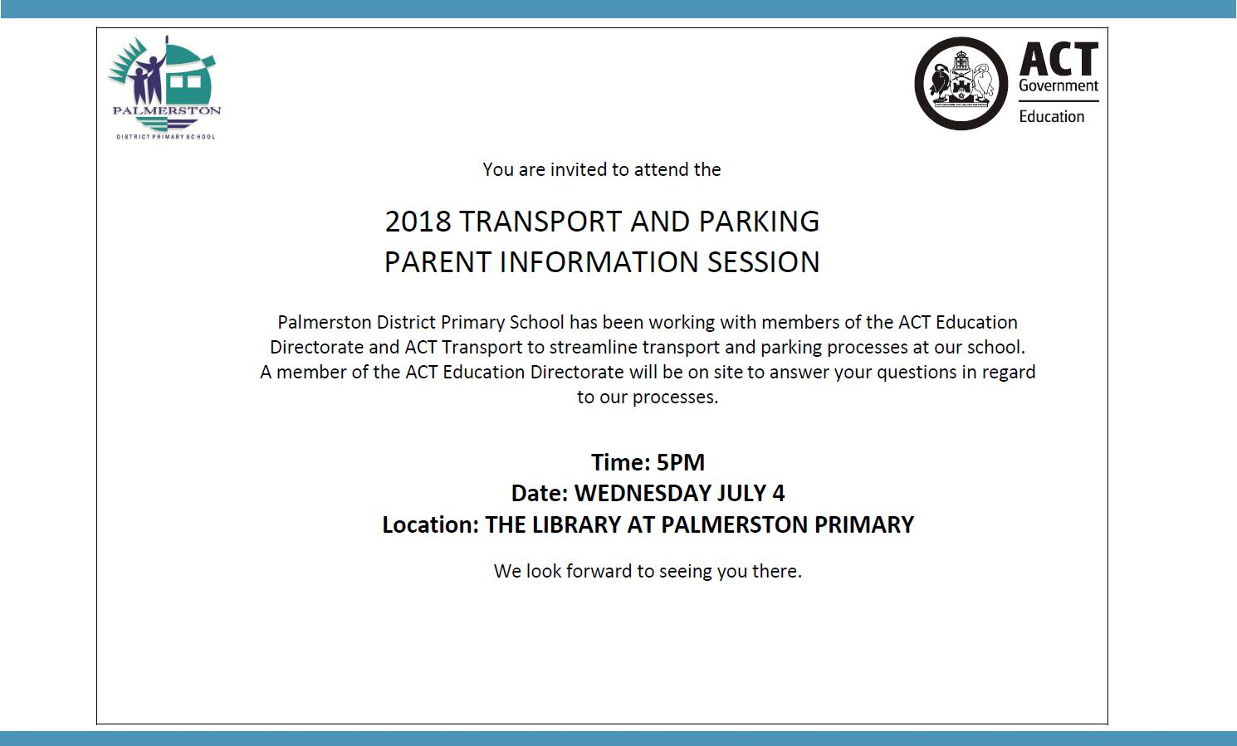

KINDERGARTEN HEALTH CHECKS

Earlier this year a pack of information was distributed to all Kindergarten families in relation to health checks conducted by School Health Team Nurses. The health checks are conducted across all ACT Government schools to assist children to have the best possible start at school. The information you returned to the school has been supplied to School Health Team. The nurses will be conducting the health checks on 2- 4 (Monday - Wednesday) July. If you have not returned your child’s health check information and you wish for the health check to be conducted, please return the envelope to your child’s teacher.

RECYLING PROGRAM
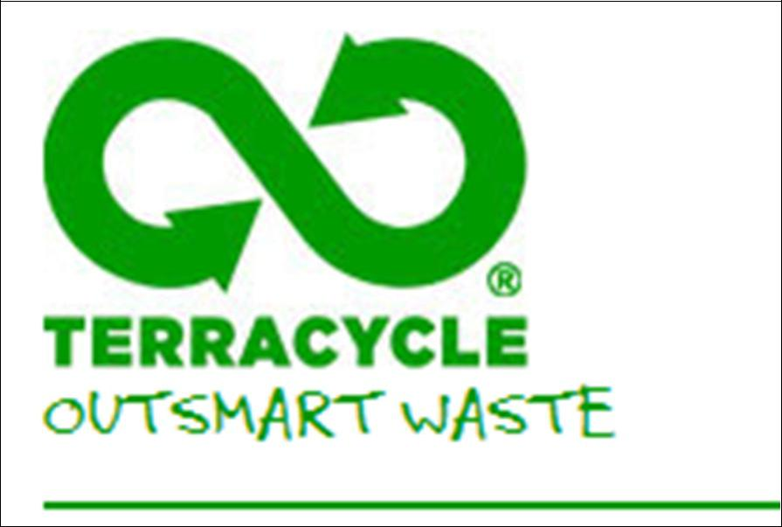

Want to raise money for the school and at the same time recycle items you normally throw away?

Palmerston Primary is registered to be part of a new recycling program. The school will be a collection point for oral care waste that we will send off to earn money for the school.

Al you have to do is bring your finished toothpaste tubes, toothbrushes,

dental floss containers and packaging and place them in the box just outside the staffroom where the club board is. We will do the rest.

Just so you know… even though the collection box has pictures of Colgate products on it – ANY BRAND OF ORAL CARE PRODUCTS IS ACCEPTED!
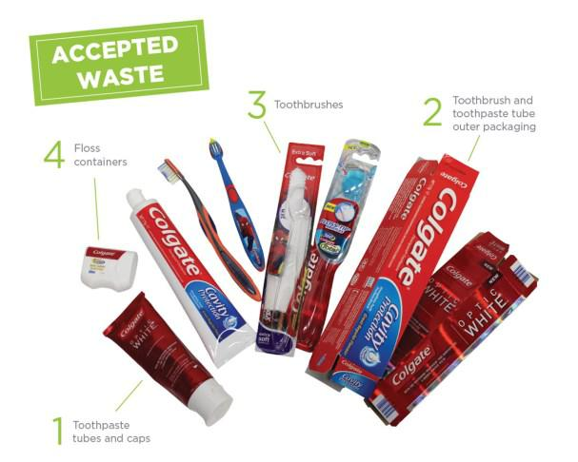

The program will be officially launched on World Environment Day June 5 at morning lines. If you already have some products you would like to bring in before then please hand in to the front office or directly to Karon Campbell - Environmental Science Teacher.

Together, we learn from each other

Palmerston Post Page 5

REPORTING

Over the last few weeks teachers have been very busy collating and recording information in order to provide you with clear, accurate and objective information about the learning and development of your child, via the ACT Directorate reporting template. At Palmerston, we use a range of mechanisms to provide information - these include Learning Journeys, informal and formal interviews and end of semester reports.

For students in Kindergarten to Year 6, teachers report student achievement using the Australian Curriculum achievement standards for each learning area. The achievement standards describe the quality of learning comprising the extent of knowledge, the depth of understanding and sophistication of skills expected of students at the end of each reporting period.

In the areas of English and mathematics you will find comments relating to the strengths of each child and areas for development. Aligned with these strengths and areas for development you will find strategies to maintain and support the progression of learning. Reports will be sent home with children on Thursday 28 June, week 9.

A-E Reports

Preschool children will receive a developmental summary report. If your child is in Kindergarten you will receive the school report. Children in Years 1 - 6 will receive a copy of the school report and an A-E report. As parents/carers you have the option of withdrawing your child from the A-E reporting process. This means that your child will still be awarded an A-E grade in the key learning areas, and a copy of the A-E report will go onto their school file. However, an A-E report will not be sent home with your child. You will receive only the school report.

Interviews

Teachers will be running interviews after reports go home, on Monday 2 - Thursday 5 July week 10. Preschool teachers will also offer interviews throughout week 10. Please call the front office on 6142 1440 to book in an interview time.

Request for duplicate reports – please return to the Front Office – Semester 1, 2018

Please indicate on the form attached if you require duplicate copies of your child’s report.

I will require a duplicate copy of my child/ren’s report. My child/ren’s name/s are:

class

class

class

Please address the duplicate report to: (please include name & address)

Together, we learn from each other

Palmerston Post Page 6

SCHOOL INTENTIONS 2019

School Leavers 2019

We have now reached the time in the year when we begin to look at our school numbers and staffing arrangements for 2019. If your circumstances have changed and your child/ren will not be attending Palmerston District Primary School in 2019 can you please let the front office staff know as soon as possible.

My child/ren will not be returning to Palmerston in 2019.

Name Class

Last day at Palmerston:

My child/ren will be attending:

Another government school in the ACT:

A non-government school in the ACT:

Moving out of the ACT

Forwarding Address:

Phone number:

Parents name:

Together, we learn from each other

Palmerston Post Page 7
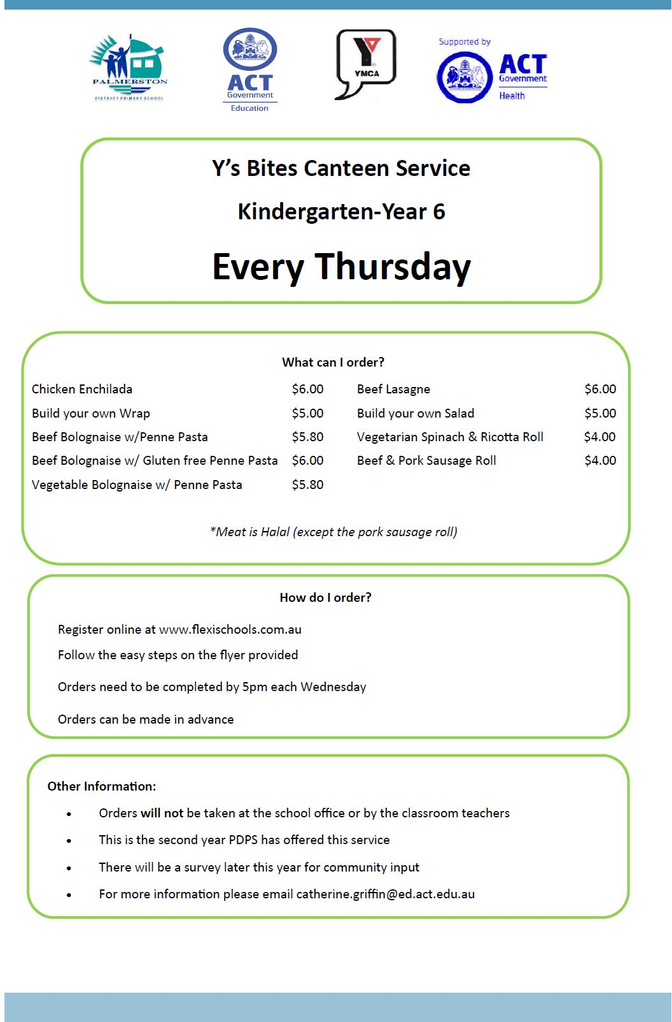

Together, we learn from each other

Palmerston Post Page 8
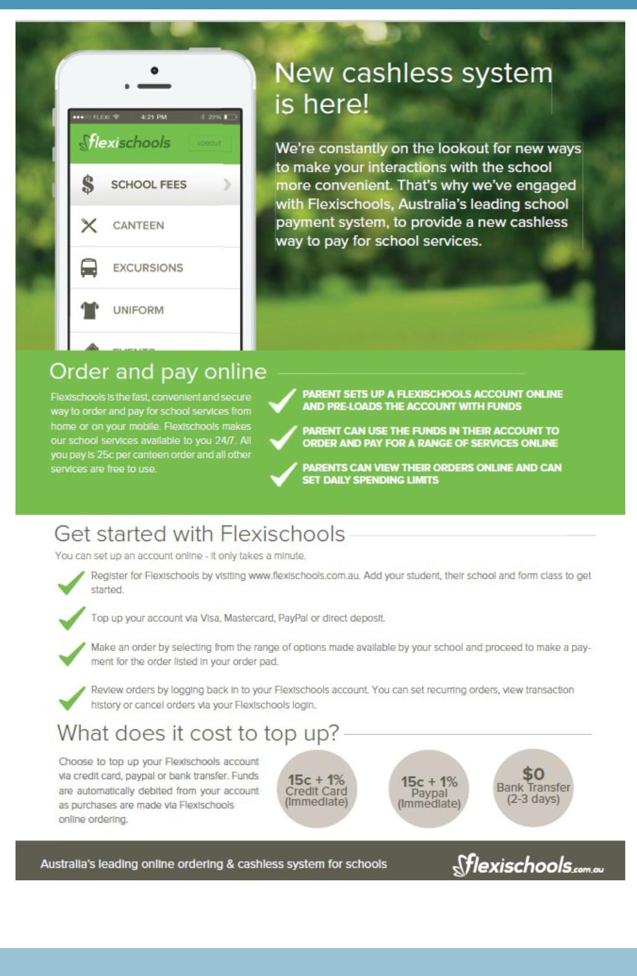

Together, we learn from each other

Palmerston Post Page 9

HIRER NEWS
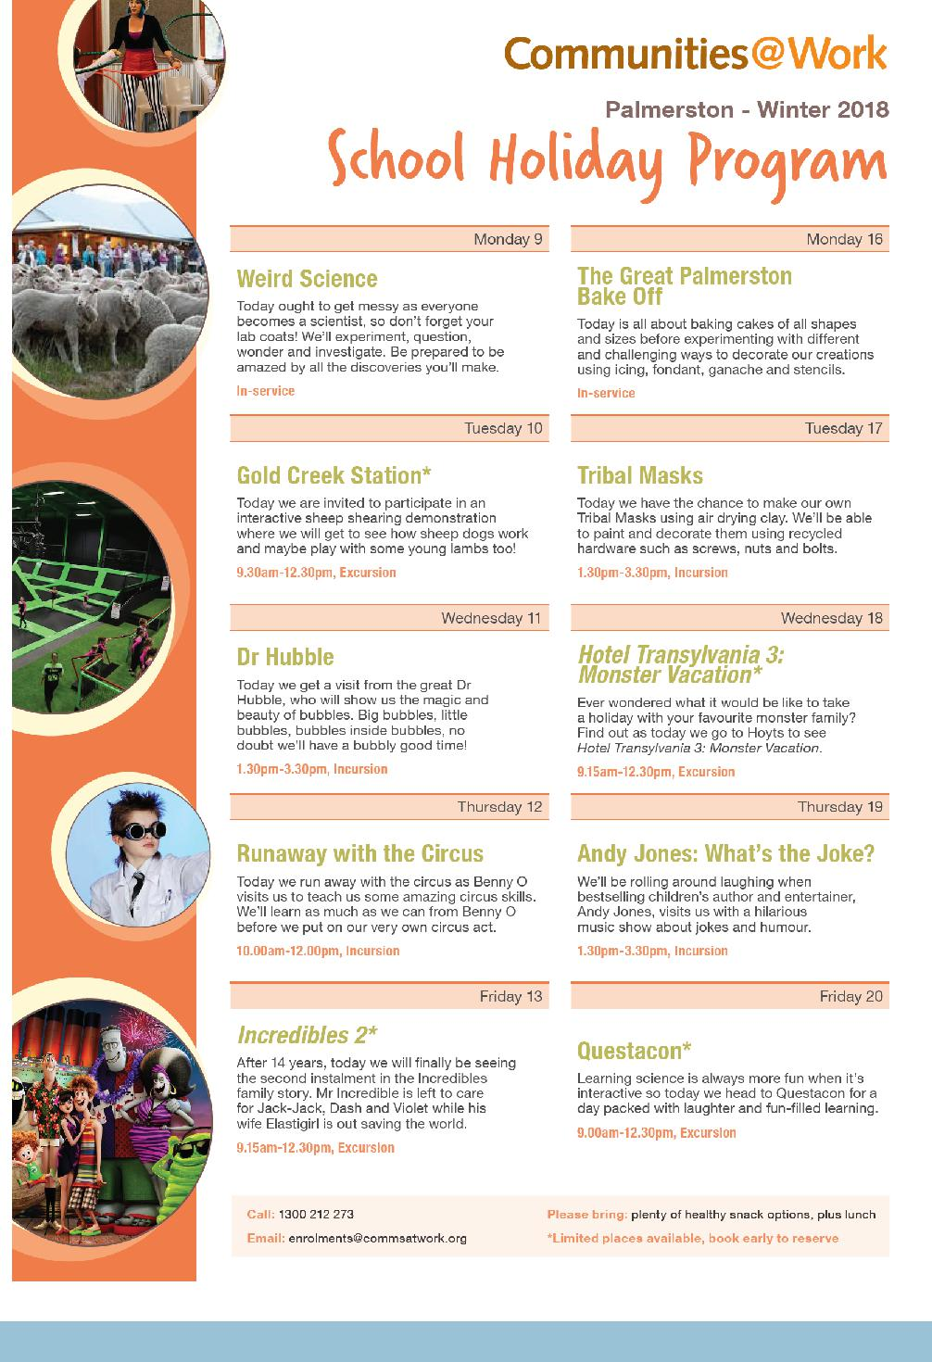

Together, we learn from each other

Palmerston Post Page 10

SCHOOL HOLIDAY PROGRAMS
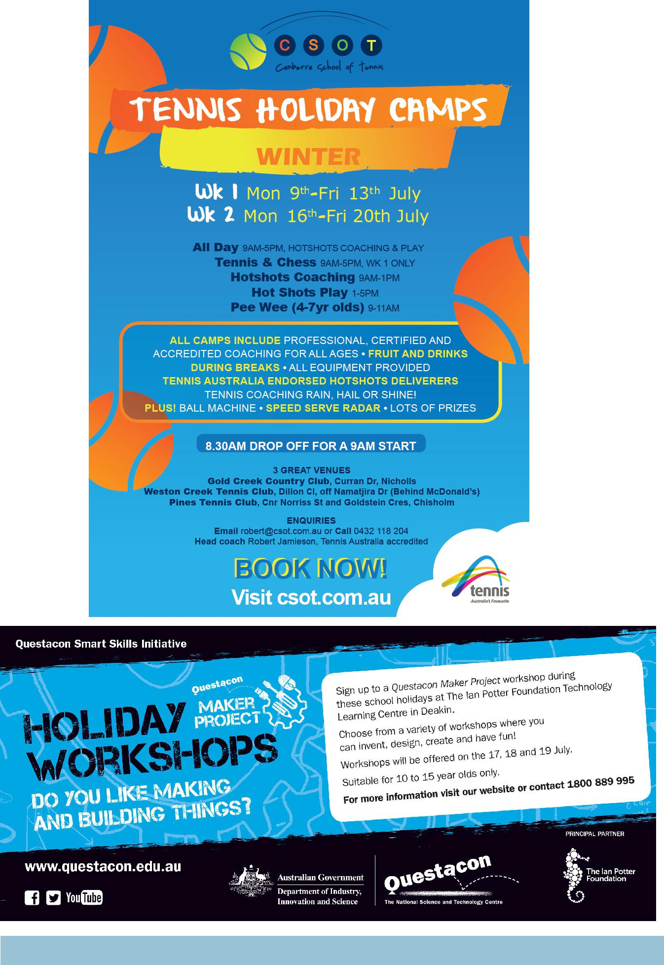

Together, we learn from each other

