Palmerston Post

5 July 2018

Week 10, Term 2

ASSEMBLY:
6 Jul | Junior - Music
DATES TO REMEMBER:
2-5 Jul | Parent Teacher
 | Interviews
6 Jul | P&C Fried Rice
 | Lunch Order
6 Jul | P&C Pyjama Day
6 Jul | P/S Fresh Food
 | Challenge
6 Jul | Last day of term 2
23 Jul | First day of term 3

NOTES HOME:

- Language Perfect Trial - 5/6/

CAP

- P&C Pyjama Day– Youngest

P&C BOARD NEWS

All P&C activities, meeting agendas and minutes are available from the school website at – Parent Corner

DEPUTY PRINCIPAL’S MESSAGE

Welcome to week 10 of term 2.

Parent Teacher Interviews

Thank you to all who attended the parent teacher interviews. I would like to thank the teachers for the work they have put into preparing the reports on student learning and staying back late on Tuesday to meet with parents and discuss the progress students have made over the semester. At Palmerston we value home-school connections and it is wonderful to see the difference it can make to a child when parents/carers and teachers work together.

NAIDOC Week

Palmerston has been celebrating NAIDOC Week a week early due to the school holidays. NAIDOC Week celebrations are held across Australia each July to celebrate the history, culture and achievements of Aboriginal and Torres Strait Islander peoples. NAIDOC is celebrated not only in Indigenous communities, but by Australians from all walks of life. The week is a great opportunity to participate in a range of activities and to support your local Aboriginal and Torres Strait Islander community. To celebrate this week Palmerston students have been visiting a hands on museum in the library. On Tuesday and Wednesday students have walked through our museum to examine various items and histories, ask your child what they learnt or saw. Thank you to the cultural integrity working party who did an amazing job setting this up.
PBL

This semester Palmerston has been implementing Positive Behaviours for Learning with a focus on the outside environment and transitions. Students have been focusing on the following: Be safe, Be respectful, Be a learner. As a part of this raffle tickets in the four house colours have been given to students who are demonstrating these behaviours, with a reward for the house that collects the most raffle tickets. This term I am pleased to announce that the students in Gudgenby have won. They have voted to have a disco at lunch tomorrow. The raffle tickets will continue to be implemented next term.

Together, we learn from each other

Palmerston Post

Car Park/Transport at Palmerston Information Session

On Wednesday evening Palmerston held an information session on traffic management at Palmerston. This was an informative session which provided insight into future management options for our carpark. From 2019 there will be a new bus network which means all routes and timetables will be different in 2019. They are now providing opportunities to hear from you if you have any ideas about school public transport. Please give them feedback at YourSay.act.gov.au. As always where possible I would like to promote active travel to school and the use of The Active Streets for Schools program, as well as the possibility of dropping or picking up your child from near the school instead of at the school. Thank you to all of the parents and carers who have remained patient in the carpark and are ensuring they drive and park safely.

Enrolments 2018 and Leavers

Letters of offer to Palmerston Preschool for 2019 have gone out. Families are coming in to accept

the offers. Year 6 students going to Government High Schools will also have had their offers of place

sent to them. If you have not enrolled your Year 6 child into a High School, please contact us and we

can assist. If you know you are leaving Palmerston at the end of the year and will not be enrolled

with us in 2019, please inform the front office or fill in the slip which is located in the newsletter.

This assists in staffing the school for next year.

Have a safe two week break.

Thanks for a great term, see you in Term 3.

Haeley Simms

K6FS LSU News

It has been a very busy and productive term. We finished our science unit inquiring into the human body and our sensory system in particular. We also explored the landscape painting style of Albert Namatjira and Vincent Van Gogh. We employed the mediums of watercolour and oil pastels. Our community artist Annie who visits us every few weeks has introduced us to Leonardo da Vinci and his painting as well as his inventions.
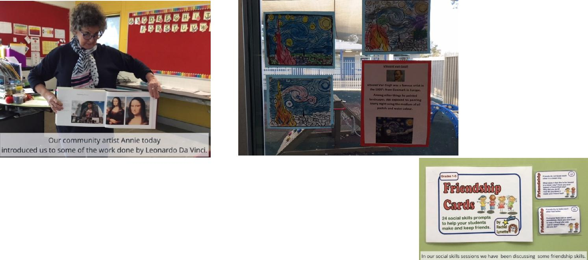

Our social skills sessions are progressing well as we continue to build a tool kit of strategies to keep ourselves calm and happy.

Together, we learn from each other

Palmerston Post

During our literacy sessions we have been using the strategy of rereading as a comprehension strategy. We have also been working on writing recounts.
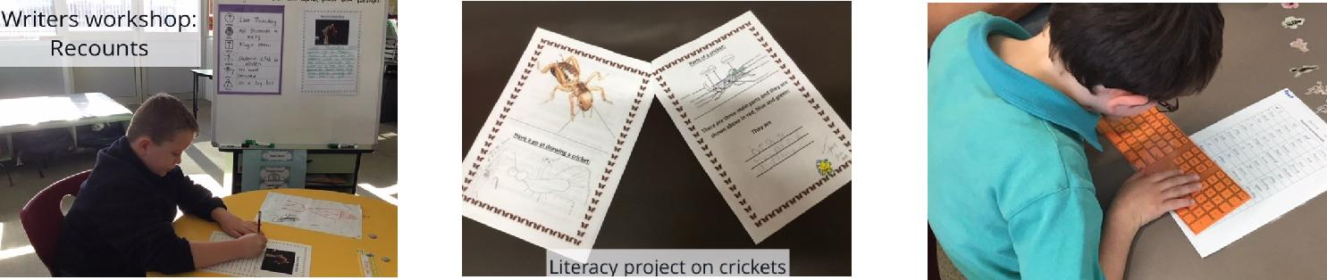

During our numeracy sessions we have been developing addition strategies as well as life skill mathematics of telling the time using analogue clocks and recognising Australian coins and their value.
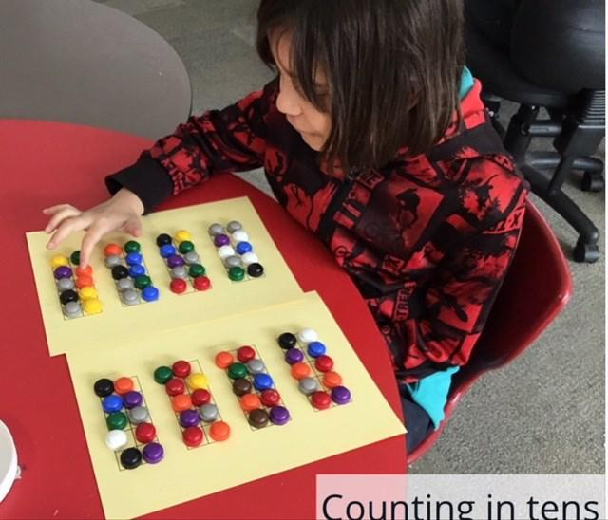

We continue to enjoy Cosmic Yoga and our bike riding sessions. The fitness app allows us to build strength and fitness.
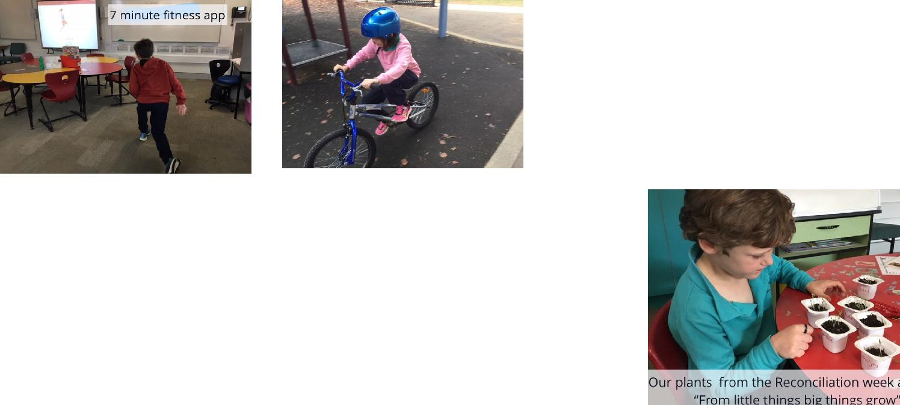

During reconciliation week we discussed the Vincent Langiari narrative through a book, video and Paul Kelly’s song “From little things big things grow”. We did a role play, wrote a pledge to be kind to all and planted small seeds and have been watching them grow with the care we provide. We continue to enjoy our weekly specialist science, Indonesian and music sessions.

Last week we accessed the wider community by travelling to a magic show in Woden. We got to experience some magic tricks and see some juggling acts. Smarty the ventriloquist with his emu was particularly popular. It’s great to finish the term with many successful learning experiences and we look forward to Term three. Have a safe and happy holiday.
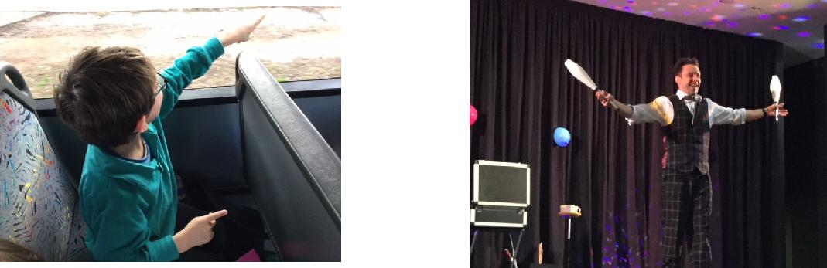

Together, we learn from each other

Palmerston Post
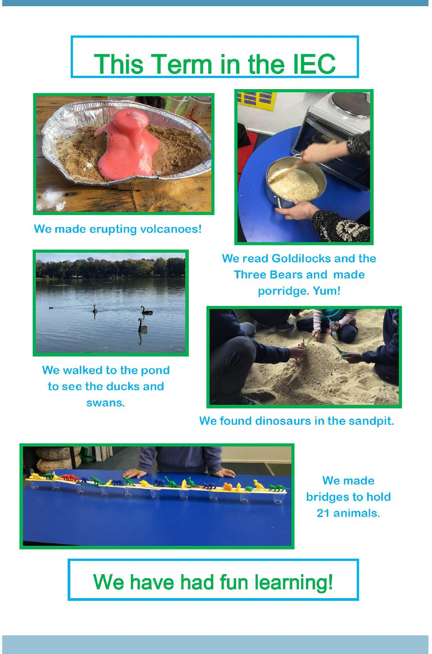

Together, we learn from each other

Palmerston Post

UPCOMING EVENTS

Preschool - Hatching Chicks

Date: 25 June - 6 July 2018

Location: Palmerston Preschool

Parent / Teacher Interviews

Date: 2-5 July 2018

Location: Palmerston Primary District School

RECYLING PROGRAM

Want to raise money for the school and at the same time recycle items you normally throw away? Palmerston Primary is registered to be part of a new recycling program. The school will be a collection point for oral care waste that we will send off to earn money for the school.

All you have to do is bring your finished toothpaste tubes, toothbrushes, dental floss containers and packaging and place them in the box just outside the staffroom where the club board is. We will do the rest.

Just so you know… even though the collection box has pictures of Colgate products on it – ANY

BRAND OF ORAL CARE PRODUCTS IS ACCEPTED!

The program was officially launched on World Environment Day June 5 at morning lines. If you already have some products you would like to bring in before then please hand in to the front office or directly to Karon Campbell - Environmental Science Teacher.
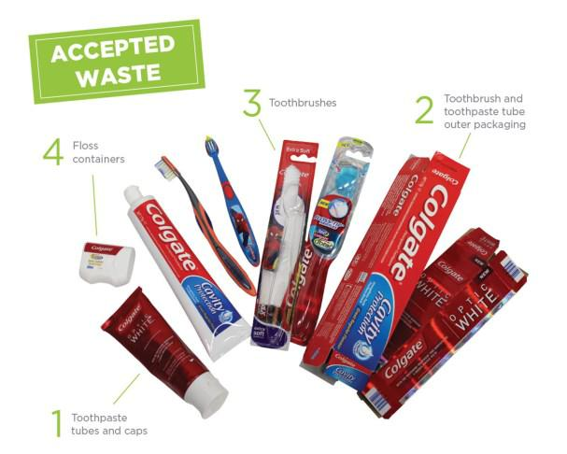
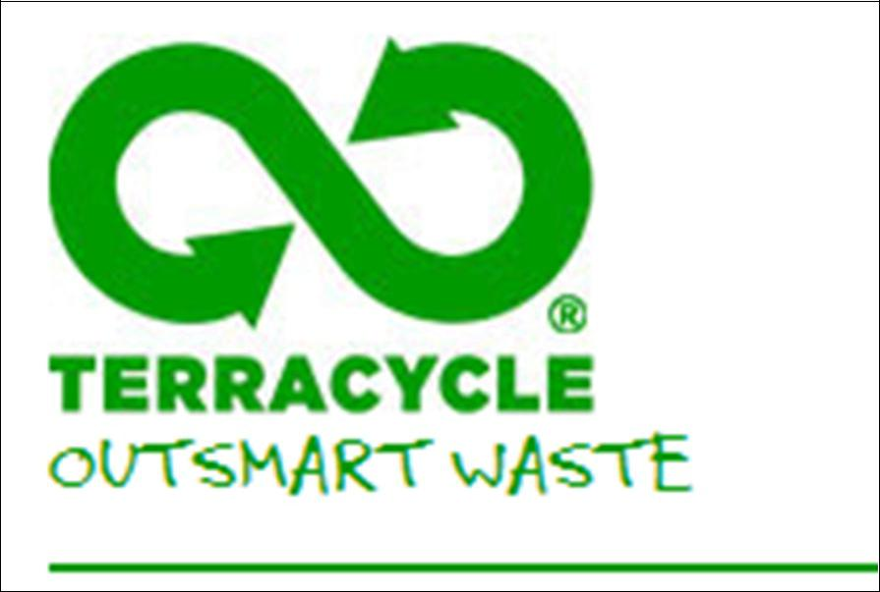

Together, we learn from each other

Palmerston Post

SCHOOL INTENTIONS 2019

School Leavers 2019

We have now reached the time in the year when we begin to look at our school numbers and staffing arrangements for 2019. If your circumstances have changed and your child/ren will not be attending Palmerston District Primary School in 2019 can you please let the front office staff know as soon as possible.

My child/ren will not be returning to Palmerston in 2019.

Name Class

Last day at Palmerston:

My child/ren will be attending:

Another government school in the ACT:

A non-government school in the ACT:

Moving out of the ACT

Forwarding Address:

Phone number:

Parent’s name:

Together, we learn from each other

Palmerston Post

COMMUNITY NEWS
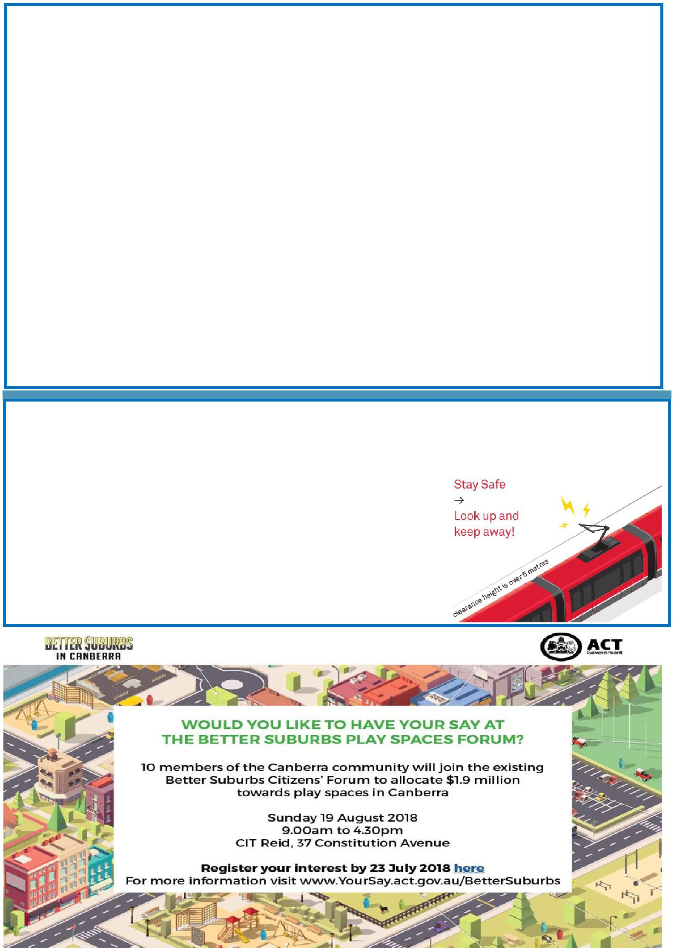

Parking Patrols near Schools

Parking Operations are now using a Licence Plate Recognition vehicle (or electronic chalking), which regularly patrols school environments to increase safety for children. Motorists that commit an offence will receive their infringement notice in the mail (rather than on their windscreen) 5-7 days after the offence.

https://www.youtube.com/watch?v=H6B6PPgOC8I

While schools can become congested during the peak times, illegal parking cannot be tolerated as it creates an unsafe environment for children. Parents are welcome to park on side streets around schools, but please remember to park legally. Infringements for parking on nature strips, footpaths, verges, street corners and near children’s crossings start from $114.

If you need to drive, park a little further from the school and walk to meet your child, or arrange a meeting point so they can walk to meet you. It’s a great way to avoid congestion and is also one of the most time efficient ways to ensure children receive the recommended 60 minutes of physical activity every day.

More information is available on the Transport Canberra website, including a range of information sheets to promote safe behaviours around schools. Please help make school environments safe.

Canberra’s Light Rail is Fast Approaching. Are you Rail Ready?

Whilst the light rail system undergoes testing to ensure it is fully functional and safe to carry passengers, light rail safety awareness among children and adults is also essential.

In addition to the Canberra Metro website, the video can also be accessed through Canberra Metro’s YouTube Channel. Please note that the video plays more seamlessly and without interruptions on the Chrome browser.

Together, we learn from each other

Palmerston Post
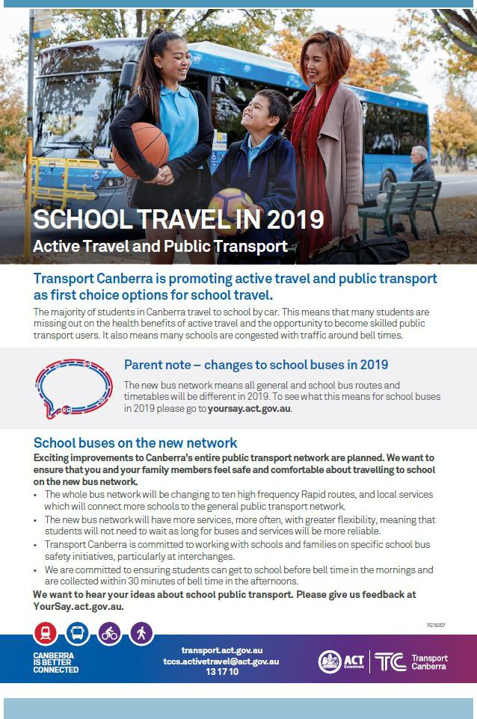

Together, we learn from each other

Palmerston Post
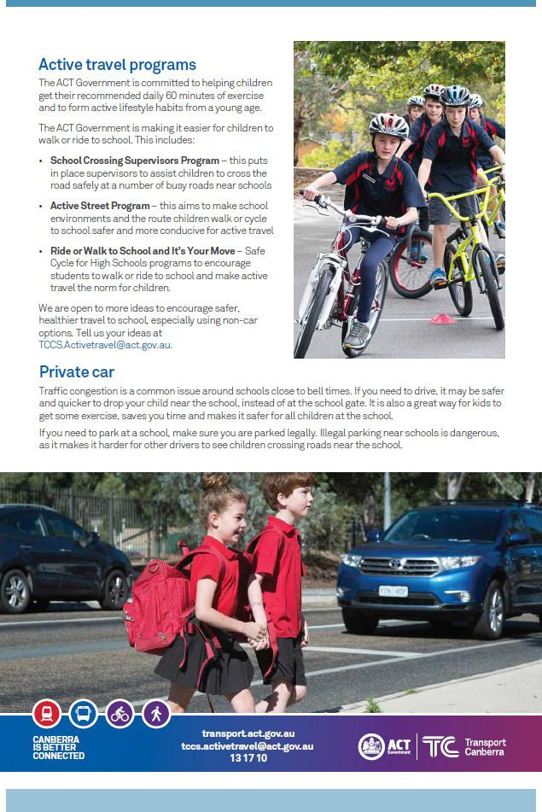

Together, we learn from each other

Palmerston Post
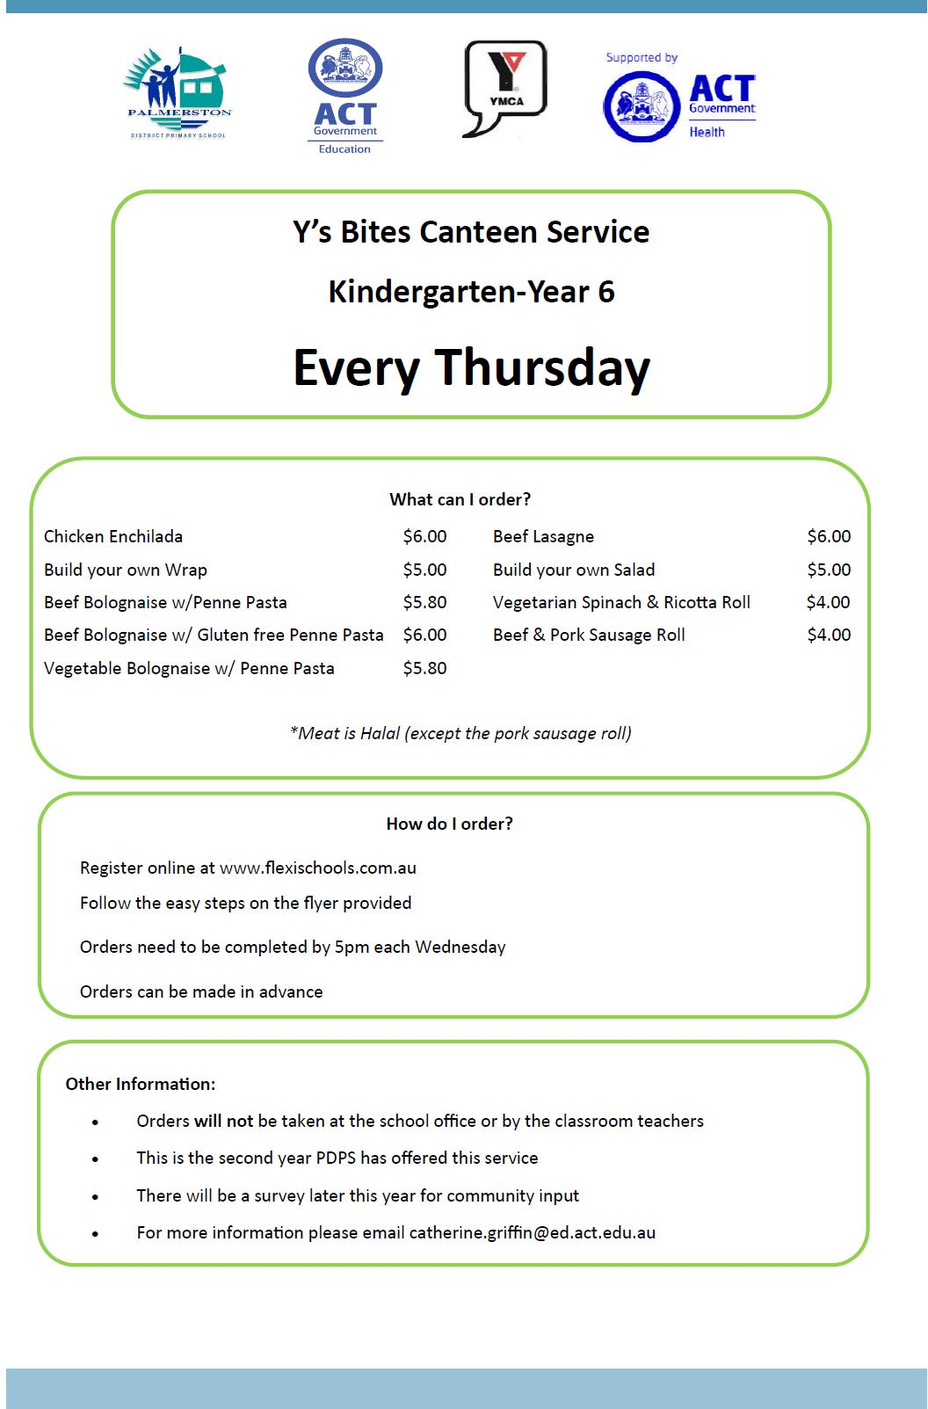

Together, we learn from each other

Palmerston Post
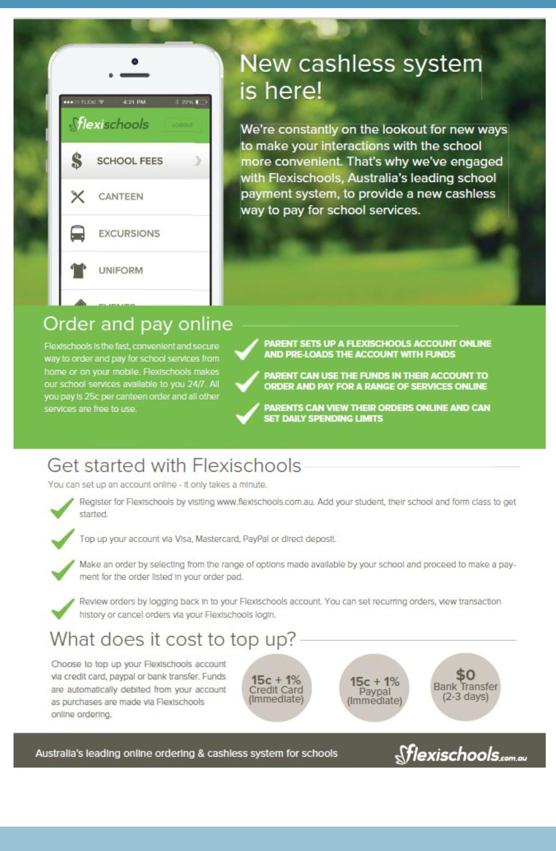

Together, we learn from each other

Palmerston Post
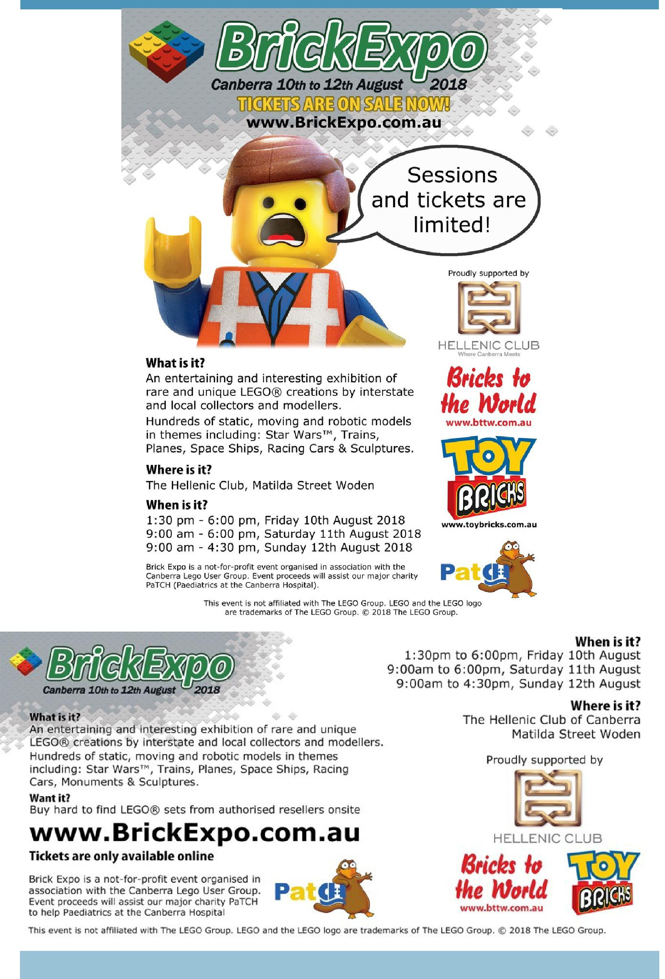

Together, we learn from each other

Palmerston Post
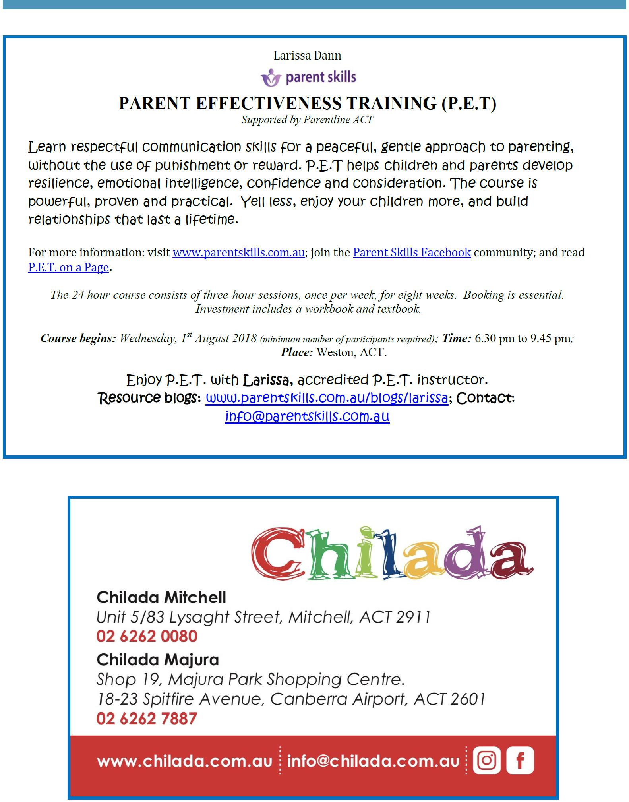

Together, we learn from each other

Palmerston Post
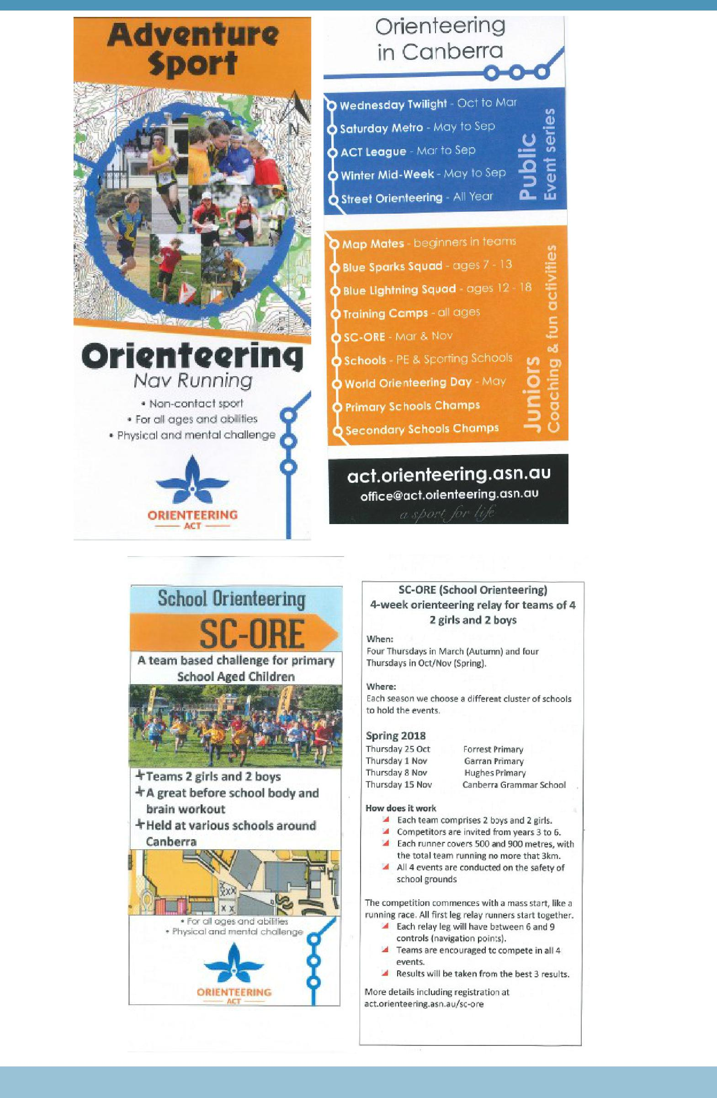

Together, we learn from each other

