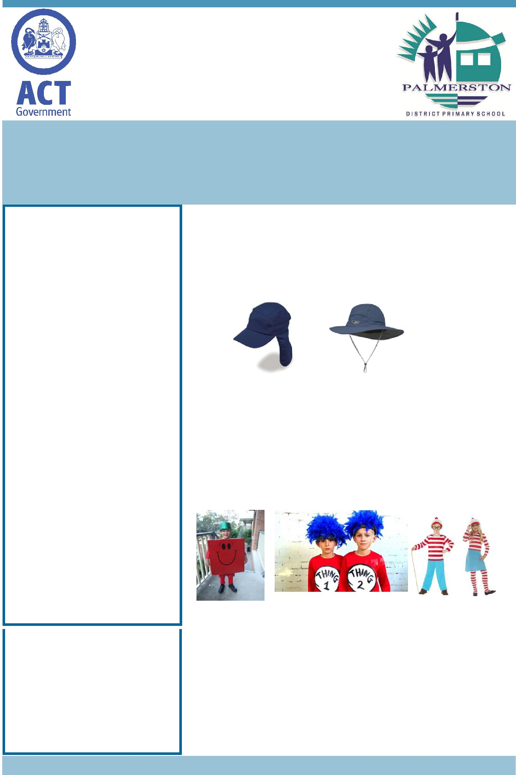
Palmerston Post

2 August 2018

Week 2, Term 3

Board Chair: Lisa Fior Board Members: Parent Reps: Jesse Dang and George Villaflor

Teacher Reps: Jessica Lago and Maxine Green

P&C President: Lisa Fior

Principal: Kate Flynn (acting) Deputy Principal: Haeley Simms (acting)

Executive Teachers: Kylie Moller, Jacqui Warden, Matt Gowen, Catherine Griffin (acting)

ASSEMBLY:

3 Aug | Senior - 3DJ, 3RC & 3/4JL
10 Aug | Junior - 1PJ, 1MC & 1AS
DATES TO REMEMBER:
3 Aug | Mufti day for Market day
3 Aug | National Aboriginal & Torres
 | Strait Island Children’s Day
 | celebrations
7 Aug | Parent Information Sessions
 | - Puberty & Personal
 | Development
13 Aug | Yr2 Dental Awareness
14 Aug | ICAS - maths
14 Aug | P/S Community Walk
16 Aug | Yr5/6 Touch Football Gala
 | Day
16 Aug | P/S Community Walk
17 Aug | Science Week activities
17 Aug | Winter Walk to School day

NOTES HOME:

- CAP Passion Project

- Taco Truck - CAP PoD

P&C BOARD NEWS P&C: 7:00pm 6 Aug 2018

All P&C activities, meeting agendas and minutes are available from the school website at – Parent Corner

School Board: 7:30am 6 Sep 2018

EXECUTIVE TEACHER’S MESSAGE

Welcome to week 3.

Now we are into August, it is now time to be wearing hats again. As we are a SunSmart school, students are strongly encouraged to wear a wide brimmed or legionnaires hat.

It is now time to start thinking about costume ideas for the PDPS Book Week Parade in week 5 on Thursday 23 August. Students are encouraged to come dressed as character from a book. Costumes can be made at home by using recycled materials or store bought items. Students are also welcome to bring along a copy of the book which includes the character they are dressed up as.

The whole school community is invited to the PDPS Book Week Parade on the blacktop. We look forward to seeing some creative costumes.

Have a great week,

Catherine Griffin

Together, we learn from each other

Palmerston Post

SEESAW UPDATE

The students and teachers have been enjoying using Seesaw over the past two terms. This term we will be increasing our use of Seesaw to include specific reminders/notices to families through the app. You would have noticed last week your child’s term overview was added to Seesaw. This assists with ease of communication to all families. If you are yet to sign up for Seesaw you can see the front office staff who will be able to provide you with a copy of the note. Thank you to all of the parents that have been liking their children’s work and commenting. We have had fantastic feedback from many parents on how they are enjoying seeing it. We have also had grandparents who are overseas being able to access their grandchildren’s work. If you have any questions or comments please feel free to pass it on to your child’s teacher or myself via the front office.

Thank you,

Haeley Simms

PBL in PRESCHOOL

Positive Behaviour for Learning (PBL) in preschool is aligned with the Early Years Learning Framework (EYLF). It also supports the guidelines of the National Quality Standard and addresses key features of preschool learning environments.

Outcomes of PBL at Palmerston preschool revolve around three key areas:

- Supporting children to have positive social behaviour experiences

- Supporting staff capacity and knowledge about behaviour guidance

- Building connections between the school and preschool that support positive learning environments

What has happened so far at preschool?

- Two Educators have visited Charnwood Dunlop School to discuss the implementation of PBL in their preschool unit

- All educators have met to discuss PBL and how it might ‘look’ in our preschool

- All preschool staff have completed a questionnaire regarding behaviour expectations in our preschool setting

What’s next?

- Week 2-3: Educators will complete a DRAFT ‘Behaviour Expectation Matrix’ for preschool

- Week 4: Students will be given an opportunity to voice their behaviour expectations within the preschool environment

- Week 5: Families will be provided with a copy of the DRAFT ‘Behaviour Expectation Matrix’.

Your feedback on this document is both encouraged and welcomed.

- Week 7: The preschool ‘behaviour expectation matrix’ will be finalised, printed and displayed in all preschool classrooms and the outdoor learning environment. It will also be available on the school’s website.

Together, we learn from each other

Palmerston Post

BOOK CLUB

Everyone should now have Issue 5 for Book Club. All orders are to be received by Friday 10 August.

Reminder you can order online via LOOP (see back of catalogue) or if you prefer to pay with correct cash/chq (made payable to Scholastic Australia) then place with the order into the Boomerang Box located in front office foyer.

Books can then take up to 2 weeks to be received and distributed.

Thanks,

Edwina

TRAFFIC UPDATE

Towards the end of last term members from ACT Transport and the ACT Education Directorate ran a meeting for our school community on transport and car parking at Palmerston. Items covered during this time included the use of buses to and from school, the improvements to car parking and the history of car parking at Palmerston.

Via the School Board, ACT Transport and the Education Directorate have provided the following responses to community questions and thoughts:

Palmerston would like to be the next school to have a lollypop/traffic controller at our crossing if the trial of this goes ahead

If the program is expanded to include additional crossings in the future, Palmerston will be considered along with other schools.

Is it possible to extend the 40km an hour zoning to past the roundabout so cars have to slow before the crossing?

Based on a desktop assessment, it looks like the signage already extends beyond the roundabout.

Is it possible to have better signage at our crossing?

Flashing lights aren’t used at children’s crossings in the ACT. The children’s crossing signage used at Palmerston is consistent with the Australian Standards, this is consistent across all schools.

Is it possible to survey how many children use this crossing in the morning?

We surveyed the crossing in March 2017 as part of the development of the School Crossing Supervisor program. 14 children crossed in the AM (8:00-9:15am) and 20 in the PM (2:30-3:45pm).

Together, we learn from each other

Palmerston Post

UPCOMING EVENTS

K-Yr6 Mufti Day

Fundraising for Yr6 Market Day

Date: Friday 3 August 2018

Location: Palmerston District Primary School *please bring in a gold coin donation*

National Aboriginal & Torres Strait Island Children’s Day celebration

Date: Friday 3 August 2018

Location: Gungahlin Child & Family Centre

Puberty & Personal Development Parent Information Sessions

Date: Tuesday 7 August 2018

Times: 9-10am & 6-7pm

Location: Palmerston District Primary School, library

Yr2 - Dental Awareness

Date: Tuesday 7 August 2018

Location: Palmerston District Primary School

Together, we learn from each other

Palmerston Post

SCHOOL INTENTIONS 2019

School Leavers 2019

We have now reached the time in the year when we begin to look at our school numbers and staffing arrangements for 2019. If your circumstances have changed and your child/ren will not be attending Palmerston District Primary School in 2019 can you please let the front office staff know as soon as possible.

My child/ren will not be returning to Palmerston in 2019.

Name Class

Last day at Palmerston:

My child/ren will be attending:

Another government school in the ACT:

A non-government school in the ACT:

Moving out of the ACT

Forwarding Address:

Phone number:

Parent’s name:

Together, we learn from each other

Palmerston Post
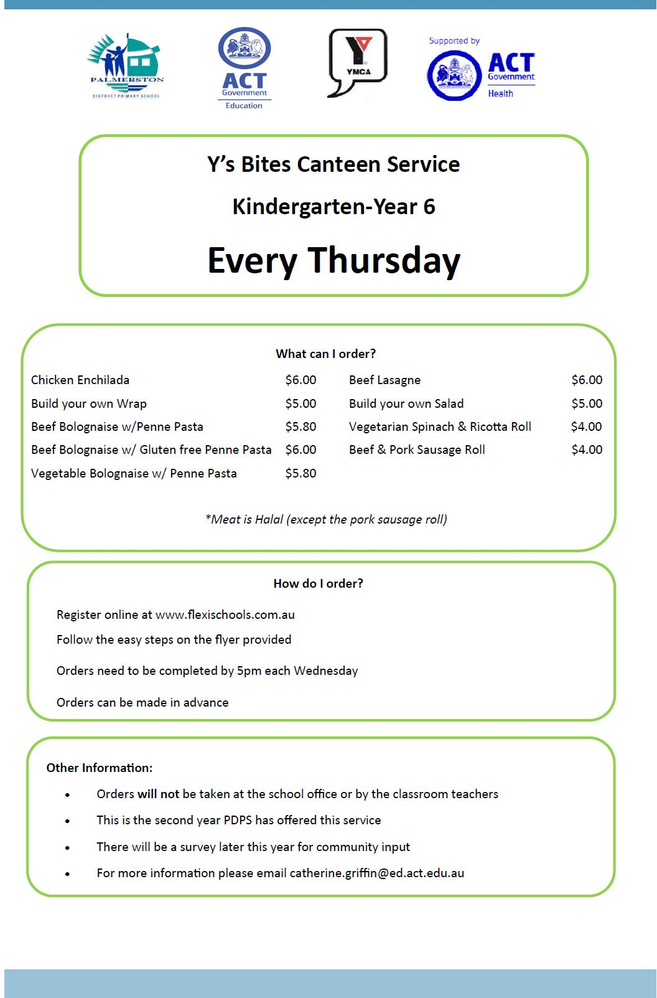

Together, we learn from each other

Palmerston Post
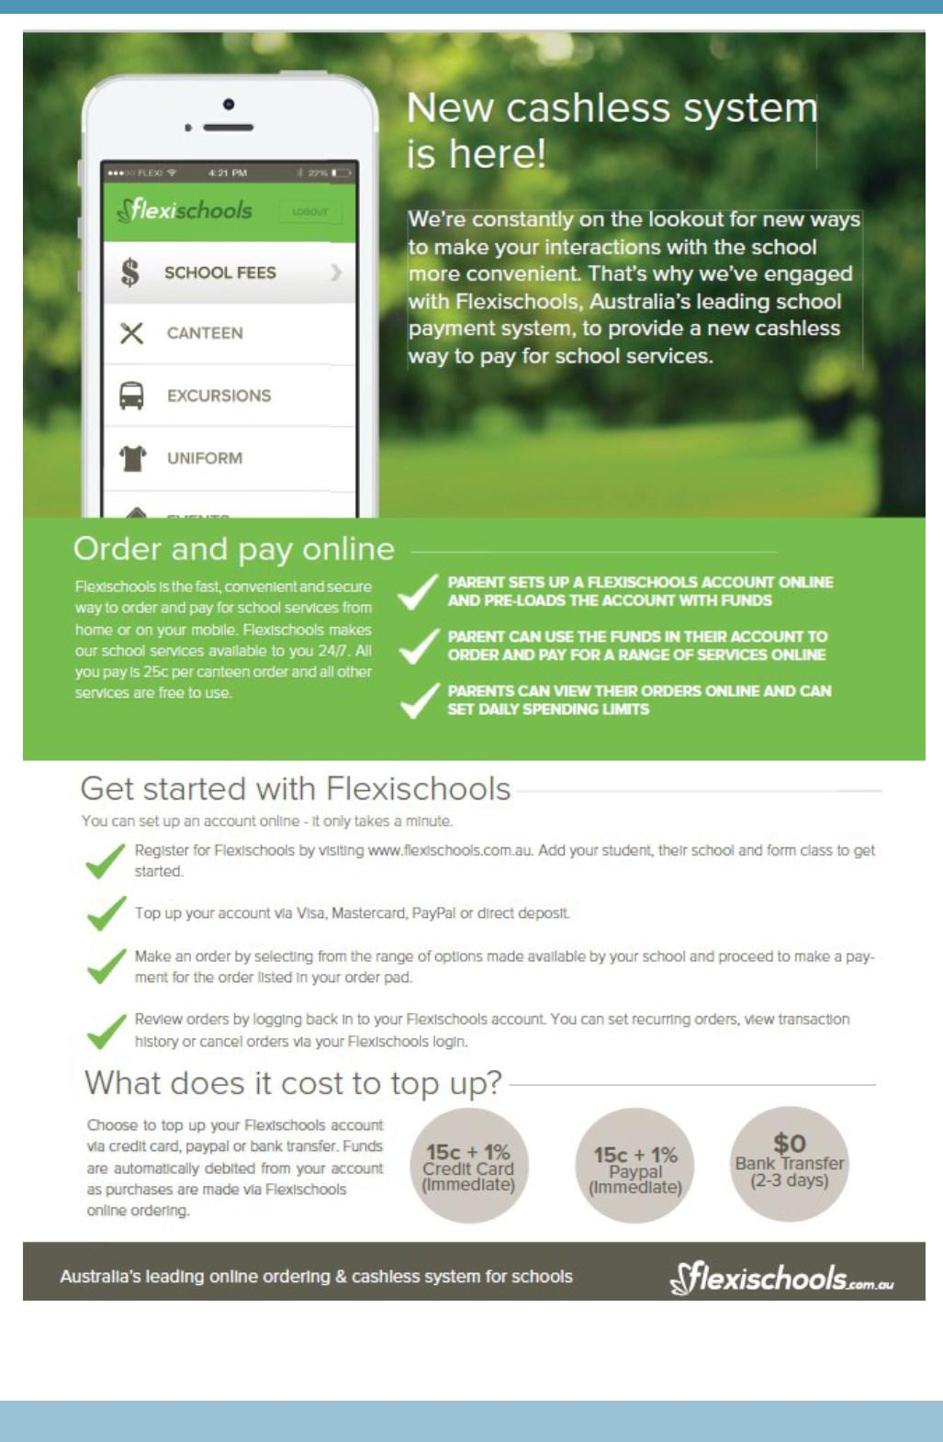

Together, we learn from each other

Palmerston Post

COMMUNITY NEWS
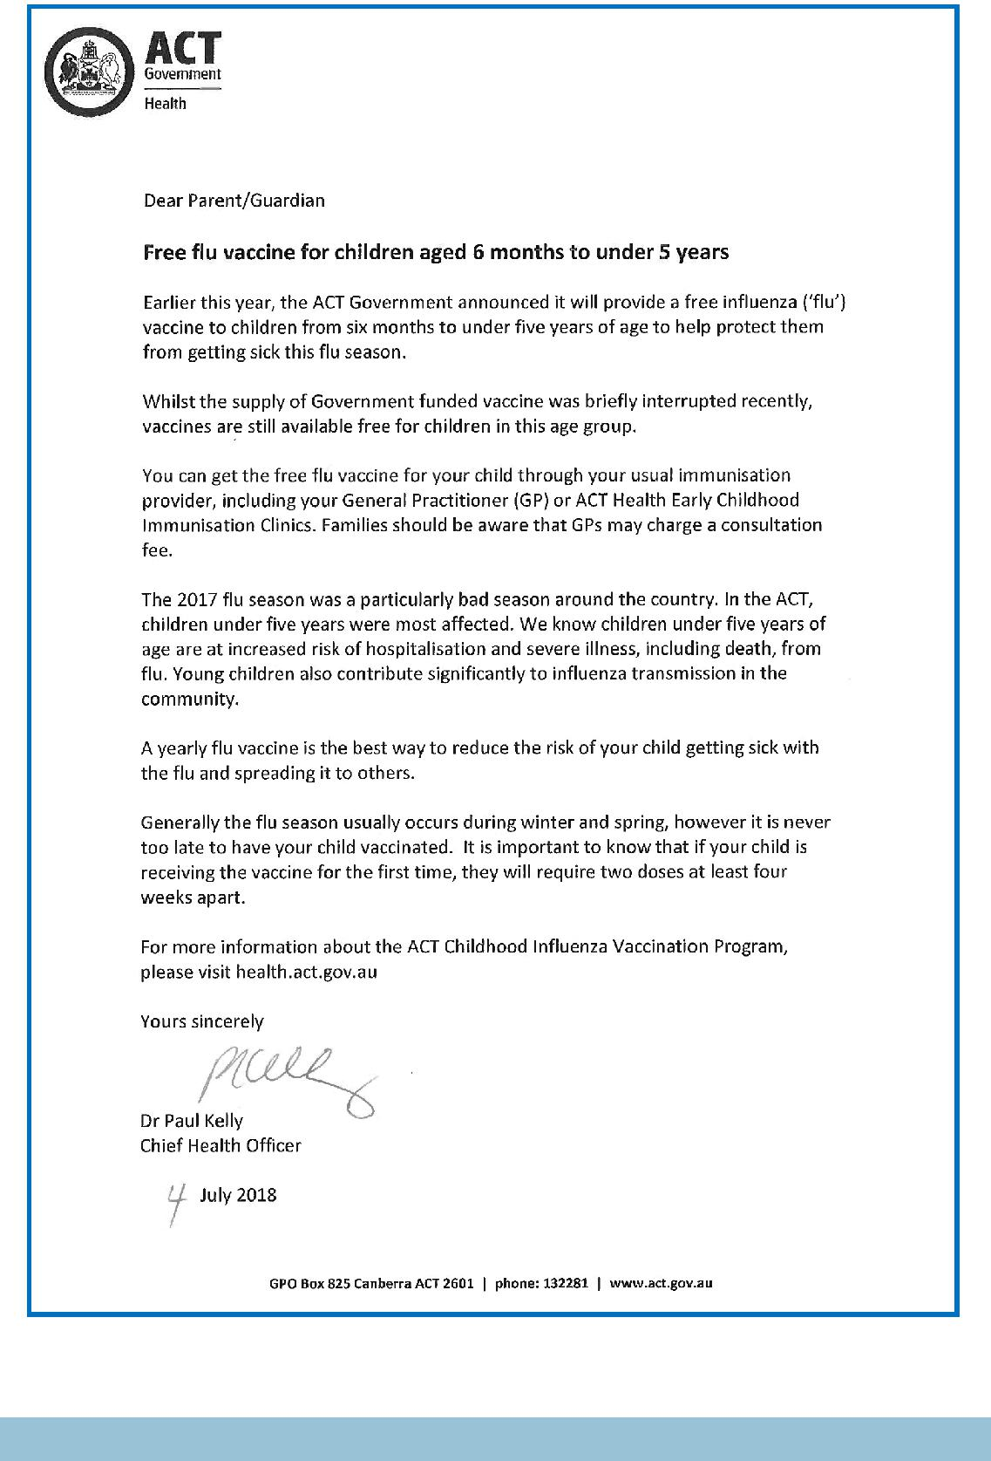

Together, we learn from each other

Palmerston Post
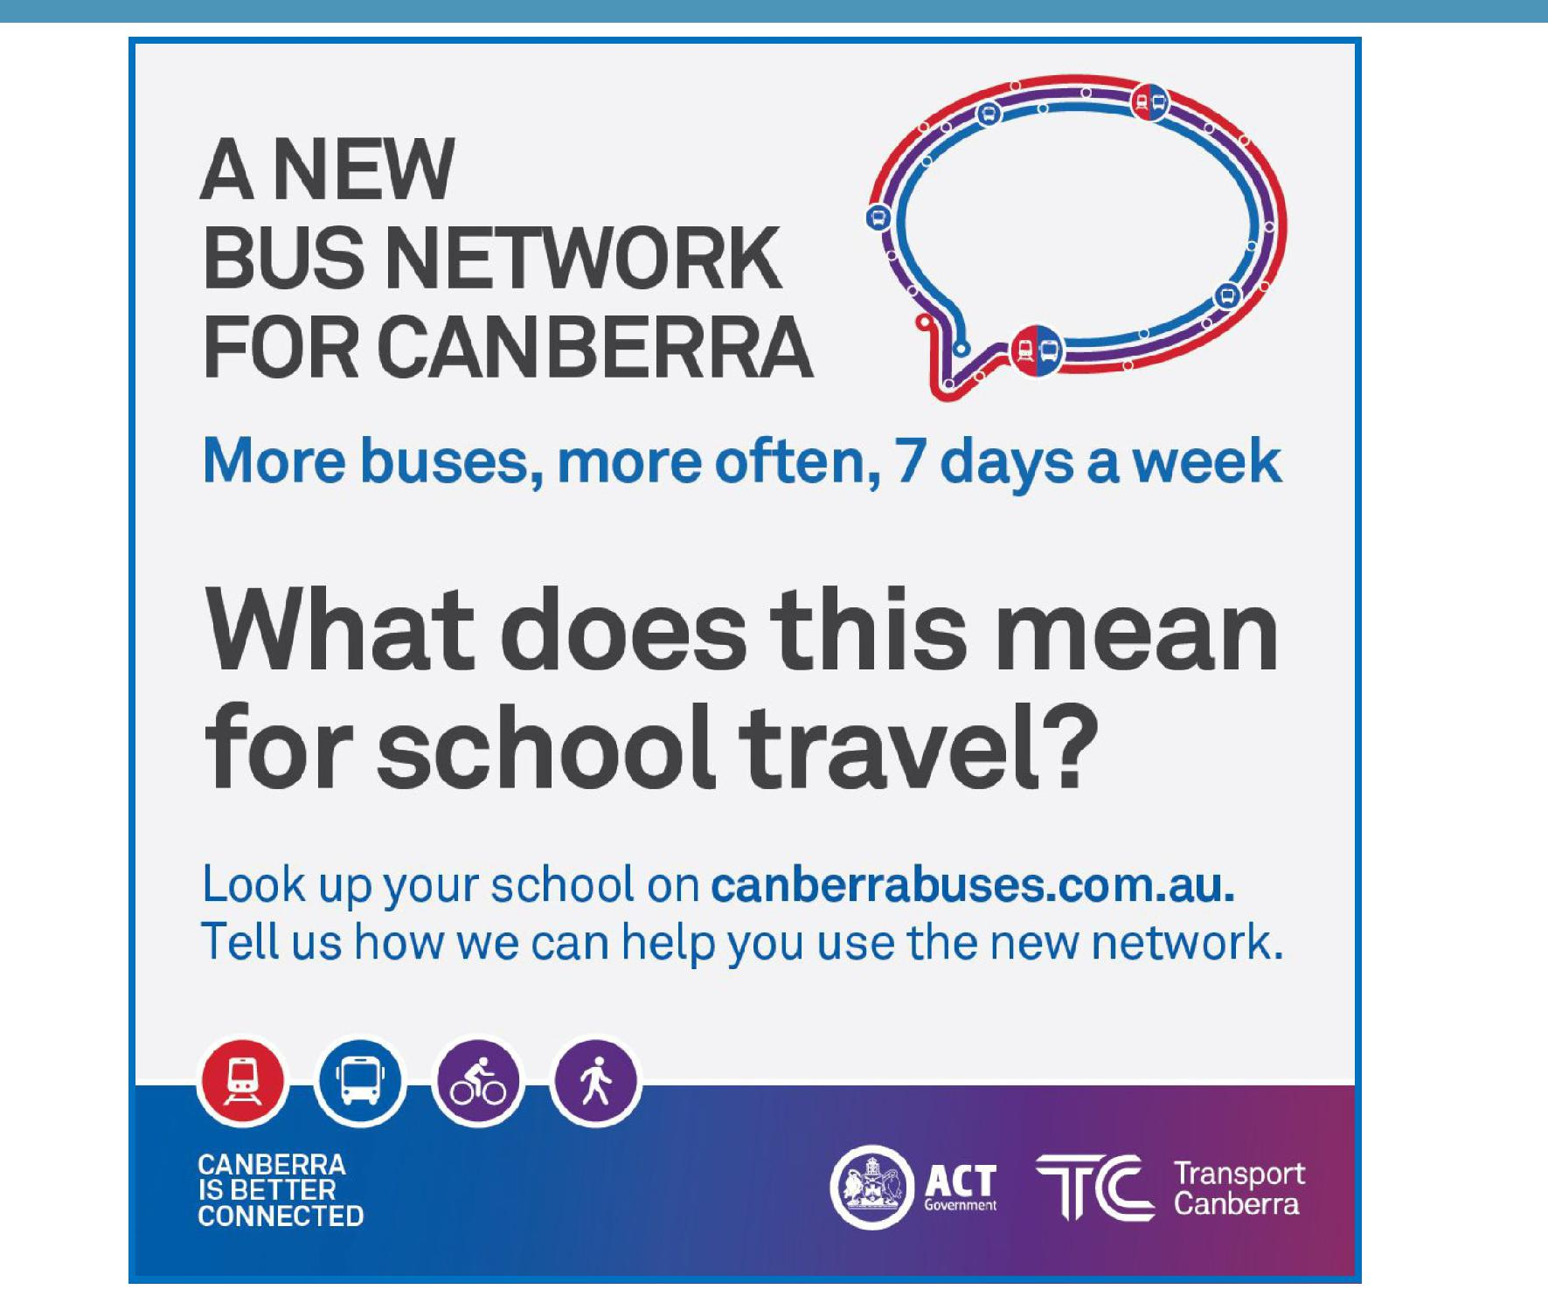

Together, we learn from each other

