What’s On

9 August 2018

Week 3, Term 3

ASSEMBLY:

10 Aug | Junior - 1PJ, 1MC & 1AS
17 Aug | Science Week Activities
DATES TO REMEMBER:
10 Aug | Mufti day for Market day
13 Aug | Yr2 Dental Awareness
13 Aug | ICAS - maths *change of
 | date*
14 Aug | P/S Community Walk
15 Aug | Governor-General’s National
 | Science Week Design
 | Challenge
16 Aug | P/S Community Walk
16 Aug | Yr5/6 Touch Football Gala
 | Day
17 Aug | Science Week activities
21 Aug | Preschool Book Week Parade
21 Aug | Yr5/6 Personal Development
 | session
23 Aug | Book Week Parade &
 | activities (P/S - Yr6)

NOTES HOME:

- CAP ‘Wrinkle in Time’ movie permission

- P/S Community Walk

- Book Week flyer

- Father’s Day Stall flyer

- Yr5/6 Personal Development

- Yr5 Band Pair - Harrison

P&C BOARD NEWS

P&C: 7:00pm 17 Sep 2018

All P&C activities, meeting agendas and minutes are available from the school website at – Parent Corner

School Board: 7:30am 6 Sep 2018

PRINCIPAL’S MESSAGE

Well, we have heard that it has snowed around Gunghalin this week. I haven’t seen it myself, but it does feel like it. This is a great time to check if your child has any lost property - jumpers!! They are on display near the blacktop. Remember to keep rugged up.
Psychologist

I would like to welcome our new psychologist, Ellie Mulligan. Ellie will be with us at Palmerston for the rest of the year. If you need to make a psychologist appointment, please call or drop by the front office and leave your details. Ellie will be working on Mondays, Tuesdays and Wednesdays.

Hats On

Our PBL team are very busy this week with our hats on, waste wise and play safely on the equipment initiatives. We are handing out raffle tickets to students spotted doing the right thing.

Science Update

Last week, our amazing Environmental Science teacher, Karon Campbell informed us that her husband is very sick. She is taking leave until his health improves. I would like to thank staff, students and community who have taken on the gardens and chickens in Karon’s absence. We wish all her family the best at this time. If you would like to assist with any part of Karon’s programs/projects just pop by, as we are setting up a roster and working through how we manage her amazing workload. Science Week this term and the Science Fair will have a more reduced look and we thank you in advance for your understanding.

Personal Development

We had many parents attend our senior school personal development parent sessions this week. Thanks to all who attended and braved the cold. We hope these sessions supported your understanding of how we teach health and personal development in the senior primary years.

Jervis Bay

I will be at Jervis Bay School for Thursday and Friday this week and on continuing Thursdays and Fridays of odd school weeks this term. Kate Flynn, the deputy, will be acting principal during my visits as a principal mentor to Jervis Bay School.

Together, we learn from each other

What’s On

Traffic

We had the traffic flow representatives visit our school this week and are awaiting more visits, monitoring of the traffic and parking and a report. The school will be able to act on the report to assist Palmerston families with traffic and parking concerns over this semester.

Have a great week,

Melissa Travers

DEPUTY PRINCIPAL’S MESSAGE

One of the lovely things about being in a school is that it is always a busy and happy place. Over the past week Kindergarten has celebrated 100 school days. They celebrated with 100 day activities and special healthy food that was so generously donated by families. Students enjoyed making 100 day crowns and glasses. It was a great occasion and a real milestone in the lives of our Kindergarten students. Thanks to all the teachers and families who helped to make this day so special.

There have been many wonderful events occurring over the last three weeks of school. Our students from the LSU enjoyed a fabulous day at Questacon. During this time the science and technology learning that they do at school was embedded by participation in the activities that the team at Questacon has for children to engage with. Our Boomerang Kids spent an afternoon at the Gungahlin Child and Family Centre where they celebrated National Aboriginal and Torres Strait Islander Children’s Day. This was a fantastic community day with children from another local Gungahlin school attending as well as family members of our Boomerang Kids. The children completed a range of activities and came back from the trip was massive smiles on their faces! A good time was certainly had by all. Yesterday we hosted a year 6 combined band performance. Children from Harrison School played alongside our Palmerston students and they all sounded terrific! Thank you to Mrs Harris for running this successful event!

This week our SRC have launched a design a poster competition which promotes and acknowledges the safety aspects related to the light rail. We are looking forward to all the creative responses we receive.

Our year 5/6 students and staff are busily preparing for Market Day and tomorrow will be our Mufti Day where all proceeds will go towards the purchasing of goods for Market day. In line with our Fresh Tastes program, the 5/6 team have been coming up with stalls that promote healthy food on the day.

I would like to thank all our community members for their feedback on the PBL matrix. The committee has collated responses and are almost finished refining the matrix document. We look forward to sharing this. A reminder that we are in the first phase of PBL which focuses on the outdoor settings and as we continue down the PBL track we will move to the in class settings. We are gradually moving forward with the mascot competition results. At present the PBL committee is working behind the scenes on this. We look forward to sharing this with you very soon.

P&C update

I would like to take the time to thank the P&C for all the work they do around the school. The members of the committee work tirelessly to make our school the best place they possibly can and items they oversee include special lunches, donating ice-blocks after sporting evets, school banking, second hand uniform shop and school discos. A reminder to place any money for the P&C into the boomerang box as school staff are unable to process P&C money, including changing money.

Have a great week,

Kate Flynn

Together, we learn from each other

What’s On

THINK U KNOW PARENT INFORMATION SESSION

Save the Date!!

Our school will be hosting a ThinkUKnow presentation on 4 September at 5:30pm in the CAP Pod. ThinkUKnow is a cyber safety education program that educates parents, carers and teachers on how people are using technology, the challenges they may face online, and how to help them overcome these in a safe and ethical way. ThinkUknow is a partnership between the Australian Federal Police, Microsoft Australia, Datacom and the Commonwealth Bank. The presentation will be delivered by a local law enforcement member and an industry volunteer. It will cover issues relating to children and young peoples’ privacy and security online, their relationships with other users and their online reputation. It provides insight into the devices young people are using, as well as the popular websites, apps and social networking sites they’re accessing. The ThinkUKnow team will also be providing an education session for our year 5/6 students. This is a great opportunity for you to learn more about young people and the online environment. For more information you can visit www.thinkuknow.org.au or contact Haeley Simms via the front office.

ICAS MATHEMATICS - CHANGE OF SITTING DATE

Students who have registered for the UNSW ICAS mathematics exam will now sit the exam on Monday 13 August. If your child has registered for the exam and is away on the day they will complete a catch up later in the week supervised by the ICAS coordinator.

If you have any questions about the change of sitting date please call the school on 6142 1440.

BOOK CLUB

Issue 5 closes this Friday (10 August).

Please ensure all orders are placed in the Boomerang Box, in front office foyer, no later than tomorrow.

Please ensure all orders placed in the box include the following

Child’s Name, a contact phone number, correct money and finally the books requested are indicated on the order form.

The books can take up to 2 weeks to be received and delivered out to classes.

Thanks,

Edwina

SCHOOL SATISFACTION SURVEY

The 2018 School Satisfaction Surveys will be conducted later this term.

Parents and carers, school staff and students (in years 5 to 12) will be asked to participate in these

important surveys. The survey results will contribute to school research and improvement processes.

Although the survey is voluntary, we hope you will want to participate. It won’t take much of your time

and will help us improve our school for your child and future students. A letter or email about the

parent and carer survey will be sent to you in August. The key ACT results from the 2017 School

Satisfaction Surveys have been published on the Education Directorate website

(www.education.act.gov.au) and a summary of our school results is provided in our 2017 School

Board Report.

Together, we learn from each other

What’s On

DSTA NEWS & UPCOMING EVENTS

High School Musical Production

The Australian Defence Force Academy’s (ADFA) Performing Arts Company will perform ‘High School Musical’ from 16 to 18 August 2018 in the ADFA Adams

Auditorium. Doors will open at 1830hrs prior to the commencement of the performance at 1900hrs.

Midshipmen and officer cadets in the ADFA Performing Arts Company hold an annual musical production to raise funds for local not-for-profit organisations and to foster community interest in creative arts.

Admission to the performance is free and the ADFA Performing Arts Company will request a gold coin donation for the evening performances in support of ‘Legacy’, a not-for-profit organisation that provides services to Australian families suffering financially and socially after the incapacitation or death of a spouse or parent, during or after their ADF service.

Queries regarding the production can be directed to the ADFA Performing Arts Company Producer, Officer Cadet Daniel Hales, at daniel.hales1@defence.gov.au.

PALMERSTON PRIDE AWARDS

Congratulations to the following students who received a PRIDE Award at assembly on 3 August.

PARTICIPATION – becoming involved, “having a go” and cooperating with others

Max - 3/4JL Rawden - 6AJ

RESPECT – respect for self, others and their property Jevanco - 6AJ

INTEGRITY – being honest, fair, responsible and loyal

Sophia - 4VS John - 6AJ

DETERMINATION - being persistent and resilient

Kaleb - 4VS Kiki - 4VS Ayan - 3/4JL Isobel - 3/4JM Zac - 3/4JM

Olivia - 6AJ

Together, we learn from each other

What’s On

UPCOMING EVENTS

K-Yr6 Mufti Day

Fundraising for Yr6 Market Day

Date: Friday 10 August 2018

Location: Palmerston District Primary School *please bring in a gold coin donation*

Yr2 - Dental Awareness

Date: Monday 13 August 2018

Location: Palmerston District Primary School

ICAS - Maths

Date: Monday 13 August 2018 *change of date*

Location: Palmerston District Primary School

Preschool Community Walk

Date: Tuesday 14 August 2018 & Thursday 16 August 2018

Governor-General's National Science Week Design Challenge

Date: Wednesday 15 August

Location: Government House

Yr5/6 Touch Football Gala Day

Date: Thursday 16 August

Location: Deakin Playing Fields

Together, we learn from each other

What’s On

Together, we learn from each other

What’s On

Together, we learn from each other

What’s On

SCHOOL INTENTIONS 2019

School Leavers 2019

We have now reached the time in the year when we begin to look at our school numbers and staffing arrangements for 2019. If your circumstances have changed and your child/ren will not be attending Palmerston District Primary School in 2019 can you please let the front office staff know as soon as possible.

My child/ren will not be returning to Palmerston in 2019.

Name Class

Last day at Palmerston:

My child/ren will be attending:

Another government school in the ACT:

A non-government school in the ACT:

Moving out of the ACT

Forwarding Address:

Phone number:

Parent’s name:

Together, we learn from each other

What’s On

INTERNATIONAL DAY OF THE WORLD’S INDIGENOUS PEOPLES

Today we celebrate International Day of the World’s Indigenous Peoples. There are an estimated 370 million indigenous people in the world, living across 90 countries. Indigenous peoples are inheritors and practitioners of unique cultures and ways of relating to people and the environment. They have retained social, cultural, economic and political characteristics that are distinct from those of the societies in which they live. The 2018 theme is Indigenous peoples’ migration and movement. For more information go to: http://www.un.org/en/events/indigenousday/
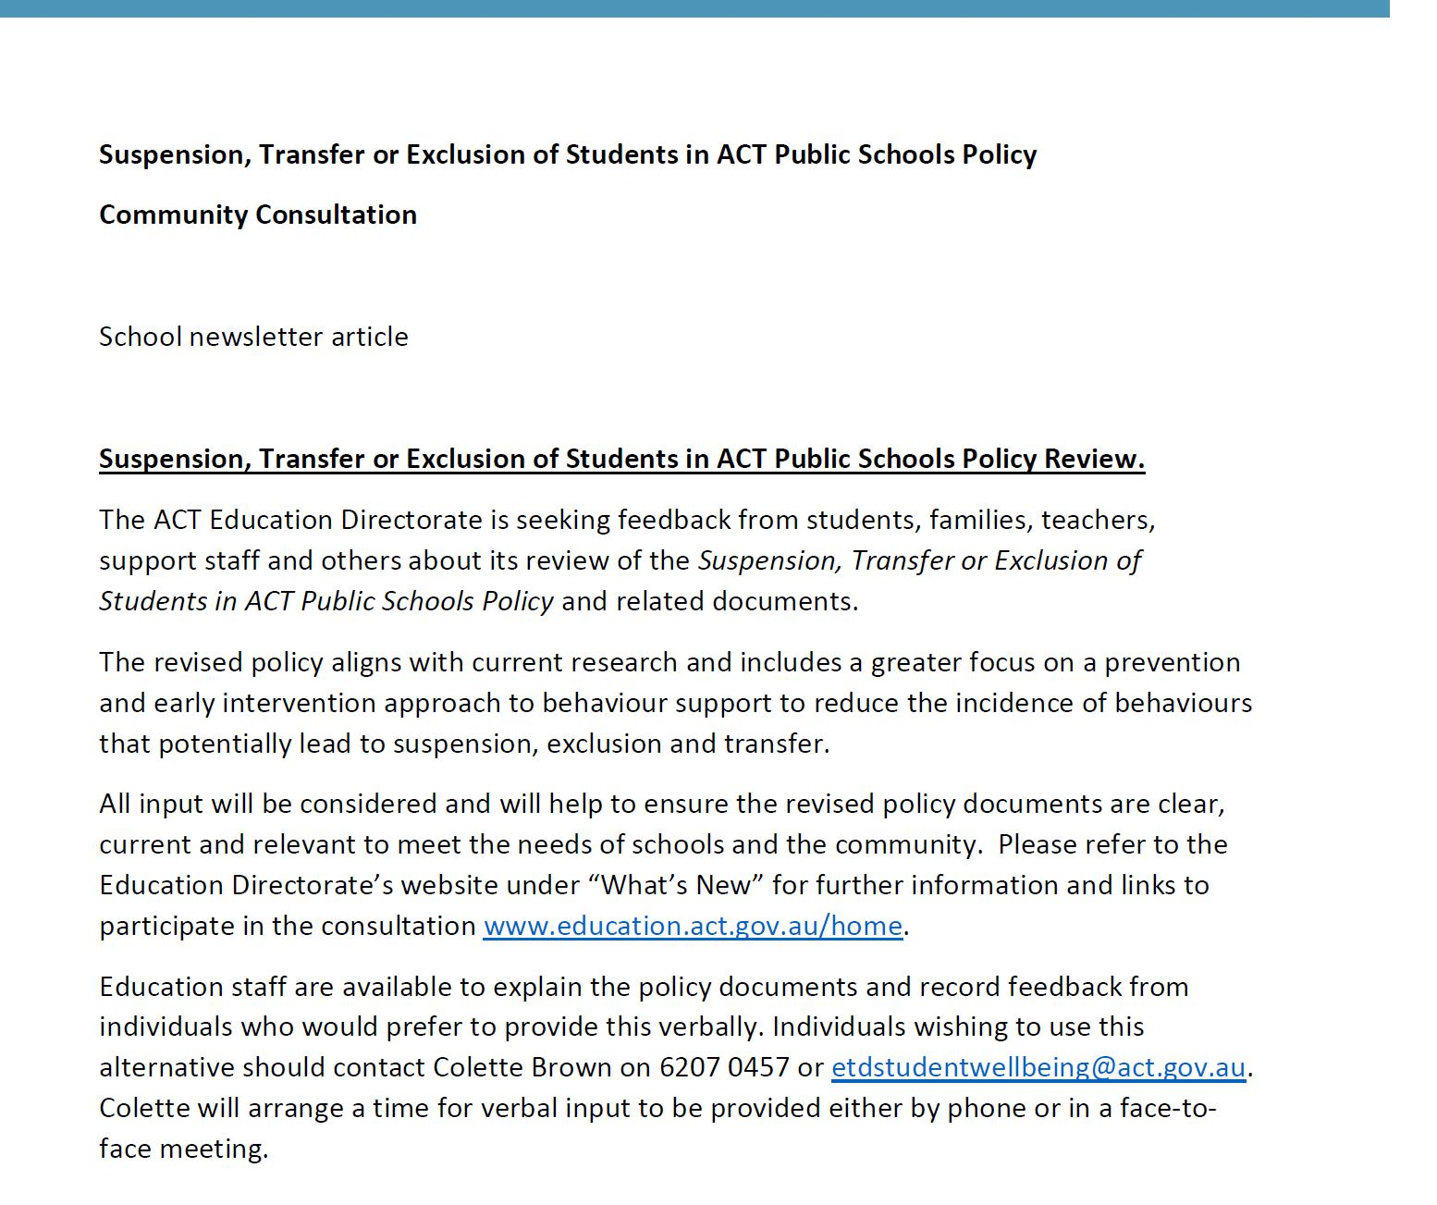

Together, we learn from each other

What’s On
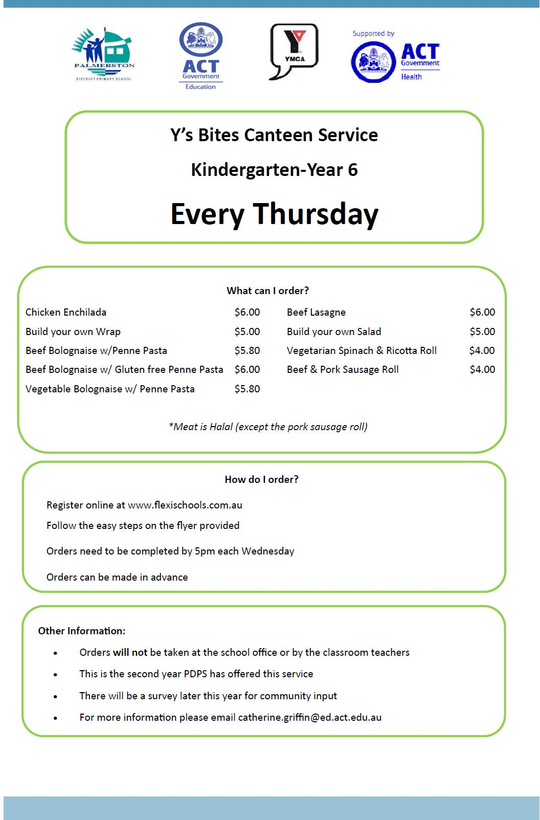

Together, we learn from each other

What’s On

Together, we learn from each other

What’s On

COMMUNITY NEWS

Together, we learn from each other

What’s On

LIGHT RAIL

As construction of the light rail in the Gungahlin area is nearing completion, the testing program will expand to include daytime activities commencing the week of 13 August. Daytime testing is an excit-ing milestone with many more opportunities to see LRVs moving up and down the light rail system! At the same time, it is important for everyone in the community to be mindful of electronic traffic sign-age, the presence of traffic management personnel and moving LRVs at intersections and crossings.

What to expect?

- Daytime testing will initially take place between Gungahlin Place and Nullarbor Avenue, and be-tween the off-peak hours of 9:30am and 3:00pm.

- A minimum of two (2) LRVs will be on the tracks testing during the day.

- “T Lights” will regulate LRV movements at intersections. During testing, these will be operational, controlling traffic movements along Flemington Road intersections with Hinder Street, Kate Crace Street and Manning Clark Crescent.

Testing activities will continue at night, as well as during the day.

From mid-September onwards, more LRVs will be testing on the tracks and the testing area will be extended from Gungahlin to Mitchell.
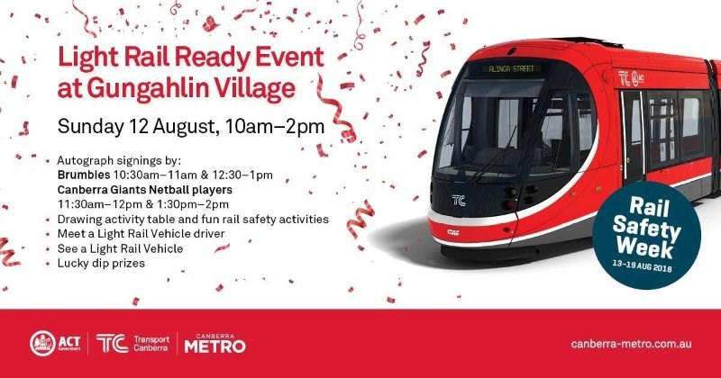

Together, we learn from each other

