Palmerston Post
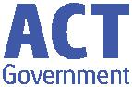

14 March 2019

Week 6, Term 1

Board Chair: Lisa Fior

Teacher Reps: Jessica Lago and Maxine Green

P&C President: Lisa Fior

Principal: Melissa Travers Deputy Principals: Haeley Simms (acting) & Kylie Moller (acting)

Executive Teachers: Matt Gowen, Felicity McNeice, Catherine Griffin (acting)

ASSEMBLY:

15 Mar No assembly

22 Mar Whole school - 1KW & 1DE

DATES TO REMEMBER:

15 Mar Yr3-6 Questacon

incursion

19 Mar Yr3-6 Author visit -

Katrina Nannestad

20 Mar Christian Education

21 Mar Harmony Day / Bullying

No Way Day

22 Mar Clean Up Australia Day

25 Mar K & Yr2 - Kenny Koala

visit

26 Mar K - Yr6 Music Viva

27 Mar Yr 1 - Kenny Koala visit

27 Mar Special Farewell

Assembly for Melissa

Travers

29 Mar Defence Morning Tea

NOTES:

- K—Yr6 Questacon flyers - youngest

- Yr6 Band - Loriendale Orchard Performance

P&C BOARD NEWS P&C: 18 March 2019

All P&C activities, meeting agendas and minutes are available from the school website at – Parent Corner

School Board:

EXECUTIVE TEACHERS’ MESSAGE

We hope everyone enjoyed celebrating Canberra’s 106th birthday by

spending time with family over the long weekend.

Questacon

On Wednesday, students within the junior school had the opportunity to attend a Questacon incursion. The performance focused on two strands of science, physical and chemical science. Here are some comments from students after the performance:

“Bi carb soda and vinegar makes gas that puts out fire”.

“Water with coloured dye is heavier than oil”.

“If you cover an instrument, over the hole it sounds deeper”.

“If you play the mouth piece of a saxophone it sounds terrible. You need the tube for it to sound nice”.

Senior students will be attending the incursion on Friday. We look forward to hearing about their experiences at the performance.
Contact Information & Medical Action Plans

Last Thursday students took home Contact Information forms. It is important that all contact information and medical plans are up to date. If you require another form or assistance in completing these forms, please contact the front office. Contact Information forms are due back at school as soon as possible.

Some of our students require medical plans. If your child requires an Asthma, Anaphylaxis, Diabetes or Epilepsy plan these plans need to be updated yearly. Please visit the front office to ensure these plans are current.

Parent Link

This week we have included a copy of the Parent Link information brochure concerning coping skills (resilience). When children learn to belong in this way it gives them the ability to make attachments, trust others and be able to form relationships with other people in their life. Have a great week,
Catherine Griffin and Felicity McNeice

Together, we learn from each other

Palmerston Post

SCHOOL BOARD NOMINEES

Voting period: 8 March - COB 22 March 2019

Voting forms are available at the front office.

Board Nominee Introductions

Kate Baron

My name is Kate Baron and I have a daughter in year 2 and a 3 year old at home. I have previously worked as a teacher in the ACT public education system. I am passionate about evidence-based teaching practice and student, teacher and staff wellbeing. I believe that a school where parents, teachers and staff work together provides the best outcomes for students and would use my place on the board to further promote community involvement in all areas of school life. I would appreciate the opportunity to help Palmerston continue to flourish as a fun, happy and engaging place for students to learn, staff to work and the community to enjoy.

Adam Davidson

As Chief Financial Officer for a large Canberra business I have experience in the financial and operational requirements for an organisation to reach its goals and objectives. I also have a keen interest in high performing organisations and what is required for teams to take their performance to the next level.

My entire life has been spent surrounded by family members who are part of the teaching profession at various levels and from this I have a solid knowledge of the ups and downs of schools and what areas require focus in order to create a great school. My aim as a board member would be to combine this with my passion for organisational performance to see continual improvement in the school’s performance across all areas be it academic, social and emotional needs, co-curricular and community engagement.

With two children already at the school and another one who will be attending in the coming years I have a vested interest in the school continuing to go from strength to strength over the long term. If elected I will be committed to accountability and a solutions-based approach to the role as parent representative on the school board.

Amy Phillips

In the past I have held both Parent Representative and Board Chair positions on the Palmerston School Board and I am keen to renew my connection with the Board again this year. In my working life I am an executive with the Department of Finance and have spent my career leading and driving improvements across many facets of public administration. I believe in quality education and providing children with a safe environment in which to learn and grow as confident members of the wider community. In my experience Palmerston provides this and much more.

I have a long association with Palmerston Primary, with my eldest starting in Kindergarten in 2009, the term after Melissa Travers took over the reins. During this time my husband Simon and I have watched the school blossom and participated in many fantastic events including assemblies, information sessions, trivia nights, Twilight Fairs, discos, graduation ceremonies, Remembrance Day activities, performance reporting sessions and the carols extravaganzas. With our youngest, Hamish, in year 2 this year we look forward to many more memorable occasions going forward.

I would cherish the opportunity to once again represent your interests, and look forward to your support.

Together, we learn from each other

Palmerston Post

UPCOMING EVENTS

Questacon Incursion

Date: Yr3-6 Friday 15 March 2019

Location: PDPS, Hall
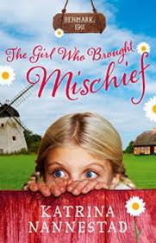

Yr3 – 6 Author Visit, Katrina Nannestad

Date: Tuesday 19 March 2019

Location: PDPS

Christian Education

Date: Wednesday 20 March 2019

Location: PDPS

Our teaching theme for 2019 is KIDS WHO MET JESUS. We will learn from the perspective of children in New Testament history who interacted with Jesus and what they discovered about him.

We are teaching the song ‘Nothing Better Than Jesus’ by Sovereign Grace.

Harmony ‘Bullying NO WAY’ Day

Date: Thursday 21 March 2019

Location: PDPS

Clean Up Australia Day

Date: Friday 22 March 2019

Location: PDPS

Special Farewell Assembly for Melissa Travers

Date: Wednesday 27 March 2019

Location: PDPS

Together, we learn from each other

Palmerston Post

Years 3-6 Author Visit—Katrina Nannestad

Palmerston District Primary School will have a special guest author visit the school on Tuesday 19 March. Katrina Nannestad will talk to students about her journey as an author. She will model a number of ideas and strategies which will help the students in developing their own writing skills.

On the day she will be have copies of her books available for purchase. She will happily sign any book that is purchased from her on the day. Students should bring the correct money, if they wish to purchase a book, on the day students will have the opportunity to buy books during break times.
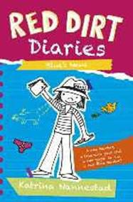

Books by Katrina Nannestad

Paperback Books - $10 each (Cash Only)

Red Dirt Diaries 1

Red Dirt Diaries 2 – Blue About Love

Red Dirt Diaries 3 – Blue’s News

The Girl Who Brought Mischief

Olive of Groves

Olive of Groves and the Great Slurp of Time

Olive of Groves and the Right Royal Romp

The Girl, the Dog and the Writer in Rome

The Girl, the Dog and the Writer in Provence

Lottie Perkins, Movie Star
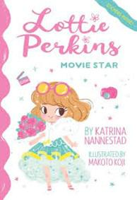

Lottie Perkins, Ballerina

Lottie Perkins, Pop Singer

Lottie Perkins,Fashion Designer

Hardcover Book Set - $50(Cash Only)

Olive Groves - all three books
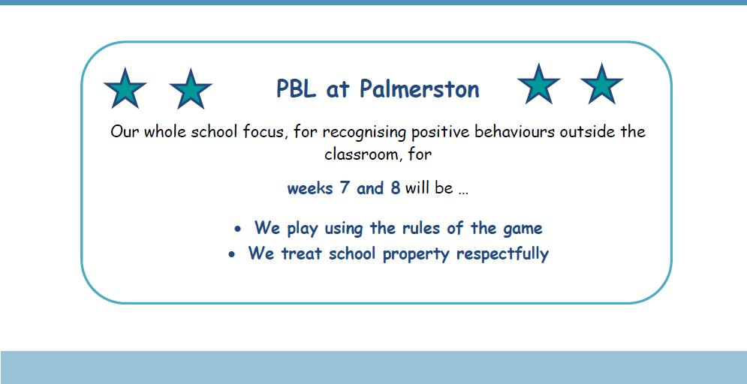

Together, we learn from each other

Palmerston Post

Book Club

All Issue 1 books have now been distributed to your classroom teacher (except a couple which are on back order).

Issue 2 has also been distributed and this issue closes on FRIDAY 22 MARCH (week 7).

If you are paying with Cash or Cheque (made payable to Scholastic Australia). Then please

- Complete the order form located at the back page of the catalogue

- make sure the child’s name and class are completed correctly and in full.

- mark each of the books they wish to order

- total all the books

- tear off the back page order form and place in an envelope with your payment and place into the

‘Boomerang Box’ located in front office foyer no later than 3pm on Friday 22 March.

Orders are generally received and distributed approximately 2 weeks after the deadline.

If you prefer to order online then
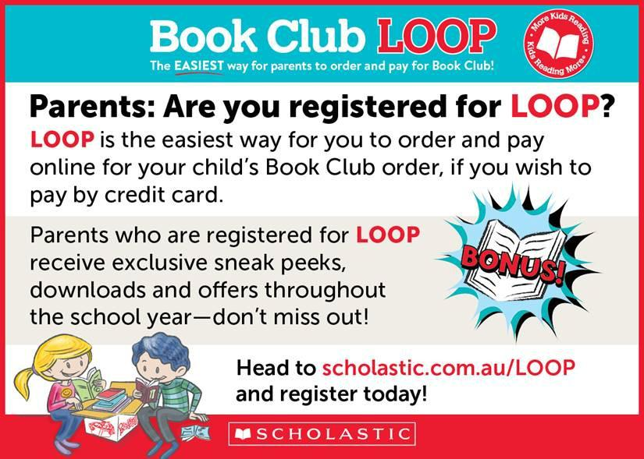

Together, we learn from each other

Palmerston Post
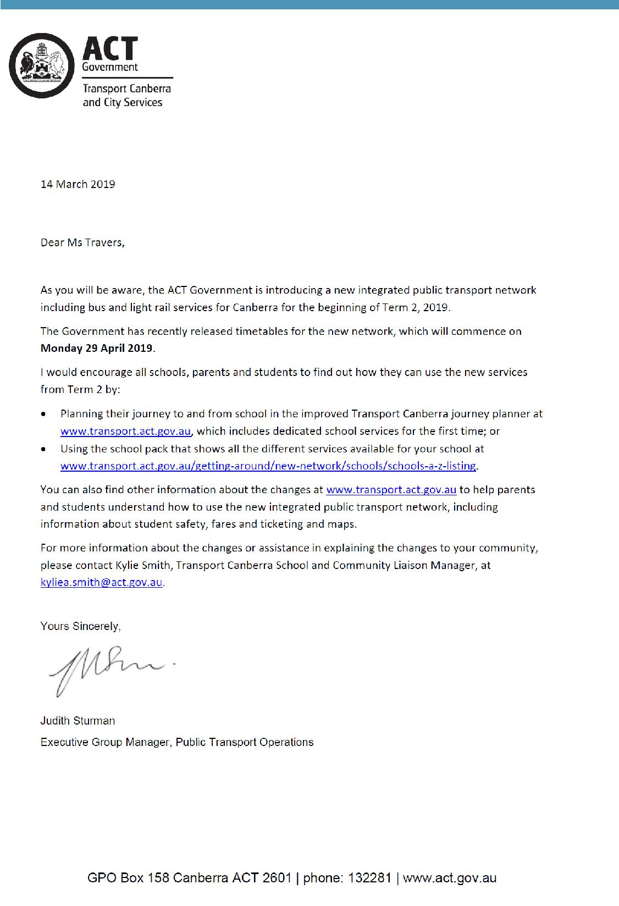

COMMUNITY NEWS

Together, we learn from each other

Palmerston Post
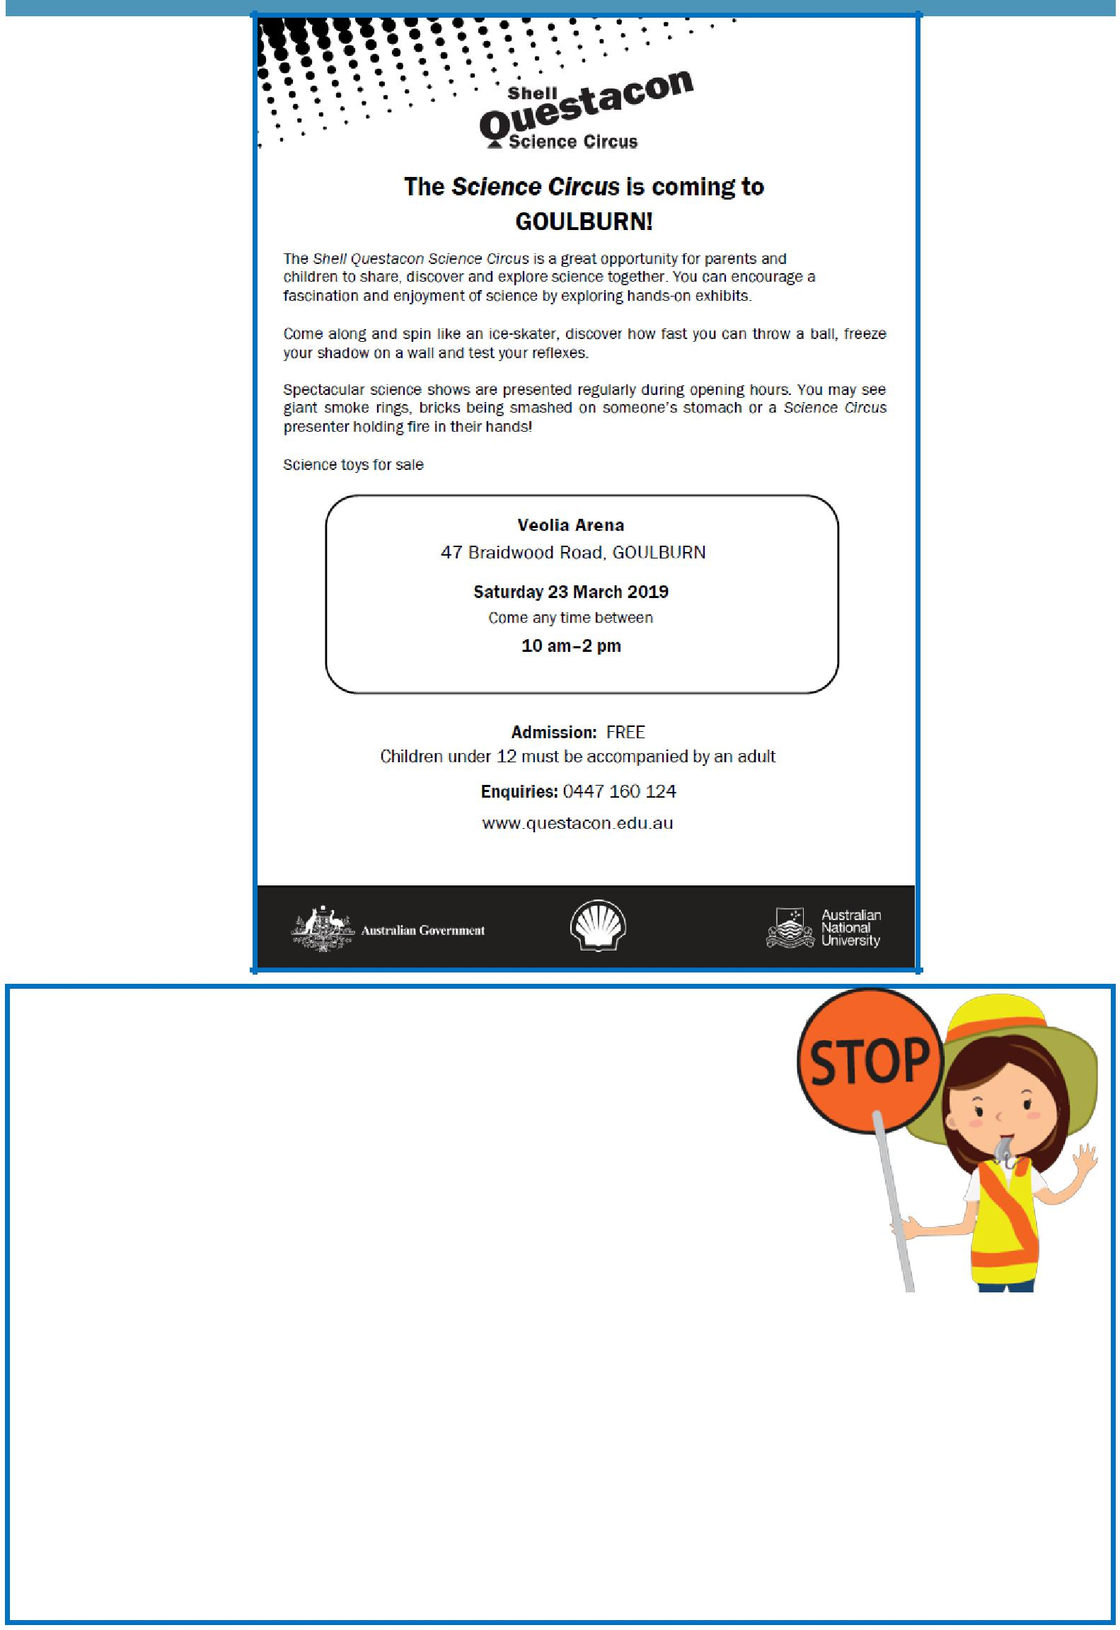

School travel and safety survey

Transport Canberra and City Services has engaged First Person Consulting to conduct research into parents’ attitudes to their children's active travel to and from schools. Part of this is investigating the role that crossing supervisors have in improving safety around schools, and the extent to which parent’s attitudes to children travelling actively change as a result.

You may have completed a similar survey last year, this is the final

survey as part of the evaluation to gauge parent perceptions about safety around schools.

To complete the survey please click here, or copy and paste the following link into your browser:

https://www.surveygizmo.com/s3/4828047/School-Crossing-Supervisor-Survey-Control-Feb19

The survey should take about five minutes. The survey will not collect any identifiable information,

and all responses will be kept confidential.

Thank you in advance for your time in completing this survey. If you have any questions please contact

the TCCS Schools Program.

Together, we learn from each other

Palmerston Post
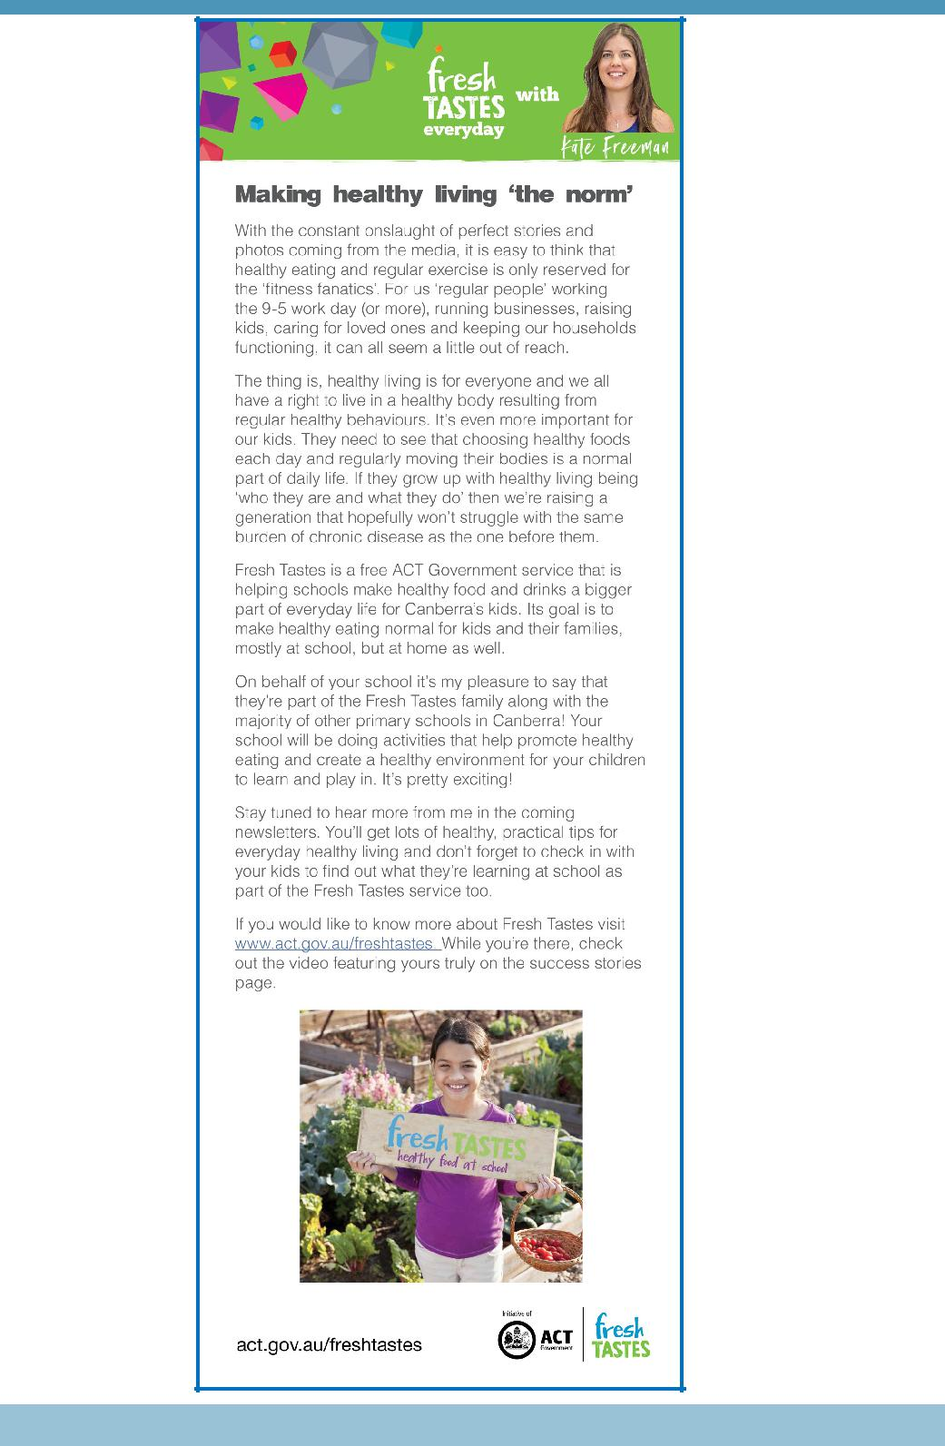

Together, we learn from each other

