What’s On
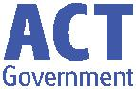

30 May 2019

Week 5, Term 2

ASSEMBLY:

31 May No assembly - Athletics carnival

7 June Junior - KFD & KKA

14 June Whole school - 5/6CW & 5/6KB

21 June Junior - KGM, KMC &

KGS

DATES TO REMEMBER:

31 May Athletics Carnival

10 June Queen’s

Birthday

public holiday

14 June Year 3/4

Birrigai Camp

14 June Whole School

Assembly

17 June Preschool

Photos

(beginning)

20 June Whole School

Photos

NOTES:

P&C BOARD NEWS P&C: 24 June 2019

All P&C activities, meeting agendas and minutes are available from the school website at – Parent Corner

School Board: 24 June 2019

PRINCIPAL’S MESSAGE

I am taking great PRIDE in being the new Principal of Palmerston. I am learning how PRIDE is a core component of our learning community, from the way Mr Phil looks after our school grounds so beautifully, through to the manner in which I hear teachers talking with their students. In joining this school– I notice how teachers acknowledge students in their class through the PRIDE certificates which are handed out at assemblies. Last week, it was heart warming to listen to the breadth of reasons why our students received their PRIDE awards, the detailed comments by teachers which exemplify to me, how well they know their students and want to

celebrate their achievements.

My curiosity leads me to observe the PRIDE shown by students about their school and ways they could contribute to evolve. This week I asked to join the year 4 classes and two year 3 classes, and spend some time with them to listen to their voice about things that they think would add great value to our school – in making some ‘dreams’ come true. Some common ideas across these five classrooms were: special lunch days (this was unanimous), soccer competitions, Lego clubs, dance clubs, a rock climbing wall in the Hall, special events for each year group, class challenges, find ways to help disadvantaged children, a whole day especially for art, Kindness to Teachers day, day trip to the snow, a Spelling Bee, a Maths-athon to name a few. The power of Palmerston Student Voice is strong. We can learn so much from our students, and it is a big part of my leadership philosophy to ensure their voice is heard, listened to, and acted upon. However hard I try though, I don’t think I can deliver on these ideas: private helicopter uber to school, roller coaster on the oval, fairy floss every recess for a year, and a unicorn for a school pet! So many ideas made me smile and relish the beautiful creativity of our student voice. Watch

this space- I think some of those amazing ideas might just come to life!

A gentle reminder please, for all jackets, hoodies, jumpers and coats to have names written inside that make them easily identifiable. Our lost property area is overflowing at the moment– we encourage students during the day to look after their personal belongings but we notice warm clothes are being left at school at the

end of the day and not claimed.

Across Term 2 I have undertaken an individual annual professional discussion with every teacher and this has given me so many ‘wow’ moments. I am learning the route into teaching from each teacher and I am blown away with the expertise on staff– did you know we have teachers who: used to be a coronary care nurse, operating theatre nurse, wedding gown designer, owned a knitting business, lived and taught in England and the USA– just to name a few! What an amazing bunch of people! They all display a great deal of PRIDE in their work and all they do for their

students.

Until next time, keep warm…and curious!

Kate Smith

Together, we learn from each other

What’s On

PALMERSTON PRIDE AWARDS
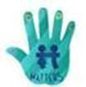

Congratulations to the following students who received a PRIDE Award at assembly on 24 May 2019.

PARTICIPATION – becoming involved, “having a go” and cooperating with others

Lachlan - KFD | Ella - KGM | Aayan Atif - 3JL | Lauren - KFD
Dexter - KGM | Nishi - KKA | Teddy - 2RC | Kate - 2MO
Olivia - 2AF | Hayden - KGS | Gurfateh - KKA | Lylah - KKA
RESPECT – having respect for self, others and their property
Olivia - KFD | Heshvi - KMC | Zohha - 1KW | Imogen - KGM
Binayak - KFD | Liya - 2SH | Elijah - 2AF | Willow - KKA
Miley - 2RC | Rhoweinaa - KKA | Christian - KGS | Elaine - KKA
INTEGRITY – being honest, fair, responsible and loyal
Finlay - 1KW | Dora - 2AF
DETERMINATION - being persistent and resilient
Krisha - KMC | Mia - 1AS | Arya - 2SH | Ethan - KMC
Tony - 1AS | Jye - 1AS | Noelle - 2SH | Pilise - 2MO
James - 2RC | Bella - 2MO | Yicheng - KGS | Kale - KGS

EMPATHY - understanding and supporting others regardless of our differences

Jewel - KMC Seanna - 2RC

PBL
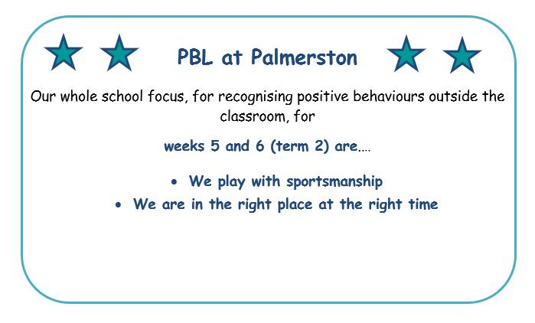

Together, we learn from each other

What’s On

Enrolments for 2020

Enrolments for the 2020 school year opened on 29 April 2019. All ACT children are guaranteed a place in their local public school for Kindergarten to year 12. However, due to growth in recent years in enrolments in the

public system, some schools no longer have the capacity to take “out of area” enrolments. These schools have been identified as “Category A” schools and a list appears on the Education Directorate website.

You will not be able to seek enrolment for your child at one of these schools unless you live within the school’s priority enrolment area (i.e., the school’s geographic zone). All schools will, however, consider cases where

there are legal issues, or exceptional circumstances based on student wellbeing. To avoid disappointment, you are encouraged to check the information on the Education Directorate’s website so you can make the best decision for your family from the options available.

Semester One Reports 2019: Parent Information Sessions

Palmerston District Primary School has been selected to pilot the new Education Directorate report format. This format will be common for students across all Kindergarten to Year 10 schools. The report is generated through the Student Administration System (SAS). Semester One reports will be emailed to parents. Please read the two fact sheets attached.

We will be holding parent information sessions to provide further information regarding the changes in the reporting process for K-6 students. If you feel you need more information in addition to the fact sheets provided or have questions, please feel welcome to attend an information session.

Thursday June 6, 8:00 – 8:30am in the Library

Thursday June 6, 9:00 – 9:30 am in the Library

Wednesday June 12, 5:30 – 6:00pm in the Library

These sessions are repeat sessions with the same information provided during each session.

Reporting Student Achievement in ACT Public Schools

In 2019 the Education Directorate are introducing a common report format, for students in Kindergarten to Year 10, through the new Student Administration System (SAS). This change will occur via a staged

implementation process, with some schools piloting the new report format in Semester 1, 2019.

Together, we learn from each other

What’s On

The new common report format uses information directly from the subject area Achievement Standards outlined in the Australian Curriculum. Achievement Standards set the goal for what all students should learn as they progress through their school life. From the first year of schooling to Year 10, students

develop knowledge and skills in eight learning areas:
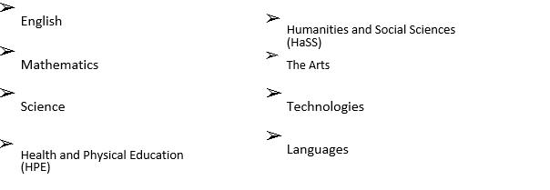

Below are some examples of Achievement Standard statements that may appear on a student report. Students will be allocated an achievement level against each sentence using a five-point scale: limited, partial, at standard, high or outstanding. The student will also receive an overall grade for the learning area using a five-point A-E scale.

Some example Mathematics statements that may appear on a report:

Foundation/ Kindergarten | Year 4 | Year 9
They read high-frequency words and | They fluently read texts that | They select evidence from texts to
blend sounds orally to read | include varied sentence | analyse and explain how language
consonant-vowel-consonant words. | structures, unfamiliar | choices and conventions are used to
 | vocabulary including | influence an audience.
 | multisyllabic words.
Their writing shows evidence of | Students create texts that | Students create texts that respond
sound and letter knowledge, | respond to issues, interpreting | to issues, interpreting and
beginning writing behaviours and | and integrating ideas from | integrating ideas from other texts.
experimentation with capital letters | other texts.
and full stops.

Some example Mathematics statements that may appear on a report:

Foundation/ Kindergarten | Year 4 | Year 9
Students count to and from 20 | They recognise common equivalent | They recognise the connections
and order small collections. | fractions in familiar contexts and | between similarity and the
 | make connections between | trigonometric ratios.
 | fraction and decimal notations up
 | to two decimal places.
Students connect events and the | Students use scaled instruments to | They make sense of the position of
days of the week. | measure temperatures, lengths, | the mean and median in skewed,
 | shapes and objects. | symmetric and bi-modal displays to
 |  | describe and interpret data.

Together, we learn from each other

What’s On

Some example Science statements that may appear on a report:

Foundation/ Kindergarten | Year 4 | Year 9
They suggest how the environment | They describe how contact and | They explain global features and
affects them and other living | non- contact forces affect | events in terms of geological
things. | interactions between objects. | processes and timescales.
 | They identify when science is used | Students design questions that
 | to understand the effect of their | can be investigated using a range
 | actions. | of inquiry skills.
Students share and reflect on | They use provided tables and | They design methods that include
observations, and ask and | column graphs to organise data | the control and accurate
respond to questions about | and identify patterns. | measurement of variables and
familiar objects and events |  | systematic collection of data and
 |  | describe how they considered
 |  | ethics and safety.
 | They suggest reasons why their | They analyse trends in data,
 | methods were fair or not. | identify relationships between
 |  | variables and reveal

Some example HPE statements that may appear on a report:

Foundation/ Kindergarten | Year 4 | Year 9
Students recognise how they are | Students recognise strategies for | Students critically analyse
growing and changing. | managing change. | contextual factors that influence
 |  | their identities, relationships,
 |  | decisions and behaviours.
They identify actions that help | They investigate how emotional | They evaluate the outcomes of
them be healthy, safe and | responses vary and understand | emotional responses to different
physically active. | how to interact positively with | situations
 | others in a variety of situations.
They describe how their body | They use decision-making and | They apply and transfer movement
responds to movement. | problem-solving skills to select and | concepts and strategies to new
 | demonstrate strategies that help | and challenging movement
 | hem stay safe, healthy and active. | situations.
They perform fundamental | They refine fundamental | They apply criteria to make
movement skills and solve | movement skills and apply | judgements about and refine their
movement challenges. | movement concepts and strategies | own and other’s specialised
 | in a variety of physical activities | movement skills and movement
 | and to solve movement | performances.
 | challenges.

There is parent friendly information available on the Australian Curriculum via the following link https://www.australiancurriculum.edu.au/parent-information/

In the ACT, student work at Standard is considered a ‘C’ grade which indicates the student is on track and demonstrating achievement at the standard. A ‘C’ grade is to be celebrated.

You will be provided an opportunity to provide feedback on the new system generated common report format early in term 3.

Together, we learn from each other

What’s On
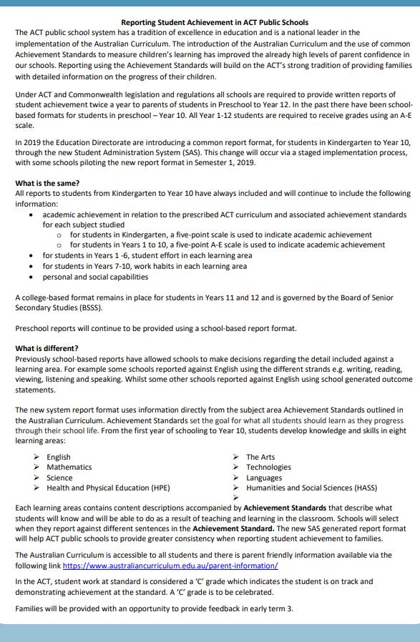

Together, we learn from each other

What’s On
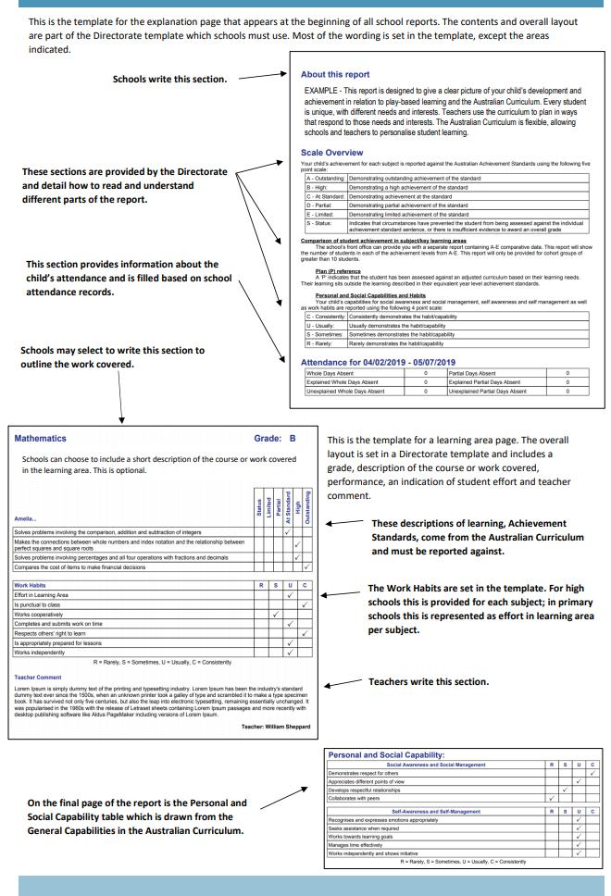

Together, we learn from each other

What’s On

UPCOMING EVENTS

Athletics Carnival

Date: Friday 31 May 2019

Location: PDPS Oval

Year 3/4 Birrigai Day Camp

Date: Friday 14 June 2019

Location: Birrigai, Tidbinbilla

School Photos

Date: Monday 17 June (Beginning Preschool)

Thursday 20 June (Whole school and end of week Preschool)

Location: Hall

* Reminder *

School banking is every Wednesday morning

Protect yourself and your family from the flu

Getting vaccinated is the best way to prevent your family getting the flu this winter. The flu vaccine can save a child’s life.

The vaccine is safe, and everyone 6 months of age and over, including pregnant women and young children, should get the vaccination.

Children are more likely to contract the flu, spread it around, and are at a higher risk of serious complications if they get sick. The flu is highly contagious and is spread easily through childcare centres and schools.

The flu vaccine is free in the ACT for:

- children aged 6 months to under 5 years

- pregnant women

- people 65 years of age and older

- all Aboriginal and Torres Strait Islander people aged 6 months and older, and

- people aged 6 months and older with some medical conditions such as severe asthma, heart or lung disease, diabetes or weakened immune systems.

Where to get your flu vaccination

Everyone can get a flu vaccine from their GP or immunisation provider.

People over 16 years of age can also get a vaccine at some pharmacies.

ACT Government Early Childhood Immunisation Clinics provide a free flu vaccination for children aged 6 months to under 5 years. To book an appointment, call Community Health Intake on 02 5124 9977.

Learn more about influenza and where to get your vaccination at health.act.gov.au/flu

Together, we learn from each other

What’s On

Community News
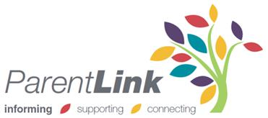

ParentLink

ParentLink provides parenting education to the community, from birth to teenage years. It is available for parents, carers, kin, teachers, and the broader community, providing information and
links to local resources and services.

The ParentLink website provides links to all ParentLink guides including a variety of topics - Start-ing School, More than Reading and Writing, Optimism and Cyber Safety.

The ParentLink suite of resources includes guides specifically for Aboriginal and Torres Strait Islander families, and access to resources for diverse cultural groups.

ParentLink guides are available to view and order via the website at,

https://www.parentlink.act.gov.au/

PARKING AROUND SCHOOLS

As we drive and park our cars around schools we all need to ensure the safety of school students is our priority. Parking illegally and unsafely across pedestrian crossings, corners and verges puts children at risk. We all need to help keep our children safe. Here is a short video demonstra-tion: https://youtu.be/AslMVXpA9Zc

Access Canberra inspectors will be patrolling our school zones to help us ensure drivers do the right thing.
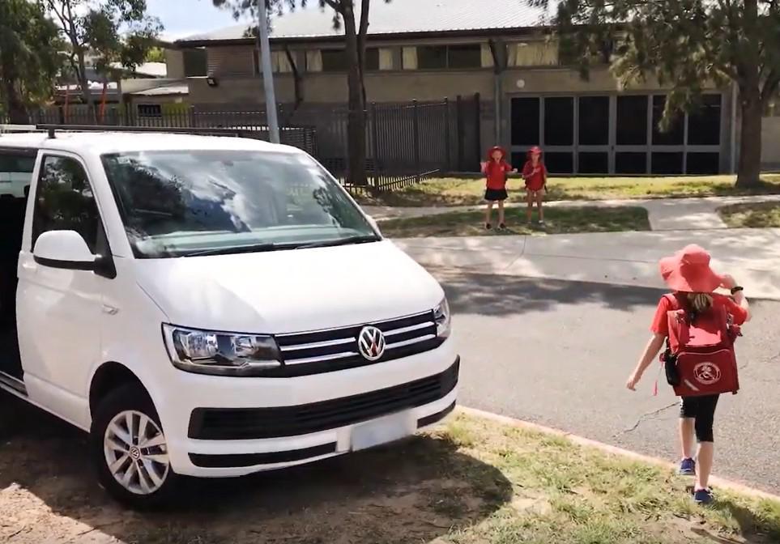

Together, we learn from each other

