What’s On

27 June 2019

Week 9, Term 2

ASSEMBLY:

28 June Senior - 3AP & 3AJ

5 July Junior - IEC

DATES TO REMEMBER:

- &

- June Kindergarten Health Checks

- June Reports home

- &

5 July P/S Healthy food challenge

3 July Dress Up as a Farmer Day

4 July Year 2 theatre excursion

5 July P&C Lunch order day

5 July P&C Pyjama Day

1-5 July Parent teacher interviews

5 July Last day of term 2

NOTES:

P&C Pyjama Day (youngest)

Dress Up as a Farmer Day (youngest) Peer Support Training (Year 5/6 only) Holiday Happenings- Available in the

front office

P&C BOARD NEWS P&C: 24 June 2019

All P&C activities, meeting agendas and minutes are available from the school website at – Parent Corner

School Board: 24 June 2019

PRINCIPAL’S MESSAGE

What a night of creative imagination we have experienced this week, with the two classes 3/4DJ and 5/6JM showcasing the research and inventions each student has undertaken this term. I was impressed by the depth of ability to conjure up some amazing inventions, that really, I questioned, why haven’t our scientists already invented? If these inventions hit the production line and appeared on our shelves I am certain they would be eagerly bought by a myriad of people. Congratulations students, as I said on our Facebook page, our

future is indeed in good hands with you on the way!

Parents and carers, we need your help please. We are increasingly becoming concerned for the parking habits being formed at the front of the school each afternoon. We are witnessing children running across the front driveway in order to get to parents waiting. I appeal to you to assist bringing safety back to our carpark by choosing one of these options. There are teachers on duty at the front of the school every day

until 3.15pm.

- Parking along Kosciusko Avenue and walking a few minutes to the front of the school to meet your child there, hug and then walk safely back to your car.

- Arrive a little after 3.00pm – we notice the congestion

clears around 3.10pm. If we had a spread of arrival times this could really impact the volume of cars competing for the limited spaces at the same time.

- Please do not park and leave your car in the middle of the islands in front of the preschool.

- Please do not park your car half on the curb and half in the disabled carparks.

- Please do not access the disabled car park if you do not hold a permit to do so.

This is something we can do together to raise the safety of our students. Thank you for your consideration with these

suggestions.

Teachers have been busy planning this week for learning programs for next term. I am really looking forward to seeing the programs that will challenge all students and provide a

rich learning experience for all.

Together, we learn from each other

What’s On

Next week is parent teacher interview week. Please engage with your child’s teacher and come in for a chat to receive further information to the school report. Building connections and partnerships with you is vitally important for growing our school community – I look forward to meeting more parents across this time. Hope to see you next week. Reports are coming home this week in a different format for K-6 students. All schools across the ACT are moving to online reports as part of the system wide Student Administration System (SAS)

structure. Preschool and IEC reports remain in the same format.

Nearly holiday time – a time to rest and rejuvenate for the amazing things that Term 3 will bring!

Until next time – stay curious!

Kate Smith

SEMESTER ONE REPORTS

Today students in K-6 will receive their 2019 Semester One Reports. These reports have been generated using the Student Administration System (SAS). Palmerston District Primary School has been selected to pilot the new Education Directorate report format. This format will be common for students across all Kindergarten to Year 10 schools. Please read the two fact sheets attached highlighting the changes from previous years.

Today reports have been emailed to parents and carers. If you have multiple children at Palmerston District Primary School, you will receive one email for each child.

If you haven’t received your child’s report please check your “Junk” inbox as it may have been delivered there.

For any parents and carers who haven’t received their child’s reports please contact the school on 6142 1440.

Parent teacher interviews are being held in week 10. Please contact the front office on 6142 1440 if you would like to book an interview.

Together, we learn from each other

What’s On
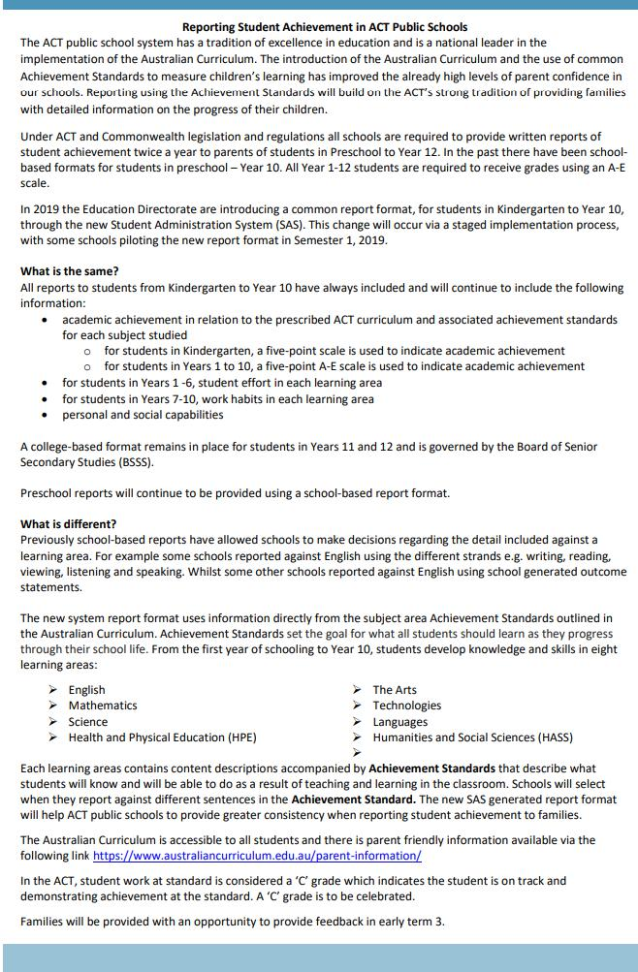

Together, we learn from each other

What’s On
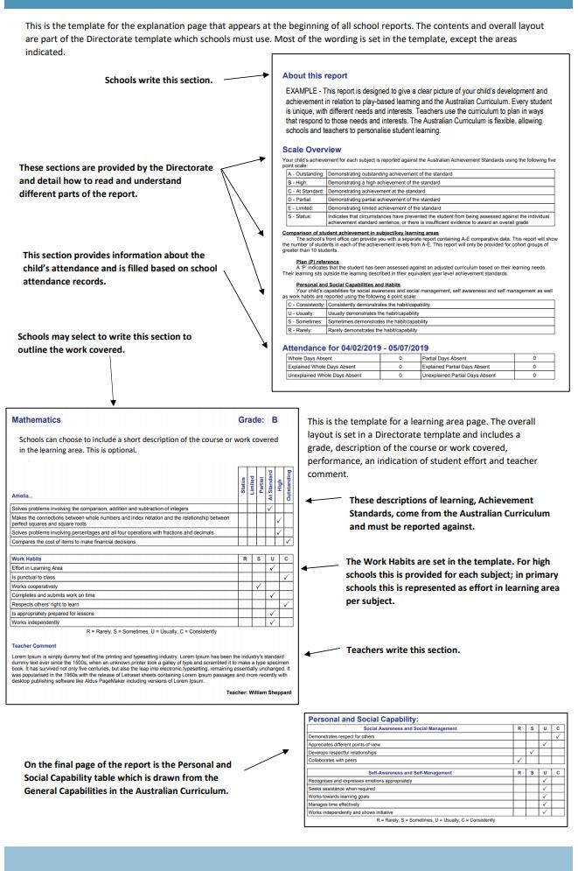

Together, we learn from each other

What’s On
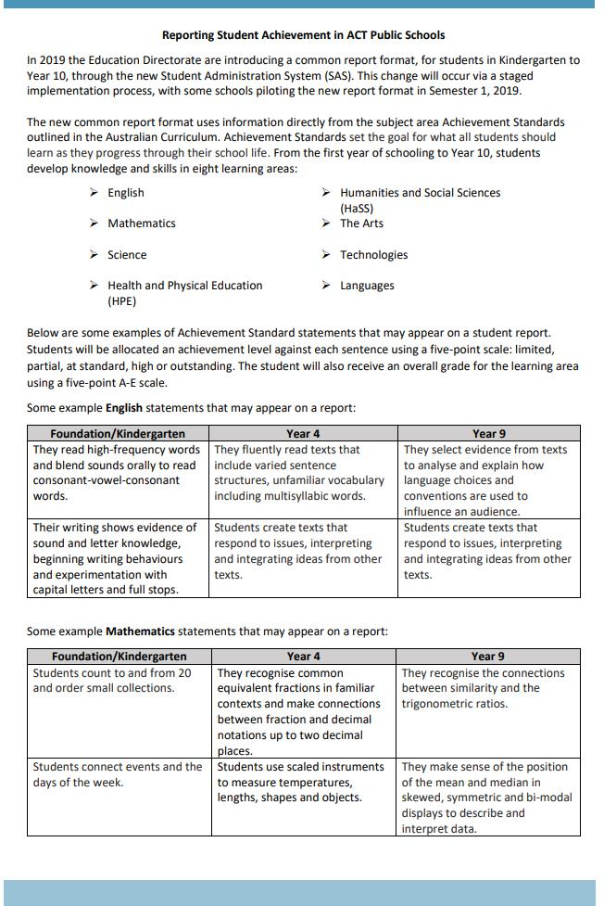

Together, we learn from each other

What’s On
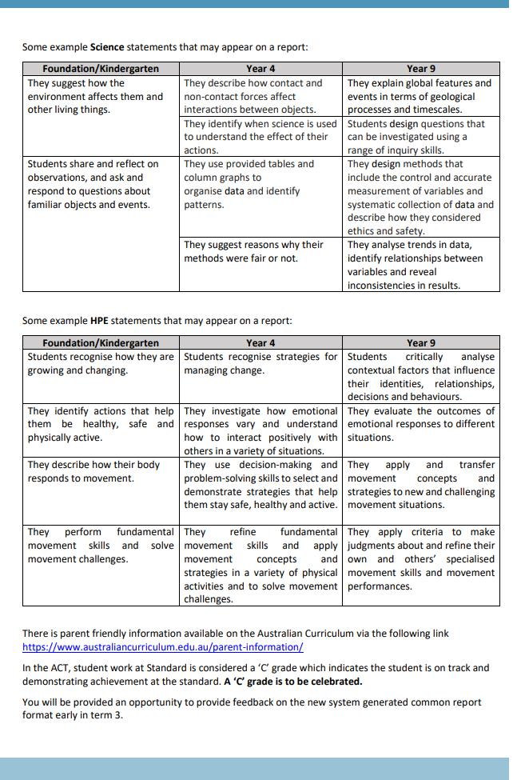

Together, we learn from each other

What’s On

PALMERSTON PRIDE AWARDS

Congratulations to the following students who received a PRIDE Award at assembly on 24 May 2019.

PARTICIPATION – becoming involved, “having a go” and cooperating with others

Tilly - KFD Jamie - 2AF Maisoora - KMC Layla - 2MO

Zaide - KKA Aseel - KGS

RESPECT – having respect for self, others and their property

Hamish - 2AF Nicholas - KMC

INTEGRITY – being honest, fair, responsible and loyal

Jaxon - 2MO

DETERMINATION - being persistent and resilient

Alex D- KFD Alex - KFD Ty - KGS Olu - KGS

EMPATHY - understanding and supporting others regardless of our differences Aastha - KGM

PBL
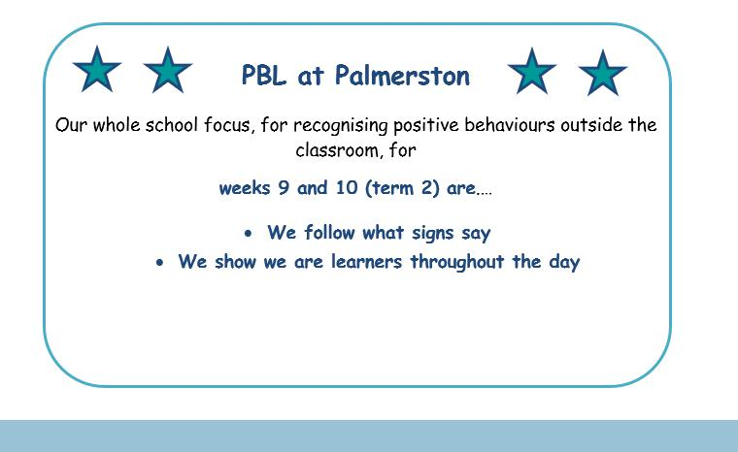

Together, we learn from each other

What’s On

DEFENCE NEWS

Defence Kids – End of Term Party

During Defence Club on Friday, 5th July, we will be having a party and I will be providing some hot chips during the lunch break. All Defence students are invited to attend and a note will be going home today regarding this event.

***POSTINGS***

As posting orders arrive please keep me updated with your family’s plans for relocation or absences e.g. deployment or courses. Then I can best support your child/ren at school. Please contact kristy.retzlaff@ed.act.edu.au or Ph: 6142 1440.

Thank-you,

Kristy Retzlaff

Defence School Mentor

DCO KidSMART Program

Commences Thursday 8th August, 3:30 – 5:00pm

Defence Community Organisation

Ground Floor, 8 Thesiger Crt, Deakin

Details: This event is only for the children of Australian Defence Force members.

The KidSMART program is designed to help primary school aged children manage issues arising from parent deployment and absence from home. It helps children to learn how to manage change, stay connected with friends, meet new people, and coping strategies when they are feeling stressed or anxious and handling different situations.

DCO is offering a four-week program for children aged from 7-10, running on consecutive Thursdays during August for one and a half hours each week (8,15,22,29 August).

Children will be provided with afternoon tea upon arrival. Parents do not need to stay for the sessions, but if you would like to remain close by the Mint Café is located across from DCO and is open until 5pm, also Deakin shops are nearby.

When registering, ensure your contact details are accurate. You will receive a booking confirmation via email, and you will be contacted to provide further registration details before the start of the program.

Please head to the Defence Community Organisation Facebook Page for booking information or alternatively contact Defence Family Helpline on 1800 624 608. I can also assist you with further information if you require assistance with bookings at kristy.retzlaff@ed.act.edu.au

Together, we learn from each other

What’s On

SRC NEWS

Together, we learn from each other

What’s On

UPCOMING EVENTS

Year 5/6 Peer Support Training Day

Date: Tuesday 2 July 2019

Location: PDPS

Dress Like a Farmer Day

Date: Wednesday 3 July 2019

Location: PDPS

Year 2 Theatre Excursion

Date: Thursday 4 July 2019

Location: Canberra Theatre

P&C Lunch Order Day & PJ Day

Date: Friday 5 July 2019

Location: PDPS

Protect yourself and your family from the flu

Getting vaccinated is the best way to prevent your family getting the flu this winter. The flu vaccine can save a child’s life.

The vaccine is safe, and everyone 6 months of age and over, including pregnant women and young children, should get the vaccination.

Children are more likely to contract the flu, spread it around, and are at a higher risk of serious complications if they get sick. The flu is highly contagious and is spread easily through childcare centres and schools.

The flu vaccine is free in the ACT for:

- children aged 6 months to under 5 years

- pregnant women

- people 65 years of age and older

- all Aboriginal and Torres Strait Islander people aged 6 months and older, and

- people aged 6 months and older with some medical conditions such as severe asthma, heart or lung disease, diabetes or weakened immune systems.

Where to get your flu vaccination

Everyone can get a flu vaccine from their GP or immunisation provider.

People over 16 years of age can also get a vaccine at some pharmacies.

ACT Government Early Childhood Immunisation Clinics provide a free flu vaccination for children aged 6 months to under 5 years. To book an appointment, call Community Health Intake on 02 5124 9977.

Learn more about influenza and where to get your vaccination at health.act.gov.au/flu

Together, we learn from each other

What’s On

P&C NEWS

P&C PJ DAY

On Friday 5th July, there will be whole school PJ dress up day. Students can wear appropriate pyjamas and footwear and bring in a gold coin donation to

start fundraising for the twilight fair.

Your help is very much appreciated to support this upcoming spectacular event.

Many Thanks

The P&C are fundraising with the Entertainment book. The Entertainment™ Book is a local restaurant and activity guide which provides hundreds of up to 50% off and 2-for-1 offers from the finest restaurants, cafes, attractions, activities, retailers and hotel accommodation. The Membership entitles buyers to exclusive offers that are virtually restriction-free, and is valid through to 1 June 2020!

The Entertainment™ Digital Membership (app) puts all of the value of the Entertainment ™ Book into the customer's smartphone. With 'near me' technology and the ability to show and save using a phone, this is

perfect for the person on-the-go, with no card or voucher to present.

To continue to celebrate our 25th Birthday in style we have a brand new promotion coming your way!

From midnight on Thursday 27th of June until midnight Sunday 30th of June (AEST) everyone who purchases their 19 |20 Membership through our Online Order Page will receive a $10 JB Hi-Fi eGift Card.

You can purchase a book through the front office or download the app via this link

https://www.entertainmentbook.com.au/orderbooks/2487s6

Together, we learn from each other

What’s On

P&C NEWS
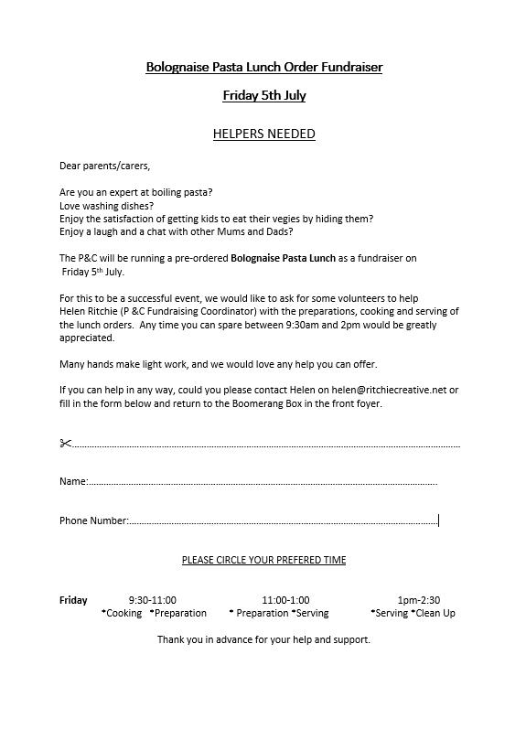

Together, we learn from each other

What’s On

With winter upon us, it’s important to remember that Canberra has lots of health options that don’t involve a trip to a hospital emergency department. Many of these are free and available after hours.

Walk-in Centres provide free, one-off treatment of minor injury and illness, including colds and flu. They’re a great choice for children over 2 years of age – children under 2 should see their GP.

Walk-in Centres are open from 7.30am to 10pm, every day of the year. They are staffed by highly skilled nurses who can provide you with a sick certificate and in some cases, medication, saving you time and money.

The service is free and no appointments are necessary.

Walk-in Centres are located in Tuggeranong, Belconnen and Gungahlin.

To find out more about getting the right health care for your symptoms, visit

www.act.gov.au/yourhealthoptions

Together, we learn from each other

What’s On
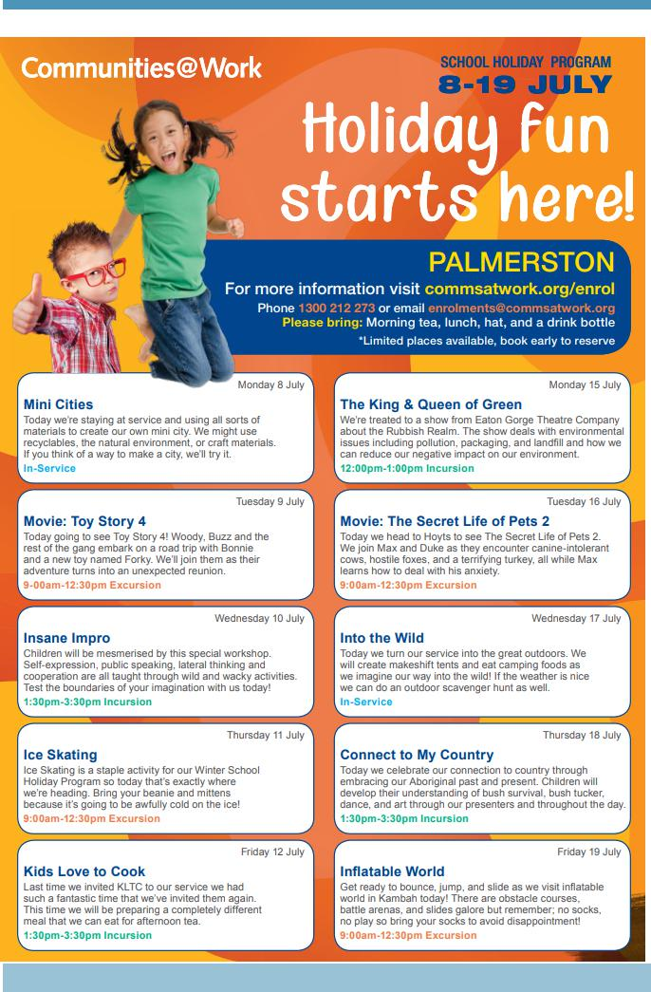

Together, we learn from each other

What’s On
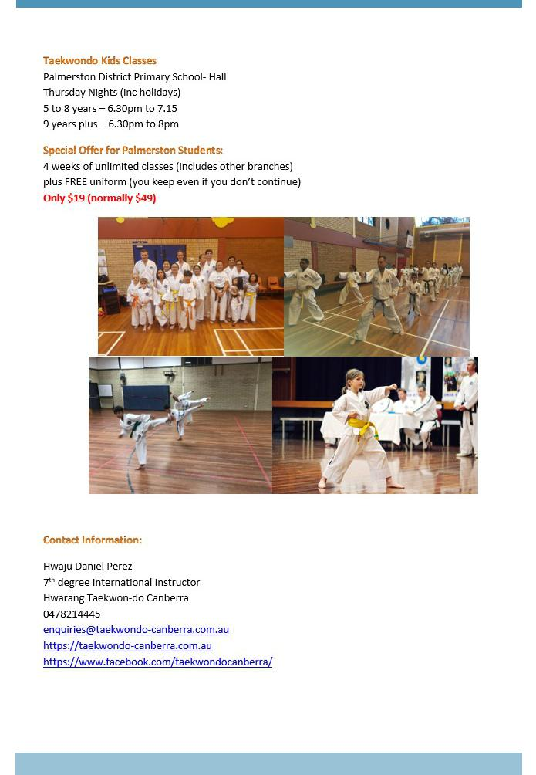

Together, we learn from each other

What’s On
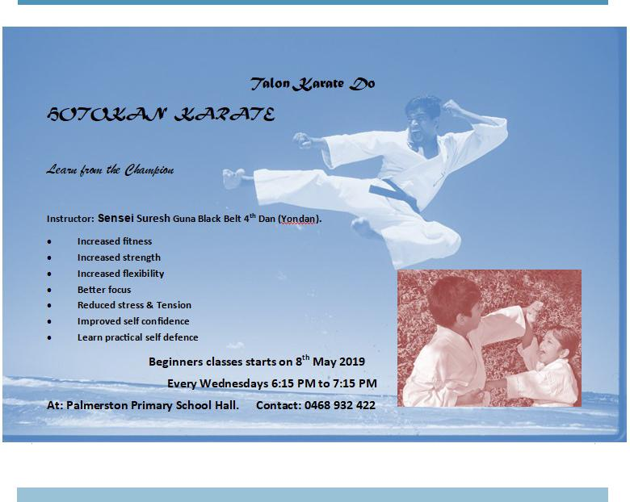

Together, we learn from each other

What’s On

Community News

ParentLink

ParentLink provides parenting education to the community, from birth to teenage years. It is available for parents, carers, kin, teachers, and the broader community, providing information and
links to local resources and services.

The ParentLink website provides links to all ParentLink guides including a variety of topics - Start-ing School, More than Reading and Writing, Optimism and Cyber Safety.

The ParentLink suite of resources includes guides specifically for Aboriginal and Torres Strait Islander families, and access to resources for diverse cultural groups.

ParentLink guides are available to view and order via the website at,

https://www.parentlink.act.gov.au/

PARKING AROUND SCHOOLS

As we drive and park our cars around schools we all need to ensure the safety of school students is our priority. Parking illegally and unsafely across pedestrian crossings, corners and verges puts children at risk. We all need to help keep our children safe. Here is a short video demonstra-tion: https://youtu.be/AslMVXpA9Zc

Access Canberra inspectors will be patrolling our school zones to help us ensure drivers do the right thing.
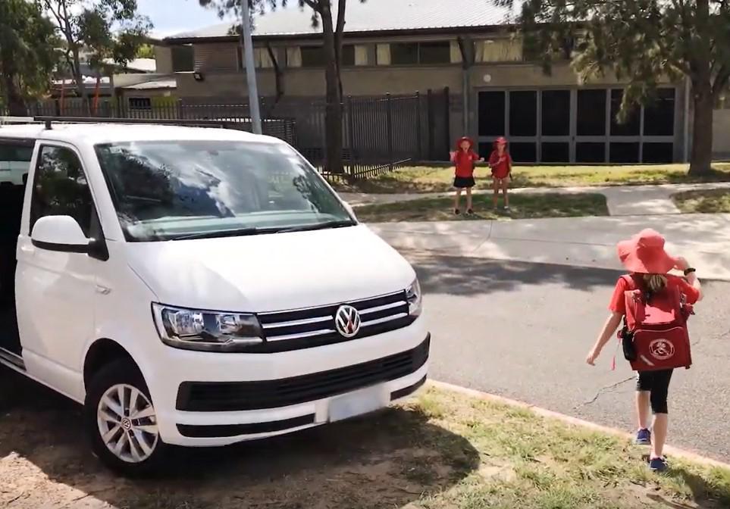

Together, we learn from each other

