PALMERSTON POST

24 May 2018

Week 4, Term 2

Board Chair: Lisa Fior Board Members: Parent Reps: Jesse Dang and George Villaflor

Teacher Reps: Jessica Lago and Maxine Green

P&C President: Lisa Fior

Principal: Kate Flynn (acting) Deputy Principal: Haeley Simms (acting)

Executive Teachers: Kylie Moller, Jacqui Warden, Matt Gowen, Catherine Griffin (acting)

ASSEMBLY:
25 | May | Senior - Yr5
1 Jun |  | Junior—2EG & 2LM
DATES TO REMEMBER:
25 | May | Yr1 Canberra Theatre
 |  | Excursion
28 | May | Reconciliation Day -
 |  | Public Holiday
29 | May | Yr1/2 Author Visit
29 | May | ICAS - Science
30 May |  | North Gungahlin
 |  | Cross Country
30 May |  | 5pm 2019 P/S
 |  | Information Session
05 | Jun | P/S Mini Athletics
 |  | Carnival
06 | Jun | K-Yr6 Athletics
 |  | Carnival
06 Jun |  | 5pm PBL Information
 |  | session
08 | Jun | P/S Mini Athletics
 |  | Carnival

NOTES HOME:

- Athletics Carnival (youngest)

- Yr5 Band Pair - Harrison

P&C BOARD NEWS P&C: 7:00pm 25 June 2018

All P&C activities, meeting agendas and minutes are available from the school website at – Parent Corner

School Board: 7:30am 21 June 2018

DEPUTY PRINCIPAL’S MESSAGE

NAPLAN

Over the past two weeks NAPLAN has taken place, with most of the tests being completed online for the first time. The NAPLAN tests provide parents and teachers with an understanding of how students are performing as they progress in their learning. NAPLAN tests are just one aspect of our school’s assessment and reporting process. Ongoing assessments are made throughout the year by our teachers. I would like to congratulate our year 3 and 5 students who have all diligently approached the assessment.

Carpark

As the weather gets colder, more and more families are driving their children to school. This places increased pressure on our carpark. I am pleased that Palmerston’s additional car spaces have now become available. This has freed up considerable spaces in the main carpark, which assists with the general flow of traffic through the school. Also included in this newsletter is further information on the bus service that travels from Crace of a morning and afternoon and how families can utilise this service. Last Friday I joined a group of students and teachers as they participated in Walk Safely to School Day. This is a great initiative and is supported by the Active Streets for Schools program, which has placed blue symbols on pathways indicating safer routes to walk to school. Thank you Mr Susko for organising this day.

Public Education Week

This week is Public Education Week . Some of our staff will be attending a Public Education Week dinner tomorrow night. Our music specialist teacher Mr Shaw has been selected to perform a song that he wrote at this special dinner. Congratulations Mr Shaw, what a wonderful achievement.

This week is an opportunity to acknowledge the great work our public schools play in educating our children.

Together, we learn from each other

Palmerston Post Page 2

Over the last week I have been fortunate to view many students’ achievements and the wonderful learning that is taking place in our classrooms. Tomorrow the year one students are travelling to the Canberra Theatre as a part of our extended literacy program. We also have some students who will be participating in orienteering classes next week.

Seesaw

During this week or next week if you have elected for your child to use the online portfolio Seesaw, an invitation will be coming home, which will allow you to see your child’s work and comment on it. I have seen some terrific work being uploaded to this space.

Communications

Just a reminder the avenues of communication at Palmerston are:

1st - Contact your child’s classroom teacher via the front office on 6142 1440.

2nd - Contact the Deputy/Executive on 6142 1440

3rd - Contact the Principal Kate Flynn on 6142 1440

Concerns, suggestions or complaints:

- Education Directorate

Liaison Unit Phone: (02) 6205 5429

Have a great week,

Haeley Simms

ROUTE 54 BUS SERVICE

To assist school children to access bus travel from Crace to Palmerston Primary School, Transport Canberra recently implemented two diversion services utilising the regular Route 254 and 54. In the morning the Route 254 that travels through Crace at 8:35 am is diverted to Palmerston Primary School arriving at 8:40 am prior to returning along Kosciusko Avenue and serving the regular passengers along this route. In the afternoon the Route 54 that leaves Gungahlin at 3:00 pm, travels along Kosciuszko Avenue, diverts to Palmerston Primary School and then travels back to Grampians Street and on to Crace. This diversion introduced for Term 2, 2018 on the route 54/254 has been designed to allow students to travel between Crace and Palmerston Primary School. This type of diversion is common practice and an efficient use of existing resources, where there is a low demand for service.

For members of the public wishing to travel to and from Palmerston Primary School outside of these times, bus services to Crace can be accessed via bus stops on Grampians Street, which is a 900 metre or approximately 12 minute walk from the front of Palmerston Primary School. If parents or grandparents are required to pick up the children from school in the afternoon and find the 900 metre walk to be difficult, they could travel to Gungahlin on the 2:29 pm Route 54 service that arrives in Gungahlin at 2:44 pm and connect with the return service at 3:00 pm which diverts to the school. The Route 254/54 is designed to provide the most direct service to the Gungahlin Town Centre for residents of Crace, which is via Kosciuszko Avenue and onto the Valley Way.

Together, we learn from each other

Palmerston Post Page 3

UPCOMING EVENTS

Year 1 Canberra Theatre Excursion ‘Yo Diddle Diddle’

Date: Friday 25 May 2018

Location: Canberra Theatre

Year 6 Woodwind Band Pair

Date: Thursday 24 May 2018

Location: Palmerston District Primary School

Year 1/2 Author Visit - Dr Cameron Stelzer

Date: Tuesday 29 May 2018

Location: Palmerston District Primary School

North/Gungahlin Cross Country

Date: Wednesday 30 May 2018

Location: Palmerston District Primary School

2019 Preschool Information Session

Date: 5pm Wednesday 30 May 2018

Location: Palmerston District Primary School, library

2019 CAP Program Information Session

Date: 5pm Wednesday 13 June 2018

Location: Palmerston District Primary School, library

SEESAW INVITATION

The students and teachers have been trialling and learning about Seesaw over the last two terms. The classes are now ready to invite parents and carers to view and participate in their child’s digital portfolio.

During weeks 4 and 5, classes will be sending out invitations to parents/carers. Keep your eyes on your child’s schoolbag for your invitation. Please see your child’s classroom teacher if you have any questions.

Thank you,

Haeley Simms

VOLUNTEERS WANTED

If you can spare some time, the library staff would love your assistance. Please drop into the library anytime on Thursdays.

Thank you,

Noreen Pidgeon & Eleni Velanis

Together, we learn from each other

Palmerston Post Page 4

PRESCHOOL 2019 INFORMATION SESSION

An information session will be held for parents of preschool children entering preschool in 2019. The session will be held at 5pm in the library at Palmerston District Primary School on Wednesday 30 May 2018. After the session you will be welcome to walk through the preschool classrooms to see the learning spaces.

Children must turn four years old by 30 April 2019 to be eligible for enrolment into preschool for the 2019 school year.

To register your interest for the session please call 6142 1440.

Come and tour the preschool facilities of the school and speak with current staff. Tours will be conducted during May on Mondays and Fridays at 9:30 to 10:00am. Book a tour of the preschool by calling the school on 6142 1440.

CAP PROGRAM

This term we will begin our testing and identification process for our CAP program in 2019. The CAP program at Palmerston District Primary School is for children who are identified as gifted students. In line with school procedures, all students currently in year 2 will be tested for the program. If your child is in another year group at Palmerston and you would like to nominate them to be tested for next year’s program, nomination forms are available now at the front office. All nomination forms must be submitted by Friday 15 June 2018 (week 7).

If you are interested in hearing more about the program itself and/or more about the testing we use to identify gifted children, please come along to an information session on Wednesday 13 June 2018 at 5pm in the library.

Thank you,

Cheryl Cassella

P&C BANKING NEWS

Unfortunately the Secret Scratch Pad reward is no longer available. The Twister Power Handball, Sparkle Glitter Pens and Glow Light are still available with more rewards coming in term 3 and 4!
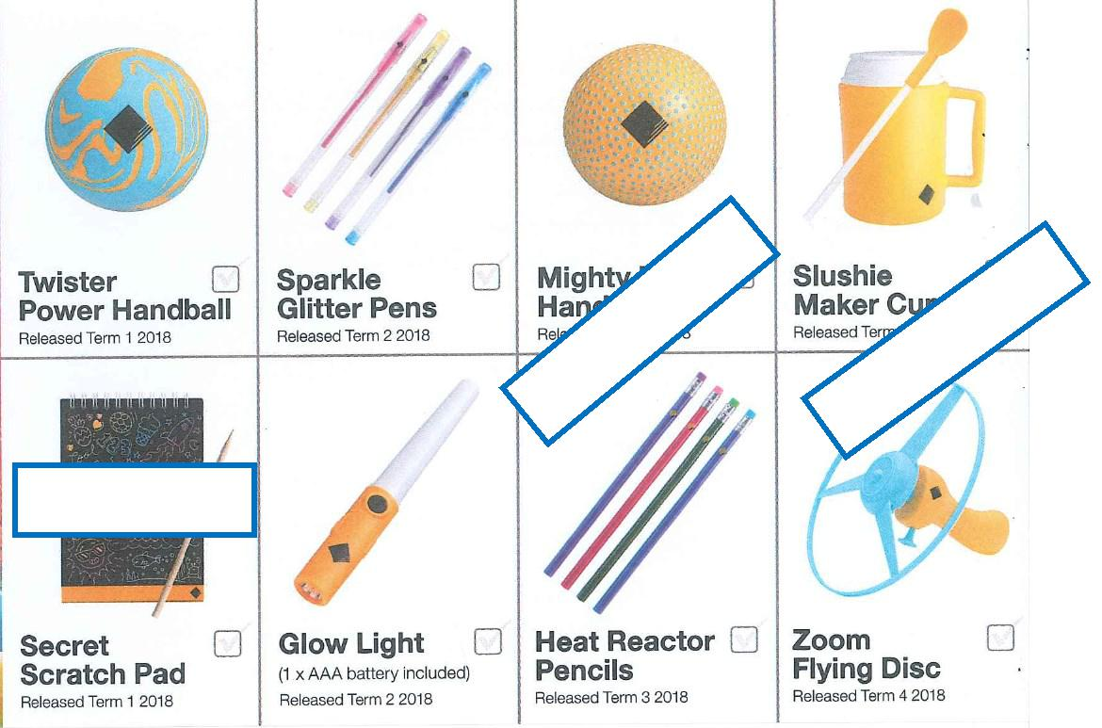

 | 3
Available | term

Not available

 | 4
Available | term

Together, we learn from each other

Palmerston Post Page 5

PBL@Palmerston

At Palmerston we are excited to continue our journey into Positive Behaviour for Learning (PBL). PBL is an evidence-based, school-wide approach that supports student behaviour to improve social and academic outcomes for all students. Our PBL team consists of teachers from all areas of our school, preschool to year 6. The PBL team will be working with the community this term to refine a framework outlining our school’s expectations for Safe, Respectful Learners, through the use of positive statements.
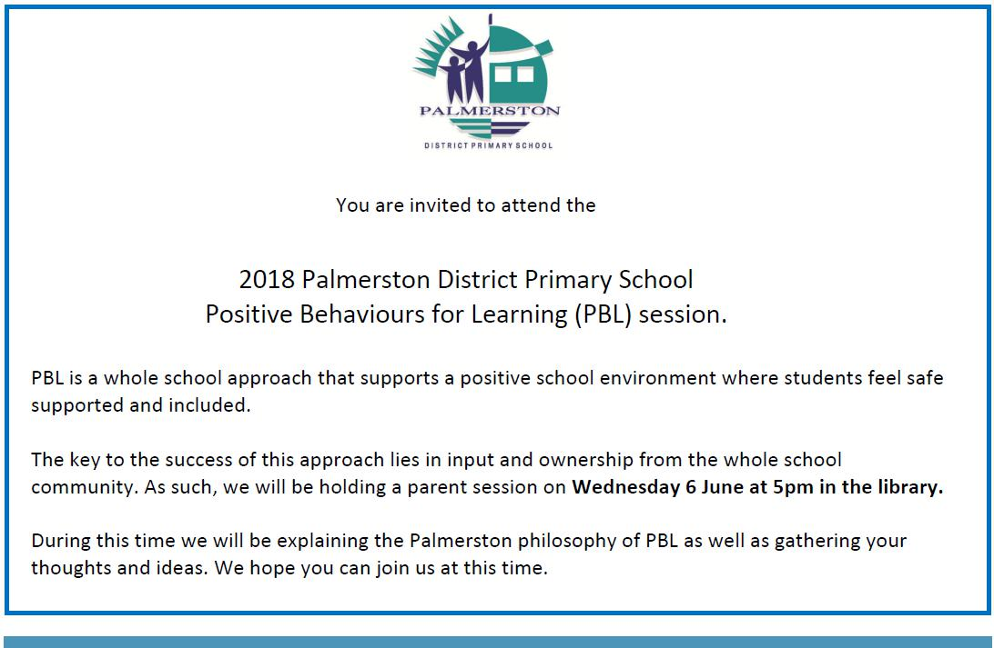

Together, we learn from each other

Palmerston Post Page 6
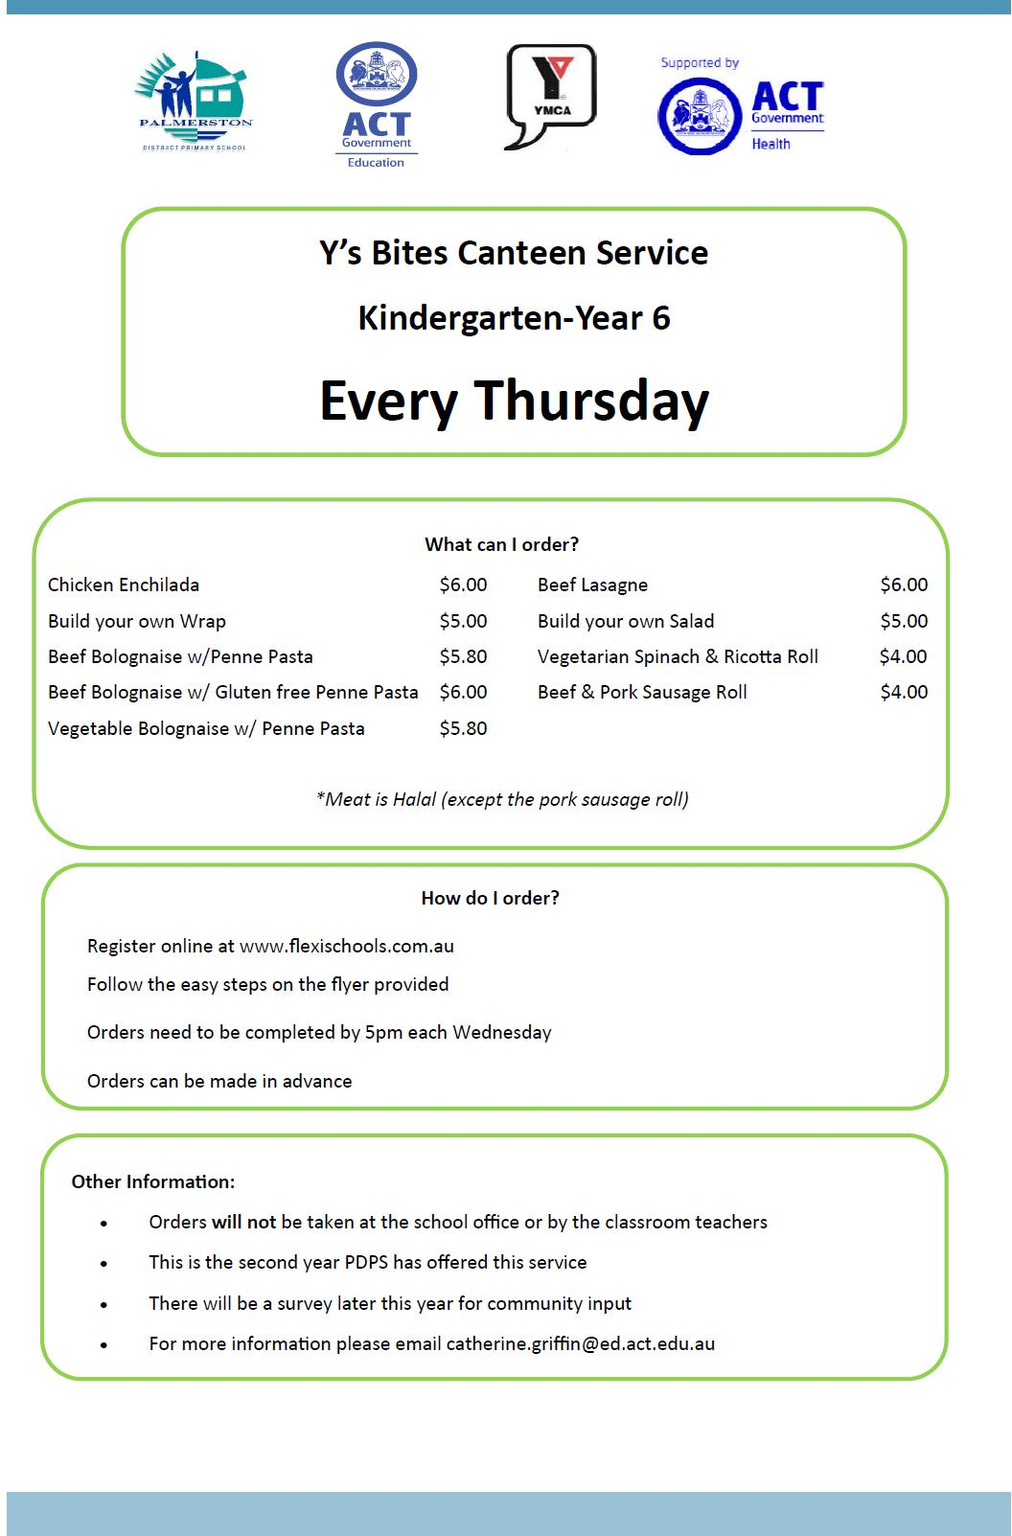

Together, we learn from each other

Palmerston Post Page 7
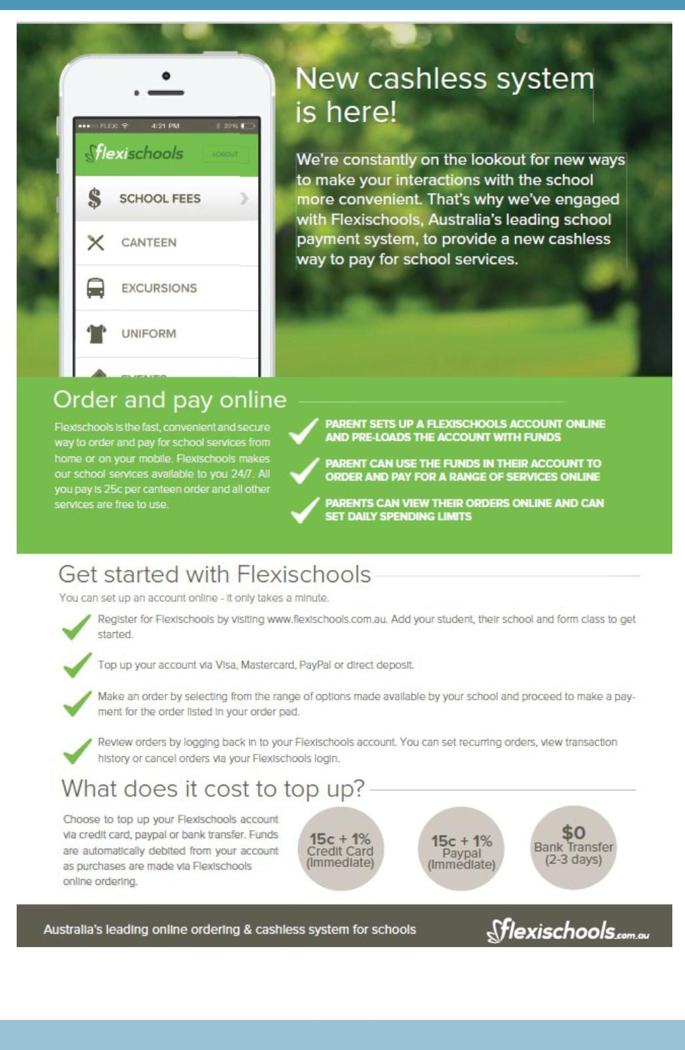

Together, we learn from each other

Palmerston Post Page 8

HIRERS

THE CANBERRA CHINESE SCHOOL INVITES YOU TO CELEBRATE THE DRAGON BOAT FESTIVAL.

Time: 12pm-3:30pm, Sunday 3 June

Venue: TB Millar Hall in Radford College, 1 College Street, Bruce

Activities: 12pm-1:30pm: Food stalls and kids’ fun activities: face painting, brush painting, calligra-phy, paper cutting/crafting and lion dance

1:30pm-3pm: Stage performance: Chinese dance, singing and martial arts

This is a FREE event and all are welcome.

For a poster of the event see the school website at www.canberrachineseschool.net

COMMUNITY NEWS

Mental Health Issues and Young People: FREE Parenting Forum

Carers ACT is hosting a unique opportunity for parents, carers and friends to learn how to recognise the warning signs and better un-derstand depression, suicide, eating disorders, deliberate self-harm and other mental health problems in young people. Mental illness in our youth – often known as the ‘invisible disease’ - is

growing at an alarming rate with many parents at a loss on how to deal with it. The speaker will be Dr Michael Carr-Gregg, one of Australia’s leading experts in parenting and child and adolescent mental health and founder of CanTeen for teenagers with cancer.

Bookings essential.

When: Tues 19 June 2018, 7-9pm, Hellenic Club, Woden

More info: Ph 6296 9900 or email mhcarers@carersact.org.au

Register : through Eventbrite http://bit.ly/2HIqSiy

Cost: free

Together, we learn from each other

Palmerston Post Page 9
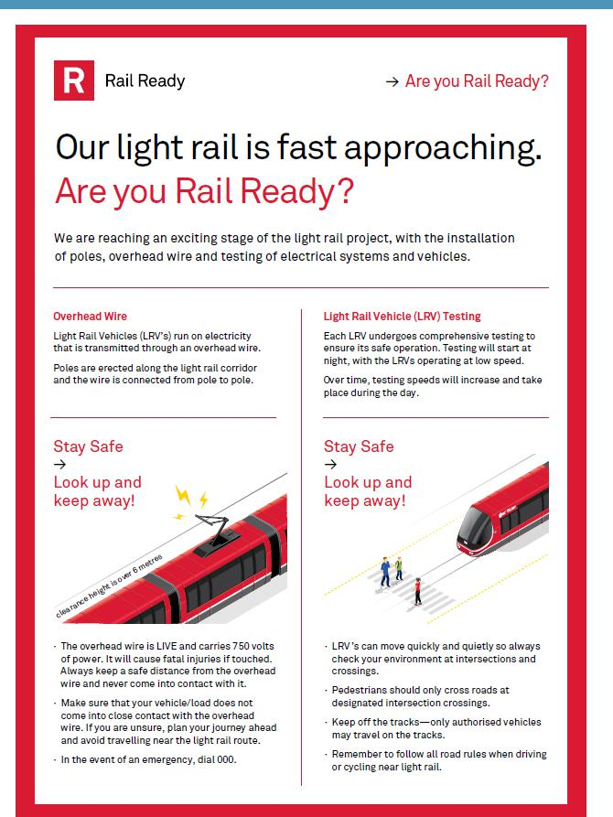

Together, we learn from each other

Palmerston Post Page 10
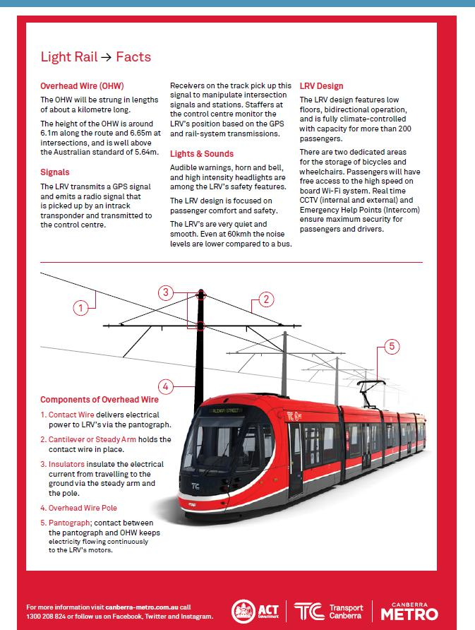

Together, we learn from each other

Palmerston Post Page 11

Reconciliation in the Park

Monday 28 May 2018

Glebe Park, Civic

10am to 2pm

Reconciliation in the Park celebrates the ACT’s historic first Reconciliation Day public holiday to be held in Australia. Join this free community event in Glebe Park in the city which features headline folk inspired pop duo Busby Marou performing live on stage.

The ARIA award-nominated stars will be joined by an array of local Indigenous performers and dancers including the Wiradjuri Echoes. Also performing is Canberra’s own The Voice finalist, teen sensation Lucy Sugerman, The Chesterfield Band, Johnny Huckle and Hardcover.

The Glebe Park event offers something for all ages. Among the activities are basket weaving, bush tucker talks, storytelling and children’s art workshops. In addition to the cultural activities the kids can join in there will be a petting zoo, jumping castle and face painting.

Grab a bite to eat at the community barbecue or from the food trucks onsite.

You can also connect and chat with the many local community organisations who will be exhibiting in Glebe Park on the day.

Reconciliation Day is an opportunity for all Canberrans to learn about our shared histories, cultures and achievements and explore how we can contribute to achieving reconciliation in Australia.

The day’s activities reflect the National Reconciliation Week 2018 theme Don’t make history a mystery which invites Australians to Learn, Share, and Grow – by exploring our past, learning more about Aboriginal and Torres Strait Islander histories and cultures, and developing a deeper understanding of our national story.

Program performers at a glance

Main stage

10am Welcome to country

11am Griffyn Ensemble

11:30am Michael Weir

12pm Busby Marou

1pm Wiradjuri Echoes

Rotunda Stage pop up performers

10am Dale Huddlestone

11am Johnny Huckle

1pm Lucy Sugerman

Main entrance pop up performers

10am Dominic Lavers

11am The Chesterfield Band

1pm Hardcover

Getting there

Transport Canberra will be running on a public holiday schedule to get you to and from the city, with concession card holders able to travel free on the public holiday.

The free City Loop service will be operating, stopping at the Akuna Street (City Walk) stop.

The Aboriginal and Torres Strait Islander Community Bus service will be operating a free shuttle service from select locations in Queanbeyan between 9:30am and 2:30pm.

Parking options include Canberra Centre, Civic Pool and city centre precinct car parks as well as the National Convention Centre.

Share your Reconciliation Day

Use #NRW2018 when sharing your day on social media.

Learn more about National Reconciliation week.

Together, we learn from each other

Palmerston Post Page 12

Last year our Directorate supplied us with a Reconciliation Week chatterbox, which was used in some classrooms. On the chatterbox is information about Reconciliation week. We are placing this in the newsletter for families to access and use.
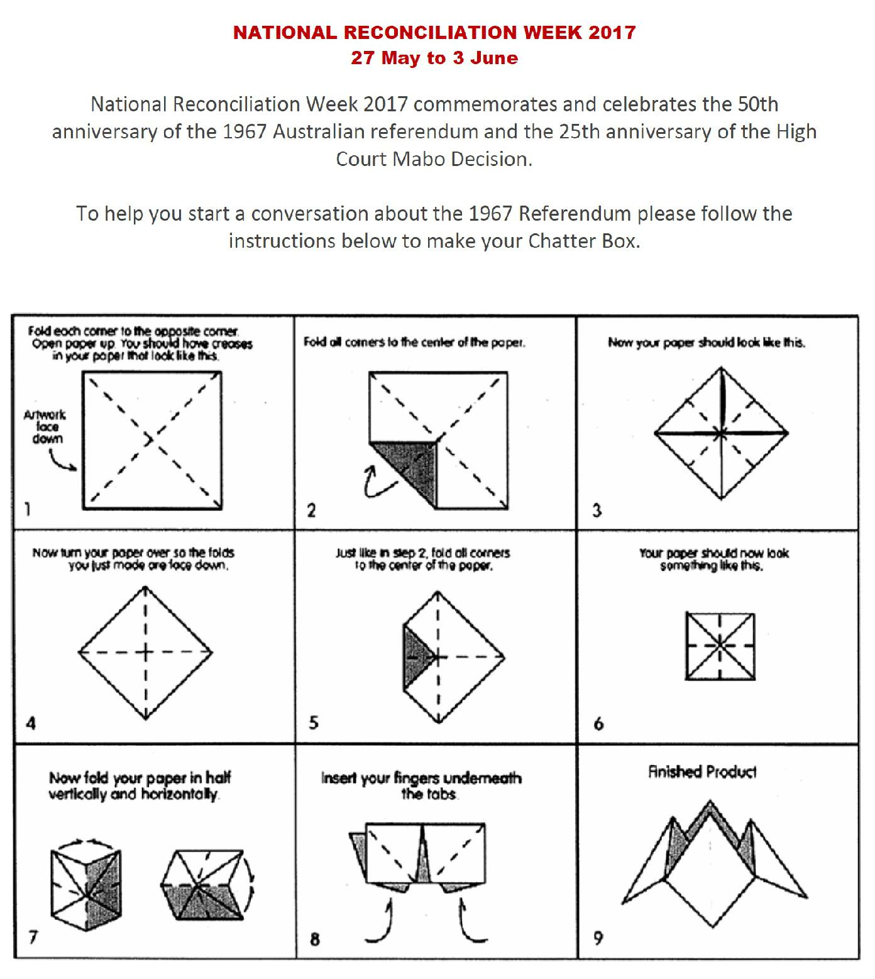

Together, we learn from each other

Palmerston Post Page 13
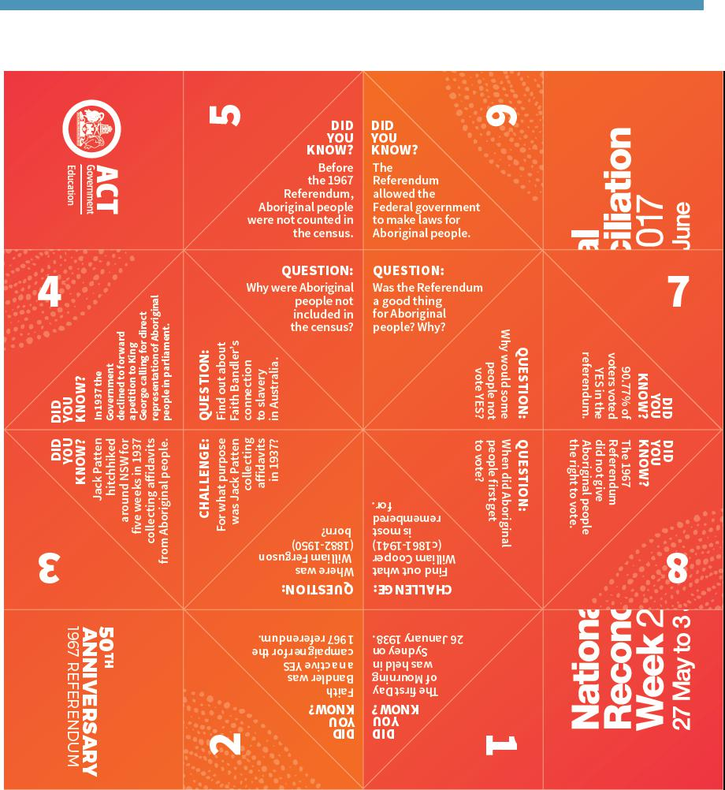

Together, we learn from each other

