What’s On

31 May 2018

Week 5, Term 2

ASSEMBLY:
1 Jun | Junior—2EG & 2LM
8 Jun | Senior - Yr 4
DATES TO REMEMBER:
05 Jun | P/S Mini Athletics
 | Carnival (begining)
05 Jun | Yr3-6 Orienteering
06 Jun | K-Yr6 Athletics
 | Carnival
06 Jun | 5pm PBL Information
 | session
08 Jun | P/S Mini Athletics
 | Carnival (end)
08 Jun | Yr3-6 Orienteering
11 Jun | PH - Queen’s Birthday
12 Jun | P/S School Photos
12 Jun | Yr3-6 Orienteering
13 Jun | Christian Education
13 Jun | ICAS - Spelling
13 Jun | 5pm CAP evening
14 Jun | School Photos
14 Jun | ICAS - Writing
15 Jun | K-Yr2 Constable
 | Kenny
15 Jun | Yr3-6 Orienteering

NOTES HOME:

- Magic Mania - LSU

- School Photo envelopes - all

- Australian Early Development Census - kindergarten

P&C BOARD NEWS P&C: 7:00pm 25 June 2018

All P&C activities, meeting agendas and minutes are available from the school website at – Parent Corner

School Board: 7:30am 21 June 2018

PRINCIPAL’S MESSAGE

Welcome to week 5 - Thursday has seemed to come around really quickly after the first Reconciliation Day public holiday on Monday.

Reconciliation Week at Palmerston

As you may have previously read, we have been acknowledging Reconciliation Day throughout the week. The children and staff have been engaging in a range of activities to learn more about Aboriginal and Torres Strait Islander cultures and histories, to share that knowledge and to grow as a nation. The types of activities include reading stories, playing sport and completing art activities.
Zone Cross Country

Yesterday we had a number of students brave the cold to attend the Zone Cross Country Carnival at Stromlo. I have been proud of the feedback we received concerning the positive mindset of our Palmerston students to try their best during their race and I congratulate all of our students who attended and thank Mr Susko for his organisation around this event. Thank you to all other staff and family members who attended the day. We had four students, Georgia, Alicia, Toby & Amelia, progress forward to the ACT Cross Country event. We wish them all the very best for this race.

Public Education Week

Last Friday night a number of Palmerston staff attended the annual Australian Education Union’s Public Education Week dinner. During the dinner, teaching staff from across Canberra come together to celebrate public education. One of our very own staff members CJ Shaw was invited by members of the union to perform on the night-I would like to congratulate Mr Shaw on his successful and well received performance. Last week one of the members of the Australian Education Union attended a morning tea at Palmerston to chat to our staff and acknowledge all the hard work they do.
Author visit- Dr Cameron Stelzer

On Tuesday we were captivated by our visiting author Dr Cameron Stelzer. While Dr Stelzer was here to promote his new books “The Scallywags”, many of our children enjoyed talking to him about his other series of books, particularly the Pie Rats series. These books have proven to be very popular with our middle to upper years children and keep on flying off the library shelves!

Together, we learn from each other

What’s On Page 2

Dr Stelzer was a real hit with our children and his visit reinforced his desire to foster a passion for reading, writing and drawing for all children.

Car Park

Last week we were able to start using our new carpark. We now have 17 extra spaces available for use. Staff from the front office, preschool, kinder, year 1 and the IEC have been utilising the spaces which has meant that there are extra car parking spaces available in the main area for families.

Observations that we have made since the carpark has opened have been extremely positive and we can see that the extra spaces are really making a welcome difference to our car parking arrangements.

Hats off period

Inline with the ACT Cancer Council recommendations we are about to head into the “hats off” period for June and July. The Cancer Council state that as the daily UV levels drop and stay low (under 3) during this time, it is recommended that we refrain from wearing hats to assist Canberra children with their winter vitamin D requirements.

Mathematics update

Today a number of our staff were off site working with our mathematics consultant Anita Chin. Anita is well renowned in mathematics circles across Australia and has helped shape the NSW syllabus (aligned to the Australian Curriculum) and has worked with our staff twice this year. The aim of today was to further streamline our mathematics approach across the school and we are looking forward to launching initiatives and ideas.

Have a great week,

Kate Flynn

RECYLING PROGRAM

Want to raise money for the school and at the same time recycle items you normally throw away?

Palmerston Primary is registered to be part of a new recycling program. The school will be a collection point for oral care waste that we will send off to earn money for the school.

Al you have to do is bring your finished toothpaste tubes, toothbrushes, dental floss containers and packaging and place them in the box just outside the staffroom where the club board is. We will do the rest.

Just so you know… even though the collection box has pictures of
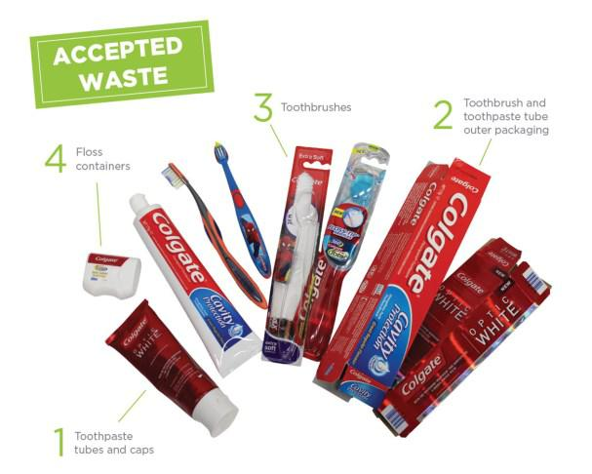

Colgate products on it – ANY BRAND OF ORAL CARE PRODUCTS IS ACCEPTED!

The program will be officially launched on World Environment Day June 5 at morning lines. If you already have some products you would like to bring in before then please hand in to the front office or directly to Karon Campbell - Environmental Science Teacher.

Together, we learn from each other

What’s On Page 3

UPCOMING EVENTS

Preschool Mini Athletics Carnival

Date: Tuesday 5 & Friday 8 June 2018

Location: Palmerston Preschool

Athletics Carnival

Date: Wednesday 6 June 2018

Location: Palmerston District Primary School, oval

PBL Information Session

Date: Wednesday 6 June 2018, 5pm

Location: Palmerston District Primary School
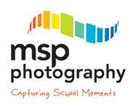

School Photos

Date: Tuesday 12 June 2018 - Preschool - Brave, Itchy & Noisy Bears

Date: Thursday 14 June 2018 - whole school (including remaining preschool classes)

Location: Palmerston District Primary School

If families require more than one set of photos they are able to place separate orders. Just complete a spare order form for your order, clearly marking mum or dad’s details. Or you can contact MSP Photography direct to place your order on 6255 9208.

Christian Education

Date: Wednesday 13 June 2018

Location: Palmerston District Primary School

2019 CAP Program Information Session

Date: 5pm Wednesday 13 June 2018

Location: Palmerston District Primary School, library

K-Yr2 Constable Kenny

Date: Friday 15 June 2018

Location: Palmerston District Primary School

Together, we learn from each other

What’s On Page 4

PALMERSTON PRIDE AWARDS

Congratulations to the following students who received a PRIDE Award at assembly.

PARTICIPATION – becoming involved, “having a go” and cooperating with others

Sarah - 3/4JL | Brendon - 6AJ | Laura - 6AJ
RESPECT – respect for self, others and their property
Emerson - LSU | Rawden - 6AJ
INTEGRITY – being honest, fair, responsible and loyal
Calvin - 2RK | Hope - 6AJ | Brody - 6AJ
DETERMINATION - being persistent and resilient
Umar - 2RK | Connor - 3/4JL | Kai - 6AJ | Olivia - 6AJ
Elektra - 6AJ

STUDENT ACHIEVEMENTS

North/Gungahlin District Cross Country

All students represent Palmerston well at yesterday’s carnival, with 4 students qualifying for the

ACT Cross Country Carnival on the 13 June 2018, our best result for the last couple of years!

Georgia - 3/4JM finished 3rd for 9yrs girls

Alicia - 4AP finished 10th for 10yrs girls

Toby - 5IH finished 5th for 11yrs boys

Amelia - 6AJ finished 10th for 12yrs girls

Congratulations and good luck at the ACT Cross Country Carnival.

Gymnastics

A huge congratulations to Isaac who came first at the Australian Nationals in the parallel bars (open ages)!

An amazing effort and result. Well done Isaac!
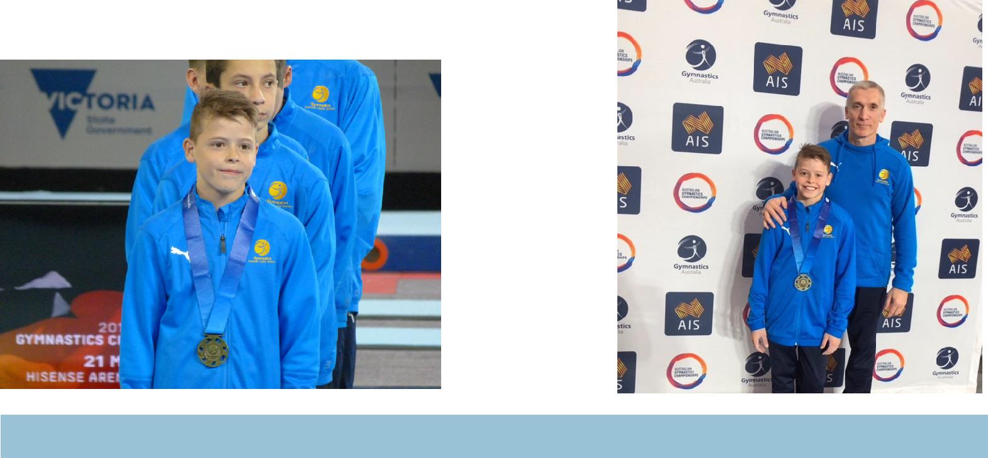

Together, we learn from each other

What’s On Page 5

PBL@Palmerston

At Palmerston we are excited to continue our journey into Positive Behaviour for Learning (PBL). PBL is an evidence-based, school-wide approach that supports student behaviour to improve social and academic outcomes for all students. Our PBL team consists of teachers from all areas of our school, preschool to year 6. The PBL team will be working with the community this term to refine a framework outlining our school’s expectations for Safe, Respectful Learners, through the use of positive statements.
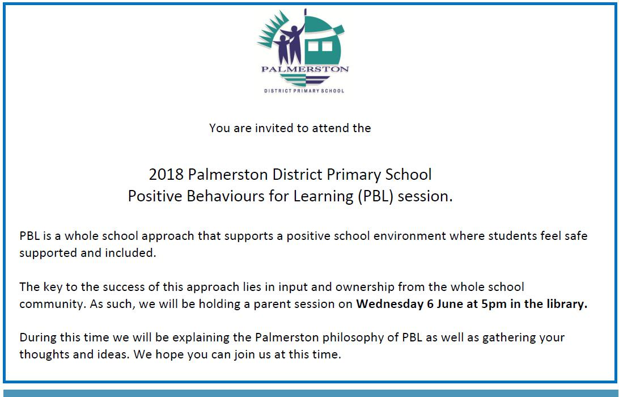

CAP PROGRAM

This term we will begin the testing and identification process for our CAP program in 2019. The CAP program at Palmerston District Primary School is for children who are identified as gifted students. In line with school procedures, all students currently in year 2 will be tested for the program. If your child is in another year group at Palmerston and you would like to nominate them to be tested for next year’s program, nomination forms are available now at the front office. All nomination forms must be submitted by Friday 15 June 2018 (week 7).

If you are interested in hearing more about the program itself and/or more about the testing we use to identify gifted children, please come along to an information session on Wednesday 13 June 2018 at 5pm in the library.

Thank you,

Cheryl Cassella

Together, we learn from each other

What’s On Page 6

SCHOOL BANKINKG NEWS
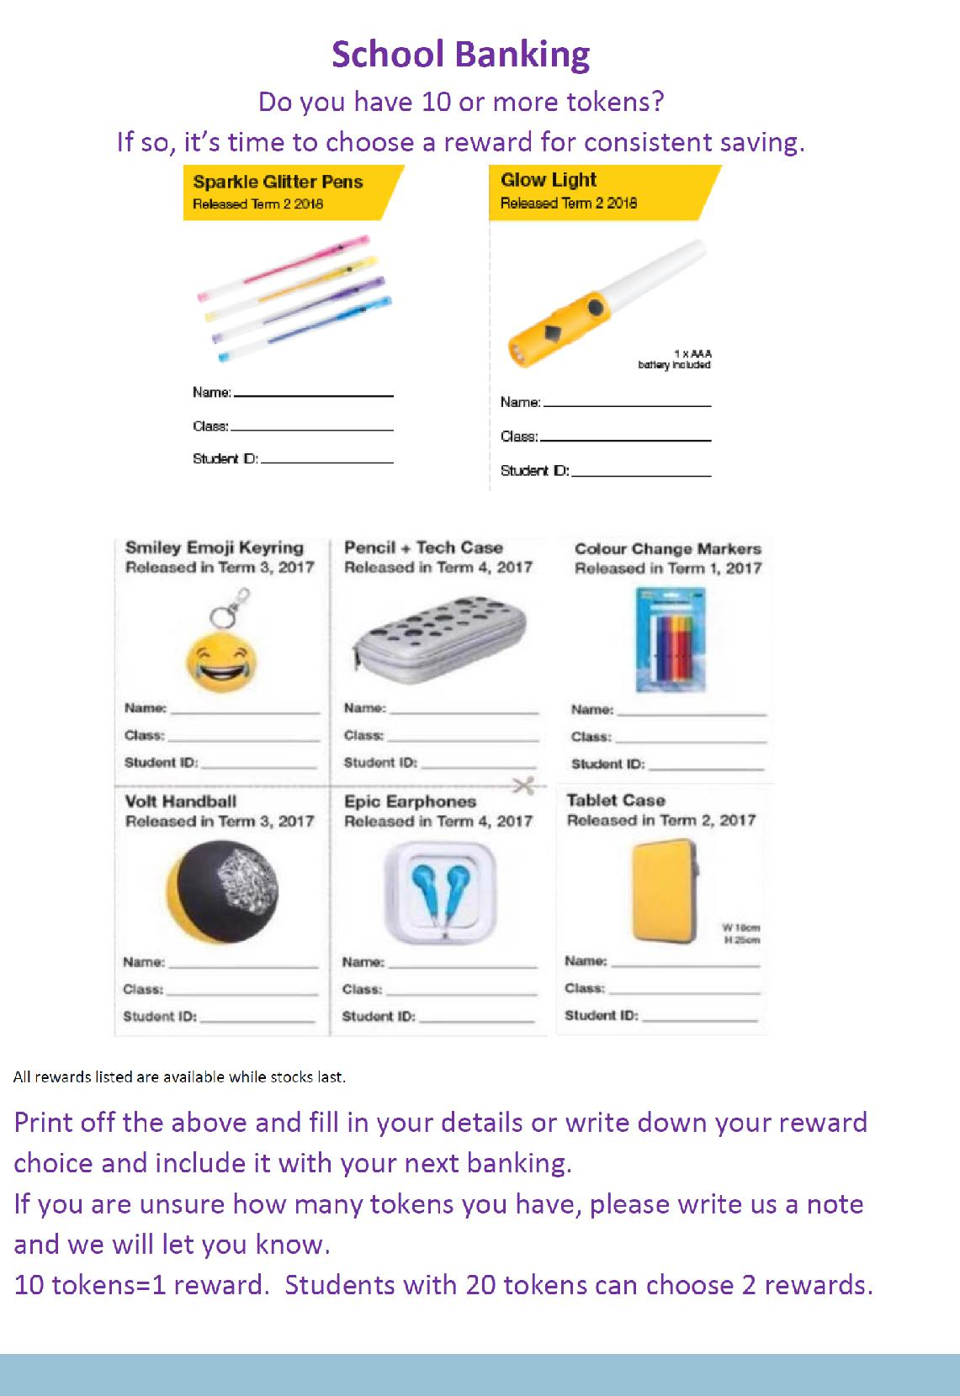

Together, we learn from each other

What’s On Page 7
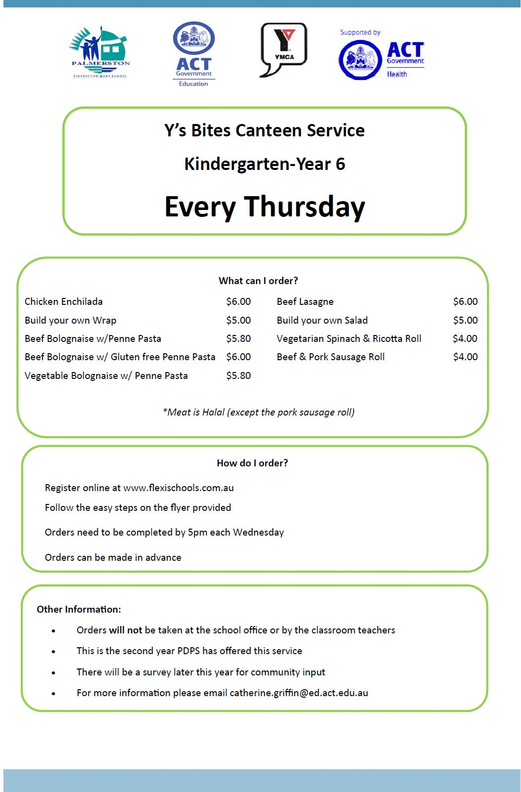

Together, we learn from each other

What’s On Page 8

Together, we learn from each other

What’s On Page 9
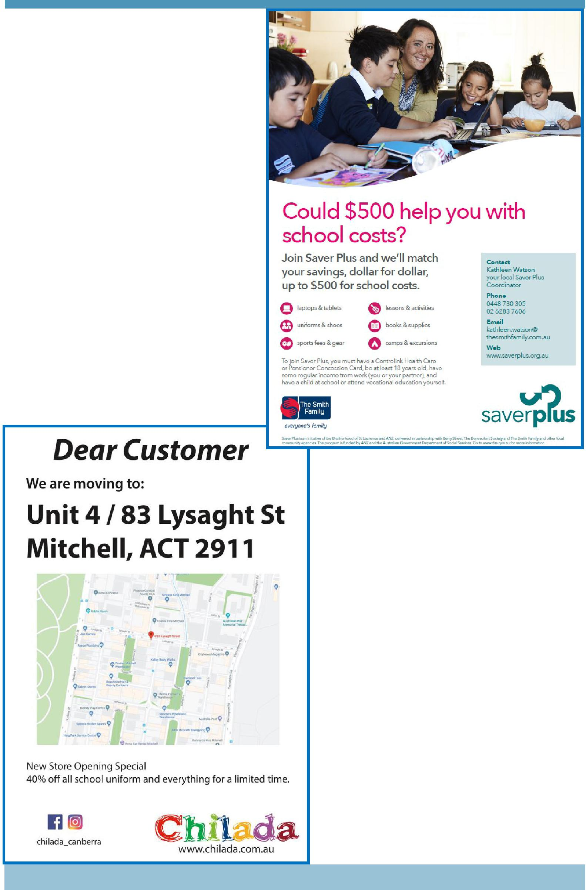

COMMUNITY NEWS

Together, we learn from each other

