ASSEMBLY:

7 Sep | Junior - 1HD & 1AE
14 Sep | Whole school - Kindy
21 Sep | Learning Journey - no
 | assembly
28 Sep | Senior - Yr4
DATES TO REMEMBER:
7 Sep | P&C School Disco
11 Sep | P/S (beginning) Crazy Hair
 | day
11 Sep | 5:30pm Parent Maths Info
 | Night
12 Sep | Yr5/6 Constable Kenny -
 | Stay OK for life
14 Sep | P/S (end) - Yr6 Crazy Hair
 | day for Twilight Fair
18 Sep | 5:50pm Digital Technology
 | Info night
20 Sep | Science Fair
21 Sep | Learning Journey
21 Sep | Walk-a-thon
25 Sep | P/S Movie Dress up day
27 Sep | Market Day
27 Sep | P/S Movie Dress up day
28 Sep | P/S, K & IEC - Canberra
 | Theatre excursion

NOTES HOME:

- Crazy Hair Day

- P/S, K & IEC - Canberra Theatre excursion

- Market Day

P&C BOARD NEWS P&C: 7:00pm 17 Sep 2018

All P&C activities, meeting agendas and minutes are available from the school website at – Parent Corner

School Board: 7:30am 29 Oct 2018

What’s On

6 September 2018

Week 7 Term 3
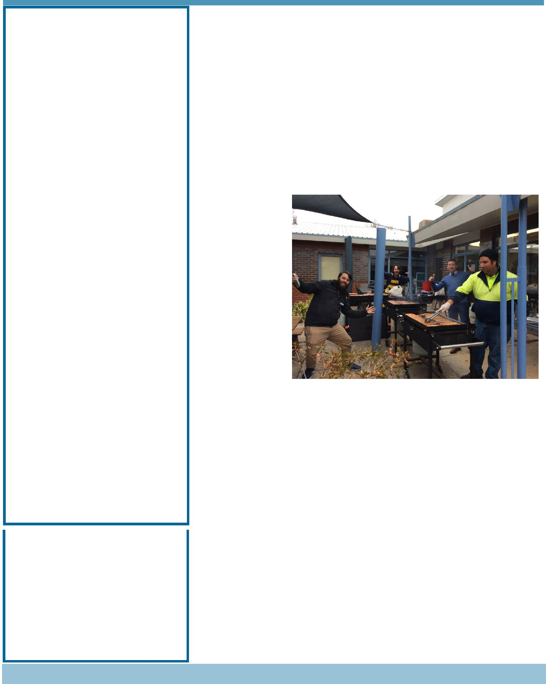

PRINCIPAL’S MESSAGE

I was in Tasmania last week, as my 88 year old mother had appendicitis and I went there to care for her. I would like to thank Mrs Flynn for overseeing the school as acting principal during my absence. Unfortunately I missed the Tournament of the Minds (ToMs) weekend. Palmerston always has a few teams that enter. Once again our students were outstanding. Thanks to Mrs Fletcher for her time and effort in preparing the students and in attending both days. Many parents acknowledged her contributions to ToMs and the commitment she has to Palmerston School.
Father’s Day

A big thank you also to all the families who came to our Father’s Day and Significant Person’s event held last Friday. I heard a great time was had by all and we just

beat the rain. Thank you to all who assisted on the day; teachers, community members and P&C.

This term is flying by and on Tuesday evening we held our cyber information session for families called Think you know. I would like to thank Mr Gowen for the organisation of this session. It is timely that we reflect on the use of social media with young children in the primary school years and the effects it can have on them. Next Wednesday, 11 September, at 5:30pm will be our Family Maths evening. I look forward to seeing you there. To assist parents in further understanding parts of the Australian Curriculum, Palmerston staff this term are providing evening workshops in:

- Maths

- Cyber bullying

- Personal Development

- Digital Technologies

Together, we learn from each other

What’s On

Unfortunately this week, we have had a break in at school. On Wednesday evening, at 2:30am, people jumped our school fence and broke into the year 6 building. They damaged items in the room and stole/damaged ipads. This incident was recorded by our security, the police were notified and they attended the school, along with the forensic unit to check for fingerprints. If you have any knowledge of who may have done this to our school and taken our property, please contact the front office. Have a great week,
Melissa Travers

DEPUTY PRINCIPAL’S MESSAGE

Welcome to another week of learning at Palmerston. I have been spending time in the classrooms and have been very impressed with the levels of engagement and the quality of work that the children are producing. I have observed the children in the CAP classrooms responding to the Achievement Standards of the Australian Curriculum by utilising higher order thinking skills to analyse and interpret elements of their individual class novels. Each novel contains a geographical element and integrates beautifully with the current Geography unit that compares cultures, including indigenous cultures both within Australia and outside of Australia.

We were overwhelmed with the level of community spirit at our annual Father’s Day Breakfast and maths games event last Friday. The weather held out for us until the last few minutes - we were really glad that we were able to feed everyone before the rain started. The students have told us that they loved the opportunity to spend time completing a maths activity with a special person and we thank all community members for supporting us on this day. I would also like to thank Catherine Griffin for organising this event and the amazing staff who turned up bright and early Friday morning to set up for the day. Thanks to the P&C who purchased
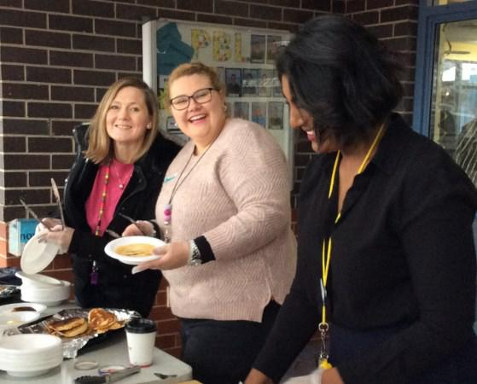
and donated the food for the day.

On Monday our year 5/6 students attended the Think U Know workshop and our parents on Tuesday

evening.. ThinkUKnow is an evidence-based cyber safety program that provides information on the

technologies young people use, the challenges they may face, and importantly, how they can be

overcome. The aim is to provide parents and students with the tools to create a safer online

environment and presentations cover what young people SAY, SEE and DO online. For more

information please visit www.thinkuknow.org.au

Have a great week,

Kate Flynn

ASTHMA

Asthma Australia offers an Asthma Care Plan template specifically for schools and care services which can be distributed to parents/guardians of children with asthma, to be completed by their GP and returned to the supervising staff and emergency medical personnel in their school. The template is also available for download on the Asthma Australia website www.asthmaaustralia.org.au or see the front office staff.

Together, we learn from each other

What’s On

STUDENT ACHIEVEMENTS

Congratulations to Dylan - 3/4JM who competed at the Australian National Eisteddfod last week. He placed:

2nd in 9 Years and Under Piano, Classical

1st in 9 Years and Under Piano, Own Choice Restricted 3rd in 9 Years and Under Piano, Australian and

1st in 9 Years and Under Piano, Own Choice Duet Amazing results, well done Dylan!

DEFENCE NEWS

Recently Defence students from Kindergarten to Year 2 had the opportunity to take part in the Tyler Turtle Program.
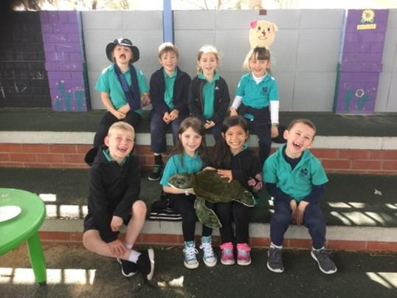

During the Tyler Turtle programs students learned resilience and strategies when encountering challenges due to Defence life such as deployments, relocations, and reuniting with family members who are returning home after a long time away. We also had a whole lot of fun blowing bubbles just like Tyler Turtle.

Think U Know

On Tuesday evening Think U know held an information session at Palmerston providing an informative guide to cybersafety. Think U Know suggested some helpful tips for at home with your child. Some of these include:

- Have open and honest conversations with your child about what to do if they see something online that upsets them

- Encourage your child to see you if they see something online that makes them uncomfortable

- Discuss appropriate safety rules about using the internet and technology. We have included this week in the newsletter an example of a family online safety contract

- Where possible, supervise use of the internet

- Consider parental controls and safe search controls

- Encourage your child to think before they post

- Know what your kids are doing online, who they are friends with, and who they may be talking to If you would like more information the Think U Know website provides factsheets and they are happy to assist with any questions you may have. If something has happened online that you are not sure of or you think is inappropriate you can contact the eSafety Commissioner.

We have sourced some information books from Think U Know for parents who may have been unable to make this session. These are available in the front office if you would like a copy.

Together, we learn from each other

What’s On

UPCOMING EVENTS

P&C “80’s/Neon” Disco

Date: Junior - 6:00-7:15pm, Senior - 7:30-9:00pm

Friday 7 September 2018

Location: Palmerston District Primary

Parent Maths Information Night

Date: 5:30pm Tuesday 11 September 2018

Location: Library, Palmerston

Yr5/6 Constable Kenny - Stay OK for Life

Date: Wednesday 12 September 2018

Location: Palmerston District Primary

Crazy Hair Day for Twilight Fair

Date: Tuesday 11 (Preschool beginning) & Friday 14 September 2018

Location: Palmerston
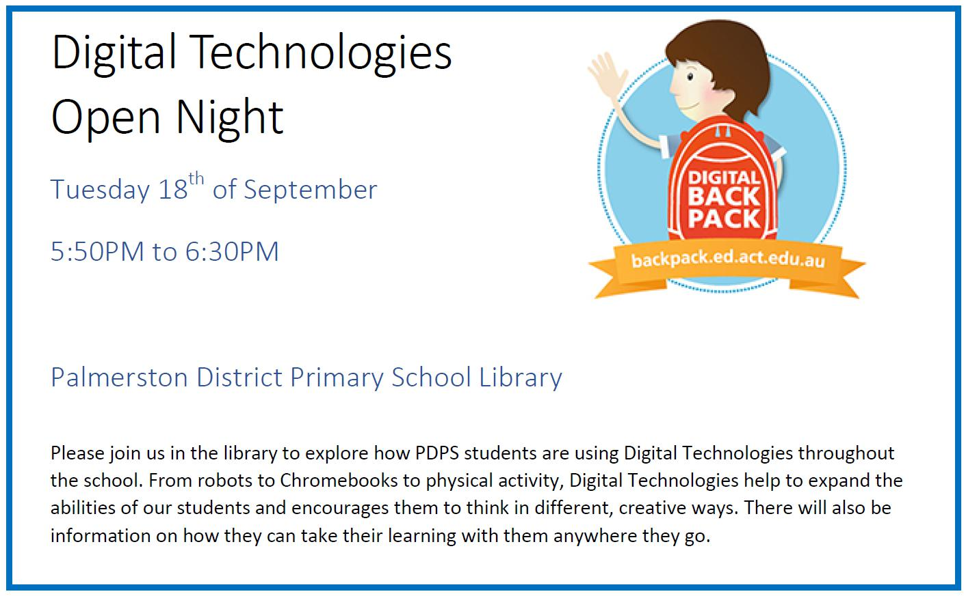

District Primary

PBL UPDATE

The PBL team have taken another step in our PBL journey and starting from today you will notice updates in our newsletter every second week around what the focus for the next fortnight will be. The picture to look out for looks like this:
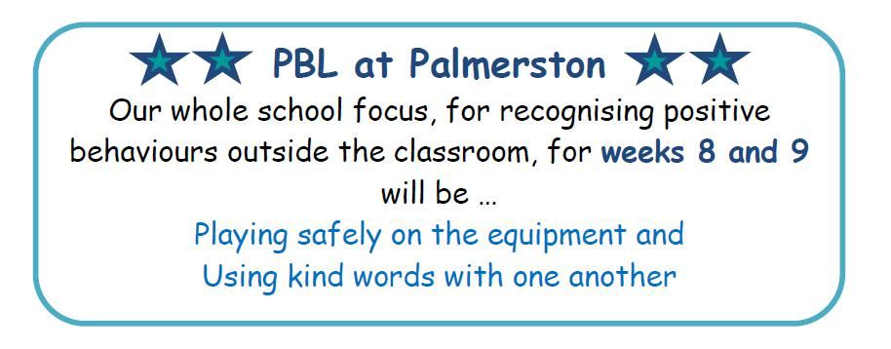

Once we have our mascot finalised it will also be added to the box above. We will also be reminding students about our fortnightly whole school focus at morning lines and via the app and Facebook.

Together, we learn from each other

What’s On

P&C NEWS

Book Club

Issue 6 closes tomorrow - 7 September.

Please ensure all orders are placed in the Boomerang Box , in front office foyer.

Please check to ensure all orders placed in the box include the following:

- Childs Name;

- a contact phone number;

- correct money;

- and the books that are required are indicated on the order form

The books can take up to 2 weeks to be received and delivered out to classes after the deadline.
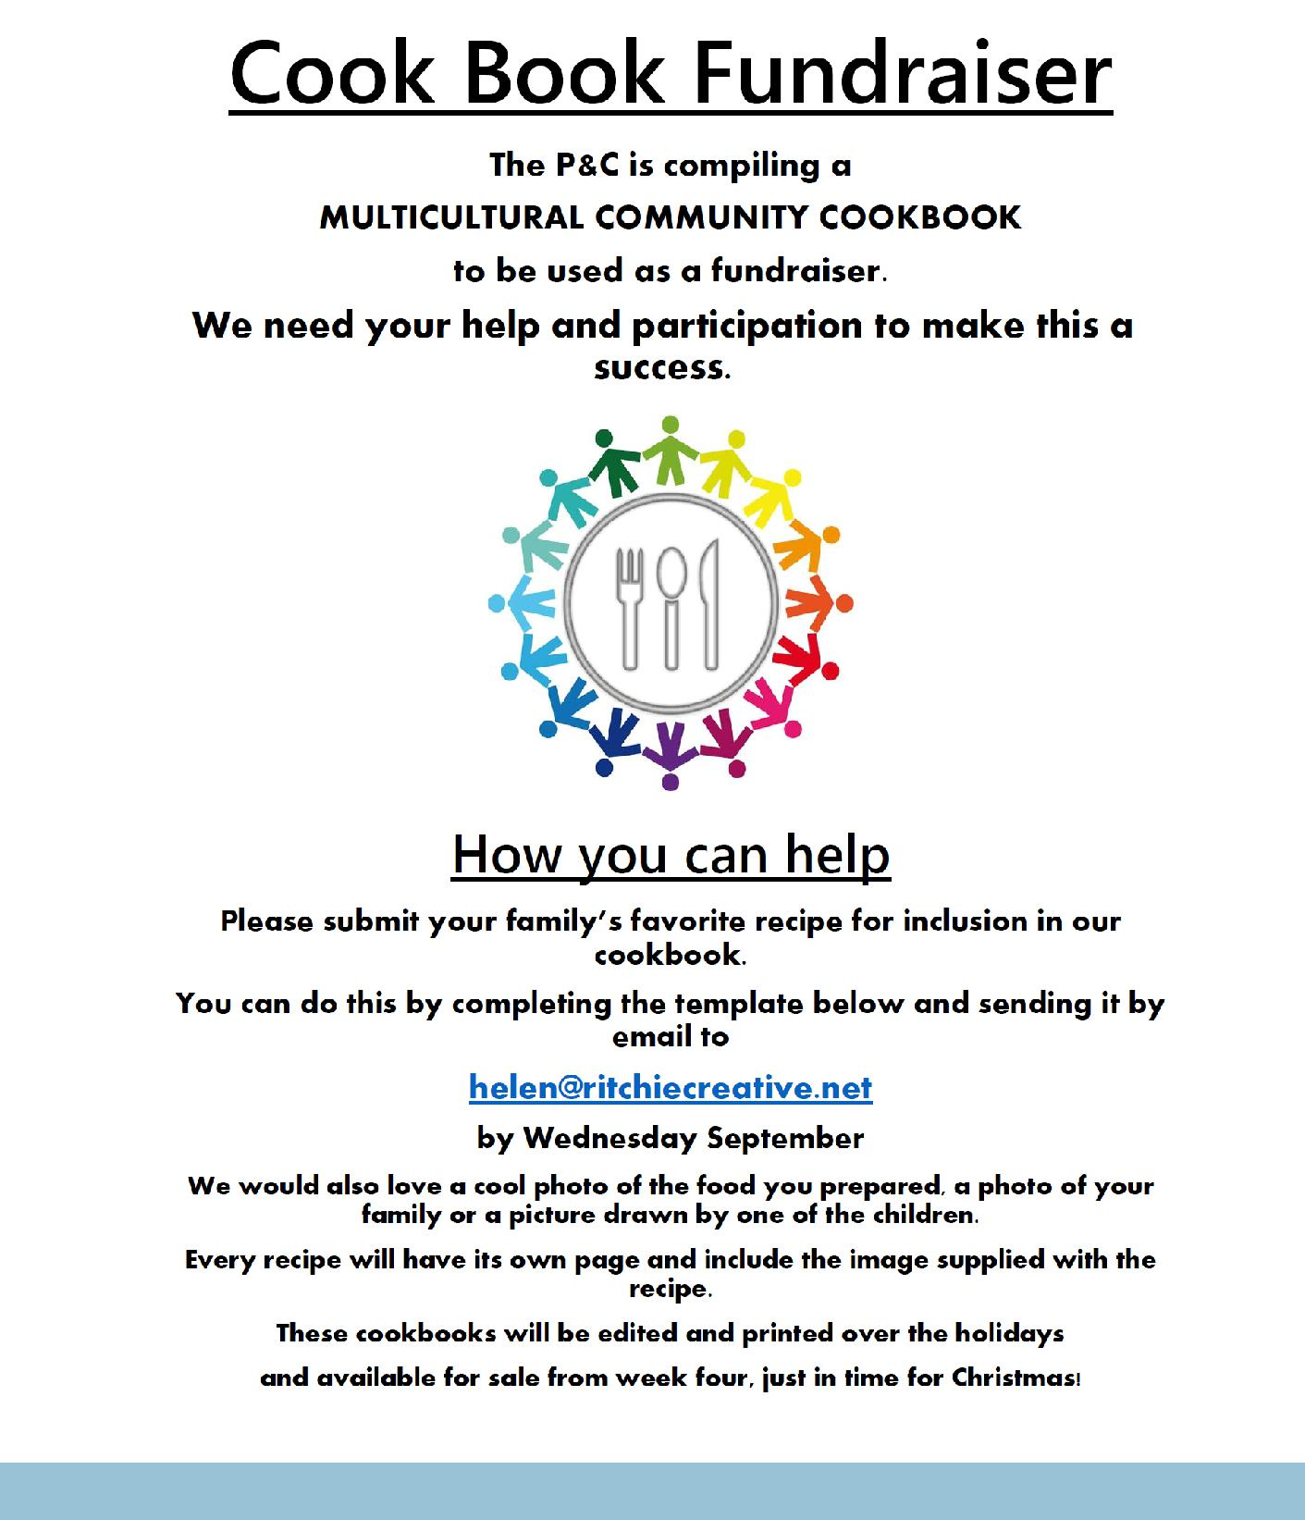

Together, we learn from each other

What’s On

Name of Recipe

_______________________________________________________________________________________________

Number of Serves: Preparation Time: Cooking

Time:

Difficulty (circle) : Kids Beginners OK for most Advanced

Category: Vegan Vegetarian Halal Gluten Free Dairy Free Other:

Culture (eg Asian, British, African):

Ingredients – 1 per box

Method:

Tips:

Please email this completed form, along with a file of a drawing or photo you would like next to the recipe, to helen@ritchiecreative.net before Wednesday 26 September 2018.

Together, we learn from each other

What’s On
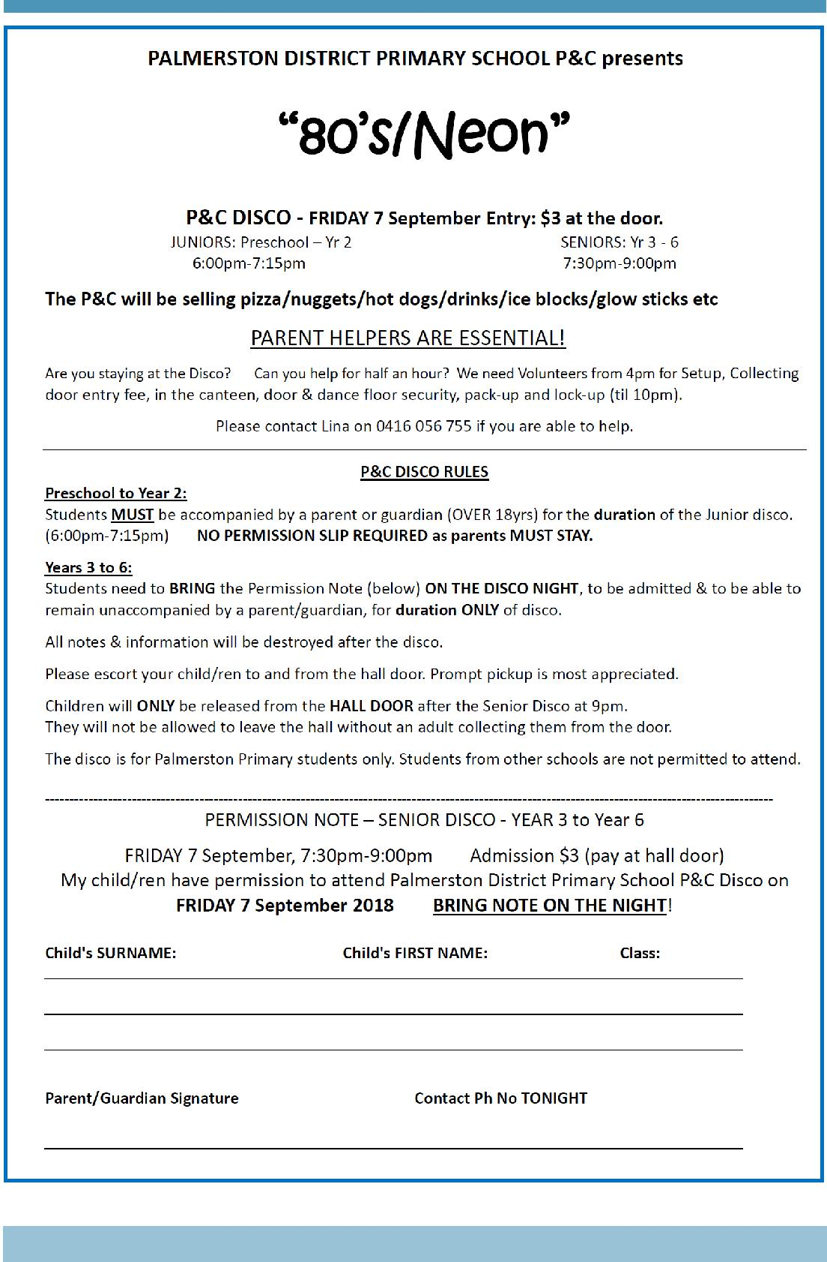

Together, we learn from each other

What’s On

SCHOOL INTENTIONS 2019

School Leavers 2019

We have now reached the time in the year when we begin to look at our school numbers and staffing arrangements for 2019. If your circumstances have changed and your child/ren will not be attending Palmerston District Primary School in 2019 can you please let the front office staff know as soon as possible.

My child/ren will not be returning to Palmerston in 2019.

Name Class

Last day at Palmerston:

My child/ren will be attending:

Another government school in the ACT:

A non-government school in the ACT:

Moving out of the ACT

Forwarding Address:

Phone number:

Parent’s name:

Together, we learn from each other

What’s On
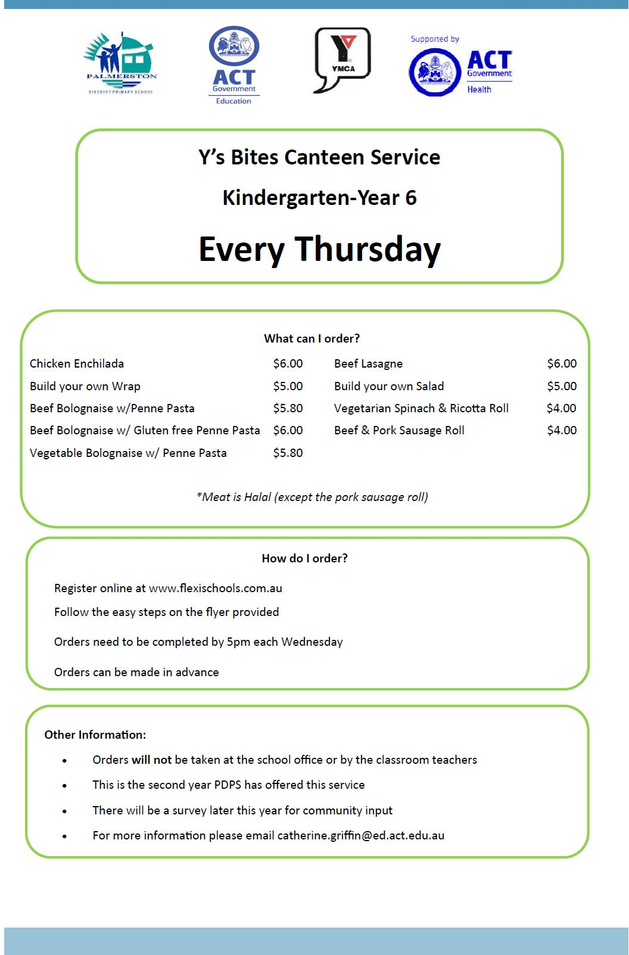

Together, we learn from each other

What’s On

Together, we learn from each other

What’s On
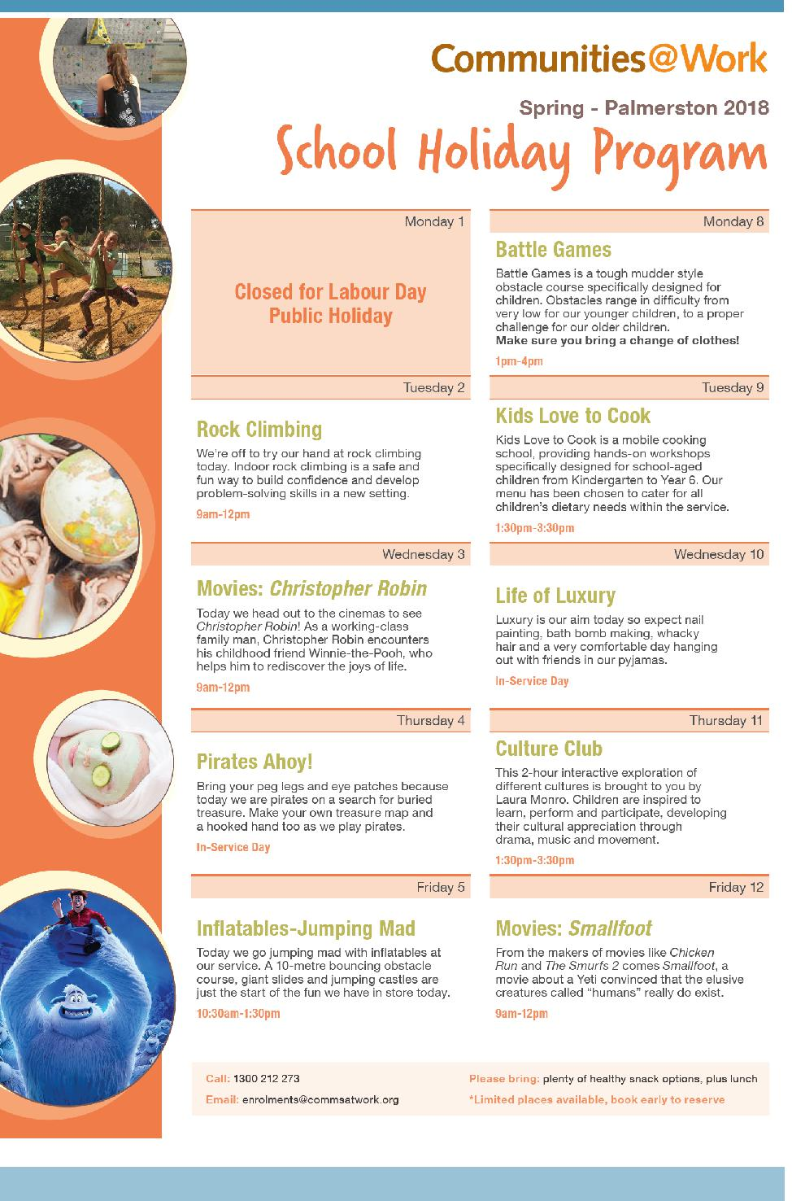

Together, we learn from each other

What’s On
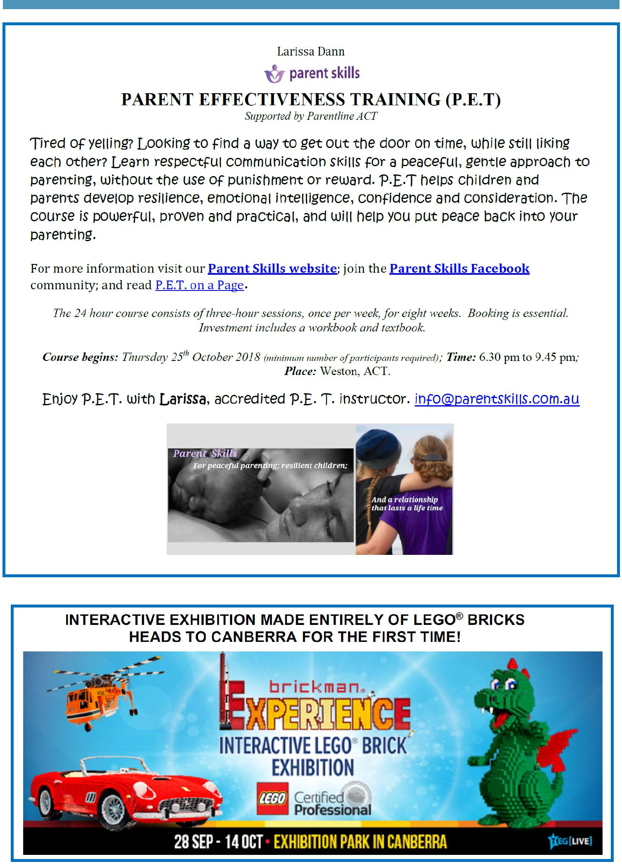

Together, we learn from each other

