Palmerston Post

28 March 2019

Week 8, Term 1

Board Chair: Lisa Fior

Teacher Reps: Jessica Lago and Maxine Green

P&C President: Lisa Fior

Principal: Melissa Travers Deputy Principals: Haeley Simms (acting) & Kylie Moller (acting)

Executive Teachers: Matt Gowen, Felicity McNeice, Catherine Griffin (acting)

ASSEMBLY:

29 Mar | Senior - 5/6CH & 5/6DT
05 Apr | Junior - 2SH & 2RC
12 Apr | No assembly - Easter
 | Hat Parade
DATES TO REMEMBER:
29 Mar | Yr1 Dress up day
1 Apr | 2MO & 2SH excursion
2 Apr | P/S Teddy Bear Picnic
3 Apr | 2RC & 2AF excursion
4 Apr | P/S Teddy Bear Picnic
5 Apr | P&C Disco
9 Apr | P/S Easter Hat Parade
10 Apr | K - Yr6 Cross Country
11 Apr | Yr5/6 Touch Football
 | Gala Day
12 Apr | K-Yr2 Easter Hat Parade

NOTES:

- K - Yr6 Cross Country

P&C BOARD NEWS P&C: 1 April 2019

All P&C activities, meeting agendas and minutes are available from the school website at – Parent Corner

School Board:

PRINCIPAL’S MESSAGE

On my last day, I write this. I would like to thank you all for being a fantastic school community. I have had a wonderful ten years as Principal of Palmerston and so enjoyed being part of your lives. Thank you for the opportunity to educate your children in partnership with you. At the farewell assembly, I was lucky to have many farewell speeches and songs from students, staff and the P&C/School Board. Thank you for the kind words.

For those who could not attend, I have included my speech below:

I will start with a quote from a favourite author:

How lucky I am, that saying goodbye is so hard- the words of AA Milne - from the book about Winnie the Poo.

The past ten years I have been with you all have been amazing. You all inspire me every day to do my best. I have always expected you to do your best, as that is what schooling is about.

We all try our best every day. We don’t all get it right, but we wake up the next day to a fresh start and try again. School is about new chances every day and new opportunities. It is also about growing, and one day growing out of primary school and making the next step. Each year we say goodbye to our year sixes as they go onto high school and we acknowledge their achievements. Now it is my turn. My turn to move on to the next step in my life. My turn to graduate from primary school! So do not be sad, but be happy:

Be happy we spent time together,

Be happy we laughed together

Be happy we learnt together

Be happy we got to share in each other’s achievements. How wonderful!

Or, I could just say, as Mahatma Gandhi once said:

There are no goodbyes for us, for wherever you are, you will always be in my heart.

Thank you and I wish you all the best.

Melissa Travers

Together, we learn from each other

Palmerston Post

SCHOOL BOARD CHAIR & P&C PRESIDENT - Farewell speech to Mrs Travers

Good morning teachers, students, parents, carers and guests,

It is an honour as school board chair to be asked here today to say a few words to farewell our principal Mrs Travers.

I first met Melissa in 2011 when considering if our new local school would be the ‘right’ place for our son to attend. Melissa provided a tour of the school and before I had left she had me more than convinced the school would be a wonderful community for us to become a part of. From that day forth we have never looked back.

I have had the privilege of working closely with Melissa now for a number of years. Through many school activities and events, the P&C and more recently as a member of the school board. All of these opportunities have provided the chance to get to know Melissa, understand her approach and to learn that no matter what or who she is dealing with she is always the same. This consistent and balanced approach is appreciated and admired by many.

Under the guard of Melissa over the last 10 years, the school has continued to grow and evolve. It has enhanced its reputation as both a beautiful school community and a learder in the provision of sound education. A legacy for which a leader should be very proud.

Melissa, as all effective leaders, has the uncanny knack of being able to engage in robust conversations, validate numerous perspectives and juggle the countless competing priorities a school community tosses up. All with a seemingly unflappable presence, skilled pragmatism, and a reassuring decisiveness. A fine balance I would say, and one that has served this community particularly well.

We would like to thank you for everything that you have brought to the Palmerston community, the many teachers you have helped grow, the many students that you have helped to learn and find their way. Thank you for your endless patience, motivation and persistence which has helped us all at many times in many different ways.

Isla would like me to end by saying: Mrs Travers, I’m sure we will all agree that she has been the most amazingest Principal, so bye Mrs Travers we will all miss you. Happy retirement and make sure you enjoy all of those opportunities to go out late on a school night.

Lisa Fior

Together, we learn from each other

Palmerston Post

RECIPES FROM MRS CAMPBELL

Pumpkin Soup

Soup really is a matter of taste and you can add in or leave out ingredients.

This is the recipe we used at school. The pumpkin was

prechopped and precooked with a combination of

microwaving and roasting the pumpkin pieces with olive oil,

salt and pepper.

Finely Chop:

- Garlic

- Brown onion

- Spring onion

- Herbs (we had parsley and celery leaves)

- Celery

Add chopped ingredients to a big pot and fry with olive oil, salt and pepper. Stir for a few minutes.

This brings out all the flavour and cooks the onion.

Add the cooked pumpkin to the big pot and mix through.

Add stock (we used ‘chicken style’ vegetarian powdered stock) and water to the amount of soup you want.

Put the lid on the pot and boil. Blend the soup for a smoother consistency before serving. Pumpkin soup is extra yummy with sour cream stirred through and crusty bread (as pictured) – we just had the soup in a cup without the extras.

2020 PRESCHOOL TOURS

Come and walk through Palmerston Preschool on a guided tour.
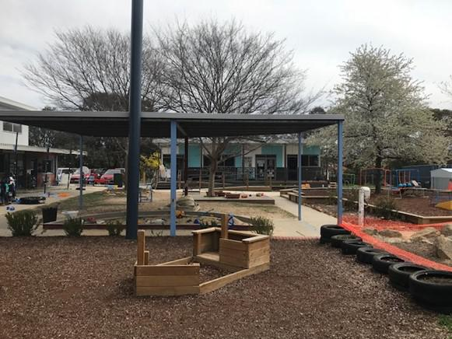

Meet the Executive teacher and Preschool staff. Learn about the Early Years Framework and Preschool program.

Observe the Preschool program in action.

Thursday 4th April 2:00 pm

Wednesday 10th April 2:00 pm

Tuesday 7th May 9:30 am

Thursday 9th May 9:30 am

Monday 13th May 2:00 pm

Please call the front office: 6142 1440 to book a preschool tour.

Together, we learn from each other

Palmerston Post

UPCOMING EVENTS

Year 1 - What I want to be when I grow up (dress up)

Date: Friday 29 March 2019

Location: PDPS

Year 2 - Hall School Museum & Heritage Centre excursion Date: Monday 1 April 2019 - 2MO & 2SH Wednesday 3 April 2019 - 2RC - 2AF

Preschool - Teddy Bear Picnic

Date: Tuesday 2 April 2019 - Itchy, Noisy & Brave Bears Thursday 4 April 2019 - Cranky, Sleepy & Hungry Bears Location: Palmerston Preschool

P&C ‘Sports Fans / Sports Team’ Disco

Date: Friday 5 April 2019

Location: PDPS, Hall

Easter Hat Parades

Date: Tuesday 9 April 2019 - Itchy, Noisy & Brave Bears Friday 12 April 2019 - Preschool - Yr2 Location: PDPS

K - Yr6 Cross Country

Date: Wednesday 10 April 2019

Location: PDPS

Yr5/6 Touch Football Gala Day

Date: Thursday 11 April 2019

* Reminder *

School banking is every Wednesday morning

Together, we learn from each other

Palmerston Post
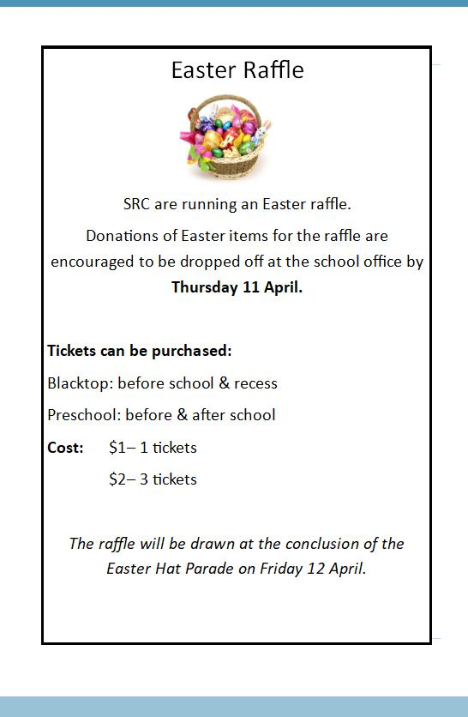

Together, we learn from each other

Palmerston Post
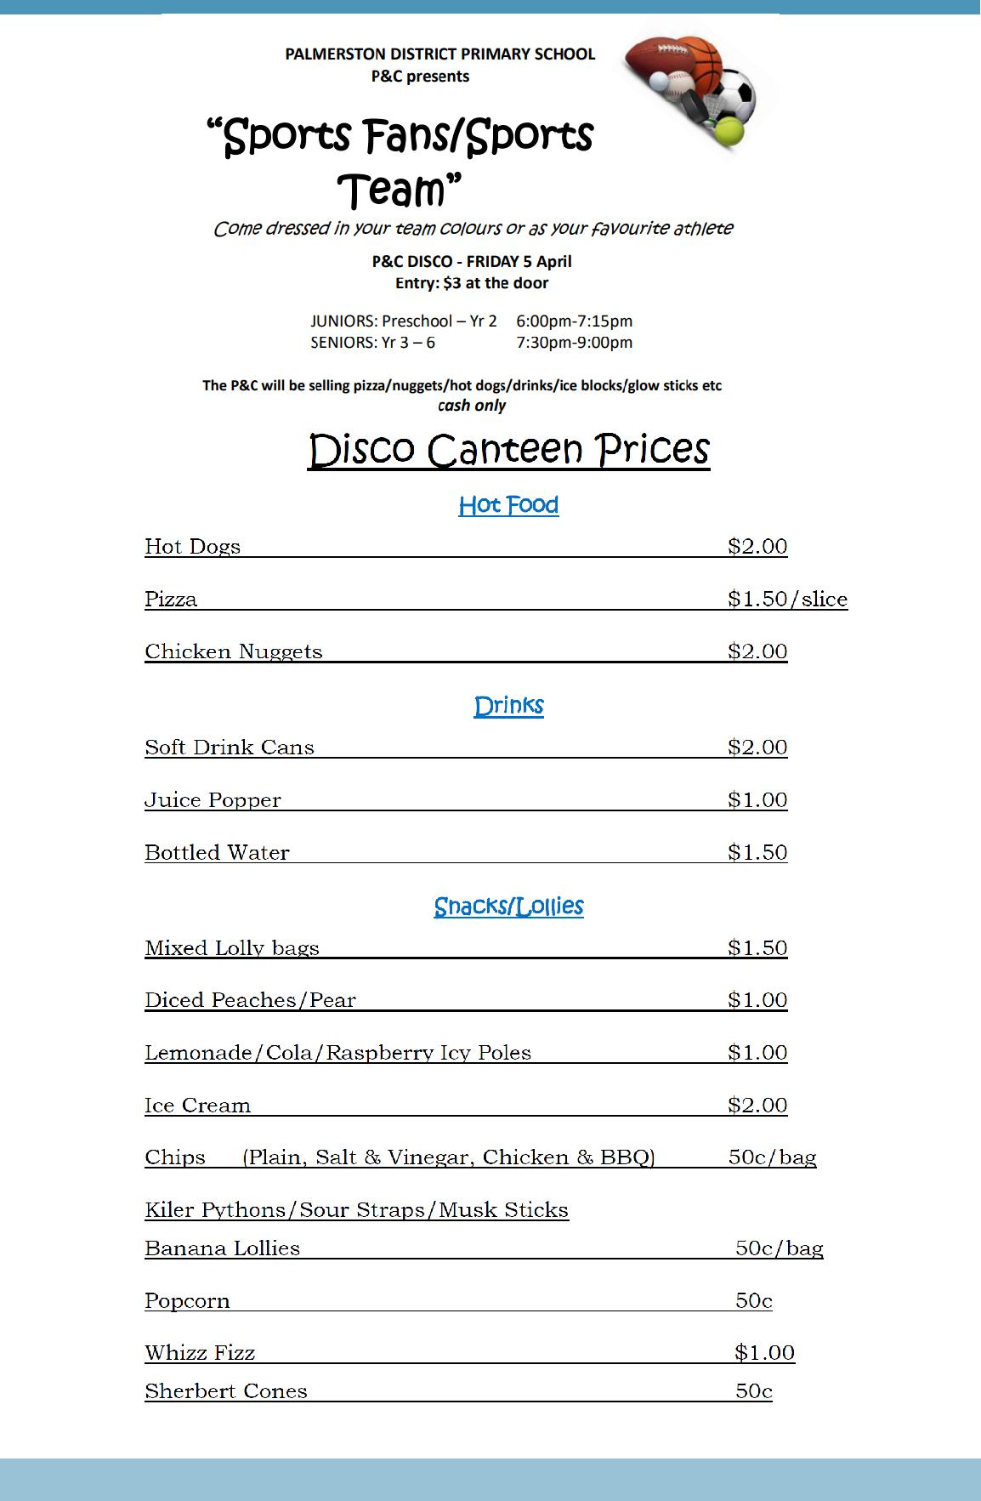

Together, we learn from each other

Palmerston Post

ACADEMIC AWARDS

Congratulations to the following students who received an Academic Award at assembly in week 7.

Kindy - | Chloe & Nicholas
Year 1 - | Zoe & Ira
Year 2 - | Ainslie & Niansh
Year 3 - | Eluney & Harely
Year 4 - | Sophie & Georgia
Year 5 - | Jacob
Year 6 - | Niina & Hannah
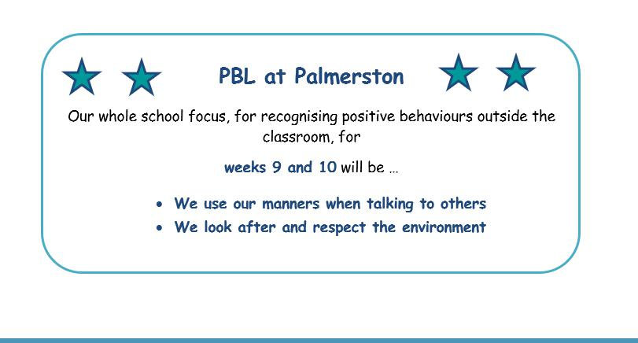

AMBULANCE COVER

The ACT Education Directorate does not provide any insurance cover for injury, disease or illness to students resulting from school activities or school-organised excursions. Claims for compensation are met where there is a legal liability to do so. Liability is not automatic and depends on the circumstances in which any injury, disease or illness was sustained.

As there is no automatic insurance cover for personal injury if your child is injured at school or during a school organised activity/excursion you should therefore consider whether taking out personal insurance cover for your child is warranted.

This insurance might cover contingencies including medical/hospital expenses, ambulance transport outside the ACT, and cancellation of transport/accommodation or loss of/damage to luggage.

The ACT Ambulance Service provides free ambulance transport for students who are injured or suddenly become ill at school or during an approved school organised activity within the ACT.

Together, we learn from each other

Palmerston Post
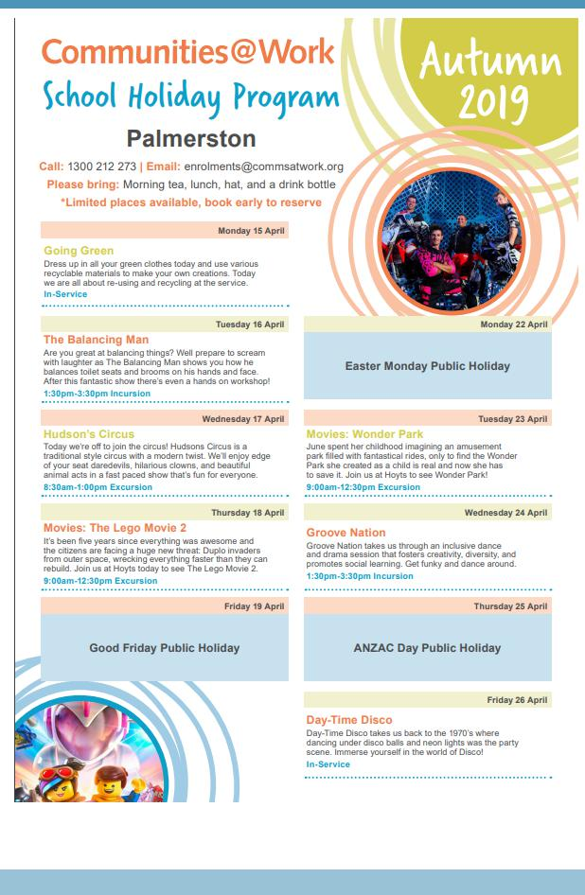

Together, we learn from each other

