Palmerston Post

4 July 2019

Week 10, Term 2

Board Chair: Lisa Fior Board Members: Parent Reps: Adam Davidson and Kate Baron

Teacher Reps: Jessica Lago and Maxine Green

P&C President: Lisa Fior

Principal: Kate Smith Deputy Principals: Haeley Simms (A/g) & Kylie Moller (A/g)

Executive Teachers: Matt Gowen, Felicity McNeice, Catherine Griffin (A/g)
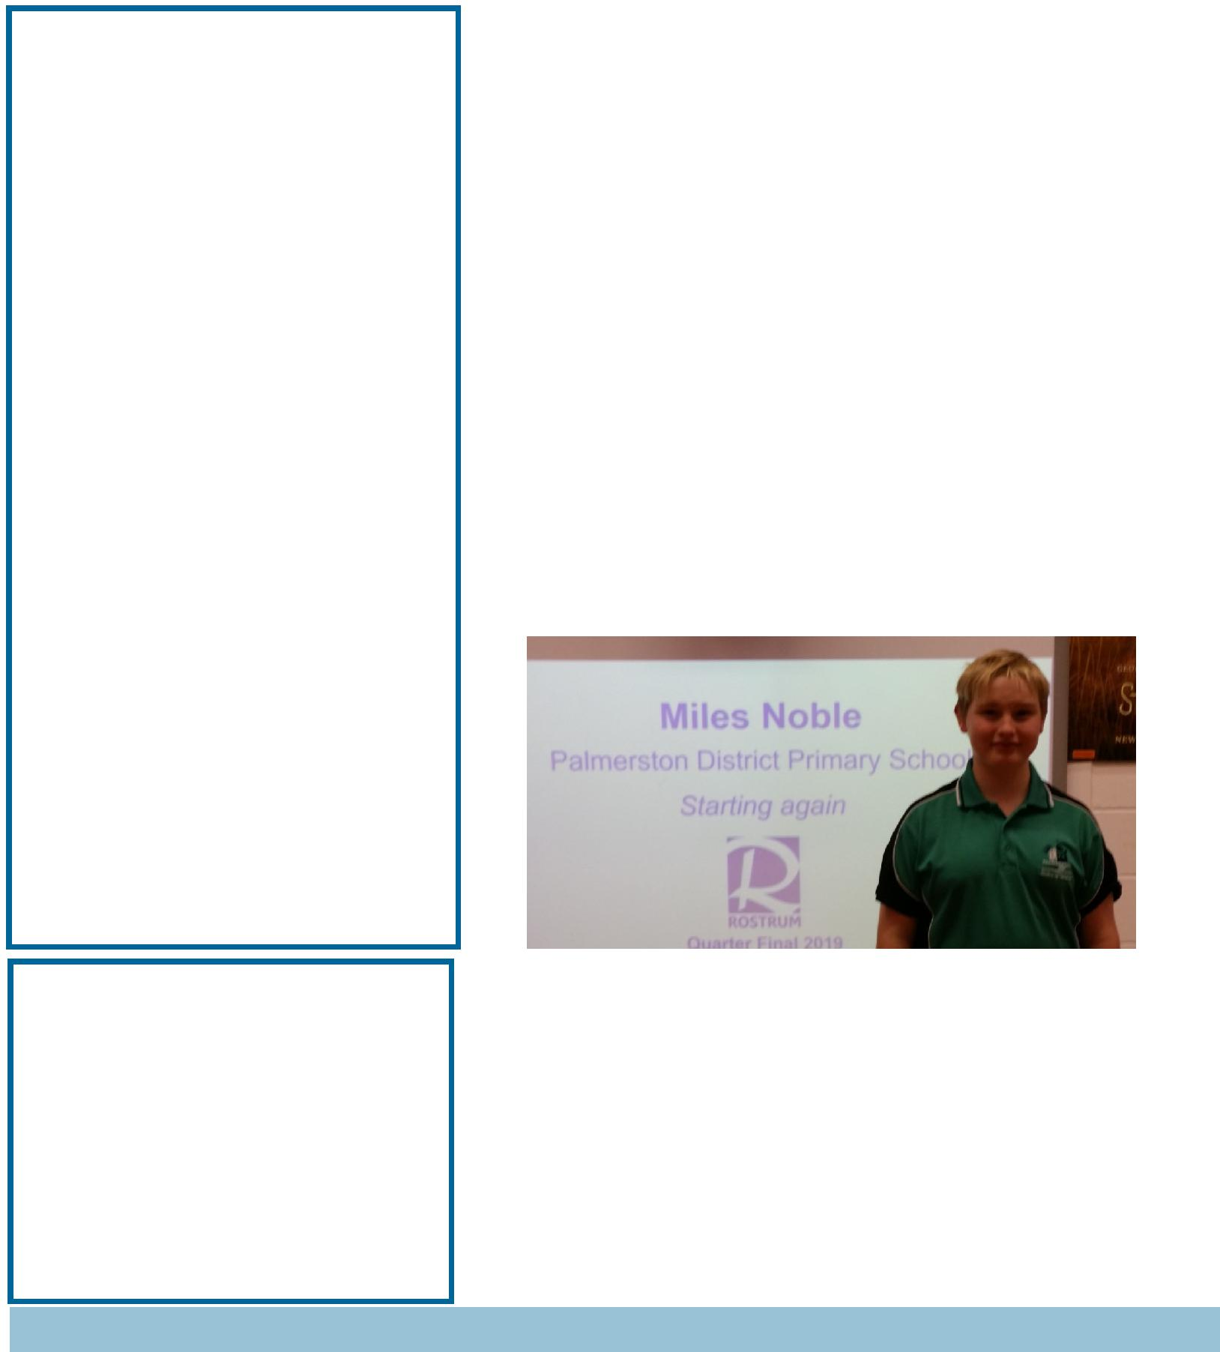

ASSEMBLY:
5 | July | Junior - IEC
DATES TO REMEMBER:
1-5 July |  | Parent teacher interviews
5 | July | P/S Healthy food challenge
5 | July | P&C Lunch order day
5 July |  | P&C Pyjama Day
5 | July | Last day of term 2
6 | July-
21 July |  | School Holidays
22 July |  | Term 3 begins
NOTES:
Holiday Happenings- Available in the
 |  | front office
 |  | P&C BOARD NEWS
P&C: 24 June 2019

All P&C activities, meeting agendas and minutes are available from the school website at – Parent Corner

School Board: 24 June 2019

PRINCIPALS’ MESSAGE

Nine weeks into this beautiful school and I have seen the very best of student voice and student leadership this week. Thank

you to all students for their participation in the “Dress like a Farmer Day” yesterday! I loved seeing so many famers and farm

animals on the blacktop first thing yesterday morning. A very big congratulations to our two School Captains for their role in initiating the event, and organising with Ms Brailey such a fun morning. To find out we raised nearly $1100 was amazing! Good on you Palmerston Community for supporting this!

Wearing our PJ’s tomorrow will top off a fantastic term – again, join in the fun, hop out of bed and come to school! I am looking

forward to wearing my favourite PJ’s of all time! Congratulations to Miles for representing our school at Rostrum

– we are very proud of your efforts, it is a wonderful skill to be able to publicly speak with confidence and I am very proud of you!

Our green team are doing wonderful things with Ms Campbell – what a dynamic bunch of environmental lovers you are. Our school is so lucky to have you work the way you do to keep our school looking so good. Today, you look extra fabulous with your

new badges. Please wear them with pride each day!

Together, we learn from each other

Palmerston Post

Kay taught me how to floss today in the Gudgenby disco, awarded for having the highest PBL points for the term. Good on you Gudgenby! Thanks Kay, you are an awesome teacher.

Thank you everyone for embracing this term in the manner in which you have. Thank you for making me feel so welcome… I have utterly loved every day back. It does not seem like 25 years ago that I walked through these doors for the first time, on it’s opening day. To all staff, parents and students, have a colossal holiday

and we will see you back on July 22nd!

Until then – stay warm…and curious!

Kate Smith

Parents and Carers

You may see some media coverage regarding recent incidents where children were approached by a man they did not know. This occurred in the suburbs of Isaacs and Monash. You can access the ACT Policing media release on their website: https://policenews.act.gov.au/news/media-releases/call-witnesses-following-two-child-approaches-0 .

This is a good reminder to help our children understand the importance of stranger safety and the need to report any unusual incidents or approaches to staff immediately.

As the school holidays will begin soon, we encourage you to have conversations with your children about moving safely in and around the community and what to do if they ever feel unsafe. Doing so will help children understand the importance of stranger safety in and out of school hours, and also the importance of reporting any unusual incidents or approaches to parents/carers or school staff immediately.

Police encourage parents, guardians and teachers to make sure children understand how to keep themselves safe, particularly when walking to and from school, and to teach children about stranger safety. Information on ways to help children to stay safe is available on the http://www.constablekenny.org.au/. In addition, the Safety4Kids is a non-government website that has useful information and links.

If you become aware of an incident, or notice anyone acting suspiciously around a school or child, contact police immediately on 131 444 or in the case of an emergency call 000. The quicker police can respond and attend to an incident of this nature, the quicker they can target the area and surrounds.

Thank you

Together, we learn from each other

Palmerston Post

ENROLMENT UPDATES

Just a reminder in regards to enrolling your child, for Preschool 2020…..for those families that have not done

an online enrolment form yet, to be considered in the 2nd Round of Offers (Applications submitted between 8th June to 13th September) we advise that you jump onto the following link www.education.act.gov.au and complete your applications. As Preschool is not compulsory, there are limited spaces available and we wouldn’t want our Palmerston families to miss out!
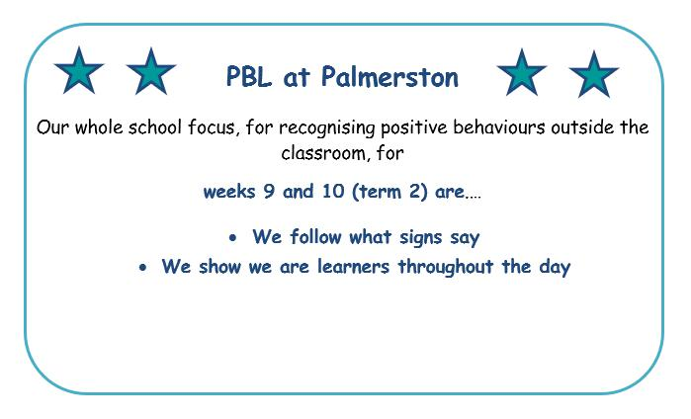

UPCOMING EVENTS

P&C Lunch Order Day

Date: Friday 5 July 2019

Location: PDPS

P&C Pyjama Day

Date: Friday 5 July 2019

Location: PDPS

Together, we learn from each other

Palmerston Post

YEAR ONE NEWS

In year one, we have been learning about ‘Light and Sound’. We have explored the different sources of natural and artificial light. Students created a chalk shadow on the blacktop and discovered that shadows were made when a solid object blocks light from the sun. They noticed that their shadows move based on the position of the sun in the sky.
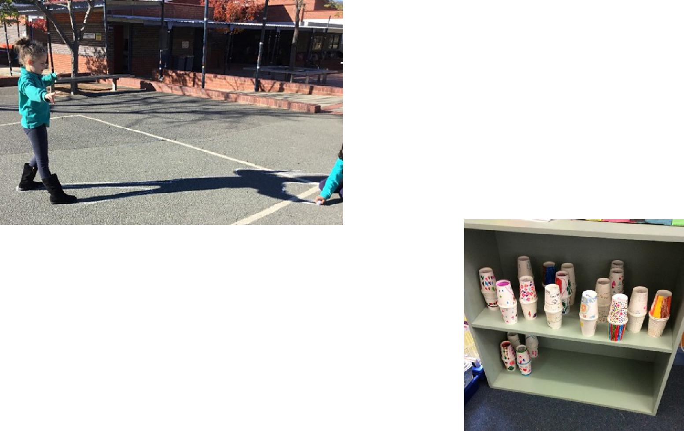

During our ‘sound’ lessons, students learnt about how sounds are made through waves or vibrations that travel through the air. They made and decorated their maracas, which they then used to create sounds. After further exploration of sound and music, students were given the opportunity to design, make and appraise their musical instruments from recycled materials.
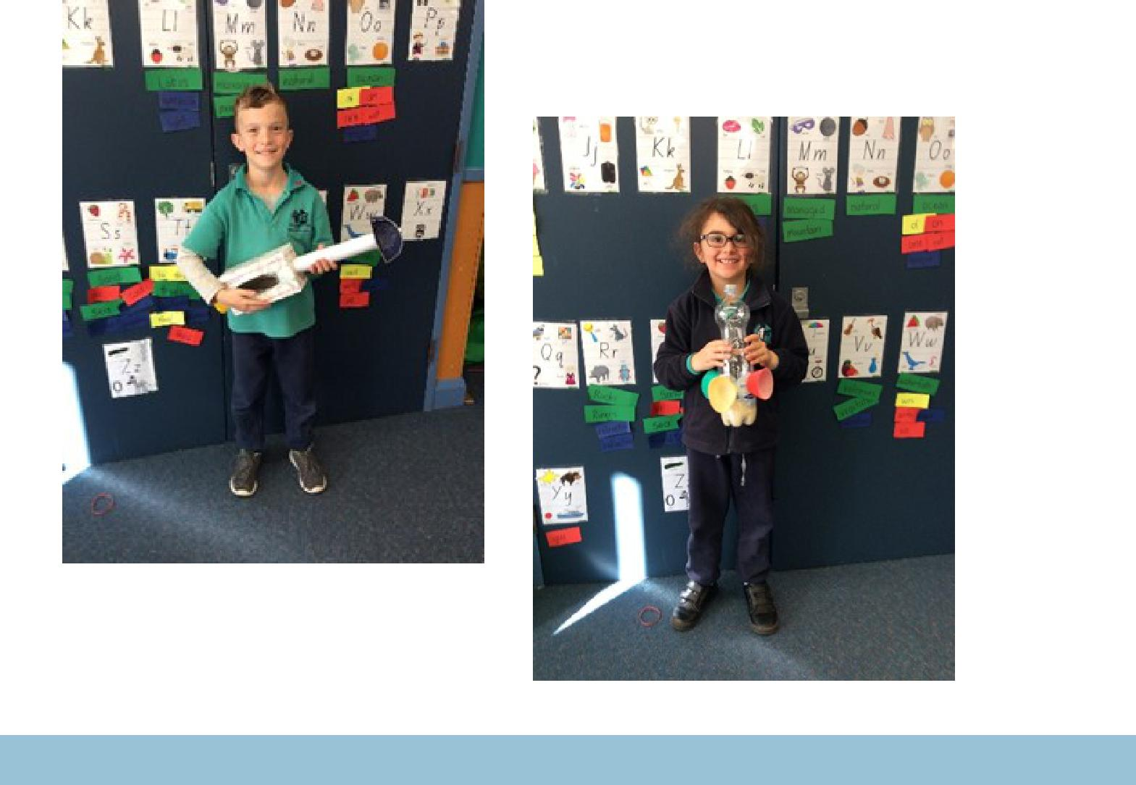

Together, we learn from each other

Palmerston Post

DEFENCE NEWS

Defence Kids – End of Term Party

During Defence Club on Friday, 5th July, we will be having a party and I will be providing some hot chips during the lunch break. All Defence students are invited to attend and a note will be going home today regarding this event.

***POSTINGS***

As posting orders arrive please keep me updated with your family’s plans for relocation or absences e.g. deployment or courses. Then I can best support your child/ren at school. Please contact kristy.retzlaff@ed.act.edu.au or Ph: 6142 1440.

Thank-you,

Kristy Retzlaff

Defence School Mentor

DCO KidSMART Program

Commences Thursday 8th August, 3:30 – 5:00pm

Defence Community Organisation

Ground Floor, 8 Thesiger Crt, Deakin

Details: This event is only for the children of Australian Defence

Force members.

The KidSMART program is designed to help primary school aged children manage issues arising from parent deployment and absence from home. It helps children to learn how to manage change, stay connected with friends, meet new people, and coping strategies when they are feeling stressed or anxious and handling different situations.

DCO is offering a four-week program for children aged from 7-10, running on consecutive Thursdays during August for one and a half hours each week (8,15,22,29 August).

Children will be provided with afternoon tea upon arrival. Parents do not need to stay for the sessions, but if you would like to remain close by the Mint Café is located across from DCO and is open until 5pm, also Deakin shops are nearby.

When registering, ensure your contact details are accurate. You will receive a booking confirmation via email, and you will be contacted to provide further registration details before the start of the program.

Please head to the Defence Community Organisation Facebook Page for booking information or alternatively contact Defence Family Helpline on 1800 624 608. I can also assist you with further information if you require assistance with bookings at kristy.retzlaff@ed.act.edu.au

Together, we learn from each other

Palmerston Post

P&C NEWS

P&C PJ DAY

On Friday 5th July, there will be whole school PJ dress up day. Students can wear appropriate pyjamas and footwear and bring in a gold coin donation to start fundraising for the twilight fair.

Your help is very much appreciated to support this upcoming spectacular event.

Many Thanks

P&C
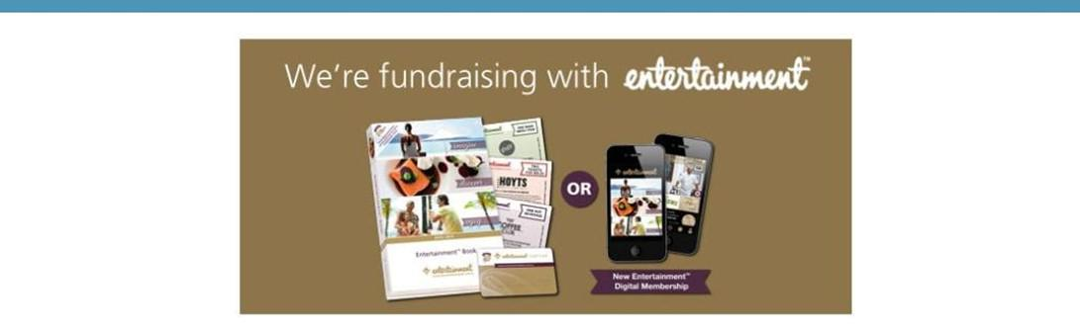

The P&C are fundraising with the Entertainment book. The Entertainment™ Book is a local restaurant and activity guide which provides hundreds of up to 50% off and 2-for-1 offers from the finest restaurants, cafes, attractions, activities, retailers and hotel accommodation. The Membership entitles buyers to exclusive offers that are virtually restriction-free, and is valid through to 1 June 2020!

The Entertainment™ Digital Membership (app) puts all of the value of the Entertainment ™ Book into the customer's smartphone. With 'near me' technology and the ability to show and save using a phone, this is

perfect for the person on-the-go, with no card or voucher to present.

You can purchase a book through the front office or download the app via this link

https://www.entertainmentbook.com.au/orderbooks/2487s6

Together, we learn from each other

Palmerston Post

P&C UNIFORM SHOP NEWS

Did you know?

The uniform shop has lots of plain navy jumpers and jackets available – a cheap alternative for anyone who regularly loses jumpers!

We also have new reusable sandwich/roll wraps and snack bags for sale. Great for Waste Free Wednesdays.
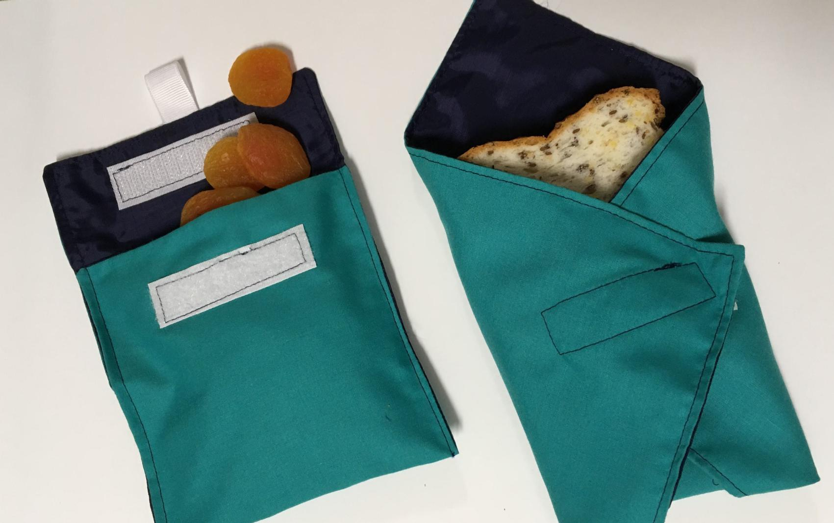

Donations to the 2nd hand Uniform Shop are always welcome and can be left at the front office any time.

Regards,

Kate and Franki

Together, we learn from each other

Palmerston Post

Uniform Shop Price List

New Merchandise

Polar Fleece Beanies (with logo) | $10
Dresses (Winter Navy) | $30
Library Bags (with logo) | $15
Round Palmerston logo Sew-on Badges (Small) | $2.50
Round Palmerston logo Sew-on Badges (Large) | $3.50
Palmerston Teaspoons | $5
Palmerston Coffee Mugs | $10
Palmerston Travel Mugs | $15
Sandwich/Roll Wrap | $8
Snack Bags | $8
Sandwich wrap and snack bag combo | $15

Second Hand Items

Hats | $2
Palmerston Polo Shirts | $2
Palmerston Long Sleeve Shirts | $3
Skivvies | $2
Jumpers – No Logo | $2
Jumpers - Logo | $5
Vest – Logo | $3
Trousers/Trackpants | $3
Shorts | $2
Skorts | $2
Sports Skirts | $2
Girls Bike Pants | $2
Dresses (navy winter and checked summer) | $5
School Bag with Logo | $10

P&C Uniform Shop is located just inside the Hall Entrance

Contact the Front Office, or P&C contact below, to make an appointment outside of standard opening hours.

Kate: 0404 675 508 Franki: 0431 675 725

Opening Times: Tuesday 2:45 - 3:15pm

Friday 8:45 – 9:15am

Together, we learn from each other

Palmerston Post

Together, we learn from each other

Palmerston Post

With winter upon us, it’s important to remember that Canberra has lots of health options that don’t involve a trip to a hospital emergency department. Many of these are free and available after hours.

Walk-in Centres provide free, one-off treatment of minor injury and illness, including colds and flu. They’re a great choice for children over 2 years of age – children under 2 should see their GP.

Walk-in Centres are open from 7.30am to 10pm, every day of the year. They are staffed by highly skilled nurses who can provide you with a sick certificate and in some cases, medication, saving you time and money.

The service is free and no appointments are necessary.

Walk-in Centres are located in Tuggeranong, Belconnen and Gungahlin.

To find out more about getting the right health care for your symptoms, visit

www.act.gov.au/yourhealthoptions

Together, we learn from each other

Palmerston Post

COMMUNITIES @ WORK
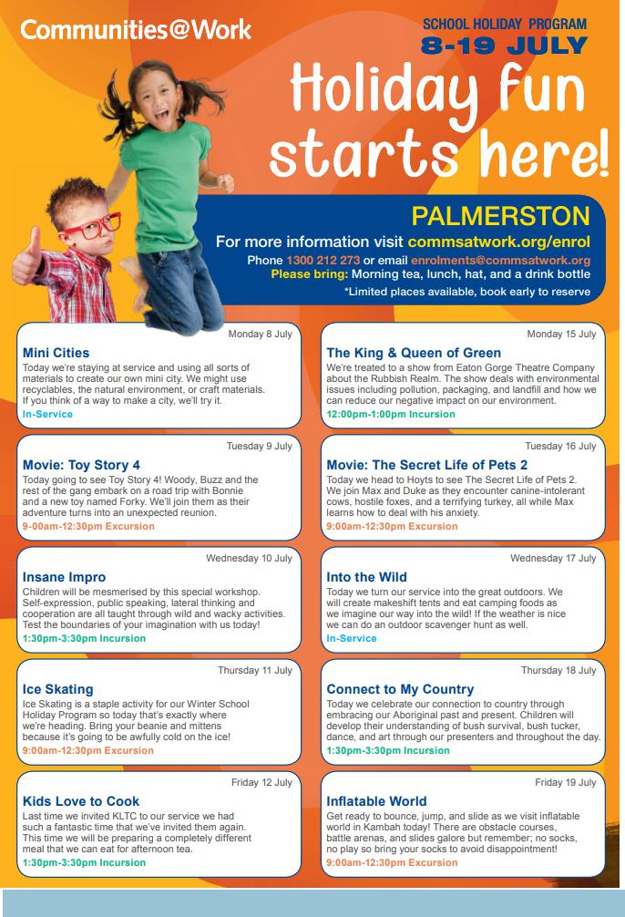

Together, we learn from each other

Palmerston Post

HIRERS NEWS
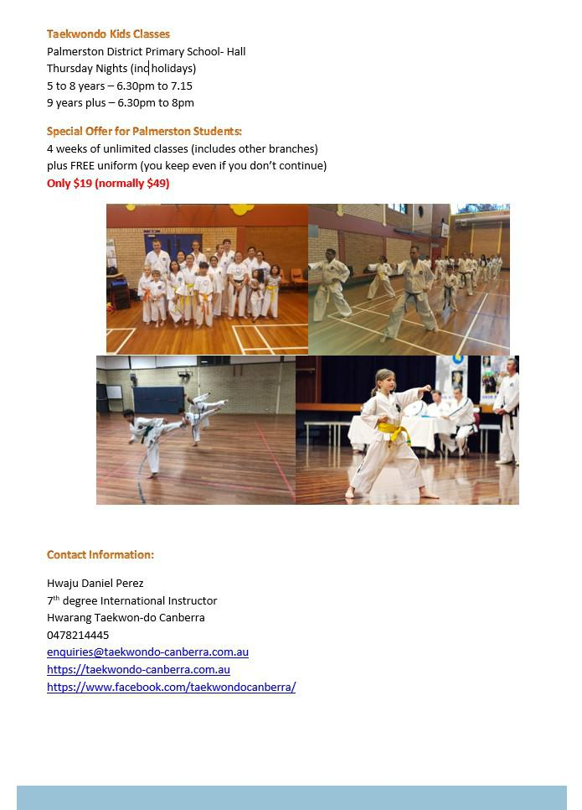

Together, we learn from each other

Palmerston Post

ParentLink

ParentLink provides parenting education to the community, from birth to teenage years. It is available for parents, carers, kin, teachers, and the broader community, providing information and links to local resources and services.

The ParentLink website provides links to all ParentLink guides including a variety of topics - Start-ing School, More than Reading and Writing, Optimism and Cyber Safety.

The ParentLink suite of resources includes guides specifically for Aboriginal and Torres Strait Islander families, and access to resources for diverse cultural groups.

ParentLink guides are available to view and order via the website at, https:// www.parentlink.act.gov.au/

PARKING AROUND SCHOOLS

As we drive and park our cars around schools we all need to ensure the safety of school students is our priority. Parking ille-gally and unsafely across pedestrian crossings, corners and verges puts children at risk. We all need to help keep our chil-dren safe. Here is a short video demonstration: https:// youtu.be/AslMVXpA9Zc
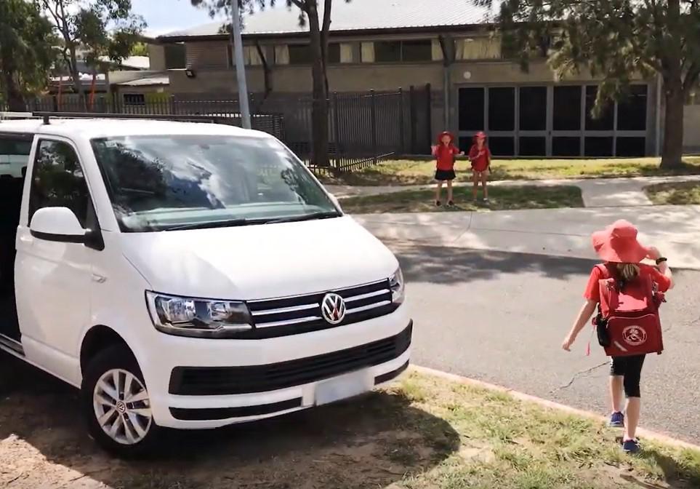
Access Canberra inspectors will be patrolling our school zones to help us ensure drivers do the right thing.

Together, we learn from each other

