What’s On
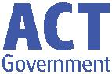

25 July 2019

Week 1, Term 3

ASSEMBLY:

Term 3
- Senior Assembly

4VS & 4RE
- Junior Assembly

2MO & 2AF
- Senior Assembly

5/6CH & 5/6DT & 5/6JM
- Junior Assembly

1DE & 1KW

DATES TO REMEMBER:

31 July - Class, sibling and Special Group

Photos

1 August—3/4 Touch Football Gala Day

13 August—Michael Salmon Author Visit

NOTES:

3/4 Touch Football Gala Day 2019

Year 6 Graduation Shirt

P&C BOARD NEWS P&C: 5 August 2019

All P&C activities, meeting agendas and minutes are available from the school website at – Parent Corner

School Board: 5 August 2019

PRINCIPAL’S MESSAGE-

Welcome to Term 3 and all the amazing things that this term brings such as Book Week, Father’s Day, Learning Journeys and a lot more!

This term we are enjoying the arrival of Miss Marijana Pasalic, our new Deputy Principal, Mrs Jo Daniels – our new Yr 2 teacher and Mrs Kirsty Brown our new Office Manager. We are very lucky to have them join us and already they are settling into this warm and embracing community well.

We farewell Mr Matthew Gowen who was approached by the Directorate to join their Assessment and Reporting Team - due to his recent experience and expertise in rolling out SAS reporting at our school. Matt will be missed enormously by students, staff and parents and we wish him all the very best for his new venture.

This week is a short newsletter as we are moving into a different rhythm of communication. This is our new Communication Structure:

School Newsletter – Weeks 2,4,6,8,10. The purpose is to inform you of whole school news, information, helpful hints and class celebrations. This will be sent out on Fridays from week 2 onwards.

School Facebook page – weekly updates – The purpose is to celebrate daily events and learning programs and provide Information on upcoming events.

School SeeSaw Class pages – The purpose is to provide daily/weekly updates with snippets of learning in progress, information and photos celebrating learning.

School Assemblies – The purpose is to showcase particular class journey of learning and share some artefacts of their learning. Classes will rotate across the year. We’ll also recognise student achievements through PRIDE Awards.

We hope this formalised structure will be informative for you, your child and family to celebrate learning and growing as well as ensuring you are informed of events.

Until next time, stay curious,

Together, we learn from each other

What’s On

School Photos

Unfortunately due to a technical issue with the photographer’s camera our group photos taken last term will need to be reshot. All group photos, including class photos, band, drumming club, house leaders, sibling photos etc will be retaken next Wednesday 31 August. Sibling photos will be taken at lunchtime.

All individual photos are completed so hopefully it will be a quick process for classes to retake their group photo.

K-6 Author Visit- Tuesday 13 August

Palmerston students will receive a visit from Michael Salmon, author and illustrator of “The Monster Who Ate Canberra” and 164 other titles, on Tuesday 13 August. Students will participate in an hour long show. Michael’s visit aims to entice students to believe in their own creativity to write engaging texts. He will show students how he invents storylines and how he moves from an idea to a printed book, engaging students in lots of laughter and enthusiastic cartooning. Following the last session, after school there will be an author book signing and sales of books in the Library. Personal copies of Michael’s books are fine to bring along if students want them signed. Attached to the newsletter is an order form for Michael’s books.

Michael also has a website that you might like to explore http://www.michaelsalmon.com.au/

PALMERSTON PRIDE AWARDS

Congratulations to the following students who received a PRIDE Award at assembly on 5 July 2019.

PARTICIPATION – becoming involved, “having a go” and cooperating with others

Rehma—2AF Vincent— KMC Keira— KMC Daenerys—2AF Maeve—2AF

Samuel—2AF Haren— KGS Hamish—2MO

RESPECT – having respect for self, others and their property

Aaron—2AF Wilbur—2MO

INTEGRITY – being honest, fair, responsible and loyal Elijah— 3AP

DETERMINATION - being persistent and resilient

Jax—KGS Elisa—KMC

EMPATHY - understanding and supporting others regardless of our differences Madison—2MO

Together, we learn from each other

What’s On

P&C NEWS
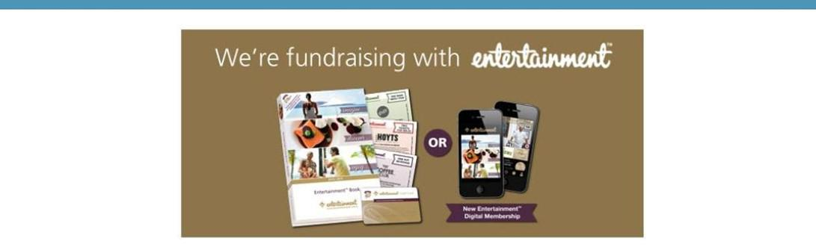

The P&C are fundraising with the Entertainment book. The Entertainment™ Book is a local restaurant and activity guide which provides hundreds of up to 50% off and 2-for-1 offers from the finest restaurants, cafes, attractions, activities, retailers and hotel accommodation. The Membership entitles buyers to exclusive offers that are virtually restriction-free, and is valid through to 1 June 2020!

The Entertainment™ Digital Membership (app) puts all of the value of the Entertainment ™ Book into the customer's smartphone. With 'near me' technology and the ability to show and save using a phone, this is

perfect for the person on-the-go, with no card or voucher to present.

To continue to celebrate our 25th Birthday in style we have a brand new promotion coming your way!

From midnight on Thursday 27th of June until midnight Sunday 30th of June (AEST) everyone who purchases their 19 |20 Membership through our Online Order Page will receive a $10 JB Hi-Fi eGift Card.

You can purchase a book through the front office or download the app via this link

https://www.entertainmentbook.com.au/orderbooks/2487s6

Together, we learn from each other

