What’s On
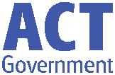

8 March 2018

Week 5, Term 1

ASSEMBLY:
9 Mar | Junior - 2LM & 2EG
16 Mar | Senior - Yr4
23 Mar | Junior - 1PJ, 1MC & 1AS
DATES TO REMEMBER:
12 Mar | Canberra Day - Public
 | Holiday
13 Mar | 9am Parent Info Session -
 | Reading (P/S - Yr1)
 | 3:30pm Riley Moon’s
 | Memorial
15 Mar | 9am Parent Info Session -
 | Reading (P/S - Yr1)
16 Mar | Harmony Day

NOTES HOME:

- Easter Hat Parade, P/S –Yr2

- Kindy Box & Photo Request

- Yr 3/4 Bus Tour

- Yr 5/6 Colonial Day

- Riley Moon Memorial Celebration, youngest

P&C BOARD NEWS

P&C:

All P&C activities, meeting agendas and minutes are available from the School website at – Parent Corner

School Board Elections held in early 2018

Voting forms available in the front office

PRINCIPAL’S MESSAGE

Next Friday we are taking part in Harmony Day and National Day of Action against Bullying and Violence. Our year 5 students, along with guidance from teachers, are presenting a senior school assembly on these two important issues. The senior students take their leadership on inclusion and harmony across the school seriously. Palmerston is a KidsMatter school and implements a number of programs across the year levels to support student wellbeing and teach inclusive behaviours and how to make responsible choices. Teachers provide lessons on this through circle times, have class expectations clearly displayed, provide opportunities for Peer Support, Protective Behaviours, and Buddy programs, and teach values lessons and inclusion programs. A major initiative this year is our Positive Behaviour for Learning program (PBL) commencing with clearly outlined playground behaviour expectations to be taught across the school.

Bullying is unfortunately an issue that can be faced by every school, not just in Canberra but across Australia and the world. Palmerston teachers and students have taken up the baton to address this issue with transparency and inclusivity through our PBL program this year. We take this seriously and have included this as part of our 5 year Strategic Plan.

How can you tell if someone is being bullied? Their chart can help fellow students decide if it’s bullying or something else. Our chart is divided into four:

Joking Around | One time thing
Everyone is having fun | Someone is being mean on pur-
No one is getting hurt | pose
Everyone is participating equally | It’s a reaction to a strong emotion
 | or feeling
 | It happens once and doesn’t
 | repeat itself

Conflict | Bullying
Two people with a balance of pow- | Repeated, unwanted aggressive
er that have a fight, argument or | behaviour towards someone
disagreement | Someone is being hurt on purpose
A solution can usually be found | Can be social, verbal, physical or
 | cyber

Together, we learn from each other

What’s On Page 2

Over the next few weeks I will talk more about safety at school an how we educate the children about bullying, as well as what we do here at Palmerston to combat it.

At Palmerston we value community involvement. This is one of the best ways for you to know the families at our school and work in partnership with us to ensure we all understand each other’s needs. As a school we come together to celebrate and to participate in the children’s achievements. Events such as carnivals, assemblies, celebrations of holidays and events, Twilight Fair, excursions and incursions, P&C events and School Board and class volunteering all bring us together as a whole school. This is the strongest way we can as a community build a great environment for our children to grow and thrive.

Please speak to me if you wish to discuss any of the above further or would like to participate more in

our whole school community.

Kind regards,

Melissa Travers

UPCOMING EVENTS

Parent Information Session on Reading - Preschool to Yr1

Date: 9:00 - 9:30am Tuesday 13 March & Thursday 15 March 2018

Location: Palmerston District Primary School, library

Date: Friday 16 March 2018

Location: Palmerston District Primary School

DEFENCE NEWS

Defence Welcome Morning Tea

A reminder we will be holding a Welcome Morning Tea for all new and returning Defence families this Friday 9 March, straight after assembly in the school staff room. Please come along and join us for the Morning.

Kristy Retzlaff

Defence School Transition Aide

Hours: Thursday – Friday 8:30am – 3:30pm
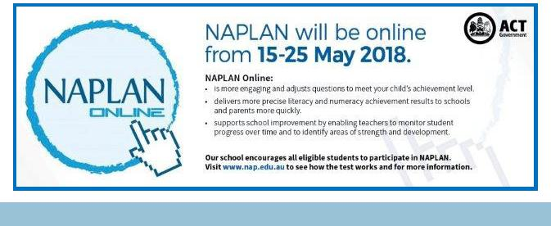

Together, we learn from each other

What’s On Page 3

SCHOOL BOARD NOMINEES

Voting period: Monday 9 March - 23 March 2018

Voting forms will be available from the front office.

Board Nominee Introductions

Lisa Fior - Nominee for the Palmerston District School Board

I am the Deputy CEO of Catholic Care Canberra & Goulburn, and have over 20 years’ experience in the social services sector. I commenced my career in this sector, working with, training and managing a team of volunteers across NSW, and then moved into supporting homeless youth across the

ACT. Following this, I progressed into management roles with youth, mental health and homelessness programs, and have completed tertiary education in Social Sciences. I currently oversee both direct service delivery and corporate areas within Catholic Care and I am passionate about providing effective and quality services to those in need in our community.

I have held various Board positions across the ACT, and am currently the President of the Palmerston Primary School P&C. I am a mother of four and two of my children are currently students at the school. Our family have been part of the Palmerston Primary community for over six years.

I have a strong interest in the broader strategic direction of Palmerston Primary as well as participating in overseeing the operations of the school and ensuring quality education delivery for our children.

Eleni Velanis - Nominee for the Palmerston District School Board

I have lived in Palmerston for 8 years, and have been a parent of the school community for 6 years. I have also worked at two schools in the ACT as a Learning Support Assistant with my current position being at Palmerston Primary for 4 years now. I have enjoyed my opportunity to work at the school and in my current role at Palmerston my duties involve assisting the Teacher Librarian in the Library with daily duties as well as working in the book fair etc, Introductory English Centre (IEC) and in the preschool. I also provide support to the team in the front office with administration tasks and First Aid assistance.

I have volunteered at community events such as the Twilight Fair and have acted as Manager of my sons soccer team.

As a result of my work in the school and the wider community I have met and built up relationships with many students and their family members. I would like the opportunity to be a part of the School Board as I feel we have a really great school and community, and I would like to be further involved in the journey ahead with everyone. I believe our children benefit from the expertise and experience that all members of a School Board bring to the school.

Together, we learn from each other

What’s On Page 4

P&C NEWS

Have any spare time up your sleeve? Then we could use you. The P&C currently have a number of opportunities available to be part of our Palmerston team.

Second hand uniform shop coordinator – ROLE FILLED

Thank you to Leonie and Kate for volunteering to take on the second hand uniform shop. Opening hours will now be 9:00-9:15am on both Wednesdays and Fridays. See the price list below.

School Banking Coordinator – ROLE FILLED

Thank you to Vanessa and Janelle for volunteering to take on School banking. This is a great resource to have at our school and we appreciate the generosity

of your time to keep it going. School banking is on Wednesday’s.

Y’S Bites lunch “more” assistants (multiple required to go on a roster)

Thank you to those who have already generously offered their assistance to help with lunches on Thursdays. If you would like to help out with this read below - more helpers still required.

Do your children like ordering lunch orders? Help us keep these coming to Palmerston Primary School. These roles can be filled on a rotating roster so you may even only help once all Term if that’s all you can do. Approximately 12:30-12:50pm every Thursday you open the canteen, meet the YMCA and take the delivery of the food and assist to sort food into class groups. Senior students come up and take the baskets to classes, return the baskets and you lock up the canteen. If this sounds like something you could do please give me (Lisa Fior) a call on 0407 107 595 to discuss further. Full training will be provided.

School Banking:

I would like to introduce our new School Banking Coordinators Vanessa Chapman and Janelle Hunter, if you have any questions regarding School Banking, please drop into the staff room on Wednesday mornings.

School Banking is every Wednesday 9am-10.30am in the staff room.

Bank books can be left at the front office by 9.30am or handed to your child’s teacher in the morning. Joanne from Commonwealth Bank will be at the preschool from 8:30am on Tuesday 13 March (week 6) to assist with questions and information about school Banking.

If you would like to open a new account, a Youthsaver account can be opened online by all parents. Visit commbank.com.au/schoolbanking and click on the link to open the Youthsaver account. Parents will need their child’s birth certificate or similar identification as well as their own to complete the process and generate an account.

Or you can visit any Commonwealth Bank branch with identification and open an account.

Together, we learn from each other

What’s On Page 5

Book Club :

Most students would have received their orders this week, however, I am still waiting on a couple of back orders to arrive. Hopefully I will have them shortly. Keep an eye out for Issue 2 as it will be arriving soon.

Regards

Edwina
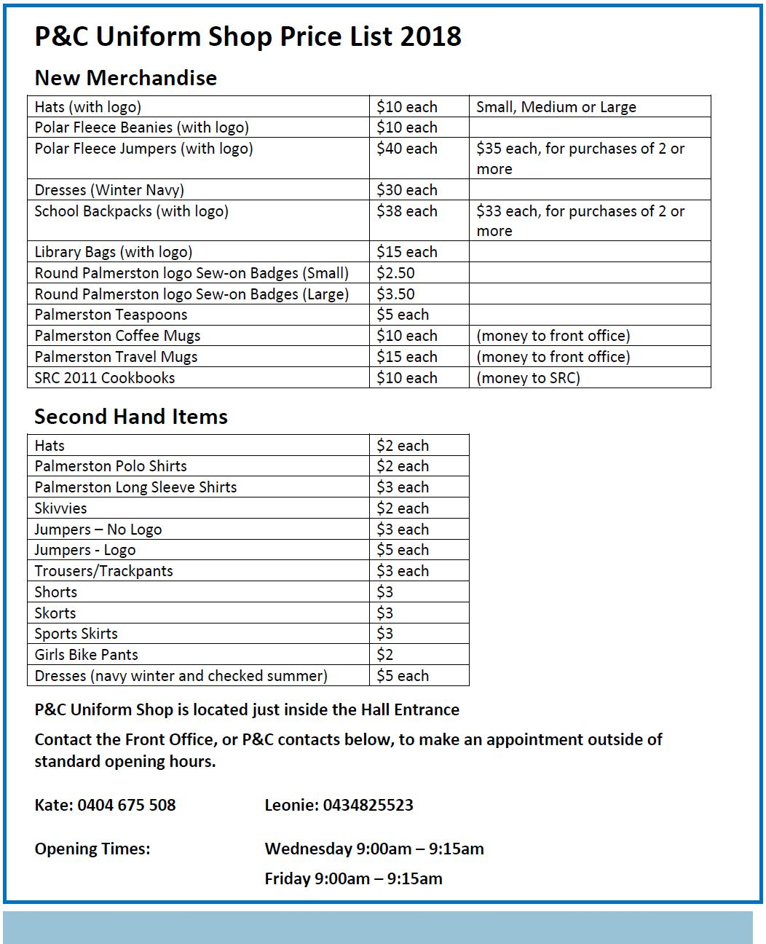

Together, we learn from each other

What’s On Page 6
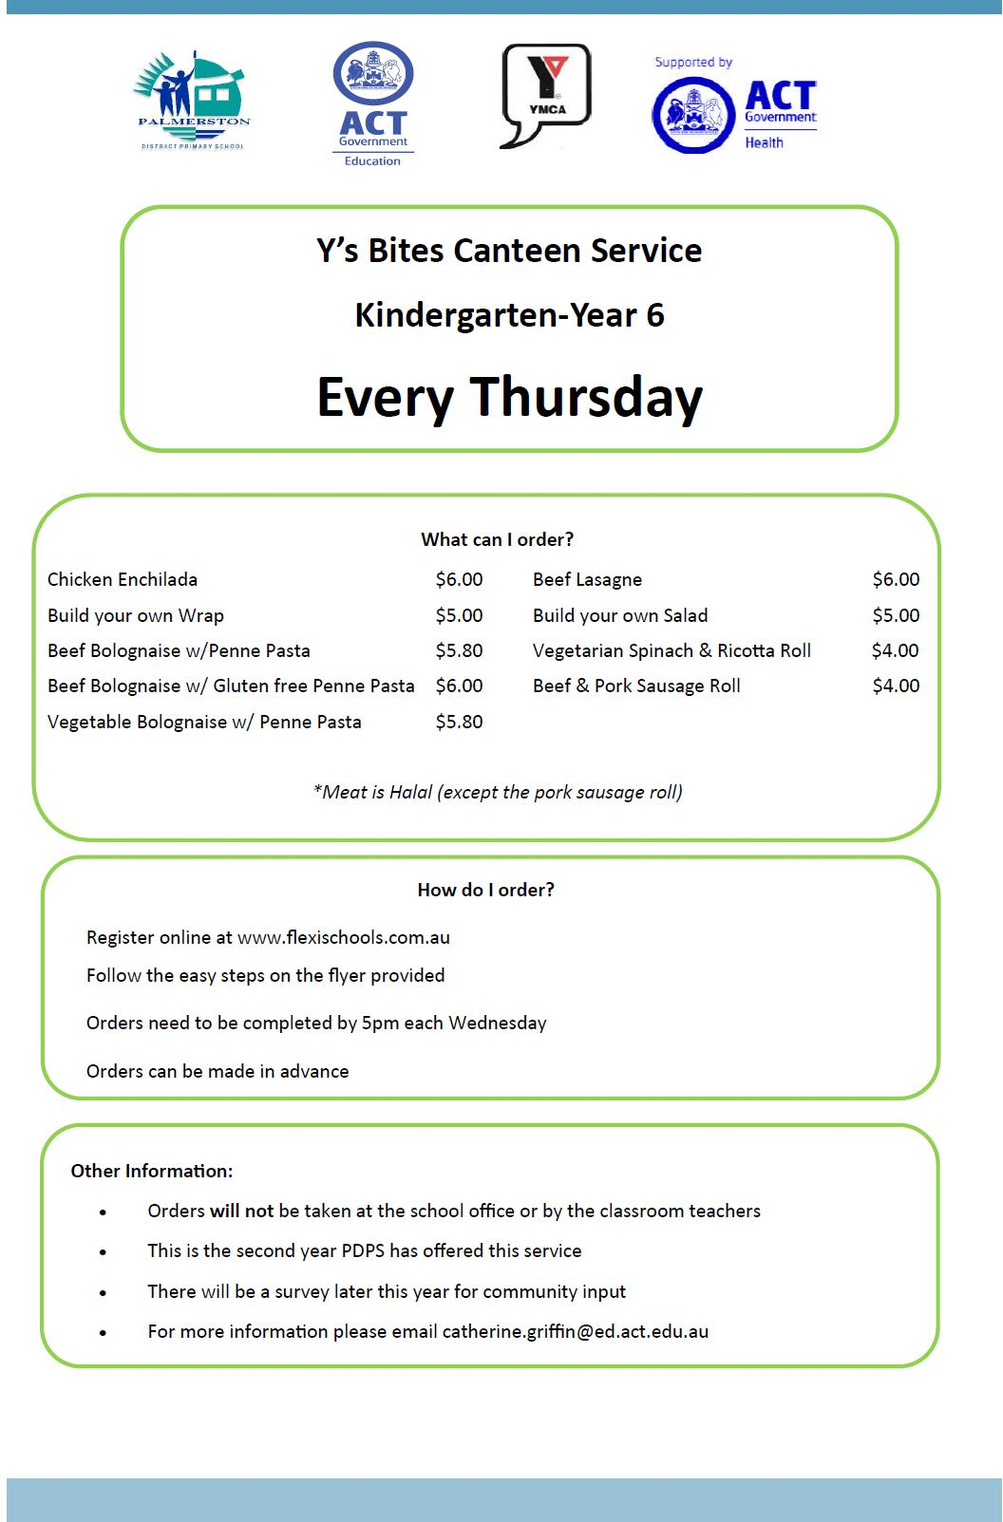

Together, we learn from each other

What’s On Page 7
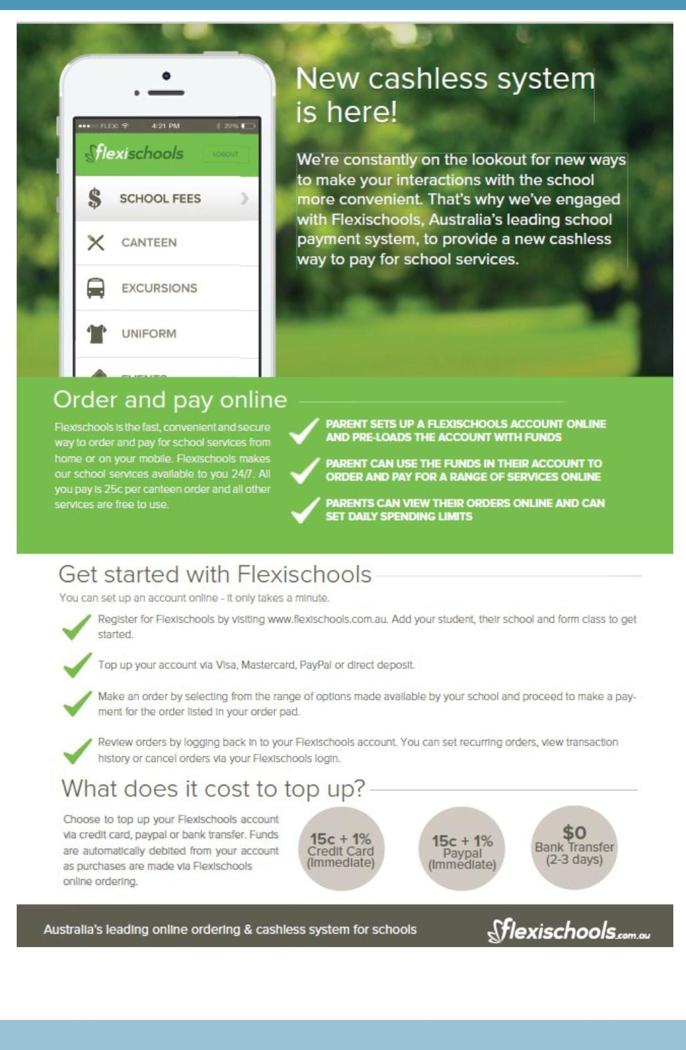

Together, we learn from each other

What’s On Page 8

COMMUNITY NEWS
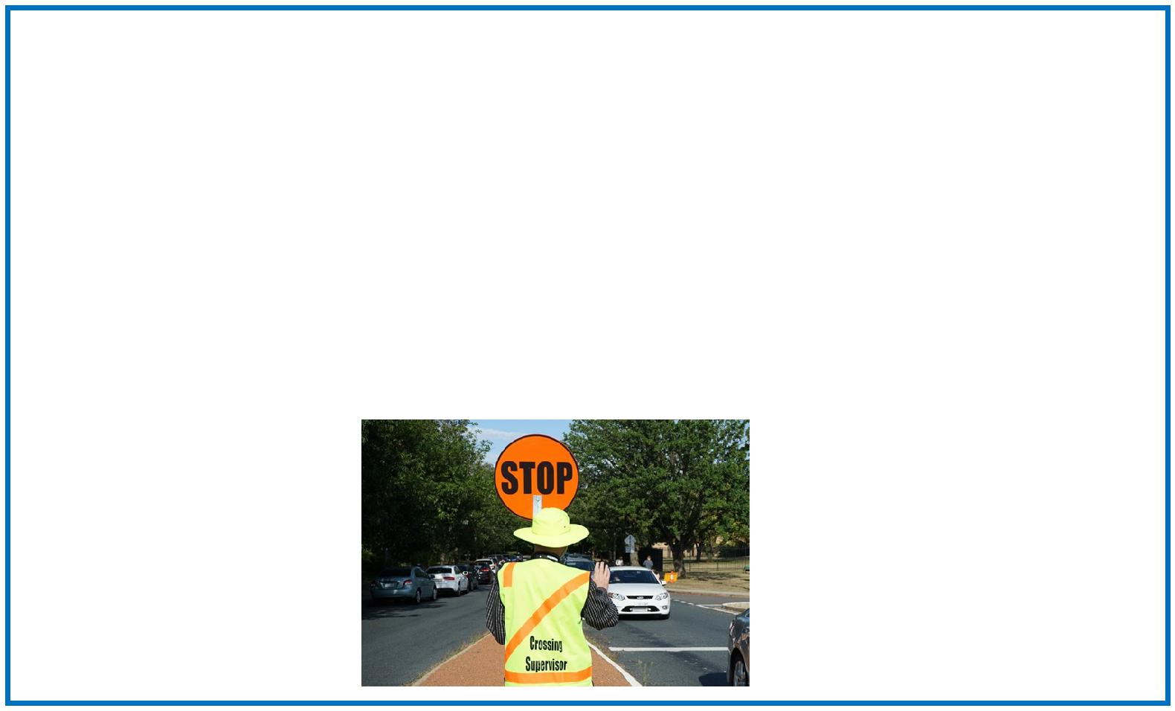

Survey: School travel and safety

Transport Canberra and City Services has engaged First Person Consulting to conduct research into parent's attitudes to their children's active travel to and from schools. Part of this process will investigate the role that School Crossing Supervisors have in improving safety around schools, and the extent to which parent attitudes to children travelling actively change as a result.

To complete the survey please click here, or copy and paste the following link into your browser: http:// www.surveygizmo.com/s3/4172965/School-Crossing-Supervisor-Survey-Control.

The survey should take about five minutes. The survey will not collect any identifiable information, and all responses will be kept confidential.

Thank you in advance for your time in completing this survey. If you have any questions please contact the TCCS Schools Program.

Together, we learn from each other

