What’s On

22 March 2018

Week 7, Term 1
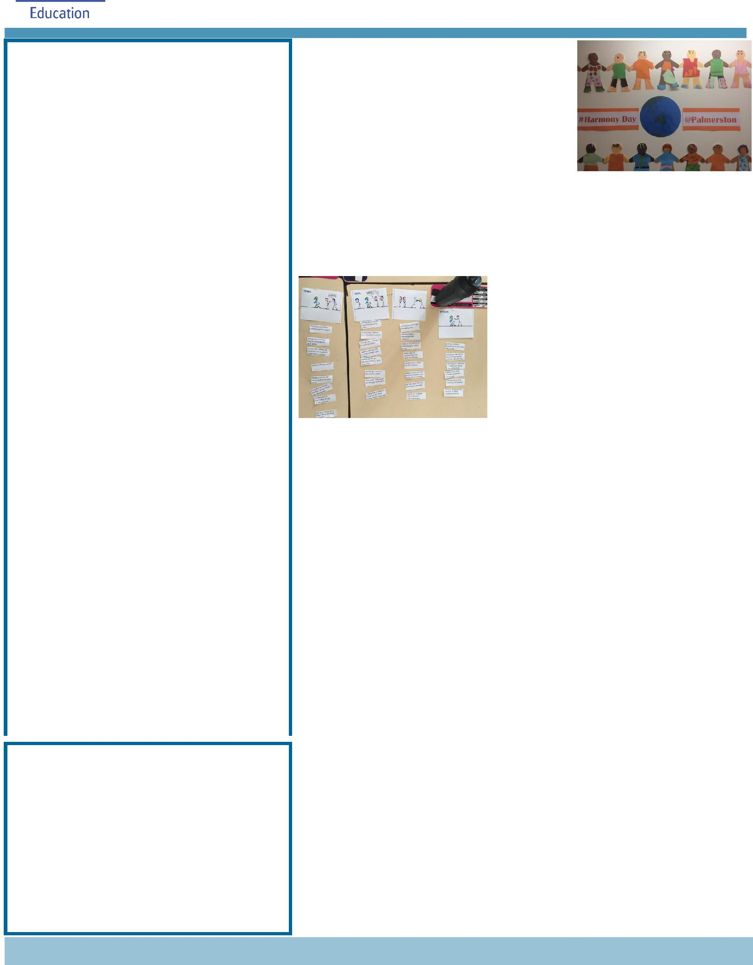

ASSEMBLY:
23 Mar |  | Junior - 1PJ, 1MC & 1AS
30 | Mar | No assembly - Good Friday
6 Apr |  | Whole School - IEC
DATES TO REMEMBER:
27 | Mar | Yr 5/6 Colonial Day
27 | Mar | P/S (beginning) Easter Hat
 |  | Parade
27 | Mar | IEC Visit to the park
29 | Mar | P/S (end) - Yr 2 Easter Hat
 |  | Parade
30 | Mar | Good Friday Public Holiday
2 Apr |  | Easter Monday Public
 |  | Holiday
3 Apr |  | Yr 3/4 Camp - Birrigai
6 Apr |  | P&C Disco
9 Apr |  | North/Gungahlin Swimming
 |  | Carnival
10 | Apr | P/S (beginning) Healthy
 |  | breakfast
11 | Apr | Cross Country Carnival
11 Apr |  | 5pm Seesaw parent
 |  | information session
13 | Apr | P/S (end) Healthy breakfast
13 | Apr | P&C Sausage Sizzle Lunch
 |  | Order

NOTES HOME:

- P&C Disco - youngest

- P&C Sausage Sizzle (K-Yr6)

- ICAS (Yr2-6)

- IEC - Visit to the park excursion

P&C BOARD NEWS P&C: 8 May 2018

All P&C activities, meeting agendas and minutes are available from the School website at – Parent Corner

School Board Elections held in early 2018

Voting closes tomorrow 23 March 2018

PRINCIPAL’S MESSAGE

Palmerston District Primary School is very lucky to have such a close community. Last Friday, the senior students put on a brilliant Harmony Day and National Action against

Bullying assembly. The performances came from the children after working with their teachers on this theme. Year six students also had wonderful conversations about what is

bullying and what is not. Children of all ages have different understandings of playground interactions and with Restorative actions, we work through each event, call parents and come to understandings for both parties.

The carpark

Over this week, we have noticed a big difference in the car parking/traffic flow around the school at pick up time. This has been a difficult time and I appreciate the feedback from so many families with suggestions to support our community. Remember the suggestion box is in the foyer and we will be passing this on to Andrew Crichton, Transport Canberra and City Services Directorate. Andrew visited our carpark yesterday, observed the traffic flow and talked to families. He will take your concerns back to Transport Canberra. If you are interested in gaining a bus between the suburb of Crace and Palmerston school, please drop by the foyer and sign the expression of interest form in the foyer. Many signatures will assist (so far we only have 19 Crace families who have signed their interest).

ANZAC Assembly

Each year, Palmerston’s Defence Services Assistant (DSTA), organises a very special ANZAC day assembly with the defence students. This year will be no exception with Kristy Retzlaff. On the first Friday back after the April School holidays, 4 May, we will be holding our ANZAC assembly.

Together, we learn from each other

What’s On Page 2

I am giving a great deal of notice, as it is a wonderful assembly to attend.

Easter Hat Parade

Next Thursday morning, we will be holding our annual Easter Hat parade. Years P-2 is encouraged to make hats at home and parade them around the school at an outdoor assembly. This has proved to be lots of fun for all and a highlight for many families at Palmerston. See you there.

Have a great week,
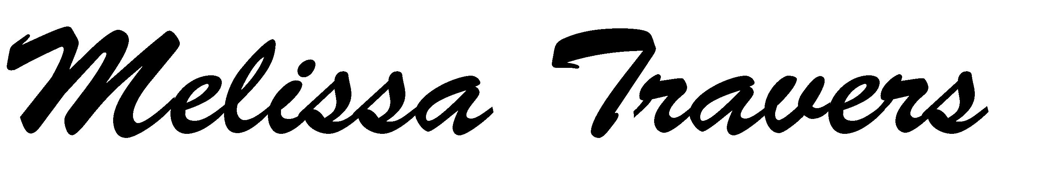

NAPLAN

We will be transitioning to NAPLAN Online testing from 15-25 May 2018. Year 3 will still be completing

the writing portion using pencil and paper.

NAPLAN Online:

- is more engaging and adjusts questions to meet a student’s achievement level.

- delivers more precise literacy and numeracy achievement results to schools and parents more quickly, and

- supports school improvement by enabling teachers to monitor student progress over time and identify areas of strength and development.

Students undertaking NAPLAN Online this year will participate in a practice/familiarisation test from 22 March 2018.

Contact me (NAPLAN Coordinator) for more information.

Seesaw

This year at Palmerston we are trialling Seesaw. Seesaw is a digital portfolio that collects students physical and digital work in one place. Earlier in the term students received a Third Party Permission note that will need to be completed if you wish your child to access Seesaw.

Each student will get their own journal and will add things to it like photos and videos. This digital journal will stay with them throughout their journey at Palmerston. Seesaw has built in tools that make it easy for students to capture their learning and develop new skills.

Seesaw has many benefits and advantages, one of the main ones being that it allows our students to develop 21st century skills in a safe and moderated environment. Another key benefit is it allows parents to see what is going on in the classroom and builds a strong home-school community where parents are notified when there is a piece of work for them to view and they are able to comment and discuss the work with their child. Parents will be receiving instructions on how to download Seesaw later in the term. A parent information session will be held on 11 April at 5pm if you would like further information.
If you would like further information please don’t hesitate to contact me via the front office.

Together, we learn from each other

What’s On Page 3

T20 CRICKET DAY

Last Thursday (week 6) 2 teams of Year 3/4 students represented our school at MILO T20 Blast School Cup Day 2018.

Each team played 4 games throughout the day and enjoyed the opportunity to showcase their cricketing skills.

All students represented our school in the best way possible; both on the field and during break/ transitioning times.

We are looking forward to more sporting gala days this year.
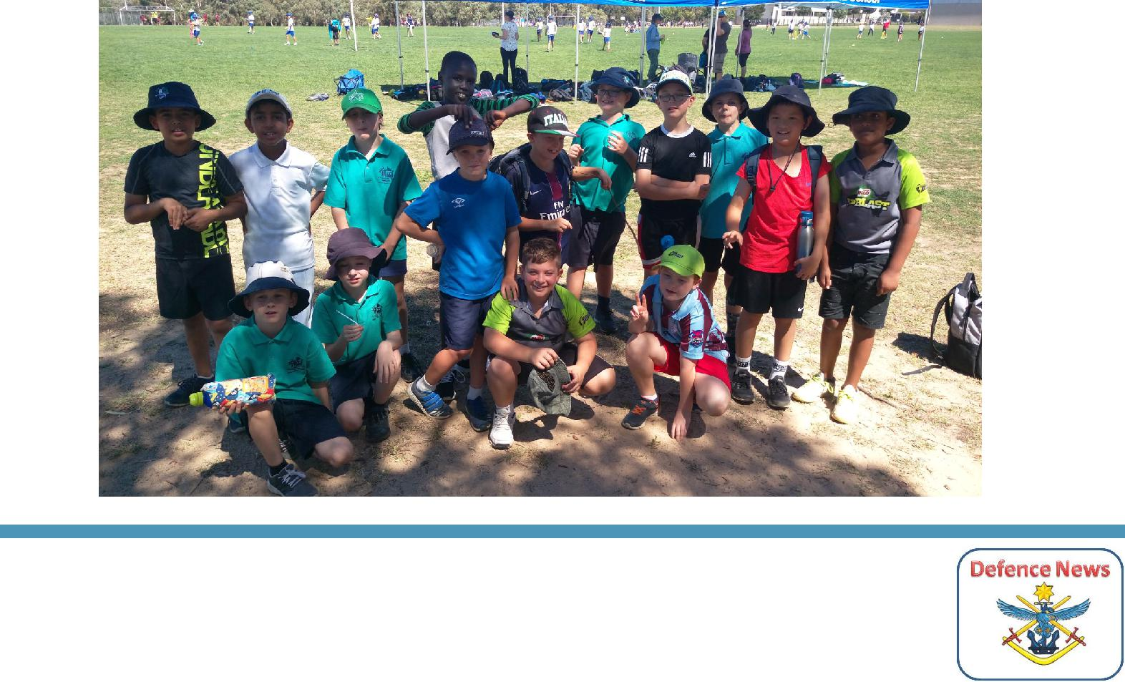

DEFENCE NEWS

PALMERSTON DISTRICT SCHOOL ANZAC SERVICE, will be held on Friday 4 May, 2018 at 9am in the School Hall. All are welcome to attend. If a member of your family is currently or has previously
served in the ADF, you are invited to forward their photo and a little background of their role by Week 9 to DSTA Kristy Retzlaff kristy.retzlaff@ed.act.ed.au for
inclusion in our ANZAC Service.

Defence Kids Activity Club – In preparation for ANZAC Day, students will be participating in a range of Anzac Crafts and activities over coming weeks.

Have a great week,

Kristy Retzlaff

Defence School Transition Aide.

Together, we learn from each other

What’s On Page 4

UPCOMING EVENTS

Yr 5/6 Colonial Day

Date: Tuesday 27 March 2018

Location: Palmerston District Primary School

P/S - Yr 2 Easter Hat Parade

Date: Tuesday 27 (Brave, Itchy & Noisy Bears) & Thursday 29 March 2018 (Hungry, Cranky & Sleepy

Bears, K-Yr2)

Location: Palmerston District Primary School.

IEC Visit to the park

Date: Tuesday 27 March 2018

Location: Palmerston to Crace

Yr 3/4 & IEC2 Bus Tour

Date: Wednesday 28 March 2018

Location: Canberra

P&C Disco

Date: Friday 6 April 2018

Location: Palmerston District Primary School, hall

Yr 3/4 Camp - Birrigai

Date: Tuesday 3 April 2018 (after Easter)

Location: Birrigai

K - Yr 6 P&C Sausage Sizzle Lunch Order

Date: Friday 13 April 2018 (please note change of date)

Location: Palmerston District Primary School

Together, we learn from each other

What’s On Page 5

ICAS

ICAS entry forms will be sent home to all students in Year 2-6.

ICAS assessments have taken place annually in schools for over thirty years and in 20 countries. Educational Assessment Australia (EAA), who design and deliver the assessments, is the not-for-profit arm of the University of New South Wales. Palmerston is once again going to take part in ICAS. This is voluntary for families.

ICAS is an annual skills development assessment program and available in the areas of English, Mathematics, Science, Spelling and Writing. Unfortunately this year will are unable to offer Digital technologies. The tests take 30–60 minutes and are supervised at school. Certificates are awarded to all students who participate. If you register to participate and are sick on the sitting date you will participate in a catch up at a suitable time in the following weeks.

Results are available to parents and students online. These online reports and analyses remain available indefinitely. ICAS reports indicate which questions were answered correctly and compare student performance to that of the other students tested.

To enrol your child in ICAS, please complete the registration form and return it, with your entry fees, to school by Friday 13 April (Week 10).
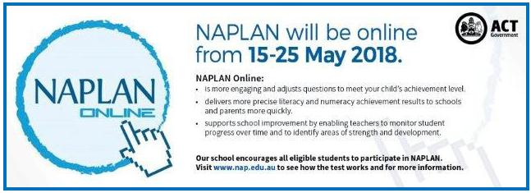

Together, we learn from each other

What’s On Page 6

P&C NEWS

2nd Hand Uniforms

If you have any uniforms that your child has grown out of and you would like to donate, the 2nd hand uniform store would greatly appreciate your donations.

Twilight Fair Refunds

If you requested a refund for the rides from the Twilight Fair and have not collected it, they are available at the front office. If they are not collected by the end of the term, it will be donated to the P&C.

Book Club:

Issue 2 closes tomorrow 23 March.

Reminder we accept cash/cheques by completing the form on the back page with all of the students details and placing in a sealed envelope/bag into the ‘Boomerang’ box located in the front office foyer.

Otherwise, if you wish to order using a credit card then please

Visit www.scholastic.com.au/LOOP (or download the APP from the App store)

For a quick start, just click on ORDER in the top menu or REGISTER first to save your details for next time

- Select your school and your child’s class

- Add your child’s first name and last initial (so the school knows who the book is for)

- Enter the item number from the Book Club catalogue

- You can order for multiple children at once if they attend the same school

- All orders are linked directly to the school for submission to Scholastic. Books will still be delivered to your child’s classroom if you order by the close date

- There’s no need to return paper order forms or payment receipt details to your school!

Thanks, Edwina

PALMERSTON DISTRICT PRIMARY SCHOOL P&C presents

“Hawaiian”

P&C DISCO - FRIDAY 6 April Entry: $3 at the door.

JUNIORS: Preschool – Yr 2 SENIORS: Yr 3 - 6

6:00pm-7:15pm 7:30pm-9:00pm

The P&C will be selling pizza/nuggets/hot dogs/drinks/ice blocks/glow sticks etc

PARENT HELPERS ARE ESSENTIAL!

Are you staying at the Disco? Can you help for half an hour? We need volunteers from 4pm for:

setup, collecting door entry fee, in the canteen, door & dance floor security, pack-up and lock-up (until 10pm).

Please contact Lina on 0416 056 755 if you are able to help.

Next meeting Week 3, Term 2 Monday 8 May

Due to Easter there is no meeting being held in week 9.

Together, we learn from each other

What’s On Page 7

SCHOOL BOARD NOMINEES

Voting period: Monday 9 March - 23 March 2018

Voting forms will be available from the front office.

Voting closes TOMORROW

Board Nominee Introductions

Lisa Fior - Nominee for the Palmerston District School Board

I am the Deputy CEO of Catholic Care Canberra & Goulburn, and have over 20 years’ experience in the social services sector. I commenced my career in this sector, working with, training and managing a team of volunteers across NSW, and then moved into supporting homeless youth across the

ACT. Following this, I progressed into management roles with youth, mental health and homelessness programs, and have completed tertiary education in Social Sciences. I currently oversee both direct service delivery and corporate areas within Catholic Care and I am passionate about providing effective and quality services to those in need in our community.

I have held various Board positions across the ACT, and am currently the President of the Palmerston Primary School P&C. I am a mother of four and two of my children are currently students at the school. Our family have been part of the Palmerston Primary community for over six years.

I have a strong interest in the broader strategic direction of Palmerston Primary as well as participating in overseeing the operations of the school and ensuring quality education delivery for our children.

Eleni Velanis - Nominee for the Palmerston District School Board

I have lived in Palmerston for 8 years, and have been a parent of the school community for 6 years. I have also worked at two schools in the ACT as a Learning Support Assistant with my current position being at Palmerston Primary for 4 years now. I have enjoyed my opportunity to work at the school and in my current role at Palmerston my duties involve assisting the Teacher Librarian in the Library with daily duties as well as working in the book fair etc, Introductory English Centre (IEC) and in the preschool. I also provide support to the team in the front office with administration tasks and First Aid assistance.

I have volunteered at community events such as the Twilight Fair and have acted as Manager of my sons soccer team.

As a result of my work in the school and the wider community I have met and built up relationships with many students and their family members. I would like the opportunity to be a part of the School Board as I feel we have a really great school and community, and I would like to be further involved in the journey ahead with everyone. I believe our children benefit from the expertise and experience that all members of a School Board bring to the school.

Together, we learn from each other

What’s On Page 8
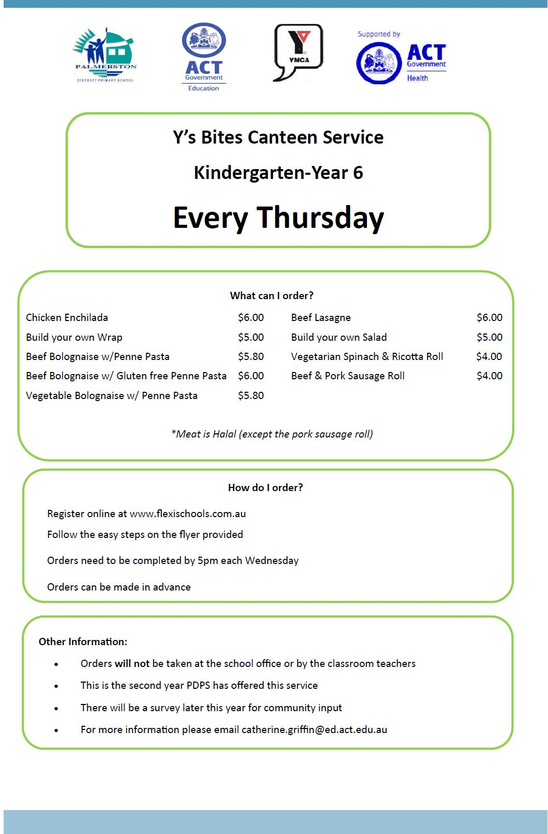

Together, we learn from each other

What’s On Page 9
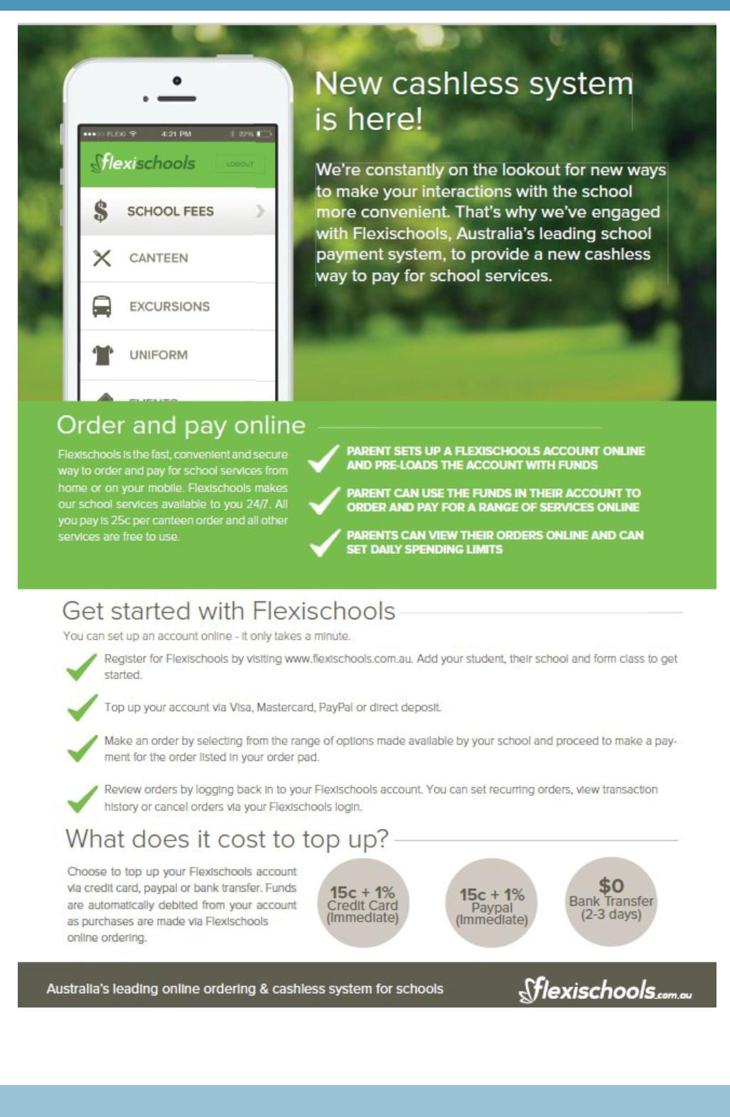

Together, we learn from each other

What’s On Page 10
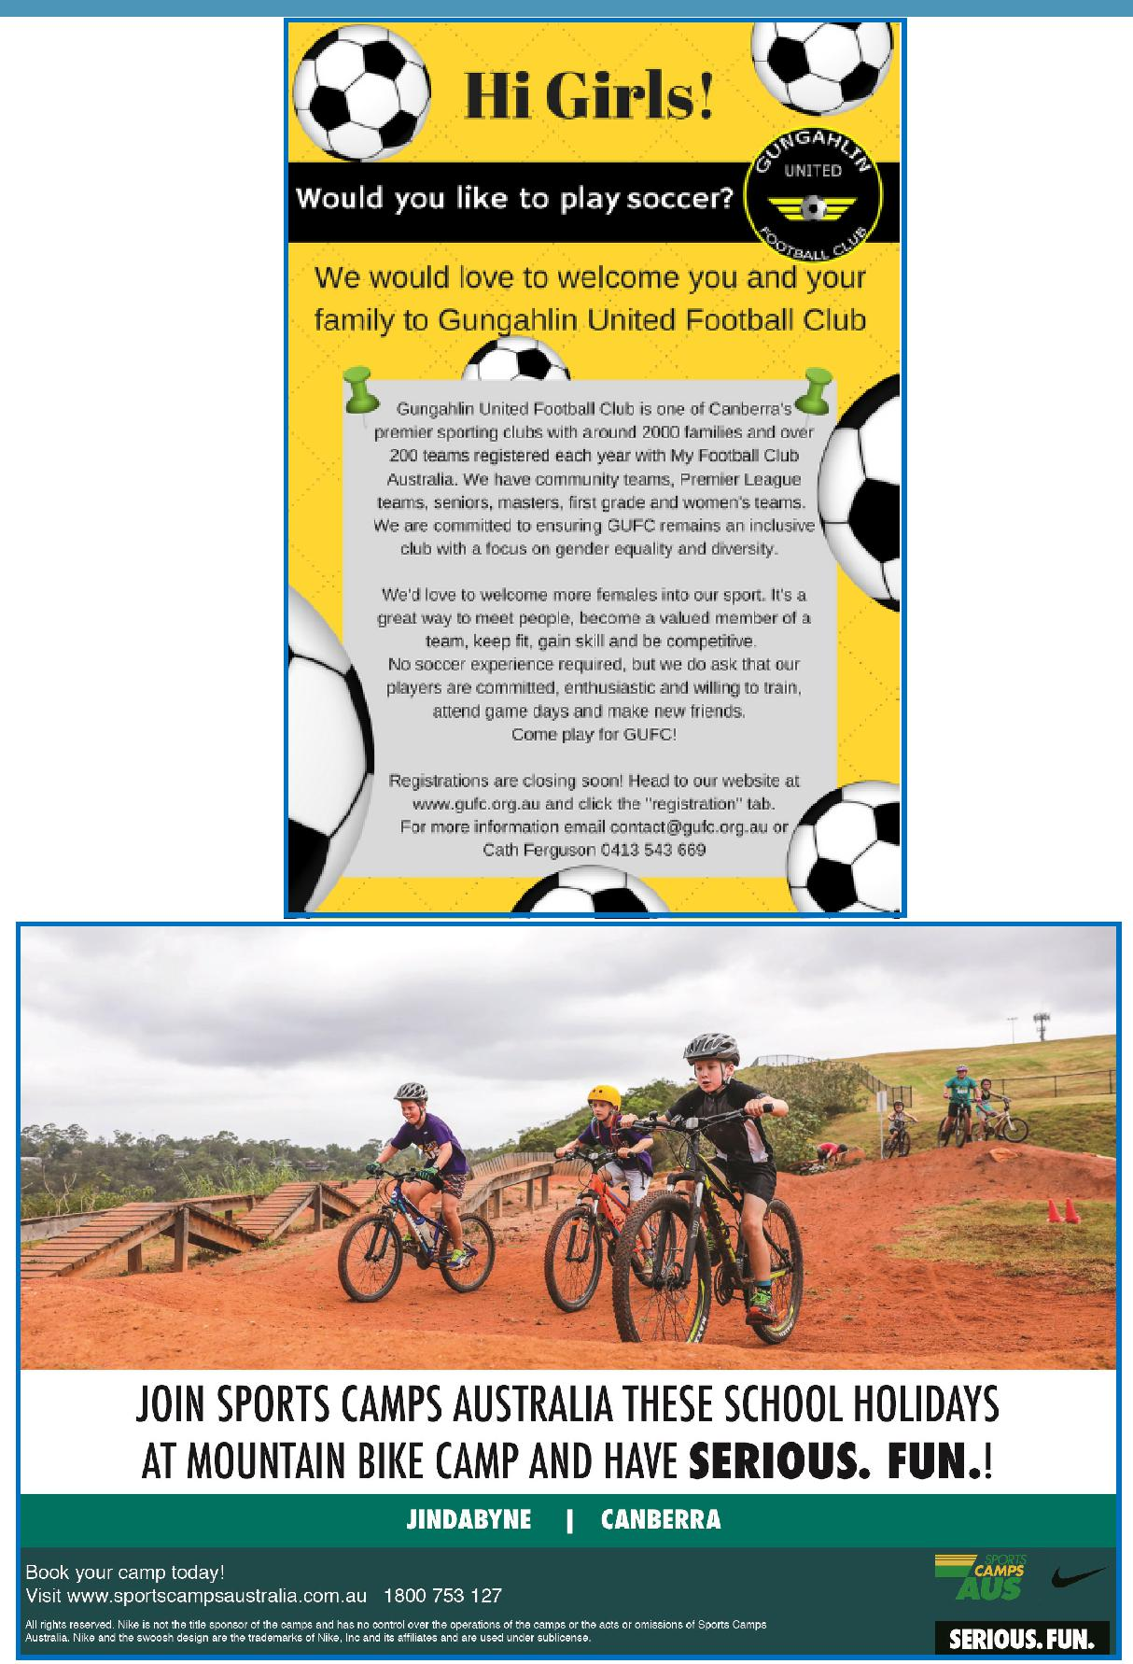

COMMUNITY NEWS

Together, we learn from each other

What’s On Page 11
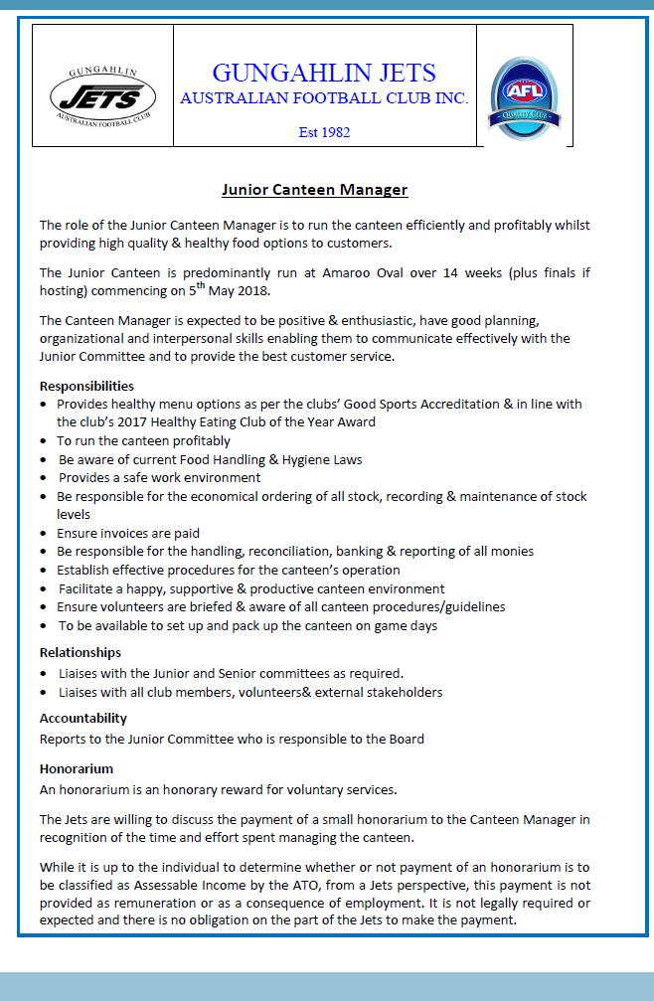

Together, we learn from each other

What’s On Page 12
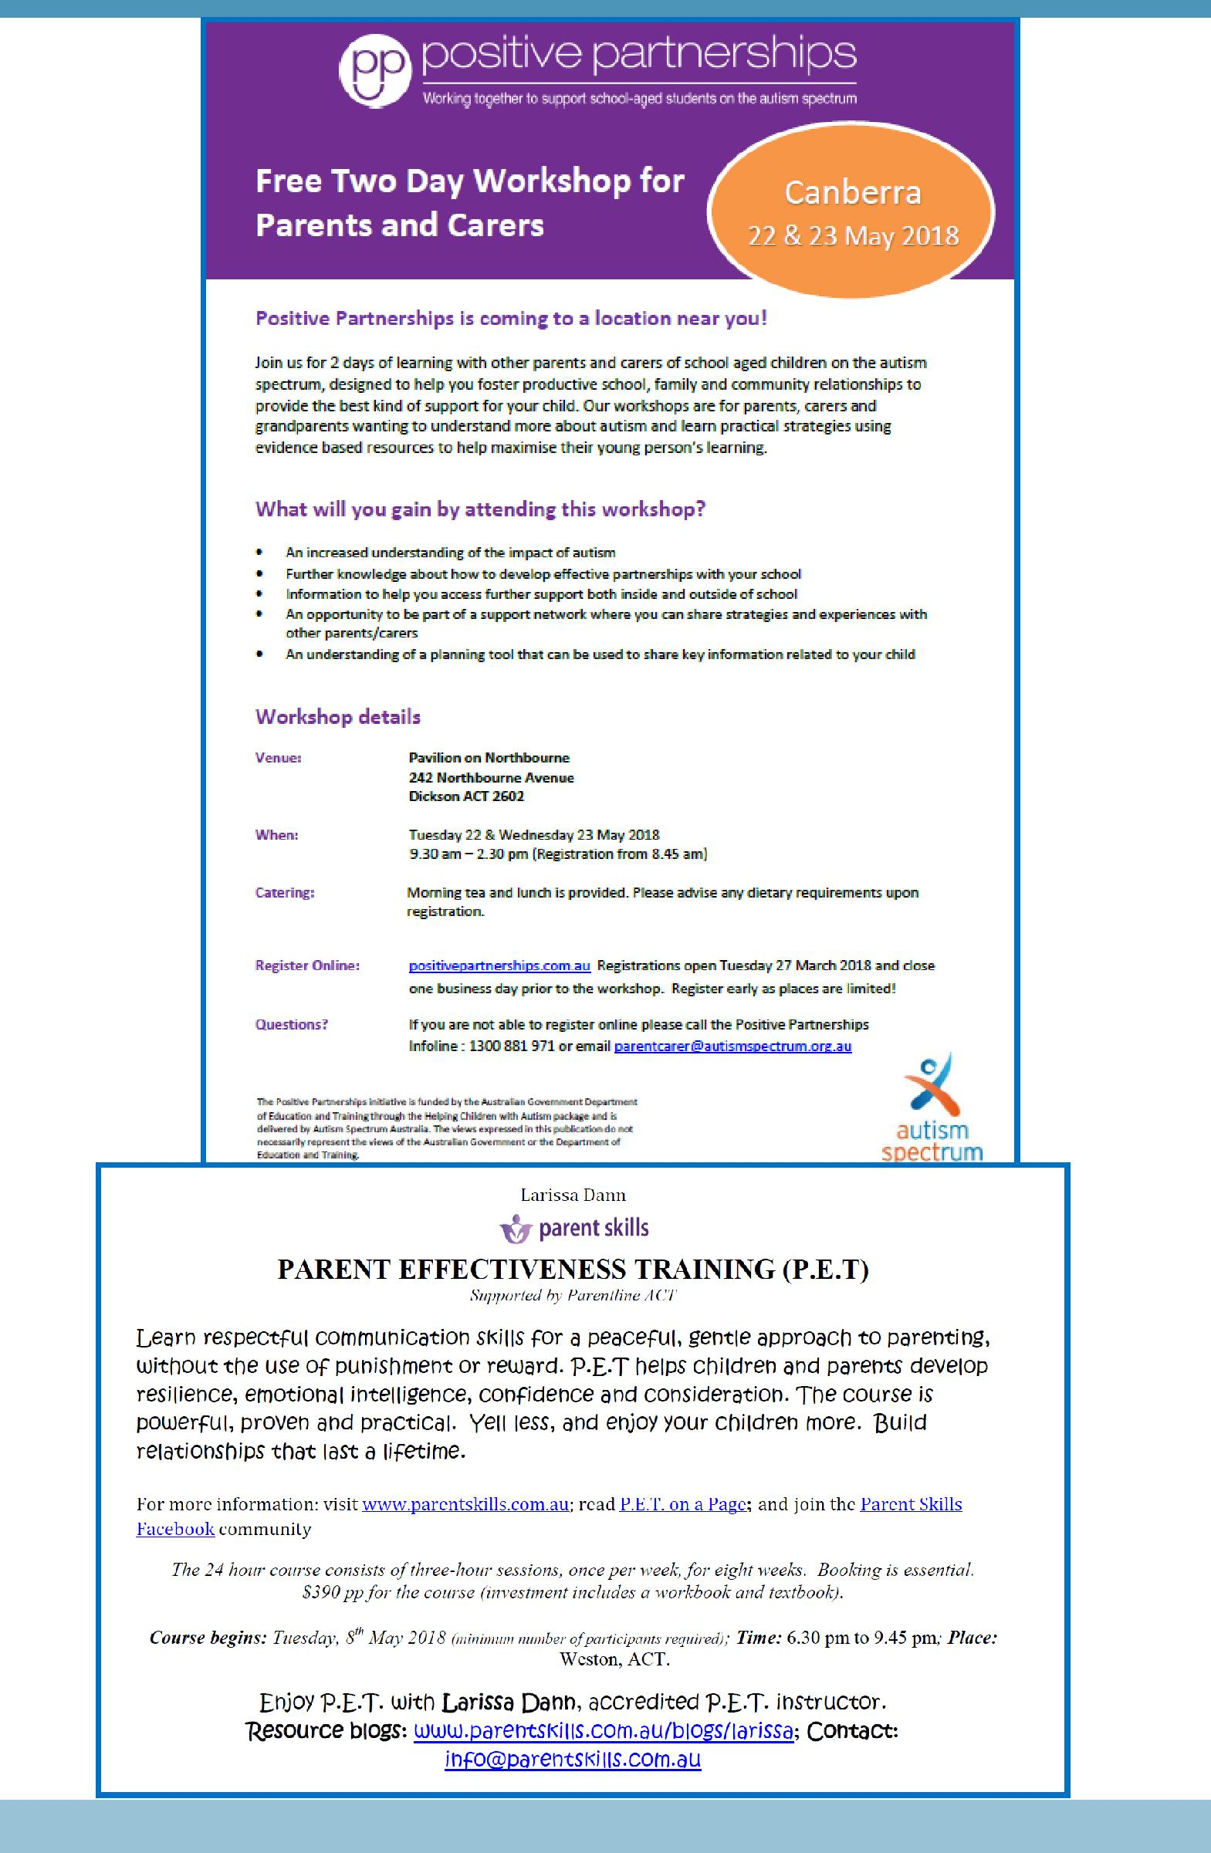

Together, we learn from each other

