What’s On

1 November 2018

Week 3 , Term 4
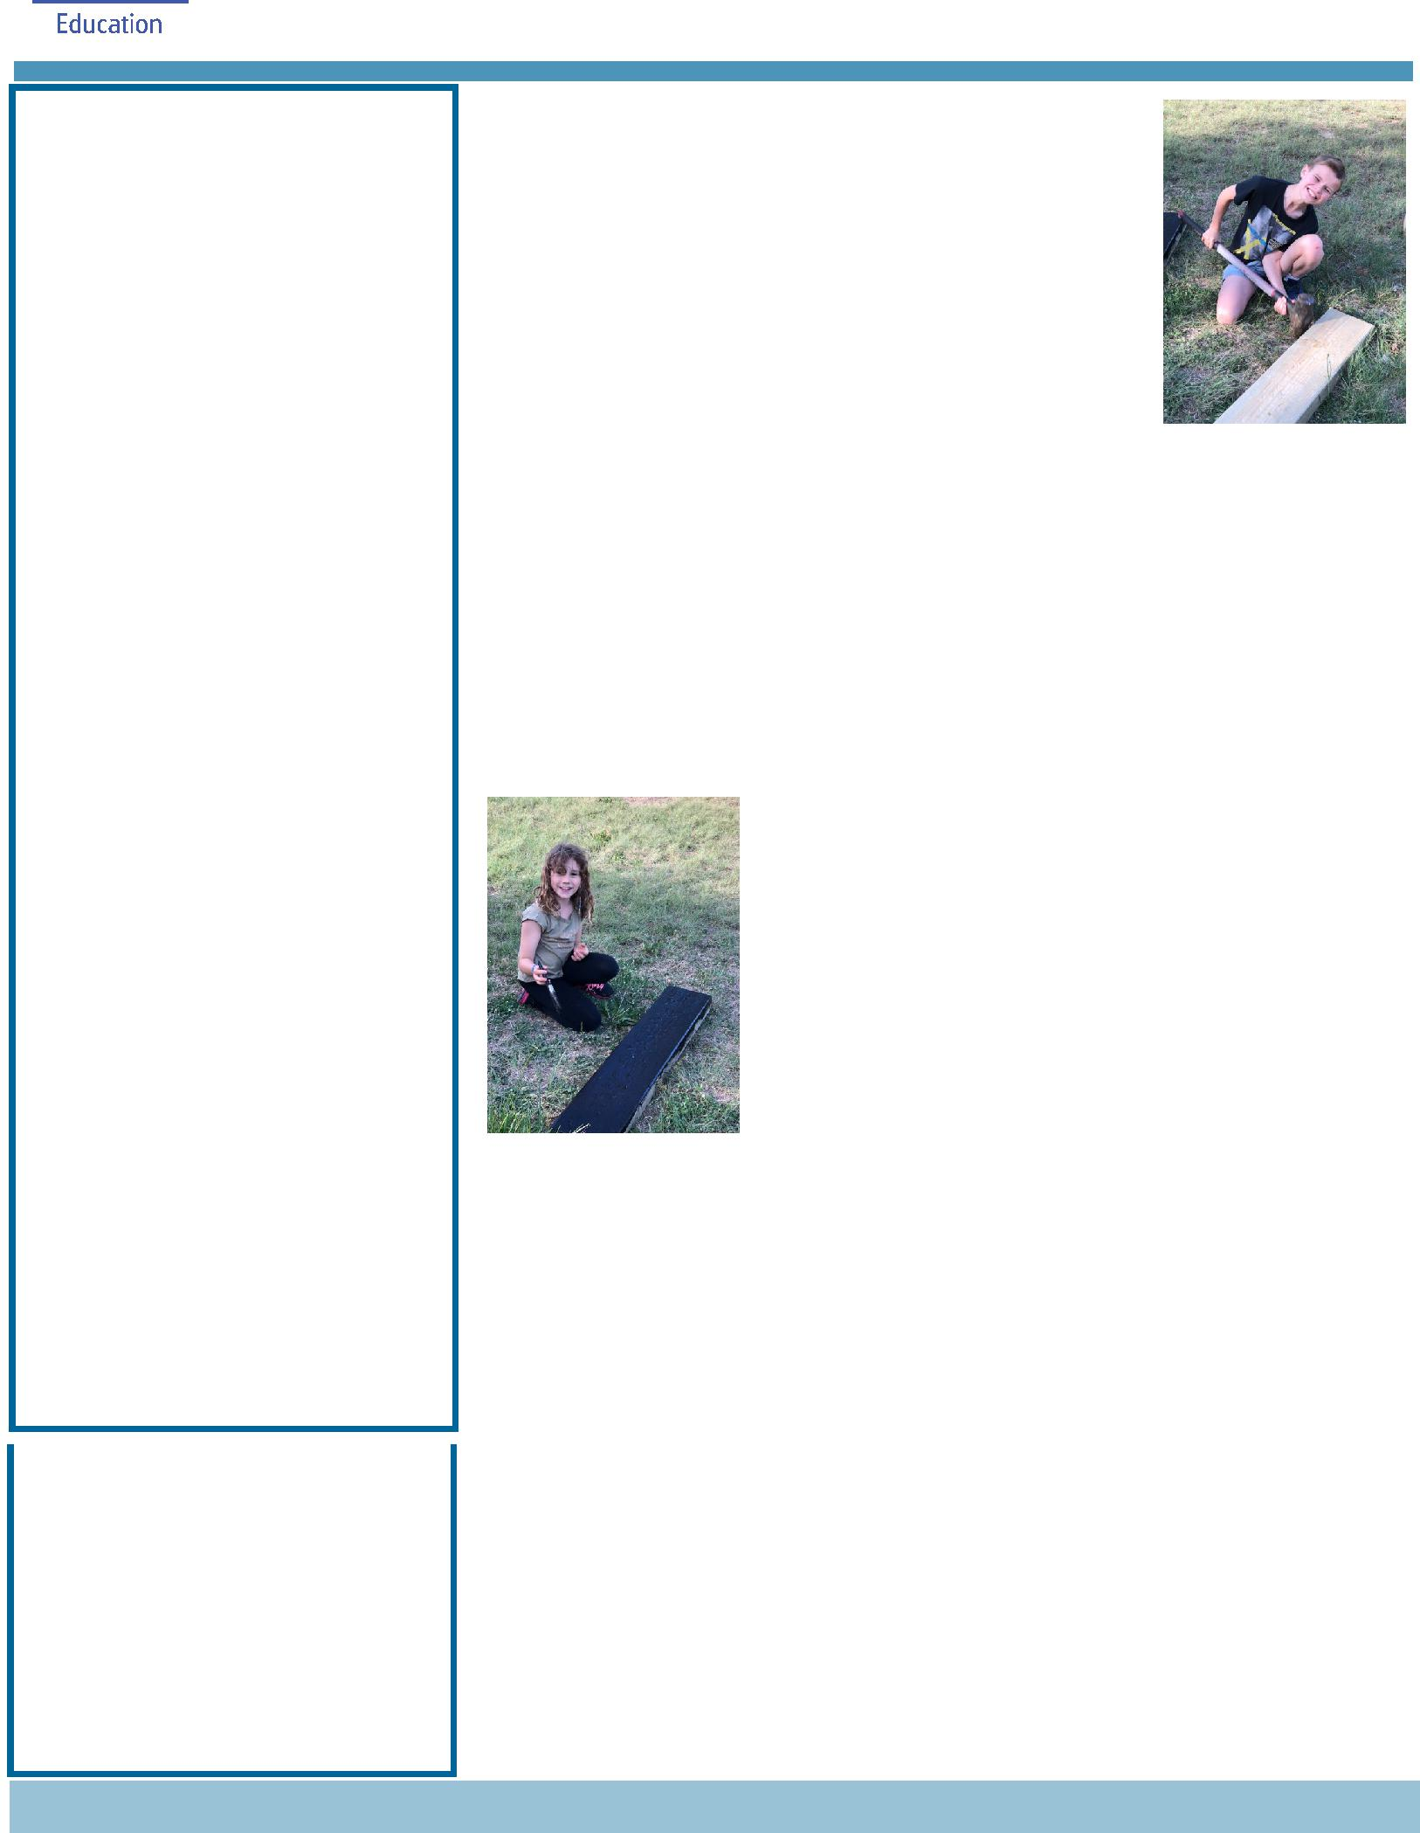

ASSEMBLY:

2 Nov Senior - Yr3

9 Nov Whole school -

Remembrance Day

DATES TO REMEMBER:

30 Oct - 2 Nov Book Fair

7 Nov Whole school & Yr6 Grad

photos

7 Nov 5pm P/S 2019 parent

info session

7 Nov 5:30pm K 2019 parent

info session

9 Nov Yr6 Gold Creek Transition

12 Nov Kindy Open morning

12 Nov Yr3/4 & IEC Questacon

excursion

13 Nov P/S Mufti Day

14 Nov 5pm 2019 P/S Info

Session

16 Nov Mufti Day for Twilight Fair

NOTES HOME:

- 2019 Bookpack

- Yr2 National Zoo & Aquarium excursion
- SRC students’ Governor-General’s Sports Fun Day
- Yr5/6 Footsteps Dance program

- Yr6 Graduation photo day

- Yr6 Band Rehearsal

P&C BOARD NEWS P&C: 7:00pm 17 Dec

All P&C activities, meeting agendas and minutes are available from the school website at – Parent Corner

School Board: 7:30am 29 Nov

DEPUTY PRINCIPAL’S MESSAGE

Cultural Integrity Garden

You may have noticed the new garden that was created last weekend between the year 5 and 6 classrooms. This is the first stage of our new Cultural Integrity garden. Earlier in the year Mrs

Campbell created a Yarnin’ Circle with some tree logs and now we have a path with a beautiful

bridge leading down to the circle. There is a large garden bed edged by boulders and logs around the circle as well. We are really looking forward to early next year when we will use the Ngunnawal Plant Book to guide us around the selection of a range of plants to put into the garden. I would like to thank and acknowledge the hard work of Neil Jones. Neil worked closely with us to create a garden that reflects the vision of the input provided by the students, parents and staff during

our consultation phase. The garden is amazing, and I hope you get the opportunity to view it in the next short while. Included in the newsletter are some photos of students who gave up their time to assist Neil when he was putting the garden together. I extend my thanks to these children as well as the community members who popped by and helped as well.

Jump Rope For Heart Launch

Monday morning saw the launch of Jump Rope for Heart. We were fortunate enough to have Emma from Jump Rope For Heart come and talk to us about importance of keeping our bodies healthy as well as providing tips on ways to do so. The main message of course was to skip! We really enjoyed a visit from the Harrison Hoppers at the end of Emma’s talk who did a fabulous skipping demonstration. We were all certainly very impressed with their skills and tricks! If you would like your family/child to participate in the fund raising, please register via the link:

https://jumprope.heartfoundation.org.au/2018/ Palmerston_District_Primary_School_-_PALMERSTON_ACT_-_131681?

utm_medium=Email&utm_source=ExactTarget&utm_campaign

Together, we learn from each other

What’s On

Whole School photo and year 6 photo

Next Wednesday students and staff will be a part of the annual whole school photo. While the photographer is here he will also be taking a photo of our year 6 students.

This photo will be presented to our students at their graduation. As always, please ensure that students are in school uniform. Please contact me at the front office if you have any further questions around this.

Information sessions

We value and maintain high levels of communication between home and school. Next Wednesday we have two information sessions that will provide families with the chance to see and hear about our preschool and kindergarten programs. At 5pm in the preschool we will be running a session for families who have children attending preschool in 2019 and at 5:30pm is a session in the kindergarten PoD for families who have children attending kindy in 2019. These sessions will provide an overview of life in both preschool and kindy as well as providing an opportunity to answer any questions.

Have a great Friday and weekend,

Kate Flynn

LOST PROPERTY

Thank you to the kindergarten parents this morning who helped sort the enormous pile of lost property. Items will be on display for one week before we take them to a charity. Please encourage your children to come and collect their belongings.
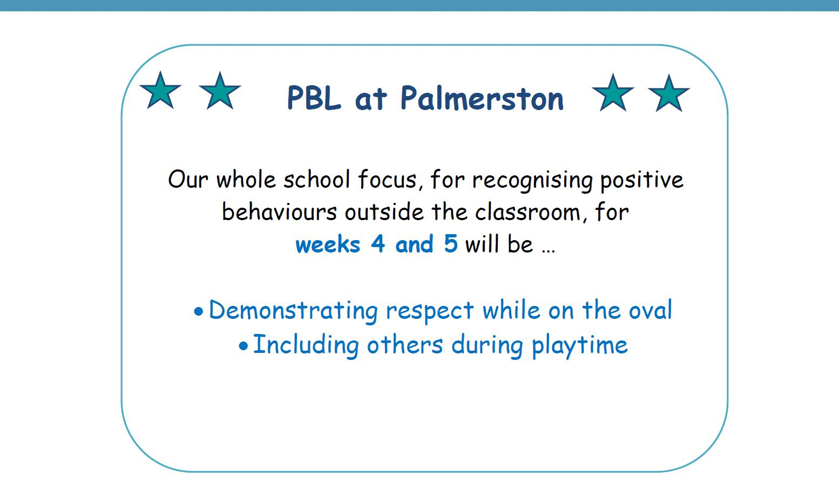

Together, we learn from each other

What’s On

UPCOMING EVENTS

5c Challenge for the Twilight Fair

Date: 22 October - 16 November

Location: Palmerston Primary

Whole School & Yr6 Graduation Photo

Date: Wednesday 7 November 2018

Location: Palmerston Primary

2019 Preschool Parent Information Session

Date: 5pm Wednesday 7 November 2018

Location: Palmerston Preschool

2019 Kindergarten Parent Information Session

Date: 5:30pm Wednesday7 November 2018

Location: Palmerston Primary

Yr6 Gold Creek School Transition

Date: Friday 9 November 2018

Location: Gold Creek School - senior site

2019 Kindergarten Open Morning

Date: Monday 12 November 2018

Location: Palmerston Primary

Yr3/4 & IEC Questacon Excursion

Date: Monday 12 November 2018

Location: Questacon

Mufti Day for the Twilight Fair

Date: Tuesday 13 November - Preschool (Brave, Itchy & Noisy bears)

Date: Friday 16 November - Preschool (Cranky, Hungry & Sleepy bears) - Yr6

Location: Palmerston Primary & Palmerston Preschool

Together, we learn from each other

What’s On

2019 BOOK PACK LISTS

Book Packs are ready! You can go online and order 2019 book packs.

Please refer to the website for book pack lists. Please follow the ordering instructions;

Go to the OfficeMax website OfficeMaxSchools.com.au

Search for Palmerston Primary School, Palmerston ACT and enter your school access key: 4TV8Q

Complete the student details and select the year level that your child will be in for 2019. Eg. If your child is in Yr.1 this year then you need to select the 2019 Yr. 2 list.

Review your requirements list and make any changes (if required). Please note that some items have been denoted as a requisite for the subject or year.

If you have more than one student at the school you will need to repeat the above steps, ordering the correct 2019 year level list.

Once completed, an order confirmation will be sent to your email address.

Order Deadlines and Delivery

Your order will be delivered to your home address. Please note: Orders will NOT be sent to the school.

Orders are delivered via Australia post’s eParcel service and you will receive an email with the Australia Post tracking ID Number. Post Offices Box addresses are NOT accepted.

Orders placed on or before 17 December will be delivered free of charge.

Orders placed after 17 December and on or before 31 December will incur a $12.95 delivery fee.

Orders placed after 31 December will incur a $12.95 delivery fee and all efforts will be made to deliver prior to the beginning of Term 1, 2019.

IMPORTANT

ALL Stationery packs need to be brought to school on the first day of Term 1, 2019 and given to the class teacher.

If you need any help placing your order, returns or refunds, delivery information or have a general enquiry please visit OfficeMaxSchool.com.au/help

Please DO NOT send any Stationery Lists or money to the school, ALL orders are through OfficeMax.

Together, we learn from each other

What’s On

Together, we learn from each other

What’s On

SUNSCREEN REMINDER

As the weather warms up and the UV level rise we encourage parents to apply sunscreen at home before school.

Sunscreen is readily available for students to reapply throughout the day

Together, we learn from each other

What’s On

P&C NEWS

Together, we learn from each other

What’s On
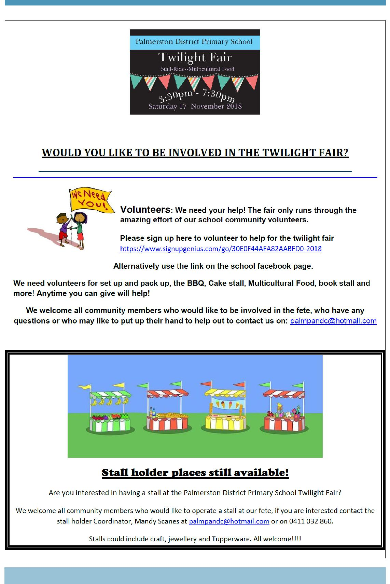

Together, we learn from each other

What’s On
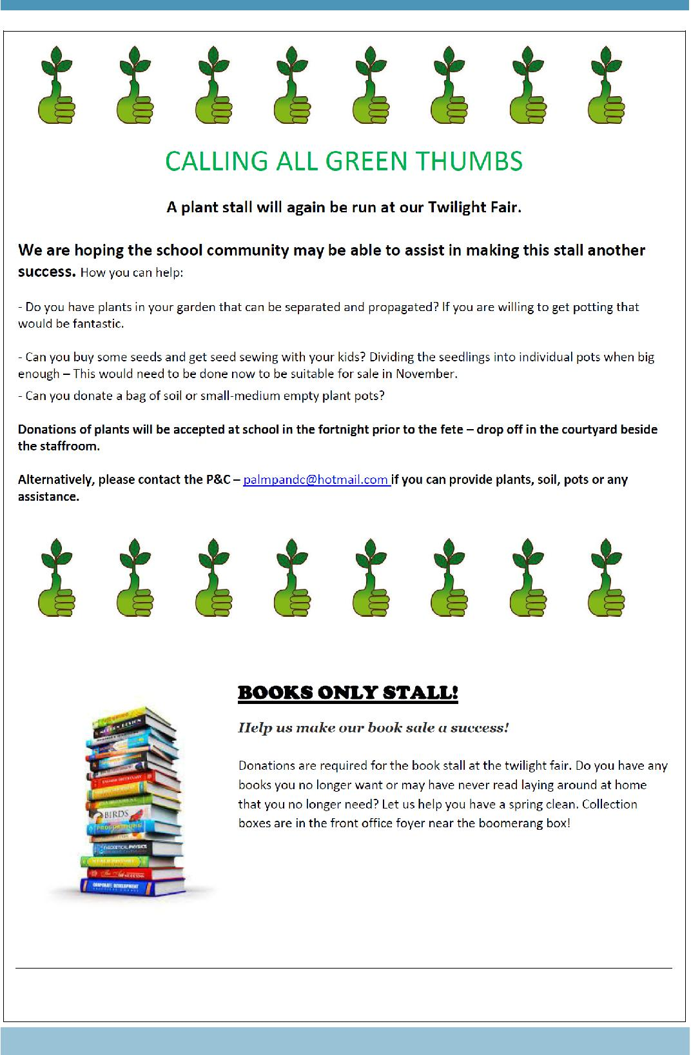

Together, we learn from each other

What’s On
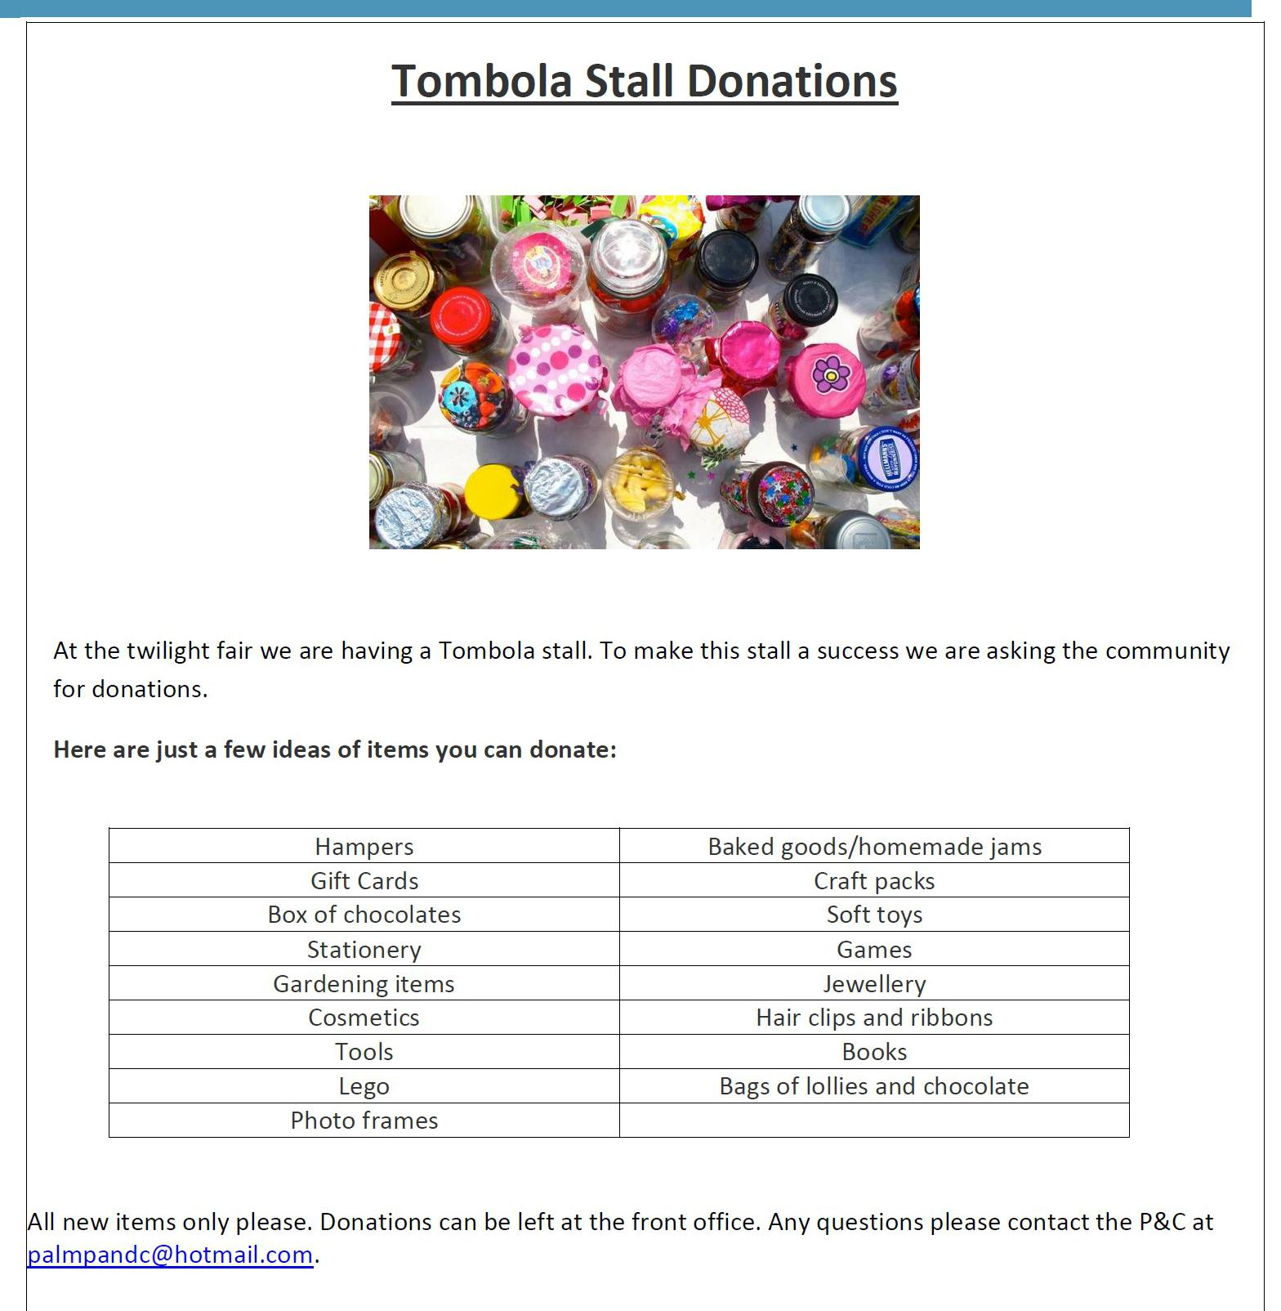

Together, we learn from each other

What’s On
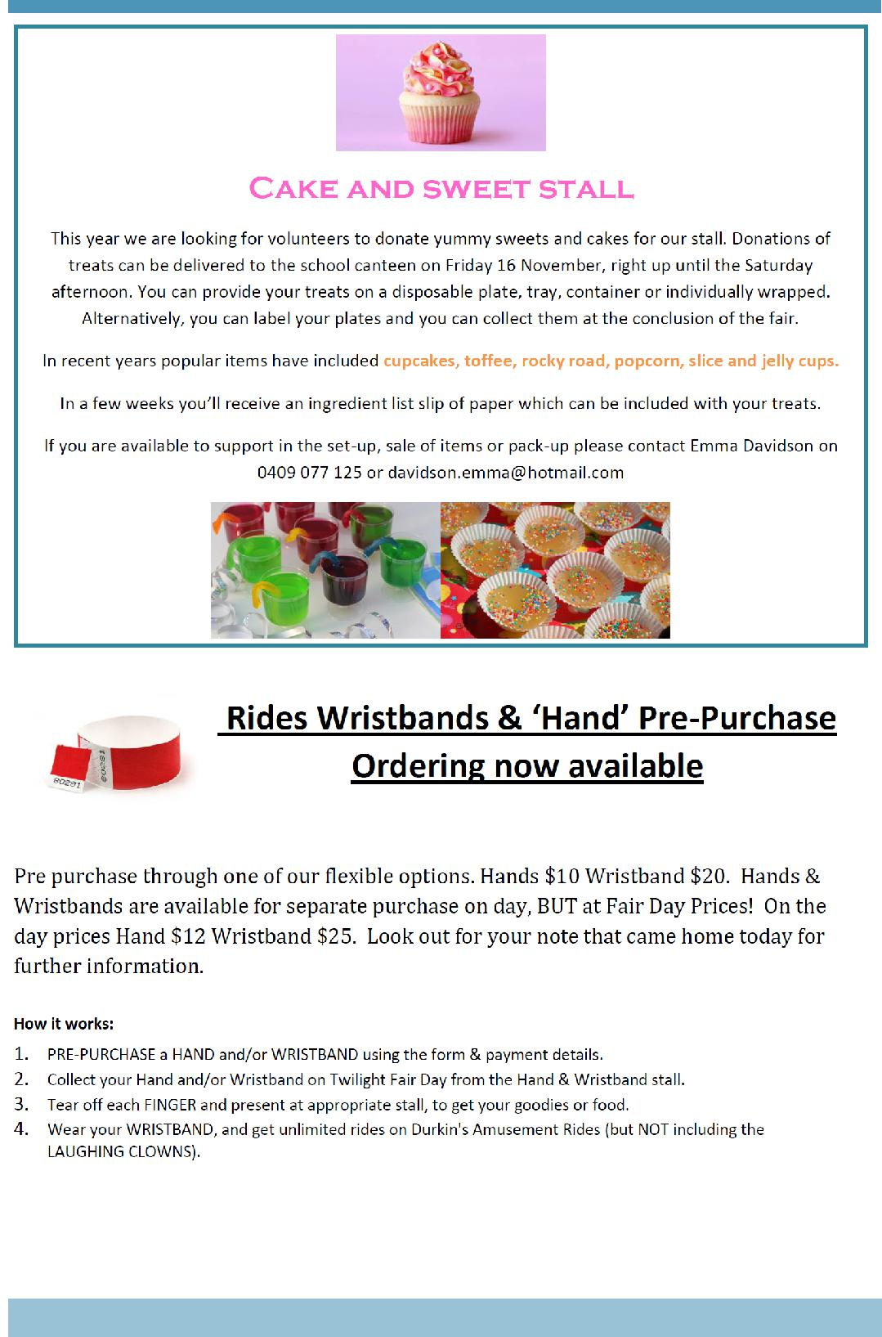

Together, we learn from each other

What’s On
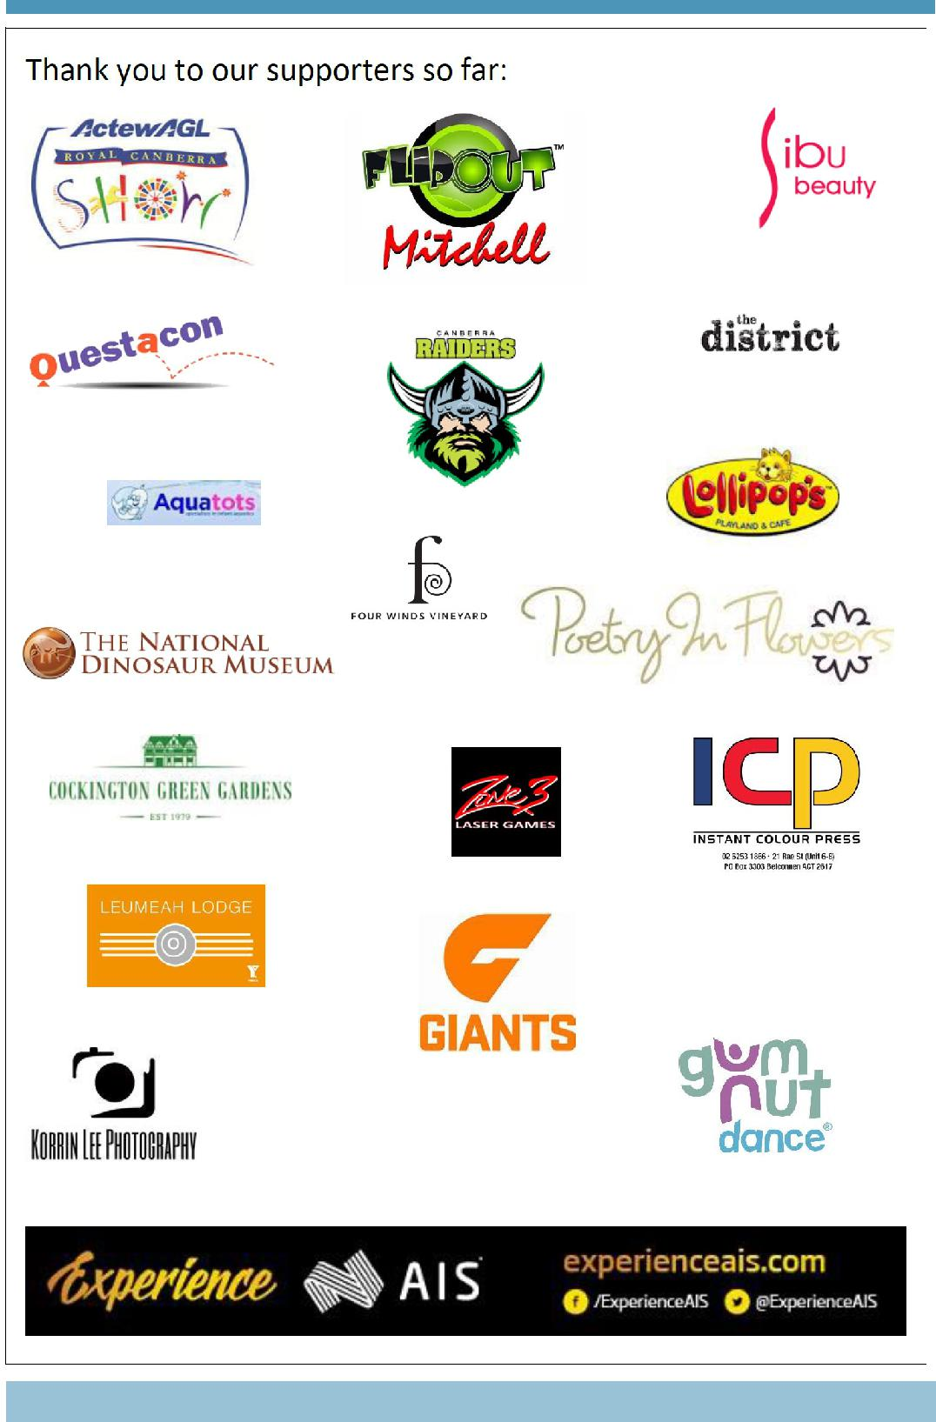

Together, we learn from each other

What’s On
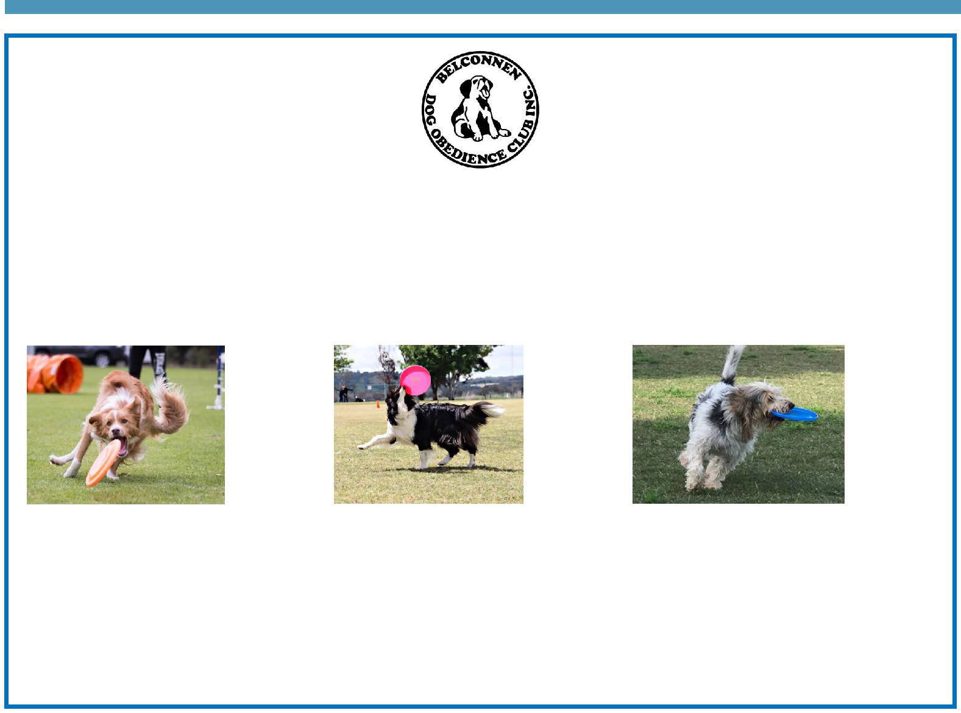

BDOC Disc Dogs Demonstration

Belconnen Dog Obedience Club will be showcasing a Disc Dog demonstration as part of the PDPS Twilight Fair. Disc Dogs is a series of disc (Frisbee) games played by a handler and their dog. Some activities include tunnels and/or jumps.

Come along as see various dogs participating in these sports including Miss Griffin’s dog Fergus.

Visit the Belconnen Disc Dogs Facebook page for more information: https://www.facebook.com/ BelconnenDiscDogs/

For further information please contact the stall co-ordinator Catherine Griffin by email catherine.griffin@ed.act.edu.au

Together, we learn from each other

What’s On

SCHOOL INTENTIONS 2019

School Leavers 2019

We have now reached the time in the year when look at our school numbers and staffing arrangements for 2019. If your circumstances have changed and your child/ren will not be attending Palmerston District Primary School in 2019 can you please let the front office staff know as soon as possible.

My child/ren will not be returning to Palmerston in 2019.

Name Class

Last day at Palmerston:

My child/ren will be attending:

Another government school in the ACT:

A non-government school in the ACT:

Moving out of the ACT

Forwarding Address:

Phone number:

Parent’s name:

Together, we learn from each other

What’s On
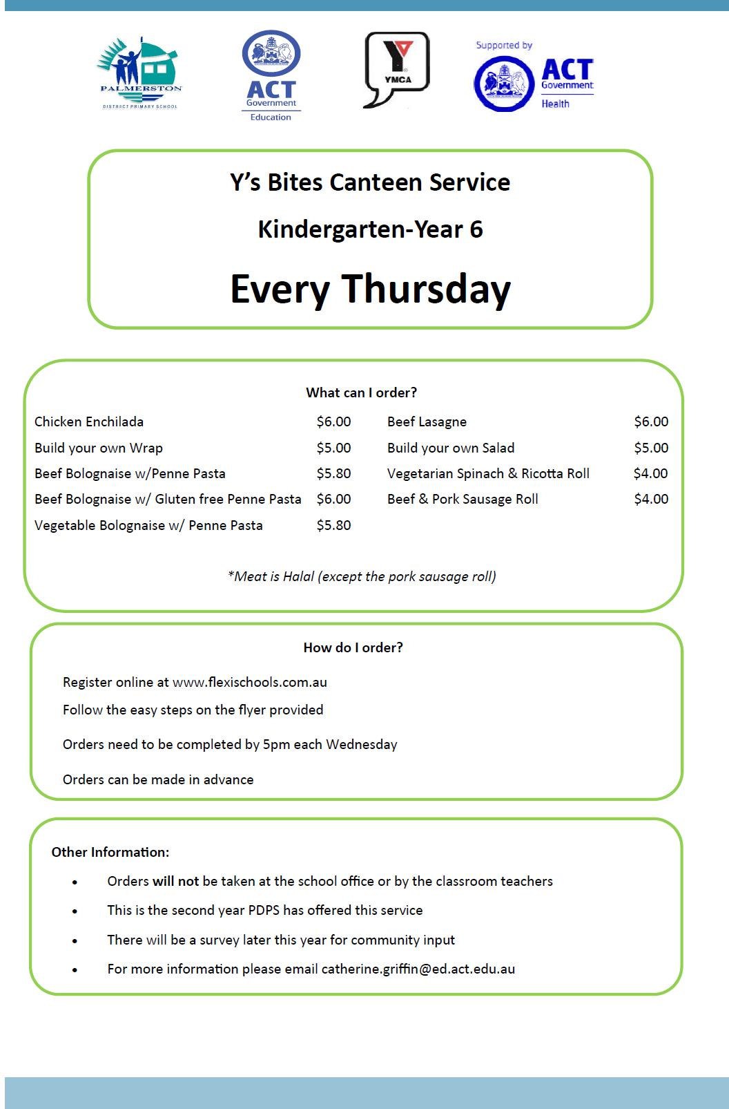

Together, we learn from each other

What’s On

Together, we learn from each other

What’s On

COMMUNITY NEWS

Year 6 students Transitioning to Year 7 at Gold Creek School (GCS), 2019

Dates to remember

Thursday 1 November 2018 |  | Parent Information Night (5.45 – 6.45pm)
Friday 9 November 2018 |  | Student Transition Day (9.10am – 2.40pm)
No later than 26 October 2018 |  | Student Transition day Invitation acceptance response to GCS
 |  | (via link provided in emails from GCS)
2 November 2018 |  | Year 7 Camp Note and 1st deposit due at GCS
9 November 2018 |  | Chromebook Notes due at GCS
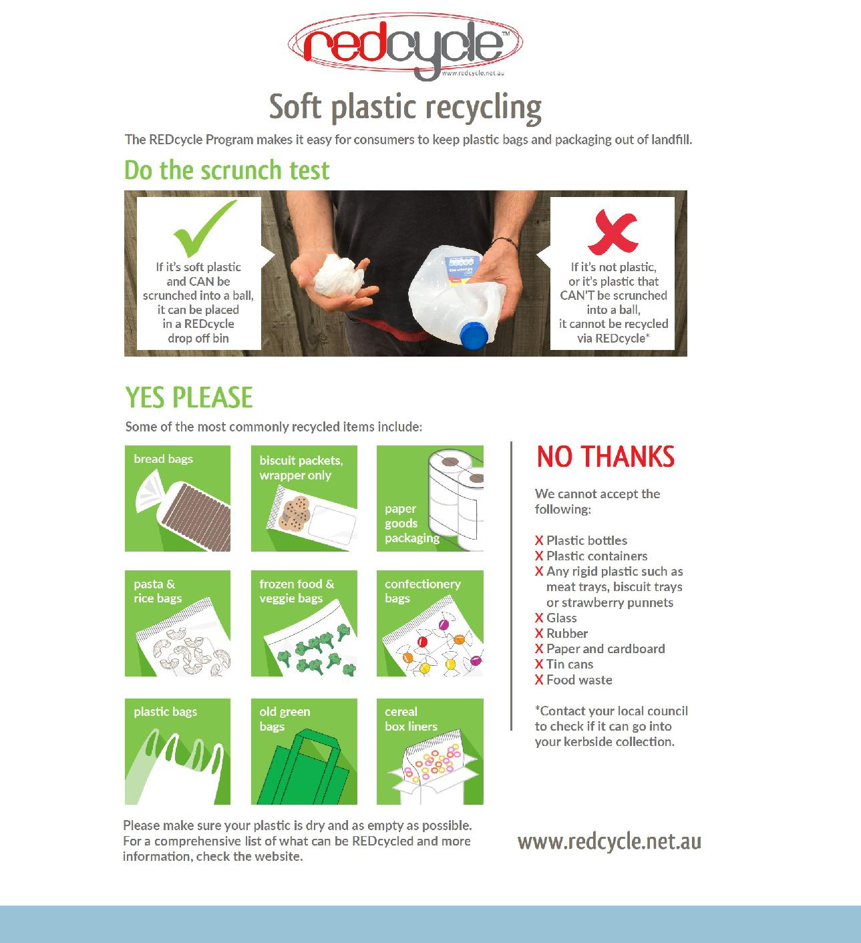

Together, we learn from each other

