Palmerston Post

8 November 2018

Week 4 , Term 4

Board Chair: Lisa Fior Board Members: Parent Reps: Jesse Dang and George Villaflor

Teacher Reps: Jessica Lago and Maxine Green

P&C President: Lisa Fior

Principal: Melissa Travers Deputy Principal: Kate Flynn & Haeley Simms (acting)

Executive Teachers: Kylie Moller, Jacqui Warden, Matt Gowen, Felicity McNeice, Catherine Griffin (acting)

ASSEMBLY:
9 Nov |  | Whole school -
 |  | Remembrance Day
DATES TO REMEMBER:
9 Nov |  | Yr6 Gold Creek Transition
12 Nov |  | Kindy Open morning
12 Nov |  | Yr3/4 & IEC Questacon
 |  | excursion
13 Nov |  | P/S Mufti Day
14 | Nov | Yr6 Graduation Photo
16 | Nov | Mufti Day for Twilight Fair
20 | Nov | Yr6 Band rehearsal
21 Nov |  | Whole school photo
21 Nov |  | BandStrav
22 | Nov | Yr2 Zoo excursion
23 | Nov | Governor-General’s
 |  | Sports Fun Day
26 Nov - 7 Dec |  |  |  | Yr2 AquaSafe
28 | Nov | Christian Education
10 | - 14 Dec |  |  | Kindy Swim &
 |  | Survive
17 | - 21 Dec |  |  | Yr1 Swim &
 |  | Survive

NOTES HOME:

- Mufti Day for Twilight Fair

P&C BOARD NEWS P&C: 7:00pm 17 Dec

All P&C activities, meeting agendas and minutes are available from the school website at – Parent Corner

School Board: 7:30am 29 Nov

PRINCIPAL’S MESSAGE

I hope you are all enjoying the rain. Our gardens will come up very green. Mr Phil may not be so excited about all the lawn mowing! The school is preparing for a hot summer and any possible bush fire alerts. We are cleaning gutters and removing any rubbish to keep us safe. Take a moment to look at the back of our school at our Yarning Circle. Stage one is completed and next year we will be planting plants from our local area.

The school is building with excitement around the upcoming Twilight Fair, so please put the 17 November in your diaries.

I would like to remind everyone, that it is a good time to plan where you would like to park during our Twilight Fair, to ensure you are not fined. Parking inspectors have been sighted fining car owners for illegal parking at other school events around Canberra. Please note:

Parents can provide a safer environment for our children and avoid incurring fines which include:

- Parking on the verge (fines from $114)

- Parking on footpaths (fines from $114)

- Stopping in a No Stopping zone (fines from $255)

- Parking in a No Parking zone (fines from $114)

- Stopping on a pedestrian or children’s crossing (fines from $383)

- Parking in a Bus Zone (fines from $153)

- Parking in a mobility (disabled) space (fines from $600)

Thanks for your support and planning ahead to ensure child safety and not experienced being fined by a parking inspector during our Twilight Fair.

This week, preschool celebrated the week 4 in Diwali style! Check out Preschool staff’s fashions in the playground!

Have a great week,

Melissa Travers

Together, we learn from each other

Palmerston Post

EXECUTIVE TEACHER’S MESSAGE

Term four is well underway with many events happening around the school. The Book Fair was a great success last week. Every morning and afternoon the library was full of busy book buyers!! The school benefits from Scholastic by gaining book points for future purchases. Thanks to Tiffany Fletcher for organising this and to all the staff who volunteered to operate the stall.

Preschool and Kindergarten Transitions

Palmerston District Primary School would like to welcome all the new and continuing families who attended the Preschool and Kindergarten information sessions last night. Our school community is looking forward to working with you and your children at the upcoming transition visits. If you have any questions about Preschool or Kindergarten transitions, please contact Felicity McNeice at the school on 6142 1440.

Whole school and year six graduation photo

Yesterday we were scheduled to have our students take place in the annual whole school and year six graduation photo. Due to the rain we have postponed the year six graduation photo till next Wednesday, 14 November. The whole school photo will be taken on Wednesday 21 November at 9:30am.

Year six transitions to Gold Creek School, Friday 9 November

Students in year six who are attending Gold Creek School have their transition day tomorrow. The day runs from 9:10am - 2:40pm with parents and carers required to provide transport to and from Gold Creek School. A great time is anticipated, and excitement is building as they move towards the next step in their schooling.

Year six graduation

Year six students and teachers are preparing for graduation that is being held on Wednesday 19 December. Graduation is a great event where students get to celebrate their achievements at Palmerston District Primary School and share special memories with peers, families and teachers.

Remembrance Day

Sunday is Remembrance Day. Tomorrow Remembrance Day will be acknowledged across the school. We will be having an assembly on the blacktop at 9am. Defence families are invited for morning tea, at the conclusion of the assembly. A minute silence will be held in classrooms at 11am. If the weather on Friday is unsuitable the assembly will be moved into the hall.

Reports & 2019

Teachers are busy writing school reports this month. Please take some time to book an interview. This can be done at the front office. Interviews are a great opportunity to discuss your child’s learning and reflect with the classroom teacher before they move into 2019.

Are you moving school?

If you are relocating schools for 2019, please notify the front office and fill in a leavers form ASAP.

We are also making 2019 classes and overseeing 2019 staffing this month.

Have a great week,

Matt Gowan

Together, we learn from each other

Palmerston Post

PALMERSTON PRIDE AWARDS

Congratulations to the following students who received a PRIDE Award at last week’s

assembly

PARTICIPATION – becoming involved, “having a go” and cooperating with others

Jaliyah - 3RC | Yuvraj - 3DJ | Laith - 5IH | Navrose - 5IH | Georgia - 5IH
Brendon - 6AJ | Laura - 6AJ | Demi - 6KB | Summer - 6KB
RESPECT – having respect for self, others and their property
Srija - 3/4JL | Aidan - LSU | Evie - 6AJ | Elektra - 6AJ
INTERGRITY - being honest, fair and responsible
Leanne - 4/5CC | Sarah - 4/5CC | Dean - 6KB
DETERMINATION - being persistent and resilient
James - 5IH | Amaan - 5IH | Lilli - 5DT | Kayley - 6KB

EMPATHY - understanding and supporting others regardless of our differences Annabella - 3RC Dom - 6KB

PRESCHOOL NEWS
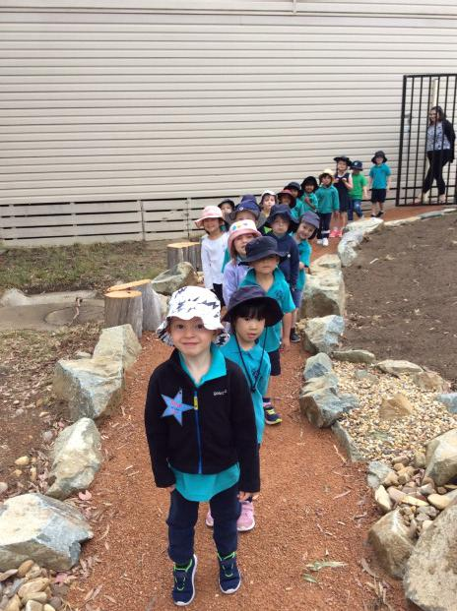

Yesterday the Cranky Bears went for a walk to the BIG school to look at the new yarning circle. We sat around and had a little ‘yarn’, recalling the many dreamtime stories we have read throughout the
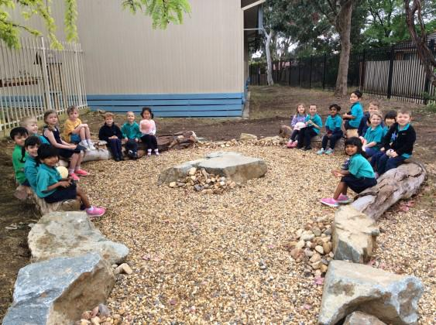
year. Our favourite is “How the Birds Got Their Colours”.
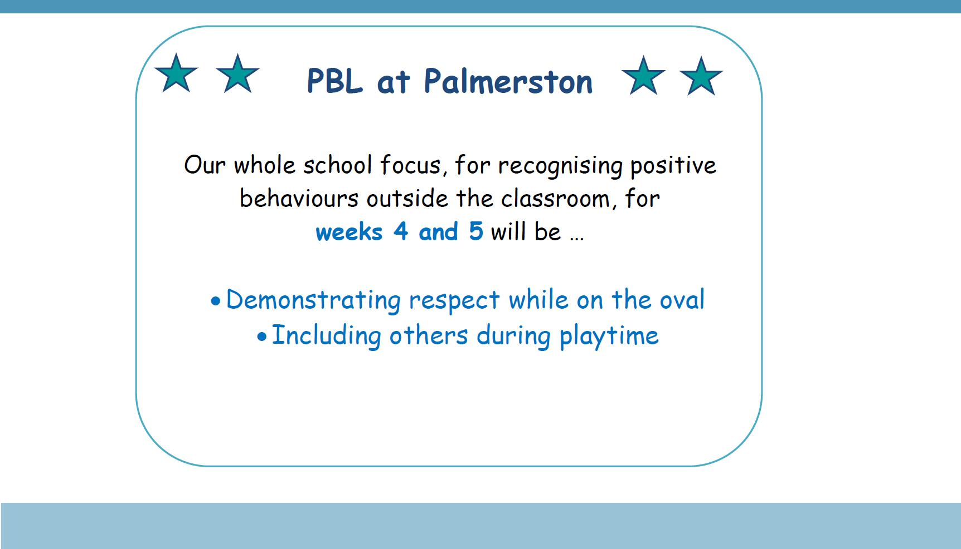

Together, we learn from each other

Palmerston Post

UPCOMING EVENTS

5c Challenge for the Twilight Fair

Date: 22 October - 16 November

Location: Palmerston Primary

Yr6 Gold Creek School Transition

Date: Friday 9 November 2018

Location: Gold Creek School - senior site

2019 Kindergarten Open Morning

Date: Monday 12 November 2018

Location: Palmerston Primary

Yr3/4 & IEC Questacon Excursion

Date: Monday 12 November 2018

Location: Questacon

Yr6 Graduation Photo *rescheduled*

Date: Wednesday 14 November 2018

Location: Palmerston Primary

Mufti Day for the Twilight Fair

Date: Tuesday 13 November - Preschool (Brave, Itchy & Noisy bears)

Date: Friday 16 November - Preschool (Cranky, Hungry & Sleepy bears) - Yr6

Location: Palmerston Primary & Palmerston Preschool

Twilight Fair

Date: Saturday 17 November 2018

Location: Palmerston Primary

Yr6 Band Rehearsal

Date: Tuesday 20 November 2018

Location: Bonner Primary School

Whole School Photo *rescheduled*

Date: Wednesday 21 November 2018

Location: Palmerston Primary

Yr6 Band Stravaganza

Date: Wednesday 21 November 2018

Location: Llewellyn Hall, ANU School of Music

Yr2 National Zoo & Aquarium excursion

Date: Thursday 22 November 2018

Location: National Zoo & Aquarium

Together, we learn from each other

Palmerston Post

ACT Education Directorate update regarding Emergency Services

The ACT Education Directorate have recently reviewed their information regarding Emergency services and have advised that members of the public should access the ACT Emergency Services website www.esa.act.gov.au for regular updated information. The ACT ESA will continue to provide public messages to the ACT community regarding bushfire and bushfire preparedness as well as material to assist the public to understand warning arrangements. Any public inquiries regarding bushfires and emergency management should be referred to the ACT ESA on 6207 8444 or at

www.esa.act.gov.au or to Access Canberra on 13 22 81 or at www.accesscanberra.act.gov.au.
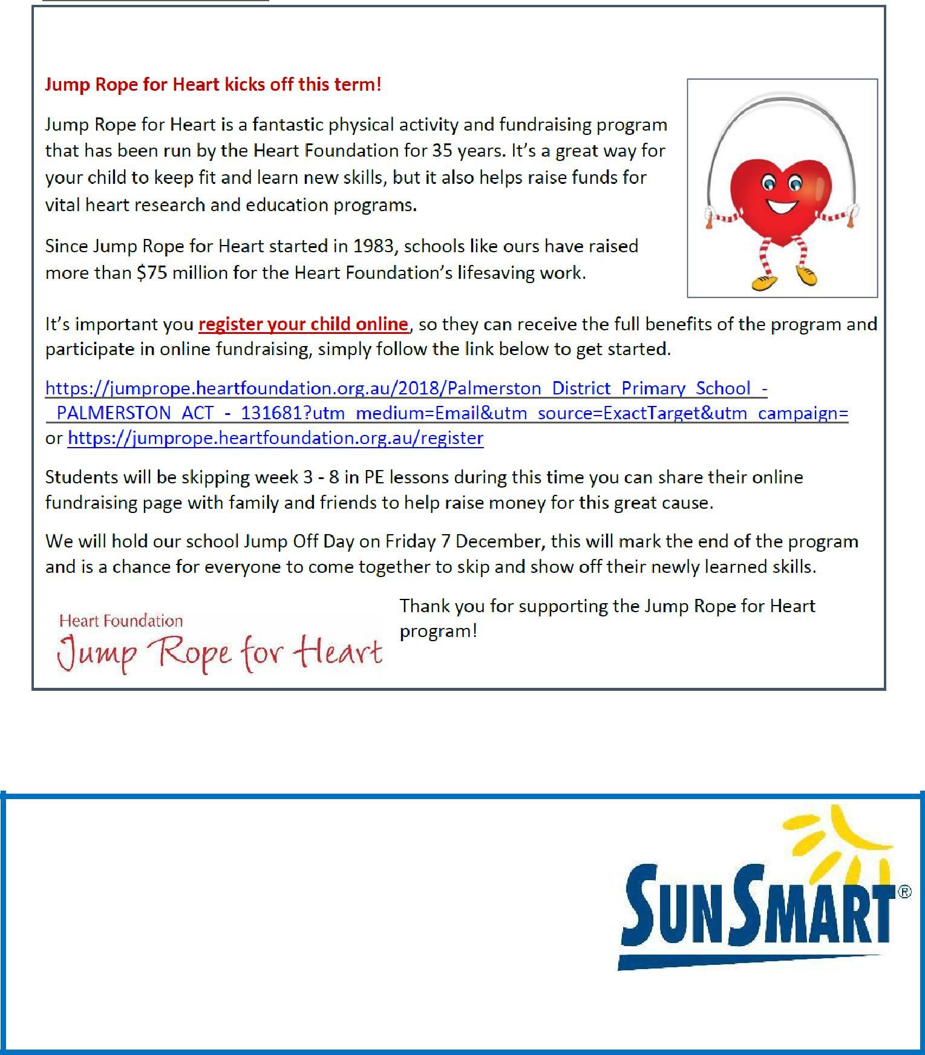

SUNSCREEN REMINDER

As the weather warms up and the UV level rise we encourage parents to apply sunscreen at home before school.

Sunscreen is readily available for students to reapply throughout the day

https://actcancer.org/prevention/sunsmart/act-schools-and-early-childhood-services/national-schools-program/

Together, we learn from each other

Palmerston Post

2019 BOOK PACK LISTS

Book Packs are ready! You can go online and order 2019 book packs.

Please refer to the website for book pack lists. Please follow the ordering instructions;

Go to the OfficeMax website OfficeMaxSchools.com.au

Search for Palmerston Primary School, Palmerston ACT and enter your school access key: 4TV8Q

Complete the student details and select the year level that your child will be in for 2019. Eg. If your child is in Yr.1 this year then you need to select the 2019 Yr. 2 list.

Review your requirements list and make any changes (if required). Please note that some items have been denoted as a requisite for the subject or year.

If you have more than one student at the school you will need to repeat the above steps, ordering the correct 2019 year level list.

Once completed, an order confirmation will be sent to your email address.

Order Deadlines and Delivery

Your order will be delivered to your home address. Please note: Orders will NOT be sent to the school.

Orders are delivered via Australia post’s eParcel service and you will receive an email with the Australia Post tracking ID Number. Post Offices Box addresses are NOT accepted.

Orders placed on or before 17 December will be delivered free of charge.

Orders placed after 17 December and on or before 31 December will incur a $12.95 delivery fee.

Orders placed after 31 December will incur a $12.95 delivery fee and all efforts will be made to deliver prior to the beginning of Term 1, 2019.

IMPORTANT

ALL Stationery packs need to be brought to school on the first day of Term 1, 2019 and given to the class teacher.

If you need any help placing your order, returns or refunds, delivery information or have a general enquiry please visit OfficeMaxSchool.com.au/help

Please DO NOT send any Stationery Lists or money to the school, ALL orders are through OfficeMax.

Together, we learn from each other

Palmerston Post

P&C NEWS
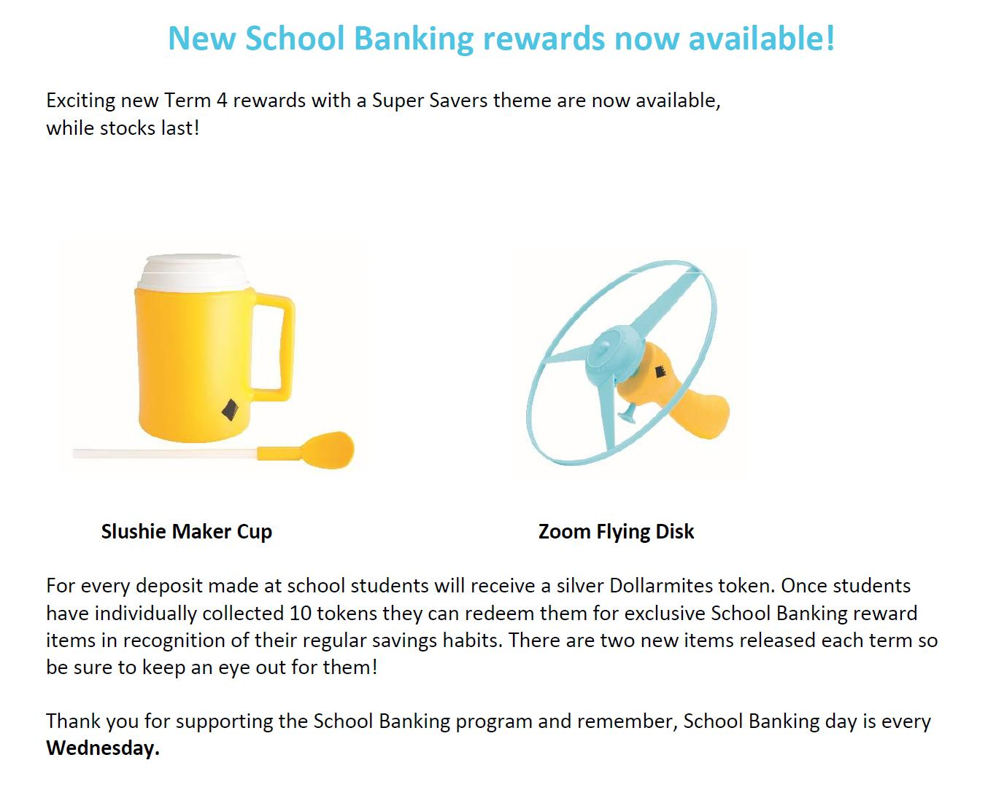

Together, we learn from each other

Palmerston Post
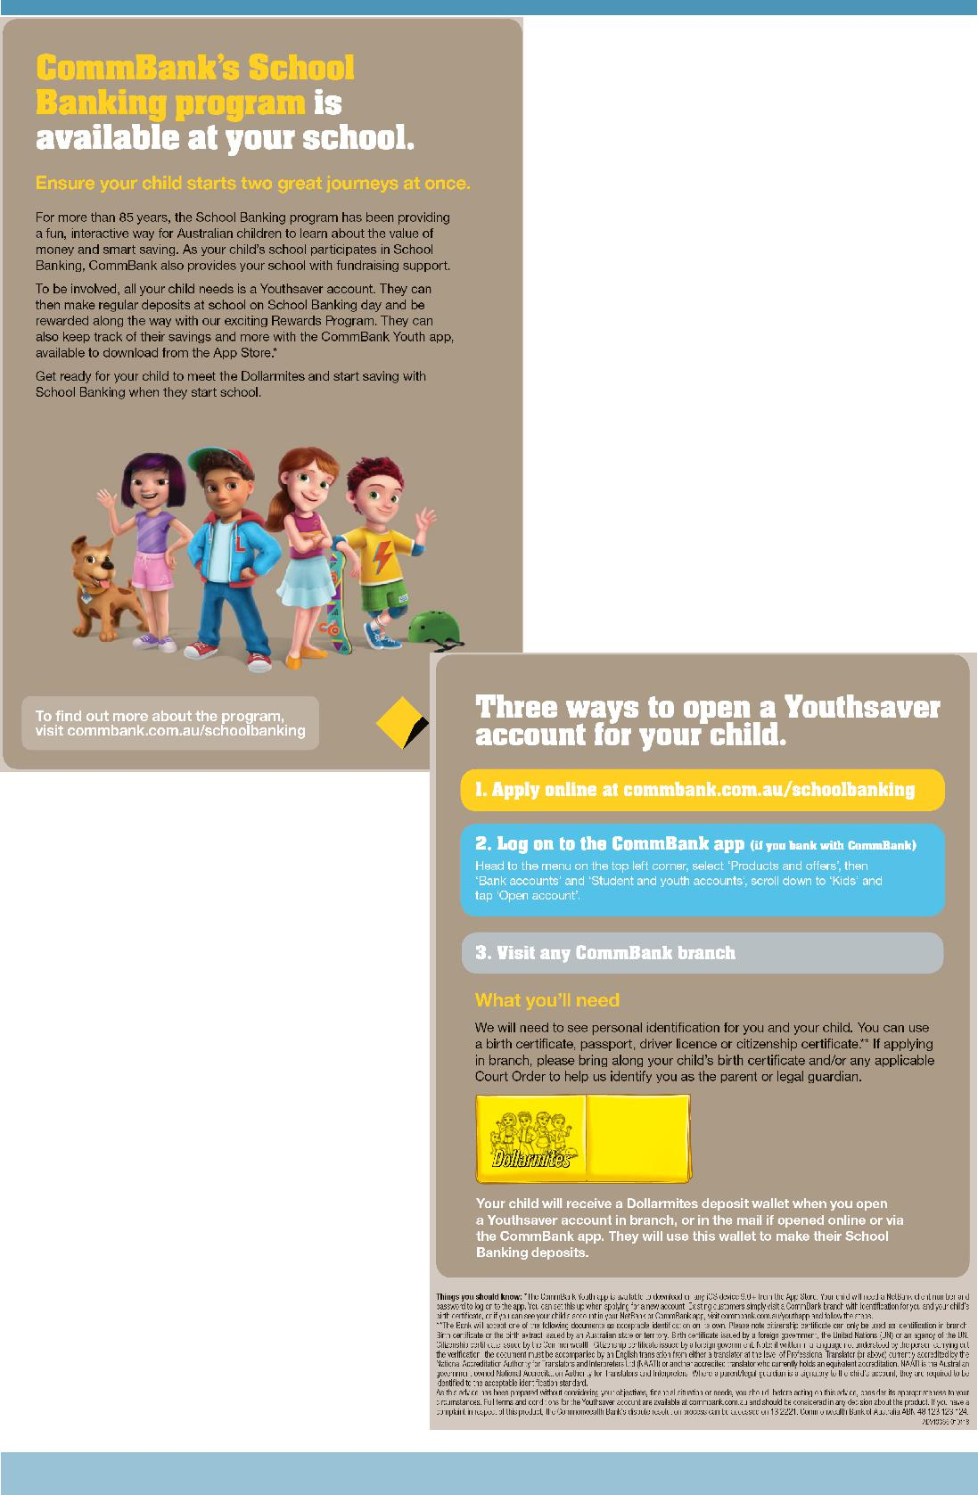

Together, we learn from each other

Palmerston Post
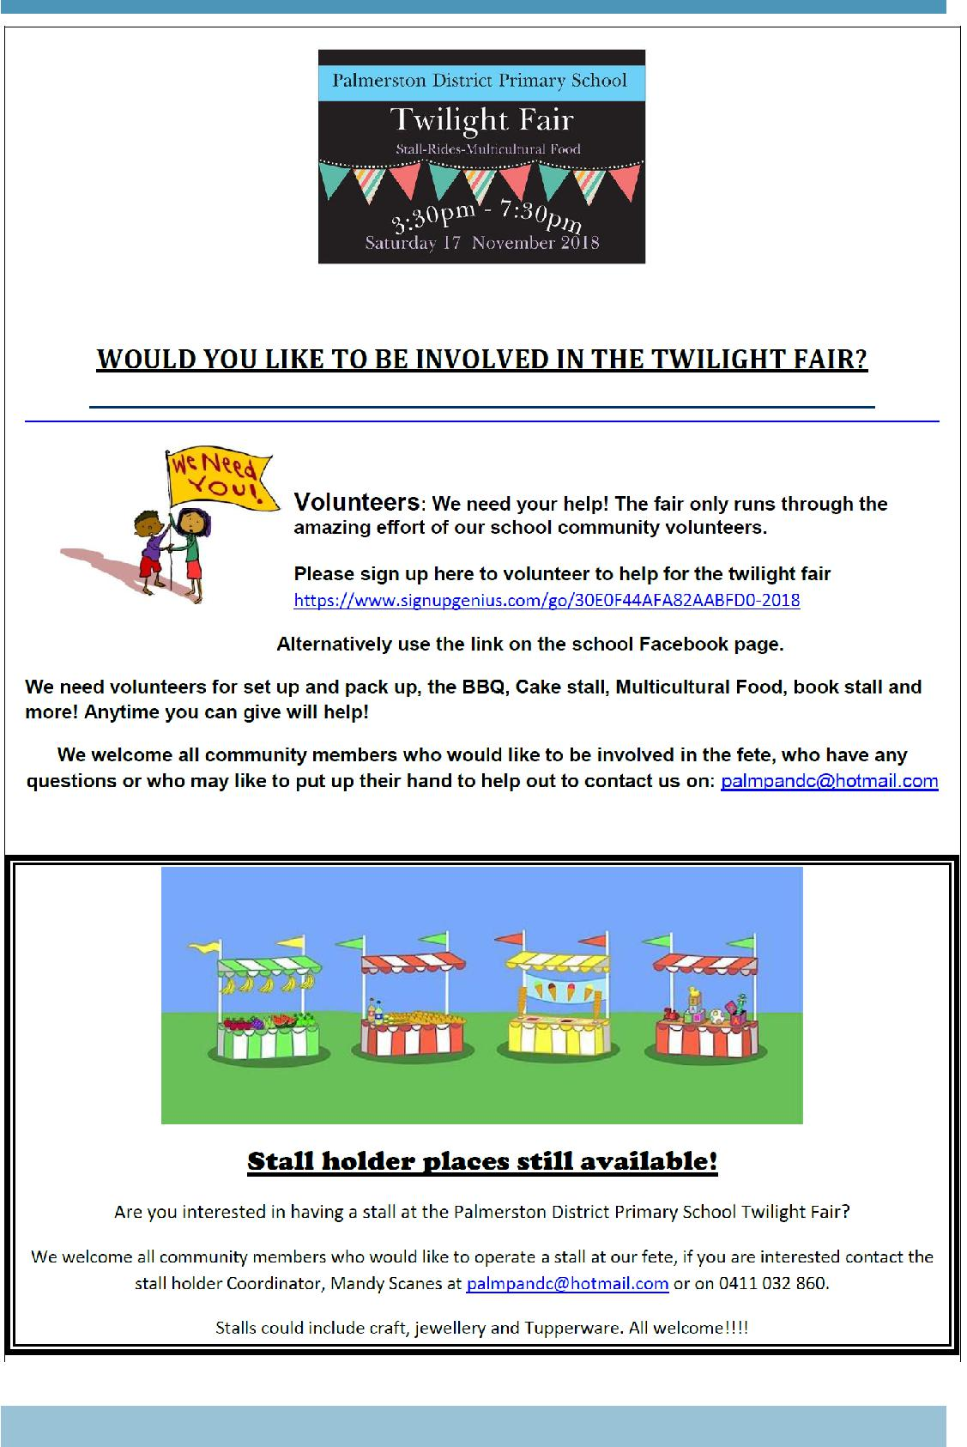

Together, we learn from each other

Palmerston Post
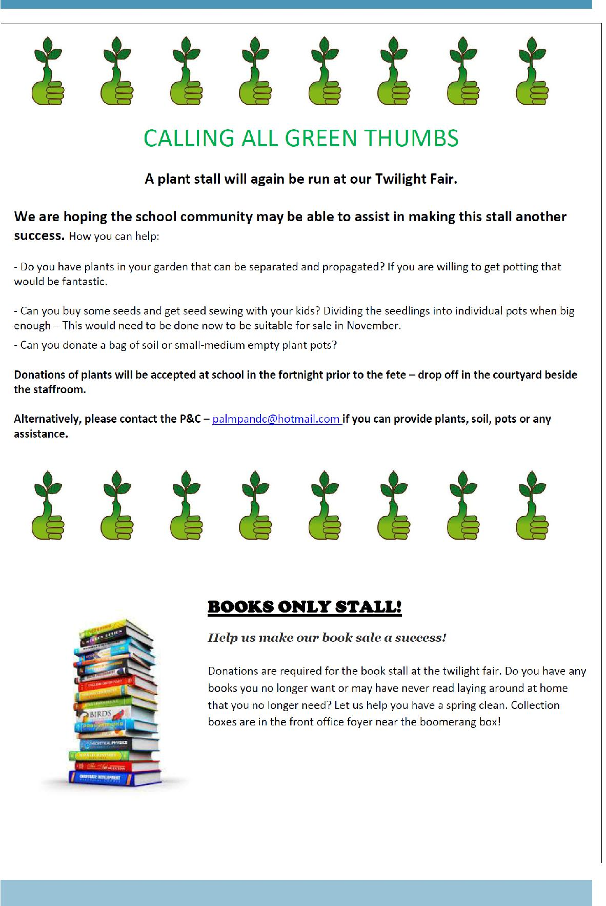

Together, we learn from each other

Palmerston Post
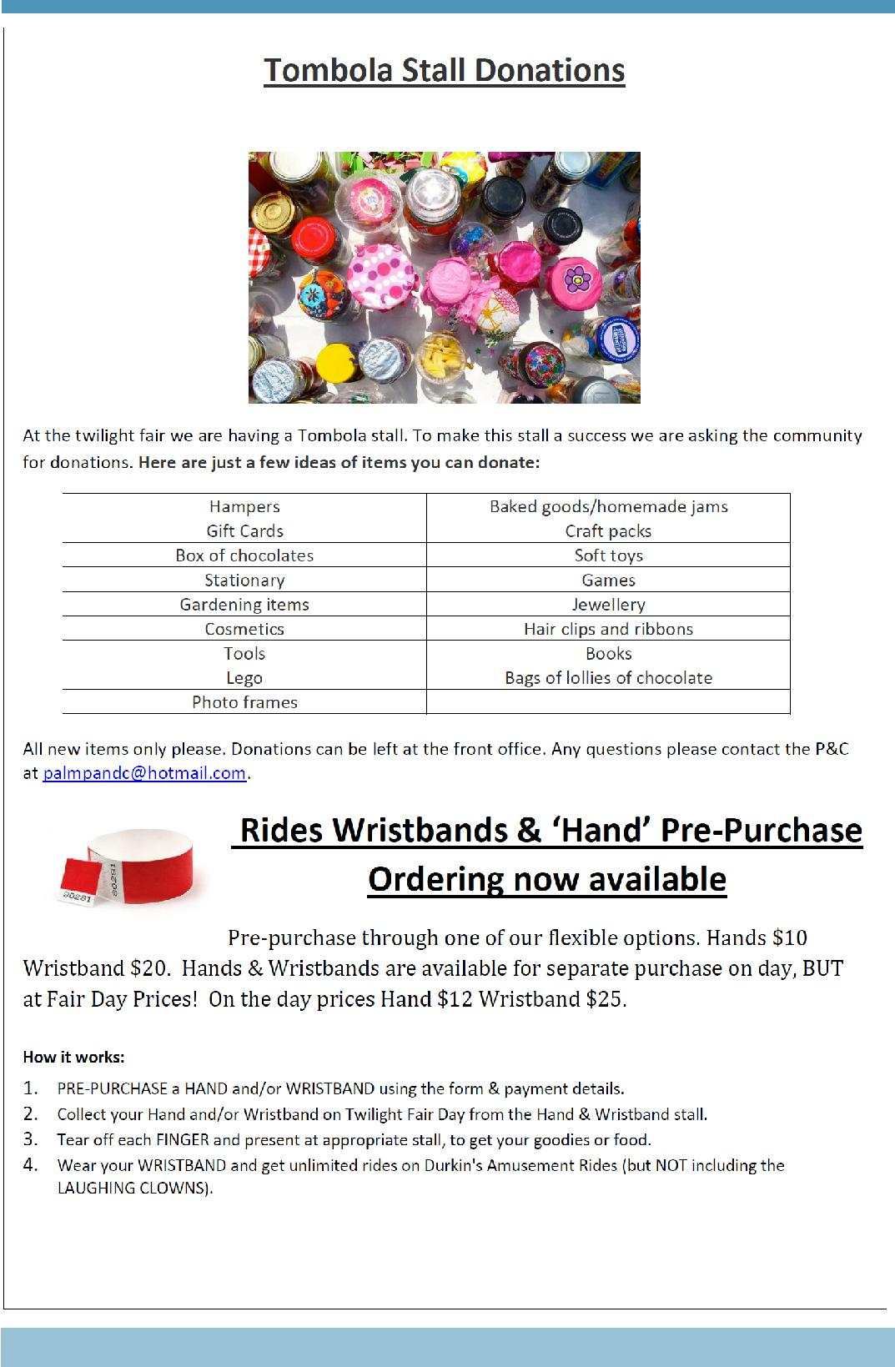

Together, we learn from each other

Palmerston Post
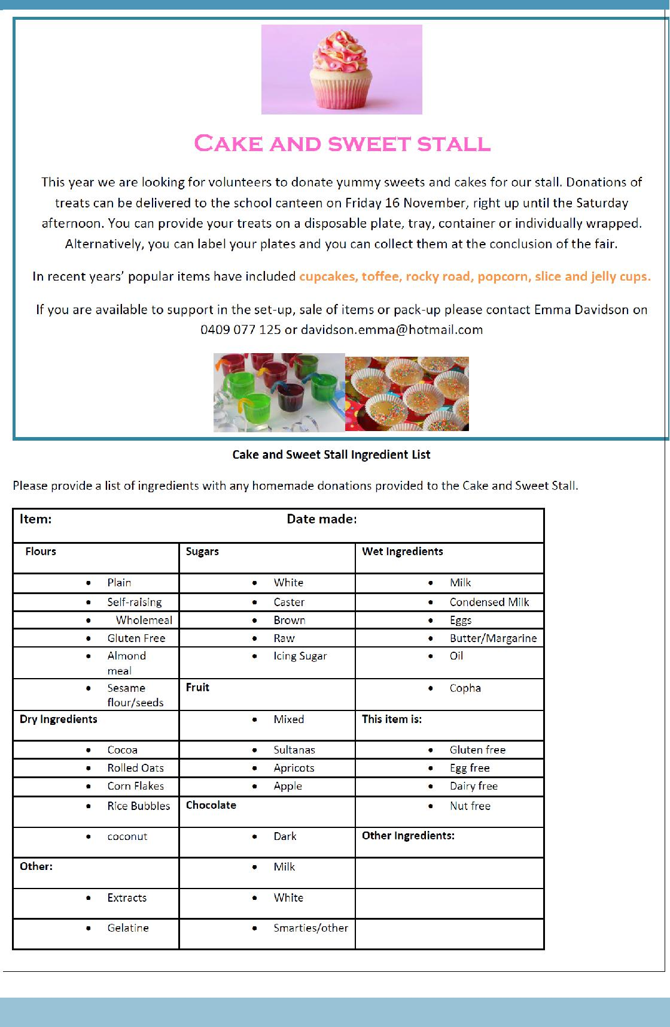

Together, we learn from each other

Palmerston Post
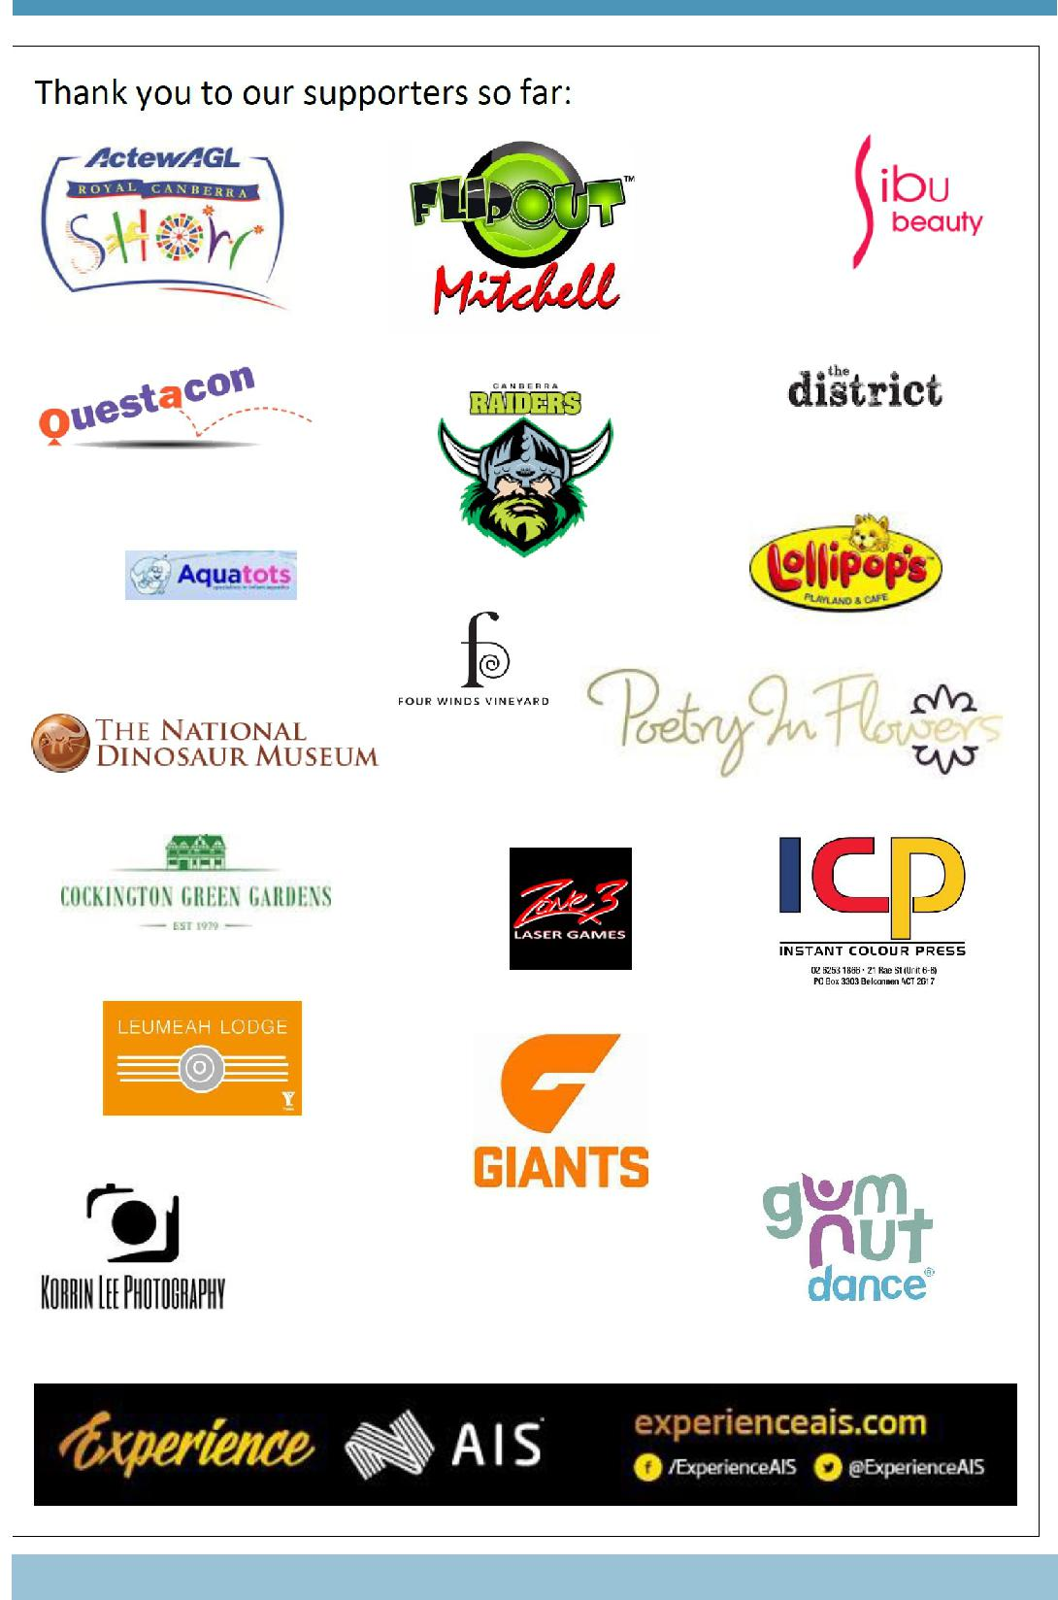

Together, we learn from each other

Palmerston Post
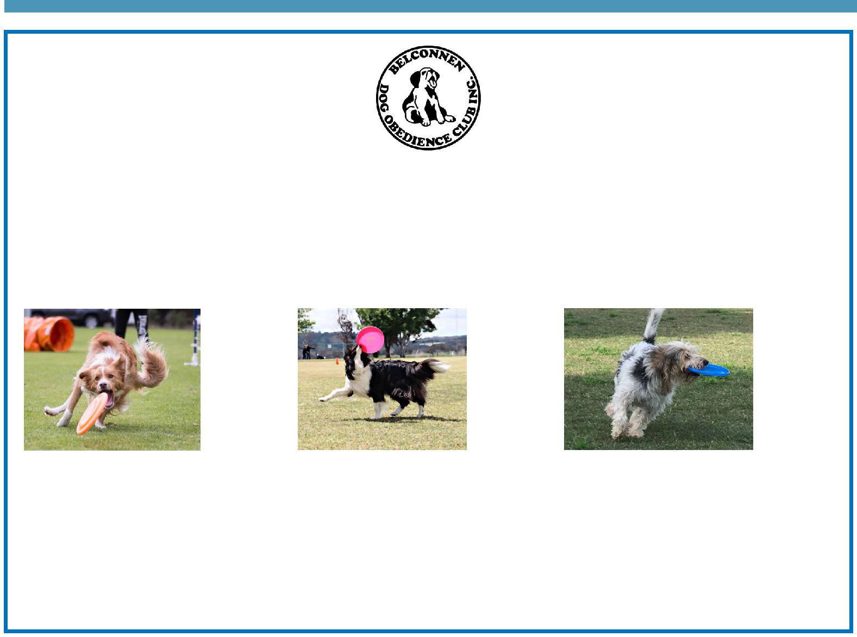

BDOC Disc Dogs Demonstration

Belconnen Dog Obedience Club will be showcasing a Disc Dog demonstration as part of the PDPS Twilight Fair. Disc Dogs is a series of disc (Frisbee) games played by a handler and their dog. Some activities include tunnels and/or jumps.

Come along as see various dogs participating in these sports including Miss Griffin’s dog Fergus.

Visit the Belconnen Disc Dogs Facebook page for more information: https://www.facebook.com/ BelconnenDiscDogs/

For further information please contact the stall co-ordinator Catherine Griffin by email catherine.griffin@ed.act.edu.au

Together, we learn from each other

Palmerston Post

SCHOOL INTENTIONS 2019

School Leavers 2019

We have now reached the time in the year when look at our school numbers and staffing arrangements for 2019. If your circumstances have changed and your child/ren will not be attending Palmerston District Primary School in 2019 can you please let the front office staff know as soon as possible.

My child/ren will not be returning to Palmerston in 2019.

Name Class

Last day at Palmerston:

My child/ren will be attending:

Another government school in the ACT:

A non-government school in the ACT:

Moving out of the ACT

Forwarding Address:

Phone number:

Parent’s name:

Together, we learn from each other

Palmerston Post
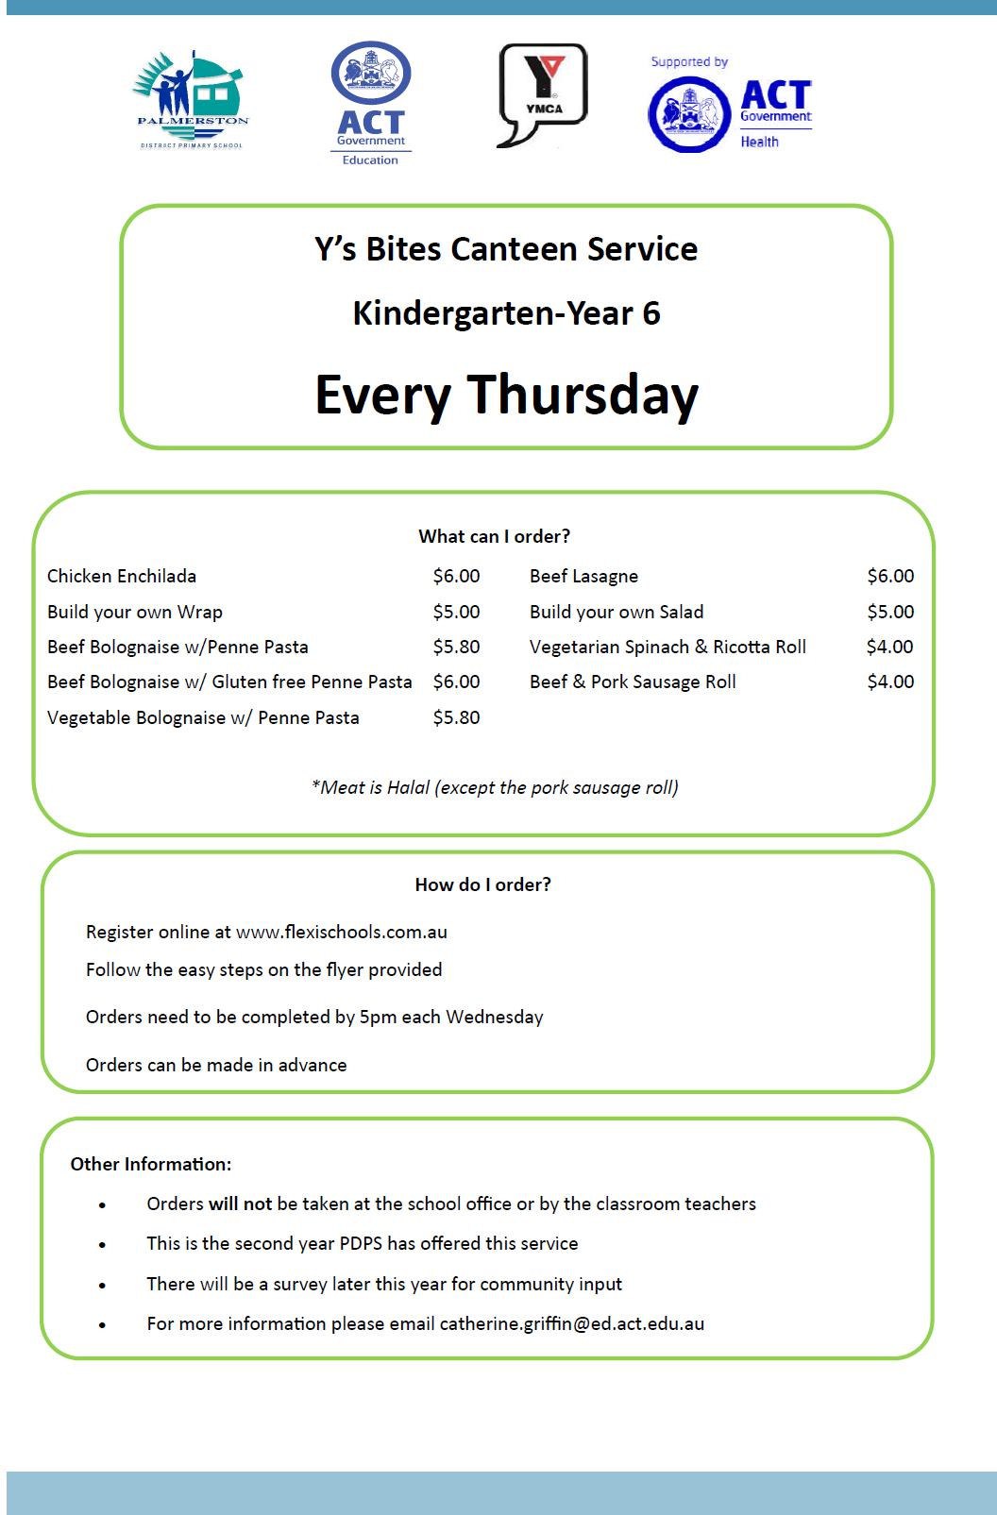

Together, we learn from each other

Palmerston Post

Together, we learn from each other

Palmerston Post

COMMUNITY NEWS

Year 6 students Transitioning to Year 7 at Gold Creek School (GCS), 2019

Dates to remember

Thursday 1 November 2018 Parent Information Night (5.45 – 6.45pm)

Friday 9 November 2018 Student Transition Day (9.10am – 2.40pm)

No later than 26 October 2018 Student Transition day Invitation acceptance response to GCS

(via link provided in emails from GCS)

2 November 2018 Year 7 Camp Note and 1st deposit due at GCS

9 November 2018 Chromebook Notes due at GCS

Together, we learn from each other

