What’s On

21 March 2019

Week 7, Term 1

ASSEMBLY:

22 Mar |  | Whole school - 1KW &
 |  | 1DE
29 Mar |  | Senior - 5/6CH & 5/6DT
05 Apr |  | Junior - 2SH & 2RC
12 | Apr | No assembly - Easter
 |  | Hat Parade
DATES TO REMEMBER:
21 | Mar | Harmony Day / Bullying
 |  | No Way Day
22 | Mar | National Ride2School
 |  | Day
22 | Mar | Clean Up Australia Day
25 Mar |  | K & Yr2 - Kenny Koala
 |  | visit
26 | Mar | K - Yr6 Music Viva
27 | Mar | Yr 1 - Kenny Koala visit
27 | Mar | Special Farewell
 |  | Assembly for Melissa
 |  | Travers
29 Mar |  | Defence Morning Tea

NOTES:

- P&C Sausage Sizzle lunch order

- P&C Hot Cross Bun order form - youngest

- Easter Hat Parade & Easter Raffle - youngest

- K - Yr6 The Ridiculous Rhyme Show incursion

- Yr4 Ukulele band - selected students

- P&C Disco - youngest

PRINCIPAL’S MESSAGE

Author Visit

This week has been an exciting week around Palmerston School with the amazing author Katrina Nannestad’s visit on Tuesday. Senior classes were able to spend time with her in the library and discuss and share writing and reading strategies. Our author visit programs have been happening at Palmerston for approximately 7 years. We have searched Australia for new and different Australian authors and enticed them to visit Palmerston in Canberra. Many of these authors have been identified through the attendance of teachers and myself at English and leadership conferences around Australia.

The school covers the cost of the authors to visit as we value their input into the students’ lives and recognise that literacy is for everyone. I would like to thank our Business Manager, Sonya Campbell, for her enterprising work in gaining hirers to pay for use of the school facilities when classes are not on, as this gives us money to pay for our co curricula activities and additional school resources. This work also ensures we keep book pack costs down.

Musica Viva

In another exciting activity, Mr Shaw has organised for Musica Viva to come to Palmerston. This is an opt-in music event for next Tuesday at a cost of $10. We are trialling this to see what interest families have in Mr Stovepipe and his music. Each year Musica Viva highlight a different genre of music. Palmerston has many music activities from clubs to formal commitments. We have year 5 and year 6 band, ukulele, guitar for seniors and for new players and African drumming. What a great musical school!

P&C BOARD NEWS P&C: 1 April 2019

All P&C activities, meeting agendas and minutes are available from the school website at – Parent Corner

School Board:

School Board

Thank you to all the community members who voted in the School Board elections. We have had such a big response. The counting will be on Friday and our new board members will meet on Monday morning at our first School Board Meeting for 2019.

Together, we learn from each other

What’s On

Reporting

Teachers have been busy with assessment and reporting as well as teaching this fortnight. Our term one reports go out at the end of week 9. This initiative came about from the P&C and School Board suggestion that as well as twice a year end of semester reports and interviews, families would like to know at the end of term one how their children were tracking. This is a Palmerston initiative and not all schools undertake term 1 reporting. I would like to thank the teachers for this additional level of professional reporting to families.

Harmony Day and Bullying No Way day

Each year we undertake a Harmony Day activity. Palmerston has 63 languages spoken across the school. To celebrate our cultural similarities and difference, we will be dancing together and trying out different dances from a range of countries. Some dances are: Cha Cha slide, Mexican Hat dance, Indian dances, Japanese dances, Bush dances, Hula dance, African Folk dance, & Bhangara Dance. For Bullying No Way activities, we have paired different age classes together, to discuss how to ‘get along’ and that conflict can happen but how do we get support and find a solution. To represent our activities and discussion, students are making paper T-shirts and we will have them on display in the corridor of the Administration building and around the school. This activity supports our school PRIDE values (Participation, Respect, Integrity, Determination, Empathy) and our PBL (Positive Behaviour for Learning) values of Being Safe, Being Respectful and Being a Learner.

Bullying is obviously never OK. So how can we tell what is bullying and what is not? This table, which is displayed around the school, may help.

Is it Bullying?

How can you tell if someone is being bullied? This chart can help you decide if it’s bullying or

something else.

Joking Around: |  | One Time thing:
• | Everyone is having fun. | • | Someone is being mean on purpose.
• | No one is getting hurt. | • | It’s a reaction to a strong emotion or
• | Everyone is participating equally. |  | feeling.
 |  | • | It happens once and doesn’t repeat
 |  |  | itself.

Conflict: |  | Bullying:
• | Two people with a balance of power that | • | Repeated, unwanted aggressive
 | have a fight, argument, or disagreement. |  | behaviour towards someone
• | A solution can usually be found. | • | Someone is being hurt on purpose.
 |  | • | Can be social, verbal, physical, or cyber.

Have a great week,

Melissa Travers

Together, we learn from each other

What’s On

SCHOOL BOARD NOMINEES

Voting period: 8 March - COB 22 March 2019

Voting forms are available at the front office.

Board Nominee Introductions

Kate Baron

My name is Kate Baron and I have a daughter in year 2 and a 3 year old at home. I have previously worked as a teacher in the ACT public education system. I am passionate about evidence-based teaching practice and student, teacher and staff wellbeing. I believe that a school where parents, teachers and staff work together provides the best outcomes for students and would use my place on the board to further promote community involvement in all areas of school life. I would appreciate the opportunity to help Palmerston continue to flourish as a fun, happy and engaging place for students to learn, staff to work and the community to enjoy.

Adam Davidson

As Chief Financial Officer for a large Canberra business I have experience in the financial and operational requirements for an organisation to reach its goals and objectives. I also have a keen interest in high performing organisations and what is required for teams to take their performance to the next level.

My entire life has been spent surrounded by family members who are part of the teaching profession at various levels and from this I have a solid knowledge of the ups and downs of schools and what areas require focus in order to create a great school. My aim as a board member would be to combine this with my passion for organisational performance to see continual improvement in the school’s performance across all areas be it academic, social and emotional needs, co-curricular and community engagement.

With two children already at the school and another one who will be attending in the coming years I have a vested interest in the school continuing to go from strength to strength over the long term. If elected I will be committed to accountability and a solutions-based approach to the role as parent representative on the school board.

Amy Phillips

In the past I have held both Parent Representative and Board Chair positions on the Palmerston School Board and I am keen to renew my connection with the Board again this year. In my working life I am an executive with the Department of Finance and have spent my career leading and driving improvements across many facets of public administration. I believe in quality education and providing children with a safe environment in which to learn and grow as confident members of the wider community. In my experience Palmerston provides this and much more.

I have a long association with Palmerston Primary, with my eldest starting in Kindergarten in 2009, the term after Melissa Travers took over the reins. During this time my husband Simon and I have watched the school blossom and participated in many fantastic events including assemblies, information sessions, trivia nights, Twilight Fairs, discos, graduation ceremonies, Remembrance Day activities, performance reporting sessions and the carols extravaganzas. With our youngest, Hamish, in year 2 this year we look forward to many more memorable occasions going forward.

I would cherish the opportunity to once again represent your interests, and look forward to your support.

Together, we learn from each other

What’s On

UPCOMING EVENTS

Harmony ‘Bullying NO WAY’ Day

Date: Thursday 21 March 2019

Location: PDPS
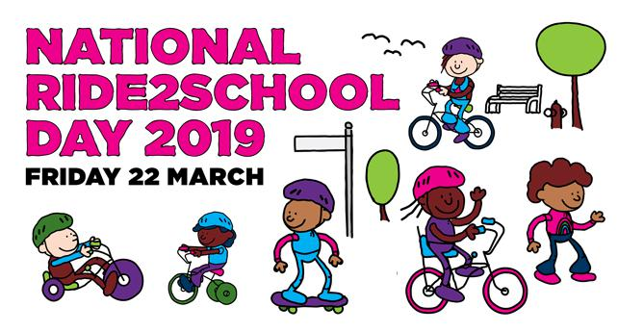

National Ride2School Day

Date: Friday 22 March 2019

Clean Up Australia Day

Date: Friday 22 March 2019

Location: PDPS

Kenny Koala visit

Date: K & Yr2 Monday 25 March 2019

Yr1 Wednesday 27 March 2019

Location: PDPS

K - Yr6 Music Viva

Date: Tuesday 26 March 2019

Location: PDPS

Special Farewell Assembly for Melissa Travers

Date: Wednesday 27 March 2019

Location: PDPS

P&C ‘Sports Fans / Sports Team’ Disco

Date: Friday 5 April 2019

Location: PDPS, Hall

Together, we learn from each other

What’s On

PALMERSTON PRIDE AWARDS
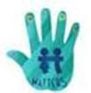

Congratulations to the following students who received a PRIDE Award at assembly this term.

PARTICIPATION – becoming involved, “having a go” and cooperating with others

Niansh - 2MO | Jacqueline - 2AF | Elijah - KMC | Kristijan - LSU
Sebastian - 5/6KB | Tyler - 5/6CW | Poppy - 3JL | Elaff - 3JL
RESPECT – having respect for self, others and their property
Ayaat - KMC | Eluney - 3/4DJ | Sarah - 5/6JM | Safina - 5/6KB
Lilli - 5/6DT | Makaydee - 3JL
INTEGRITY – being honest, fair, responsible and loyal
Harley - 3AP | Mason - 5/6JM | Kobe - 5/6KB | Amara - 5/6CW
Cindy - 5/6DT | Charlotte - 5/6CH
DETERMINATION - being persistent and resilient
Michael - 3AP | Rosie - 4RE | Jeremy - 5/6CH
EMPATHY - understanding and supporting others regardless of our differences
Isla - 2MO | Sopiato - 3/4DJ | Laith - 5/6CH | Emmanuel - 3JL
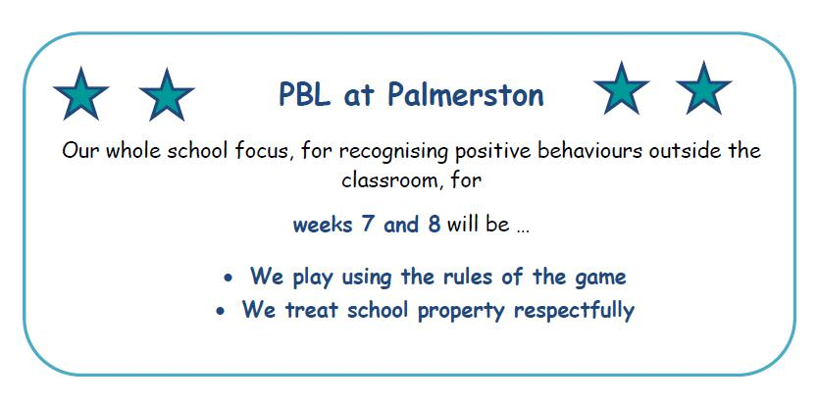

Together, we learn from each other

What’s On

CAR PARK UPDATE

A reminder to ensure we continue to be safe in the car park. It is important to drive cautiously in schools. Schools can be congested in peak times. There are parking officers that regularly patrol Palmerston and issue parking fines. Please park in dedicated spaces and not on the verge. Parking on the verge causes limited visibility.

Last year we added an additional car park to increase the capacity and this year we have been working hard liaising with members of Traffic and Asset Management to further improve our car park. We are pleased that this has now progressed to surveyors visiting the school to prepare for some work that is planned for our school car park. At this point in time we have an estimate that this work will take approx. three weeks. We will keep you informed of the details, progress and dates of this proposed work.

Thank you for your patience and support.

Together, we learn from each other

What’s On

COMMUNITY NEWS
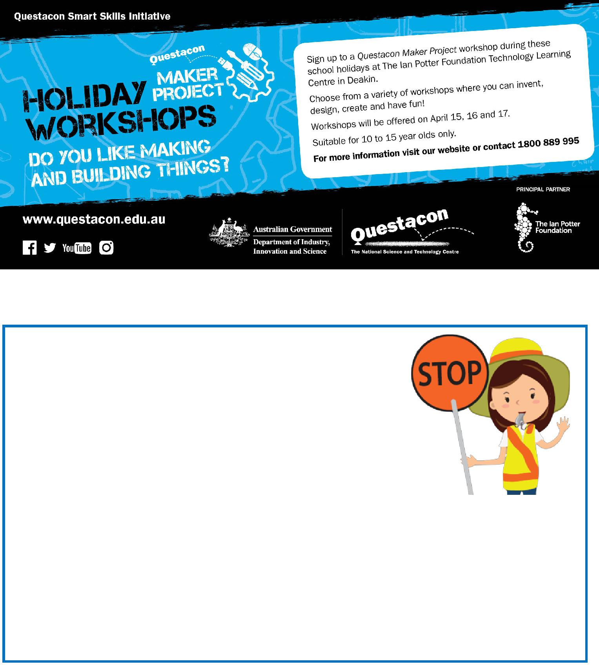

School travel and safety survey

Transport Canberra and City Services has engaged First Person Consulting to conduct research into parents’ attitudes to their children's active travel to and from schools. Part of this is investigating

the role that crossing supervisors have in improving safety around

schools, and the extent to which parent’s attitudes to children travelling actively change as a result.

You may have completed a similar survey last year, this is the final survey as part of the evaluation to gauge parent perceptions about safety around schools.

To complete the survey please click here, or copy and paste the following link into your browser:

https://www.surveygizmo.com/s3/4828047/School-Crossing-Supervisor-Survey-Control-Feb19

The survey should take about five minutes. The survey will not collect any identifiable information,

and all responses will be kept confidential.

Thank you in advance for your time in completing this survey. If you have any questions please contact

Together, we learn from each other

