Palmerston Post

15 November 2018

Week 5, Term 4

Board Chair: Lisa Fior Board Members: Parent Reps: Jesse Dang and George Villaflor

Teacher Reps: Jessica Lago and Maxine Green

P&C President: Lisa Fior

Principal: Melissa Travers Deputy Principal: Kate Flynn & Haeley Simms (acting)

Executive Teachers: Kylie Moller, Matt Gowen, Felicity McNeice, Catherine Griffin (acting)

ASSEMBLY:

16 Nov Junior - 2MG, 2MO & 2RK

23 Nov Senior - Yr4

DATES TO REMEMBER:

16 | Nov | Mufti Day for Twilight Fair
20 | Nov | Yr6 Band rehearsal
21 Nov |  | Whole school photo
21 Nov |  | BandStrav
22 | Nov | Yr2 Zoo excursion
23 | Nov | Governor-General’s Sports
 |  | Fun Day
26 Nov - 7 Dec |  |  | Yr2 AquaSafe
28 | Nov | Christian Education
10 | - 14 Dec |  | Kindy Swim &
 |  | Survive
11 Dec |  | P/S End of year
 |  | celebration (Brave, Itchy &
 |  | Noisy)
14 Dec |  | P/S End of year
 |  | celebration (Cranky, Hungry &
 |  | Sleepy)
17 | - 21 Dec |  | Yr1 Swim &
 |  | Survive
19 | Dec | Yr6 Graduation
20 | Dec | K-Yr6 Fishing incursion

NOTES HOME:

- Twilight Fair - Cake stall

P&C BOARD NEWS P&C: 7:00pm 17 Dec

All P&C activities, meeting agendas and minutes are available from the school website at – Parent Corner

School Board: 7:30am 29 Nov

DEPUTY PRINCIPAL’S MESSAGE

It’s hard to believe that we have reached the mid-way point of the term. I was on the blacktop earlier in the week and talked with some year 6 students about their time at Palmerston. One of the students was telling me that they really wanted the next few weeks to go as slowly as possible, so they could maximise their time here. We then started talking about some of the wonderful activities that they have experienced this year. A range of events and learning experiences were mentioned including the author visits, NAIDOC week museum tour, the sporting carnivals, excursions, Walkathon and Market Day. The list could have gone on and on!!!!

An important event held last week was the Remembrance Day Ceremony. Thank you to Kristy Retzlaff our DSTA for facilitating this important occasion and a big thank you to Blake Lancashire for his speech. Blake was an impressive speaker whose moving words contributed in making us stop and reflect on the meaning of Remembrance Day, in particular the 2018

Remembrance Day which marked the 100 year anniversary of the end of World War

- I was again amazed by our students who spoke on the day and made our ceremony even more memorable through

their participation. A nice finish to the morning was the morning tea we were able to share with our defence families in the staff room. We are all looking forward to the Twilight Fair on Saturday and we are crossing our fingers for fine weather! There has been a large band of parents and teachers who have worked tirelessly to prepare for Saturday and in advance I would like to thank them for their support. We hope to see as many of you as possible on the day.

Have a great Friday,

Kate Flynn

Together, we learn from each other

Palmerston Post

This Term in the IEC

The term we are planting seeds and seedlings that we hope will grow happily in the garden!
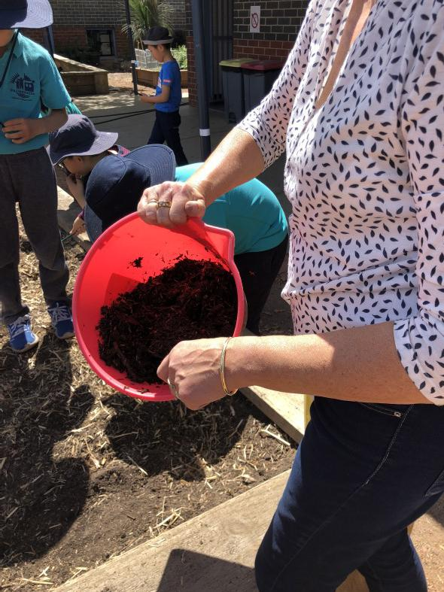
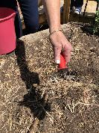

We added straw and compost to the

soil so that it has lots of nutrients and good bacteria.
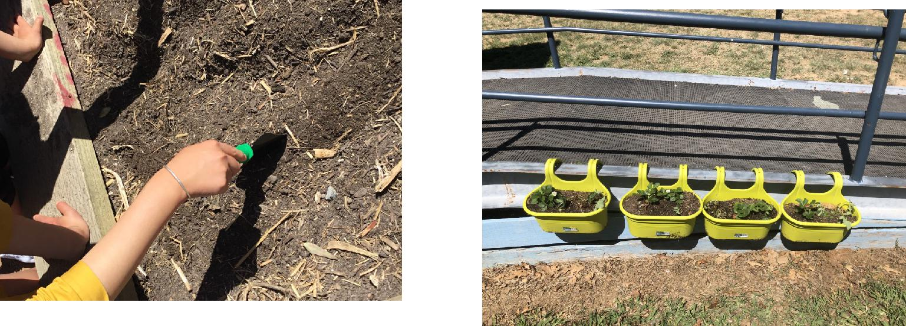

We planted corn and

sunflowers in the garden.
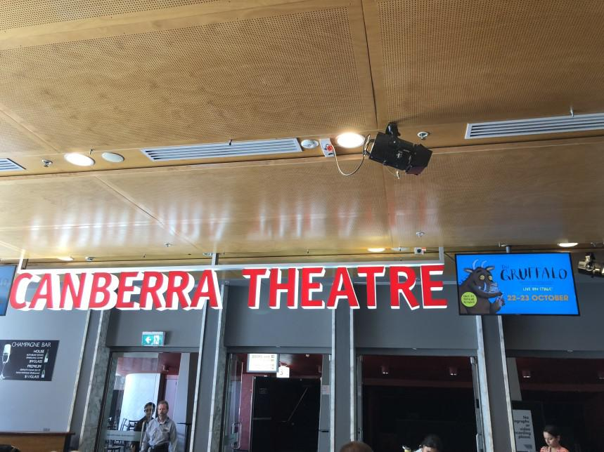

We planted strawberry seedlings in the pots.

We also went to see The Gruffalo at the Canberra Theatre.

We are having fun learning!

Together, we learn from each other

Palmerston Post

More from the IEC

When went to Questacon last week we got to participate in lots of fun science activities.

We also saw an awesome show about liquid nitrogen.
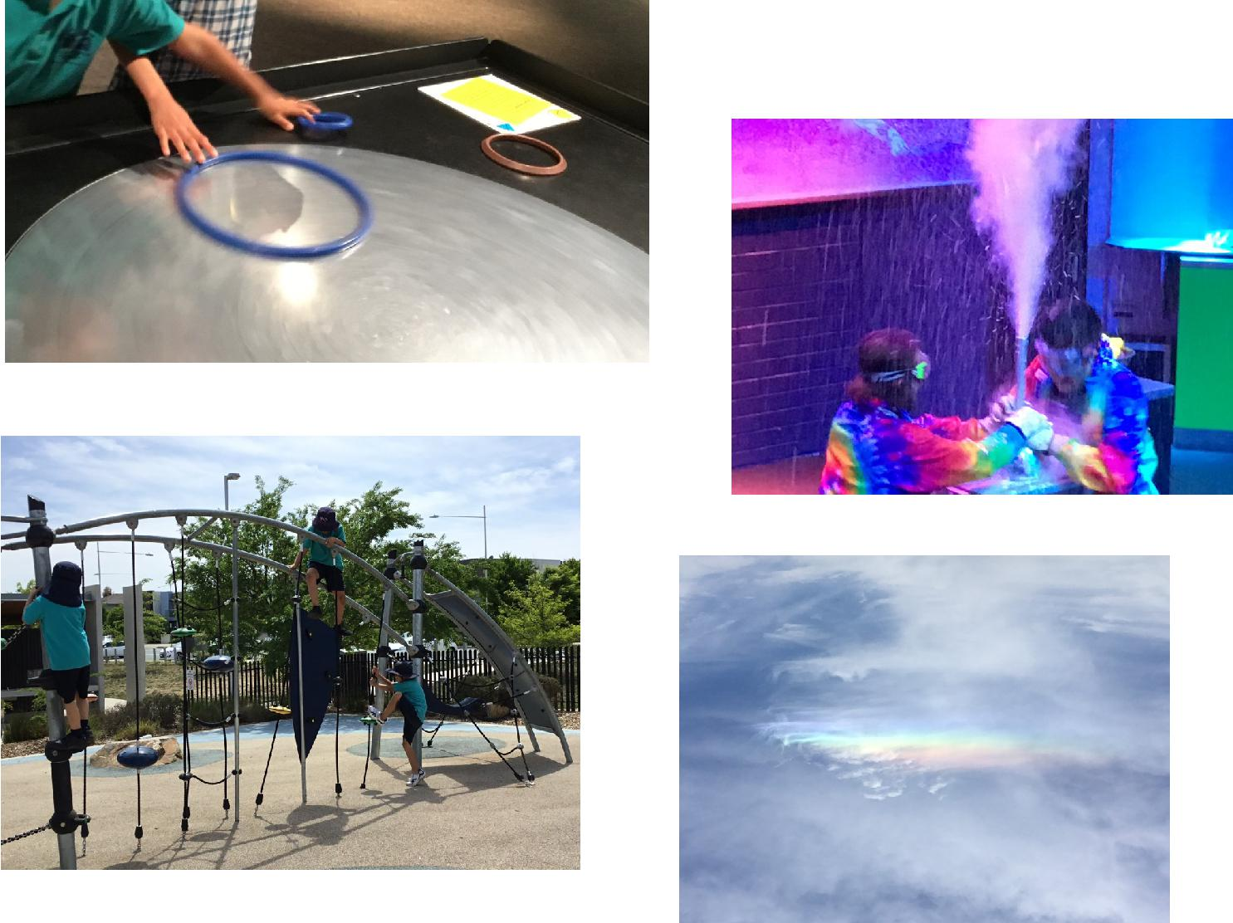

Last week we also walked to Crace park. It was another fun day. Now we are writing about what we did there.
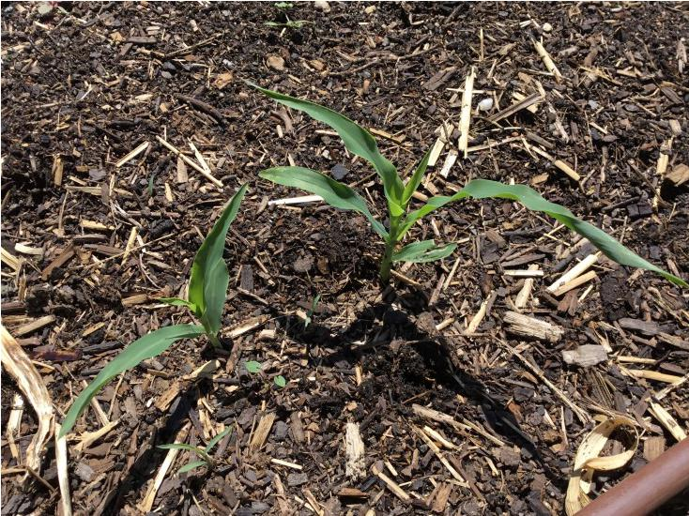

We saw a rainbow while we were there and it wasn’t even raining!

Look at our corn...it is growing very well!

We are having fun learning!

Together, we learn from each other

Palmerston Post

UPCOMING EVENTS

Mufti Day for the Twilight Fair

Date: Friday 16 November - Preschool (Cranky, Hungry & Sleepy bears) - Yr6

Location: Palmerston Primary & Palmerston Preschool

Twilight Fair

Date: 3:30-7:30pm Saturday 17 November 2018

Location: Palmerston Primary

Yr6 Band Rehearsal

Date: Tuesday 20 November 2018

Location: Bonner Primary School

Whole School Photo *rescheduled*

Date: 9:30am Wednesday 21 November 2018

Location: Palmerston Primary

Yr6 Band Stravaganza

Date: Wednesday 21 November 2018

Location: Llewellyn Hall, ANU School of Music

Yr2 National Zoo & Aquarium excursion

Date: Thursday 22 November 2018

Location: National Zoo & Aquarium

SRC - Governor-General’s Sports Fun Day

Date: Friday 23 November 2018

Location: Government House

Yr2 Aqua Safe Swimming program

Date: Monday 26 November - Friday 7 December 2018

Location: Gungahlin Leisure Centre

Christian Education

Date: Wednesday 28 November 2018

Location: Palmerston Primary

Christmas Concert

Date: Thursday 6 December 2018

Location: Palmerston Primary

Jump Rope for Heart “Jump Off”

Date: Friday 7 December 2018

Location: Palmerston Primary

Together, we learn from each other

Palmerston Post
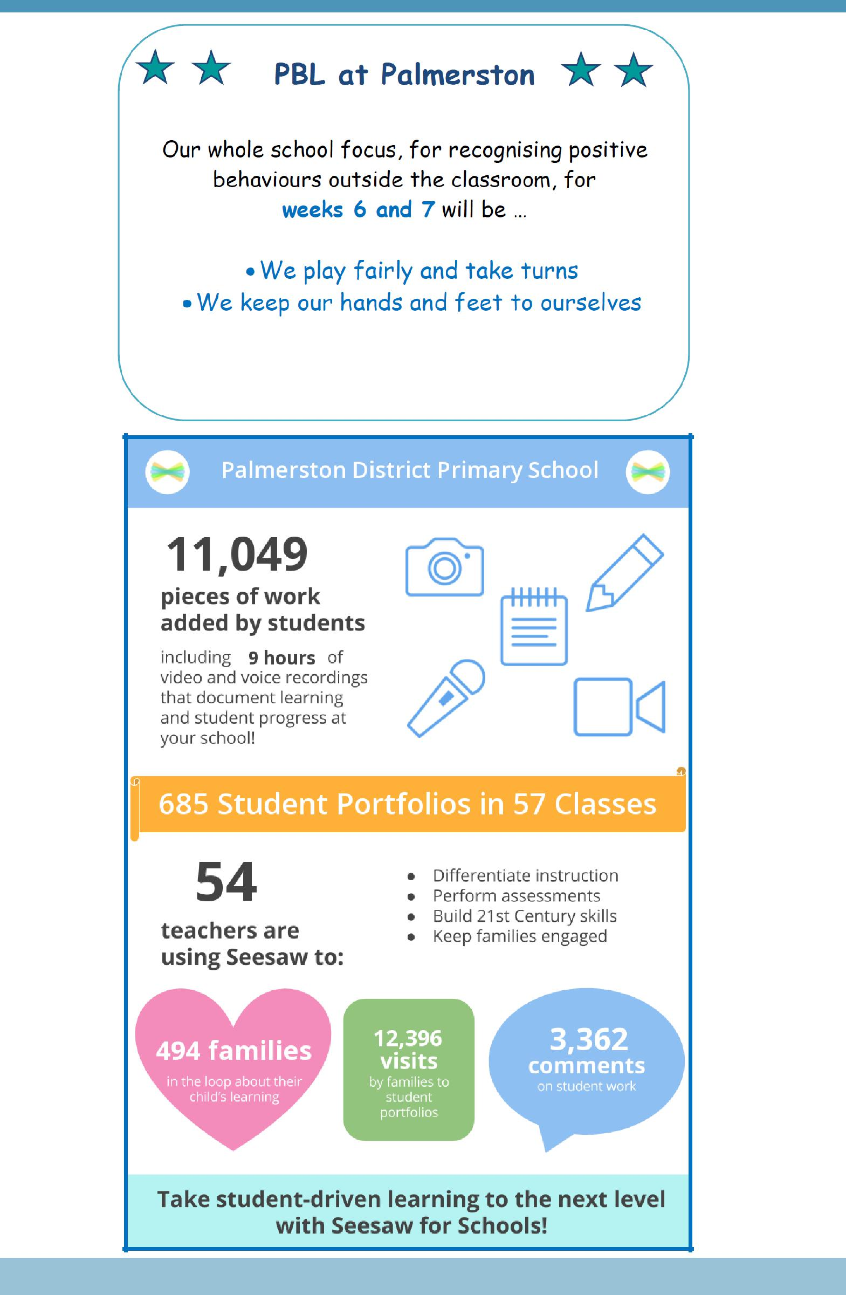

Together, we learn from each other

Palmerston Post

ACT Education Directorate update regarding Emergency Services

The ACT Education Directorate have recently reviewed their information regarding Emergency services and have advised that members of the public should access the ACT Emergency Services website www.esa.act.gov.au for regular updated information. The ACT ESA will continue to provide public messages to the ACT community regarding bushfire and bushfire preparedness as well as material to assist the public to understand warning arrangements. Any public inquiries regarding bushfires and emergency management should be referred to the ACT ESA on 6207 8444 or at

www.esa.act.gov.au or to Access Canberra on 13 22 81 or at www.accesscanberra.act.gov.au.
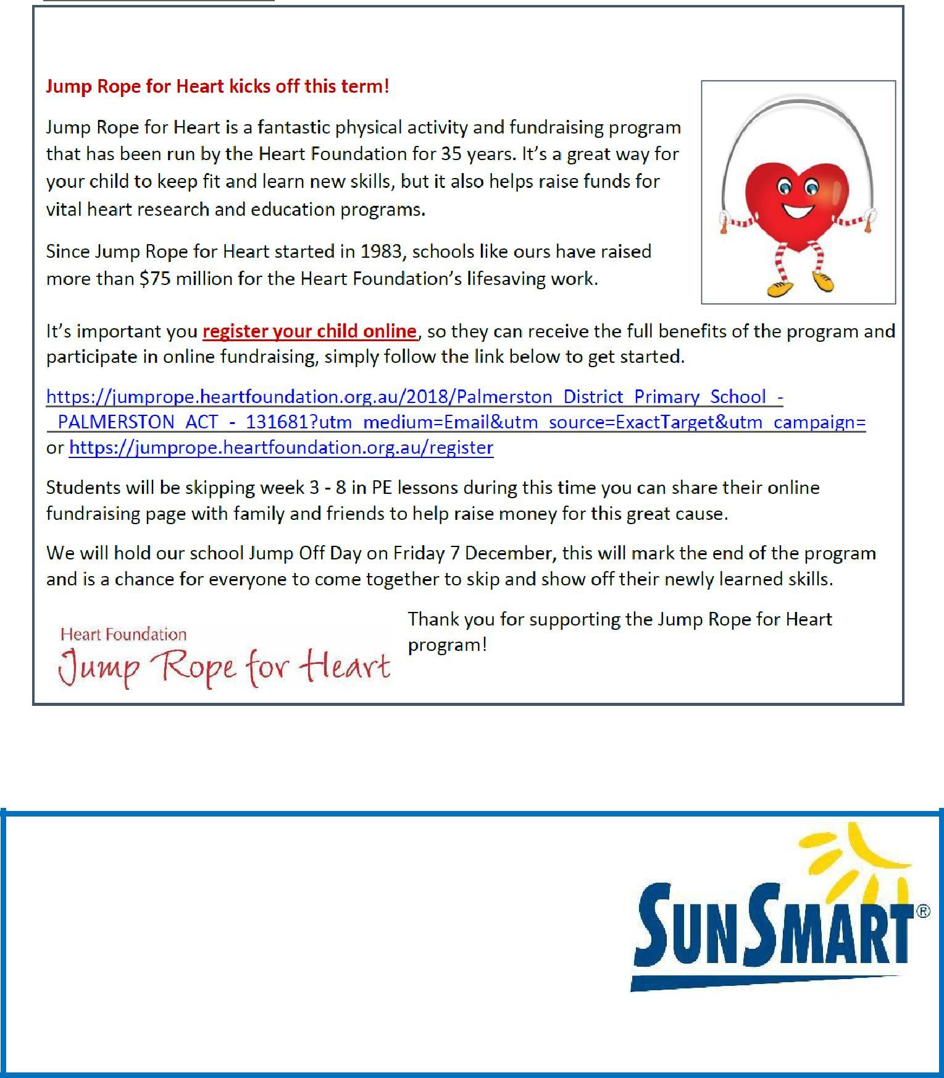

SUNSCREEN REMINDER

As the weather warms up and the UV level rise we encourage parents to apply sunscreen at home before school.

Sunscreen is readily available for students to reapply throughout the day

https://actcancer.org/prevention/sunsmart/act-schools-and-early-childhood-services/national-schools-program/

Together, we learn from each other

Palmerston Post

2019 BOOK PACK LISTS

Book Packs are ready! You can go online and order 2019 book packs.

Please refer to the website for book pack lists. Please follow the ordering instructions;

Go to the OfficeMax website OfficeMaxSchools.com.au

Search for Palmerston Primary School, Palmerston ACT and enter your school access key: 4TV8Q

Complete the student details and select the year level that your child will be in for 2019. Eg. If your child is in Yr.1 this year then you need to select the 2019 Yr. 2 list.

Review your requirements list and make any changes (if required). Please note that some items have been denoted as a requisite for the subject or year.

If you have more than one student at the school you will need to repeat the above steps, ordering the correct 2019 year level list.

Once completed, an order confirmation will be sent to your email address.

Order Deadlines and Delivery

Your order will be delivered to your home address. Please note: Orders will NOT be sent to the school.

Orders are delivered via Australia post’s eParcel service and you will receive an email with the Australia Post tracking ID Number. Post Offices Box addresses are NOT accepted.

Orders placed on or before 17 December will be delivered free of charge.

Orders placed after 17 December and on or before 31 December will incur a $12.95 delivery fee.

Orders placed after 31 December will incur a $12.95 delivery fee and all efforts will be made to deliver prior to the beginning of Term 1, 2019.

IMPORTANT

ALL Stationery packs need to be brought to school on the first day of Term 1, 2019 and given to the class teacher.

If you need any help placing your order, returns or refunds, delivery information or have a general enquiry please visit OfficeMaxSchool.com.au/help

Please DO NOT send any Stationery Lists or money to the school, ALL orders are through OfficeMax.

Together, we learn from each other

Palmerston Post
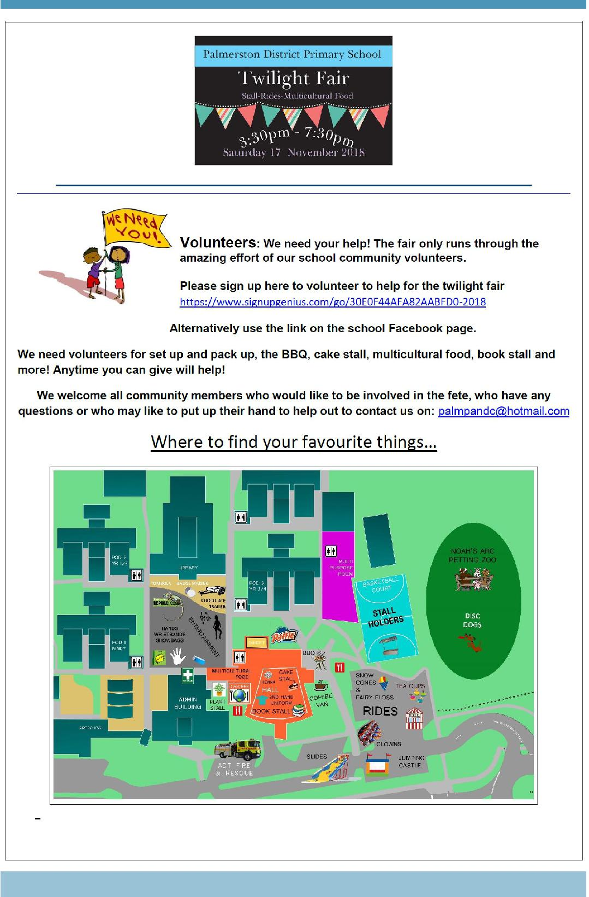

Together, we learn from each other

Palmerston Post
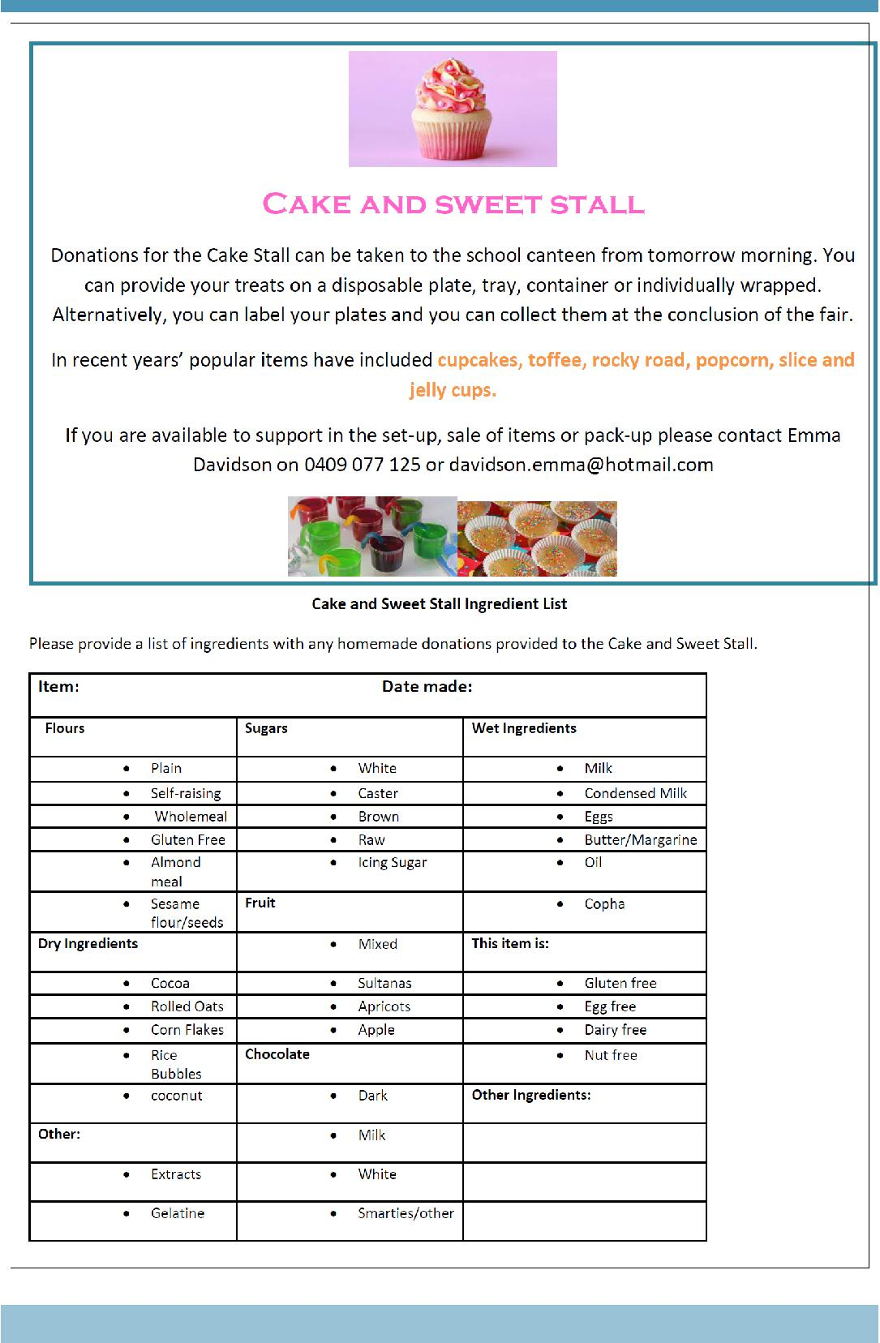

Together, we learn from each other

Palmerston Post
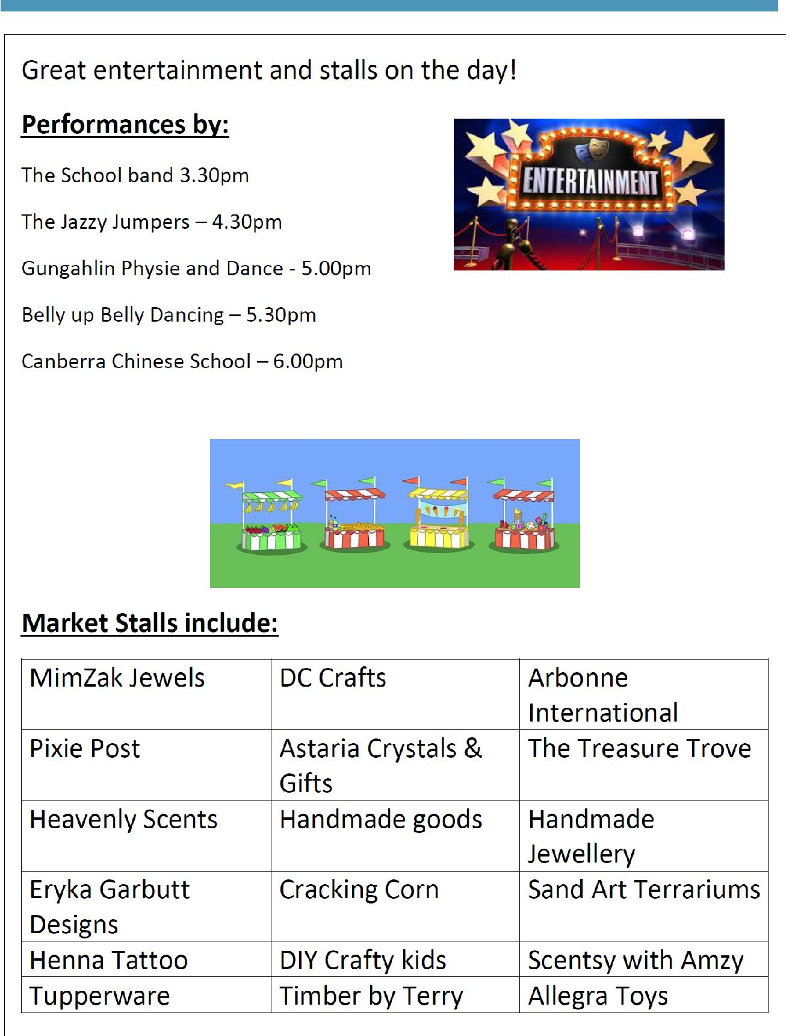

Together, we learn from each other

Palmerston Post
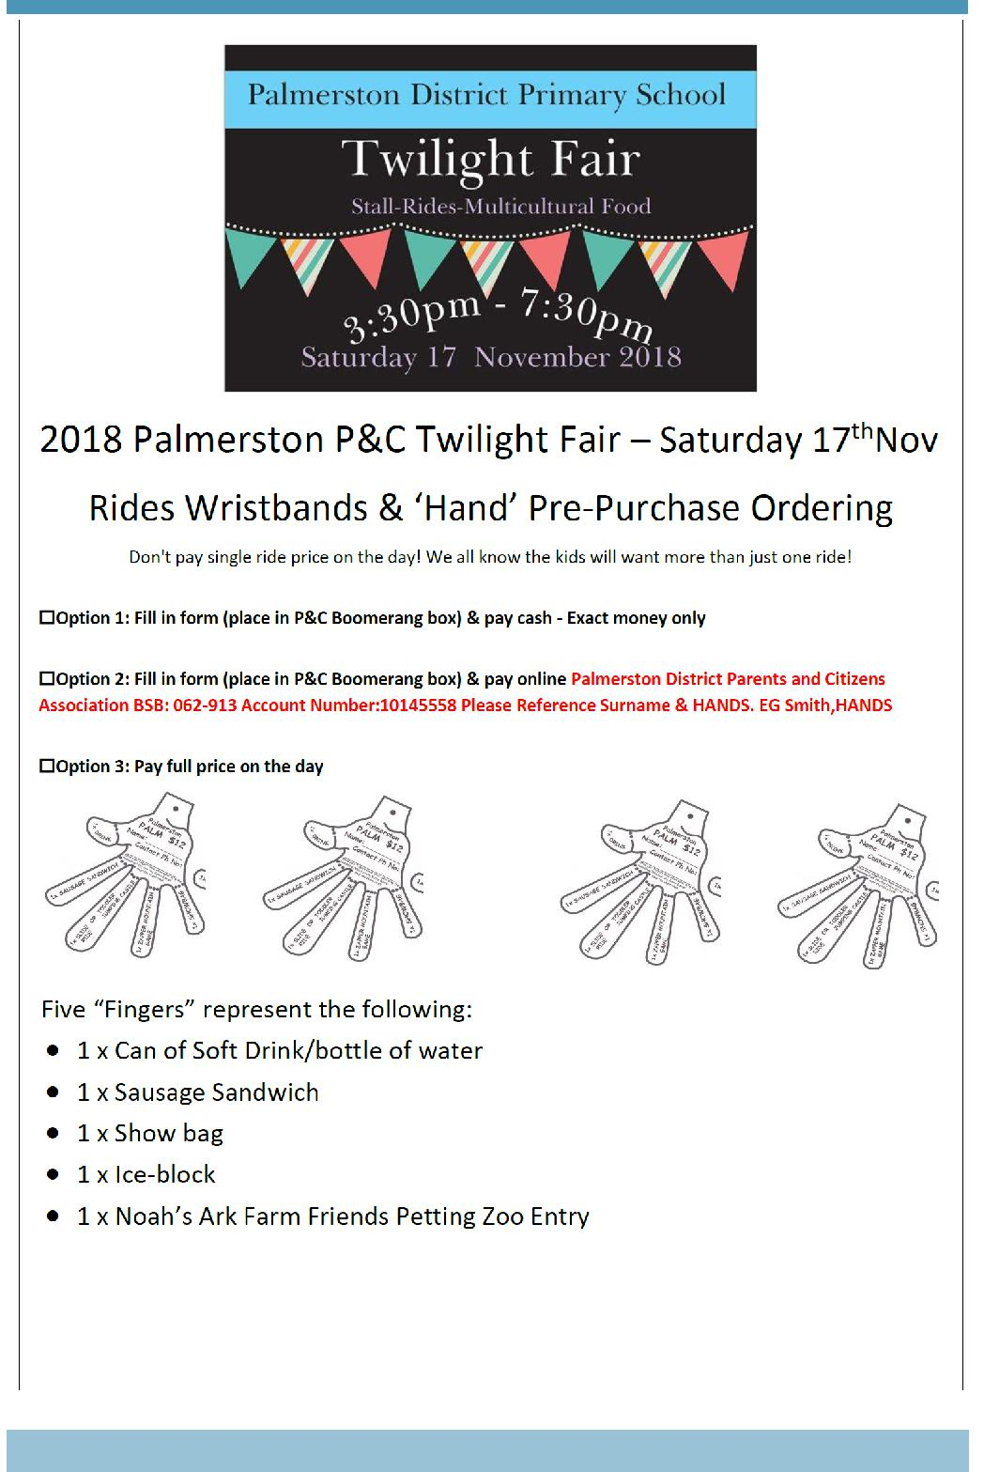

Together, we learn from each other

Palmerston Post
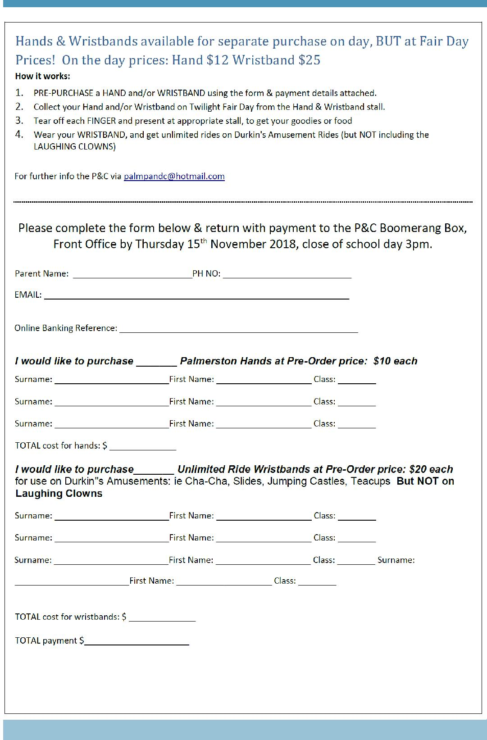

Together, we learn from each other

Palmerston Post
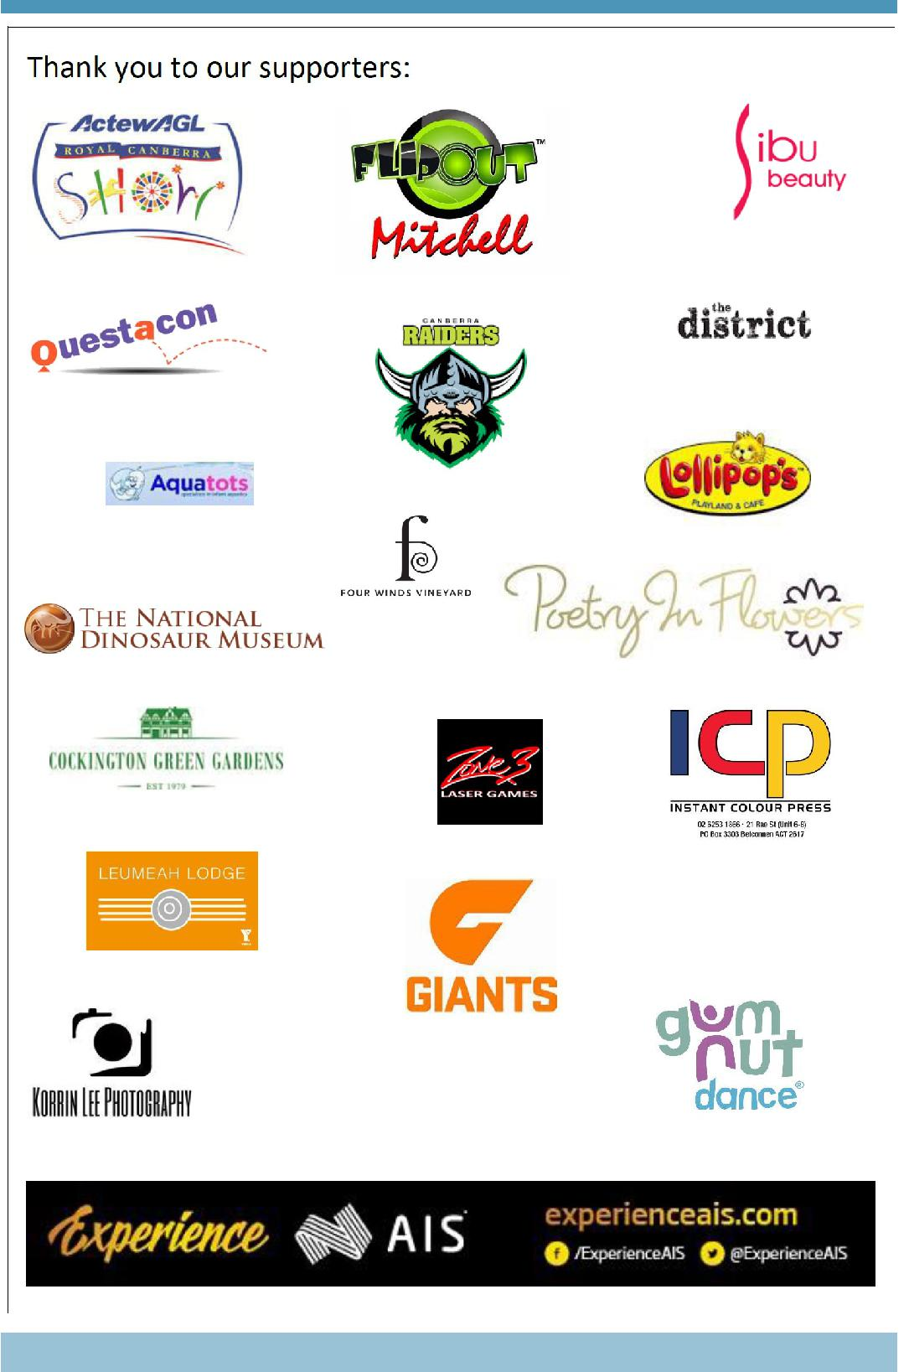

Together, we learn from each other

Palmerston Post
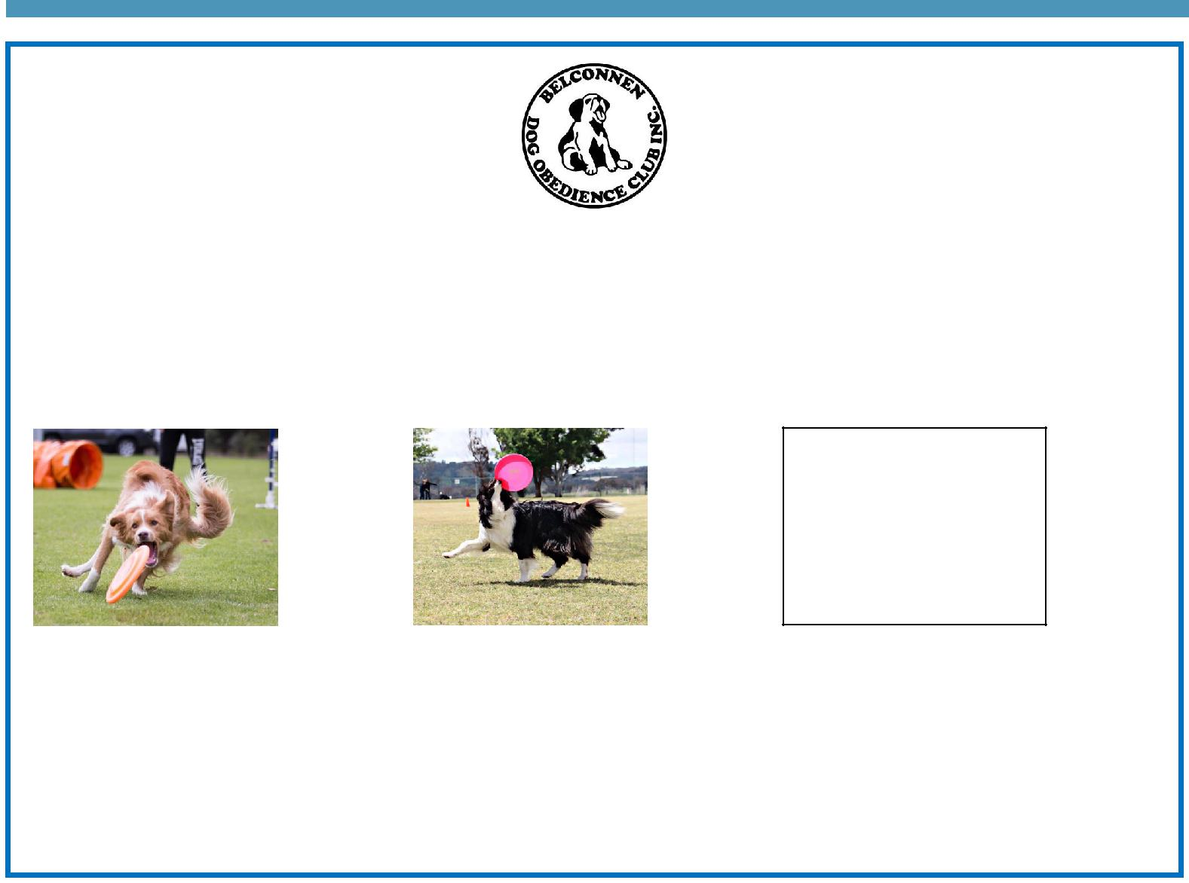

BDOC Disc Dogs Demonstration

Belconnen Dog Obedience Club will be showcasing a Disc Dog demonstration as part of the PDPS Twilight Fair. Disc Dogs is a series of disc (Frisbee) games played by a handler and their dog. Some activities include tunnels and/or jumps.

Come along as see various dogs participating in these sports including Miss Griffin’s dog Fergus.

Visit the Belconnen Disc Dogs Facebook page for more information: https://www.facebook.com/ BelconnenDiscDogs/

For further information please contact the stall co-ordinator Catherine Griffin by email catherine.griffin@ed.act.edu.au

Together, we learn from each other

Palmerston Post

SCHOOL INTENTIONS 2019

School Leavers 2019

We have now reached the time in the year when look at our school numbers and staffing arrangements for 2019. If your circumstances have changed and your child/ren will not be attending Palmerston District Primary School in 2019 can you please let the front office staff know as soon as possible.

My child/ren will not be returning to Palmerston in 2019.

Name Class

Last day at Palmerston:

My child/ren will be attending:

Another government school in the ACT:

A non-government school in the ACT:

Moving out of the ACT

Forwarding Address:

Phone number:

Parent’s name:

Together, we learn from each other

Palmerston Post
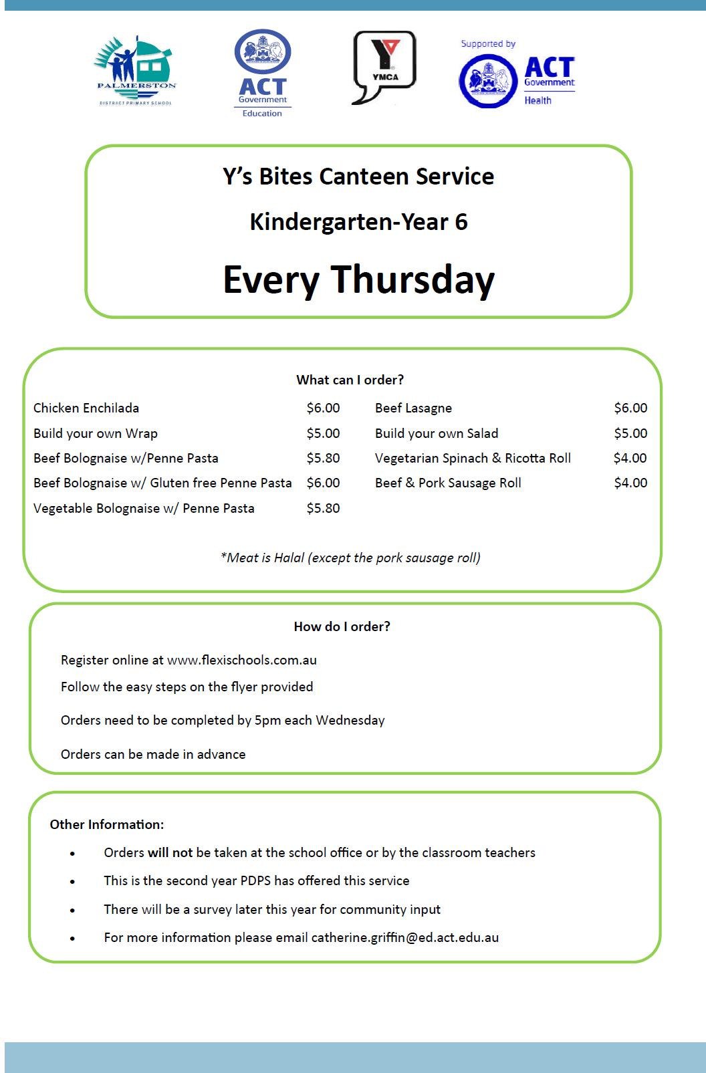

Together, we learn from each other

Palmerston Post

Together, we learn from each other

