PALMERSTON POST

8 February 2018

Week 1, Term 1

Board Chair: Julian Fior, Board Members: Parent Reps: Jesse Dang and George Villaflor

P&C President: Lisa Fior

Principal: Melissa Travers Deputy Principal: Kate Flynn

Executive Teachers: Haeley Simms, Kylie Moller, Jacqui Warden, Matt Gowan, Catherine Griffin (acting)

ASSEMBLY:
9 Feb No assembly
16 Feb Senior - Yr 6

DATES TO REMEMBER:

13 Feb Information Evening

- please note the 5pm section of the

information evening will now be held in the library (not the hall)

NOTES HOME:

Swimming Carnival medical (K-Yr6)

Yr5/6 Camp medical (Yr5-6)

P&C BOARD NEWS

P&C:

All P&C activities, meeting agendas and minutes are available from the School website at – Parent Corner

School Board Elections held in early 2018

PRINCIPAL’S MESSAGE

Welcome to Palmerston District Primary School 2018. We have had a very smooth start to school this week. We welcomed 132 pre-schoolers and overall, just over 700 students attend Palmerston this year. Our mission is to maintain a small school feel and inclusion for all. We pride ourselves in working in partnership with you. To maintain this, you need an avenue to voice your opinion. This is through our P&C, School Board or meeting with your child’s teacher. Each year we run a parent / teacher information evening to inform you of your child’s education for the year and for you to meet your child’s teacher. Please come along on Tuesday next week, to be part of this session – details in this newsletter.

Avenues of Communication

Each year we work on how to better communicate – a home/ school partnership. I will list our avenues:

- Parent/Teacher Information Evening - 5pm Tuesday 13 February – commencing in the library ( previously advertised as the Hall)

- Newsletter/ notes/ email
- Website
- Palmerston app
- See Saw ( new this year)
- Parent workshops on curriculum
- Points of reporting and parent/teacher interviews
- Make an appointment with your child’s teacher or call

- If unsure of the outcome of meeting with your child’s teacher is meeting your needs, talk to their supervisor then, the deputy principal

- Visit or call the front office
- Read the information board outside the school
- Come to an assembly
- Join the P&C or School Board

- And more, when we are walking around before and after school you can just ask us!

This year teachers undertook three professional learning days before school commenced. Last Tuesday we undertook learning on how to better teach reading through guided reading

Together, we learn from each other

PALMERSTON POST Page 2

strategies with Carmel Small from Adelaide. On the Wednesday we had our own staff present to us on being a PBL school (Positive Behaviour Learning with a 2018 focus on the playtimes). On the Thursday we had Anita Chin from Sydney present on teaching Maths P-6. Both Carmel and Anita will be back to mentor teachers and demonstrate lessons in the classrooms this year. Palmerston is committed to providing the highest quality professional learning for staff.

The School Board will be undertaking voting again this term for 2 positions. Please take the time to think about being a Palmerston Board member. The school board manual is available from the front office from Monday and will explain the role of being a Board member. We meet on Thursday mornings at 7.30am weeks 1 and 7 of each term.

School Beautification

I would like to thanks Mr Phil our school Building Services Officer (janitor) for his amazing school beautification projects. I would also like to pass my thanks onto our business Manager, Sonya Campbell for overseeing our school finances so that we can create an amazing school learning environment. When in the school next, have a look at our extended preschool grounds, new classrooms and outdoor teaching spaces. The Education Directorate has provided us with funds to create new learning spaces for 6 classes this year. They look fabulous! We are just fine tuning the areas with desks/ chairs, IT resources and equipment that is still arriving. We will also be creating another parking area near preschool for teaching staff to free up parking bays for families this year and covered walkways to the portable buildings.

School surrounds- bikes/cars/walking/times

Please remember to park in the bays, drive safely and slowly around the school, Kiss and Drop is just that (not long term parking), walk through the underpass or use the crossing, walk bikes through the school to the bike racks and dogs must stay outside the fences . Let’s keep each other safe and care for each other.

School Times

Preschool

• | Commences | 8.45am
• | Finishes | 2.45pm
Year K-6
• | Commences | 8.55am for morning lines on blacktop
• | Finishes | 3pm

The library is open from 8.30am and a teacher is roaming from 8.30am. Please remember to not drop off children earlier than those times, as staff may not be around to supervise. We have had a number of children around the school after 3pm in the past and they have not been picked up for 1/2hr to 1hr after school has completed. Please remember that you are to arrange for a responsible person to pick up your child at 3pm. Communities at Work hire our school hall and run a Before and After School program. You can book online to use this facility if you are experiencing difficulty in arranging to pick up your child. It is not run by the school, but we work closely together to support child wellbeing.

New Staff Welcome

We have a few new staff this year. I would like to welcome back Haeley Elliott and Richa Oberai from maternity leave. We have two new executive staff for our leadership team, Jacqui Warden who supervises the Preschool and Kindergarten teams and Matthew Gowen who supervises the year 5 and 6 team.

Together, we learn from each other

PALMERSTON POST Page 3

Staff new to our school are:

- Anna Sanders

- Sarah Chandramohan

- Dean Joy

- Albert Palazzo

- Laurie Imhoff

- Mary O’Kane

- Faeza Samnakay

- Sharely Pavier

- Natalie Leighton

- Kye Madden

Our Leadership Team are:

• Kate Flynn Deputy Principal

• Sonya Campbell Business Manager

Executive Teachers

• | Jacqui Warden | Pre School –Kindergarten
• | Catherine Griffin | Year 1 (acting)
• | Haeley Simms | Year 2-4 | – Mon- Thurs
• | Matthew Gowen | Year 5-6 | & LSU
• | Kylie Moller | IEC / Specialist Teachers (SWAT Team) Mon- Wed

I would also like to welcome our new school psychologist, Jeanine Leabeater. If you need to contact her, you can call the front office to make an appointment.

We are truly excited about being back at school and hop to see you at the parent / teacher evening,

Melissa Travers

2018 INFORMATION EVENING

We are looking forward to meeting with you at our Parent Information Evening next Tuesday 13 February at 5pm.
The evening will provide:

- An introduction to new staff
- An overview of the school’s draft annual Action Plan for 2018
- An opportunity for teaching teams to outline the year and invite parents into their classrooms
- A class overview will be available
- A School Banking Representative will be available

Each teaching team will present their sessions twice to enable parents to choose which session they attend based on the age/s of their child/children.
Details: Tuesday 13 February
5:00pm General Session in the school library with whole staff

5:20-5:40pm Session 1 in teaching teams (Held in PODS)
5:50pm-6:10pm Session 2 (repeat of session 1)

Please note this was previously advertised as being held in the school hall and will now take place in the school library.

Together, we learn from each other

PALMERSTON POST Page 4
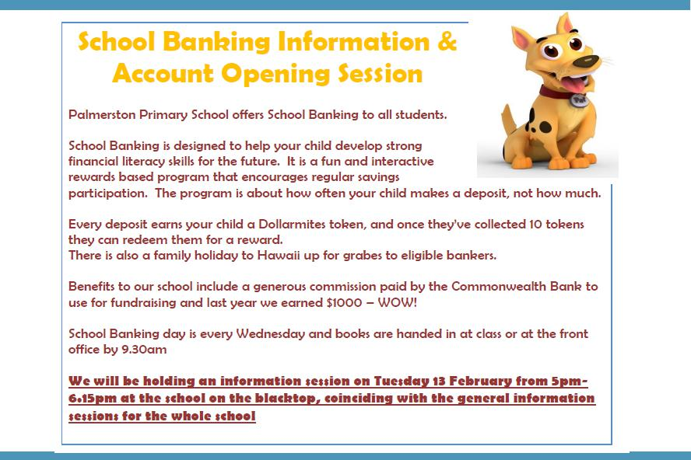

RIDE OR WALK TO SCHOOL PROGRAM

Our school is pleased to be part of the Ride or Walk to School program, encouraging our students to ride, walk, scoot, skate board or even roller-skate to school!

Overwhelming evidence shows that kids who use active travel to get to school are more alert and ready to learn and it contributes to getting their recommended 60 minutes of daily physical activity. Another big bonus is it reduces the number of cars coming to school each day for pick up and drop off. Even if it’s only part way, we’d love to see lots of our students riding and walking each day.

Did you know we have an app you can download to keep you up to date with what is happening at Palmerston?

Together, we learn from each other

PALMERSTON POST Page 5

UPCOMING EVENTS

Parent Information Sessions

Date: 13 February 2018

Location: Palmerston District Primary School - Library

Swimming Carnival

Date: 22 February 2018

Locaton: Dickson Aquatic Centre

Yr5/6 Camp - Borambola

Date: 26-28 February 2018

Location: Borambola, NSW Sport & Recreation

ASSEMBLIES

We look forward to running our assemblies each week. During this time a variety of performances are celebrated. All community members are invited to attend.

This year we are trialling a new model with our assemblies. We will host senior assemblies in the even weeks (with Year 6 hosting in week 2) and junior assemblies in the odd weeks. Please contact Kate Flynn if you have any questions.

Together, we learn from each other

PALMERSTON POST Page 6

Think before you park…and keep our kids safe!

With school now back for the year we are encouraging all parents to make parking safety a priority!

This means:

- keep clear of ‘no stopping’ and ‘no parking’ zones

- don’t park in bus zones on school crossings, across footpaths or driveways; and

- don’t double (or triple) park!

Remember - it’s okay to park a little further away from the school and walk the rest of the way! Consider - having a pre-determined meeting spot agreed with your kids. That way if you are a little late, they know where to wait.

Think – visibility around schools and if your car may be blocking the view of crossings for other motorists. Also be mindful when entering or leaving parking spots – look twice!

Be kind – to other road users and pedestrians and also if you see any parking officers in the area – they are doing their job and working to keep our kids safe!

Note - licence Plate Recognition (or electronic chalking) vans are now actively monitoring schools. Penalties range from $114 upwards to $600. Details at www.act.gov.au/accessCBR

SCHOOL BOARD NOMINATIONS 2018

School Board elections will be held in early 2018

Membership of the School Board is a wonderful opportunity for parents to participate in the ongoing management of the school and to contribute to the determination of the school’s future directions. There are two (2) vacancies for parent representatives on the Palmerston District Primary School Board for the period 1 April 2018 to 31 March 2020. Election of the parent representative will be undertaken in the first few weeks of the 2018 school year. Nomination period:

Opens – 11:00am on Monday 5 February 2018

Closes – 11:00am on Monday 12 February 2018

Voting period (if election is required):

Opens – 11:00am on Monday 26 February 2018

Closes – 11:00am on Monday 5 March 2018

The positions for election will be:

Two (2) - Parent Representative Position. Elected positions run for a two (2) year term.

The successful candidates will be announced by Monday, 26 March 2018.

If you are interested in being a member of the Palmerston District Primary School Board for 2018-2020 and would like more information about the roles and responsibilities of School Board members, please contact the Principal, Melissa Travers on 6142 1440. A copy of the School Board Manual is also available for perusal at the front office. Nomination forms will be available from the school front office from Monday, 5 February 2018. If you would like to have a form before that date, please contact the school front office on 6142 1440.

Together, we learn from each other

PALMERSTON POST Page 7

HIRERS
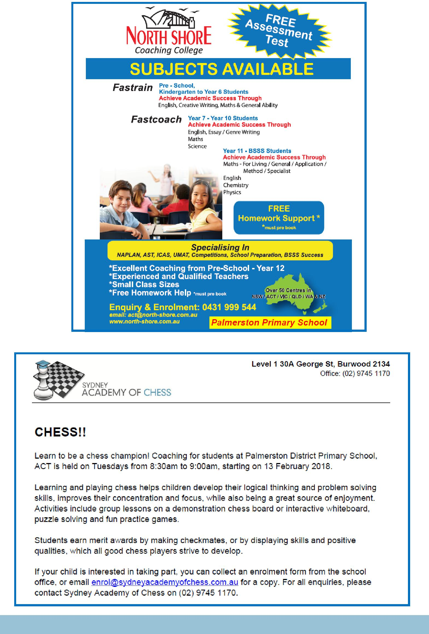

Together, we learn from each other

PALMERSTON POST Page 8

Together, we learn from each other

PALMERSTON POST Page 9

COMMUNITY NEWS

Together, we learn from each other

PALMERSTON POST Page 10
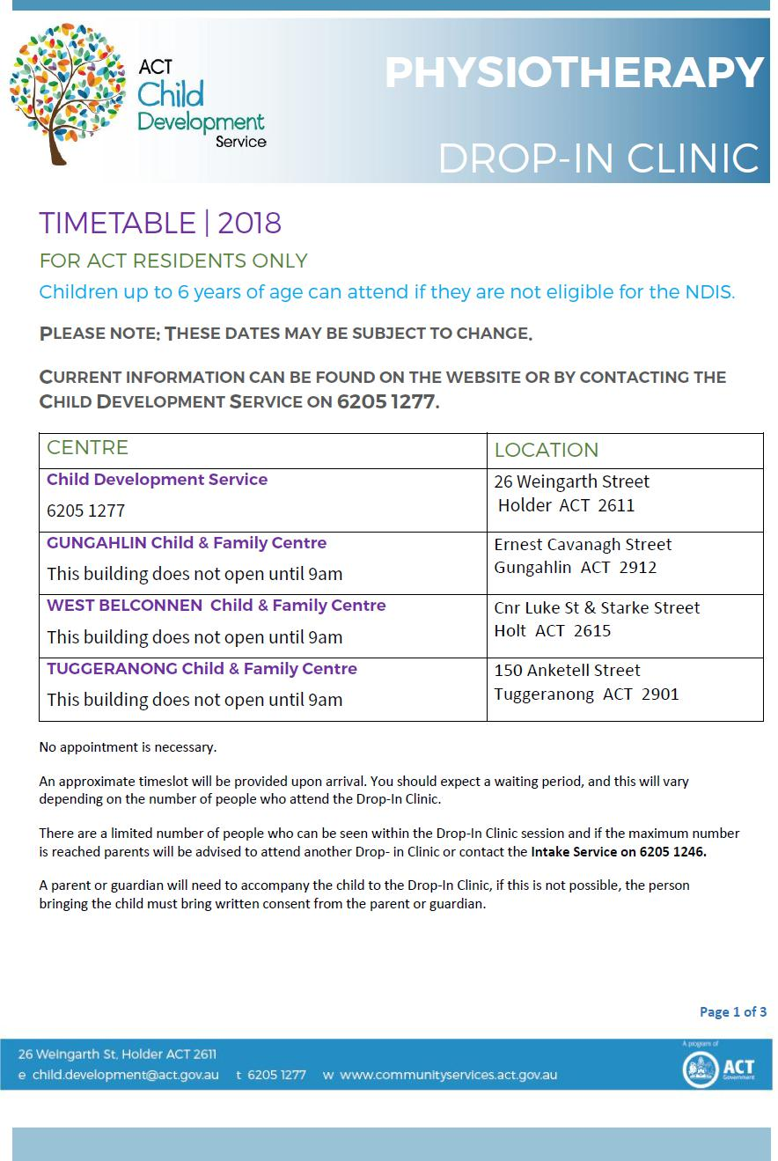

Together, we learn from each other

PALMERSTON POST Page 11
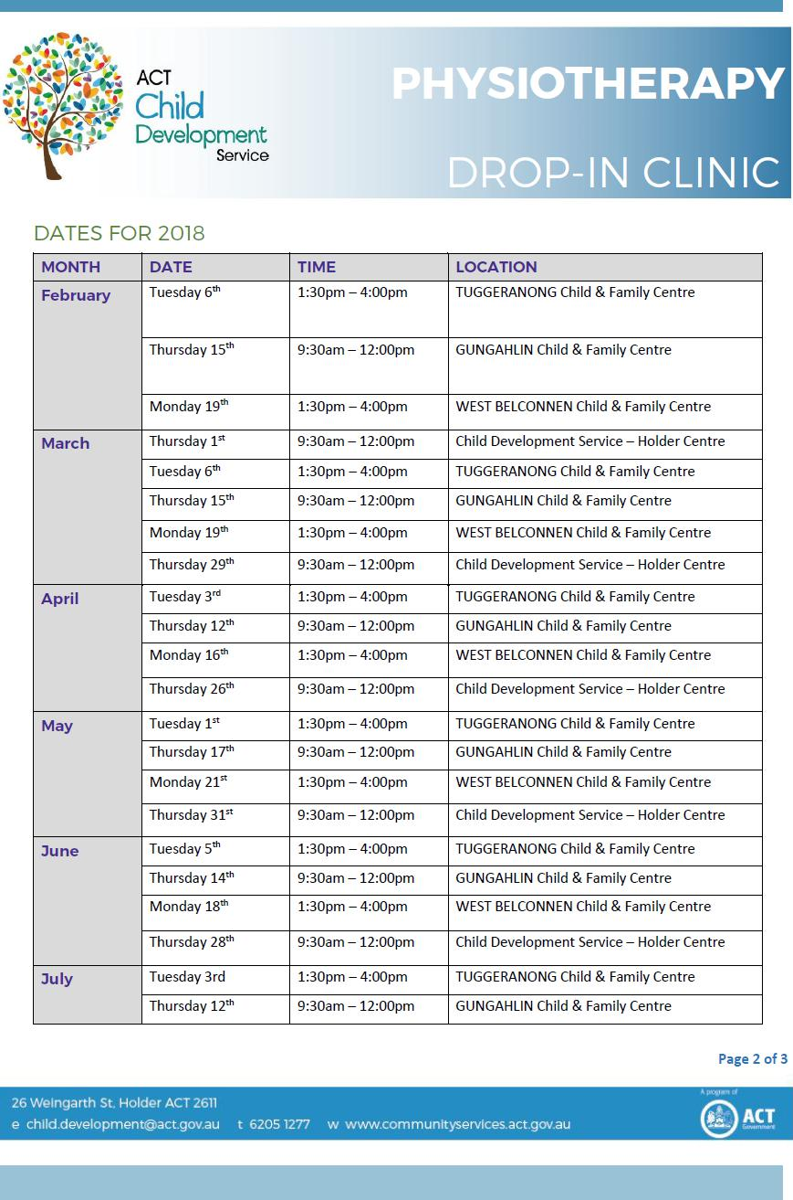

Together, we learn from each other

PALMERSTON POST Page 12
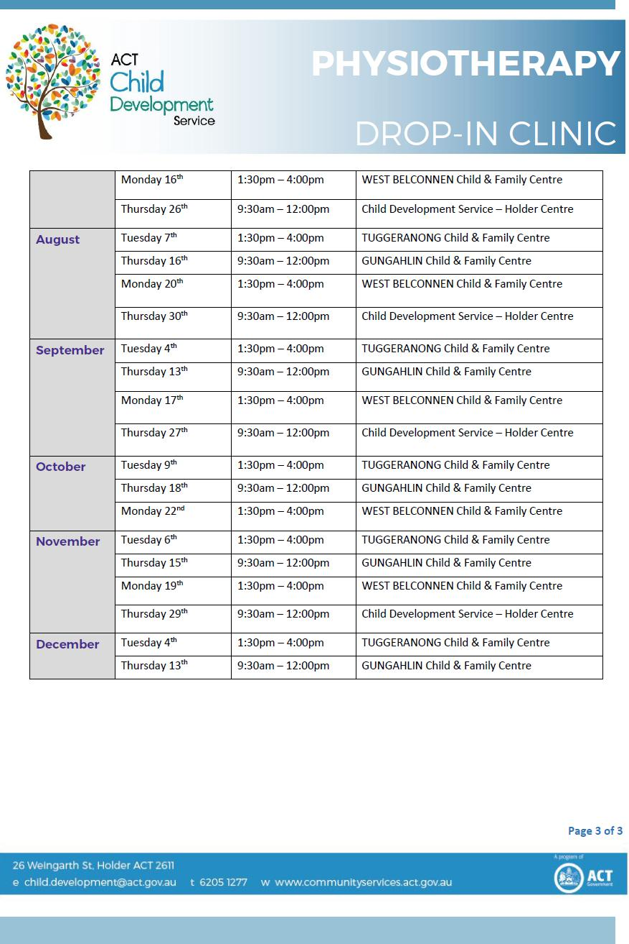

Together, we learn from each other

