What’s On

28 June 2018

Week 9, Term 2

ASSEMBLY:
29 Jun | Whole School -
 | Indonesian
6 Jul | Junior - Music

DATES TO REMEMBER:

29 Jun Yr2-4 & IEC Canberra Theatre excursion

2-4 Jul Kindy Health Checks

2-5 Jul Parent Teacher

Interviews

3 Jul P/S Fresh Food

Challenge

4 Jul Transport & Parking

Parent Info Session

6 Jul P/S Fresh Food

Challenge

NOTES HOME:

- Mrs Wei leave - 5/6WW

- Ms Black leave - Noisy & Sleepy

- Y’Bites Canteen Service - youngest

P&C BOARD NEWS P&C: 7:00pm 25 June 2018

All P&C activities, meeting agendas and minutes are available from the school website at – Parent Corner

PRINCIPAL’S MESSAGE

Water pipe update

Thank you all for your support with our leaking water pipe last Friday. It was certainly a shock to arrive at school and see our “water feature” down near our dinosaur park. Students, staff, the community and the ACT Education Directorate were fantastic in their response to this issue and we were able to band together to move forward to get the leak in the pipe fixed. This involved free water and portable toilets for all the staff and students and plenty of communication between the school and families. I would like to thank Neil Jones who we regularly employ within the school who came in over the weekend to fix our path and pavers.

Transport

A reminder that we will be hosting an information session on transport and parking at our school. A member of the ACT Directorate and ACT Transport next Wednesday 4 July at 5pm. This is to assist and answer questions that community members may have about our car parking and the bus service between Crace and Palmerston.

Information for families regarding social media use

I have recently received numerous questions from families regarding the use of social media. The ACT Education Directorate has information on their website about children keeping safe online. The following link provides a wealth of knowledge about how to be cybersmart and how to use the internet safely. https:// www.education.act.gov.au/teaching_and_learning/learn-anywhere-ict-for-students/keeping-safe-online
The website also includes a link to the Office of the Children’s eSafety Commissioner. The site provides information, publications and resources for students, families and schools. We thought you might be interested in the following information about social media from the Office of the Children’s eSafety Commissioner Website:

Together, we learn from each other

What’s On Page 2
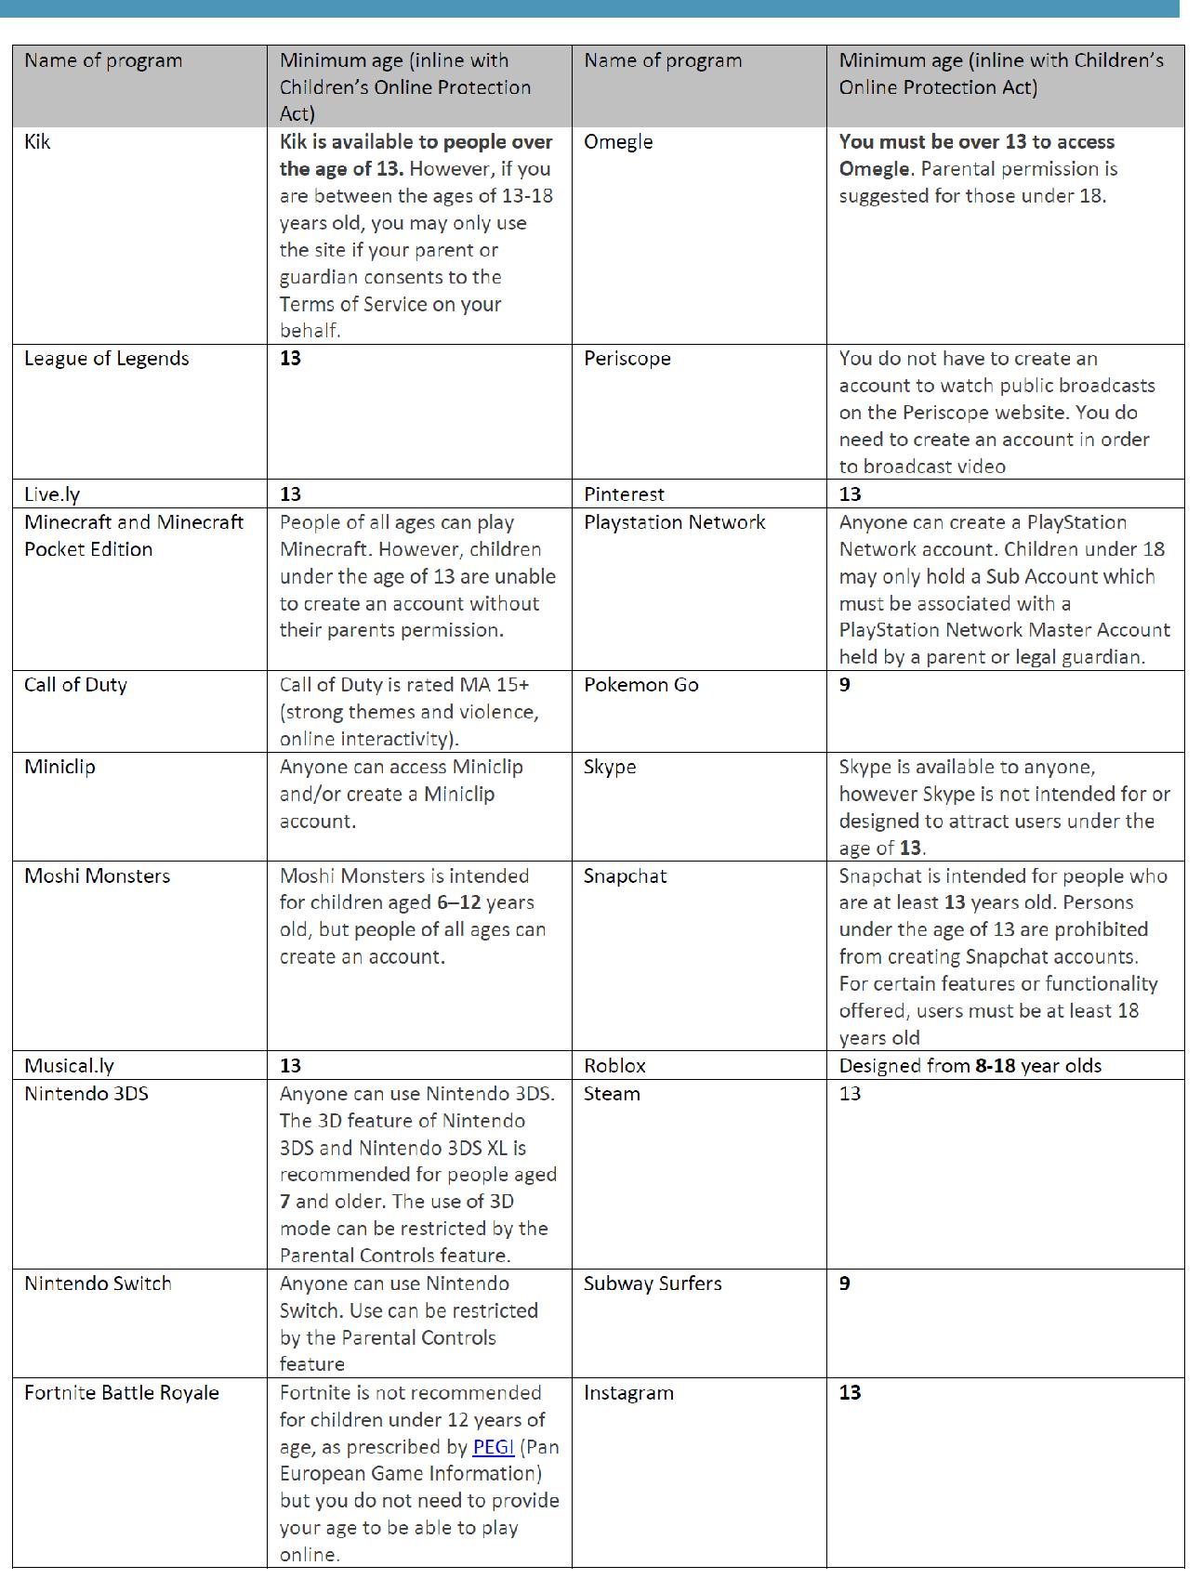

Together, we learn from each other

What’s On Page 3

Reporting and interviews

Palmerston staff has now completed the end of semester one reports which are due home today. At Palmerston, we utilise the ACT Directorate template in order to provide you with a clear picture regarding the progress of your child in relation to their learning and development. Interviews will be held next week. If you would like to book an appointment to see your child’s class teacher for an interview please call the front office on 6142 1440.

CAP program

We are currently awaiting some of the paperwork for our CAP testing processes. As soon as this all arrives our CAP testing will commence. We are predicting next week and the start of term three. Palmerston District Primary School utilises the CoGAT testing, in line with other Gungahlin schools. The tests are sent away to be marked and will be returned to us some time next term and anticipate that all results will be finalised towards the end of term three.

Have a great weekend.

Kate Flynn

UPCOMING EVENTS

Preschool - Hatching Chicks

Date: 25 June - 6 July 2018

Location: Palmerston Preschool
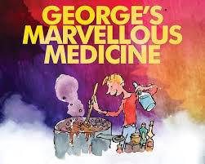

Yr2-4 & IEC - George’s Marvellous Medicine show

Date: 29 June 2018

Location: Canberra Theatre

Kindy Health Checks

Date: 2-4 July 2018

Location: Palmerston Primary District School

Parent / Teacher Interviews

Date: 2-5 July 2018

Location: Palmerston Primary District School

Together, we learn from each other

What’s On Page 4
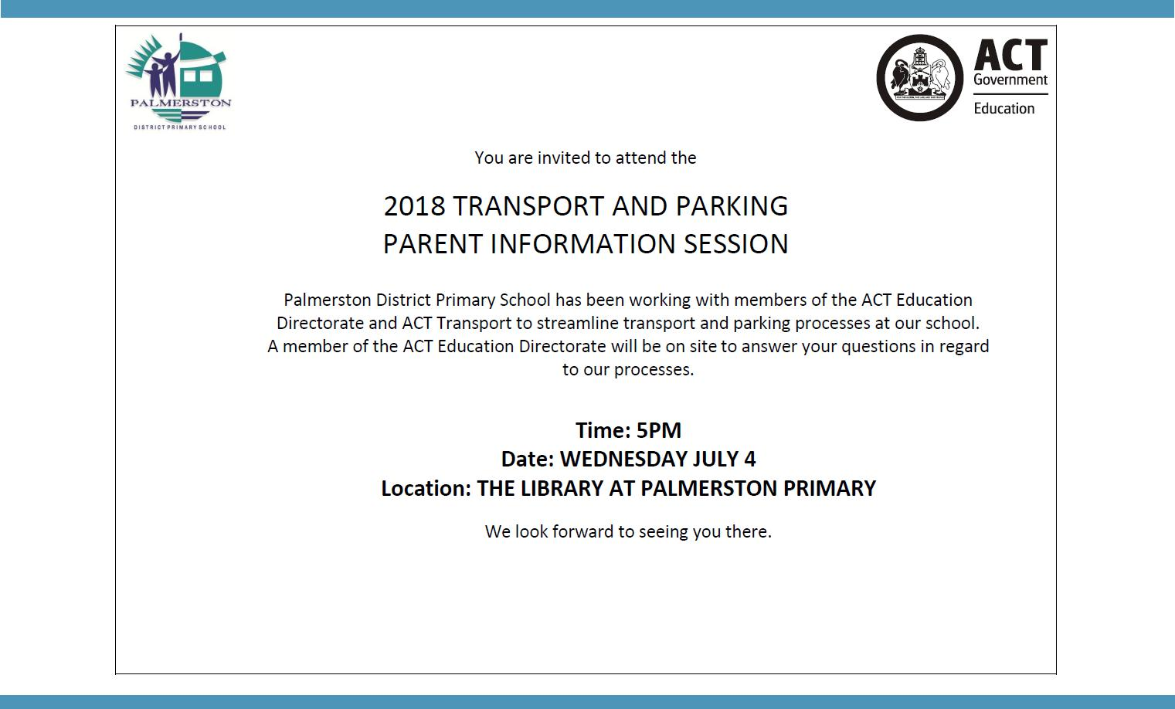

KINDERGARTEN HEALTH CHECKS

Earlier this year a information pack was distributed to all Kindergarten families in relation to health checks conducted by School Health Team Nurses. The health checks are conducted across all ACT Government schools to assist children to have the best possible start at school. The information you returned to the school has been supplied to School Health Team. The nurses will be conducting the health checks on 2- 4 (Monday - Wednesday) July. If you have not returned your child’s health check information and you wish for the health check to be conducted, please return the envelope to your child’s teacher.

RECYLING PROGRAM
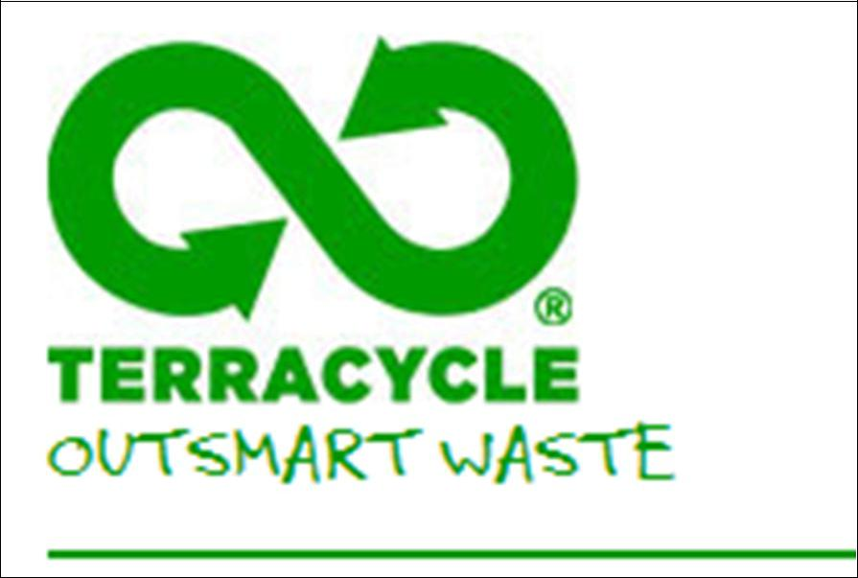

Want to raise money for the school and at the same time recycle items you normally throw away?

Palmerston Primary is registered to be part of a new recycling program. The school will be a collection point for oral care waste that we will send off to earn money for the school.

All you have to do is bring your finished toothpaste tubes, toothbrushes,

dental floss containers and packaging and place them in the box just outside the staffroom where the club board is. We will do the rest.

Just so you know… even though the collection box has pictures of Colgate products on it – ANY BRAND OF ORAL CARE PRODUCTS IS ACCEPTED!
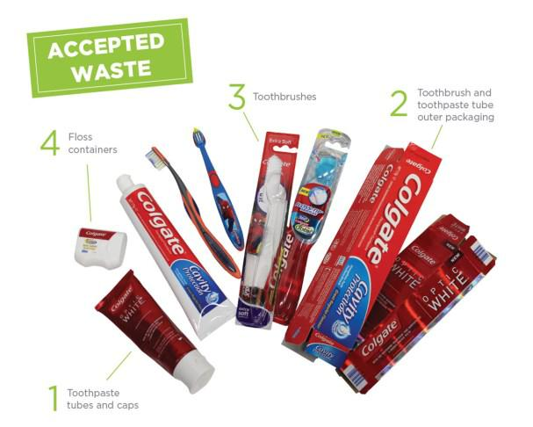

The program will be officially launched on World Environment Day June 5 at morning lines. If you already have some products you would like to bring in before then please hand in to the front office or directly to Karon Campbell - Environmental Science Teacher.

Together, we learn from each other

What’s On Page 5

SCHOOL INTENTIONS 2019

School Leavers 2019

We have now reached the time in the year when we begin to look at our school numbers and staffing arrangements for 2019. If your circumstances have changed and your child/ren will not be attending Palmerston District Primary School in 2019 can you please let the front office staff know as soon as possible.

My child/ren will not be returning to Palmerston in 2019.

Name Class

Last day at Palmerston:

My child/ren will be attending:

Another government school in the ACT:

A non-government school in the ACT:

Moving out of the ACT

Forwarding Address:

Phone number:

Parent’s name:

Together, we learn from each other

What’s On Page 6
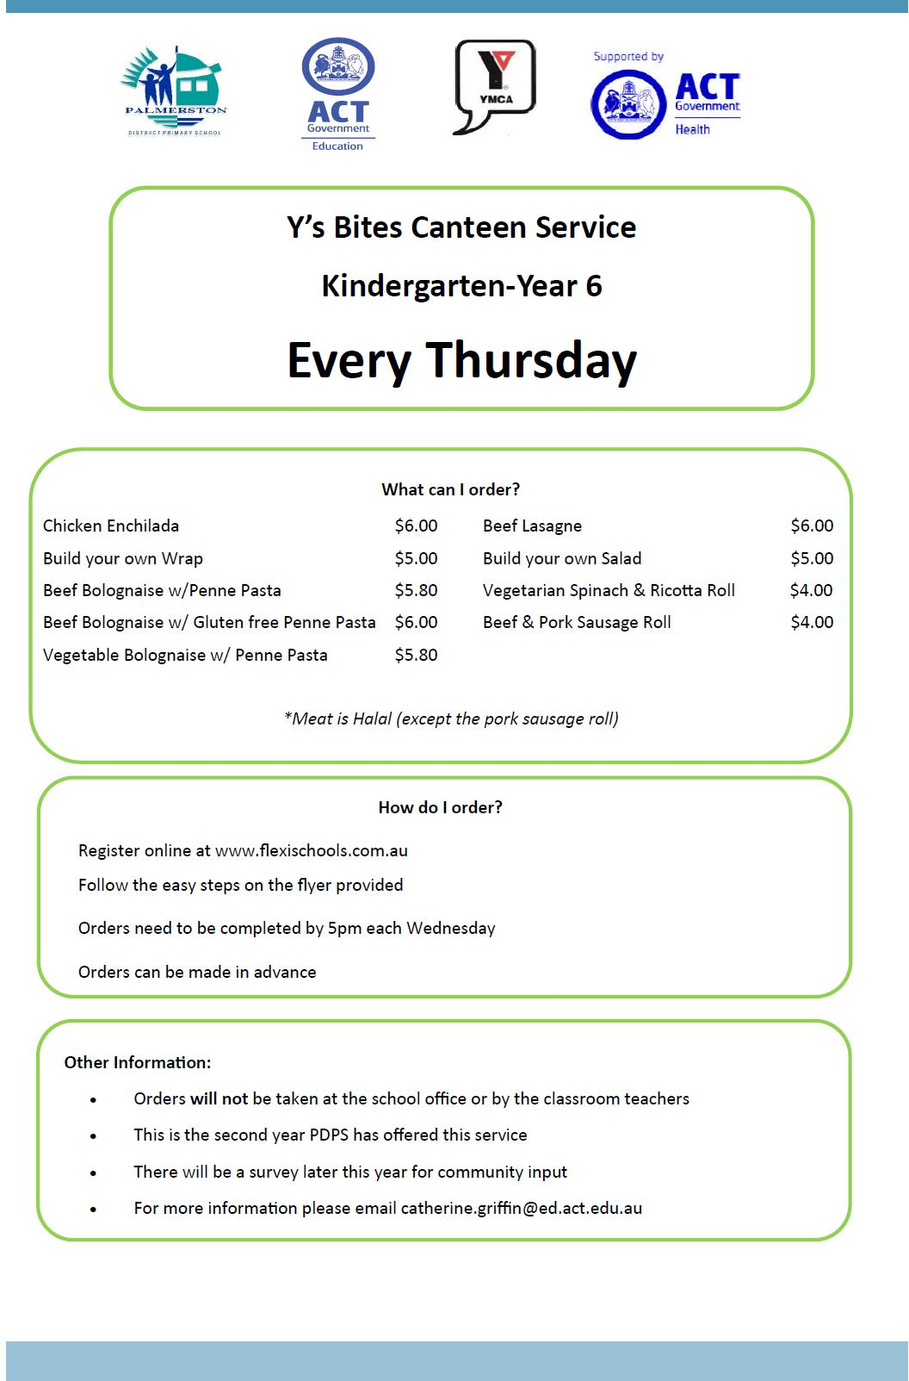

Together, we learn from each other

What’s On Page 7
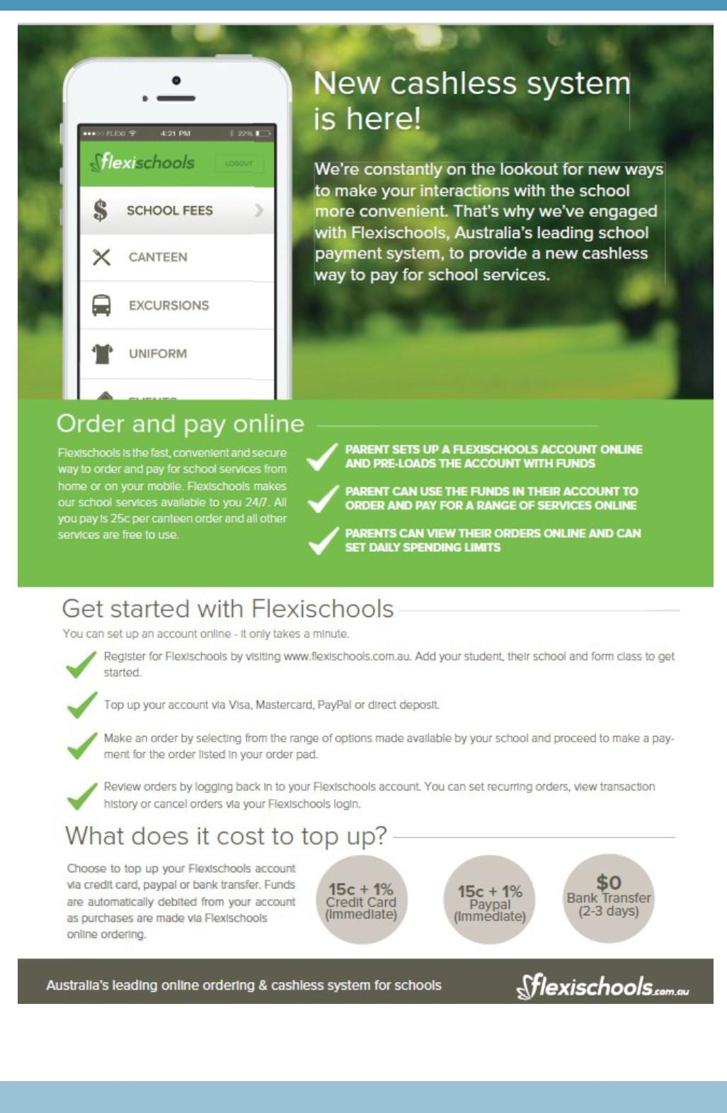

Together, we learn from each other

What’s On Page 8

COMMUNITY NEWS

Parking Patrols near Schools

Parking Operations are now using a Licence Plate Recognition vehicle (or electronic chalking), which regularly patrols school environments to increase safety for children. Motorists that commit an offence will receive their infringement notice in the mail (rather than on their windscreen) 5-7 days after the offence.

https://www.youtube.com/watch?v=H6B6PPgOC8I

While schools can become congested during the peak times, illegal parking cannot be tolerated as it creates an unsafe environment for children. Parents are welcome to park on side streets around schools, but please remember to park legally. Infringements for parking on nature strips, footpaths, verges, street corners and near children’s crossings start from $114.

If you need to drive, park a little further from the school and walk to meet your child, or arrange a meeting point so they can walk to meet you. It’s a great way to avoid congestion and is also one of the most time efficient ways to ensure children receive the recommended 60 minutes of physical activity every day.

More information is available on the Transport Canberra website, including a range of information sheets to promote safe behaviours around schools. Please help make school environments safe.

Canberra’s Light Rail is Fast Approaching. Are you Rail Ready?

Whilst the light rail system undergoes testing to ensure it is fully functional and safe to carry passengers, light rail safety awareness among children and adults is also essential.

In addition to the Canberra Metro website, the video can also be accessed through Canberra Metro’s YouTube Channel. Please note that the video plays more seamlessly and without interruptions on the Chrome browser.

Together, we learn from each other

What’s On Page 9
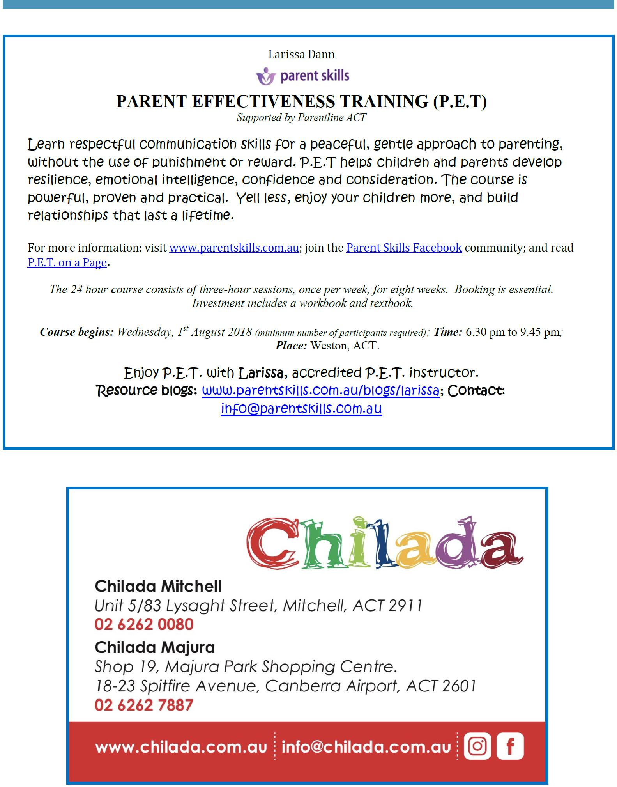

Together, we learn from each other

What’s On Page 10
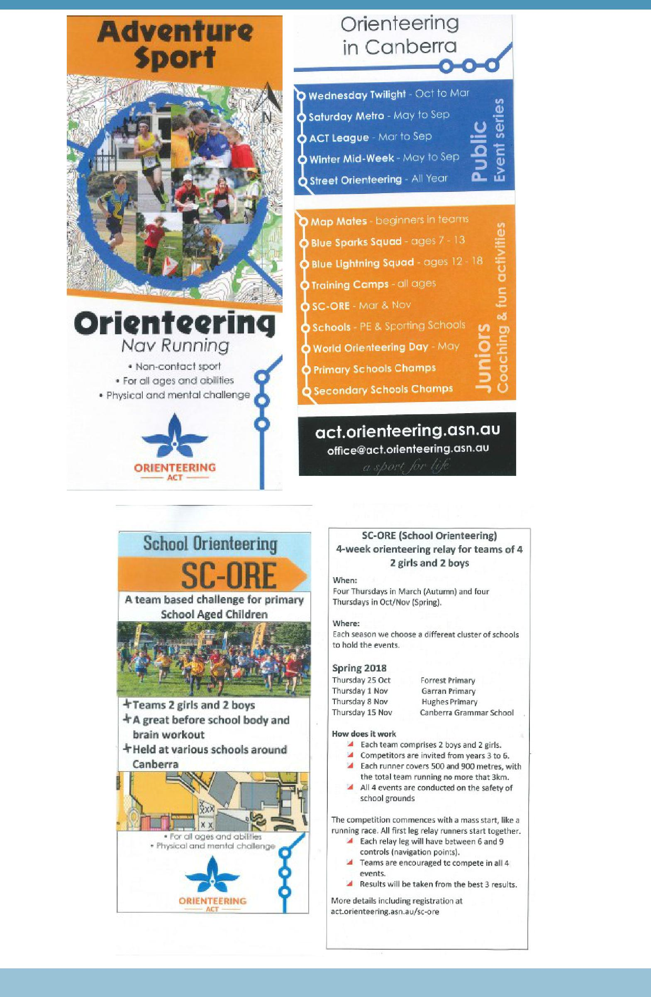

Together, we learn from each other

