Palmerston Post

26 July 2018

Week 1, Term 3

Board Chair: Lisa Fior Board Members: Parent Reps: Jesse Dang and George Villaflor

Teacher Reps: Jessica Lago and Maxine Green

P&C President: Lisa Fior

Principal: Kate Flynn (acting) Deputy Principal: Haeley Simms (acting)

Executive Teachers: Kylie Moller, Jacqui Warden, Matt Gowen, Catherine Griffin (acting)

ASSEMBLY:

27 Jul | Junior - 2MO, 2MG & 2RK
3 Aug | Senior - 3DJ, 3RC & 3/4JL
DATES TO REMEMBER:
30 Jul | Yr6 Wayan Kulit
 | performance
31 Jul | ICAS - English
1 Aug | K6FS Questacon excursion
3 Aug | National Aboriginal & Torres
 | Strait Island Children’s Day
 | celebrations
7 Aug | Parent Information Session -
 | Health & Sexuality
13 Aug | Yr2 Dental Awareness
14 Aug | ICAS - maths
14 Aug | P/S Community Walk

NOTES HOME:

- Market Day Mufti Day - youngest

- Satisfaction Survey - Yr5/6

- 100 days of Kindy celebration -

K

- National Aboriginal & Torres

Strait Island Children’s Day celebration excursion

P&C BOARD NEWS P&C: 7:00pm 6 Aug 2018

All P&C activities, meeting agendas and minutes are available from the school website at – Parent Corner

School Board: 7:30am 6 Sep 2018

PRINCIPAL’S MESSAGE

Welcome back to Palmerston for term 3. I am so excited to be back at Palmerston. I had a wonderful term as principal of Jervis Bay School. The Territory has a lovely community there and a vibrant school environment. I even learnt how to shoo kangaroos off the school oval!

I would like to thank Kate Flynn for acting as Principal during my secondment to Jervis Bay School. This term I will be making a few more trips to Jervis Bay School as part of my role as mentoring principal. During these times, Kate Flynn will continue to lead the school.

I look forward to an exciting term of student learning, events and excitement.

Melissa Travers

DEPUTY PRINCIPAL’S MESSAGE

I hope that you had a relaxing and enjoyable break.

PBL update

We are rolling out some exciting initiatives this term as our PBL journey continues. The mascot competition closed towards the end of last term and we are looking forward to progressing with this in the next few days. Assisting us with this is the newly formed PBL student team. This team consists of representatives from year 6 (and will be open to other middle and senior school year levels later in the term) whose role will be to support our school on the PBL journey. The types of activities the students will be involved in include assisting in the selection of the school PBL mascot, promoting PBL at morning lines, acknowledging positive choices via the raffle ticket process and engaging in peer mediation processes. The PBL team look forward to sharing further progress with you as the term unfolds.

Together, we learn from each other

Palmerston Post

Hats off period coming to an end

In line with the ACT Cancer Council recommendations, as we reach the end of July, we are about to head into the “hats on” period again. The Cancer Council states that as the daily UV levels begin to rise again, we return to wearing our hats from August 1.

Carpark news

As stated before we are really pleased with the progress of our car parking. We thank the community for supporting us with this. I would like to take the opportunity to provide a few reminders around car parking. The new carpark near the preschool is designated for teachers only. This allows for extra spaces in the main carpark for families to access the school and school buildings. I would also like to remind families that the ‘kiss and drop’ area is to be accessed only for a quick drop off or pick up - if you are waiting to access this area please be mindful to avoid traffic congestion. Your continued ongoing support with this would be greatly appreciated.

Staffing update

We would like to welcome our new school psychologist Ellie Mortimer. Ellie will be here with us on a Monday, Tuesday or Wednesday. Ellie has been into the school this week. She is on leave next week and will return in week three.

Have a great week,

Kate Flynn

UPCOMING EVENTS
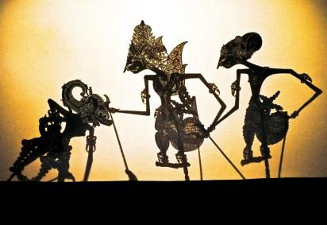

Yr6 Wayan Kulit Shadow Puppet show

Date: Monday 30 July 2018

Location: National Gallery of Australia

K6FS (LSU) Questacon excursion

Date: Wednesday 1 August 2018

Location: Questacon

National Aboriginal & Torres Strait Island Children’s Day celebration

Date: Friday 3 August 2018

Location: Gungahlin Child & Family Centre

Together, we learn from each other

Palmerston Post

SCHOOL INTENTIONS 2019

School Leavers 2019

We have now reached the time in the year when we begin to look at our school numbers and staffing arrangements for 2019. If your circumstances have changed and your child/ren will not be attending Palmerston District Primary School in 2019 can you please let the front office staff know as soon as possible.

My child/ren will not be returning to Palmerston in 2019.

Name Class

Last day at Palmerston:

My child/ren will be attending:

Another government school in the ACT:

A non-government school in the ACT:

Moving out of the ACT

Forwarding Address:

Phone number:

Parent’s name:

Together, we learn from each other

Palmerston Post
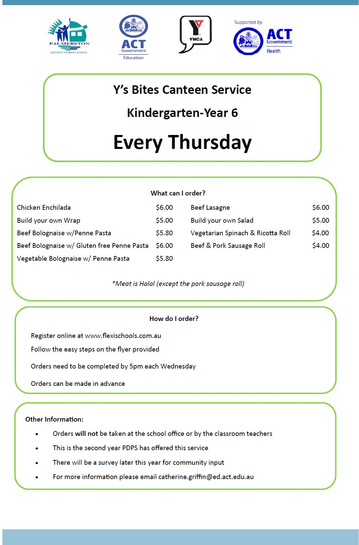

Together, we learn from each other

Palmerston Post

Together, we learn from each other

Palmerston Post

HIRER NEWS
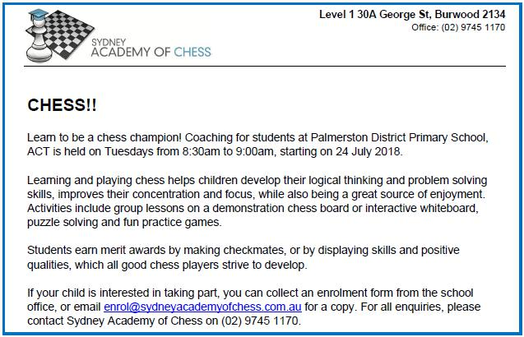

COMMUNITY NEWS
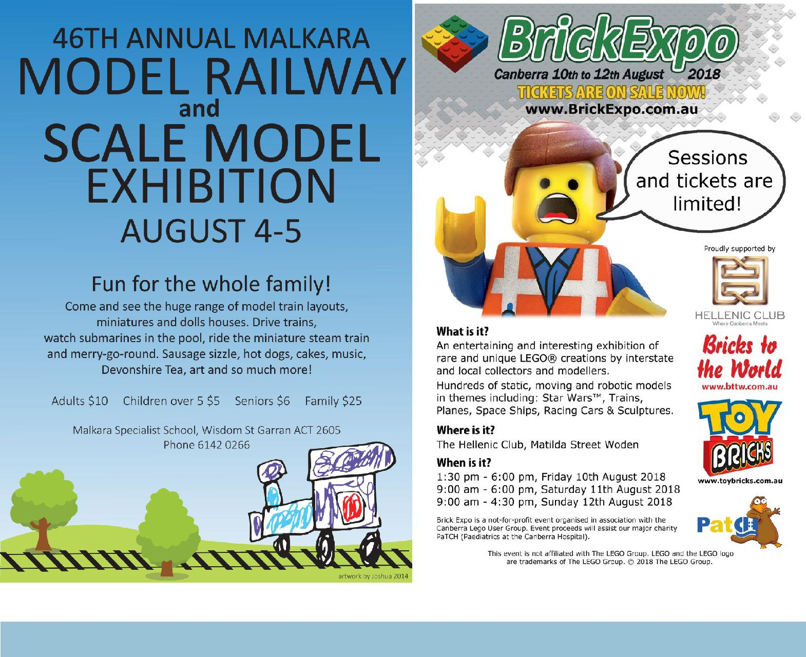

Together, we learn from each other

Palmerston Post

COMMUNITY NEWS
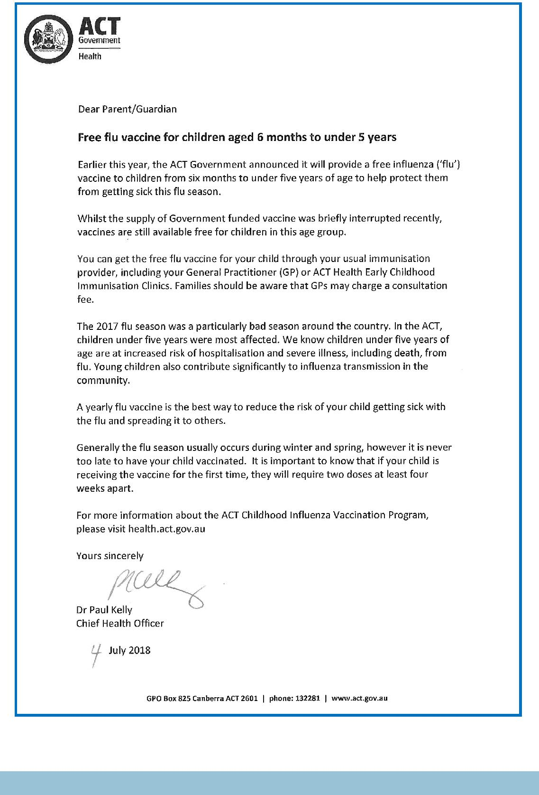

Together, we learn from each other

Palmerston Post
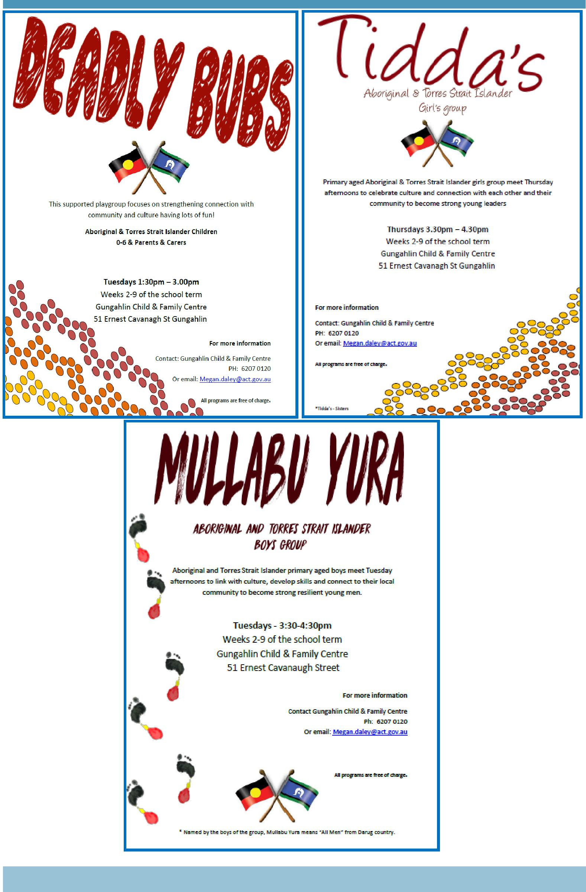

Together, we learn from each other

Palmerston Post
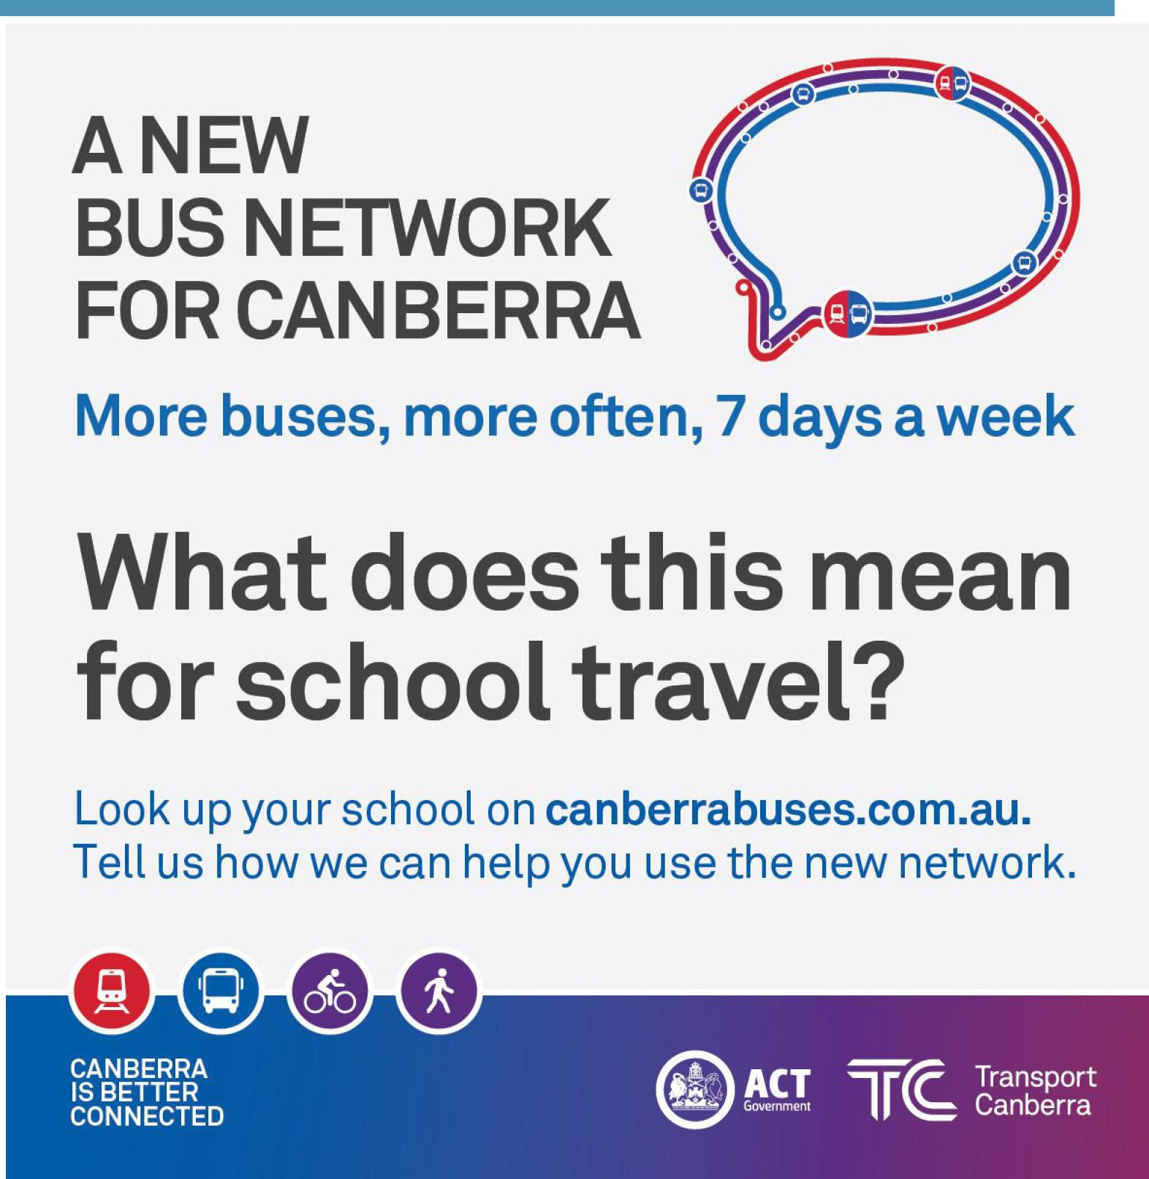

Together, we learn from each other

Palmerston Post
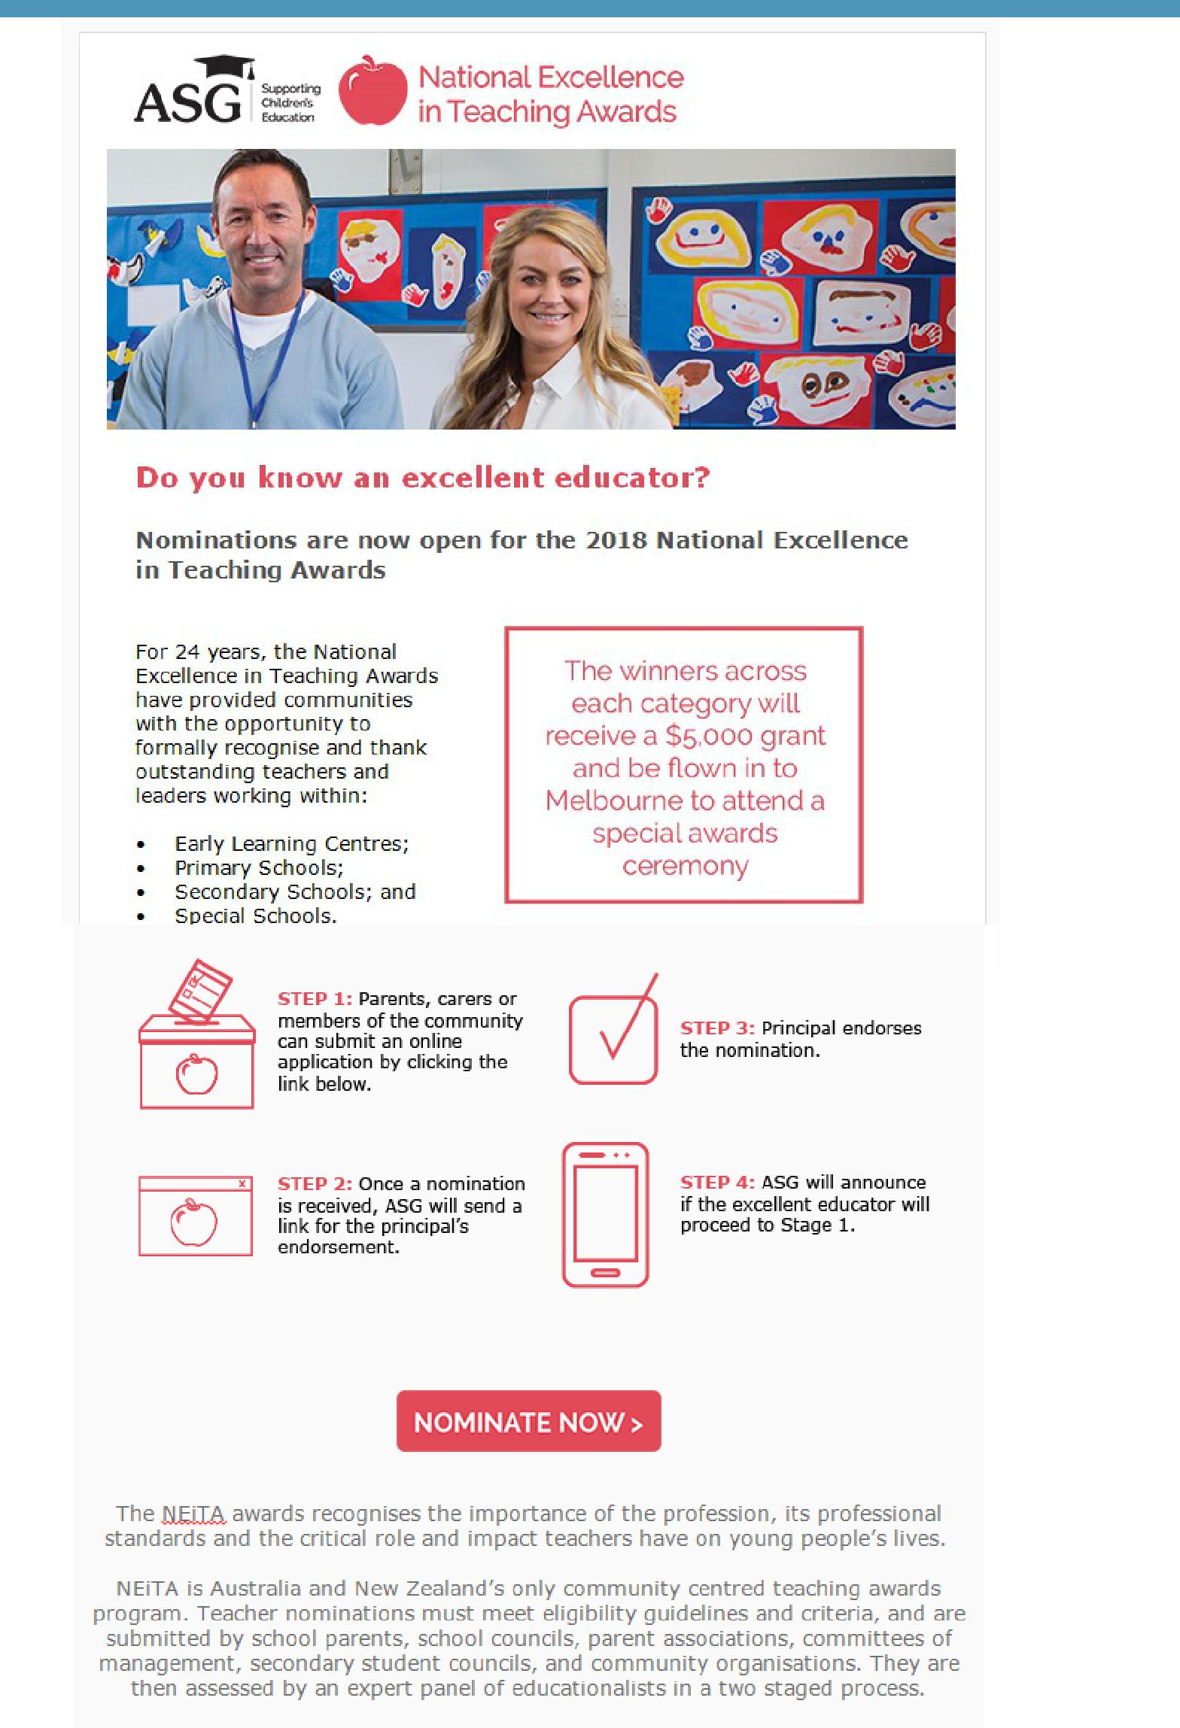

https://www.asg.com.au/about-asg/neita

Together, we learn from each other

