PALMERSTON VISION FOR TEACHING ENGLISH
PRESCHOOL TO YEAR 6 - 2016

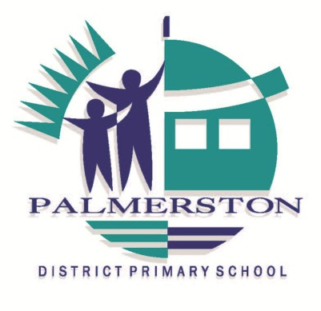

RESOURCES WE USE AT PDPS:

M100 Words

SRA Comprehension Cards

Jacob’s Ladder reading and comprehension series

The Daily 5 – Fostering Literacy Independence in the Elementary Grades, Boushey & Moser, 2006

The CAFÉ Book – Engaging All Students in Daily Literacy Assessment & Intruction, Boushey & Moser, 2009

Igniting a Passion for Reading – Successful Strategies for Building Lifetime Readers, Layne 2009

Journals in the Classroom – Isaacs & Brodine, 1994

Writing: Teachers & Children at work, Graves, 1983

Craft Lessons – Teaching Writing K-8, Fletcher & Portalupi, 2007

Craft Lessons Non- Fiction – Teaching Information Writing K-8, Fletcher & Portalupi, 2001

Teaching Reading Comprehension, Sheena Cameron

The Writing Book, Sheena Cameron and Louise Dempsey, 2013

Words Their Way (Various Publications), Bear, Invernizzi, Templeton and Johnston, 2008-2012

MultiLit – Reading Tutor Program, MiniLit Program and PreLit Program, MultiLit Propriety Limited Australia

Canberra Theatre/Hattie .4 growth

