PALMERSTON POST

15 March 2018

Week 6, Term 1
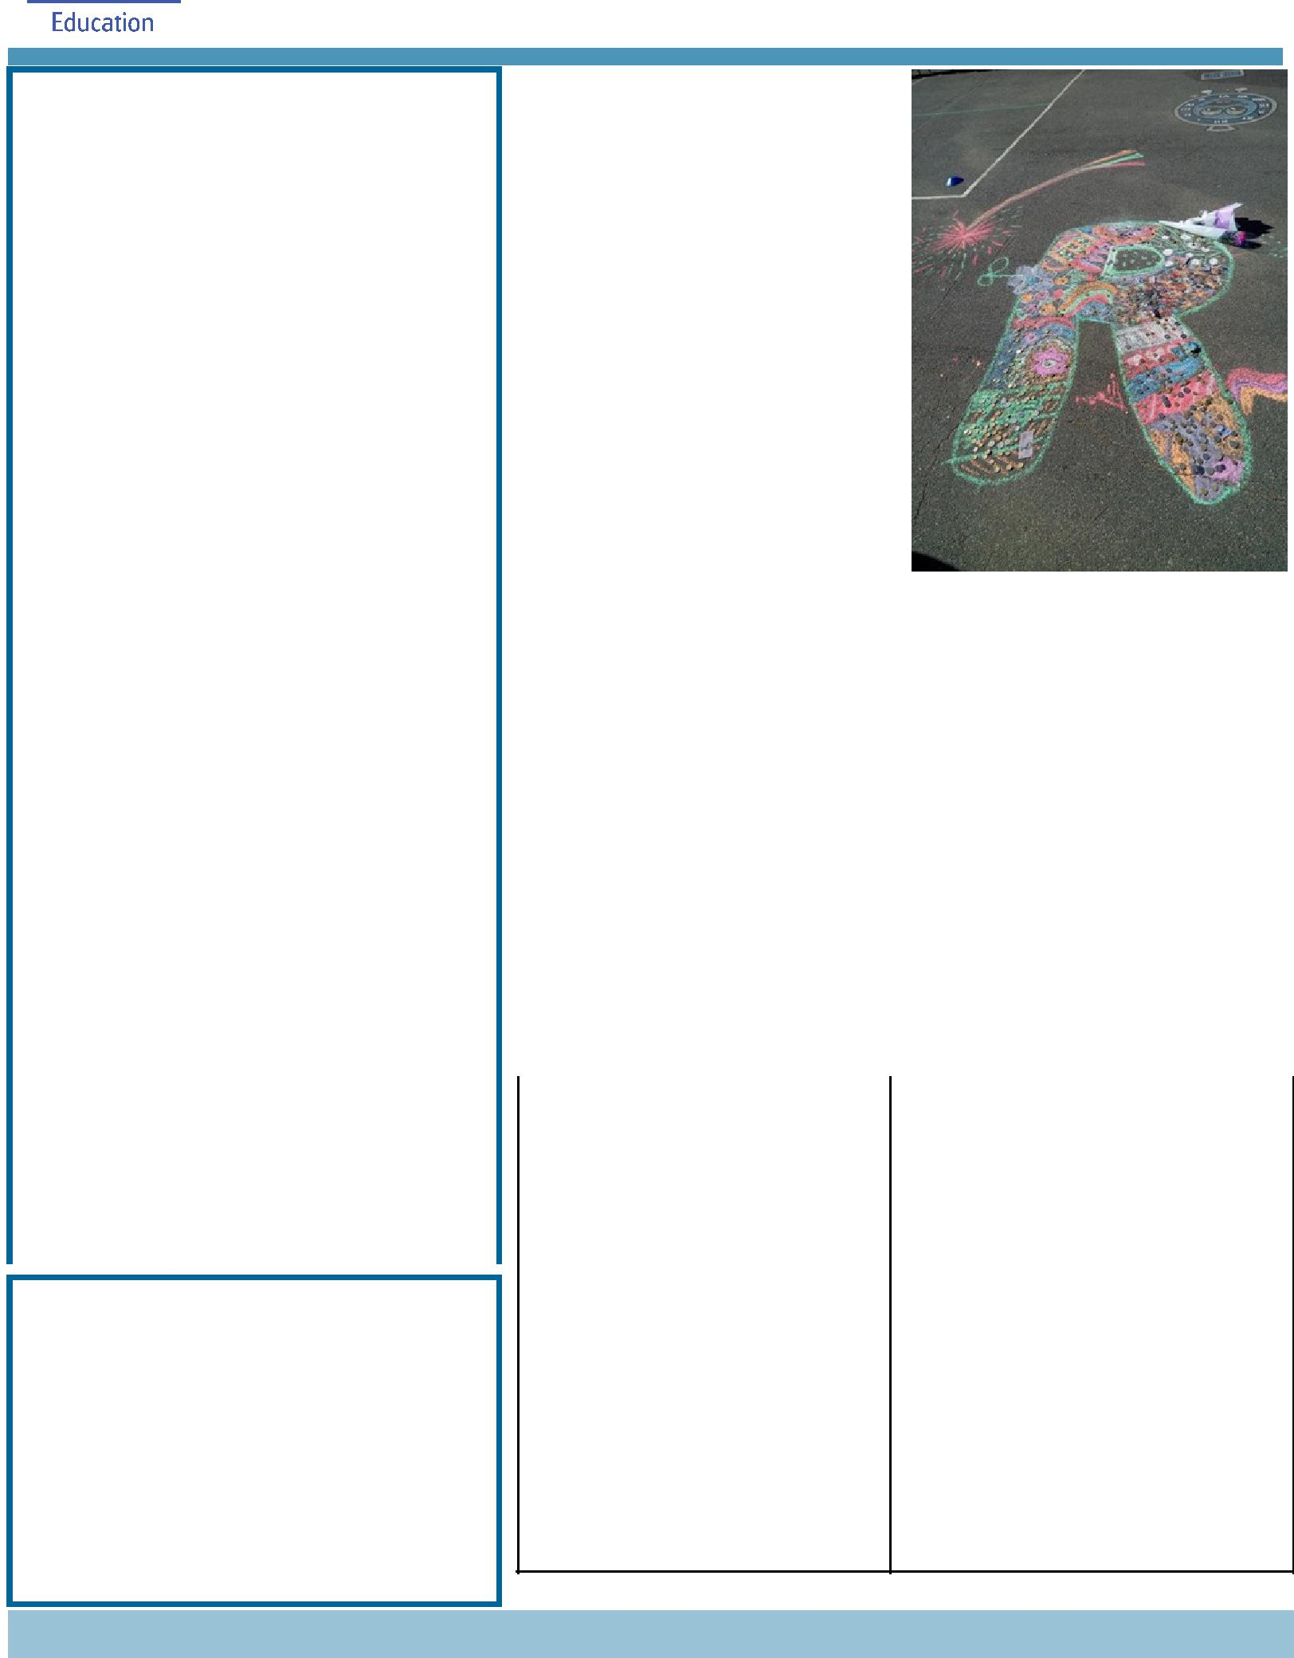

ASSEMBLY:
16 | Mar | Senior - Yr 5
23 Mar |  | Junior - 1PJ, 1MC & 1AS
30 | Mar | No assembly - Good Friday
DATES TO REMEMBER:
16 Mar |  | Harmony Day
21 | Mar | Christian Education
27 | Mar | Yr 5/6 Colonial Day
27 | Mar | P/S (beginning)Easter Hat
 |  | Parade
29 | Mar | P/S (end) - Yr 2 Easter Hat
 |  | Parade
30 | Mar | Good Friday Public Holiday
2 Apr |  | Easter Monday Public
 |  | Holiday
3 Apr |  | Yr 3/4 Camp - Birrigai
6 Apr |  | P&C Disco
9 Apr |  | North Gungahlin Swimming
 |  | Carnival
10 | Apr | P/S (beginning) Healthy
 |  | breakfast
11 | Apr | Cross Country Carnival
11 Apr |  | 5pm Seesaw parent
 |  | information session
13 | Apr | P/S (end) Healthy breakfast

NOTES HOME:

- Yr 3/4 Camp Final Details

- Jacqui Warden’s Introduction, P/S –K

- Yr 5/6 Camp update

- Library Trust Fund receipts - going home on Friday

P&C BOARD NEWS

P&C:

All P&C activities, meeting agendas and minutes are available from the School website at – Parent Corner

School Board Elections held in early 2018

Voting forms available in the front office

PRINCIPAL’S MESSAGE

I would like to thank the Palmerston community for their support of the memorial for Riley Moon and his family. On Tuesday afternoon we had approximately 300 people attend the memorial and celebrate Riley’s life. The family offered an opportunity for others to donate to the ‘Love your Sister’ charity and we raised $500.

Last week I spoke about how we support children and their wellbeing at school. This is a second part to how we are addressing the National Day of Action against Bullying. Bullying is a challenging and complex issue to address, but one that we are committed to addressing as a school community and as a broader education system. Our senior students will give out the following teaching posters to each class so that we all have a common understanding of what Bullying is and isn’t. How can you tell if someone is being bullied? Their chart can help fellow students decide if it’s bullying or something else. Our chart is divided into four:

Joking Around | One time thing
Everyone is having fun | Someone is being mean on
No one is getting hurt | purpose
Everyone is participating | It’s a reaction to a strong
equally | emotion or feeling
 | It happens once and doesn’t
 | repeat itself

Conflict | Bullying
Two people with a balance | Repeated, unwanted
of power that have a fight, | aggressive behaviour towards
argument or disagreement | someone
A solution can usually | Someone is being hurt on
be found | purpose
 | Can be social, verbal, physical
 | or cyber

Together, we learn from each other

Palmerston Post Page 2

Our school has a clear policy in relation to bullying which can be found here: Palmerston District Primary School (PDPS) website under Our School/ Policy and Procedures A copy of these policies can be found on the department’s website: http://www.det.act.gov.au/publications_and_policies. We have named it Student Wellbeing Procedures as it sits under the Education Directorate’s Policy. PDPS procedures should be read in conjunction with the following Education Directorate’s policies:

- Countering Bullying, Harassment and Violence in ACT Public Schools (2007)

- Providing Safe Schools Policy P-12

- Countering Sexual Harassment in ACT Public Schools

If there is an incident involving our students, these are the steps you can expect us to take:

- We listen to the student/parent and ensure immediate safety.

- Senior teachers investigate the claim and follow our school procedures of contacting families and involving them in the conversations and putting consequences in place appropriate to the actions and age of the child.

- We undertake restorative procedures so students are making restoration.

- We follow up and work with students and families to ensure we can educate the children on safety and support positive change.

If your child has been involved in a bullying-related incident and you feel that you haven’t had a response in line with the above, you should initially raise this with me, as your school Principal. If you have done this and you still feel as though the issue has not been addressed in line with our policy, please contact our Complaints and Liaison Unit via www.education.act.gov.au/contact_us.

Please also remember that psychological support is available for students in all of our schools and we encourage you to reach out if you believe your child is struggling with bullying in school.

We also encourage you to talk with your children at home about the behaviours that are expected of them at school. Bullying is an issue that we need to address as a community, and often incidents occur or escalate outside of the school gates.

While social media is often an avenue to share experiences and express opinions, we ask that you be mindful of the potential impact of comments or information shared in this realm, particularly given that these situations involve minors.

Bullying is a challenging ethical balance for us to address because every child is entitled to an education, and every child is of course entitled to feel safe in their school. We will continue to work hard to find the right balance of these two considerations, and we do understand how distressing it is for students and families involved in incidents of bullying.

Palmerston is a community school and we at all times value your opinions and welcome your thoughts. At times children can act inappropriately and together as a community, we can address what they have done and what they could do in the future. School is a place for learning. The senior assembly this week is a time for the children to give us their thoughts (through their plays) and how they are showing their resilience and working as a team to ensure bullying behaviour is not accepted at Palmerston.

Melissa Travers

Together, we learn from each other

Palmerston Post Page 3

UPCOMING EVENTS

Date: Friday 16 March 2018

Location: Palmerston District Primary School Harmony Day is a day where all Australians

celebrate our cultural diversity. The message of Harmony Day is ‘Everyone Belongs’, which means that all Australians are a welcome part of our country regardless of their background.

Palmerston District Primary School will celebrate Harmony Day within classrooms by participating in a variety of lessons. The students at Palmerston will also participate in a fun Harmony Day scavenger hunt. Students are encouraged to wear traditional dress or something orange to school tomorrow for our Harmony Day celebration.

Christian Education (optional)

Date: Wednesday 21 March 2018

Location: Palmerston District Primary School

The Christian Education program is run by New Life Presbyterian Church and this year the teaching theme is Horrible History- Fantastic Future. We will learn about four people from Old Testament Bible history who had a ‘horrible’ time… but who God used to be heroes and leaders. We will teach the song ‘God’s Good All The Time’ by Colin Buchanan.

Term 1 will introduce the character of Joseph and trace his history to Jesus at Easter.

Yr 5/6 Colonial Day

Date: Monday 26 March 2018

Location: Palmerston District Primary School

P/S - Yr 2 Easter Hat Parade

Date: Tuesday 27 (Brave, Itchy & Noisy Bears) & Thursday 29 March 2018 (Hungry, Cranky & Sleepy

Bears, K-Yr2)

Location: Palmerston District Primary School

Yr 3/4 & IEC2 Bus Tour

Date: Wednesday 28 March 2018

Location: Canberra

Yr 3/4 Camp - Birrigai

Date: Tuesday 3 April 2018 (after Easter)

Location: Birrigai

K - Yr 6 P&C Sausage Sizzle Lunch Order

Date: Friday 13 April 2018 (please note change of date)

Location: Palmerston District Primary School

Together, we learn from each other

Palmerston Post Page 4

PALMERSTON PRIDE AWARDS
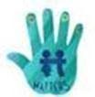

Congratulations to the following students who received a PRIDE Award at assembly on 9 March 2018.

PARTICIPATION – becoming involved, “having a go” and cooperating with others Rehma - 1AE Sienna - 2MG

RESPECT – respect for self, others and their property Jasper - 1AE Arya - 1MC

INTEGRITY – being honest, fair, responsible and loyalty Stella - 1PJ William - 2MG

DETERMINATION - being persistent and resilient

Israel - 1PJ

EMPATHY - understanding and supporting others, regardless of our differences LiYa - 1MC

ARTIST OF THE MONTH

Oscar - 1AE Devine - 1PJ

STUDENT ACHIEVEMENTS

The students listed below have been selected by audition for the ACT Instrumental Music Program’s Extension Ensembles in 2018. This is the equivalent of ACT representation in Music.

Billy - 5/6WW | Primary Concert Band
Madelene - 5DT: | Primary Concert Choir
Raafi - 5/6WW: | Primary Concert Band
Julia - 5/6WW: | Primary Concert Band & Primary Concert Choir
Niina - 5DT: | Primary Concert Choir

DEFENCE NEWS

PALMERSTON DISTRICT SCHOOL ANZAC SERVICE, will be held on Friday 4 May, 2018 at 9am in the School Hall. All are welcome to attend. If a member of your family is currently or has previously

served in the ADF, you are invited to forward their photo and a little background of their role by Week 9 to DSTA Kristy Retzlaff kristy.retzlaff@ed.act.ed.au for

inclusion in our ANZAC Service.

Defence Kids Activity Club – In preparation for ANZAC Day, students will be participating in a range of Anzac Crafts and activities over coming weeks.

Have a great week,

Kristy Retzlaff

Defence School Transition Aide.

Together, we learn from each other

Palmerston Post Page 5

YEAR 5/6 NEWS

Aussie Hoops Program

Aussie Hoops introduces children to basketball in a structured and fun environment. The basketball clinics consist of warm-up games, skill activities and modified games all delivered by accredited coaches. All students in Year 3–6 have been lucky enough to participate in these clinics this term.
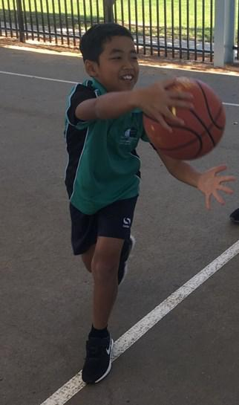
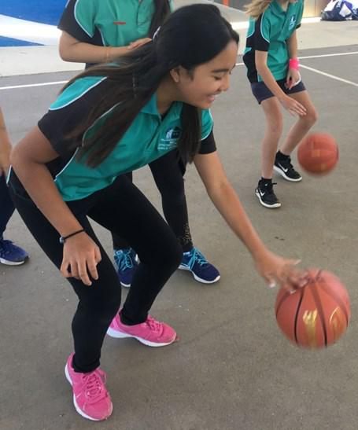

Student Quotes

“The basketball clinics are really fun. My favourite part

was shooting baskets. It just feels nice when the ball

goes in the hoop, especially from the three point line. So far I am really enjoying the clinic, except for

the push ups.” – Si Thu, 6KB

“That was the most fun since the start of term! We just had basketball clinics, it was amazing, except

for the part when I accidentally smashed the ball in my eye. The rest was absolutely magnificent and

amazing. We did throwing, shooting, dribbling, passing and competitive games.” – Amin, 6KB

“I thought the basketball clinic was really fun because we were trying new sports and we were having

a go. When we split up into girls and boys we were doing shooting and everyone was really supportive of each other whether they got it in the hoop or not. We also practised dribbling skills. Overall, I

thought it was really fun and helpful to learn new skills and give it a go!” – Amelia, 6AJ

“I thought the basketball clinic was excellent. The people that ran it were nice and there were a lot of different types of dribbling skills we had to do. One was dribbling up and back along the basketball court and another was doing small and large bounces. We also did some shooting from the three point line. In my opinion, the basketball clinic was very enjoyable.” – Isaac, 6AJ
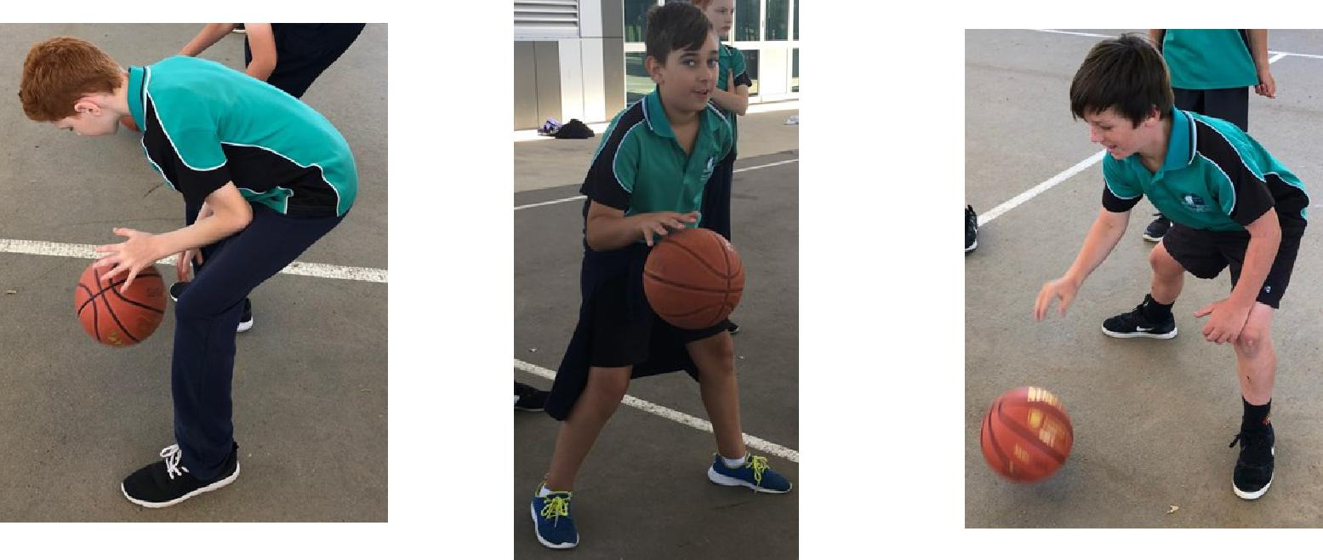

Together, we learn from each other

Palmerston Post Page 6

Creative writing workshop with author, Harry Laing

Last week students worked with local author Harry Laing. Harry is a poet, children’s author, creative writing teacher and comic performer. He is the author of Shoctopus – Poems to grip you, a book of illustrated poems for 6 to 12 year olds.
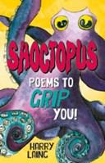
Harry modelled a number of quick writes with the students before the children had a go. They produced some wonderful work including pieces about the dreams of an object in the room, and the titanic struggle between two objects (for example Pencil Man vs Eraser Man).

The students were extremely engaged in this fast-paced session of writing. Here are some of their thoughts on the experience:

“As soon as I walked through the library door I knew this was going to be fun.” - Toby, 5IH

“He told us to look around the room and choose any object and write about what their dream would be like. I chose the puppet theatre and how it would love to go to Broadway and perform in front of judges. I learnt that poems don’t have to be rhyming and can be as silly as you want and that you can be so creative with your writing.” - Hannah, 5IH

“What I enjoyed was his humour, his story acting and jokes.” James - 5IH

I had a great time with Harry Laing. I wrote poems and made a little story about Diamond man and Dirt man. I even told five big juicy lies about myself.” Callum - 5IH

“The best part was actually at the end when Harry Laing sang this poem about him being a 93-year-old angry lady.” Cohen - 5IH

“Before I went into the room I thought I couldn’t write a poem, but when I walked out I thought I am very good at writing a poem.” Charlotte - 5IH

SCHOOL TRANSPORT/CAR PARK INFORMATION

At Palmerston we are committed to creating a safe environment for the entire school community. I would like to remind parents that it takes an entire community to create a safe school environment. The school carpark can become congested during peak times and it is important to remember to park in the designated areas and cross at the designated crossings to ensure the safety of our students. To assist us with possible solutions for our car park Andrew Crichton from Transport Canberra and City Services Directorate will be attending our school at 3pm on the 21 March to gain an understanding of the environment around the school and some of the issues facing us. In this newsletter you will also find a survey that you can complete to assist Andrew in understanding parent/carer concerns about all school carparks. If you have any suggestions to assist us with the car park area we will have a suggestion box located at the front office for you to place your suggestion. Additionally, we are investigating with ACTION the possibility of a bus route between Crace and Palmerston. If you would like to support this initiative there will be an expression of interest form at the front office where you can put your name and address to allow the bus company to gauge how many families feel strongly about this. This could create an opportunity for a new bus route. If we receive enough interest we will forward this information on to the bus company to support getting a bus from Crace for our families. The School Board will discuss this initiative at their next meeting.

If you have any questions or queries please do not hesitate to contact me via the front office. Haeley Simms

Together, we learn from each other

Palmerston Post Page 7

SCHOOL BOARD NOMINEES

Voting period: Monday 9 March - 23 March 2018

Voting forms will be available from the front office.

Board Nominee Introductions

Lisa Fior - Nominee for the Palmerston District School Board

I am the Deputy CEO of Catholic Care Canberra & Goulburn, and have over 20 years’ experience in the social services sector. I commenced my career in this sector, working with, training and managing a team of volunteers across NSW, and then moved into supporting homeless youth across the

ACT. Following this, I progressed into management roles with youth, mental health and homelessness programs, and have completed tertiary education in Social Sciences. I currently oversee both direct service delivery and corporate areas within Catholic Care and I am passionate about providing effective and quality services to those in need in our community.

I have held various Board positions across the ACT, and am currently the President of the Palmerston Primary School P&C. I am a mother of four and two of my children are currently students at the school. Our family have been part of the Palmerston Primary community for over six years.

I have a strong interest in the broader strategic direction of Palmerston Primary as well as participating in overseeing the operations of the school and ensuring quality education delivery for our children.

Eleni Velanis - Nominee for the Palmerston District School Board

I have lived in Palmerston for 8 years, and have been a parent of the school community for 6 years. I have also worked at two schools in the ACT as a Learning Support Assistant with my current position being at Palmerston Primary for 4 years now. I have enjoyed my opportunity to work at the school and in my current role at Palmerston my duties involve assisting the Teacher Librarian in the Library with daily duties as well as working in the book fair etc, Introductory English Centre (IEC) and in the preschool. I also provide support to the team in the front office with administration tasks and First Aid assistance.

I have volunteered at community events such as the Twilight Fair and have acted as Manager of my sons soccer team.

As a result of my work in the school and the wider community I have met and built up relationships with many students and their family members. I would like the opportunity to be a part of the School Board as I feel we have a really great school and community, and I would like to be further involved in the journey ahead with everyone. I believe our children benefit from the expertise and experience that all members of a School Board bring to the school.

Together, we learn from each other

Palmerston Post Page 8

P&C NEWS

School Banking:

School Banking is every Wednesday 9am-10.30am in the staff room.

Bank books can be left at the front office by 9.30am or handed to your child’s teacher in the morning. Unfortunately, Jo from Commonwealth Bank was unable to make last Tuesday morning for the info session at Pre School, We will advise if this can be rescheduled at a later date.

If you would like to open a new account, a Youthsaver account can be opened online by all parents. Visit commbank.com.au/schoolbanking and click on the link to open the Youthsaver account. Parents will need their child’s birth certificate or similar identification as well as their own to complete the process and generate an account.

Or you can visit any Commonwealth Bank branch with identification and open an account.

Book Club :

Issue 2 has now arrived and hopefully all catalogues have been distributed. All orders are due in by next Friday 23 March

Reminder we accept cash/cheques by completing the form on the back page with all of the student’s details and placing in a sealed envelope/bag into the ‘Boomerang’ box located in the front office foyer. Otherwise, if you wish to order using a credit card then please

Visit www.scholastic.com.au/LOOP (or download the APP from the App store)

For a quick start, just click on ORDER in the top menu or REGISTER first to save your details for next time:

- Select your school and your child’s class

- Add your child’s first name and last initial (so the school knows who the book is for)

- Enter the item number from the Book Club catalogue

- You can order for multiple children at once if they attend the same school

- All orders are linked directly to the school for submission to Scholastic. Books will still be delivered to your child’s classroom if you order by the closing date

- There’s no need to return paper order forms or payment receipt details to your school!

Regards

Edwina
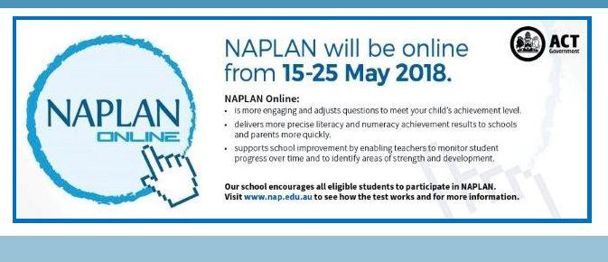

Together, we learn from each other

Palmerston Post Page 9
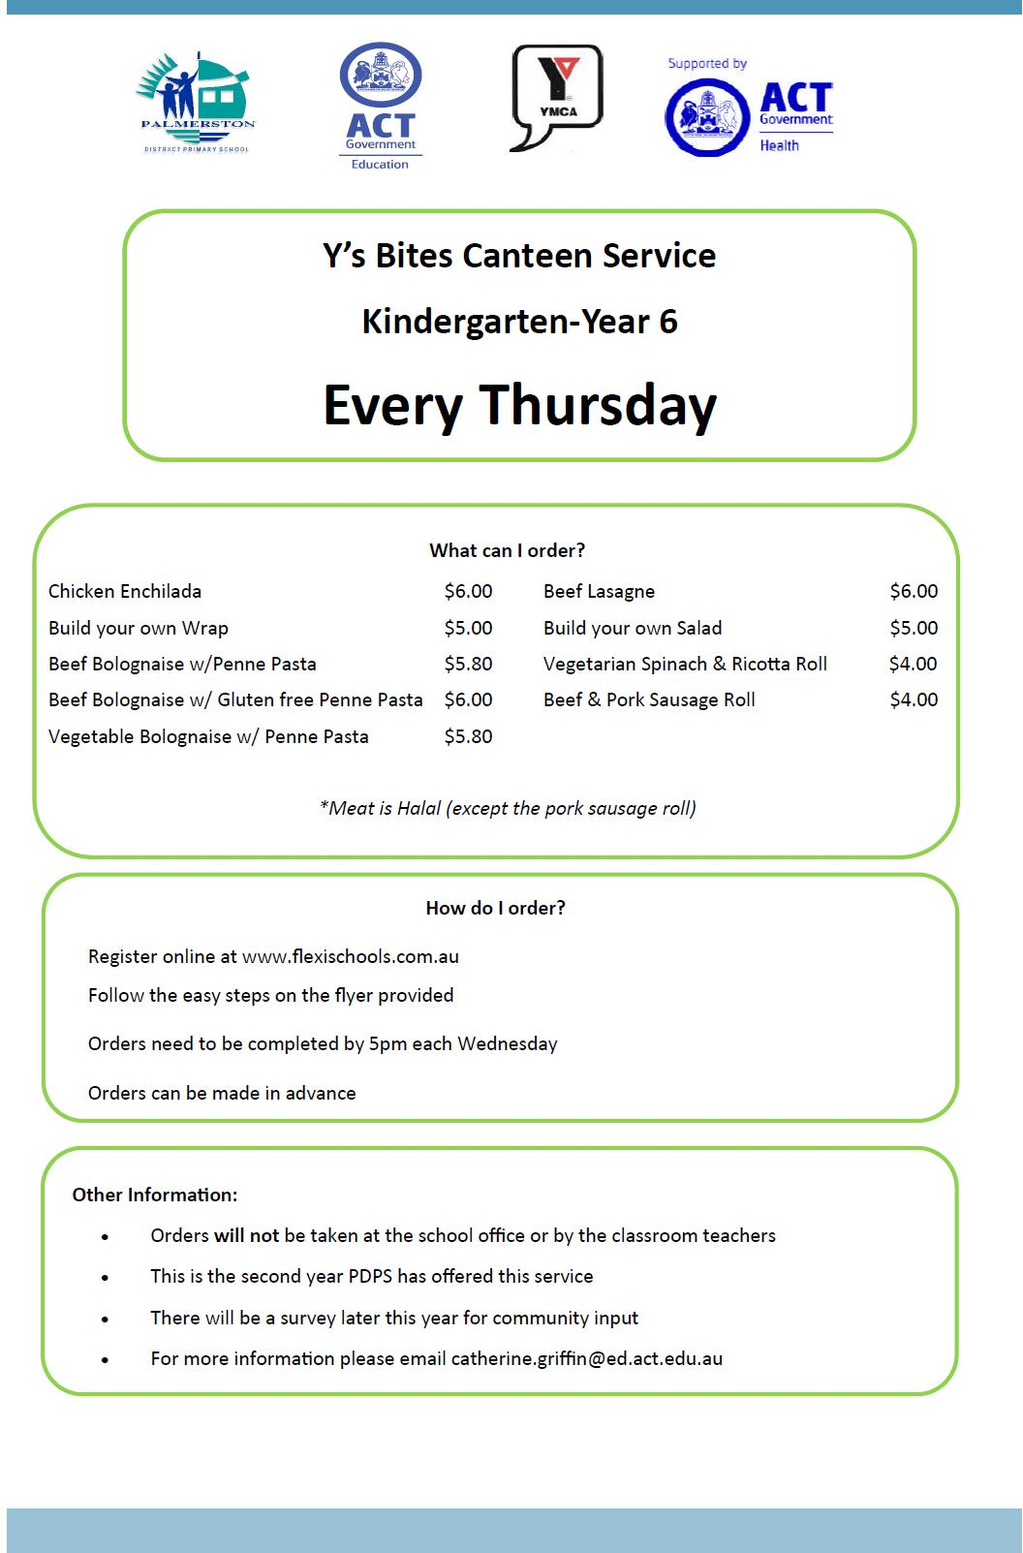

Together, we learn from each other

Palmerston Post Page 10

Together, we learn from each other

Palmerston Post Page 11
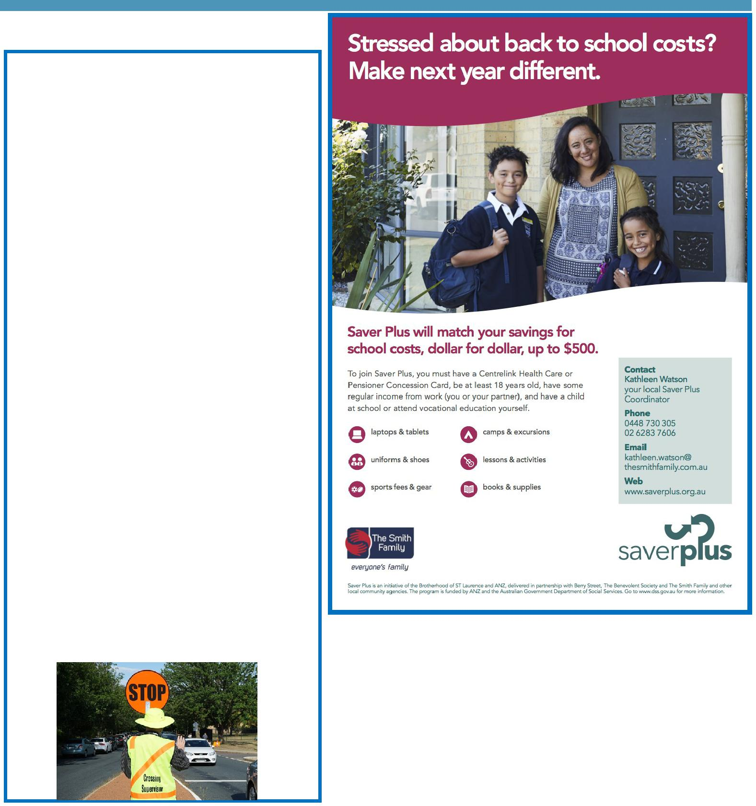

COMMUNITY NEWS

Survey: School travel and safety

Transport Canberra and City Services has engaged First Person Consulting to conduct research into parent's attitudes to their children's active travel to and from schools. Part of this process will investigate the role that School Crossing Supervisors have in improving safety around schools, and the extent to which parent attitudes to children travelling actively change as a result.

To complete the survey please click here, or copy and paste the following link into your browser: http:// www.surveygizmo.com/s3/4172965/ School-Crossing-Supervisor-Survey-Control.

The survey should take about five minutes. The survey will not collect any identifiable information, and all responses will be kept confidential. Thank you in advance for your time in completing this survey. If you have any questions please contact the TCCS Schools Program.

Together, we learn from each other

Palmerston Post Page 12
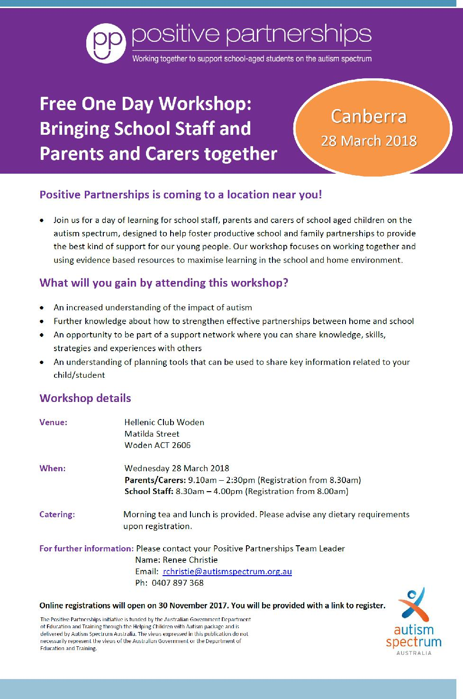

Together, we learn from each other

Palmerston Post Page 13
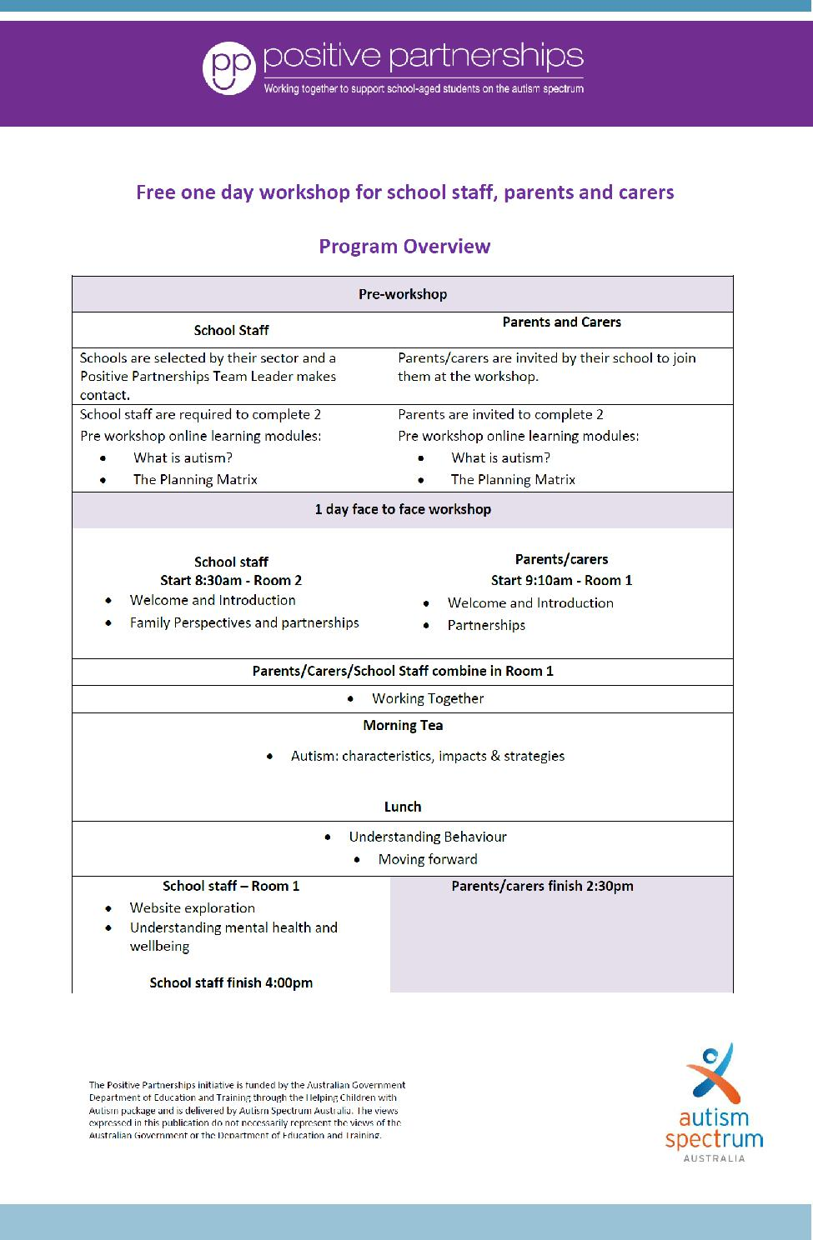

Together, we learn from each other

Palmerston Post Page 14

Together, we learn from each other

