Palmerston Post
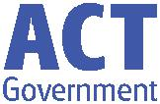

29 March 2018

Week 8, Term 1

ASSEMBLY:
30 | Mar | No assembly - Good Friday
6 Apr |  | Whole School - IEC
DATES TO REMEMBER:
30 | Mar | Good Friday Public Holiday
2 Apr |  | Easter Monday Public
 |  | Holiday
3 Apr |  | Yr 3/4 Camp - Birrigai
6 Apr |  | P&C Disco
9 Apr |  | North/Gungahlin Swimming
 |  | Carnival
10 | Apr | P/S (beginning) Healthy
 |  | breakfast
11 | Apr | Cross Country Carnival
11 Apr |  | 5pm Seesaw parent
 |  | information session
13 | Apr | P/S (end) Healthy breakfast
13 | Apr | P&C Sausage Sizzle Lunch
 |  | Order

NOTES HOME:

- Seesaw Parent Information Session - youngest

- Cross Country - youngest

- Yr 3/4 Camp reminder

P&C BOARD NEWS P&C: 8 May 2018

All P&C activities, meeting agendas and minutes are available from the School website at – Parent Corner

School Board:

DEPUTY PRINCIPAL’S MESSAGE

Dear Parents and Carers,

Professional learning update

At the moment the Palmerston staff have been participating in a range of professional learning activities. These include lesson demonstrations by Anita Chin. Anita is a mathematics consultant from NSW who delivered a day of professional learning to our staff in January around mathematics and the Australian Curriculum. Last week Anita visited our school and through demonstration lessons, she provided teachers with practical activities to meet the individual needs of our students. Some of our staff also attended the 2 hour ‘Chin-Up” session where practical advice on the teaching of mathematics through the Australian Curriculum was given.

In line with the 2018 draft Annual Action Plan, the entire staff participated in a session on the use of formative assessment to gauge the learning of students during our Professional Learning Community time on Tuesday afternoon. This session was the first of many sessions on formative assessment that we will roll out this year. Along with that, all teaching staff will be including formative assessment on their development plan for the 2018 school year.

Easter Hat Parade

Tuesday morning and this morning saw us participate in our annual Easter Hat parade. We thoroughly enjoyed seeing the start of the week preschool groups model their beautiful Easter hats to us on Tuesday morning. We were overwhelmed with the wonderfully creative hats we saw this morning in the

P-2 outdoor assembly. This has proved to be lots of fun for all and a highlight for many families and staff at Palmerston. I’d like to say a big thank you to Catherine Griffin for organising this event as well as the Easter raffle, which raised over $690! Thank you also to the community for your fantastic donations.

Together, we learn from each other

Palmerston Post Page 2

Planning Days

This week staff have been engaging in planning days. During this time teaching teams meet with a member of the leadership team to utilise student data to accurately plan engaging unit plans for term 2. Staff work particularly hard at this time to ensure that our planning will continue to see students’ growth in learning.

Cross Country

We are looking forward to our Cross Country Carnival on Wednesday in week 10. We encourage all students to participate to the best of their ability which may be walking, running or jogging the course. As always we remind families to ensure that children have appropriate footwear and sun smart clothing. Sunscreen will be available on the day. Parent volunteers are welcome, please see Mr Susko if you are able to assist.

Thank you to the P&C

Our amazing P&C have two events coming up over the next few weeks. These include the disco next Friday night and the sausage sizzle special lunch on Friday week 10. We thank the P&C for running these initiatives to support our school- they do an amazing job!

Wishing you a safe and happy Easter break and looking forward to seeing you next Tuesday.
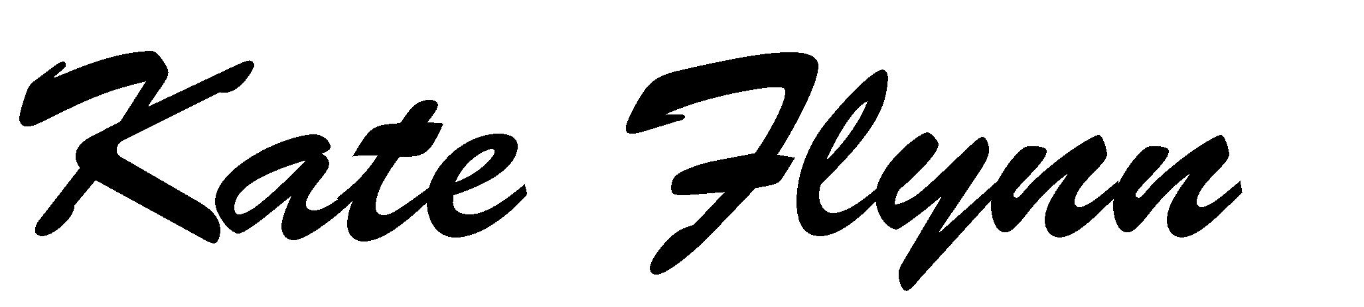

PALMERSTON PRIDE AWARDS

Congratulations to the following students who received a PRIDE Award at assembly on 23 March 2018, week 7.

PARTICIPATION – becoming involved, “having a go” and cooperating with others

Natasha - KGS | James - 1MC | Ayush - 1PJ | Pilise - 1HD
Saad - 2LM | Layla - 2LM
RESPECT – respect for self, others and their property
Coby - KGS | Maeve - 1MC | Nikki - 2EG | Kayla - 2EG

INTEGRITY – being honest, fair, responsible and loyalty

DETERMINATION - being persistent and resilient

Thomas - 1HD Amelia - 1PJ

EMPATHY - understanding and supporting others, regardless of our differences

Together, we learn from each other

Palmerston Post Page 3

UPCOMING EVENTS

Yr 3/4 Camp - Birrigai

Date: Tuesday 3 April 2018 (after Easter)

Location: Birrigai

P&C Disco

Date: Friday 6 April 2018

Location: Palmerston District Primary School, hall

K - Yr 6 P&C Sausage Sizzle Lunch Order

Date: Friday 13 April 2018 (please note change of date)

Location: Palmerston District Primary School

YEAR 4 UKULELE BAND

Parent Information Morning

When: Tuesday 3 April

Where: 8:30am in the Library

The ukulele band is a great opportunity for year 4 students to learn about music in a fun and supportive environment. Students will be taught by a musically experienced classroom teacher. Expressions of interest notes will be sent home on Thursday 5 April. Selection is limited to 20 places and will be based on students’ expressions of interest submitted before the due date. Please join us for the information morning to ask any questions.

DSTA NEWS

Canberra College of Piping and Drumming
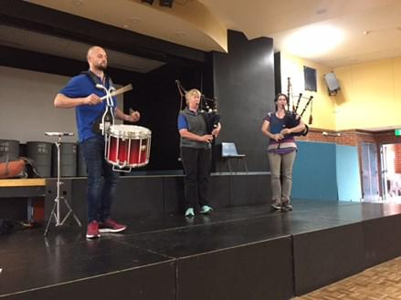

Thank you to the Canberra College of Piping and Drumming for visiting our school last Friday. Students and staff were in
awe of amazing performance demonstrated by Steven, Alaine and Kerrie.
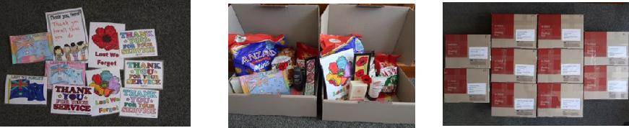

Defence Club - Anzac Day Care Packages Thanks to all the defence students and friends for providing beautiful art work and

assisting in packing 10 Anzac Day Care packages. These have been posted off this week to Soldiers, Sailors, Aircrewman (male and female) who are deployed and serving away from home this Anzac Day. Thank you to our serving ADF members.

Anzac Assembly
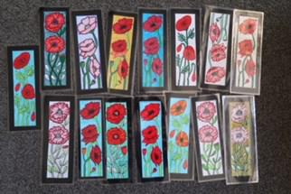

Reminder our whole school Anzac Assembly will be on held Friday 4 May at 9:00am, this is the first Friday in Term 2.

Together, we learn from each other

Palmerston Post Page 4

PARKING AROUND SCHOOL

A number of people within our community have identified that a Licence Plate Recognition (LPR) vehicle has recently been patrolling the streets around Palmerston District Primary School. This has led to a number of parents receiving infringement notices.

The ACT Government has provided advice that anyone wishing to contest their infringement notice should do so through the normal process. More information is available on the Access Canberra website. This needs to be done by each individual as the circumstances will be reviewed on a case by case basis.

The school requested a visit from the Transport Canberra and City Services’ (TCCS) Schools Program last week to review and discuss parking around the school. Following this visit, a number of options are being considered to see what can be done to support travel to and from the school.

The ACT Government would like to reiterate that parking along verges is dangerous, especially for children. Children should not be required to avoid cars on the verge when trying to cross the road. It also reduces the line of sight for cars travelling along the road, significantly increasing the risk of a child being struck if they step out from behind an illegally parked car.

If you have any questions, please contact Andrew Crichton from TCCS directly. You may contact Andrew via his email Andrew.Crichton@act.gov.au. Andrew has also provided us with a survey that parents are able to complete. The link for the survey is: http://www.surveygizmo.com/s3/4172965/ School-Crossing-Supervisor-Survey-Control.

The Education Directorate (EDU) is in the process of expanding the Palmerston District Primary School car park by 18 spaces (17 standard spaces and 1 Accessibility space). The design has been finalised and construction is expected to start in May 2018. This will bring the total number of spaces at the school to 100 (including all types of spaces onsite).

If you have any suggestions to assist us with the car park area we will have a suggestion box located at the front office for you to place your suggestion. Additionally, we are investigating with ACTION the possibility of a bus route between Crace and Palmerston. If you would like to support this initiative there will be an expression of interest form at the front office where you can put your name and address to allow the bus company to gauge how many families feel strongly about this. This could create an opportunity for a new bus route.
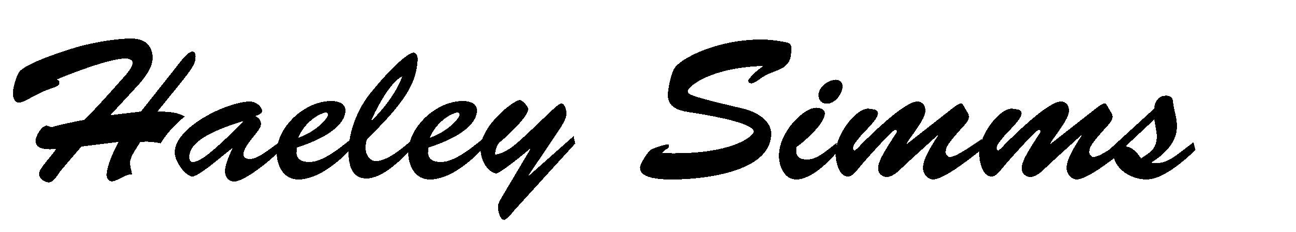

Together, we learn from each other

Palmerston Post Page 5
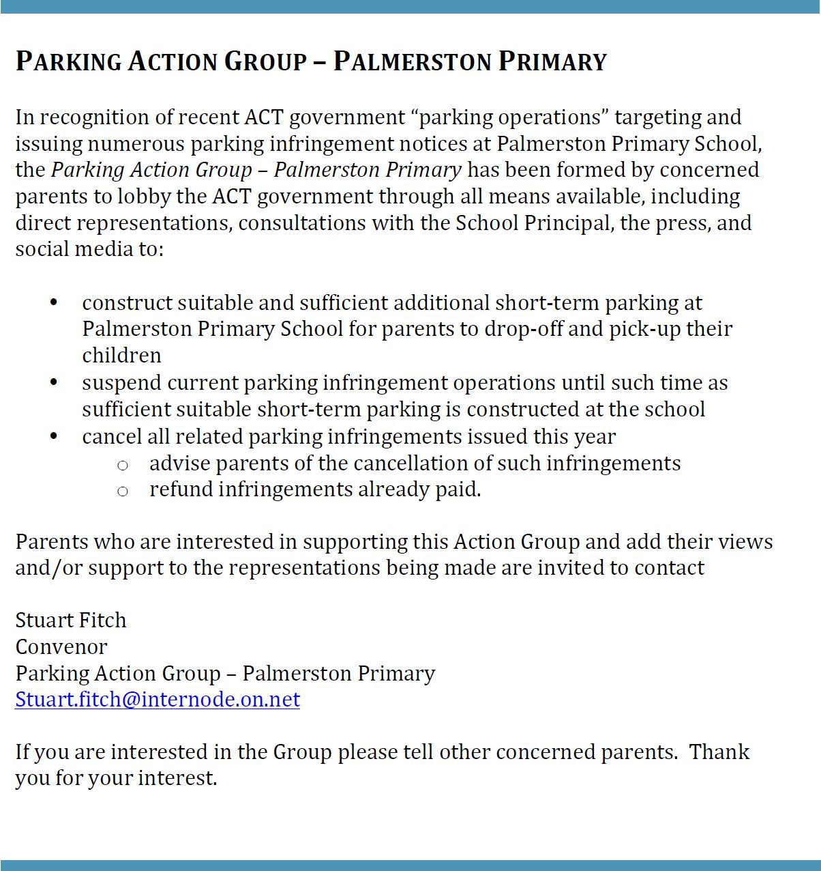

Survey: School travel and safety

Transport Canberra and City Services has engaged First Person Consulting to conduct research into parent's attitudes to their children's active travel to and from schools. Part of this process will investigate the role that School Crossing Supervisors have in improving safety around schools, and the extent to which parent attitudes to children travelling actively change as a result.

To complete the survey please click here, or copy and paste the following link into your browser:

http://www.surveygizmo.com/s3/4172965/School-Crossing-Supervisor-Survey-Control.

The survey should take about five minutes. The survey will not collect any identifiable information, and all responses will be kept confidential.
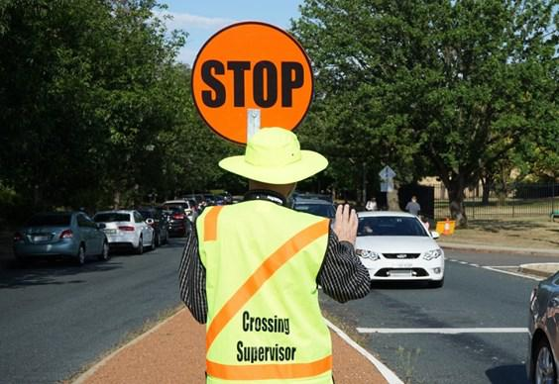

Thank you in advance for your time in completing this survey. If you have any questions please contact the TCCS Schools Program.

Together, we learn from each other

Palmerston Post Page 6

ICAS

ICAS entry forms will be sent home to all students in Year 2-6.

ICAS assessments have taken place annually in schools for over thirty years and in 20 countries. Educational Assessment Australia (EAA), who design and deliver the assessments, is the not-for-profit arm of the University of New South Wales. Palmerston is once again going to take part in ICAS. This is voluntary for families.

ICAS is an annual skills development assessment program and available in the areas of English, Mathematics, Science, Spelling and Writing. Unfortunately this year will are unable to offer Digital technologies. The tests take 30–60 minutes and are supervised at school. Certificates are awarded to all students who participate. If you register to participate and are sick on the sitting date you will participate in a catch up at a suitable time in the following weeks.

Results are available to parents and students online. These online reports and analyses remain available indefinitely. ICAS reports indicate which questions were answered correctly and compare student performance to that of the other students tested.

To enrol your child in ICAS, please complete the registration form and return it, with your entry fees, to school by Friday 13 April (Week 10).
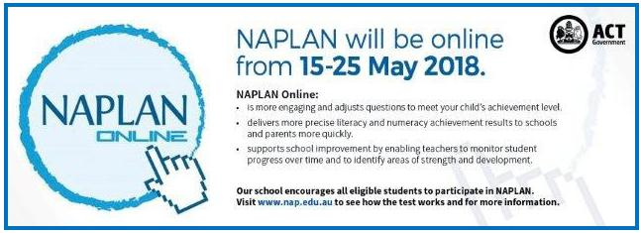

Together, we learn from each other

Palmerston Post Page 7
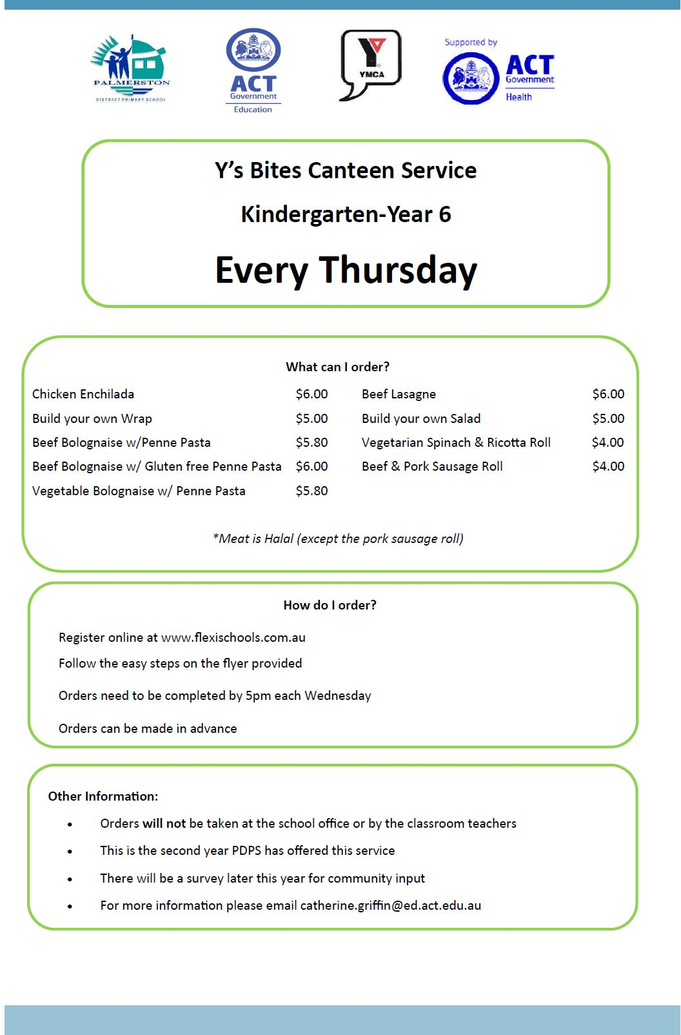

Together, we learn from each other

Palmerston Post Page 8

Together, we learn from each other

Palmerston Post Page 9

COMMUNITY NEWS

Fresh Tastes Your Little Experts

The Fresh Tastes team from ACT Health have developed a new series of short videos staring Canberra kids telling us how it is when it comes to healthy eating, packing lunchboxes, cooking food and growing fresh pro-duce.

We just love seeing how these little experts can teach us adults a thing or two. Click here to view the full suite of hilarious healthy habit forming tips.

Together, we learn from each other

