PALMERSTON POST

16 August 2018

Week 4, Term 3

Board Chair: Lisa Fior Board Members: Parent Reps: Jesse Dang and George Villaflor

Teacher Reps: Jessica Lago and Maxine Green

P&C President: Lisa Fior

Principal: Melissa Travers Deputy Principal: Kate Flynn

Executive Teachers: Kylie Moller, Jacqui Warden, Matt Gowen, Catherine Griffin (acting)

ASSEMBLY:

17 Aug | Science Week Activities
24 Aug | Senior - Yr6
DATES TO REMEMBER:
17 Aug | Science Week activities
21 Aug | Preschool Book Week Parade
21 Aug | Yr5/6 Personal Development
 | session
23 Aug | Book Week Parade &
 | activities (P/S - Yr6)
24 Aug | Yr5 Band Pair (at Palmerston)
28 Aug P/S Father’s Day Stay & Play
29 Aug | Yr3-6 Author Visit—Susan
 | Berran
30 Aug | Nth/Gungahlin Track & Field
31 Aug P/S Father’s Day Stay & Play
31 Aug | K-Yr6 Father’s Day Breakfast
 | & maths games & stall

NOTES HOME:

- Tournament of Minds

- Think U Know - Cyber Safety Parent Information Session

- P/S Father’s Day Stay & Play

- Yr5 Woodwind Band Pair - change of venue

P&C BOARD NEWS

P&C: 7:00pm 17 Sep 2018

All P&C activities, meeting agendas and minutes are available from the school website at – Parent Corner

School Board: 7:30am 6 Sep 2018

EXECUTIVE TEACHER’S MESSAGE

While on Library duty this week I asked students from various ages what exciting things they had been doing at school. The responses I got were very mixed and covered all aspects of the curriculum but a very large stand out concept was about getting along with others. Students told me that they particularly enjoyed PE and working together with games, others enjoyed having the opportunity of playing chess with friends at lunchtime in the library, while others enjoyed the peer support program that the year 5 & 6 students were running. The concept they have learnt in all of these activities is how to make and maintain friendships. While these skills are often overlooked as functions of a school, where learning to read and write is the priority, they are in actual fact, life skills of working with others, particularly working sometimes with others who you may not know very well or not agree with. These concepts are all part of the KidsMatter program that we run at Palmerston and are part of our Strategic Goals. It is particularly great that the students are recognising them as important concepts to learn. Students were entertained this week with a Band performance from students from Narangba Valley High from Queensland. Students were particularly fascinated by the variety of instruments including the string section with a double bass and an electric guitar. I believe some students even danced to the music at the end of the performance.

Over the last couple of weeks staff have been reflecting on the teaching of writing. In particular about the need for authentic writing, that is: a purpose and reason to write. Writing and the teaching of writing has greatly changed over time - previously it used to be broken up into spelling, grammar, punctuation and structure. I am of the era where grammar was not taught at all. Today we want to have our students have a love of writing, of expressing themselves in a variety of ways and for many purposes.

Together, we learn from each other

Palmerston Post

You might like to discuss with your child the different types of writing you do in your daily life; shopping lists, reports for work, emails for work or to friends, some of you might even write journals in your free time - if that exists as a parent!

In talking of writing - next week we celebrate some wonderful authors with Book Week so please remember to dress up for Book Week on Thursday the 23rd August. Also a reminder that the Science boards for the Science Fair can be collected from the front office each afternoon.

The Directorate’s policy for Excursion procedures and requirements have recently changed. The medical form will now be required to be filled in only once a year. On excursion notes in the future it will ask if there have been changes to your child’s medical status since filling in the initial form. A new medical and consent form will be coming out shortly. Please ensure your medical records are up to date with the front office.

There is also a new suspension policy and the Directorate is asking for parental feedback. Further details are below.

Suspension, Transfer or Exclusion of Students in ACT Public Schools Policy Review.

The ACT Education Directorate is seeking feedback from students, families, teachers, support staff and others about its review of the Suspension, Transfer or Exclusion of Students in ACT Public Schools Policy and related documents.

The revised policy aligns with current research and includes a greater focus on a prevention and early intervention approach to behaviour support to reduce the incidence of behaviours that potentially lead to suspension, exclusion and transfer.

All input will be considered and will help to ensure the revised policy documents are clear, current and relevant to meet the needs of schools and the community. Please refer to the Education Directorate’s website under “What’s New” for further information and links to participate in the consultation www.education.act.gov.au/home.

Education staff are available to explain the policy documents and record feedback from individuals who would prefer to provide this verbally. Individuals wishing to use this alternative should contact Colette Brown on 6207 0457 or etdstudentwellbeing@act.gov.au. Colette will arrange a time for verbal input to be provided either by phone or in a face-to-face meeting.

This week I would like to leave you with the following quote - “We know from human history and the latest learning science that success comes from the combination of academic knowledge and the

ability to work with others” Walter Isaacson Aspen Institute.

I hope you have a great week,

Felicity McNeice

Together, we learn from each other

Palmerston Post

THINK U KNOW PARENT INFORMATION SESSION

Save the Date!!

Our school will be hosting a ThinkUKnow presentation on 4 September at 5:30pm in the CAP Pod. ThinkUKnow is a cyber safety education program that educates parents, carers and teachers on how people are using technology, the challenges they may face online, and how to help them overcome these in a safe and ethical way. ThinkUknow is a partnership between the Australian Federal Police, Microsoft Australia, Datacom and the Commonwealth Bank. The presentation will be delivered by a local law enforcement member and an industry volunteer. It will cover issues relating to children and young peoples’ privacy and security online, their relationships with other users and their online reputation. It provides insight into the devices young people are using, as well as the popular websites, apps and social networking sites they’re accessing. The ThinkUKnow team will also be providing an education session for our year 5/6 students. This is a great opportunity for you to learn more about young people and the online environment. For more information you can visit www.thinkuknow.org.au or contact Haeley Simms via the front office.

SCHOOL SATISFACTION SURVEY

The School Satisfaction Survey have been emailed out to families. Although the survey is voluntary, we hope you will participate. It won’t take much of your time and will help us improve our school for your child and future students. Any difficulties with logging on or with the survey, please call the front office on 6142 1440.

The survey results will contribute to school research and improvement processes.

The key ACT results from the 2017 School Satisfaction Surveys have been published on the Education Directorate website (www.education.act.gov.au) and a summary of our school results is provided in our 2017 School Board Report.

PALMERSTON PRIDE AWARDS
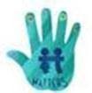

Congratulations to the following students who received a PRIDE Award at assembly on 10 August 2018.

PARTICIPATION – becoming involved, “having a go” and cooperating with others

Ojas - 2EG Thomas - 2MG

RESPECT – respect for self, others and their property
Joel - KFD | Eddie - KFD | Jamie - 1AE | Violet - 1HD | Aarefin - 1HD
INTEGRITY – being honest, fair, responsible and loyal
Naeva - 1HD | Htat Htat - 2EG
DETERMINATION - being persistent and resilient
Lucia - KFD | Jason - KGS | Skyla - KGS | Cadence - 1AE | Snehdeep - 1HD
Layla - 1HD | Olivia - 2EG | Nikola - 2MG | Dexter—2MG

Together, we learn from each other

Palmerston Post

YR5/6 PEER SUPPORT PROGRAM

On Thursday afternoons, the whole school participates in the Peer Support program for 30 minutes. Two peer leaders facilitate a small group of younger students who work together through a number of structured activities. This year, we are working on a module called Keeping Friends helping us explore the concept of friendship, building relationships and developing skills in empathy and critical thinking. This week, students will be exploring how to join groups and how to accept others into their friendship group. Our year 5/6 students are enjoying the opportunity to display and enhance their leadership qualities while supporting all students at Palmerston District Primary School.
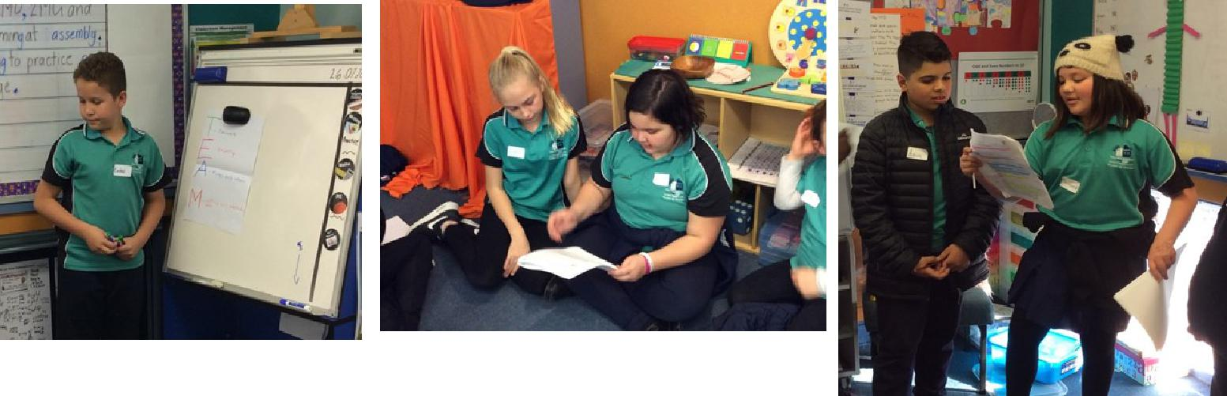

Market Day Preparation

This term, students in Year 5/6 have been using their mathematical skills and knowledge in real life situations to develop Market Day stalls. This year, Market Day will be held on Thursday 27 September 2018 (Week 10). All activities will be run by Year 5/6 students and the money raised will go towards the Year 6 graduation.

All students from across the school will be able to participate in games and purchase healthy treats and miscellaneous goods from stalls. The 5/6 students are in the early stages of planning and are excitedly preparing for Market Day and can’t wait to show the school community what they have planned for this year.

Together, we learn from each other

Palmerston Post

UPCOMING EVENTS

Preschool (Brave, Itchy & Noisy) Book Week Parade

Date: Tuesday 21 August

Location: Palmerston District Primary

Yr5/6 Puberty & Personal Development

Date: 9:15 am Tuesday 21 August

Location: Palmerston District Primary

Preschool (Cranky, Hungry & Sleepy) & K-Yr6 Book Week Parade Date: Thursday 23 August

Location: Palmerston District Primary

Yr 5 Woodwind Band Pair

Date: Friday 24 August

Location: Hall, Palmerston District Primary

Preschool (Brave, Itchy & Noisy) Father’s Day Stay & Play Date: Tuesday 28 August

Location: Palmerston District Primary

Yr3-6 Author Visit - Susan Berran

Date: Wednesday 29 August

Location: Palmerston District Primary

Preschool (Cranky, Hungry & Sleepy) Stay & Play

Date: Friday 31 August

Location: Palmerston District Primary

K-Yr6 Father’s Day Breakfast & Maths Games & Stall Date: Friday 31 August

Location: On the blacktop & in PoDs

Yr5/6 Think U Know Cyber Safety

Date: Monday 3 September 2018

Location: Palmerston District Primary

Think U Know Cyber Safety Parent Information Session Date: 5:30-7:00pm Tuesday 4 September 2018

Location: Multipurpose Building, Palmerston

Together, we learn from each other

Palmerston Post
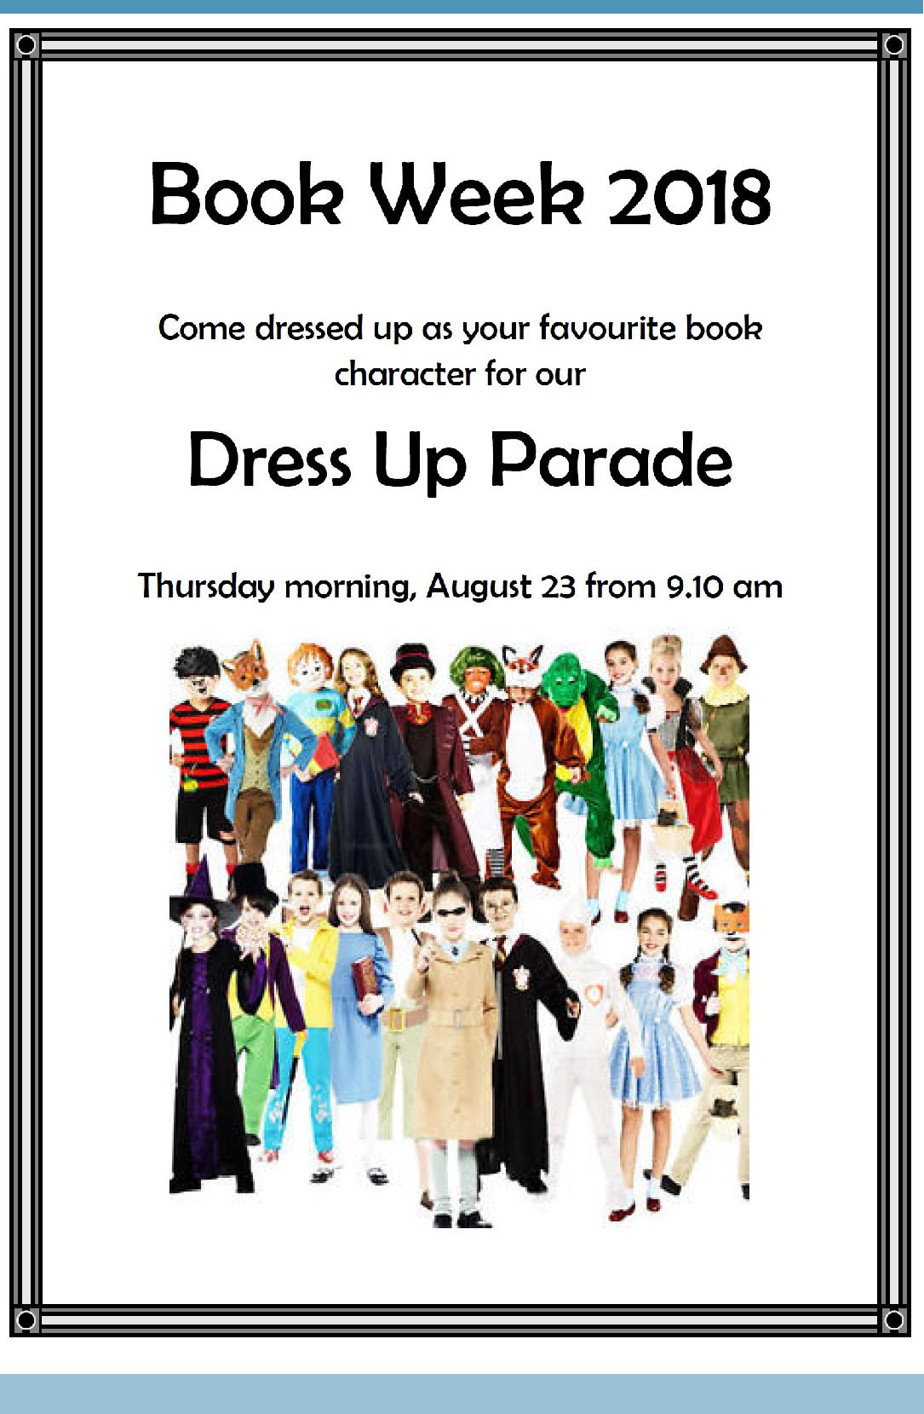

Together, we learn from each other

Palmerston Post

SCHOOL INTENTIONS 2019

School Leavers 2019

We have now reached the time in the year when we begin to look at our school numbers and staffing arrangements for 2019. If your circumstances have changed and your child/ren will not be attending Palmerston District Primary School in 2019 can you please let the front office staff know as soon as possible.

My child/ren will not be returning to Palmerston in 2019.

Name Class

Last day at Palmerston:

My child/ren will be attending:

Another government school in the ACT:

A non-government school in the ACT:

Moving out of the ACT

Forwarding Address:

Phone number:

Parent’s name:

Together, we learn from each other

Palmerston Post
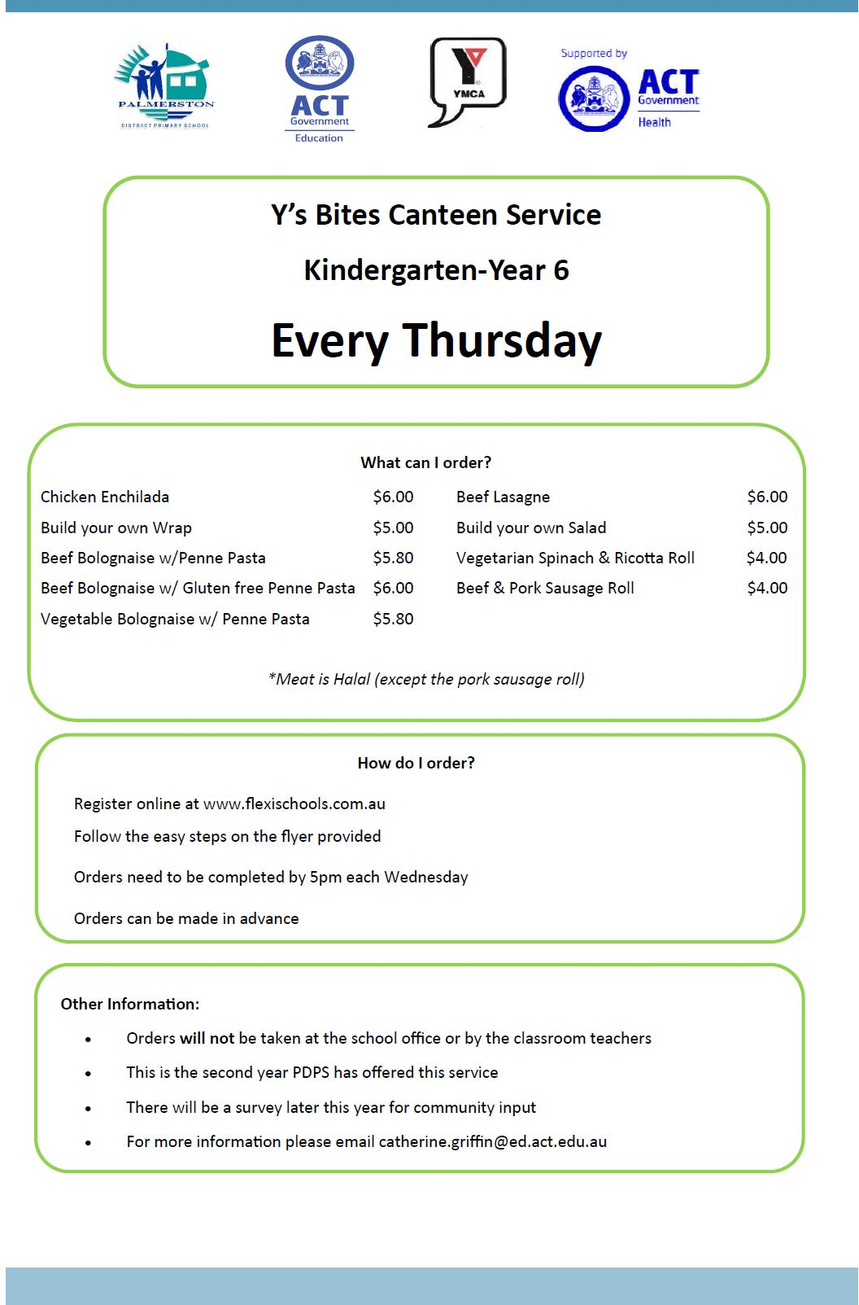

Together, we learn from each other

Palmerston Post
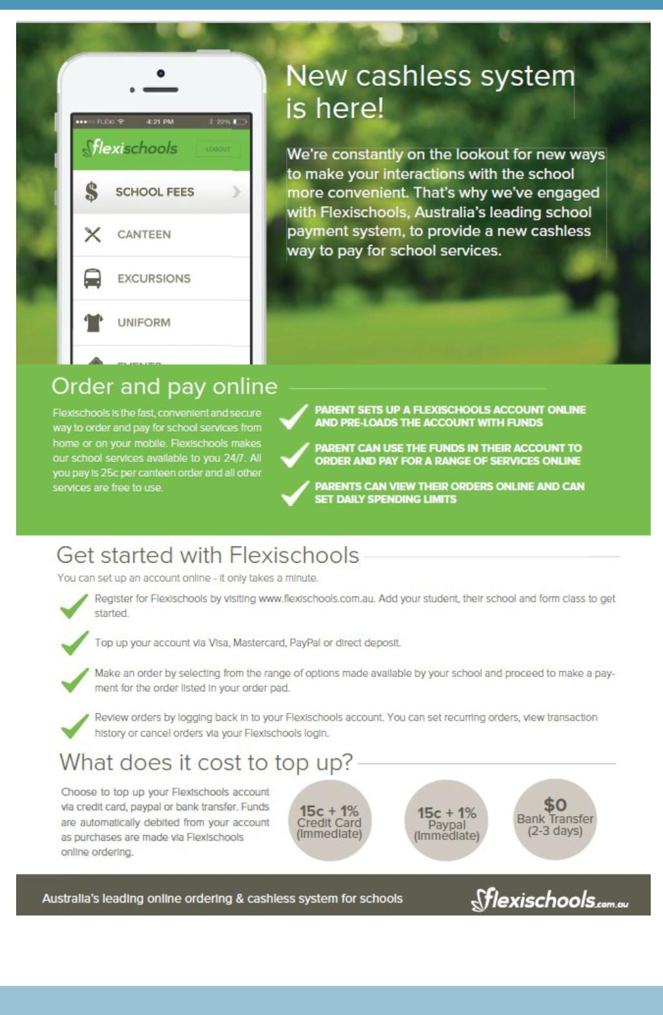

Together, we learn from each other

Palmerston Post
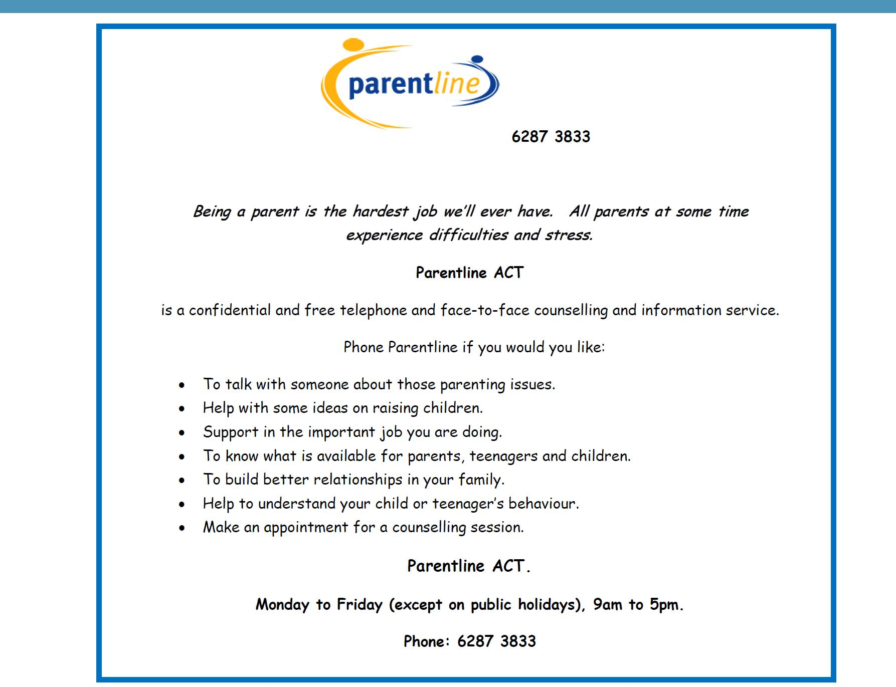

Together, we learn from each other

