PALMERSTON POST

30 August 2018

Week 6, Term 3

Board Chair: Lisa Fior Board Members: Parent Reps: Jesse Dang and George Villaflor

Teacher Reps: Jessica Lago and Maxine Green

P&C President: Lisa Fior

Principal: Melissa Travers Deputy Principal: Kate Flynn

Executive Teachers: Kylie Moller, Jacqui Warden, Matt Gowen, Catherine Griffin (acting)

ASSEMBLY:

31 Aug | Father’s Day Celebrations
7 Sep | Junior - 1HD & 1AE
DATES TO REMEMBER:
31 Aug | P/S Father’s Day Stay & Play
31 Aug | K-Yr6 Father’s Day Breakfast
 | & maths games & stall
3 Sep | Yr5/6 Think U Know - Cyber
 | Saftey (students)
4 Sep | Parent Information Session -
 | Cyber Safety
5 Sep | Christian Education
6 Sep | LSU DreamCricket Clinic
7 Sep | P&C School Disco
11 Sep | 5:30pm Parent Maths Info
 | Night
12 Sep | Yr5/6 Constable Kenny - Stay
 | OK for life
14 Sep | Mufti Day for Twilight Fair

NOTES HOME:

- Walkathon

- P&C Disco

- Digital Technologies Info Night

P&C BOARD NEWS

P&C: 7:00pm 17 Sep 2018

All P&C activities, meeting agendas and minutes are available from the school website at – Parent Corner

School Board: 7:30am 6 Sep 2018

EXECUTIVE TEACHER’S MESSAGE

With Term 3 well under way there have been a number of exciting events happening around Palmerston school. Last Friday, we hosted the Year 5 combined band practice. Our woodwind band combined with the Harrison School woodwind and brass bands to learn from each other and play in a larger band. The year 5 combined band performed a lovely concert to an enthusiastic audience of parents, teachers and students.

Tournament of the Minds

On the weekend we had 4 teams of students attend the annual Tournament of the Minds (ToMs) weekend at Campbell High. Our senior students performed with enthusiasm and represented Palmerston extremely well. Congratulations to Palmerston 4 who received a Spirit of ToMs award for perseverance and commitment to performing. Thank you to all parents and teachers who attended and supported our Palmerston students over the weekend.
Author visit - Susan Berran

Yesterday students from Yr3-6 participated in an author visit from successful children's illustrator and author Susan Berran. Her books are packed with plenty of fun, action and 'gross stuff' which she believes is the perfect formula for encouraging kids to love reading and writing. Her upbeat and interactive visit made her an extremely popular presenter with our students. If you would like to order some of her books, the link is attached to the newsletter email.

Father’s Day

Tomorrow we will be celebrating Father’s Day with the fathers and significant people in our community. You are invited to attend a breakfast from 8am, kindly donated by the P&C. You can then participate in playing maths games with your children, in their classroom from 8.30am. We will also be hosting a gift stall later in the day where students will be able to purchase a gift for $2.

Together, we learn from each other

Palmerston Post

School Satisfaction Survey

The 2018 School Satisfaction Survey has been taking place at Palmerston over the past 2 weeks. All students from years 5 and 6 complete the survey in class to allow the school to collect data, listen to student voice and plan future improvement processes. All parents have been emailed the Parent School Satisfaction Survey. Thank you for the 170 parent responses we have had so far. The survey closes on Tuesday 4 September. All responses are valued and contribute to the shaping of Palmerston School.

ThinkUKnow

Palmerston School will be hosting a ThinkUKnow presentation on Tuesday 4 September at 5:30pm in the CAP Pod. ThinkUKnow is a cyber safety program that educates parents, carers and teachers on how people are using technology, the challenges they may face online, and how to help them overcome these in a safe and ethical way. This is a great opportunity to learn more about the online platforms children are accessing and we welcome all families to join us for the informative presentation.
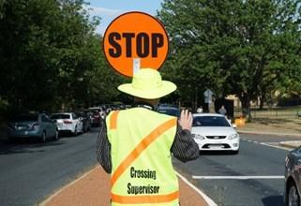
School travel and safety survey

Transport Canberra and City Services has engaged First Person Consulting to conduct research into parents’ attitudes to their children's active travel to and from schools. Part of this is investigating the role that Crossing Supervisors have in improving safety around schools, and the extent to which parent’s attitudes to children travelling actively change as a result. All schools in the ACT

have been asked to complete the survey whether or not they have an appointed crossing supervisor. To complete the survey please copy and paste the following link into your browser: http:// www.surveygizmo.com/s3/4535360/-School-Crossing-Supervisor-Survey-Control-Sept18

The survey should take about five minutes. The survey will not collect any identifiable information, and all responses will be kept confidential.

Thank you in advance for your time in completing this survey. If you have any questions please contact the TCCS Schools Program

PBL Voting

Positive Behaviour Learning Mascot voting will continue until Friday 7 September. If you would like to vote for your favourite, please follow the link: https://goo.gl/forms/dLm7Mm4jqqOeyKbh2
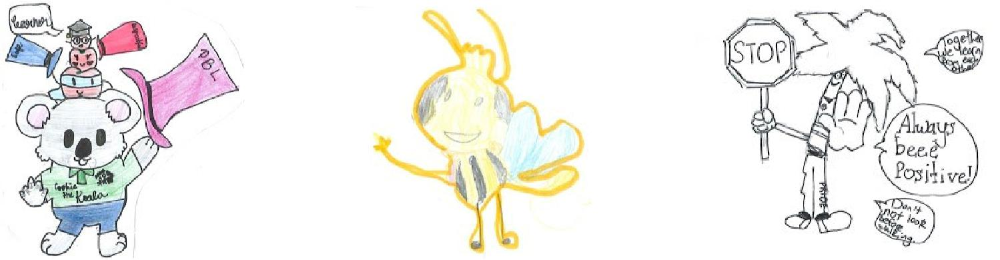

Cookie the Koala PBL Bee The Palmerston Tree

Enjoy your weekend,

Matt Gowen

Together, we learn from each other

Palmerston Post

BOOK CLUB

Issue 6 closes Friday Week 7 (7 September).

Please ensure all orders are placed in the Boomerang Box, in front office foyer.

Please check to ensure all orders placed in the box include the following:

Child’s Name, a contact phone number, correct money, and the books that are required are indicated on the order form.

The books can take up to 2 weeks to be received and delivered out to classes after the deadline.

Thanks,

Edwina

WORKING WITH VULNERABLE PEOPLE CARD

Just a reminder, to families, we support the ACT Government Policy in safeguarding our students by complying with the Working with Vulnerable People (WWVP process). We ask our parents/carers who volunteer regularly in our school to apply for the WWVP card.

The WWVP Act requires those who work or volunteer with vulnerable people to have a background check and be registered. The process is very simple to apply for a WWVP registration card follow these three easy steps.

- Complete a WWVP application for registration (online)

- Attend an Access Canberra Service Centre located at Belconnen, Gungahlin, Tuggeranong or Woden to provide proof of your identity and have your photo taken.

- Receive your WWVP registration card by post after access Canberra has assessed your

application.

When you have your card, drop into the front office show us and we will keep a photocopy of it.

Together, we learn from each other

Palmerston Post

UPCOMING EVENTS

Preschool (Cranky, Hungry & Sleepy) Father’s Day - Stay & Play

Date: Friday 31 August

Location: Palmerston Preschool

K-Yr6 Father’s Day Breakfast & Maths Games & Stall

Date: Friday 31 August

Location: On the blacktop & in PoDs

Yr5/6 Think U Know Cyber Safety

Date: Monday 3 September 2018

Location: Palmerston District Primary

Think U Know Cyber Safety Parent Information Session

Date: 5:30-7:00pm Tuesday 4 September 2018

Location: Multipurpose Building (CAP PoD), Palmerston Primary

Christian Education

Date: Wednesday 5 September 2018

Location: Hall, Palmerston Primary

Our teaching theme for 2018 is HORRIBLE HISTORY - FANTASTIC FUTURE. We will learn about four people from Old Testament Bible history who had a ‘horrible’ time… but who God used to be heroes and leaders. We are teaching the song ‘God’s Good All The Time’ by Colin Buchanan.

Term 3 will introduce the character of Daniel (in ancient Babylon) and trace his history to Jesus.

LSU DreamCricket

Date: Thursday 6 September 2018

Location: Palmerston District Primary

P&C “80’s/Neon” Disco

Date: Junior - 6:00-7:15pm, Senior - 7:30-9:00pm

Friday 7 September 2018

Location: Palmerston District Primary

Parent Maths Information Night

Date: 5:30pm Tuesday 11 September 2018

Location: Library, Palmerston
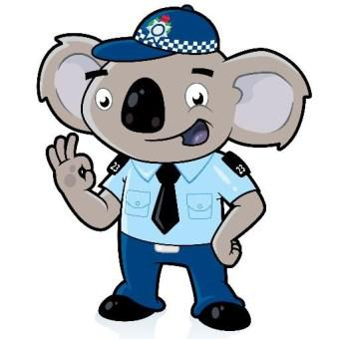

Yr5/6 Constable Kenny - Stay OK for Life

Date: Wednesday 12 September 2018

Location: Palmerston District Primary

Together, we learn from each other

Palmerston Post

PALMERSTON PRIDE AWARDS
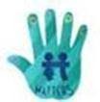

Congratulations to the following students who received a PRIDE Award at assembly on 24 August 2018.

PARTICIPATION – becoming involved, “having a go” and cooperating with others

Logan - 3RC Maddox - 5IH Cindy - 5DT Angus - 6AJ

RESPECT – having respect for self, others and their property

Trinity - 3/4JL Laura - 6AJ

INTEGRITY – being honest, fair, responsible and loyal Ninissa - 6AJ

DETERMINATION - being persistent and resilient

Aayan - 3RC Johanna - 4/5CC Molly - 4/5CC Sophie - 3/4JL

Cohen - 5IH Tyler - 5DT Kai - 6AJ Julien - 6AJ

WRITING AWARDS

Sonia - 5DT Arvand - 5DT
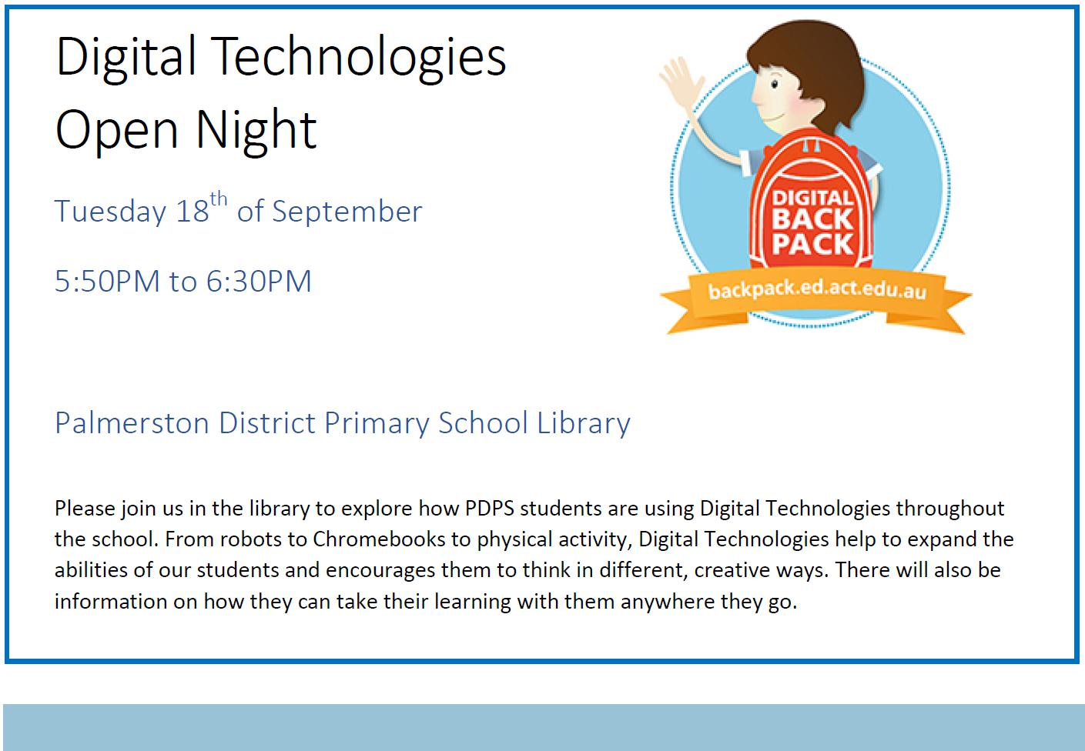

Together, we learn from each other

Palmerston Post
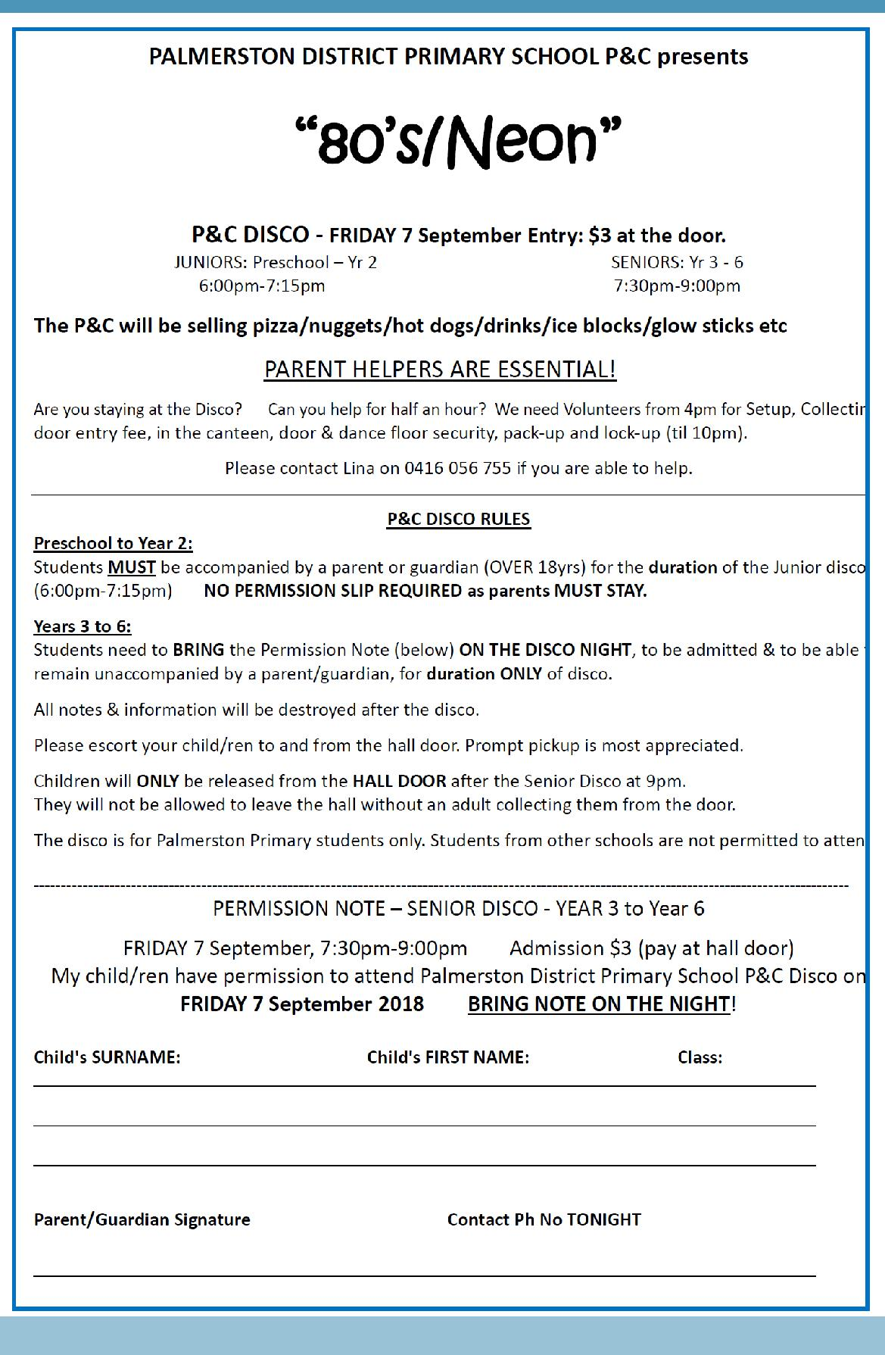

Together, we learn from each other

Palmerston Post
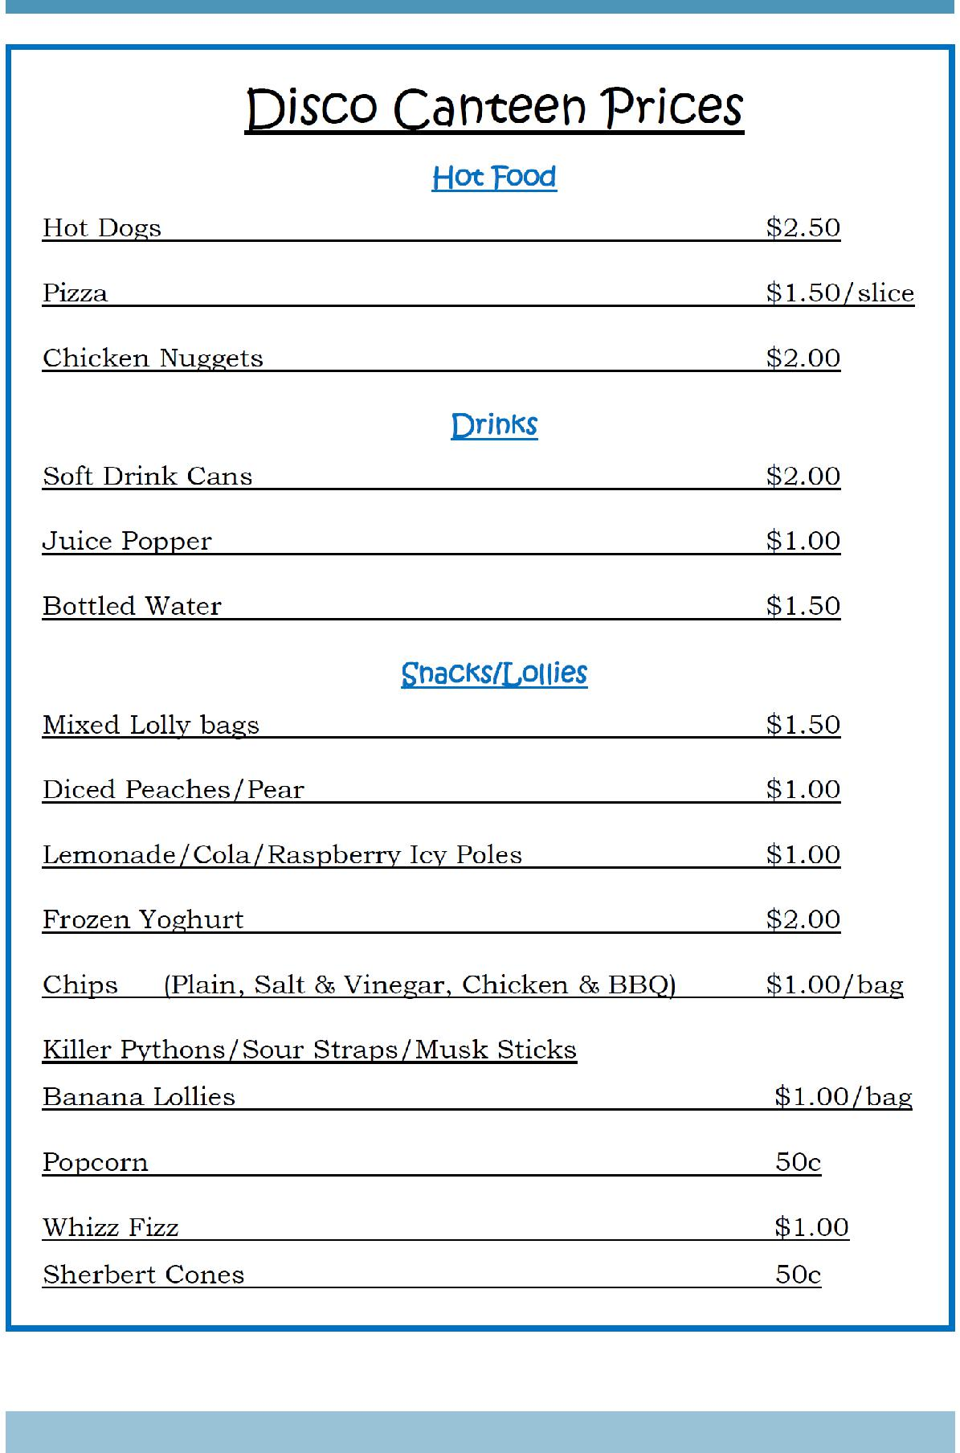

Together, we learn from each other

Palmerston Post

SCHOOL INTENTIONS 2019

School Leavers 2019

We have now reached the time in the year when we begin to look at our school numbers and staffing arrangements for 2019. If your circumstances have changed and your child/ren will not be attending Palmerston District Primary School in 2019 can you please let the front office staff know as soon as possible.

My child/ren will not be returning to Palmerston in 2019.

Name Class

Last day at Palmerston:

My child/ren will be attending:

Another government school in the ACT:

A non-government school in the ACT:

Moving out of the ACT

Forwarding Address:

Phone number:

Parent’s name:

Together, we learn from each other

Palmerston Post
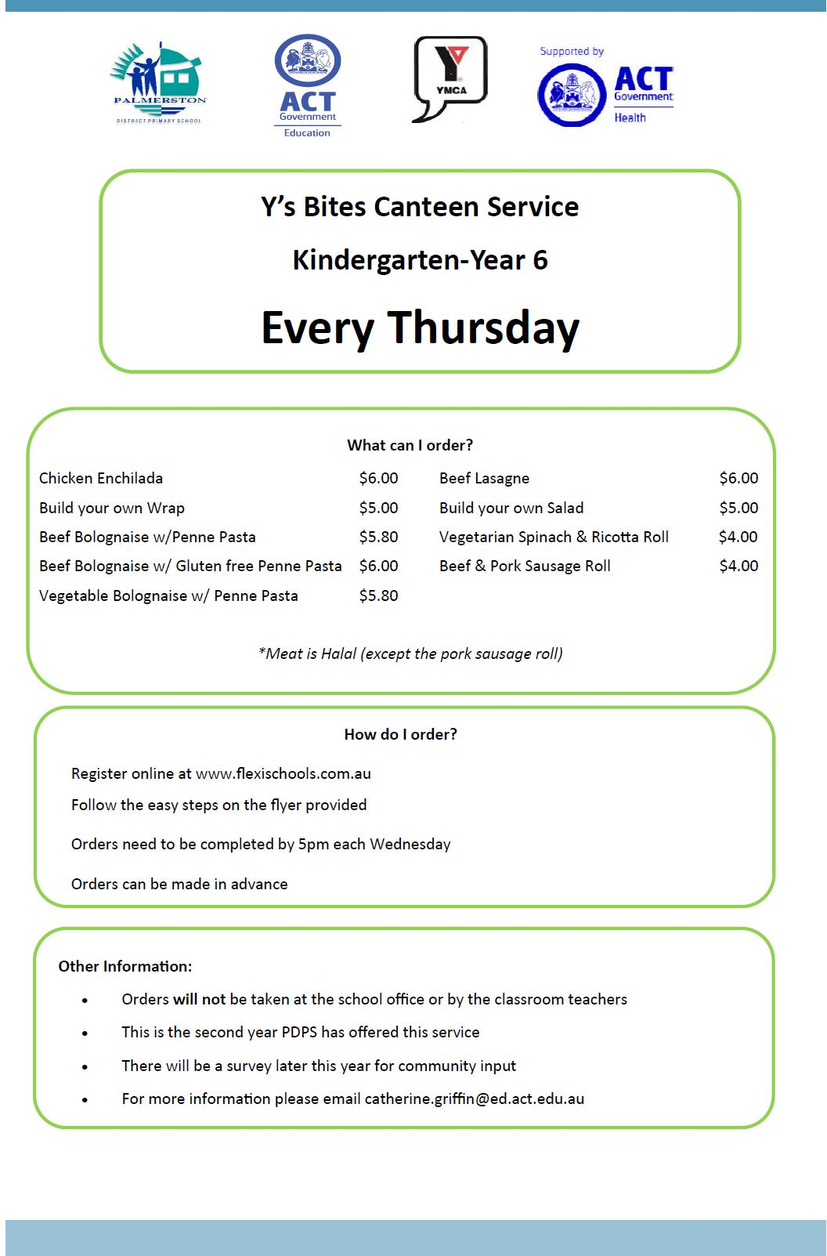

Together, we learn from each other

Palmerston Post
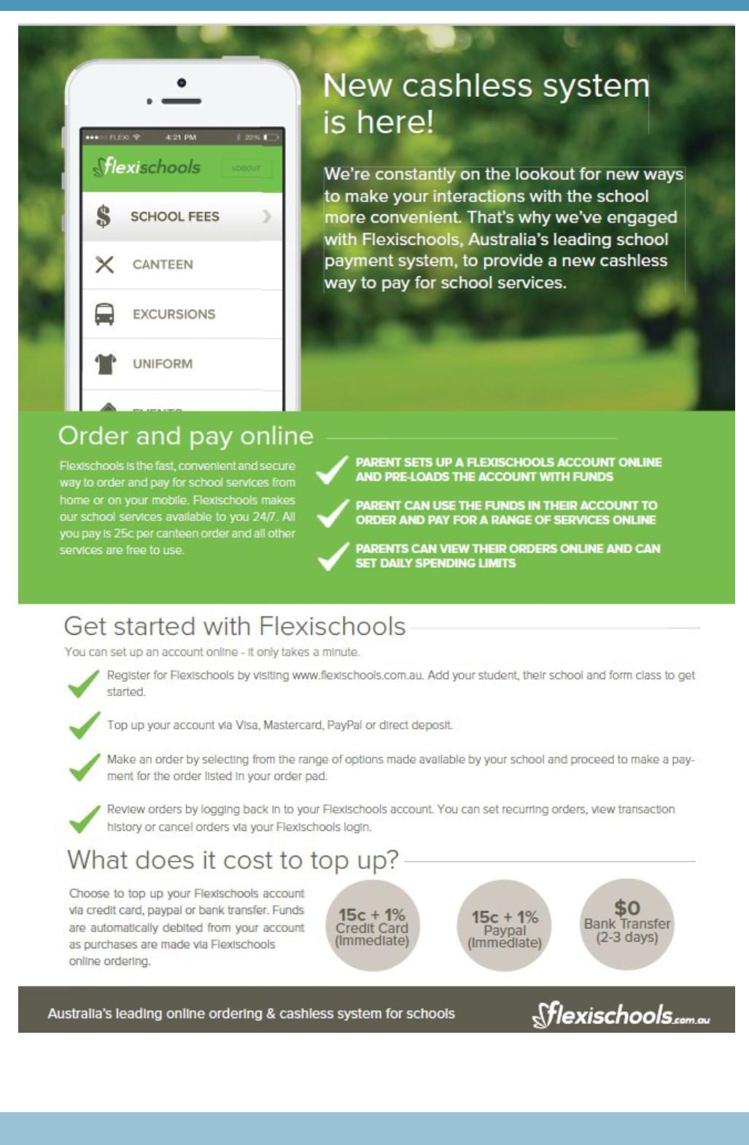

Together, we learn from each other

Palmerston Post
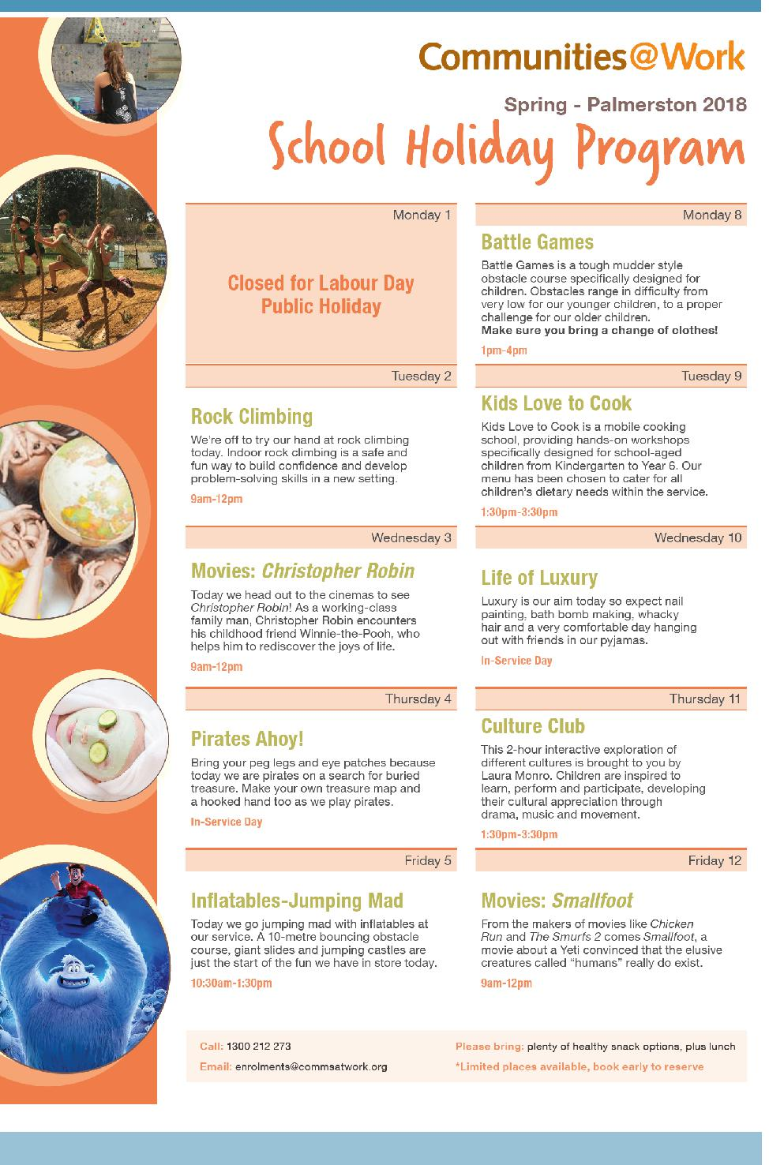

Together, we learn from each other

Palmerston Post
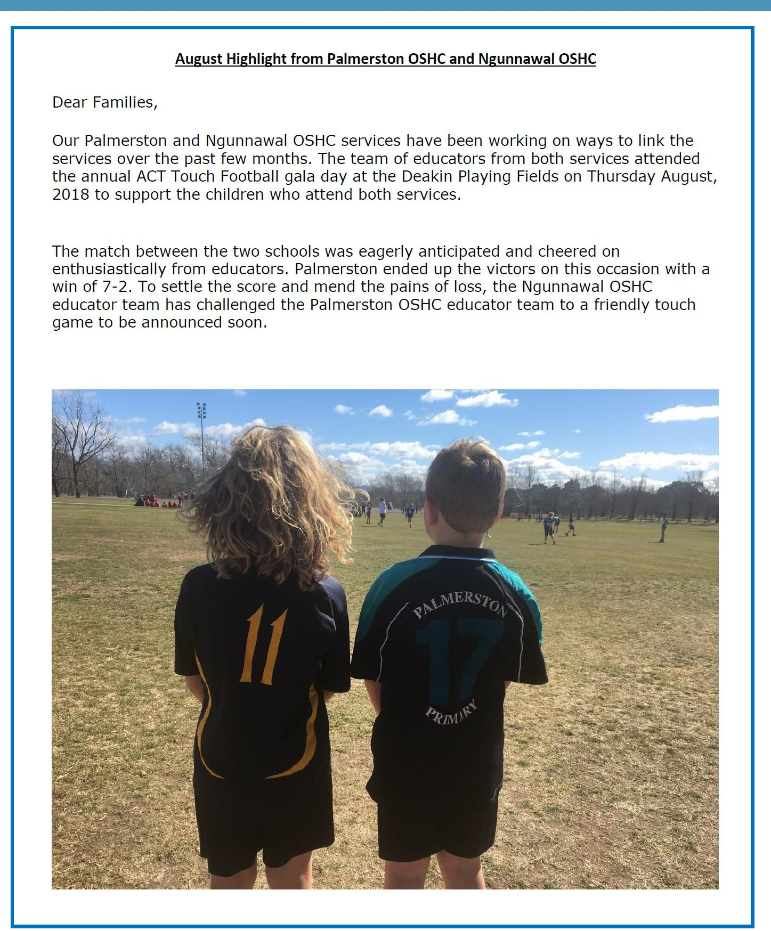

Together, we learn from each other

Palmerston Post
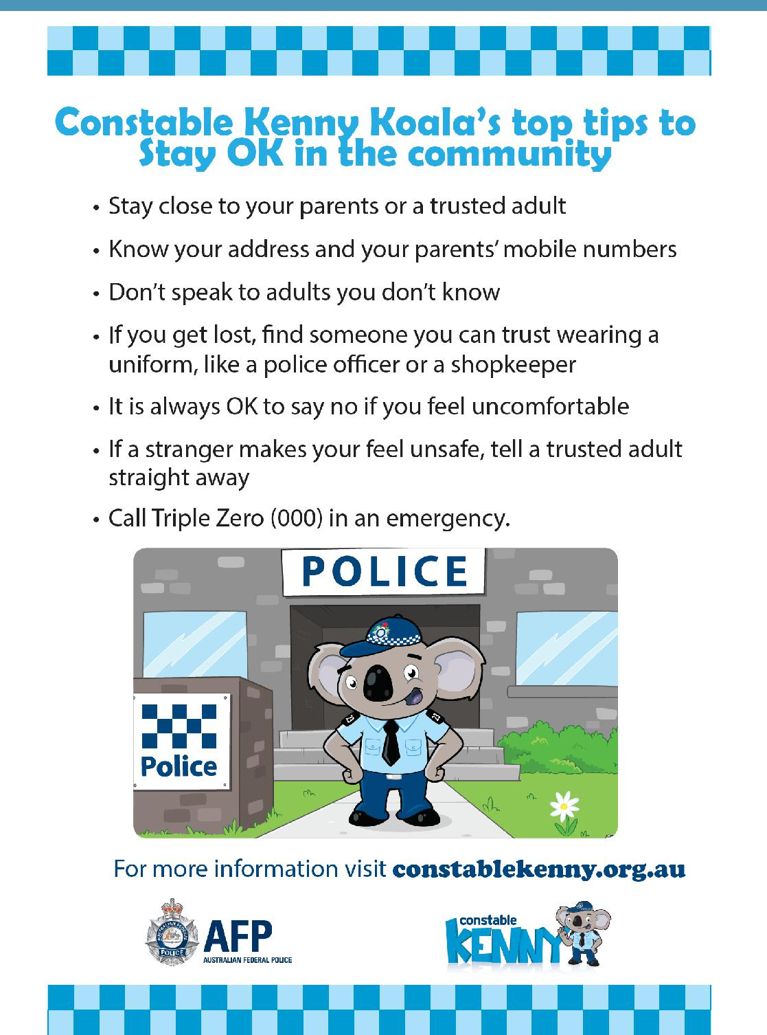

Together, we learn from each other

