What’s On
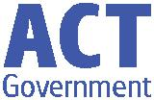

20 September 2018

Week 9, Term 3

ASSEMBLY:

21 Sep Learning Journey - no assembly

28 Sep Senior - Yr4

DATES TO REMEMBER:

21 | Sep | Science Fair
21 | Sep | Learning Journey
21 | Sep | Walk-a-thon
25 Sep |  | P/S Movie Dress up
 |  | day
27 Sep |  | Market Day
27 Sep |  | P/S Movie Dress up
 |  | day
28 Sep |  | P/S, K & IEC -
 |  | Canberra Theatre
 |  | excursion
29 | Sep - 14 Oct School
 |  | Holidays
15 Oct |  | Term 4

NOTES HOME:

- P/S (beginning) & IEC Theatre excursion - The Gruffalo

- Yr6 Band Stravaganza

- Yr3 & Yr 5 NAPLAN results

P&C BOARD NEWS P&C: 7:00pm 29 Oct 2018

All P&C activities, meeting agendas and minutes are available from the school website at – Parent Corner

School Board: 7:30am 29 Oct 2018

PRINCIPAL’S MESSAGE

The weather is now truly spring. With the warmer weather comes lost property! This is the time of the year to check if you have all your children’s jumpers. The lost property is overflowing. We do hand out named jumpers, but each term, we still have an overflowing lost property drawer.

2019 Book Packs

The teachers have created a bookpack list for 2019 classes. These list will come out to you next term. We have worked with teachers to ensure we only ask for minimal supplies to be contributed by families. We have reduced the consumables allowance. Remember, the bookpack list is optional, but we encourage you to purchase the supplies on the list to ensure consistency of supplies in the classroom and quality of the pencils and textas. The library trust is a voluntary contribution and is tax deductable. Thank you for your support.

Positive Behaviour for Learning- PBL

Palmerston school now has PBL up and running with a great response. (PBL is Positive Behaviour for Learning). Each fortnight we have a focus on catching the children being positive, playing safely and playing well together. This last fortnight was on playing safely on the equipment and being kind to each other. A reward for the winning house group will be decided upon later this week. Then on Friday we will announce our next two week focus.

Teacher Awards

Fabulous teachers are well worth recognising and you can nominate a great teacher for a Commonwealth Bank Teaching Award until September 27. A number of outstanding teachers and school leaders across Australia will receive a $45,000 Teaching Fellowship including support for professional development and a $30,000 school project to improve student outcomes. https://www.teachingawards.com.au

Our New Speakers

Our new speakers have been installed around the school. We have upgraded the speakers on the blacktop, installed speakers under the basketball court and have loud speakers that can reach across the oval. We will use them all for the first time at the walk-a-thon and we are ready for amazing announcements and music at out Twilight Fair. Thanks to the P&C for the donation of money that enabled this initiative.

Together, we learn from each other

What’s On

Play Equipment

Just a reminder about the use of play equipment outside of school hours! As a PBL school we have set up good use of play equipment around the school with teachers explicitly teaching how to use the equipment. Staff have made a video to show the children and we give raffle tickets out to positively reinforce the correct use of the equipment. We ask you that if you use our equipment after school, that you follow our in-school guidelines. Ask your children. This ensures that the children are not confused about safe play.

We ask that there is no play on the preschool equipment after hours, but please feel free to have your child play on the school equipment after school hours under your supervision. After School Care use the senior play equipment between 3 and 6 pm, so please be mindful that that area is for them during those hours. Our junior play equipment is always free after hours and not used by school hirers.

NAPLAN

Year 3 and 5 students who participated in NAPLAN will have their reports sent home today. Please look in bags for the envelope.

Events

This Friday we have our Learning Journey, Walk-a-thon and Science Fair. Next week will be our Market Day. Enjoy.

Have a great end of term and enjoy the sunshine and warmer weather,

Melissa Travers
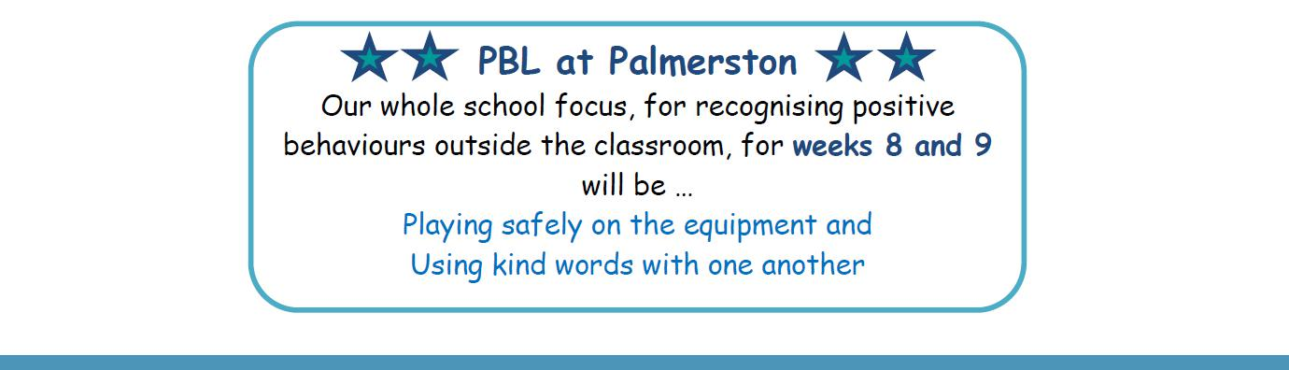

IMMUNISATION RECORDS

We are currently checking that all students in the school have an immunisation record or statutory

declaration explaining otherwise on file. If your child has recently had immunisations and the school doesn’t have a copy can you please provide the office with a copy. Shortly we will be sending letters home to those who haven’t provided us with an immunisation record or statutory declaration. Thank you for your assistance.

Together, we learn from each other

What’s On

RAIL READY POSTER COMPETITION

These are the winners for the Light Rail Poster Competition that the SRC ran to raise awareness around the light rail safety
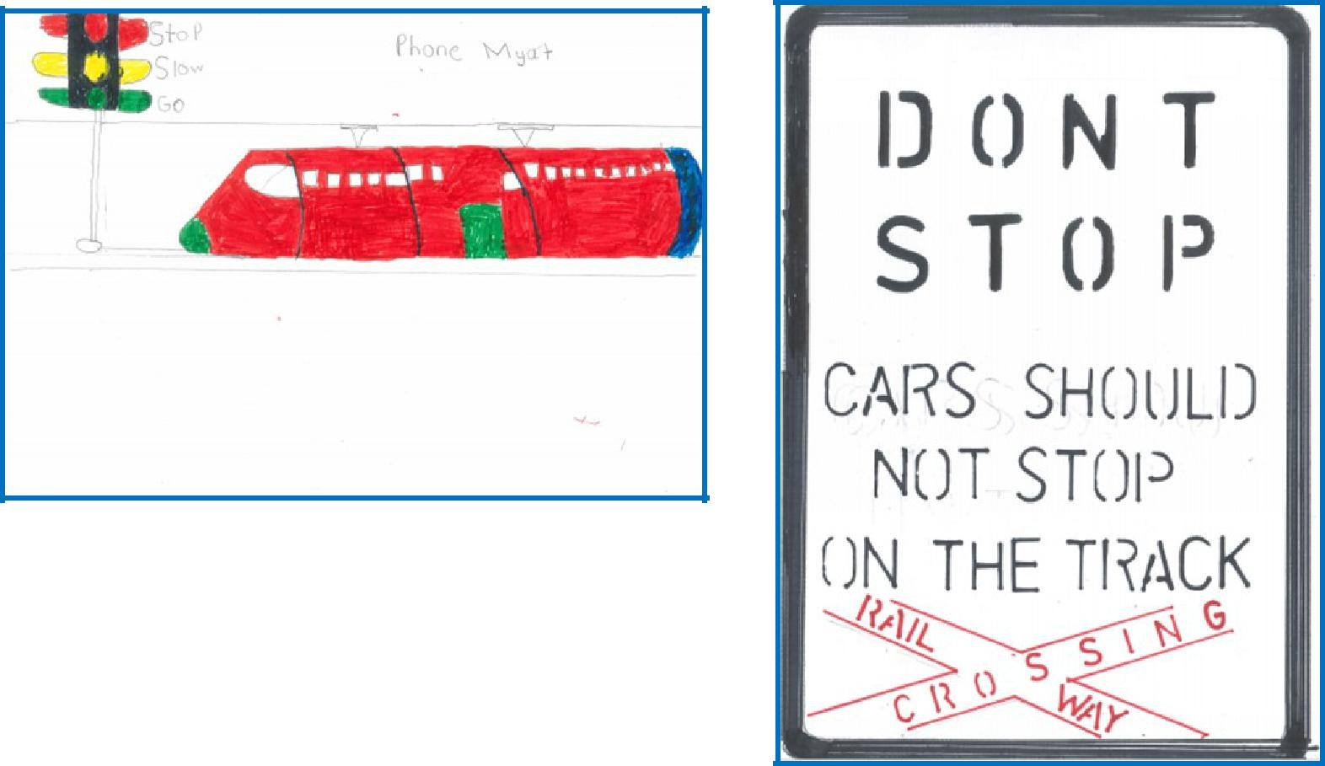

Zunair - 6KB

Phone - 1MC
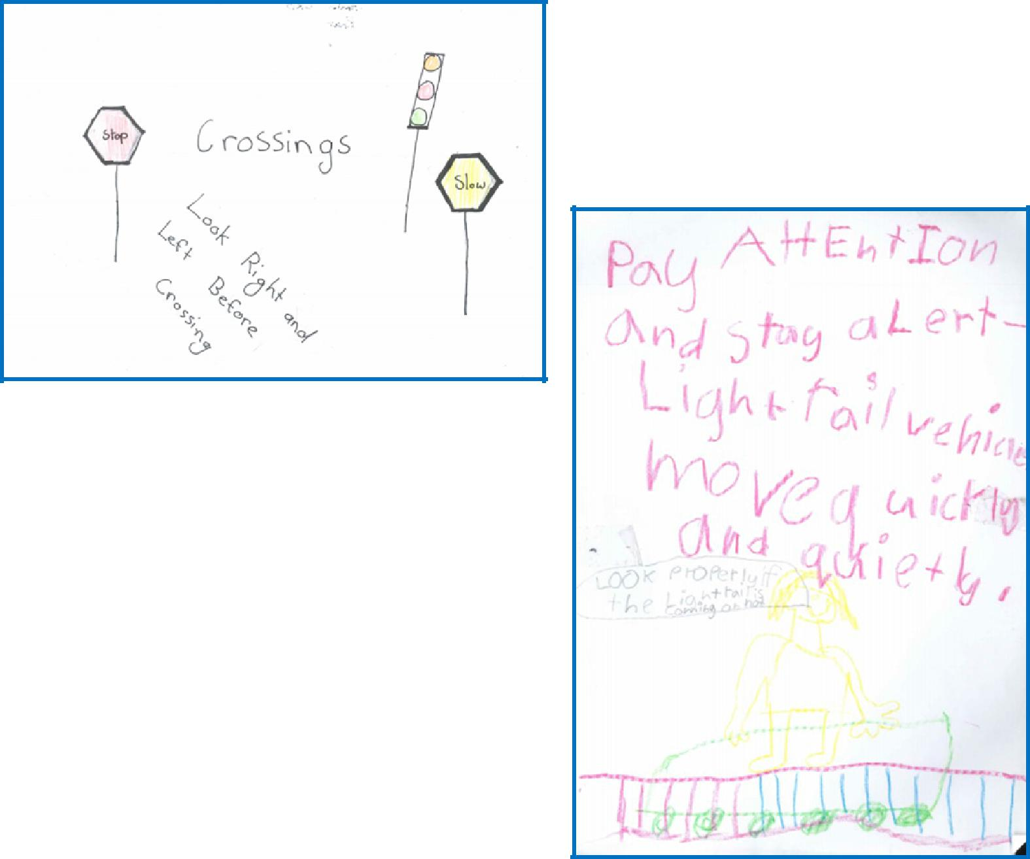

Amin - 6KB
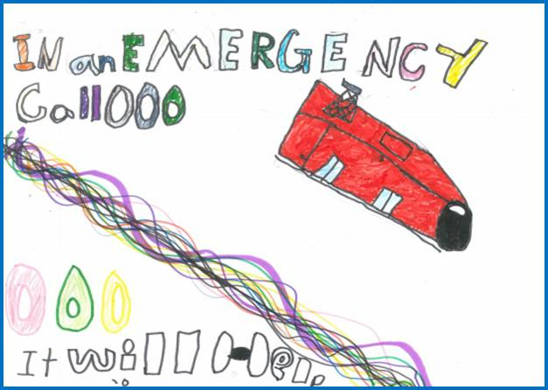

Maria-Pia - 4VS

Rehma - 1AE

Together, we learn from each other

What’s On
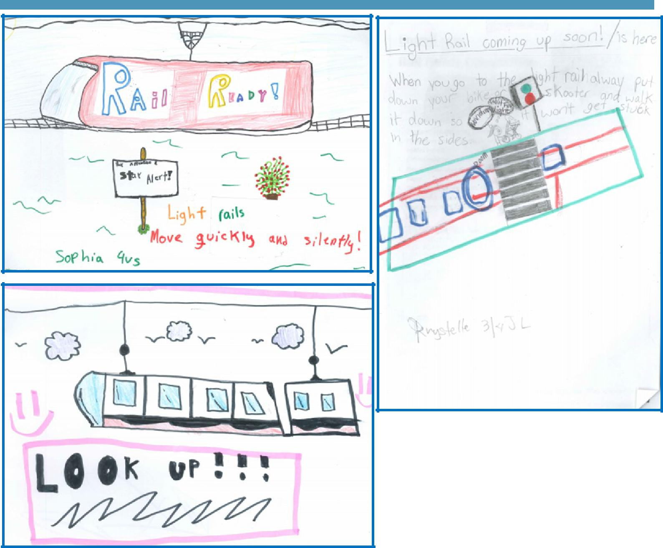

Alex - 4VS
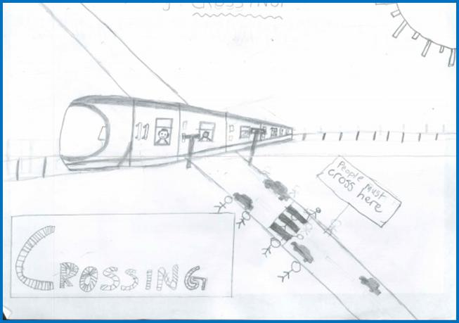

Hamza & Danny - 4VS

Krystelle—3/4JL
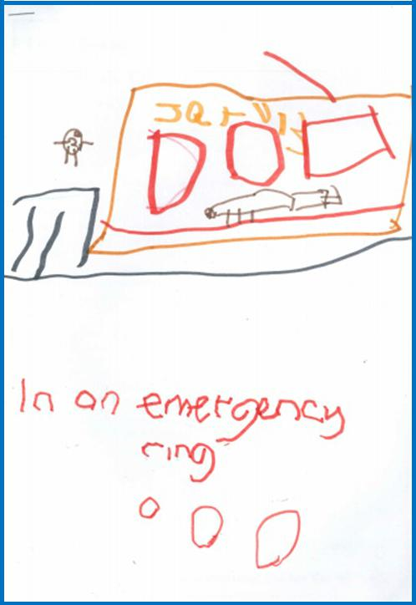

Jarvis - LSU

Together, we learn from each other

What’s On

Jayda - 4VS
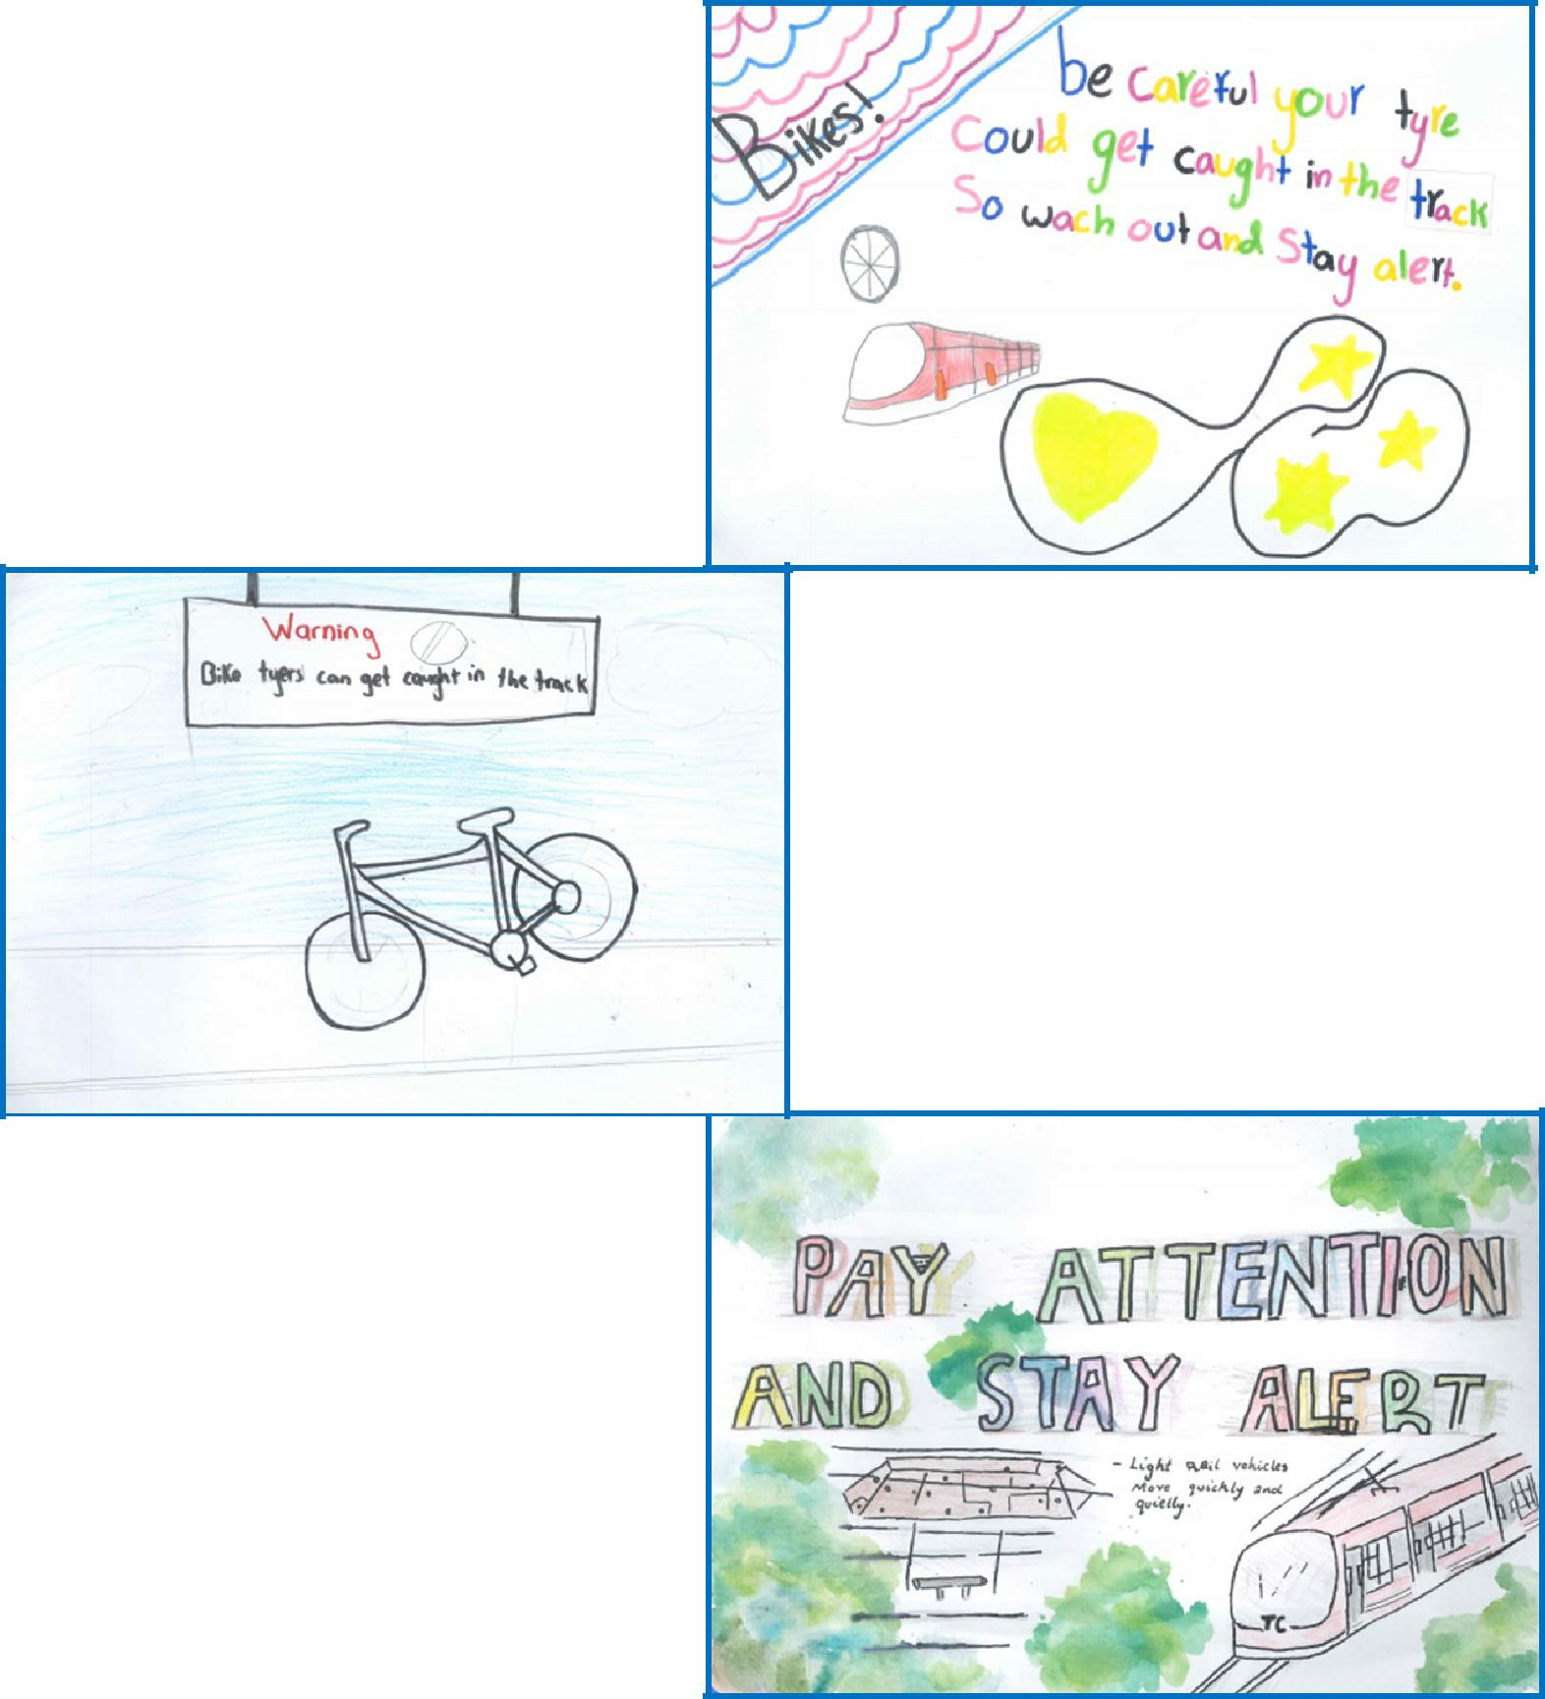

Charley - 4VS

Danny - 6KB

Cindy - 4VS

Together, we learn from each other

What’s On

UPCOMING EVENTS

Science Fair

Date: Thursday 20 & Friday 21 September 2018

Location: Library, Palmerston District Primary

Preschool (end) & K-Yr6 Learning Journey

Date: Friday 21 September 2018

Location: Palmerston Preschool

Walk-a-thon

Date: Friday 21 September 2018

Location: Palmerston District Primary

Preschool (beginning) Movie Dress Up Day

Date: Tuesday 25 September 2018

Location: Palmerston Preschool

Preschool (end) Movie Dress Up Day

Date: Thursday 27 September 2018

Location: Palmerston Preschool

Market Day

Date: Thursday 27 September 2018

Location: Black top, Palmerston District Primary

Preschool (end), Kindy & IEC - Canberra Theatre excursion ‘Josephine wants to dance’

Date: Friday 28 September 2018

Location: Canberra Theatre

Together, we learn from each other

What’s On

P&C NEWS

Together, we learn from each other

What’s On

Name of Recipe

_______________________________________________________________________________________________

Number of Serves: Preparation Time: Cooking

Time:

Difficulty (circle) : Kids Beginners OK for most Advanced

Category: Vegan Vegetarian Halal Gluten Free Dairy Free Other:

Culture (eg Asian, British, African):

Ingredients – 1 per box

Method:

Tips:

Together, we learn from each other

What’s On

SCHOOL INTENTIONS 2019

School Leavers 2019

We have now reached the time in the year when we begin to look at our school numbers and staffing arrangements for 2019. If your circumstances have changed and your child/ren will not be attending Palmerston District Primary School in 2019 can you please let the front office staff know as soon as possible.

My child/ren will not be returning to Palmerston in 2019.

Name Class

Last day at Palmerston:

My child/ren will be attending:

Another government school in the ACT:

A non-government school in the ACT:

Moving out of the ACT

Forwarding Address:

Phone number:

Parent’s name:

Together, we learn from each other

What’s On
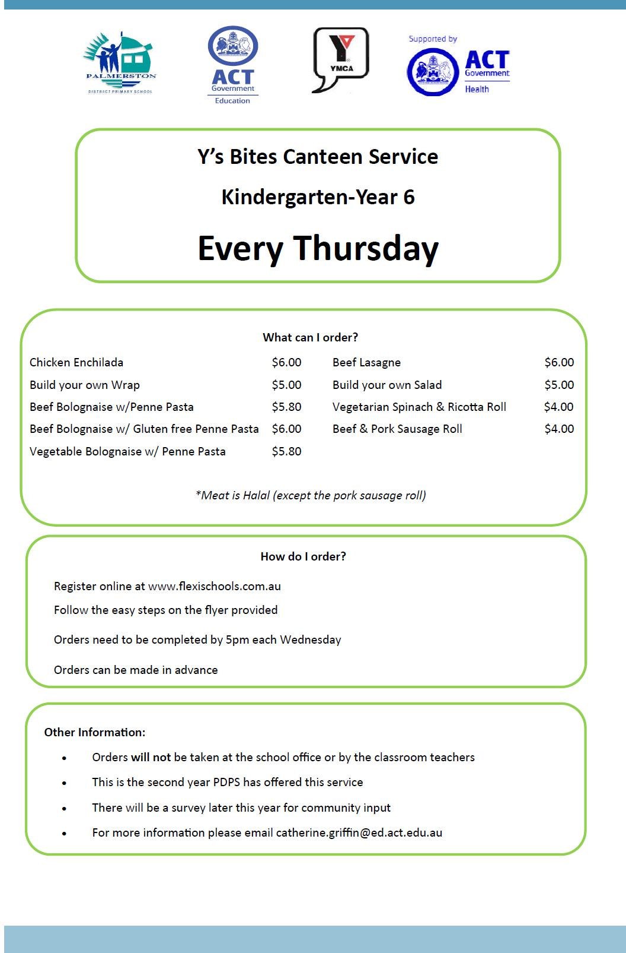

Together, we learn from each other

What’s On
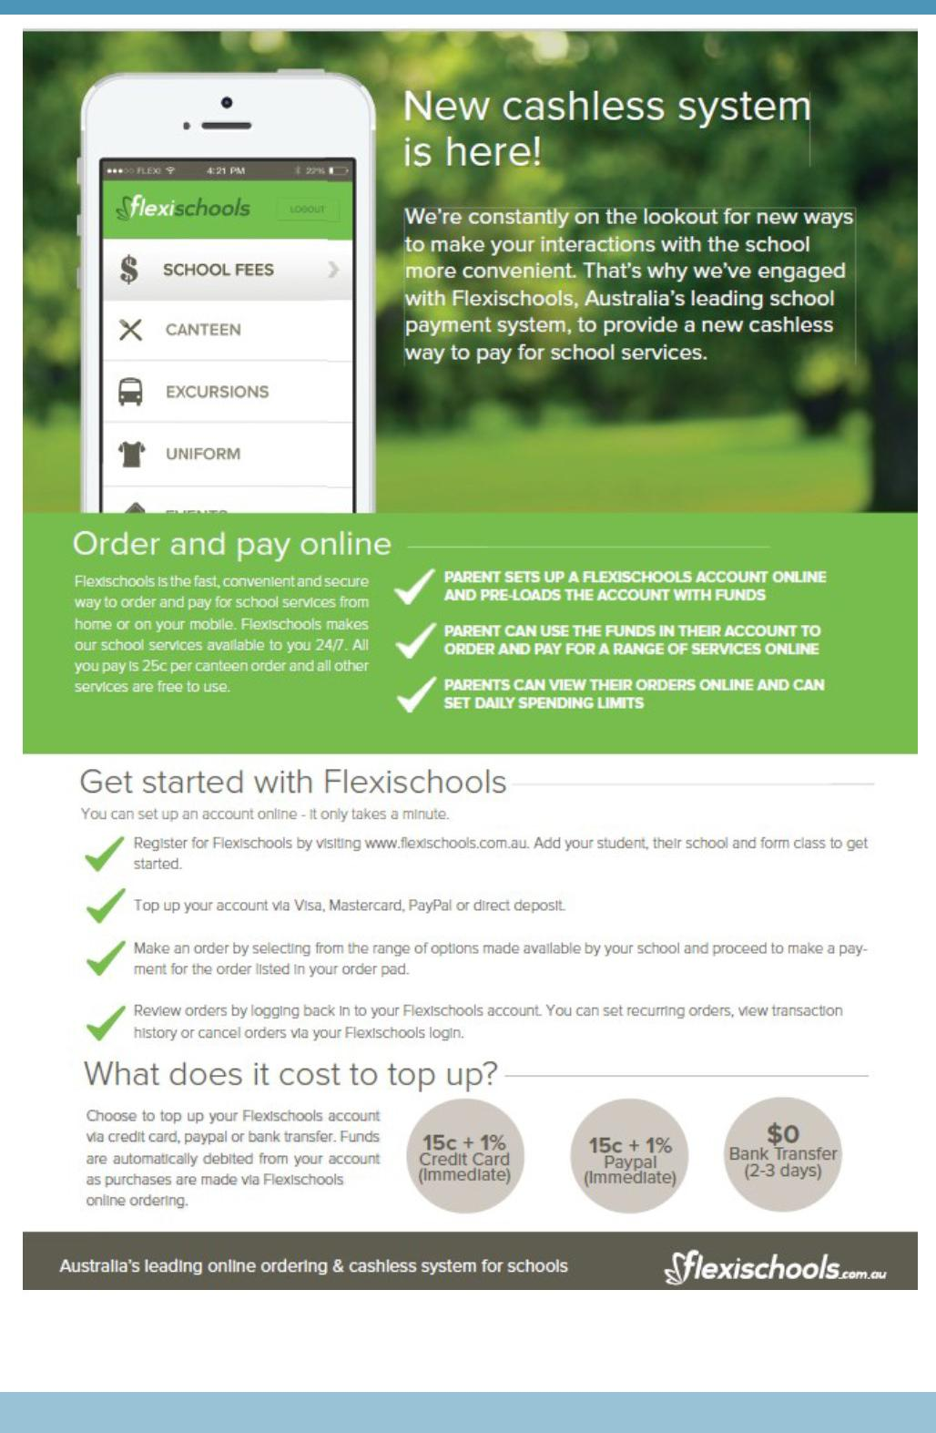

Together, we learn from each other

What’s On
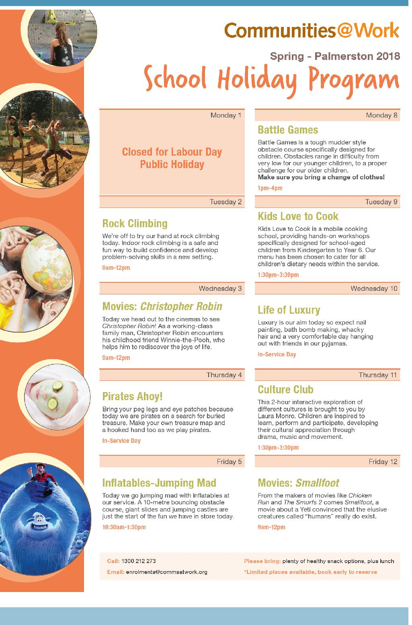

Together, we learn from each other

What’s On

INSTRUMENTAL MUSIC PROGRAM EXTENSION ENSEMBLES FOR 2019

Applications for auditions are now open

Current year 3 – 5 students are eligible to apply for -

Primary Concert Choir – Singers in years 4-6 in 2019 in ACT public schools

Current year 6 students who will be attending a public high school in 2018 are eligible to apply for auditions for the following IMP ensembles.

Junior Concert Band – Brass, woodwind and percussion players in years 7 & 8 in 2019 in ACT public schools

Percussion Ensemble – Percussion players in years 7 - 12 in 2019 in ACT public schools

Senior Concert Choir – Singers in years 7 – 12 in 2019 in ACT public schools

Website link - http://www.imp.act.edu.au/our_ensembles/auditions
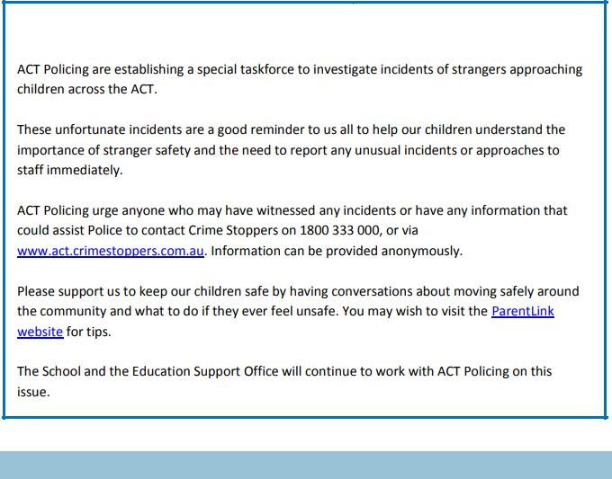

Together, we learn from each other

What’s On
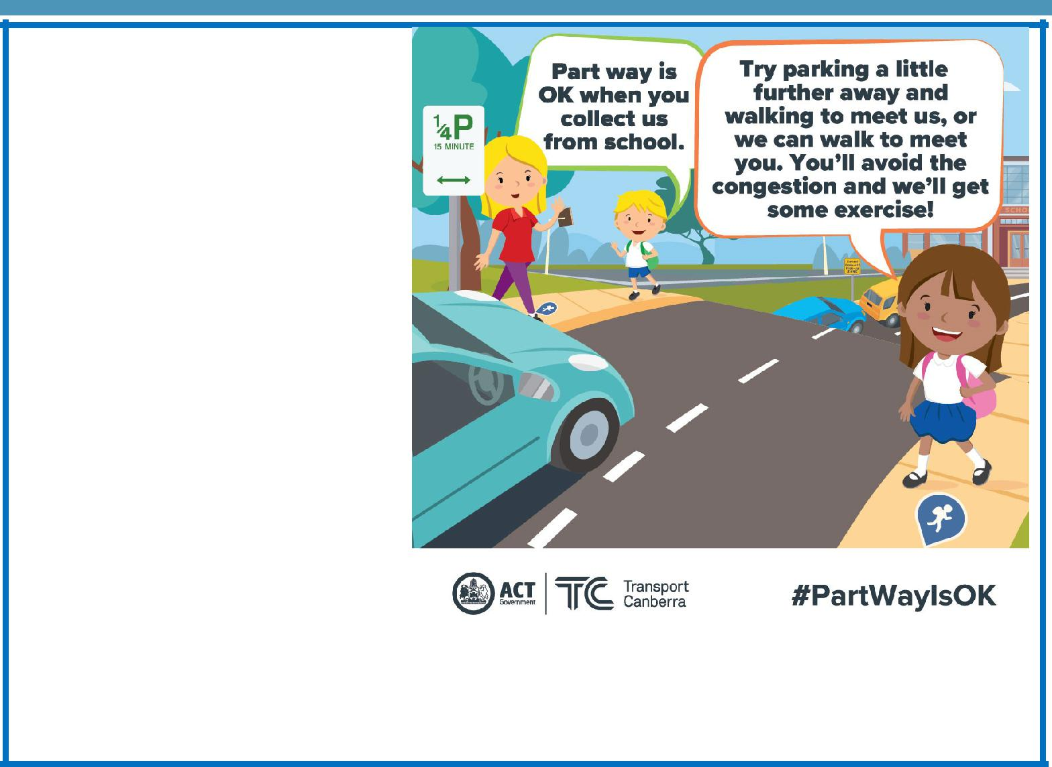

Part way is OK

Traffic congestion is a common issue around most schools during the morning and afternoon peak periods. Roads aren’t designed to cope with the sudden increase in traffic volumes for 15-20 minute periods. There is no traffic engineering solution to resolve this problem, roads and carparks simply aren’t built to meet the high demand over a short timeframe.

One way to reduce the congestion around our school is to use part way drop off and pick up locations. Part way points can significantly reduce the burden on the school carpark and the local road network and are ideal for families who live too far away from

the school to use active travel for the entire journey.

Not only will you help to reduce congestion around the school, children will also receive the associated health benefits.

School travel and safety survey

Transport Canberra and City Services has engaged First Person Consulting to conduct research into parents’ attitudes to their children's active travel to and from schools. Part of this is investigating the role that Crossing Supervisors have in improving safety around schools, and the extent to which parent’s attitudes to children travelling actively change as a result.

To complete the survey please click here, or copy and paste the following link into your browser:

http://www.surveygizmo.com/s3/4535360/-School-Crossing-Supervisor-Survey-Control-Sept18

The survey should take about five minutes. The survey will not collect any identifiable information, and all responses will be kept confidential.

Thank you in advance for your time in completing this survey. If you have any questions please

contact the TCCS Schools Program.

Together, we learn from each other

What’s On

OPEN DAYS

Emergency Services Open Day on Sunday 28 October 2018 from 10am to 3pm.

The Open Day provides an opportunity for the ACT community to learn how emergency services works. It is a day of family fun with the opportunity for people of all ages to sit in trucks, try out fire hoses, ride in a helicopter, tour the incident management facilities and learn about Emergency Services Agency operations. A family event filled with entertainment, food, skills demonstrations, and hands on activities! This is an exciting day out for all ages where you can meet the people who keep our community safe, and learn how you can take care of what matters most during an emergency. It's up to all of us to work together for a strong and resilient Canberra. FREE entry and parking

ACT Emergency Services Agency

9 Amberley Ave, Fairbairn Business Park Majura ACT

Tidbinbilla Nature Reserve Open Day on Sunday 7 October 2018 from 10am to 3pm.

The annual Tidbinbilla Open Day is on again this year. Mark this date in your diary for a fun-filled day of nature-based experiences, kid’s activities, live music, displays, demonstrations and more - held in the greatest venue of all, the great outdoors! The theme this year is ‘Rediscover Tidbinbilla’ where we encourage you to explore the Reserve with renewed curiosity and a fresh perspective.

Rediscover the rich Indigenous culture of Tidbinbilla through a guided experience on Ngunnawal Country. Rediscover adventure and take the chance to explore our natural environment through immersive NaturePlay activities. Rediscover science with a hands on experience to learn about our Threatened Species Breeding Programs. Rediscover heritage and take a step back in time to explore the stories of the Tidbinbilla Valley and how they have shaped the reserve to what it is today.

A relaxed family friendly atmosphere with free entry to Tidbinbilla Nature Reserve all day. https:// www.tidbinbilla.act.gov.au/whats-happening

Together, we learn from each other

