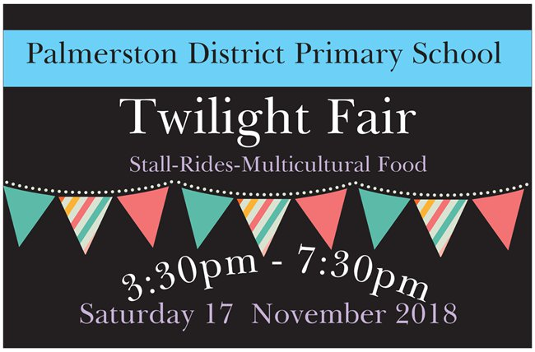

2018 Palmerston P&C Twilight Fair – Saturday 17thNov
Rides Wristbands & ‘Hand’ Pre-Purchase Ordering
Don't pay single ride price on the day! We all know the kids will want more than just one ride!
Option 1: Fill in form (place in P&C Boomerang box) & pay cash - Exact money only
Option 2: Fill in form (place in P&C Boomerang box) & pay online Palmerston District Parents and Citizens Association BSB: 062-913 Account Number:10145558 Please Reference Surname & HANDS. EG Smith,HANDS
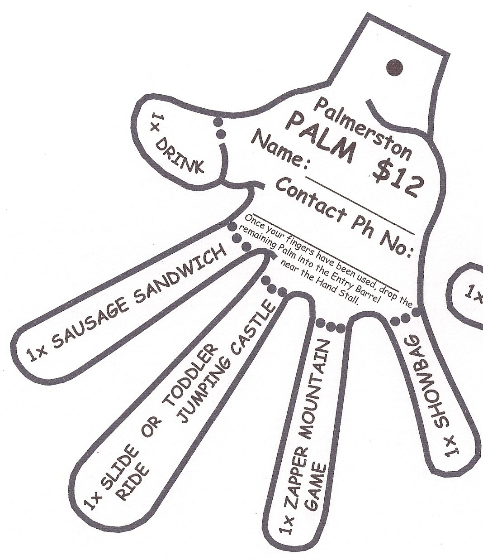
Option 3: Pay full price on the day

Five “Fingers” represent the following:
- 1 x Can of Soft Drink/bottle of water
- 1 x Sausage Sandwich
- 1 x Show bag
- 1 x Ice-block
- 1 x Noah’s Ark Farm Friends Petting Zoo Entry

Hands & Wristbands available for separate purchase on day, BUT at Fair Day Prices! On the day prices: Hand $12 Wristband $25
How it works:
- PRE-PURCHASE a HAND and/or WRISTBAND using the form & payment details attached.
- Collect your Hand and/or Wristband on Twilight Fair Day from the Hand & Wristband stall.
- Tear off each FINGER and present at appropriate stall, to get your goodies or food
- Wear your WRISTBAND, and get unlimited rides on Durkin's Amusement Rides (but NOT including the LAUGHING CLOWNS)

For further info the P&C via palmpandc@hotmail.com

Please complete the form below & return with payment to the P&C Boomerang Box, Front Office by Thursday 15th November 2018, close of school day 3pm.
Parent Name: _________________________PH NO: ___________________________
EMAIL: ________________________________________________________________
Online Banking Reference: __________________________________________________
I would like to purchase _______ Palmerston Hands at Pre-Order price: $10 each
Surname: ________________________First Name: ____________________ Class: ________
Surname: ________________________First Name: ____________________ Class: ________
Surname: ________________________First Name: ____________________ Class: ________
TOTAL cost for hands: $ ______________

I would like to purchase_______ Unlimited Ride Wristbands at Pre-Order price: $20 each
for use on Durkin''s Amusements: íe Cha-Cha, Slides, Jumping Castles, Teacups But NOT on Laughing Clowns
Surname: ________________________First Name: ____________________ Class: ________
Surname: ________________________First Name: ____________________ Class: ________
Surname: ________________________First Name: ____________________ Class: ________ Surname: ________________________First Name: ____________________ Class: ________
TOTAL cost for wristbands: $ ______________

TOTAL payment $______________________

