ASSEMBLY:

14 Dec Whole school - Music

21 Dec No assembly - Talent Quest

DATES TO REMEMBER:

14 Dec |  | P/S End of year
 |  | celebration (Cranky,
 |  | Hungry & Sleepy)
14 Dec |  | P&C Lunch Order -
 |  | Sausage sizzle
17 | - 21 Dec Yr1 Swim & Survive
19 | Dec | Yr6 Graduation
20 | Dec | K-Yr6 Fishing
 |  | incursion
21 Dec |  | Talent Quest

NOTES HOME:

- Yr1 swimming reminder

P&C BOARD NEWS P&C: 7:00pm 17 Dec

All P&C activities, meeting agendas and minutes are available from the school website at – Parent Corner

School Board:

What’s On

13 December 2018

Week 9, Term 4
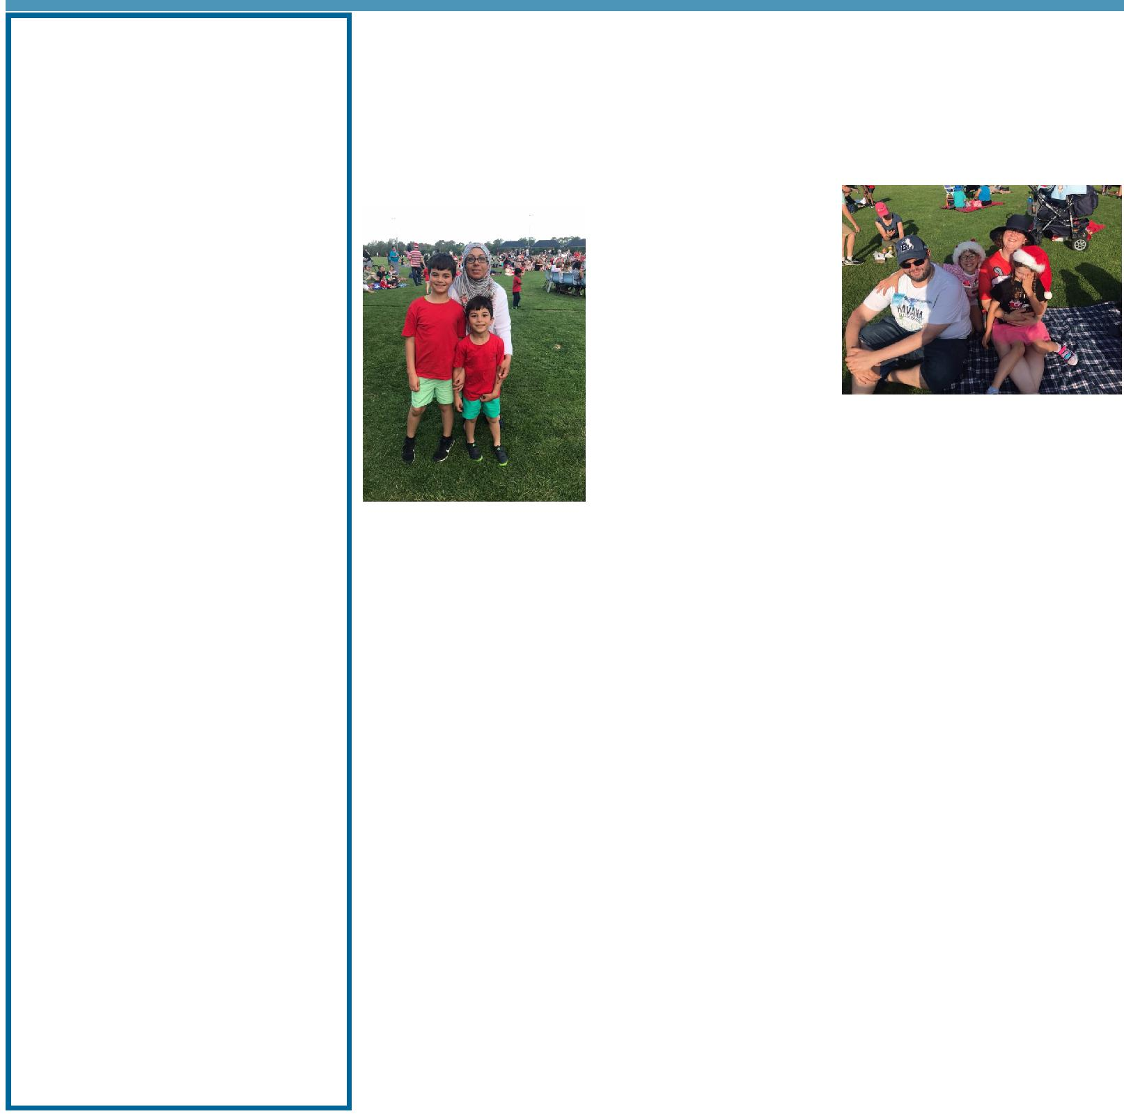

PRINCIPAL’S MESSAGE

Welcome to the second last week of term. I hope you booked in a time to meet with your child’s teacher this week. We have had many parents say how wonderful the opportunity was to discuss their child’s learning with their child’s class teacher.

Last week we had an amazing Christmas Concert on the Palmerston Oval. I have had many positive comments

from families that they loved the opportunity to sit with their child/ren and picnic while being entertained with Christmas songs. I would like to

thank the Christmas Concert committee and the P&C for suggesting such a great idea. A fun time was had by all.

At this time of the year, we have a number of staff moving to Palmerston and some leaving. I would like to thank all the staff for a great year of teaching and learning. The support staff provide an amazing level of assistance to our students. Then, there is Mr Phil who has once again provided a wonderfully kept building and surrounds. I would like to announce that Mrs Kate Flynn is taking up a position at Franklin Primary School as Deputy Principal. Kate has worked outstandingly for the Palmerston community since 2010. She is an amazing leader and I wish her all the best in her career. Teachers who are leaving us next year:

- Rachel Ashcroft has won a position at Miles Franklin School and will then take maternity leave

- Lynn Boxsell is retiring

- Cheryl Cassella will be taking a year’s leave

- Hayley Elliott is relocating to Queensland

- Kate Flynn will be taking up the Deputy Principal position at Franklin Primary School

- Emma Gusse will be relocating to Newcastle

- Robin Greer is retiring

- Peta James will commence maternity leave

- Richa Oberai is relocating to Queensland

Together, we learn from each other

What’s On

Welcome to new staff for 2019 who have commenced teaching at Palmerston this term and are already part of our teaching community:

- Kate Ashcroft

- Rachelle Evans

- Alice Ferarri

- Yukari Fitzpatrick

- Georgia Morrison

Welcome to experienced staff who will arrive in 2019 from other schools:

- Lucinda Cooper from Yarralumla Primary School

- Bec Fortescue from Namadgi School

- Craig White from Kaleen Primary School

2019 is looking to be another exciting year. Staff will be attending school the week before the children. We take this opportunity to attend professional learning. Our learning will be on Cultural Integrity, applying the Australian Curriculum Achievement Standards, and working in Professional Learning Teams using multiple sources of data.

Have a great last week of school. In Week 10 we have our year 6 Graduation, our fishing incursion and our talent quest.

Melissa Travers

DEPUTY PRINCIPAL’S MESSAGE

Writing the newsletter item this week is filled with many emotions as it will be my final newsletter item at Palmerston. I consider myself extremely fortunate to have been a member of this wonderful school since 2010. During this time, I have worked alongside amazing staff, students and parents and I would like to thank you all for sharing this special journey with me. Palmerston is an amazing school where through fun, dedication and hard work our students achieve success in many social and academic learning areas. Palmerston is a place where people and community are at the heart of all the decisions made and programs implemented. I would like to acknowledge the tireless work of everyone at PDPS including the front office staff, Mr Phil, release providers, relief teachers, executive teachers, teacher assistants and the classroom teachers who each day promote the school vision, teach great programs and provide excellent care to the children at our school. I would finally like to thank the parent community for the ongoing support provided to us at Palmerston. We truly appreciate all that you do.

I will think fondly of Palmerston and will always have a smile on my face when I think of the many wonderful years spent here. Thank you again. Have a wonderful end of year and Christmas holiday break.

I am looking forward to the year 6 graduation next Wednesday. Our year 1 students will be attending swimming lessons. If they have a sibling who is graduating please let me know.

Kate Flynn

Together, we learn from each other

What’s On

UPCOMING EVENTS

Year 1 Swim & Survive Swimming program

Date: Monday 17 December - Friday 21 December 2018

Location: Gungahlin Leisure Centre

Yr6 Graduation

Date: 9:15am Wednesday 19 December 2018

Location: Palmerston Primary

K - Yr6 Fishing Incursion

Date: Thursday 20 December 2018

Location: Palmerston Primary

Talent Quest

Date: Friday 21 December 2018

Location: Palmerston Primary

Date for your Diary: 2019 Swimming Carnival

The Palmerston District Primary School 2019 swimming carnival will be held on Wednesday 20 February 2019 (Term one, week three) at Dickson Pool. All K-6 students will be receiving permission notes next year and students wishing to compete in races will be asked to nominate at this time. The cost of this carnival will be approximately $10.

SCHOOL BOARD 2019

Next year we will have 2 parent vacancies on the School Board. Nominations will open on the 4 February 2109 and close on 18 February. Please keep these dates in mind if you are interested in applying for one of these positions.
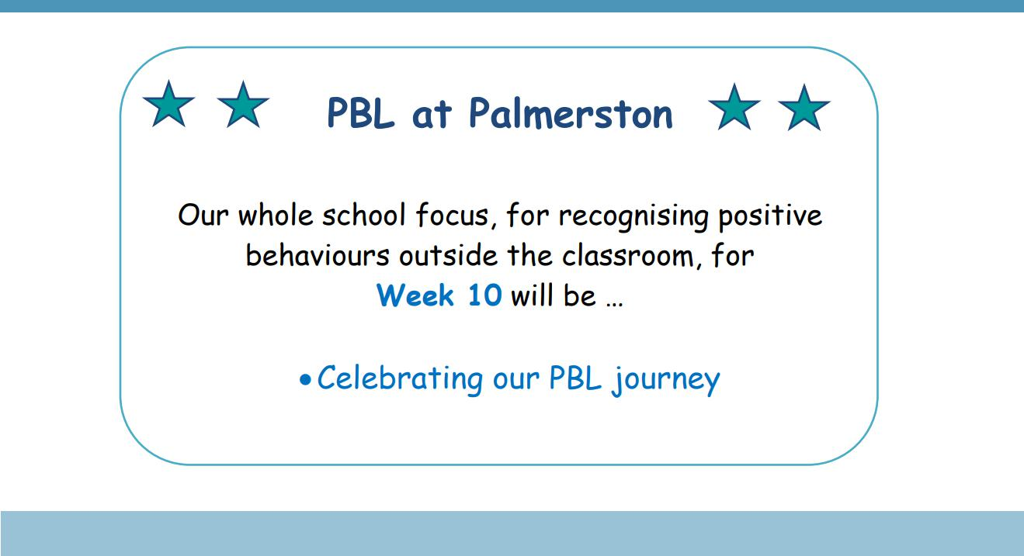

Together, we learn from each other

What’s On

2019 BOOK PACK LISTS

Book Packs are ready! You can go online and order 2019 book packs.

Please refer to the website for book pack lists. Please follow the ordering instructions;

Go to the OfficeMax website OfficeMaxSchools.com.au

Search for Palmerston Primary School, Palmerston ACT and enter your school access key: 4TV8Q

Complete the student details and select the year level that your child will be in for 2019. Eg. If your child is in Yr.1 this year then you need to select the 2019 Yr. 2 list.

Review your requirements list and make any changes (if required). Please note that some items have been denoted as a requisite for the subject or year.

If you have more than one student at the school you will need to repeat the above steps, ordering the correct 2019 year level list.

Once completed, an order confirmation will be sent to your email address.

Order Deadlines and Delivery

Your order will be delivered to your home address. Please note: Orders will NOT be sent to the school.

Orders are delivered via Australia post’s eParcel service and you will receive an email with the Australia Post tracking ID Number. Post Offices Box addresses are NOT accepted.

Orders placed on or before 17 December will be delivered free of charge.

Orders placed after 17 December and on or before 31 December will incur a $12.95 delivery fee.

Orders placed after 31 December will incur a $12.95 delivery fee and all efforts will be made to deliver prior to the beginning of Term 1, 2019.

IMPORTANT

ALL Stationery packs need to be brought to school on the first day of Term 1, 2019 and given to the class teacher.

If you need any help placing your order, returns or refunds, delivery information or have a general enquiry please visit OfficeMaxSchool.com.au/help

Please DO NOT send any Stationery Lists or money to the school, ALL orders are through OfficeMax.

Together, we learn from each other

What’s On

SCHOOL INTENTIONS 2019

School Leavers 2019

We have now reached the time in the year when we look at our school numbers and staffing arrangements for 2019. If your circumstances have changed and your child/ren will not be attending Palmerston District Primary School in 2019 can you please let the front office staff know as soon as possible.

My child/ren will not be returning to Palmerston in 2019.

Name Class

Last day at Palmerston:

My child/ren will be attending:

Another government school in the ACT:

A non-government school in the ACT:

Moving out of the ACT

Forwarding Address:

Phone number:

Parent’s name:

Together, we learn from each other

What’s On

HIRERS
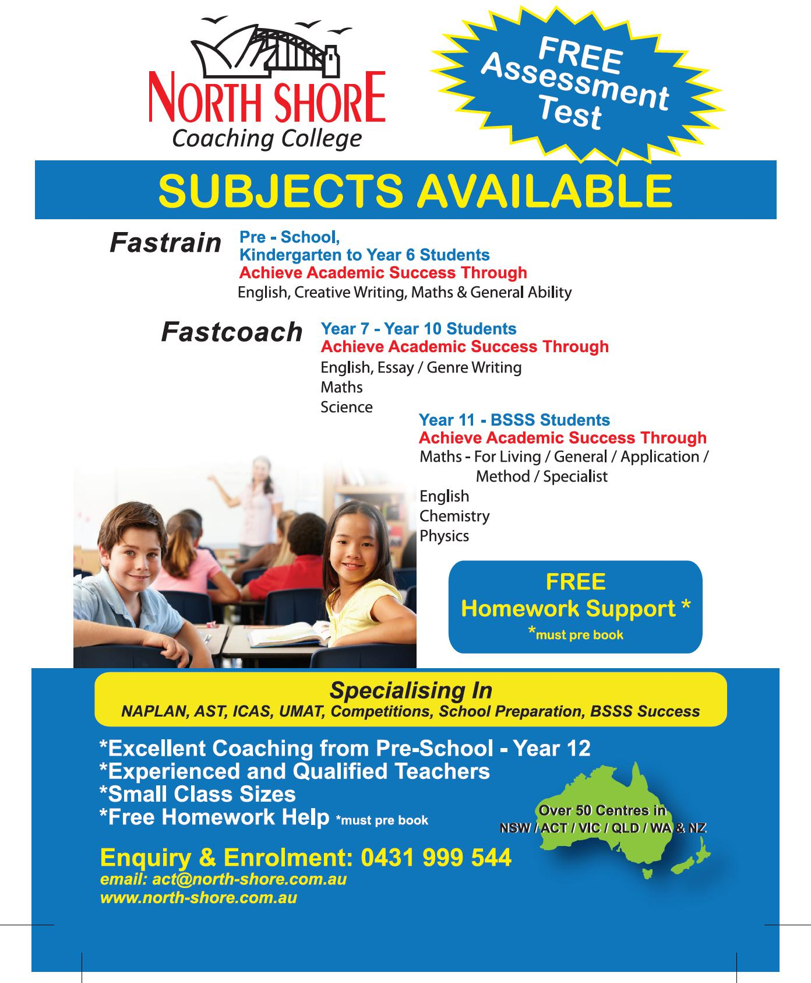

Together, we learn from each other

