Tombola Stall Donations

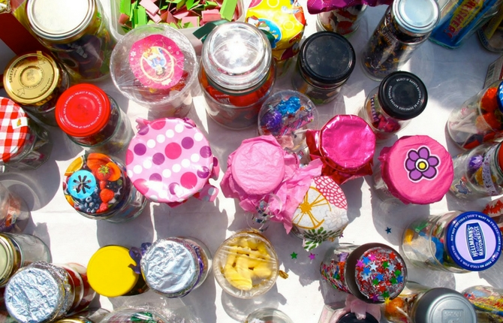

At the twilight fair we are having a Tombola stall. To make this stall a success we are asking the community for donations.

Here are just a few ideas of items you can donate:

Hampers | Baked goods/homemade jams
Gift Cards | Craft packs
Box of chocolates | Soft toys
Stationary | Games
Gardening items | Jewelry
Cosmetics | Hair clips and ribbons
Tools | Books
Lego | Bags of lollies of chocolate
Photo frames

All new items only please. Donations can be left in the foyer.
Any questions please contact the P&C at palmpandc@hotmail.com.

