Palmerston District Primary School acknowledges

the Ngunnawal People,

the traditional owners and custodians of this land.

Palmerston Post

PRINCIPAL’S MESSAGE

What a sensational term we have just flown through, there are so many highlights to celebrate. Working our way through freezing cold windy days, and emerging into some warm sunshine and warm breezes, we notice the change that comes to us as we adapt to the next season. Seasonal change, and beautifully, launching into Spring gives everyone a renewed energy. At Palmerston Primary this term, I have experienced many firsts; the Science Fair certainly demonstrated student energy and passion for research, the Learning Journey certainly demonstrated high energy within every classroom and outdoor learning space, Book Week demonstrated creative energy in some of the most amazing costumes I have ever seen, let’s not forget the Walkathon and how many thousands of laps that were completed last week – lots of energy expended. This is just to name a few. The energy from the P&C with their special lunch and spooky disco are other highlights to celebrate this amazing community and contributions we all make to make our mark on who we are.

As with all things in life, change appears and we roll with it. There are a few new things coming our way that I will introduce you to here, and you will find detailed explanation further in our newsletter.

- New Carpark – you will see this much needed change occurring across the school holidays, in fact, the preparation for it will have begun on Thursday afternoon. We are having a team of dedicated workman to come onsite across the entire holidays to create a new and safer carpark, with new flow, new spaces for new routines – all with the premise to maximise flow and safety. All going to plan, it will be completed and ready for use day one of Term 4. There may be some minor landscaping to be completed during the first week of term.

- Skoolbag app – we are hoping the change to using this app will be taken up by all families. The main reason is that all notes, newsletter etc put onto this app can be translated immediately into over 60 different languages which will be a huge change for our multicultural families for whom English is not their first language. This further

meets our mission for equity. When all families can access our notes for special lunch days, excursions etc…we hope to see greater participation. This is a real winning change for our community .

- Student absences via SAS – our Directorate is rolling out across all schools, a changed process for dealing with student absences. All teachers will electronically mark the roll by 9.15, and around 9.30, the automated system will generate an SMS message to you to then reply to. Your explanation for the absence will be automatically registered on SAS. This change will make a very big difference to the efficiency of student absences.

This week, we farewell Mrs Haeley Simms, as she was successful in a School Leader Transfer to North Ainslie Primary School, starting next term. We thank Haeley for her dedication to all stakeholders at Palmerston, for her high level of energy and leadership. Haeley has been here for several years and has a huge corporate knowledge of families and will be missed by us all. Please join with me in wishing Haeley all the very best as she experiences change and all the marvellous ways she will add value to her new school.

We welcome next term, Mr Greg Taylor from Ainslie Primary School to join our leadership team and teacher to share Yr 3 with Miss Fortesque. Mrs Kristina Collins who has won our second executive teacher position and is already doing a wonderful job in the Library, building our collection and creating dynamic displays to encourage reading.

We also farewell Ms Robina Jeffs who has been a valuable part of our staff, working with students to extend their writing and acting as a sounding board. Robina has captured many moments of supporting and extending literacy for students, encouraging and modelling the way to be successful writers and indeed authors. We wish Robina all the very best as she now takes up a new position at Franklin early Childhood School.

Cont over….

PRINCIPAL’S MESSAGE cont..
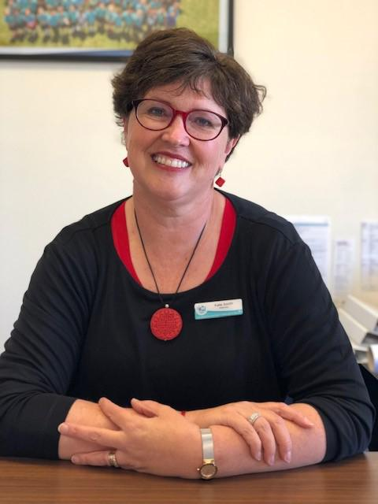

I am looking forward to supporting my son play in the National U16’s Rugby Championships all of next week, held here in Canberra. As a junior Brumby player’s Mum, I relish the opportunity to see this fine team of young athletes navigate their way through hard tackles, wins, losses, resilience, leadership and opportunities to make connections through sport all across Australia. I wish for every family to have a wonderful Spring break, to enjoy the sunshine, Floriade, everything beautiful that Canberra has to offer, and if you are lucky enough top be travelling interstate or internationally, travel safely, relish your moments and I look forward to greeting you for term 4.

Until then, enjoy this quote around change by Robin Sharma – Change is hard at first, messy in the middle and gorgeous at the end… we are all in this together, thank you (in anticipation) for being open to the changes outlined above.

Kate Smith

Principal

Absence Notifications

From Week 1, Term 4 an important part of our transition into the new School Administration System (SAS) will be sending SMS messages to inform of student absences. You will receive an SMS message to let you know your child has been recorded as absent on the morning of their absence. We will endeavour to send this by 9.30am every day. This will reassure you of your child's arrival at school and make it easier for you to keep your child's attendance record up-to-date when they are absent.

You simply reply via SMS, with your child's name and the reason for your child’s absence and this will be saved directly to child’s attendance records. If you do not reply, your child’s absence will be recorded as “unexplained”. For unexpected absences, responding to the SMS will streamline our processes. The preferred way of explaining your child's absence will be responding to the txt message2. If your child arrives at school after 9.05am they must be signed in via the front office .

Some examples of Parent Replies:

(Student Name) is sick today, thanks (Parent Name)

(Student Name) (Roll Class) was late to school this morning because ........., thanks (Parent Name)

Hi (School Name). (Student Name) is at home sick today, thanks (Parent Name)

Both (Student Name) (Roll Class) and (Student Name) (Roll Class) will be absent from school (date) because ......, thanks (Parent Name).

As always if you have any concerns please contact the Front Office on 61421440.

DEPUTY PRINCIPAL MESSAGE

The end of term always brings out my nostalgic side. I exhale loudly, close my eyes and smile. I allow myself time to reflect on personal and team successes and achievements, and stop to consider how I can be better, and do better, in the term to come.

Karl Barth once said, “Joy is really the simplest form of gratitude”, and every day this term I have found joy in my work and in this amazing school community.

“Joy is really the simplest form of gratitude”.

I am grateful for so many wonderful experiences this term. Here is just a small snapshot. This term I have found joy dancing like nobody is watching with my preschool friends. I have celebrated and applauded Kindergarten word wizards who have proudly walked into the office to share their wonderful writing. I have laughed during friendly debates with Year One students who are convinced I am really a secret spy that goes by the spy name Madame Butterfly and have marvelled at Year Two students who kindly invited me into their classroom to share their learning about reading and number strategies. I discovered joy in Year Three, where excited students took time to teach me more about volcanoes and smiled to myself after chatting with Year Four students on the playground who were eager to teach me games they were playing. I have felt a great sense of pride and joy watching our Year Five and Six leaders demonstrate their maturity, skills and kindness during Peer Support lessons. I experienced joy sitting with the truly wonderful students in the LSU enjoying a drink and practising my table manners and my heart sings watching the little ones in the IEC skip to the bus in the afternoons. “Joy is the simplest form of gratitude.” Indeed, it is.

We are all life-long learners, always curious. Throughout life there will always be knowledge to be gained, experiences to be had and opportunities to be taken. This term I am truly grateful to our wonderful staff for embracing this idea. I am also so proud of their commitment to further embed the systems of the PBL framework at our wonderful school through professional development and collaboration. Our learning this term has included creating positive and organised classroom environments, responding to negative incidents in a consistent manner and the power of relationships. Most recently we have also taken time to further reflect on how we supervise all settings across our school and

improving ways we scan, move and interact with students. Next term we will be participating in discussions about how we acknowledge our students and taking time to develop lessons to assist students to understand our whole school behaviour expectations.

I am indeed a life-long learner. These holidays I will be flying to the USA to attend a PBIS (PBL here in Australia) leadership conference. I am so excited to extend my knowledge of the PBL framework and then share this with our community to enhance our already fabulous school culture.

Finally, I would like to thank you all for making me feel so welcome. Thank you from the bottom of my heart. Our school community is such a beautiful one to be part of and I feel truly blessed, and grateful. I hope these holidays you stop to take time to celebrate the achievements of your beautiful children. Congratulate them on a job well done. They deserve it.

Enjoy a safe, happy and restful break. See you next term.

Marijana Pasalic
Diversity, Inclusion and Wellbeing

Principal: | Carpark Upgrade
Kate Smith
Deputy Principals:
Marijana Pasalic
Helen Cox
Executive Teachers:
Felicity McNiece
Kylie Moller
Haeley Simms
Kristina Collins
Business Manager:
Sonya Campbell
Office Manager:
Kirsty Brown
Board Chair:
Lisa Fior
P & C President:
Lisa Fior
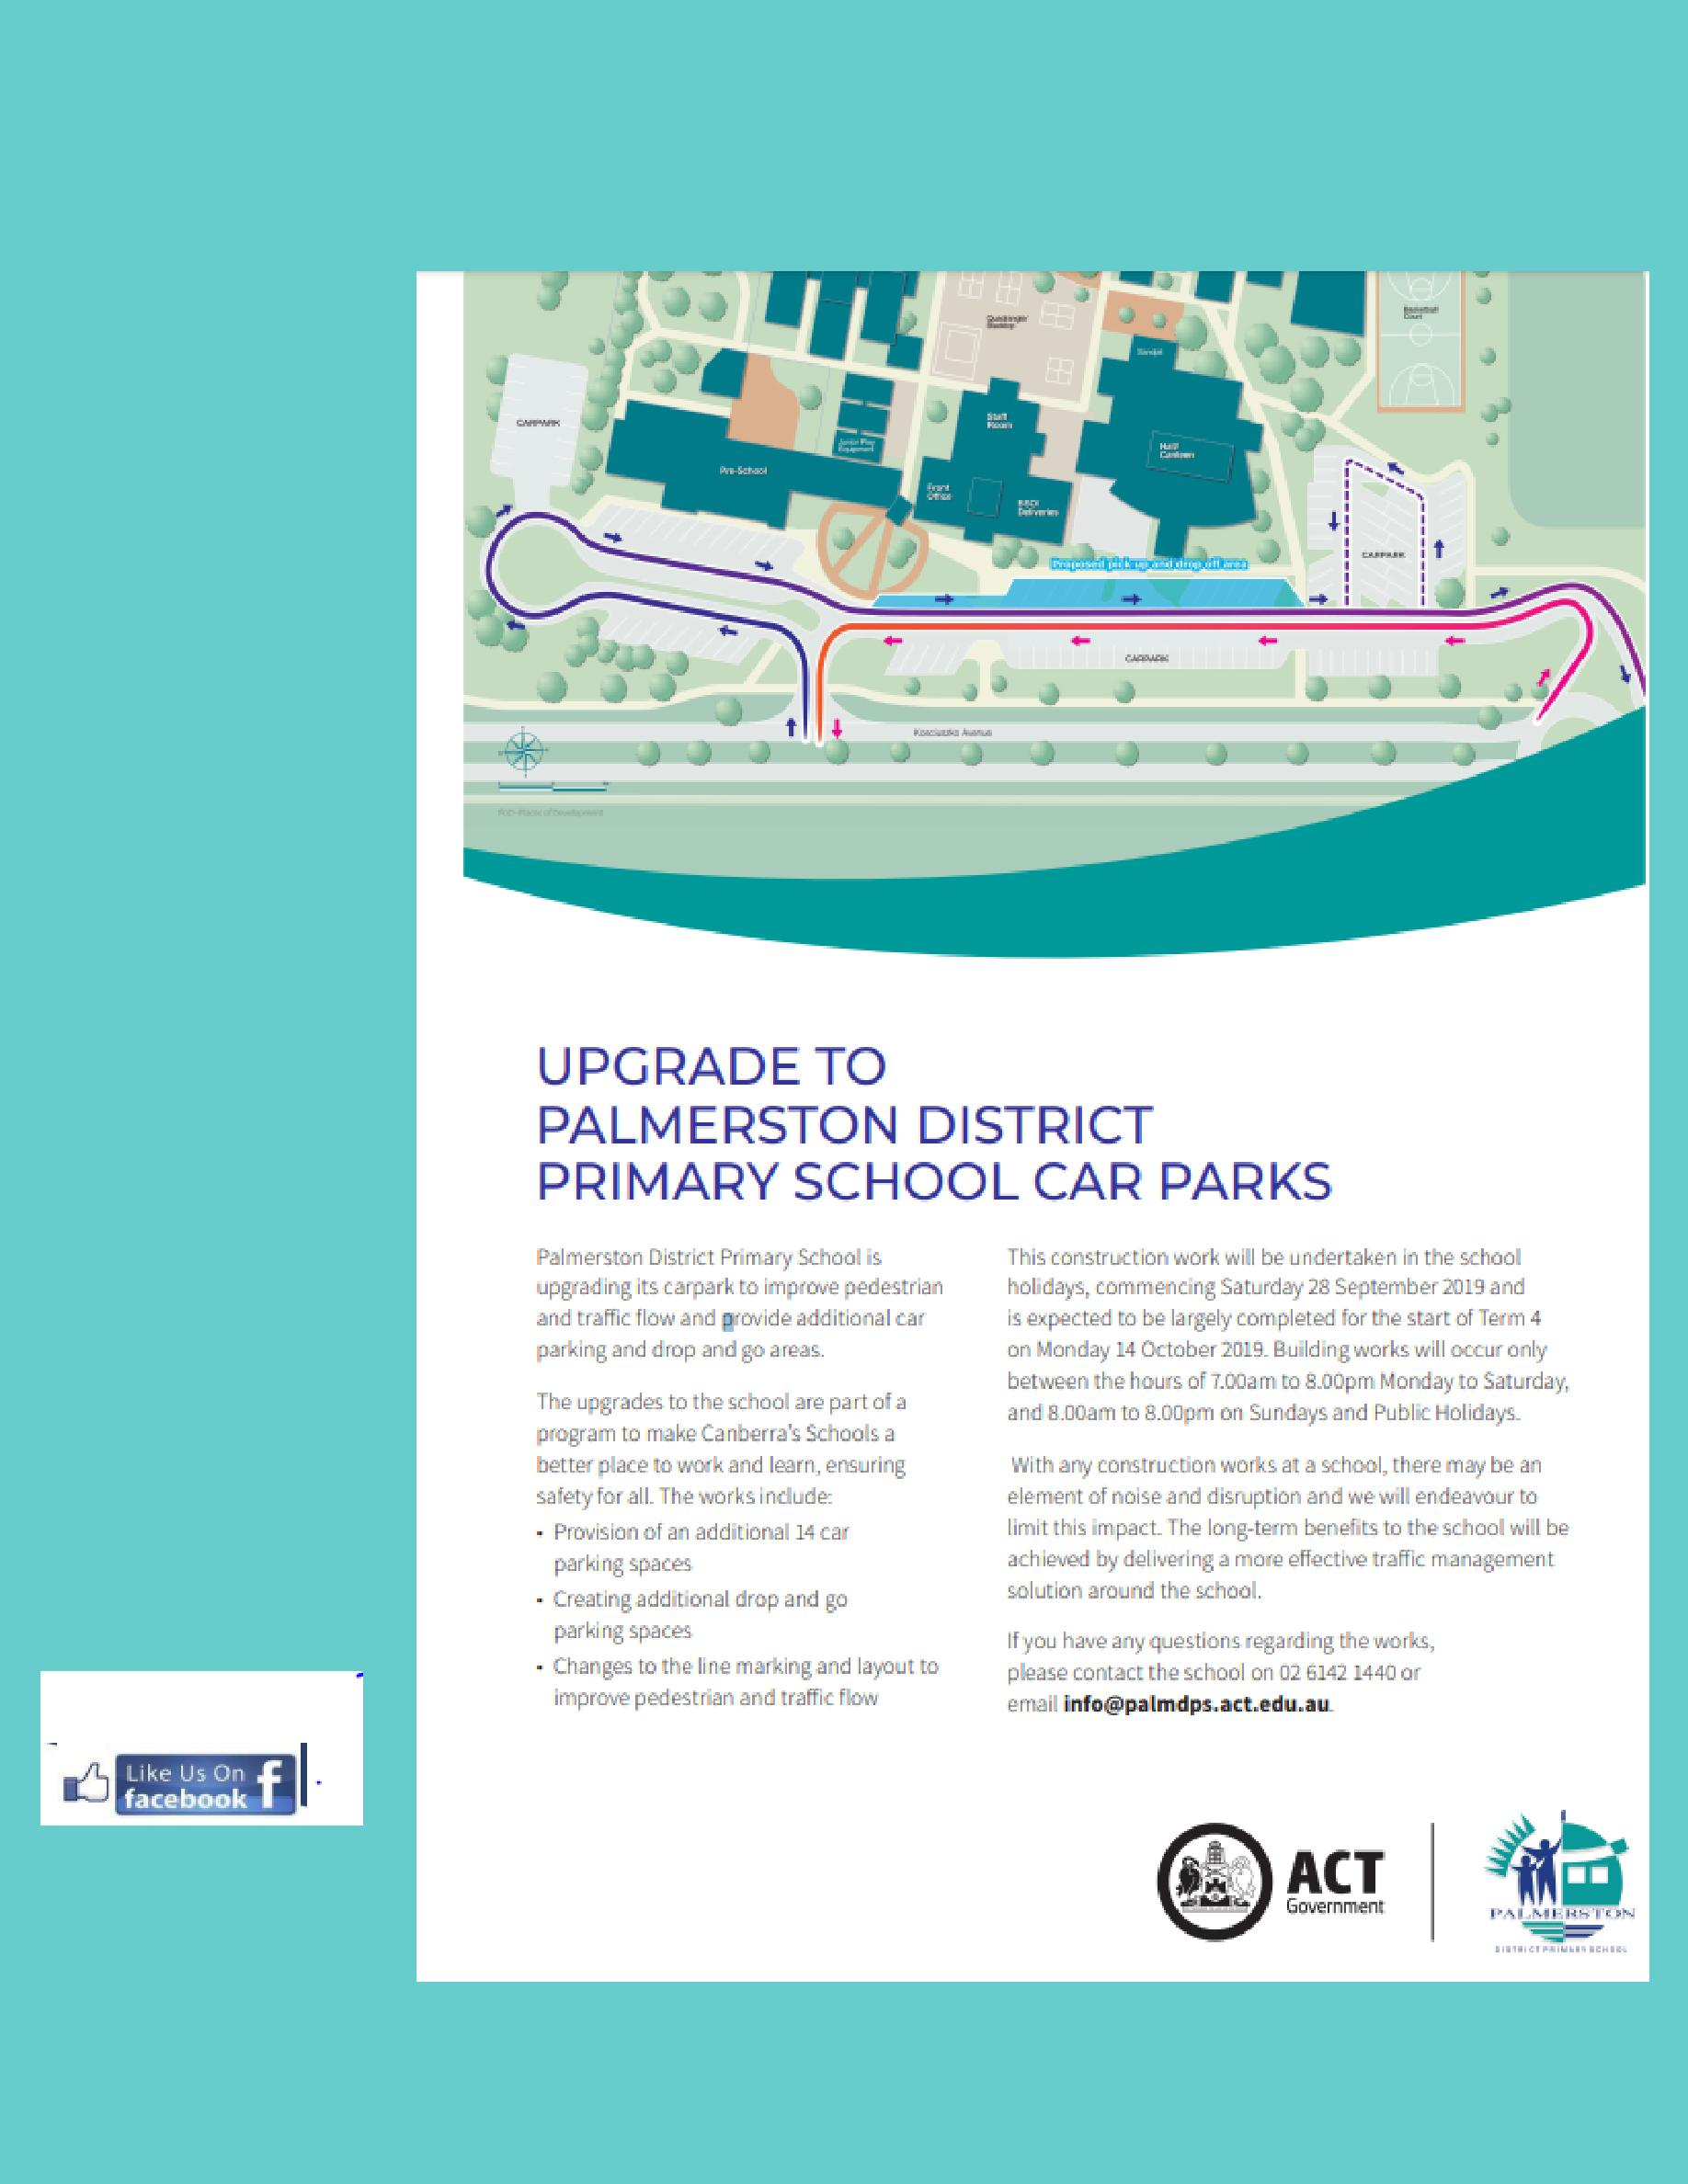
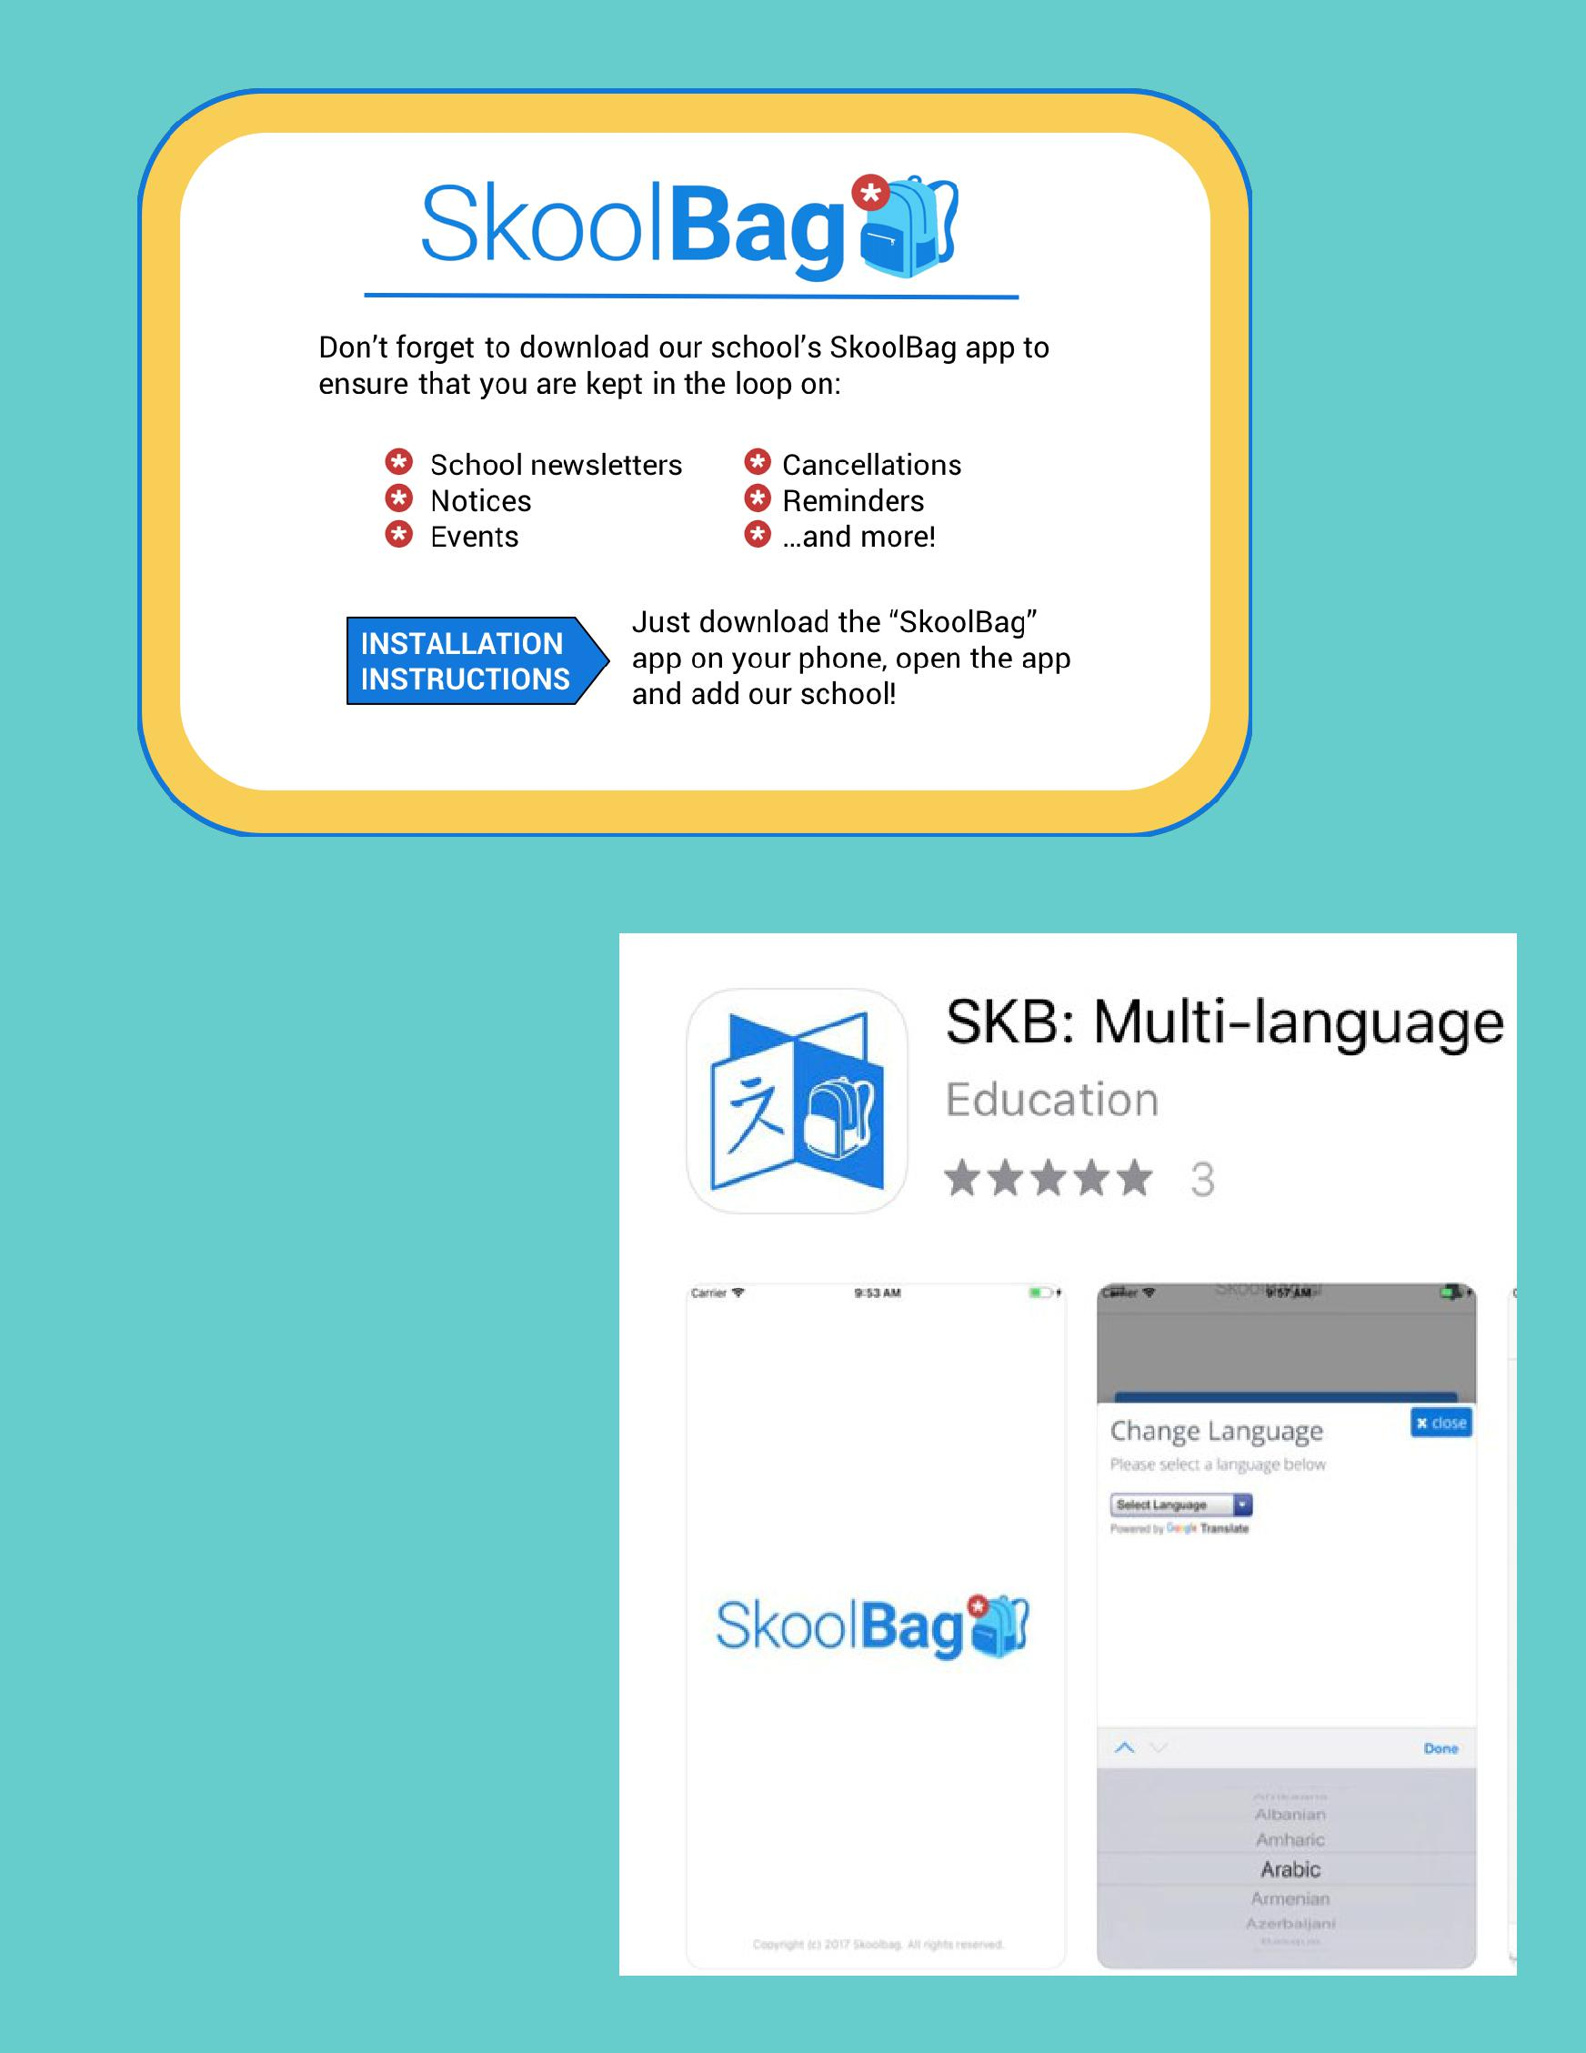

The SkoolBag app is the easiest way to stay up-to-date with school events, last minute notices, newsletters and all school communications.

For those who would like to receive notifications in their chosen language please download the SKB : Multi-language app .

Just download the “SkoolBag” app on your phone, open the app and our school.

All P&C activities, meeting agendas and minutes are available from the school website at – Parent Corner

P & C/BOARD NEWS

The P&C are fundraising with the Entertainment book. The Entertainment™ Book is a local restaurant and activity guide which provides hundreds of up to 50% off and 2-for-1 offers from the finest restaurants, cafes, attractions, activities, retailers and hotel accommodation. The Membership entitles buyers to exclusive offers that are virtually restriction-free, and is valid through to 1 June 2020!

The Entertainment™ Digital Membership (app) puts all of the value of the Entertainment ™ Book into the customer's smartphone. With 'near me' technology and the ability to show and save using a phone, this is perfect for the person on-the-go, with no card or voucher to present.

You can purchase a book through the front office or download the app via this link

https://www.entertainmentbook.com.au/orderbooks/2487s6

6

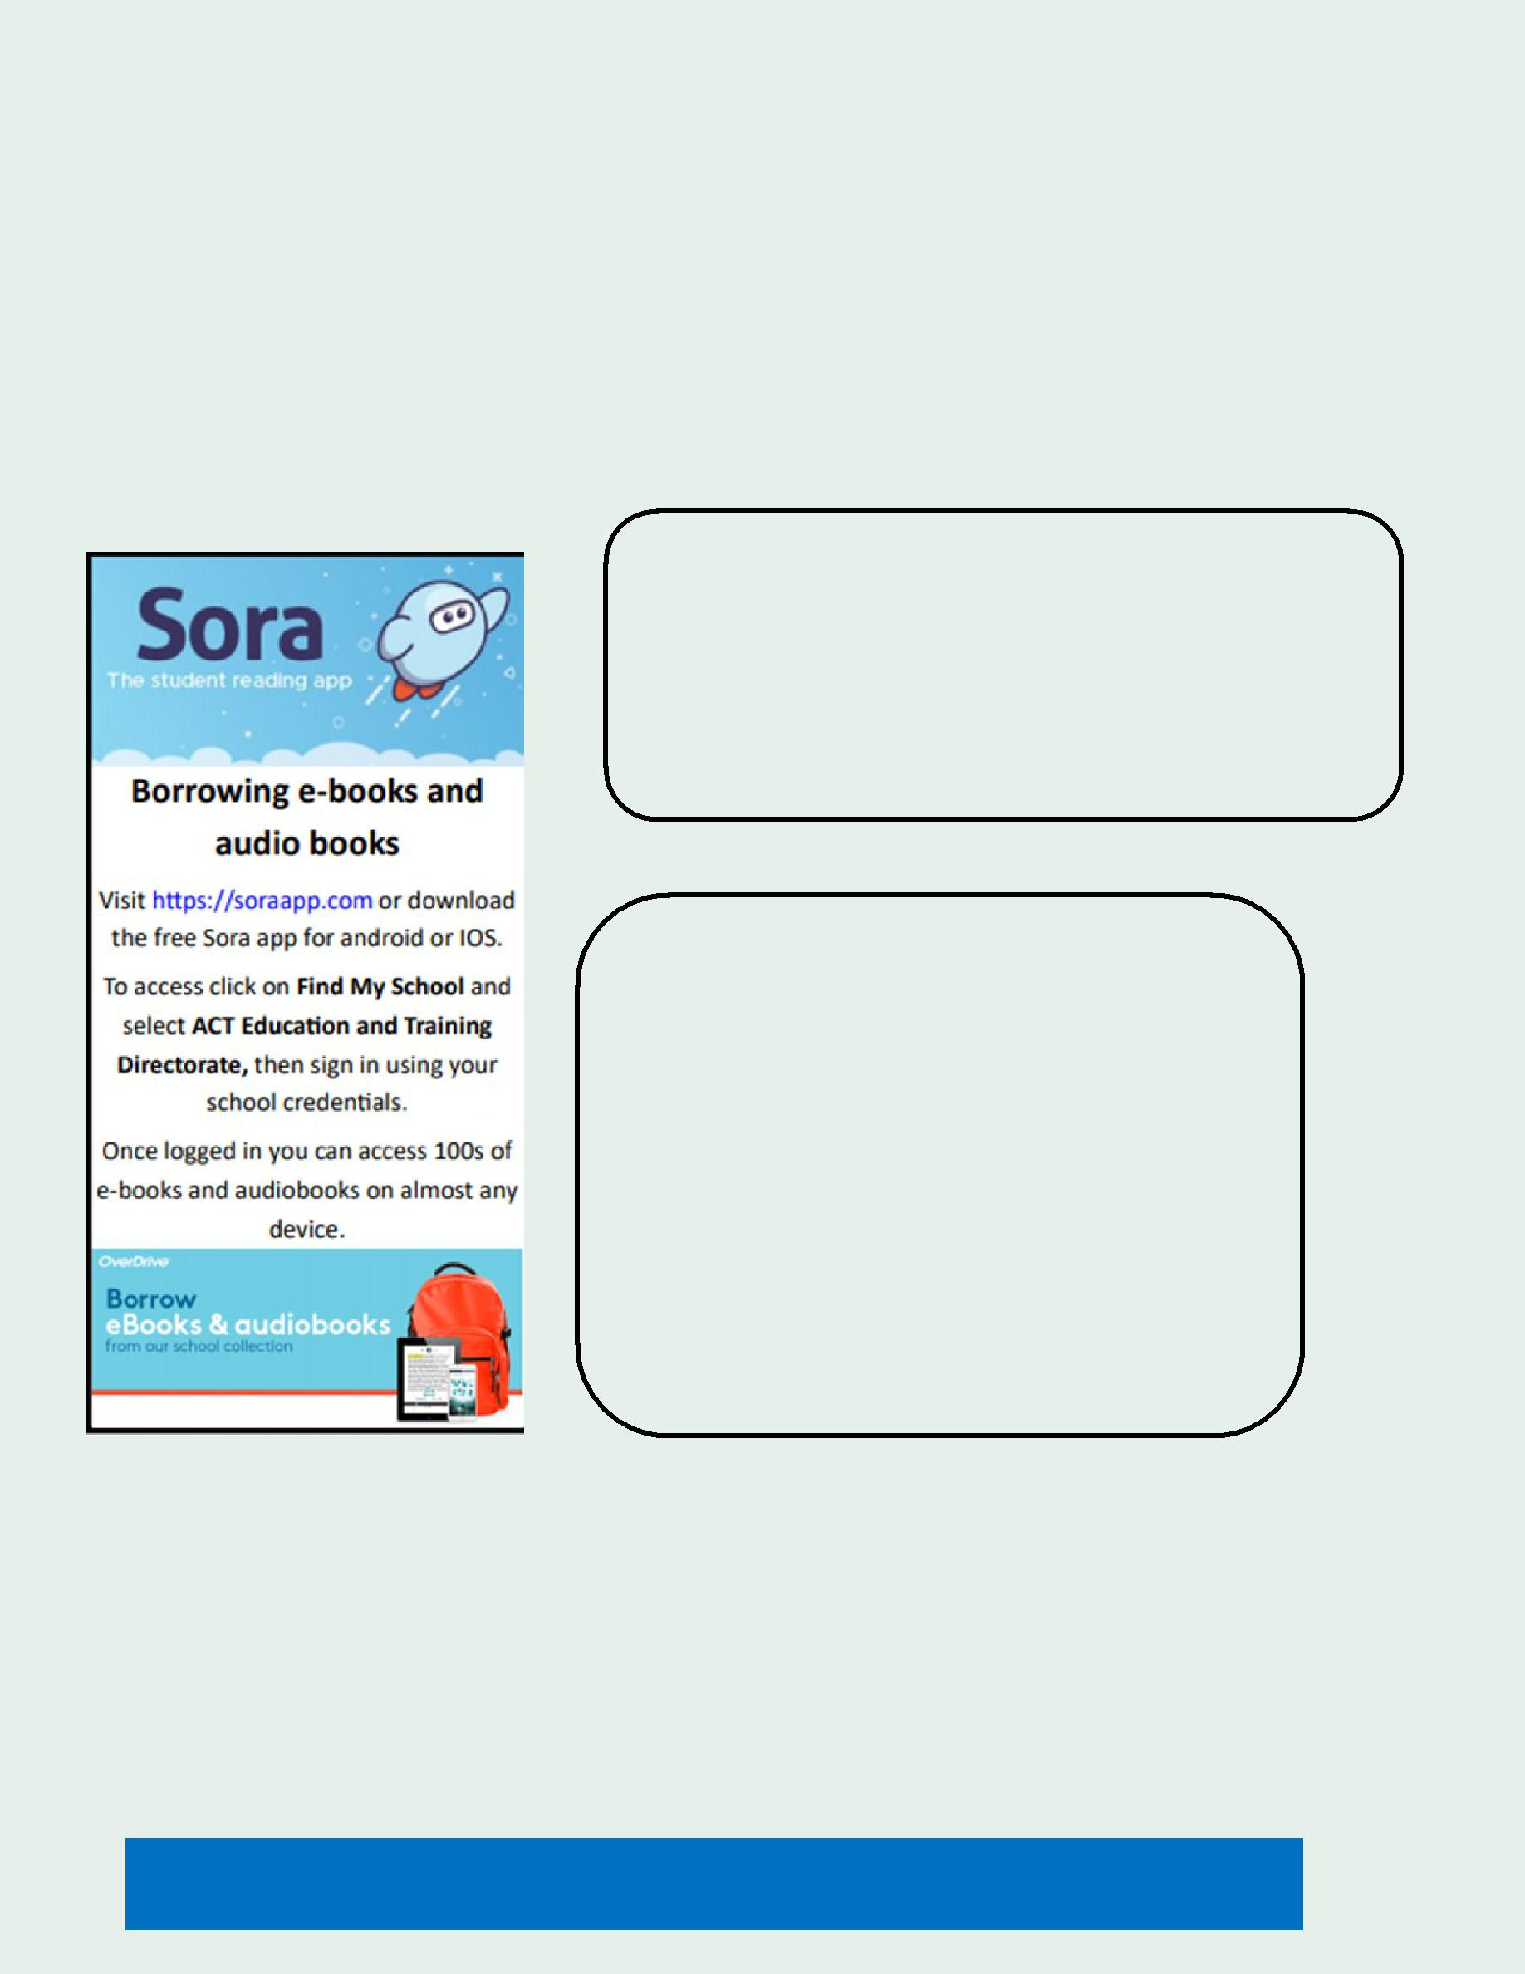
Library News

Bilingual Books Needed – Do you have books at home in your first language that might be suitable for our collec-tion? We are hoping to build our collection of bilingual books in Languages Other Than English to support our stu-dents with a second language to maintain and develop their first language literacy. We would be very grateful for donations of books suitable for P-6 students in any of the languages spoken within our community. Books can be left at the Front Office or dropped into the Library.

School Holiday Reading

Over the holidays you might like to try the new Sora App for student reading. This app provides access to literally hundreds of suitable books specially chosen for students.

Book Covering

Thank you to those families who have offered to help with covering books. If you are able to help occasionally, please email Kristna.collins@ed.act.edu.au

Similarly, if you are able to help occasionally in the Library with shelving etc please let us know.

Don’t forget the Library is open every day before school from 8.30am for students (accompanied by their parents) to read together or chose books to borrow!

WTTT Together We Learn From Each Other

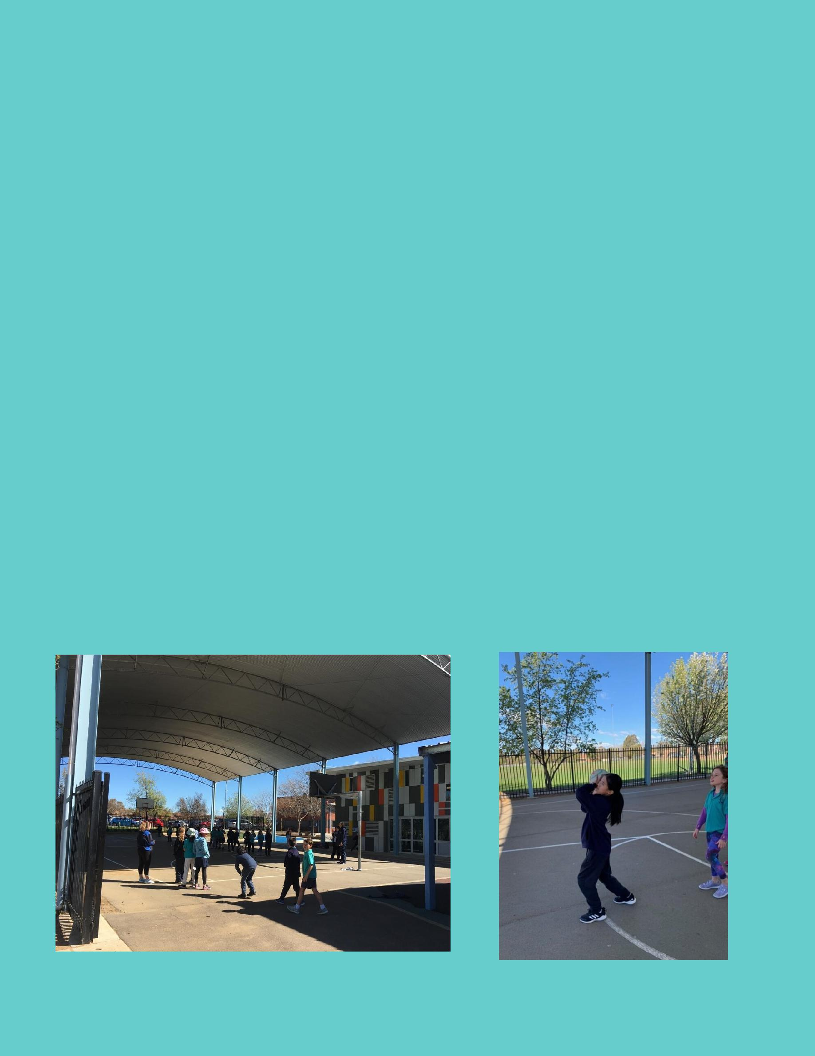
Palmerston District Primary School are proud to be a Sporting School

Palmerston District Primary School has been successful in securing funding for Term 3 of the Sporting School Program. We have partnered with Netball ACT to deliver netball clinics to classes in years 3-6 in weeks 6-9 this term. Please see some photos attached.

Sporting Schools is a $200 million Government program designed to help schools increase children’s participation in physical activity and connect children with community sport.

More than 85% of schools around Australia receive Sporting Schools funding, which supports children to get active and have fun.

Engagement in sport and physical activity can help keep children healthy, happy and socially engaged, all of which can impact on their intellectual capacity and academic achievements.

The program provides children with positive sporting experiences to help develop a lifelong interest in sport and physical activity.

Sporting Schools is in partnership with more than 33 of the country’s leading sporting organisations who develop quality, nationally-endorsed resources and activities tailored for primary and secondary school students.

Support from parents and families is also known to have a positive impact on a child’s motivation and enjoyment of sport.

To find out more about Sporting Schools or how parents and families can support positive sporting experiences at home, simply visit www.sportingschools.gov.au

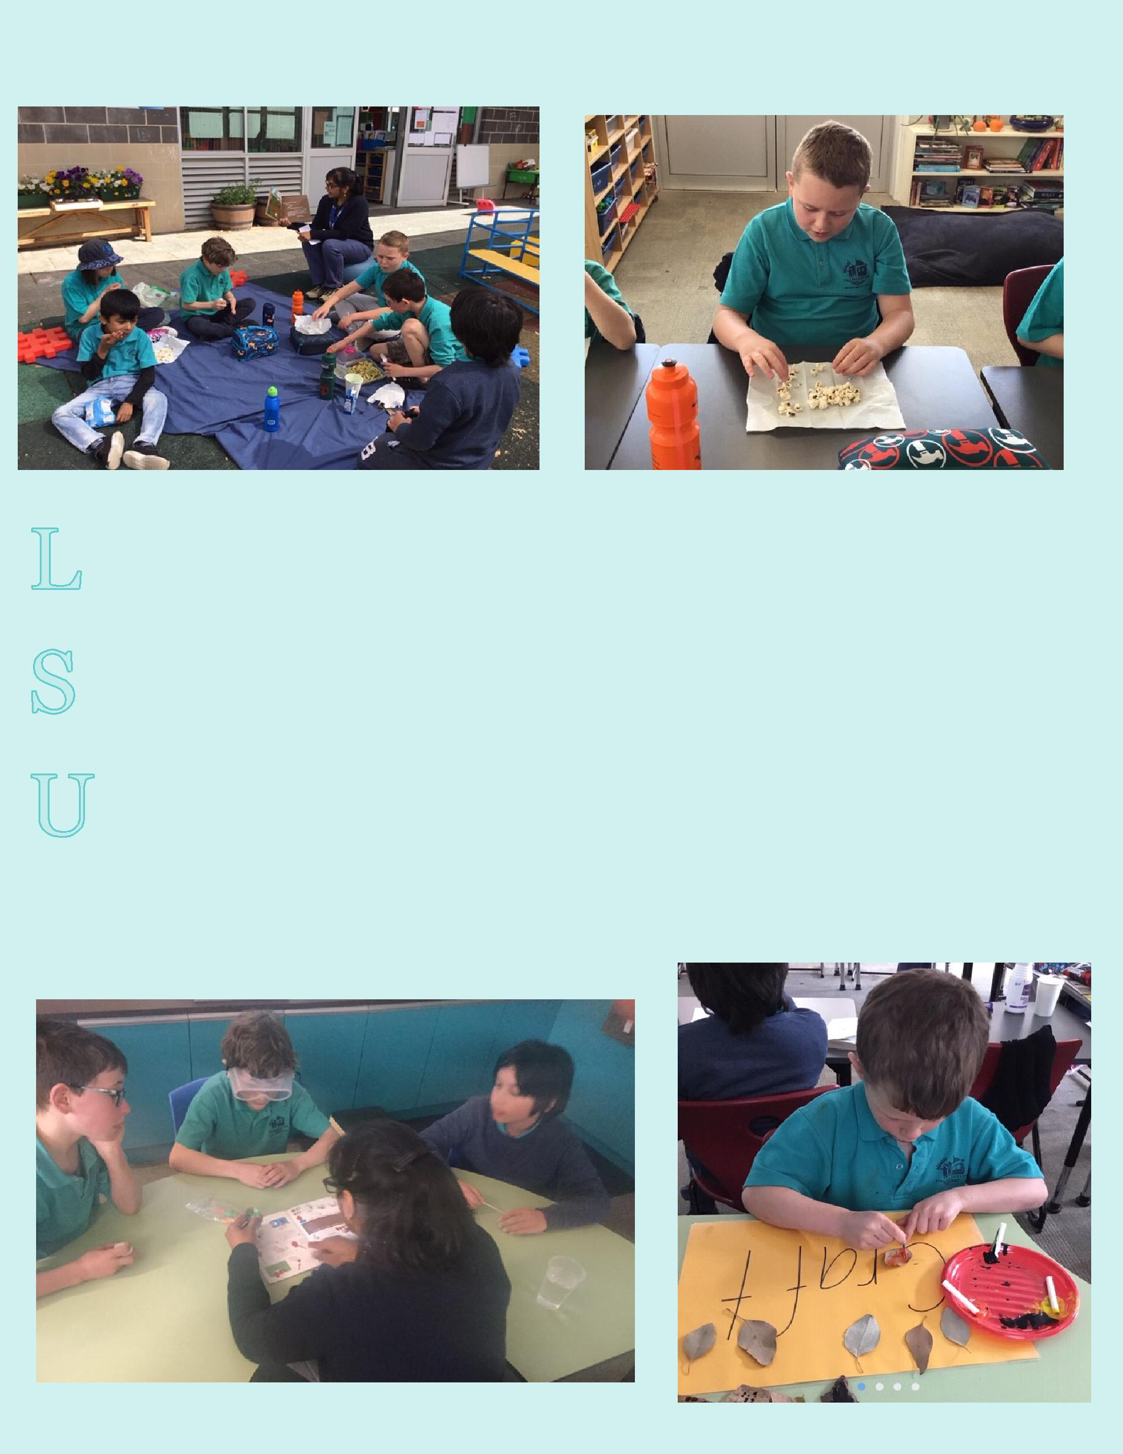
CLASSROOM CONNECTIONS

We have had a busy couple of weeks with lots of hands on activities as we are getting a bit tired. We had our life skills day and tried out a drink with different textures and tastes to broaden our pallet. We cooked sausage rolls and dined with etiquette. During geometry sessions we have been using our geometry sets to create 2D shapes and during number work we used popcorn to count and add- yummy numeracy. We have been working with obstacle courses to build our muscle tone and have been having lunch in the shade in the courtyard while listening to Indigenous stories. We entered the ACT Science Fair as well as the school Science Fair with our biological inquiry on keeping cut avocados fresh. We continue to enjoy chemical science experiments from our Chemistry kit. We completed our recount of our excursion and have started writing letters during our Writers Workshop.

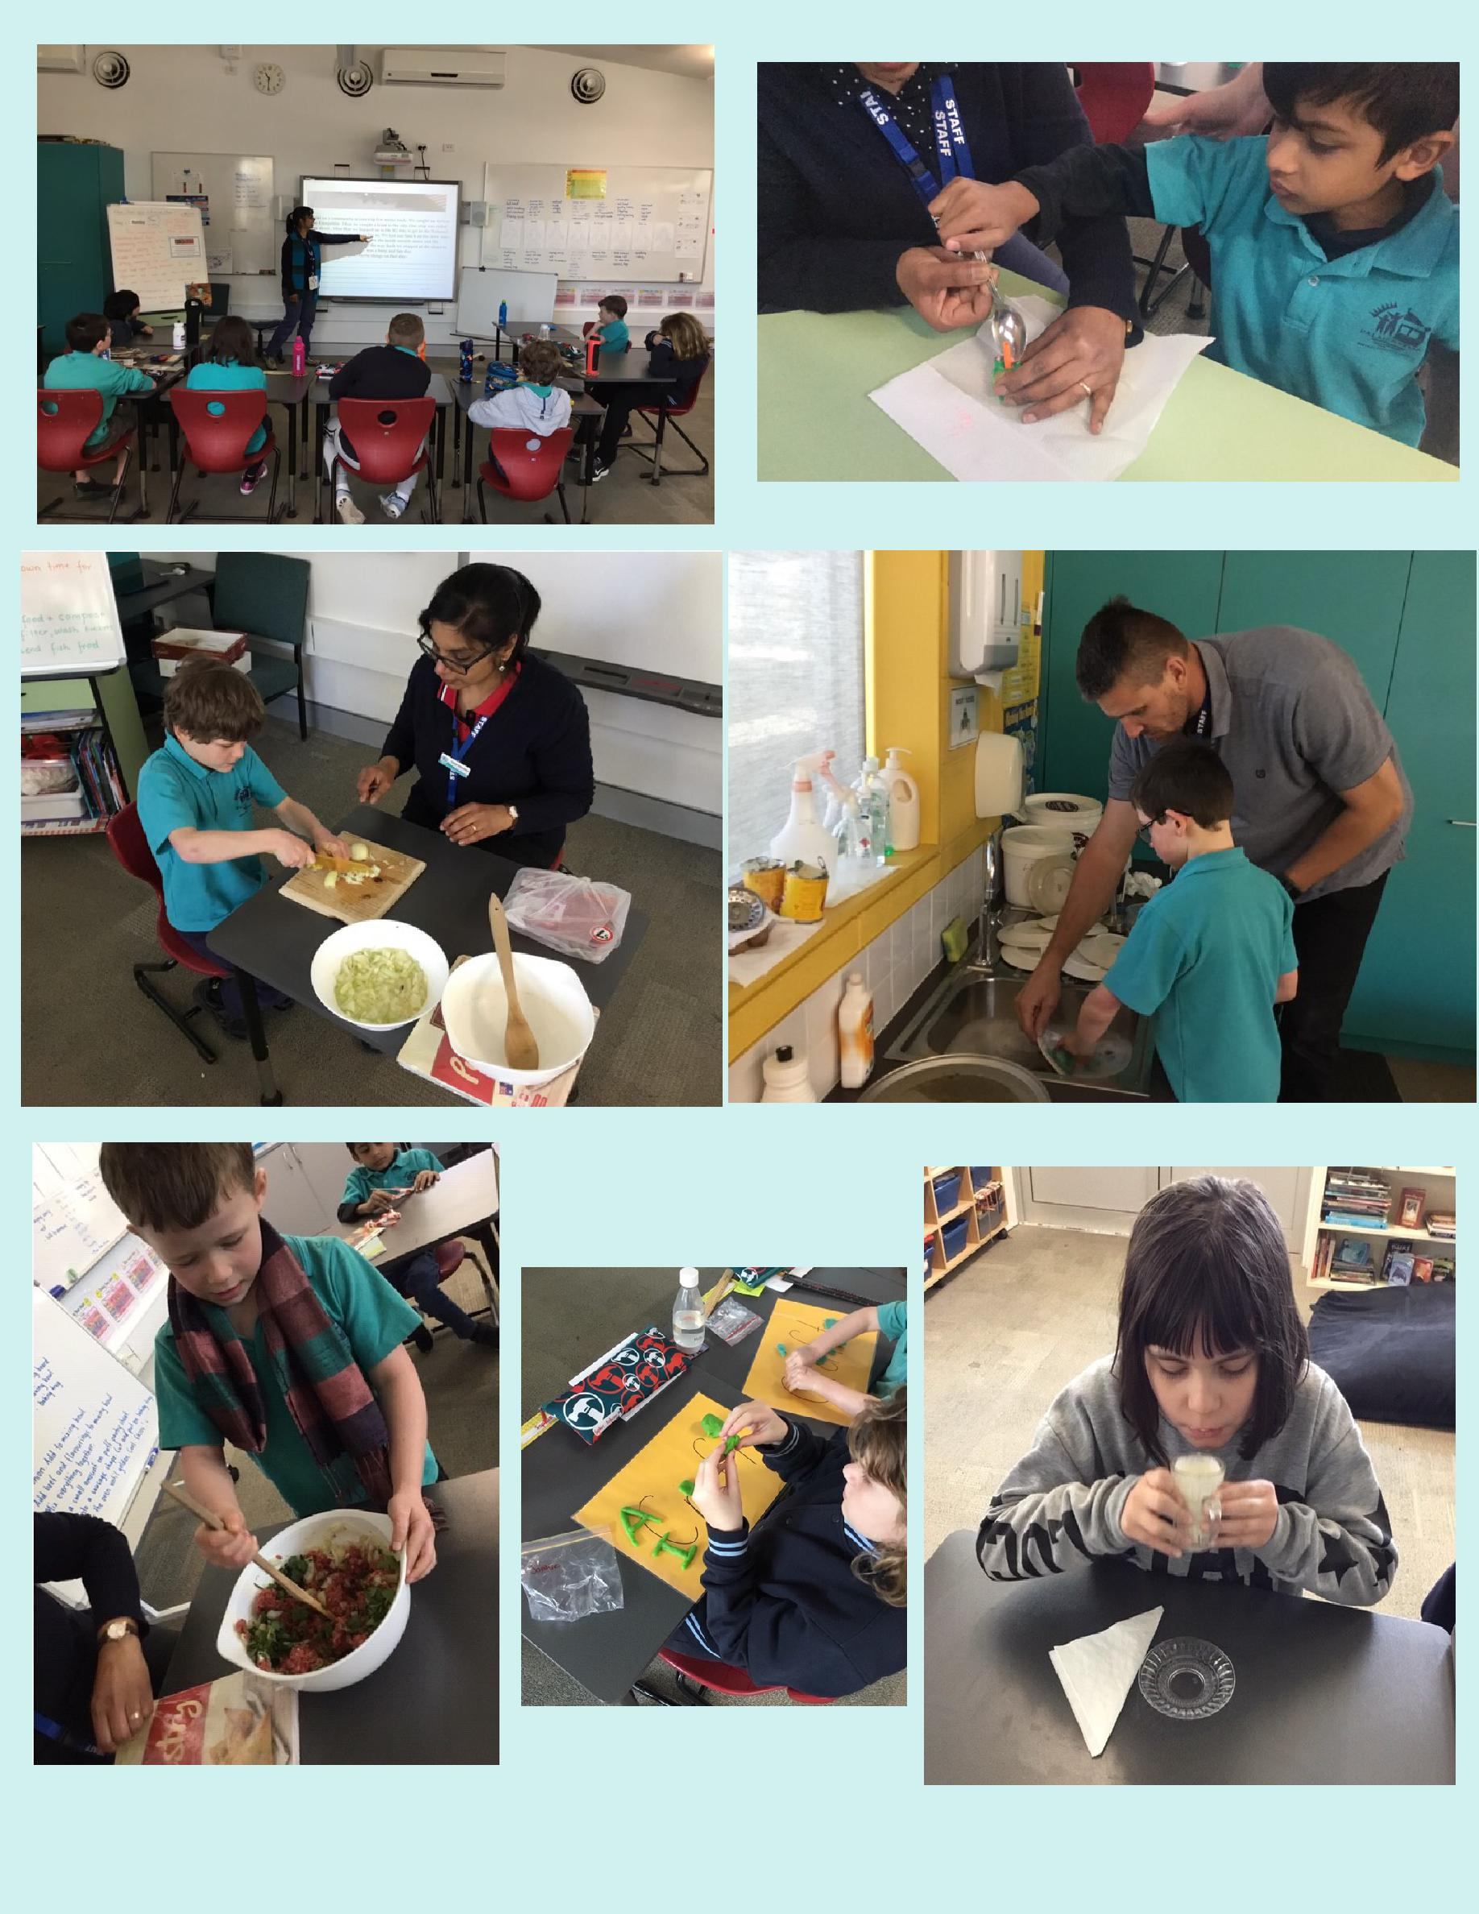

PALMERSTON PRIDE

Congratulations to the following students who received a PRIDE Award at assembly.

PARTICIPATION – becoming involved, “having a go” and cooperating with others.

Aidan—KGM | Kenzie—KGM | Olivia—2DZ | Stephanie—2DZ
Atreya—2DZ | Arya—2SH | Arnav—2SH | Hamish—2MO
Seb—1HD | Eloise—1HD | Ayush—2AF | Kittevat—1KW
Trong—1DE | Lily—KFD | Arshia—KFD | John—KKA

RESPECT – having respect for self, others and their property.

Adi—2DZ | Louie—2AF | Zayaan— 1DE | Lylah—KKA
INTEGRITY – being honest, fair, responsible and loyal.
Heshvi –KMC | Bella—2MO
DETERMINATION - being persistent and resilient.
George—KGM | Vissot—KMC | James—2DZ | Phone—2SH
Monique—2SH | Violet—2MO | Olivia—2AF | Owen—1KW
Vilai—1KW | Alexis—1AS | Mia—1AS | Chris—KKA

EMPATHY - understanding and supporting others regardless of our differences.

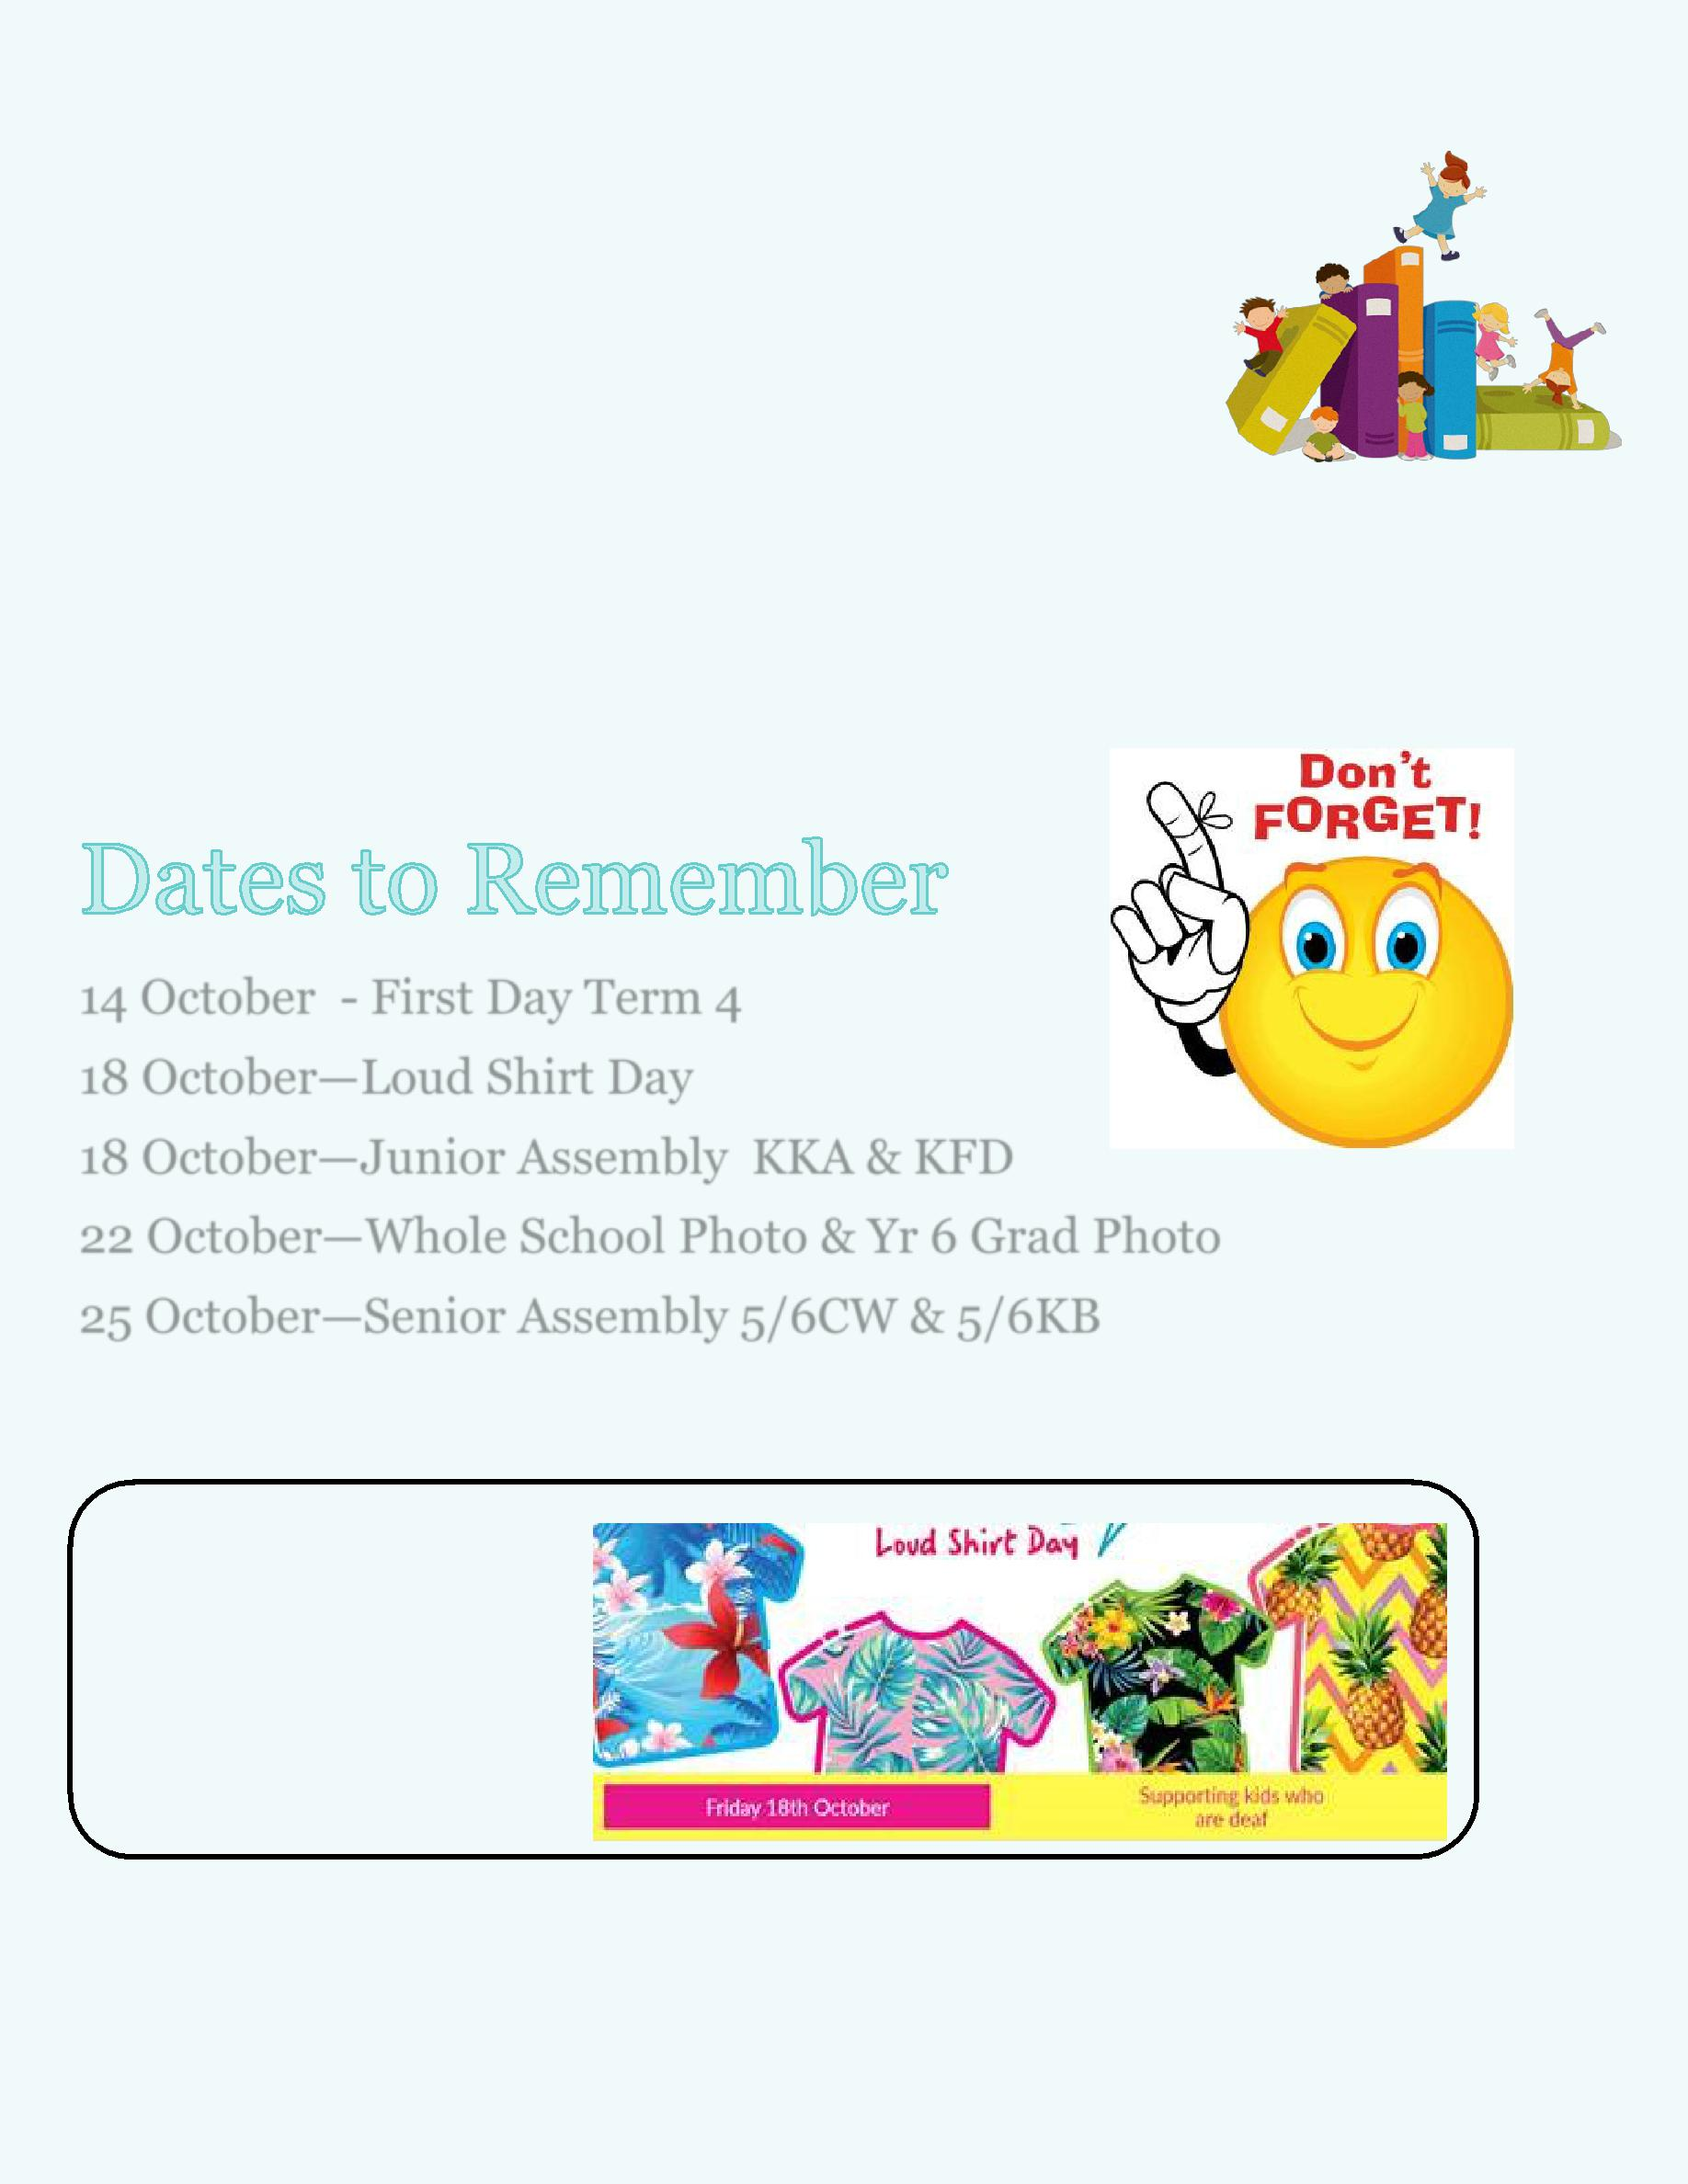
Book Club News

Scholastic have advised that there is a delay in sending books ordered from the last catalogue (Issue6). Unfortunately we will not receive these books until early Term 4.

Scholastic have asked me to pass on their apologies for any inconvenience.

Edwina

14 October - First Day Term 4

18 October—Loud Shirt Day

18 October—Junior Assembly KKA & KFD

22 October—Whole School Photo & Yr 6 Grad Photo

25 October—Senior Assembly 5/6CW & 5/6KB

Students are encouraged to come to school wearing their loud shirts on Friday 18th October.

DEFENCE NEWS

An ADF Family Event: Teen SMART (Ages 11-14), Canberra

Date: Thursday 3rd Oct and Friday 4th October

Time: 12:00pm to 2:30pm, both days.

Where: Defence Community Organisation,
Thesiger Crt, Deakin, ACT 2600

Register: https://www.eventbrite.com.au/e/an-adf-families-event-teensmart-11-14-years-canberra -tickets-69252360675

NOTE: This event is only for Australian Defence Force members and their families. This school holidays, teens of ADF members aged between 11 and 14 are invited to participate in a two-day ‘TeenSMART’ mini-workshop designed to provide teens with skills to manage life within a military family. The workshop will focus on positive self -image, maintaining a peer support network, parental absence, self-care and goal setting. Come along and share ideas, experiences and pizza!

When registering, ensure your email address is accurate as you will receive a booking confirmation and further information via email.

Defence Community Organisation – Coffee Connections - Northside

Location: Café Injoy, 39 O’Hanlon Place Nicholls, ACT
Date: Tuesday, 1st Oct, 2019
Time: 10:00am – 11:30am

NOTE: This event is only for Australian Defence Force members, partners and their families.

ADF members,partners and families in Canberra are invited to join us at our regular Northside coffee group. Come along to this child-friendly café, relax with other ADF families and meet DCO staff.

Kids welcome, but please reserve a ticket for them so we know how many people are coming. When registering, ensure your email address is accurate as you will receive a booking confirmation and further information via email.

Tickets available Eventbrite to RSVP on Canberra Defence Community Organisation Facebook Page.

13

Postings

Are you posting this year or early next year? I would love to know where you are heading for 2019/2020 so I can support your child, if your family are moving into another locality or school. You can contact me via email

kristy.retzlaff@ed.act.edu.au or 6142 1440.

Thank you,

Kristy Retzlaff

Defence School Mentor

Remembrance Day Preparations

I am looking for an expression of interest for serving ADF parents within our school, who might be interested being apart of our whole school Remem-brance Day Service on

Monday 11th November. Please let me know prior to the end of the school holidays via,

kristy.retzlaff@ed.act.edu.au or 6142 1440.

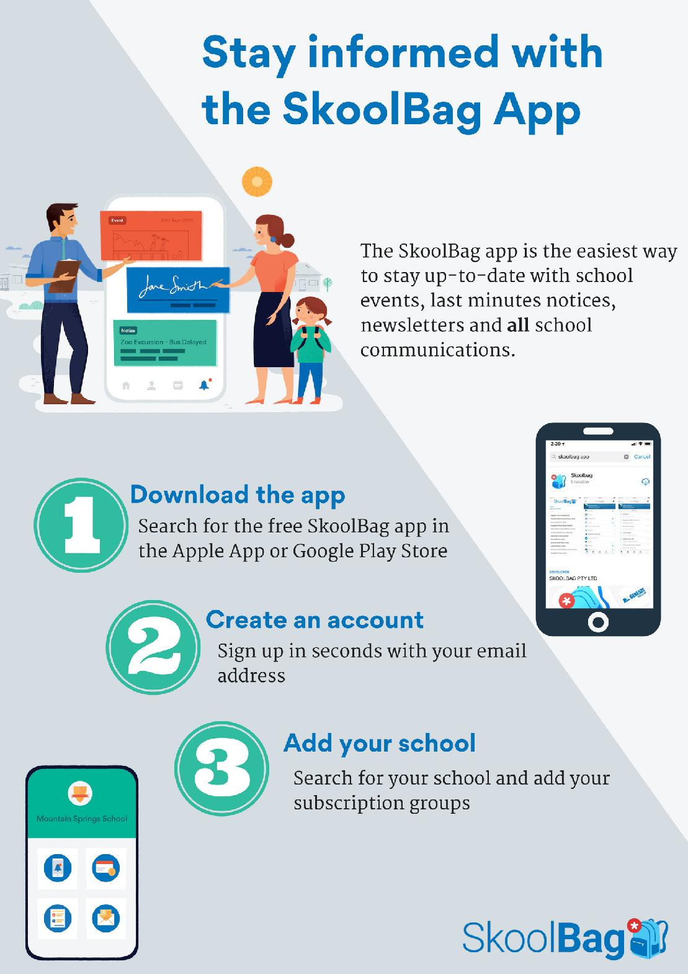

COMMUNITY CONNECTIONS

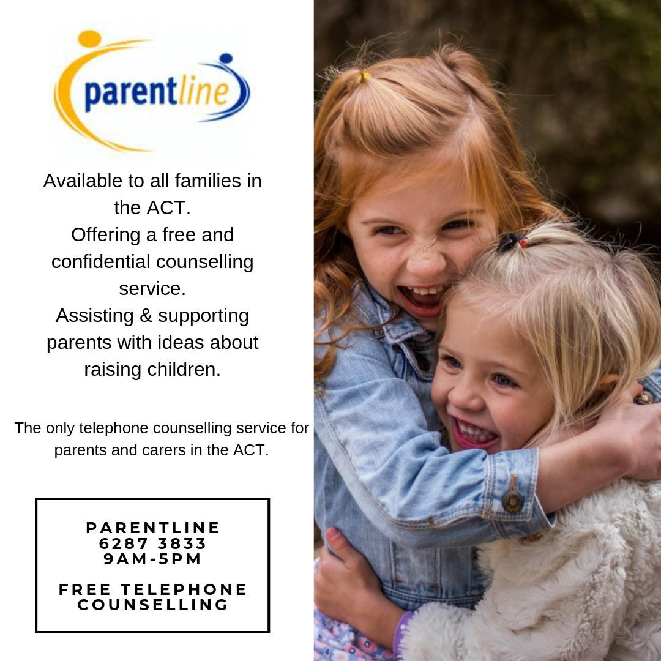

Together WeTogether We Learn From Each Other

An interim updated weekend bus timetable commencing Saturday 28 September is now available online.

An updated weekend bus timetable commences from Saturday 28 September 2019. Updated timetables are available online at transport.act.gov.au

There are no changes to weekday or school services.

The NXTBUS website nxtbus.act.gov.au provides real time service information (up to 90 minutes before

scheduled departure) or use the Transport Canberra’s Journey Planner to look up departure times and plan your trip ahead of time.

For further details visit transport.act.gov.au or call 13 17 10.

Together WeTogether We Learn From Each Other

