What’s On
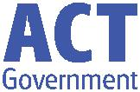

4 April 2018

Week 9, Term 1

ASSEMBLY:
6 Apr | Whole School - IEC
13 Apr | Senior– Year 3
DATES TO REMEMBER:
6 Apr | P&C Disco
9 Apr | North/Gungahlin
 | Swimming Carnival
10 Apr | P/S (beginning)
 | Healthy breakfast
11 Apr | Cross Country
 | Carnival
11 Apr | 5pm Seesaw parent
 | information session
13 Apr | P/S (end) Healthy
 | breakfast
13 Apr | P&C Sausage Sizzle
 | Lunch Order

NOTES HOME:

- ICAS Digital Technologies (Yr 2-6)

- Ukulele Band Expression of Interest (Yr 4)

- Rostrum (Yr 3-6)

P&C BOARD NEWS P&C: 8 May 2018

All P&C activities, meeting agendas and minutes are available from the School website at – Parent Corner

School Board:

PRINCIPAL’S MESSAGE

I hope you all had a relaxing Easter weekend. The students have come back rested and enthusiastic for the last two weeks of term. Each morning at assembly I can feel the excitement of learning and see the enthusiasm in the classrooms as I walk around. The students have been working hard this term and I would like to acknowledge their commitment to school and also, the commitment from the teachers.

Easter Hat Parade

Last Thursday we had the Easter Hat parade. The Junior school P-2 excelled once again with creative Easter Hat designs. A great time was had by all. Thank you for the Easter egg and gift donations.

Light Rail Ambassadors

Today, we have four senior students attending the light rail presentation, as they will be light rail ambassadors. Thanks to Mr Gowen and Ms Brailey and parents who attended with them.

School Board

The School Board members for 2018 can now be announced. Welcome to Lisa Fior and George Villaflor to the roles along with Jesse Dang as our parent reps. Teachers reps remain the same; Jess Lago and Maxine Green. Thank you to all who were interested in being on the school board this year. I would like to pass on our thanks to Julian Fior who was our School Board chair and is leaving the position after the AGM.
Environmental Award

ACTSMART will be attending our school assembly tomorrow as Palmerston District Primary School has been awarded ACTSMART Schools Five Star accreditation! Our dynamic environmental science teacher, Karon Campbell has provided an environment of learning for our students that has led to Palmerston being recognised in excellence in this area. “Karon your dedication and passion has resulted in the school being an example of ‘best practice’ in sustainability education.”

Enjoy sunshine this week,

Melissa Travers

Together, we learn from each other

What’s On Page 2

UPCOMING EVENTS

P&C Disco

Date: Friday 6 April 2018

Location: Palmerston District Primary School, hall

K - Yr 6 P&C Sausage Sizzle Lunch Order

Date: Friday 13 April 2018 (please note change of date)

Location: Palmerston District Primary School
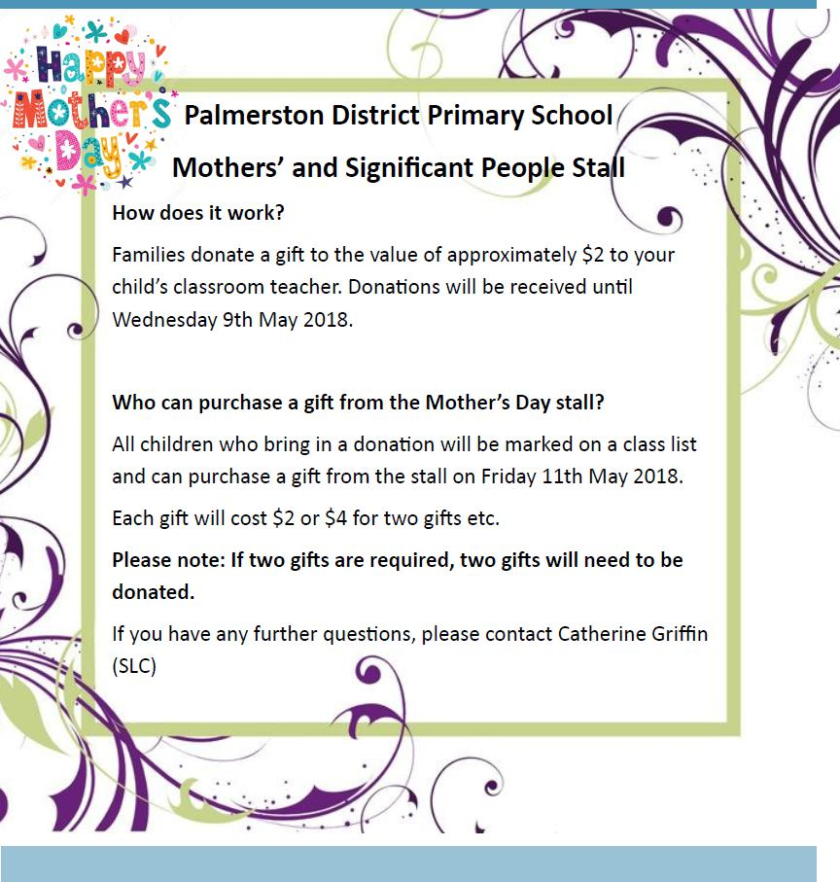

Together, we learn from each other

What’s On Page 3

ICAS

ICAS entry forms will be sent home to all students in Year 2-6.

ICAS assessments have taken place annually in schools for over thirty years and in 20 countries. Educational Assessment Australia (EAA), who design and deliver the assessments, is the not-for-profit arm of the University of New South Wales. Palmerston is once again going to take part in ICAS. This is voluntary for families.

ICAS is an annual skills development assessment program and available in the areas of English, Mathematics, Science, Spelling and Writing. Palmerston School is now able to offer Digital Technologies. The tests take 30–60 minutes and are supervised at school. Certificates are awarded to all students who participate. If you register to participate and are sick on the sitting date you will participate in a catch up at a suitable time in the following weeks.

Results are available to parents and students online. These online reports and analyses remain available indefinitely. ICAS reports indicate which questions were answered correctly and compare student performance to that of the other students tested.

To enrol your child in ICAS, please complete the registration form and return it, with your entry fees, to school by Friday 13 April (Week 10).
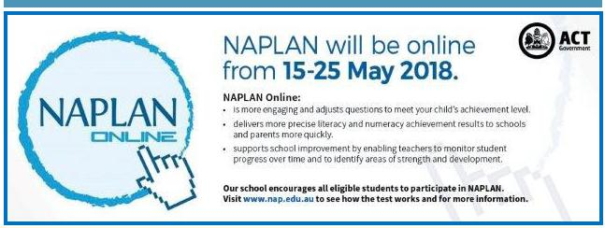

Together, we learn from each other

What’s On Page 4
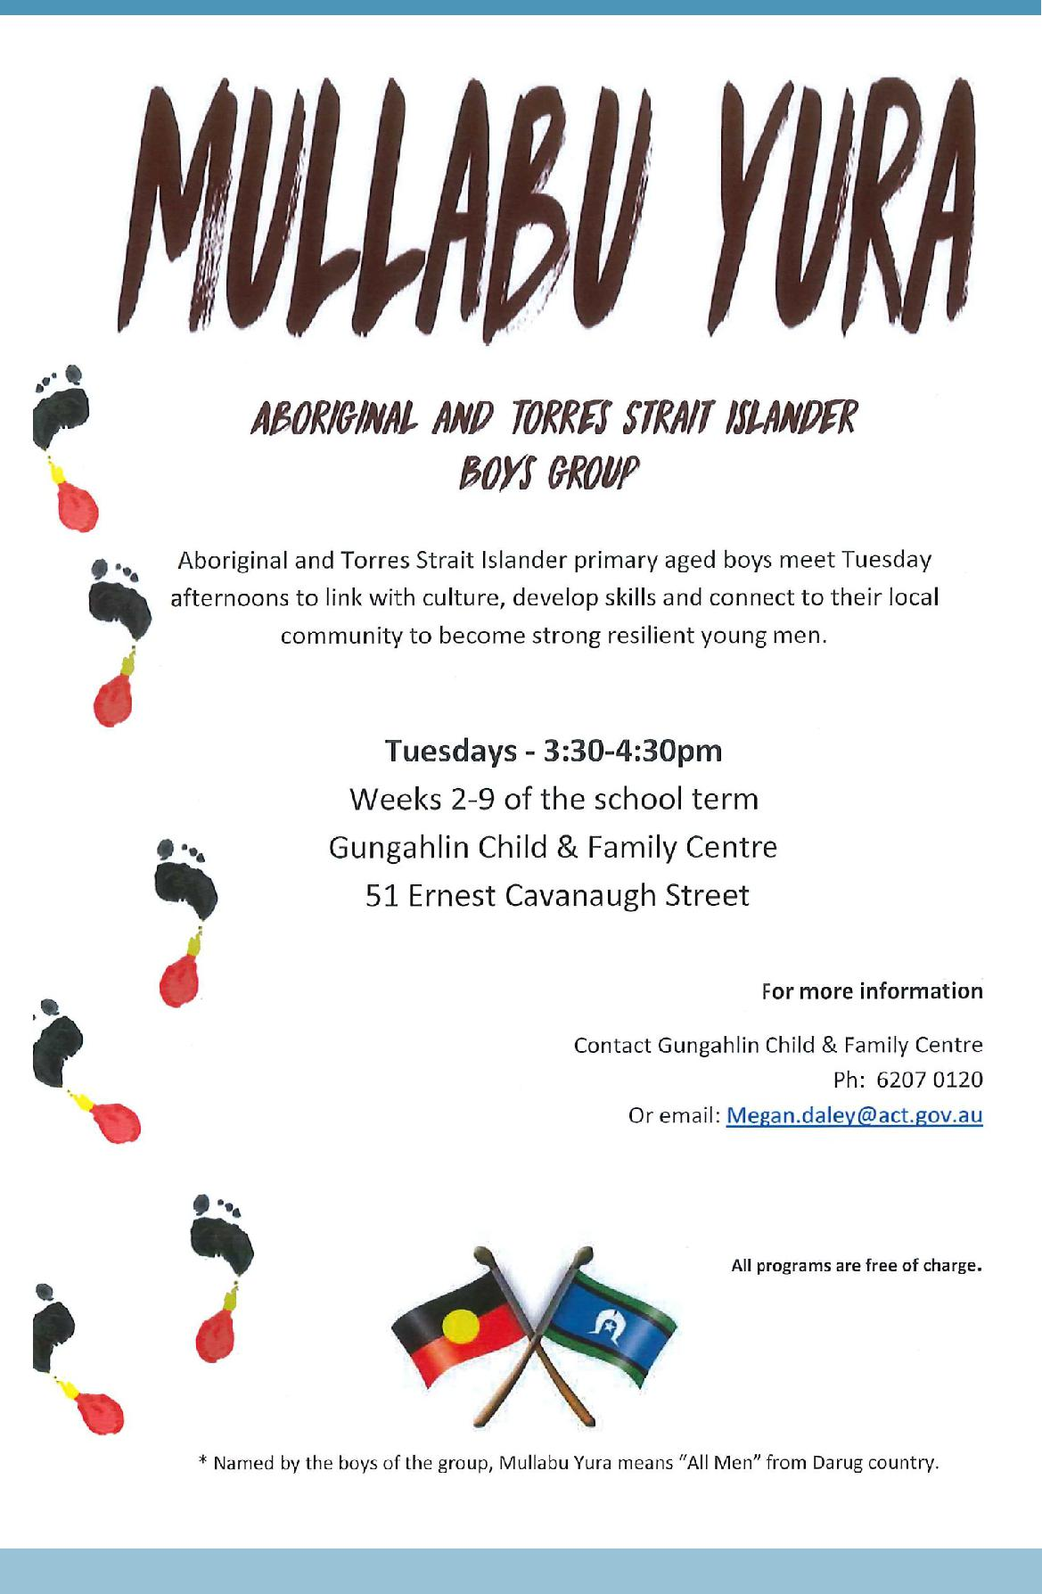

Together, we learn from each other

What’s On Page 5
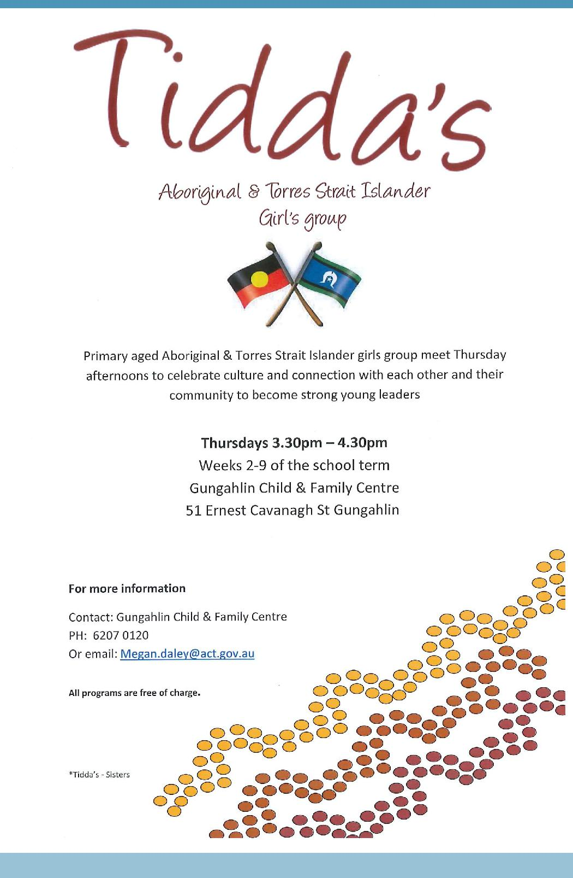

Together, we learn from each other

What’s On Page 6
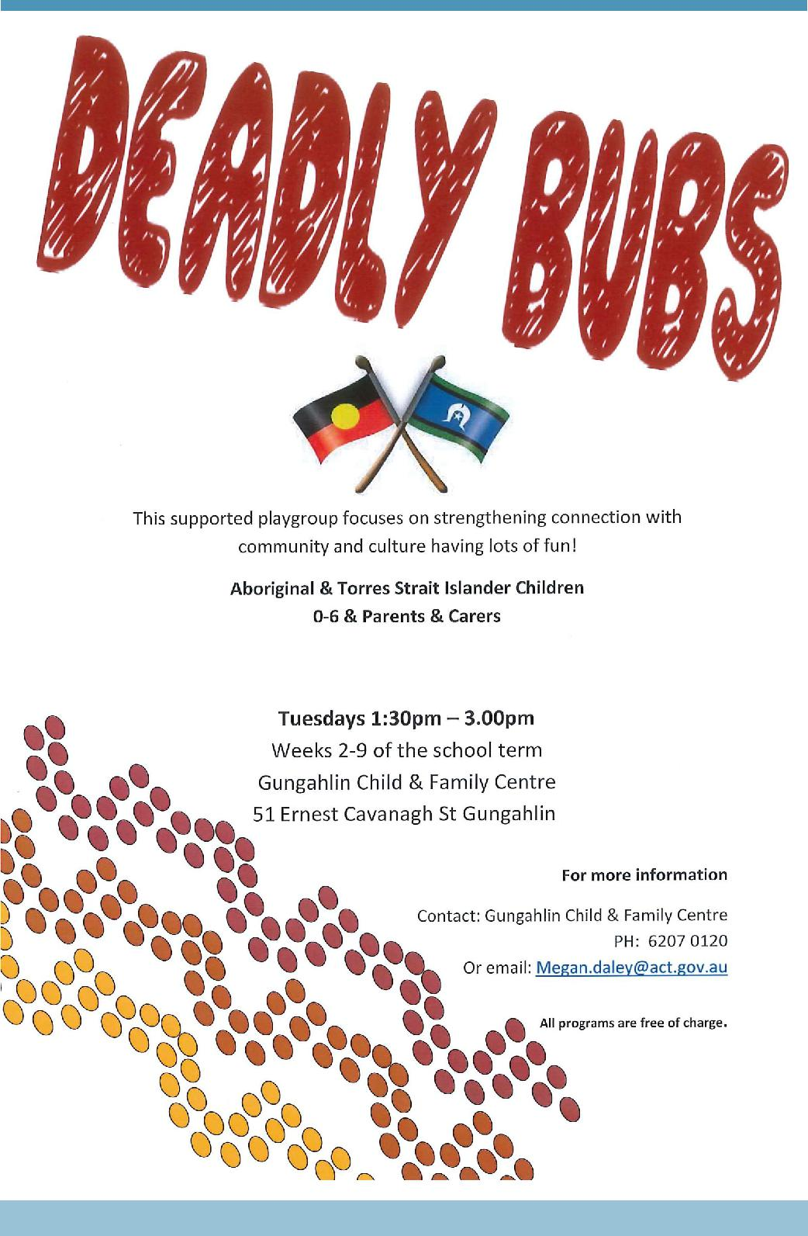

Together, we learn from each other

What’s On Page 7
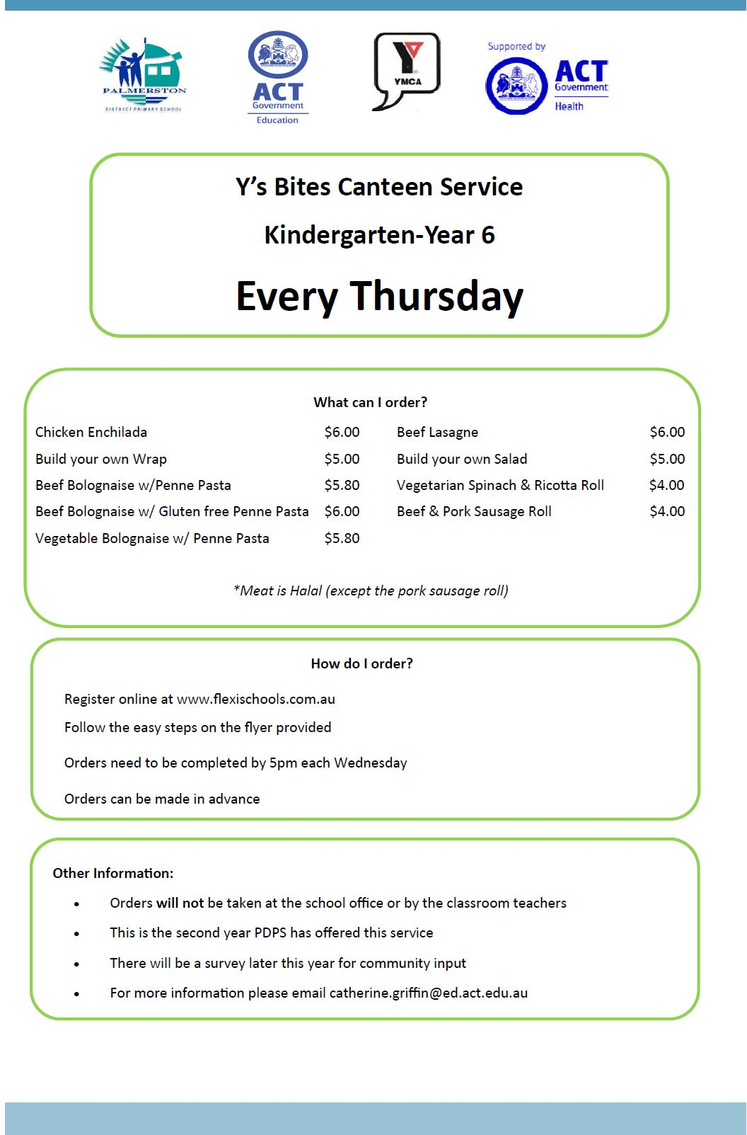

Together, we learn from each other

What’s On Page 8
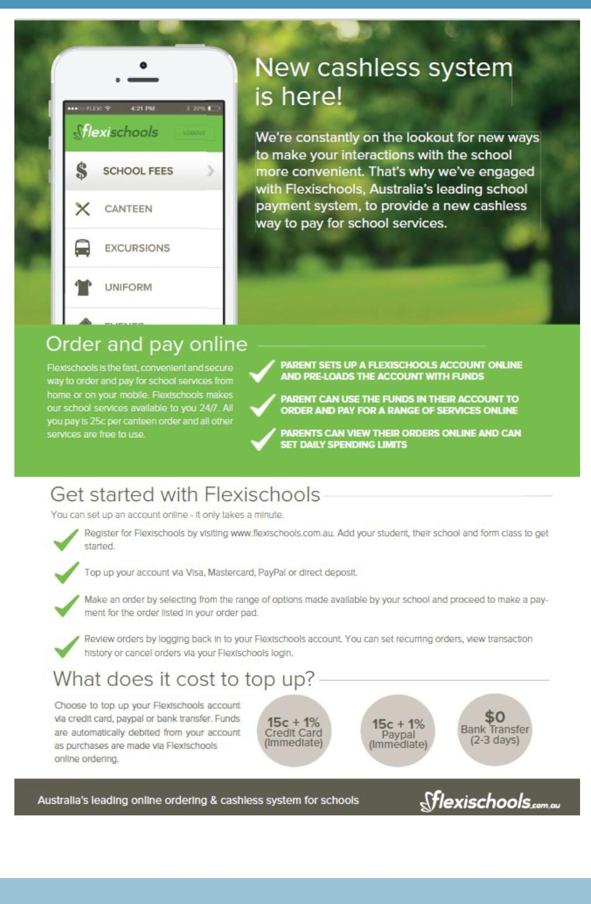

Together, we learn from each other

What’s On Page 9

COMMUNITY NEWS

REMEMBER TO PARK SAFELY AND LEGALLY AROUND SCHOOLS

Every day across Canberra, parents are parking illegally in school zones and putting all kids in the area at risk. With school parking patrols increasing in 2018, if you keep doing it, you will get caught and you will be fined.

Check out this short video– https://www.youtube.com/watch?v=H6B6PPgOC8I

THINK BEFORE YOU PARK…AND KEEP OUR KIDS SAFE - MAKE PARKING SAFETY A PRIORITY!

Please:

- keep clear of ‘no stopping’ and ‘no parking’ zones

- don’t park in bus zones on school crossings, across footpaths or driveways; and

- don’t double (or triple) park.

Remember - it’s okay to park a little further away from the school and walk the rest of the way! Consider - having a pre-determined meeting spot agreed with your kids. That way if you are a little late, they know where to wait.

Think – visibility around schools and if your car may be blocking the view of crossings for other motorists. Also be mindful when entering or leaving parking spots – look twice!

Be kind – to other road users and pedestrians and also if you see any parking officers in the area – they are doing their job and working to keep our kids safe!

Note - licence Plate Recognition (or electronic chalking) vans are now actively monitoring schools. Penalties range from $114 upwards to $600. Details at www.act.gov.au/accessCBR

Together, we learn from each other

