What’s On

23 August 2018

Week 5, Term 3

ASSEMBLY:

24 Aug Senior - Yr6

31 Aug Father’s Day Celebrations

DATES TO REMEMBER:

24 Aug Yr5 Band Pair (at Palmerston)

28 Aug P/S Father’s Day Stay & Play

29 Aug Yr3-6 Author Visit—Susan

Berran

30 Aug Nth/Gungahlin Track & Field

31 Aug P/S Father’s Day Stay & Play

31 Aug K-Yr6 Father’s Day Breakfast

& maths games & stall

3 Sep Yr5/6 Think U Know - Cyber

Saftey (students)

4 Sep Parent Information Session -

Cyber Safety

6 Sep LSU DreamCricket Clinic

7 Sep P&C School Disco

NOTES HOME:

- School Photos

- K-Yr6 Mathematics Information Night (youngest)

- Father’s Day Breakfast information (youngest)

P&C BOARD NEWS

P&C: 7:00pm 17 Sep 2018

All P&C activities, meeting agendas and minutes are available from the school website at – Parent Corner

School Board: 7:30am 6 Sep 2018

PRINCIPAL’S MESSAGE

I would like to thank all the families that could make it to our annual Book Week Parade. A great time was had by all. Each year we are so lucky to have a community that so values books, reading and community events.

This weekend we have our annual Tournament of the Minds (ToMs) weekend at Campbell High for our senior students. ToMs is run by Mrs Fletcher and our students compete against other schools in Canberra in interpretive drama events over Saturday and Sunday. Palmerston students have been in ToMs for many years and we always do well. Thanks Mrs Fletcher. Also big thanks in advance to the teachers who attend and support and to the parents who transport their children there and support them.

We have a great event on next week, a favourite author of the Palmerston students will be visiting – Susan Berran. And remember, Friday next week is our Father’s Day breakfast and maths games morning.

ACT Policing is investigating reports of a child approached at a Belconnen area primary school.

These unfortunate incidents are a good reminder to us all to help our children understand the importance of stranger safety and the need to report any unusual incidents or approaches to staff immediately. ACT Policing urging anyone who may have witnessed any incidents or have any information that could assist Police to contact Crime Stoppers on 1800 333 000, or via www.act.crimestoppers.com.au Information can be provided anonymously.

Please support us to keep our children safe by having conversations about moving safely around the community and what to do if they ever feel unsafe. You may wish to visit the ParentLink website for tips. Our teachers will also discuss protective behaviours next week.

Together, we learn from each other

What’s On

The School and the Education Support Office will continue to work with ACT Policing on this issue.

Please do not hesitate to contact me should you have any questions.

Have a great week,

Melissa Travers

DEPUTY PRINCIPAL’S MESSAGE

Book Week

What a fantastic week we have had this week celebrating the wonder of books! We kick started the week with a book parade of costumes by our start of the week preschool classes. In line with the 2018 Book Week theme “Find Your Treasure” we saw many fabulous pirate costumes as well as fairies, Dr Seuss characters and many more.

Today we had a fabulous time at both end of the week preschool group parade and the K-6 Book Week parade. The costumes were amazing and we thoroughly enjoyed seeing the characters from books come to life. I would like to say a big thank you to Ms McNeice and Mrs Fletcher for organising this event and thank all families for supporting this successful event.

Wellbeing

Here at Palmerston we run a variety of wellbeing programs throughout the year under the KidsMatter umbrella. KidsMatter is a mental health and wellbeing framework that has been proven to make a positive difference to the lives of Australian children. It provides the methods and tools to help schools support the social and emotional needs of children.

In my newsletter items for the remainder of the term I thought I would take the time to focus on and highlight some of the wellbeing programs and processes we have in place to support our students at Palmerston.

Peer Support

Peer support is an evidence based, peer led approach designed to enhance the mental, social and emotional wellbeing of children. All year levels K-6 participate in this program and it supports a positive school climate and culture.

Peer support empowers young people to support each other and contribute positively to the life of the school, develops skills in resilience, assertiveness, decision making, problem solving and leadership and provides authentic leadership opportunities for our year 5/6 students.

The Peer Support program operates on a Thursday afternoon for the majority of term three. This program is run by our year 5/6 students who have had specific training in the Peer Support modules which take a different focus each year. This year the focus is on relationships and building and keeping friendships. Please go to www.peersupport.edu.au for more information.

Circle Time

Circle Time is an evidence based, positive whole school approach that empowers students. It is used to support children and teachers to work together to celebrate successes and to discuss ideas and problems that may affect either individuals or groups of students. Circle Time has proved successful in promoting positive relationships and makes significant impact in developing children’s social and emotional skills and attitudes. Circle Time also helps to create a sense of belonging and connectedness within a group.

Together, we learn from each other

What’s On

PBL update

We are pleased to announce that we now are moving forward with the mascot competition. We were overwhelmed with the amount of entries received for the completion and staff and students have had a really tricky time choosing semi-finalists. The semi-finalists will be announced on Monday dur-ing morning lines by our PBL student group. We would love to hear from you about what you would like the mascot to be. Voting slips will be available on the black top before morning lines each day next week including at the Father’s Day breakfast. A table with voting slips will be set up in front of the deck near kindergarten. The students will also be provided with the time to vote. If you cannot make it into the school before school or on Father’s Day you can also pop by the front office and place your vote.

We look forward to seeing many of you at the Father’s Day breakfast next week.

Kate Flynn

WORKING WITH VULNERABLE PEOPLE CARD

Just a reminder, to families, we support the ACT Government Policy in safeguarding our students by complying with the Working with Vulnerable People (WWVP process). We ask our parents/carers who volunteer regularly in our school to apply for the WWVP card.

The WWVP Act requires those who work or volunteer with vulnerable people to have a background check and be registered. The process is very simple to apply for a WWVP registration card follow these three easy steps.

- Complete a WWVP application for registration (online)

- Attend an Access Canberra Service Centre located at Belconnen, Gungahlin, Tuggeranong or Woden to provide proof of your identity and have your photo taken.

- Receive your WWVP registration card by post after access Canberra has assessed your

application.

When you have your card, drop into the front office show us and we will keep a photocopy of it.

THINK U KNOW PARENT INFORMATION SESSION

Save the Date!!

Our school will be hosting a ThinkUKnow presentation on 4 September at 5:30pm in the CAP Pod. ThinkUKnow is a cyber safety education program that educates parents, carers and teachers on how people are using technology, the challenges they may face online, and how to help them overcome these in a safe and ethical way. ThinkUknow is a partnership between the Australian Federal Police, Microsoft Australia, Datacom and the Commonwealth Bank. The presentation will be delivered by a local law enforcement member and an industry volunteer. It will cover issues relating to children and young peoples’ privacy and security online, their relationships with other users and their online reputation. It provides insight into the devices young people are using, as well as the popular websites, apps and social networking sites they’re accessing. The ThinkUKnow team will also be providing an education session for our year 5/6 students. This is a great opportunity for you to learn more about young people and the online environment. For more information you can visit www.thinkuknow.org.au or contact Haeley Simms via the front office.

Together, we learn from each other

What’s On

UPCOMING EVENTS

Yr 5 Woodwind Band Pair

Date: Friday 24 August

Location: Hall, Palmerston District Primary

Preschool (Brave, Itchy & Noisy) Father’s Day - Stay & Play Date: Tuesday 28 August

Location: Palmerston Preschool

Yr3-6 Author Visit - Susan Berran

Date: Wednesday 29 August

Location: Palmerston District Primary

Preschool (Cranky, Hungry & Sleepy) Father’s Day - Stay & Play Date: Friday 31 August

Location: Palmerston Preschool

K-Yr6 Father’s Day Breakfast & Maths Games & Stall

Date: Friday 31 August

Location: On the blacktop & in PoDs

Yr5/6 Think U Know Cyber Safety

Date: Monday 3 September 2018

Location: Palmerston District Primary

Think U Know Cyber Safety Parent Information Session

Date: 5:30-7:00pm Tuesday 4 September 2018

Location: Multipurpose Building, Palmerston

LSU DreamCricket

Date: Thursday 6 September 2018

Location: Palmerston District Primary

P&C “80’s/Neon” Disco

Date: Junior - 6:00-7:15pm, Senior - 7:30-9:00pm Friday 7 September 2018

Location: Palmerston District Primary

Together, we learn from each other

What’s On
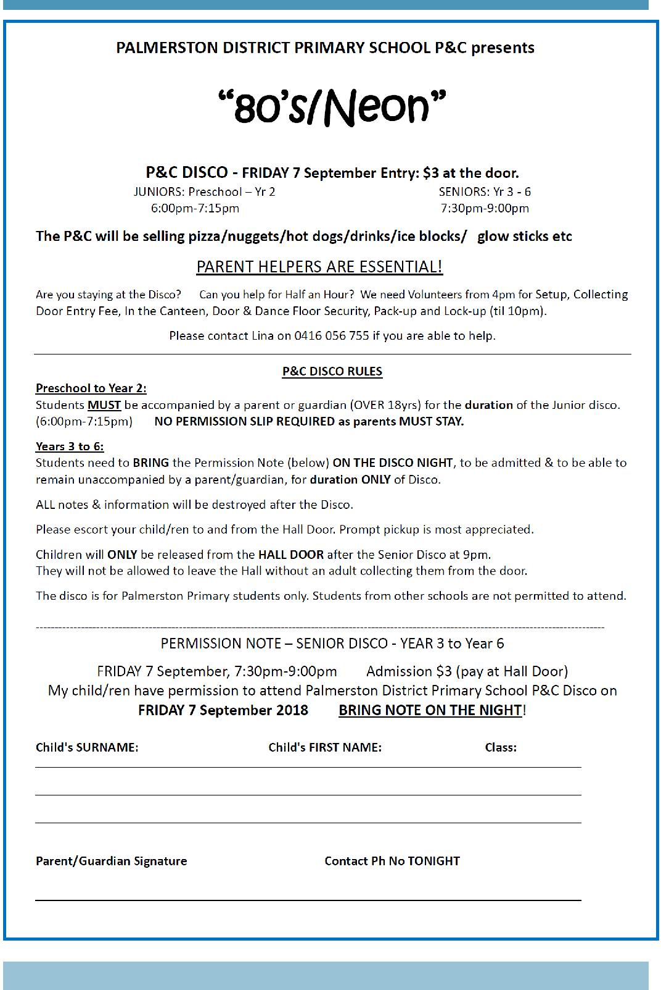

Together, we learn from each other

What’s On
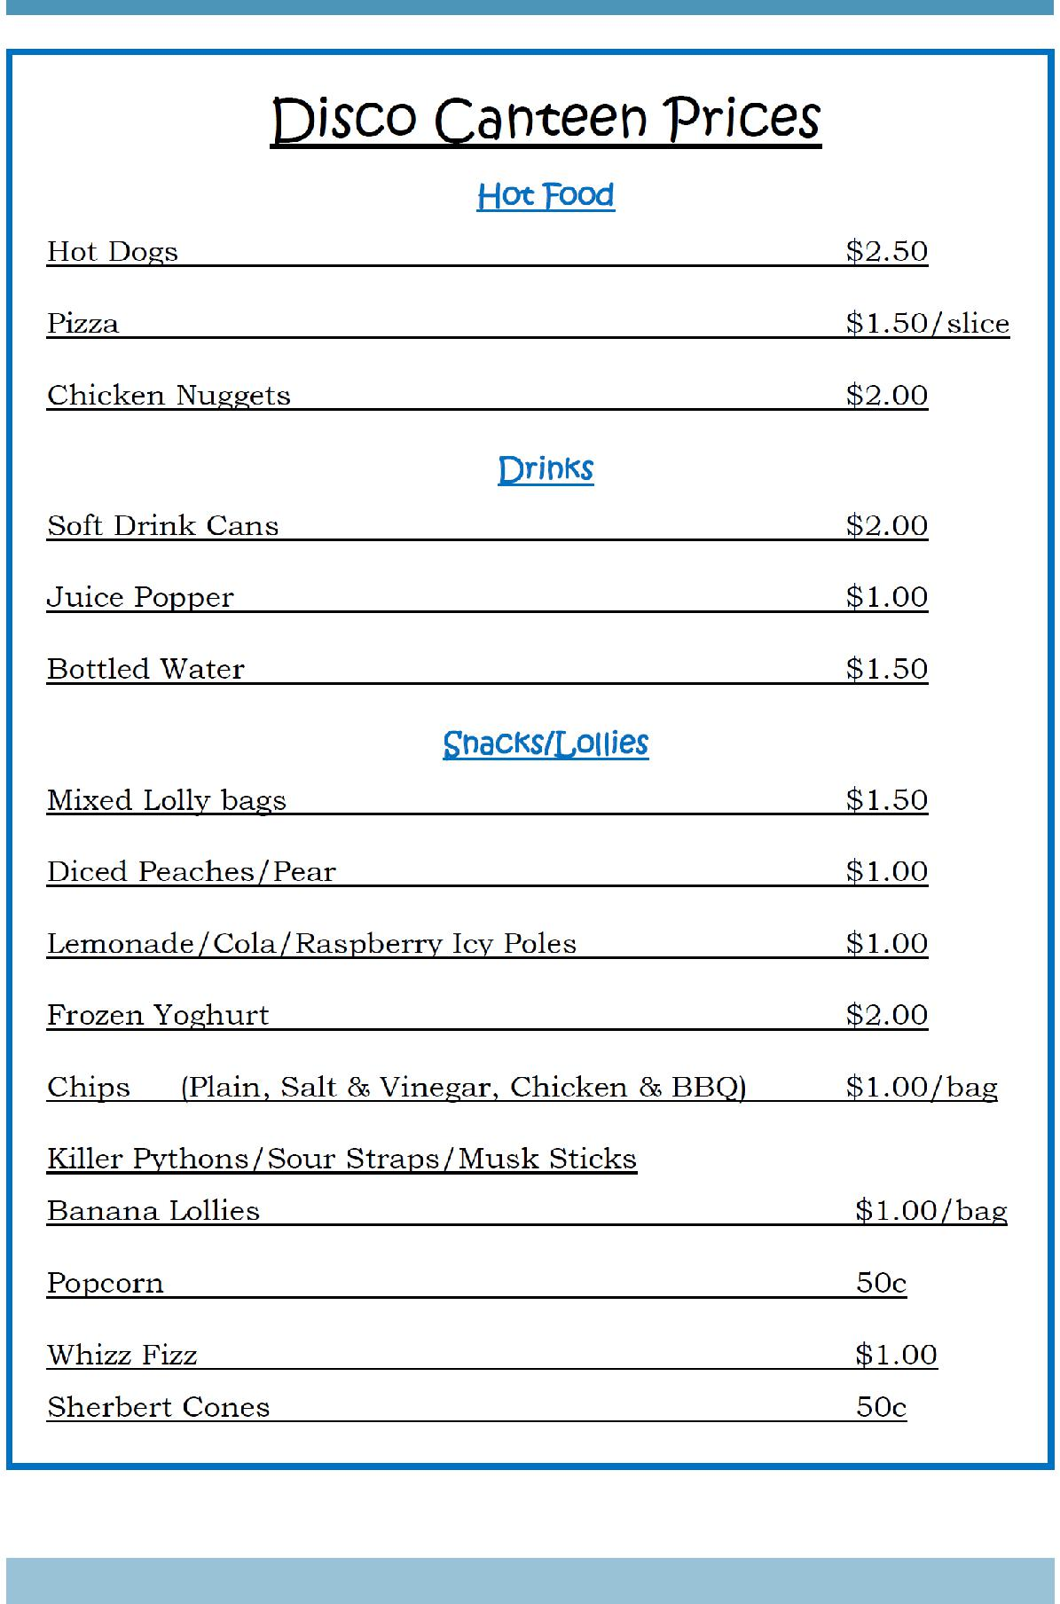

Together, we learn from each other

What’s On

SCHOOL INTENTIONS 2019

School Leavers 2019

We have now reached the time in the year when we begin to look at our school numbers and staffing arrangements for 2019. If your circumstances have changed and your child/ren will not be attending Palmerston District Primary School in 2019 can you please let the front office staff know as soon as possible.

My child/ren will not be returning to Palmerston in 2019.

Name Class

Last day at Palmerston:

My child/ren will be attending:

Another government school in the ACT:

A non-government school in the ACT:

Moving out of the ACT

Forwarding Address:

Phone number:

Parent’s name:

Together, we learn from each other

What’s On
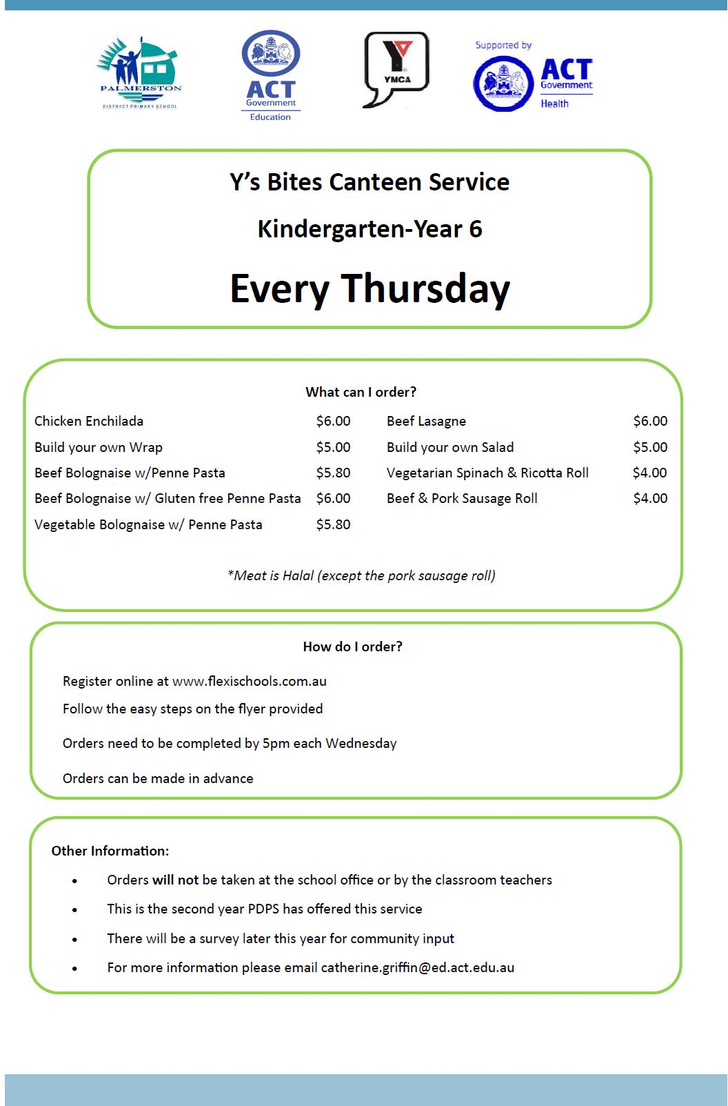

Together, we learn from each other

What’s On
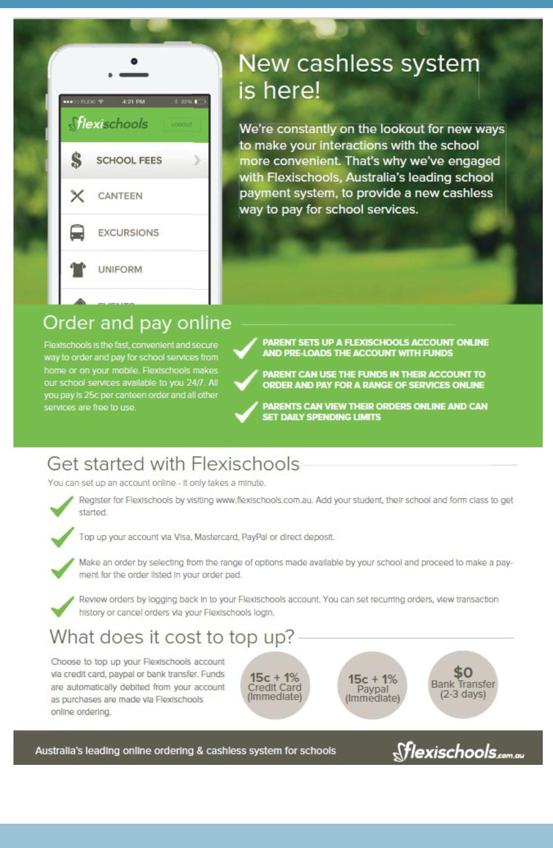

Together, we learn from each other

What’s On
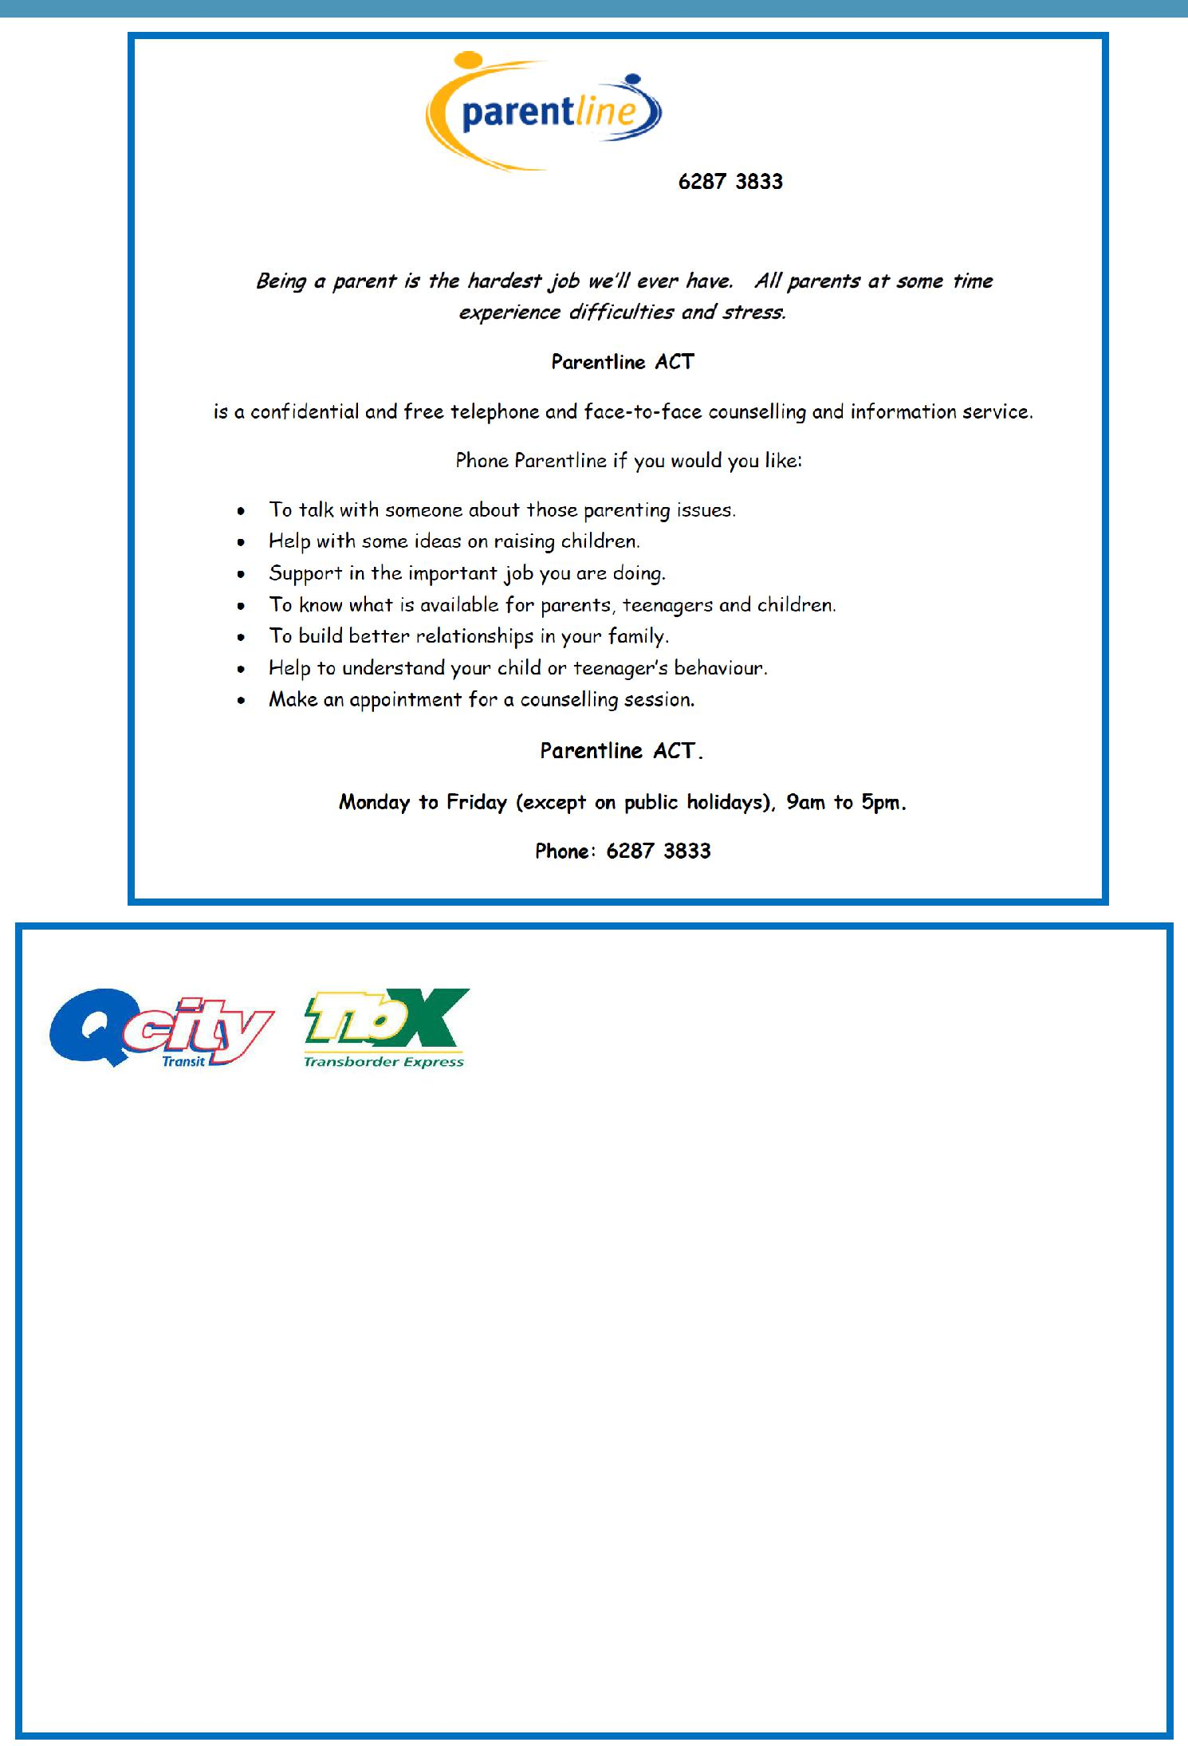

CHANGES TO SCHOOL BUS SERVICES

Changes will come into effect from Monday 3 September 2018. These changes are being implemented to improve the provision of consistent, accurate and easily identifiable bus services across regional New South

Wales and improve customer access to current transport information. The naming and numbering of school routes will be updated as detailed on the Schedule of School Route Service Changes attached. In addition, a full listing of the new school route numbers will be available on the Qcity Transit website, www.qcitytransit.com.au prior to the changes coming into effect on the 3rd September 2018.

During a transition period of one month all school bus services will display the current/old bus number and the new bus number to ensure students and teacher can clearly identify them.

A list of the school services that effect your school is in the table below for information.

Current Bus | New Bus | AM/ | Coming From (AM)/Going To (PM):
No. | No. | PM
81 (Bilby) | S102 | AM | Jiparu via Hall Interchange
83 (Koala) | S203 | PM | Murrumbateman via Hall Interchange

Together, we learn from each other

What’s On
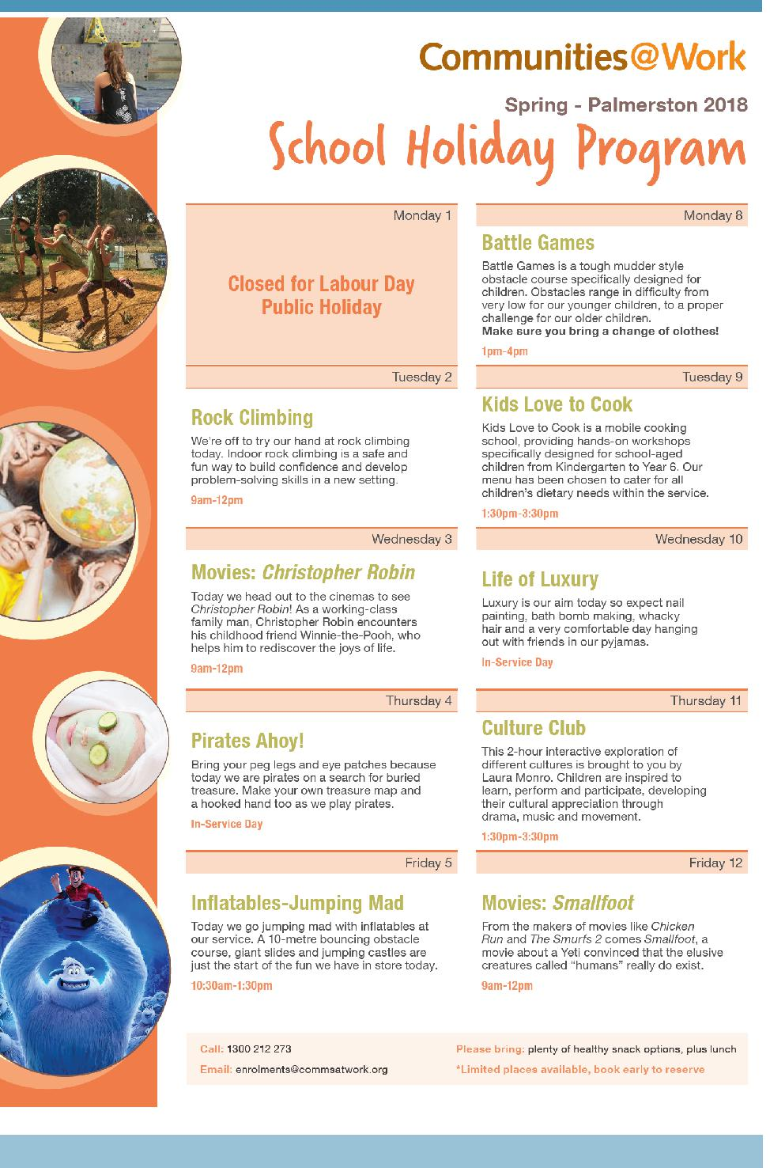

Together, we learn from each other

