Teacher’s celebrating mufti day (for the Twilight Fair)
Palmerston Post

22 November 2018

Week 6, Term 4

Board Chair: Lisa Fior Board Members: Parent Reps: Jesse Dang and George Villaflor

Teacher Reps: Jessica Lago and Maxine Green

P&C President: Lisa Fior

Principal: Melissa Travers Deputy Principal: Kate Flynn & Haeley Simms (acting)

Executive Teachers: Kylie Moller, Matt Gowen, Felicity McNeice, Catherine Griffin (acting)
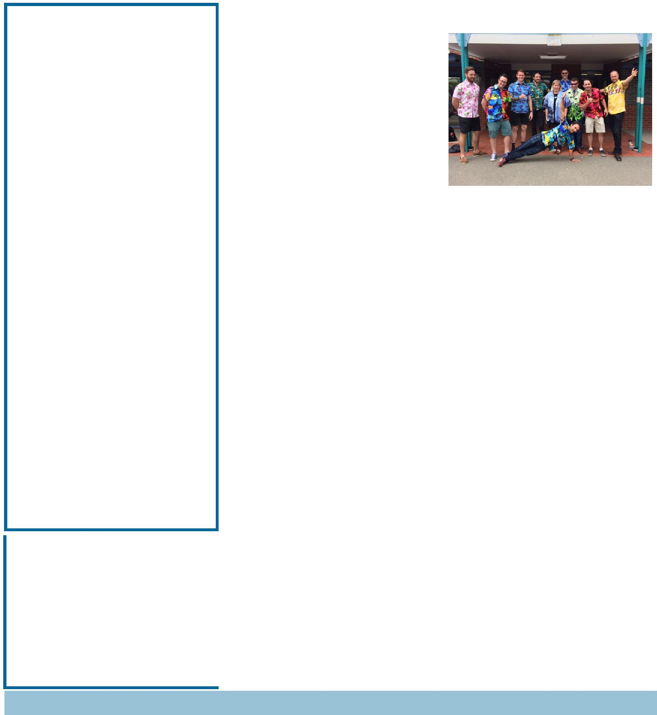

ASSEMBLY:
23 | Nov | Senior - Yr4
DATES TO REMEMBER:
23 | Nov | Governor-General’s Sports
 |  | Fun Day
26 Nov - 7 Dec |  |  |  | Yr2 AquaSafe
28 | Nov | Christian Education
10 | - 14 Dec |  |  | Kindy Swim &
 |  | Survive
11 Dec |  | P/S End of year
 |  | celebration (Brave, Itchy &
 |  | Noisy)
14 Dec |  | P/S End of year
 |  | celebration (Cranky, Hungry &
 |  | Sleepy)
17 | - 21 Dec |  |  | Yr1 Swim &
 |  | Survive
19 | Dec | Yr6 Graduation
20 | Dec | K-Yr6 Fishing incursion
21 | Dec | Talent Quest

NOTES HOME:

- 5IH - movie permission

P&C BOARD NEWS P&C: 7:00pm 17 Dec

All P&C activities, meeting agendas and minutes are available from the school website at – Parent Corner

School Board: 7:30am 29 Nov

DEPUTY PRINCIPAL MESSAGE

Twilight Fair

A great time was had by all at the Twilight Fair on Saturday. The multicultural food was very filling and it tasted delicious. It was lovely to look around and see both children and adults smiling and having such a wonderful time. A

community event such as the fair brings us all together and reminds us of what a great school we have! A very big thank you to the P&C who worked very hard to ensure it was a great success. Thank you to all of those hard working volunteers who put in hours/days/weeks of effort to make the fair such a great success. Thank you to all the wonderful teachers who gave up their Saturday to come down and run the badge stall, Tombola and Chocolate trailer. Thank you to those who attended and supported the school.

Bandstravaganza

Last night some of our year 5/6 students performed in Banstravaganza at Llewellyn Hall. The students proudly represented Palmerston. The IMP music program is a fantastic program that will continue for our year 5/6 students next year.

Zoo excursion

Today the Year Two students went to the National Zoo and Aquarium as a part of their learning in science and mathematics. A great time was had by all, in particular the students enjoyed the new areas of the zoo that have recently been opened. The students excitedly told me all about their adventures at the zoo and some students were lucky enough to feed different animals.

Together, we learn from each other

Palmerston Post

Volunteers Morning Tea

It is time for our annual morning tea for volunteers. This is a morning tea for all of the very special volunteers at Palmerston. These volunteers do a range of amazing jobs and we would like to take this opportunity to thank them. This will be held on 12 December at 9:30am in the staffroom.

Reports & Interviews

Reports will be going home Friday 7 November and parent teacher interviews will be held throughout week 9. Please make an appointment via the front office.

Sustainability

Palmerston is proud to be working towards being a sustainable school. The Green Team at Palmerston is a program run by our Environmental Science teacher for students in years 3/4. This program aims to encourage the development of environmentally conscious citizens. Students spend their time working on different aspects of this throughout the school. This year the students have been working hard to ensure that Palmerston recycles as much waste as possible. As a part of this initiative Palmerston now has yellow bins that are located in each PoD where soft plastics can be recycled. The students in the Green team assist with this process every week. This is a fantastic starting point for our students to develop a sense of awareness and responsibility for the environment.
Diwali Celebrations
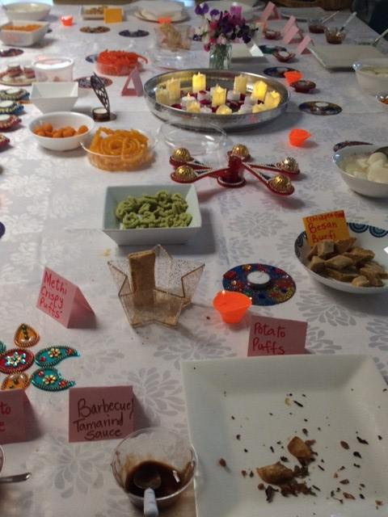

Diwali, the Hindu festival of lights occurs each year. It is India’s biggest and most important holiday of the year. It is a time when people come together to celebrate by sharing delicious foods, lighting candles and by decorating homes and shops. The teachers at Palmerston were lucky enough to have their own Diwali celebration this year. Some of our staff members put on a special morning tea with a range of delicious food. We really enjoyed the feast and the opportunity to learn more about Diwali. Thank you to all involved!
Haeley Simms

PALMERSTON PRIDE AWARDS

Congratulations to the following students who received a PRIDE Award at last week’s assembly

PARTICIPATION – becoming involved, “having a go” and cooperating with others

Ryan - KFD | Lincoln - KFD | Cianna - KFD | Elaina—KFD | MacKenna - KFD
Manuella - KGS | Jason - KGS | Andrew - KGS | Ariba - KSH | Tony - KSH
Manha - KSH | Emma - KGS | Emma - KSH | Finlay - KSH | Yuchen - 1MC
Jasmine - 1MC | Julian - 2RK | Lucy - 2MG
RESPECT – having respect for self, others and their property
Anna - 2RK | Aidan - LSU
INTERGRITY - being honest, fair and responsible
Gafatasi - 2RK | Ava - 2LM | Natalie - 2MG
DETERMINATION - being persistent and resilient
Matilda - KGS | Nicholas - KGS | Sophia - KSH | Alexis - KSH | Emma - KSH
Savleen - 1MC | Atreya - 1MC | Siwoo - 2RK | Holly - 2LM
WRITING AWARD
Andy - KSH | Emma - KSH | Alexis - KSH

Together, we learn from each other

Palmerston Post

UPCOMING EVENTS

SRC - Governor-General’s Sports Fun Day

Date: Friday 23 November 2018

Location: Government House

Yr2 Aqua Safe Swimming program

Date: Monday 26 November - Friday 7 December 2018

Location: Gungahlin Leisure Centre

Christian Education

Date: Wednesday 28 November 2018

Location: Palmerston Primary

Our teaching theme for 2018 is HORRIBLE HISTORY - FANTASTIC FUTURE. We will learn about four people from Old Testament Bible history who had a ‘horrible’ time… but who God used to be heroes and leaders. We are teaching the song ‘God’s Good All The Time’ by Colin Buchanan.

Term 4 will introduce the character of Moses (born in ancient Egypt) and trace his history to Jesus (born in Bethlehem).

Whole School Photo *rescheduled*

Date: Friday 30 November 2018

Location: Palmerston Primary

Christmas Concert

Date: Thursday 6 December 2018

Location: Palmerston Primary

Jump Rope for Heart “Jump Off”

Date: Friday 7 December 2018

Location: Palmerston Primary

Volunteer’s Morning Tea

Date: 9:30am Wednesday 12 December 2018

Location: Palmerston Primary - staff room

Yr6 Graduation

Date: 9:15am Wednesday 19 December 2018

Location: Palmerston Primary

K - Yr6 Fishing Incursion

Date: Thursday 20 December 2018

Location: Palmerston Primary

Talent Quest

Date: Friday 21 December 2018

Location: Palmerston Primary

Together, we learn from each other

Palmerston Post
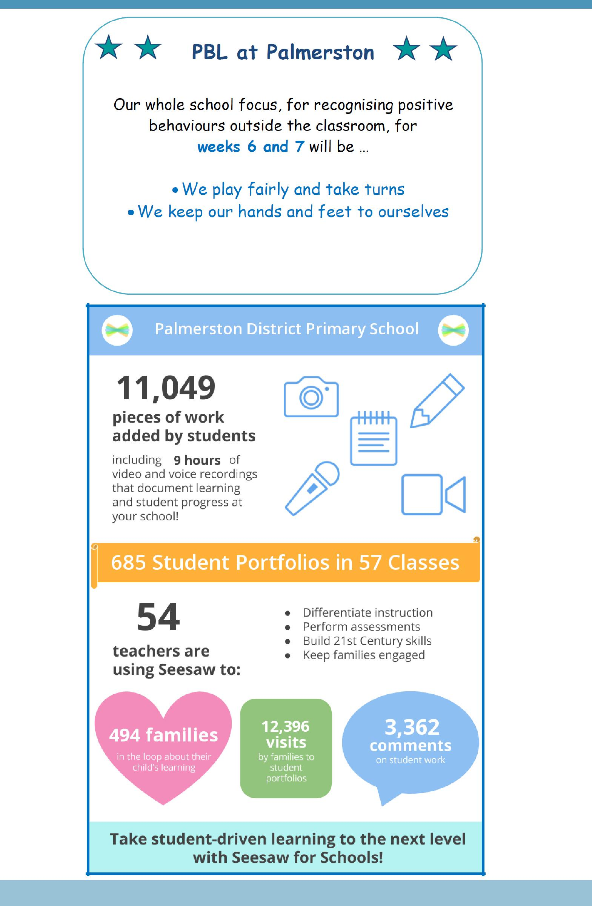

Together, we learn from each other

Palmerston Post

P&C NEWS

School Banking

Unfortunately we are experiencing delays with banking rewards. Rewards orders have been placed, which hopefully arrive over the next couple weeks.

Next Wednesday (28 November) will be the last chance to place orders for banking rewards this year.

Book Club

The final catalogue for the year has now been distributed to the classes. All orders need to be received by Friday 30 November.

Twilight Fair

A huge thankyou to my helpers (Mrs Saro 4VS, Fran P and Leanne H) in the canteen prior to the fair in cooking up the marvelous curries. It was a job well done!.

Another big thankyou to all the volunteers who helped make the Multicultural Food Stall a great success on the day, you were all fantastic.

Thanks,

Edwina

LIBRARY NEWS

Monday 26 November

No more student borrowing from the library from Monday 26 November.

Monday 3 December

All library books are due back on Monday 3 December.

Thank you,

Library staff

Together, we learn from each other

Palmerston Post

2019 BOOK PACK LISTS

Book Packs are ready! You can go online and order 2019 book packs.

Please refer to the website for book pack lists. Please follow the ordering instructions;

Go to the OfficeMax website OfficeMaxSchools.com.au

Search for Palmerston Primary School, Palmerston ACT and enter your school access key: 4TV8Q

Complete the student details and select the year level that your child will be in for 2019. Eg. If your child is in Yr.1 this year then you need to select the 2019 Yr. 2 list.

Review your requirements list and make any changes (if required). Please note that some items have been denoted as a requisite for the subject or year.

If you have more than one student at the school you will need to repeat the above steps, ordering the correct 2019 year level list.

Once completed, an order confirmation will be sent to your email address.

Order Deadlines and Delivery

Your order will be delivered to your home address. Please note: Orders will NOT be sent to the school.

Orders are delivered via Australia post’s eParcel service and you will receive an email with the Australia Post tracking ID Number. Post Offices Box addresses are NOT accepted.

Orders placed on or before 17 December will be delivered free of charge.

Orders placed after 17 December and on or before 31 December will incur a $12.95 delivery fee.

Orders placed after 31 December will incur a $12.95 delivery fee and all efforts will be made to deliver prior to the beginning of Term 1, 2019.

IMPORTANT

ALL Stationery packs need to be brought to school on the first day of Term 1, 2019 and given to the class teacher.

If you need any help placing your order, returns or refunds, delivery information or have a general enquiry please visit OfficeMaxSchool.com.au/help

Please DO NOT send any Stationery Lists or money to the school, ALL orders are through OfficeMax.

Together, we learn from each other

Palmerston Post
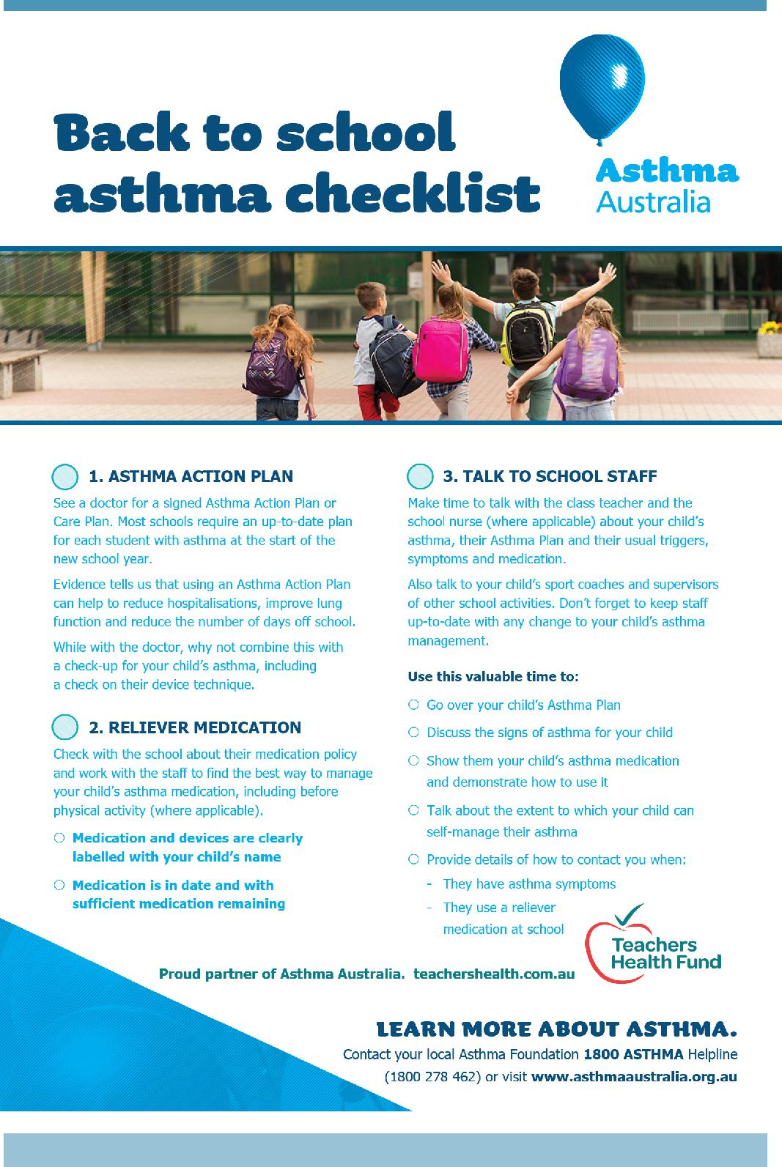

Together, we learn from each other

Palmerston Post

SCHOOL INTENTIONS 2019

School Leavers 2019

We have now reached the time in the year when we look at our school numbers and staffing arrangements for 2019. If your circumstances have changed and your child/ren will not be attending Palmerston District Primary School in 2019 can you please let the front office staff know as soon as possible.

My child/ren will not be returning to Palmerston in 2019.

Name Class

Last day at Palmerston:

My child/ren will be attending:

Another government school in the ACT:

A non-government school in the ACT:

Moving out of the ACT

Forwarding Address:

Phone number:

Parent’s name:

Together, we learn from each other

Palmerston Post
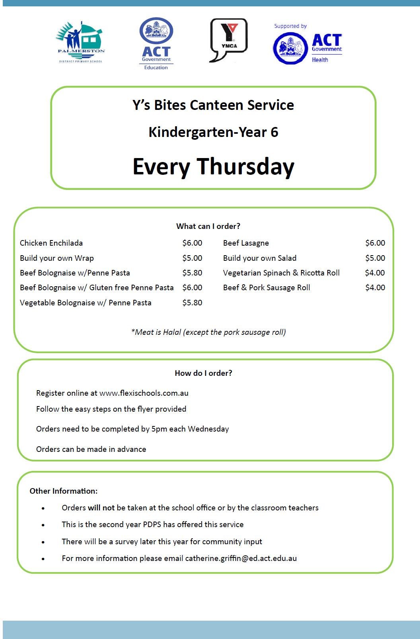

Together, we learn from each other

Palmerston Post
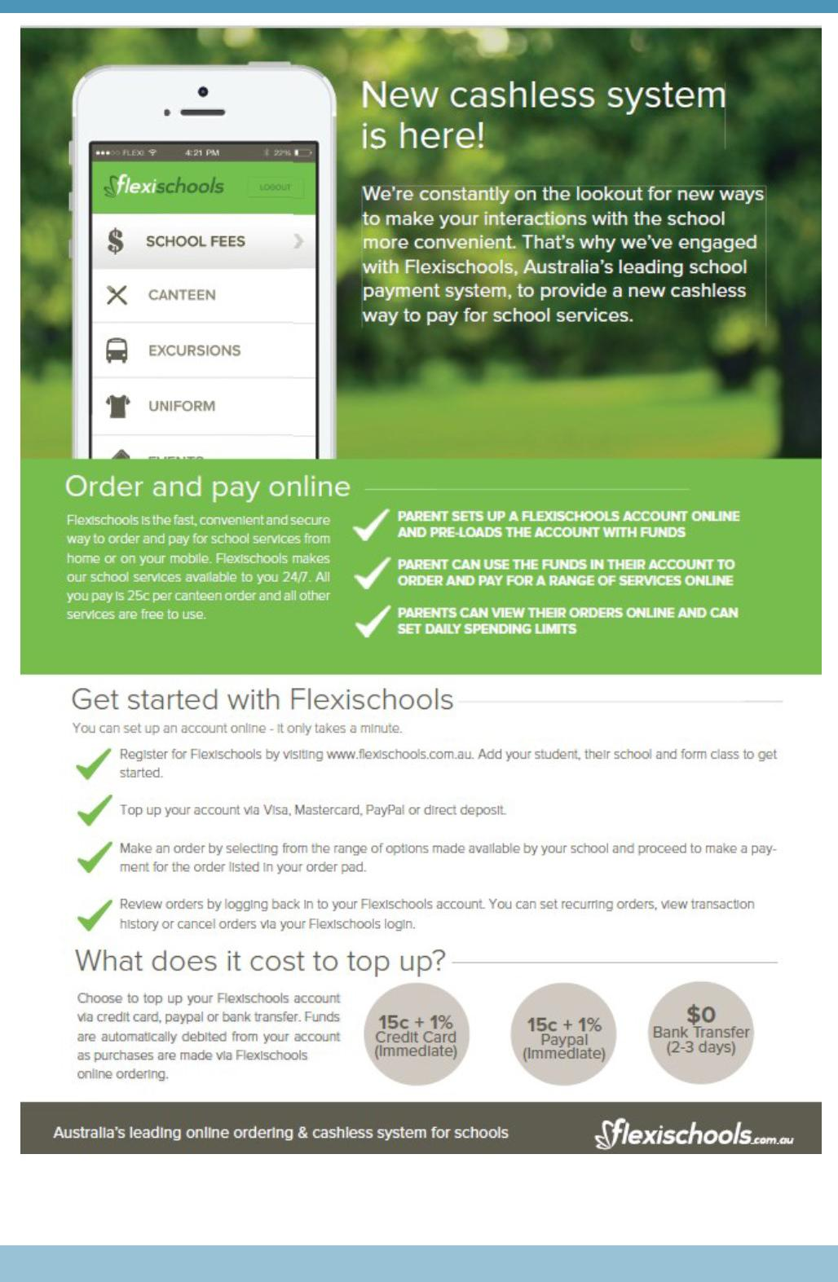

Together, we learn from each other

Palmerston Post

Indigenous Scholarships Available

Would you like your children to learn how to run, jump and throw in a fun and safe environment? Thanks to the support of the ACT Government Little Athletics ACT, have a number of Indigenous scholarships available for the

2018/2019 season.

The mission of Little Athletics is to develop children of all abilities by promoting positive attitudes and a healthy lifestyle through family and community involvement in athletic activities. Our centres provide opportunities for children aged between five and sixteen to make friends
outside of school in a positive environment. Parents and carers can make new friends at Little A’s

too. Volunteering to help rake the long jump pit or time-keep running events is a great ice-breaker that can help create long lasting friendships for you and your family.

Scholarships are available for those who live in the ACT, Braidwood, Cooma, Queanbeyan, Murrumbateman and Yass. For further details please contact Malcolm Lavender on (02) 6247 1296

- Option 3 or development@actlaa.org.au.

Together, we learn from each other

