Palmerston Post
12 April 2018

Week 10, Term 1

Board Chair: Lisa Fior Board Members: Parent Reps: Jesse Dang and George Villaflor

P&C President: Lisa Fior

Principal: Melissa Travers Deputy Principal: Kate Flynn

Executive Teachers: Haeley Simms, Kylie Moller, Jacqui Warden, Matt Gowan, Catherine Griffin (acting)

ASSEMBLY:
13 Apr Senior– Year 3

DATES TO REMEMBER:

13 Apr P/S (end) Healthy breakfast

13 Apr P&C Sausage Sizzle

Lunch Order

14– 29 Apr School Holidays

30 Apr Term 2 Starts

NOTES HOME:

- Suara Indonesian Dance (Yr3– 6)

- Mother’s day notes (youngest)

- Holiday Happenings (youngest)

P&C BOARD NEWS P&C: 8 May 2018

All P&C activities, meeting agendas and minutes are available from the School website at – Parent Corner

School Board:

DEPUTY PRINCIPAL’S MESSAGE

Farewell Mrs Davies

Tomorrow we farewell our longest running staff member Mrs Jenny Davies. Jenny has been at Palmerston for 23 years and tomorrow marks the end of her working career and the beginning of her retirement. Jenny has made a significant impact on the culture at Palmerston, working in a range of places from the library, the preschool and now in the front office. Her smiling face and positive attitude will be missed. Yesterday, the staff joined with her in celebrating the commencement of a new adventure which involves a holiday up north to escape the Canberra winter.

Attendance

I would like to remind all families about our processes relating to student attendance. These processes align with the Directorate’s Education Participation (Enrolment and Attendance) policy. Each day, staff record the attendance of the students within their class on the new student administration system (SAS). The school is required to maintain accurate and up to date attendance records and as such, the school may contact families to follow up on unexplained absences. In line with the Directorate policy, when unexplained absences reach a maximum of seven days in a school year official procedures to ensure students meet the school attendance requirements are required to commence. This may include notifications via attendance letters. Our new system, SAS, has highlighted that a percentage of children have taken some unexplained leave this year and we ask if families with children in this situation could contact the front office.

Together, we learn from each other

Palmerston Post Page 2

Cross Country

What a glorious day we had for our Cross Country carnival yesterday. The participation levels and positive attitude of the students was really impressive. The way the houses cheered for the competitors as they ran past is worthy of mention as it was a true demonstration of support for one another. Thank you to Mr Susko and the committee for their organisation of the day. I would also like to thank all parent volunteers, the P&C for the ice blocks and all families in attendance for supporting us as we moved from the oval to the basketball court so we could access more shade.

Positive Behaviour for Learning

This term staff has been in the initial stages of rolling out our Positive Behaviour for Learning program. This is something that is in place in many schools across the ACT and is based on research from America and American schools. For us at Palmerston this program is all about acknowledging, teaching and celebrating the positives choices and actions that we see each day. In term 2 we will be holding a parent workshop to gather greater levels of input around the shaping of this program at Palmerston.

See Saw

Thank you to all the parents who attended our information session last night. We are really excited to launch See Saw with our community in term 2. Thank you to Haeley Simms and David Witte for their organisation and presentation.

Car park update

We have heard today that work on the new car park behind the preschool building will commence over the school holidays. This will involve the instalment of bollards and the installation of an appropriate car park entry. We are excited about this and look forward to the anticipated addition of 13/14 car spaces.

Wishing you all a safe and enjoyable break,

Kate Flynn

Together, we learn from each other

Palmerston Post Page 3

UPCOMING EVENTS

K - Yr 6 P&C Sausage Sizzle Lunch Order

Date: Friday 13 April 2018

Location: Palmerston District Primary School

Preschool Healthy Breakfast

Date: Friday 13 April 2018

Location: Palmerston Preschool

ANZAC Day Service

Date: Friday May 4 2018

Location: Palmerston District Primary School

ACADEMIC AWARD WINNERS

Congratulations to our Academic Award winners.

Manning– 1AS | Daenerys– 1MC | Jasper– 1AE
Miley– 1HD | Sopiato– 2LM | Emerson– LSU
Hannah– 5IH | Poppy– 5DT

SEESAW

Seesaw is a digital portfolio that allows our students to develop critical 21st century skills. It builds a strong home/school partnership by providing parents with real time notifications of their child’s learning. During Term 1 The teachers and students have been busy learning how to use Seesaw and uploading work samples for their parents/carers to view. Yesterday we held a parent Seesaw

information session which outlined what Seesaw is and how parents can use Seesaw.

In order to ensure a successful transition to Seesaw we have decided to provide parent/carer access to Seesaw during week 4 and 5 of term 2. We look forward to sharing the fantastic work with you.

Please contact me via the front office if you have any questions or queries regarding Seesaw. Haeley Simms

Together, we learn from each other

Palmerston Post Page 4

PRESCHOOL 2019 INFORMATION SESSION

An information session will be held for parents of preschool children entering preschool in 2019. The session will be held in the Library at Palmerston District Primary School on Wednesday 30 May 2018. After the session you will be welcome to walk through the preschool classrooms to see the learning spaces.

Children must turn four years old by 30 April 2019 to be eligible for enrolment into preschool for the 2019 school year.

To put forward your interest for the session please call 6142 1440.

Come and tour the preschool facilities of the school and speak with current staff. Tours will be conducted during May on Tuesdays and Fridays at 9.30 to 10.00am. Book a tour of the preschool by calling the school on 6142 1440.

ICAS

ICAS entry forms will be sent home to all students in Year 2-6.

ICAS assessments have taken place annually in schools for over thirty years and in 20 countries. Educational Assessment Australia (EAA), who design and deliver the assessments, is the not-for-profit arm of the University of New South Wales. Palmerston is once again going to take part in ICAS. This is voluntary for families.

ICAS is an annual skills development assessment program and available in the areas of English, Mathematics, Science, Spelling and Writing. Palmerston School is now able to offer Digital Technologies. The tests take 30–60 minutes and are supervised at school. Certificates are awarded to all students who participate. If you register to participate and are sick on the sitting date you will participate in a catch up at a suitable time in the following weeks.

Results are available to parents and students online. These online reports and analyses remain available indefinitely. ICAS reports indicate which questions were answered correctly and compare student performance to that of the other students tested.

To enrol your child in ICAS, please complete the registration form and return it, with your entry fees, to school by Friday 13 April (Week 10).

Together, we learn from each other

Palmerston Post Page 5
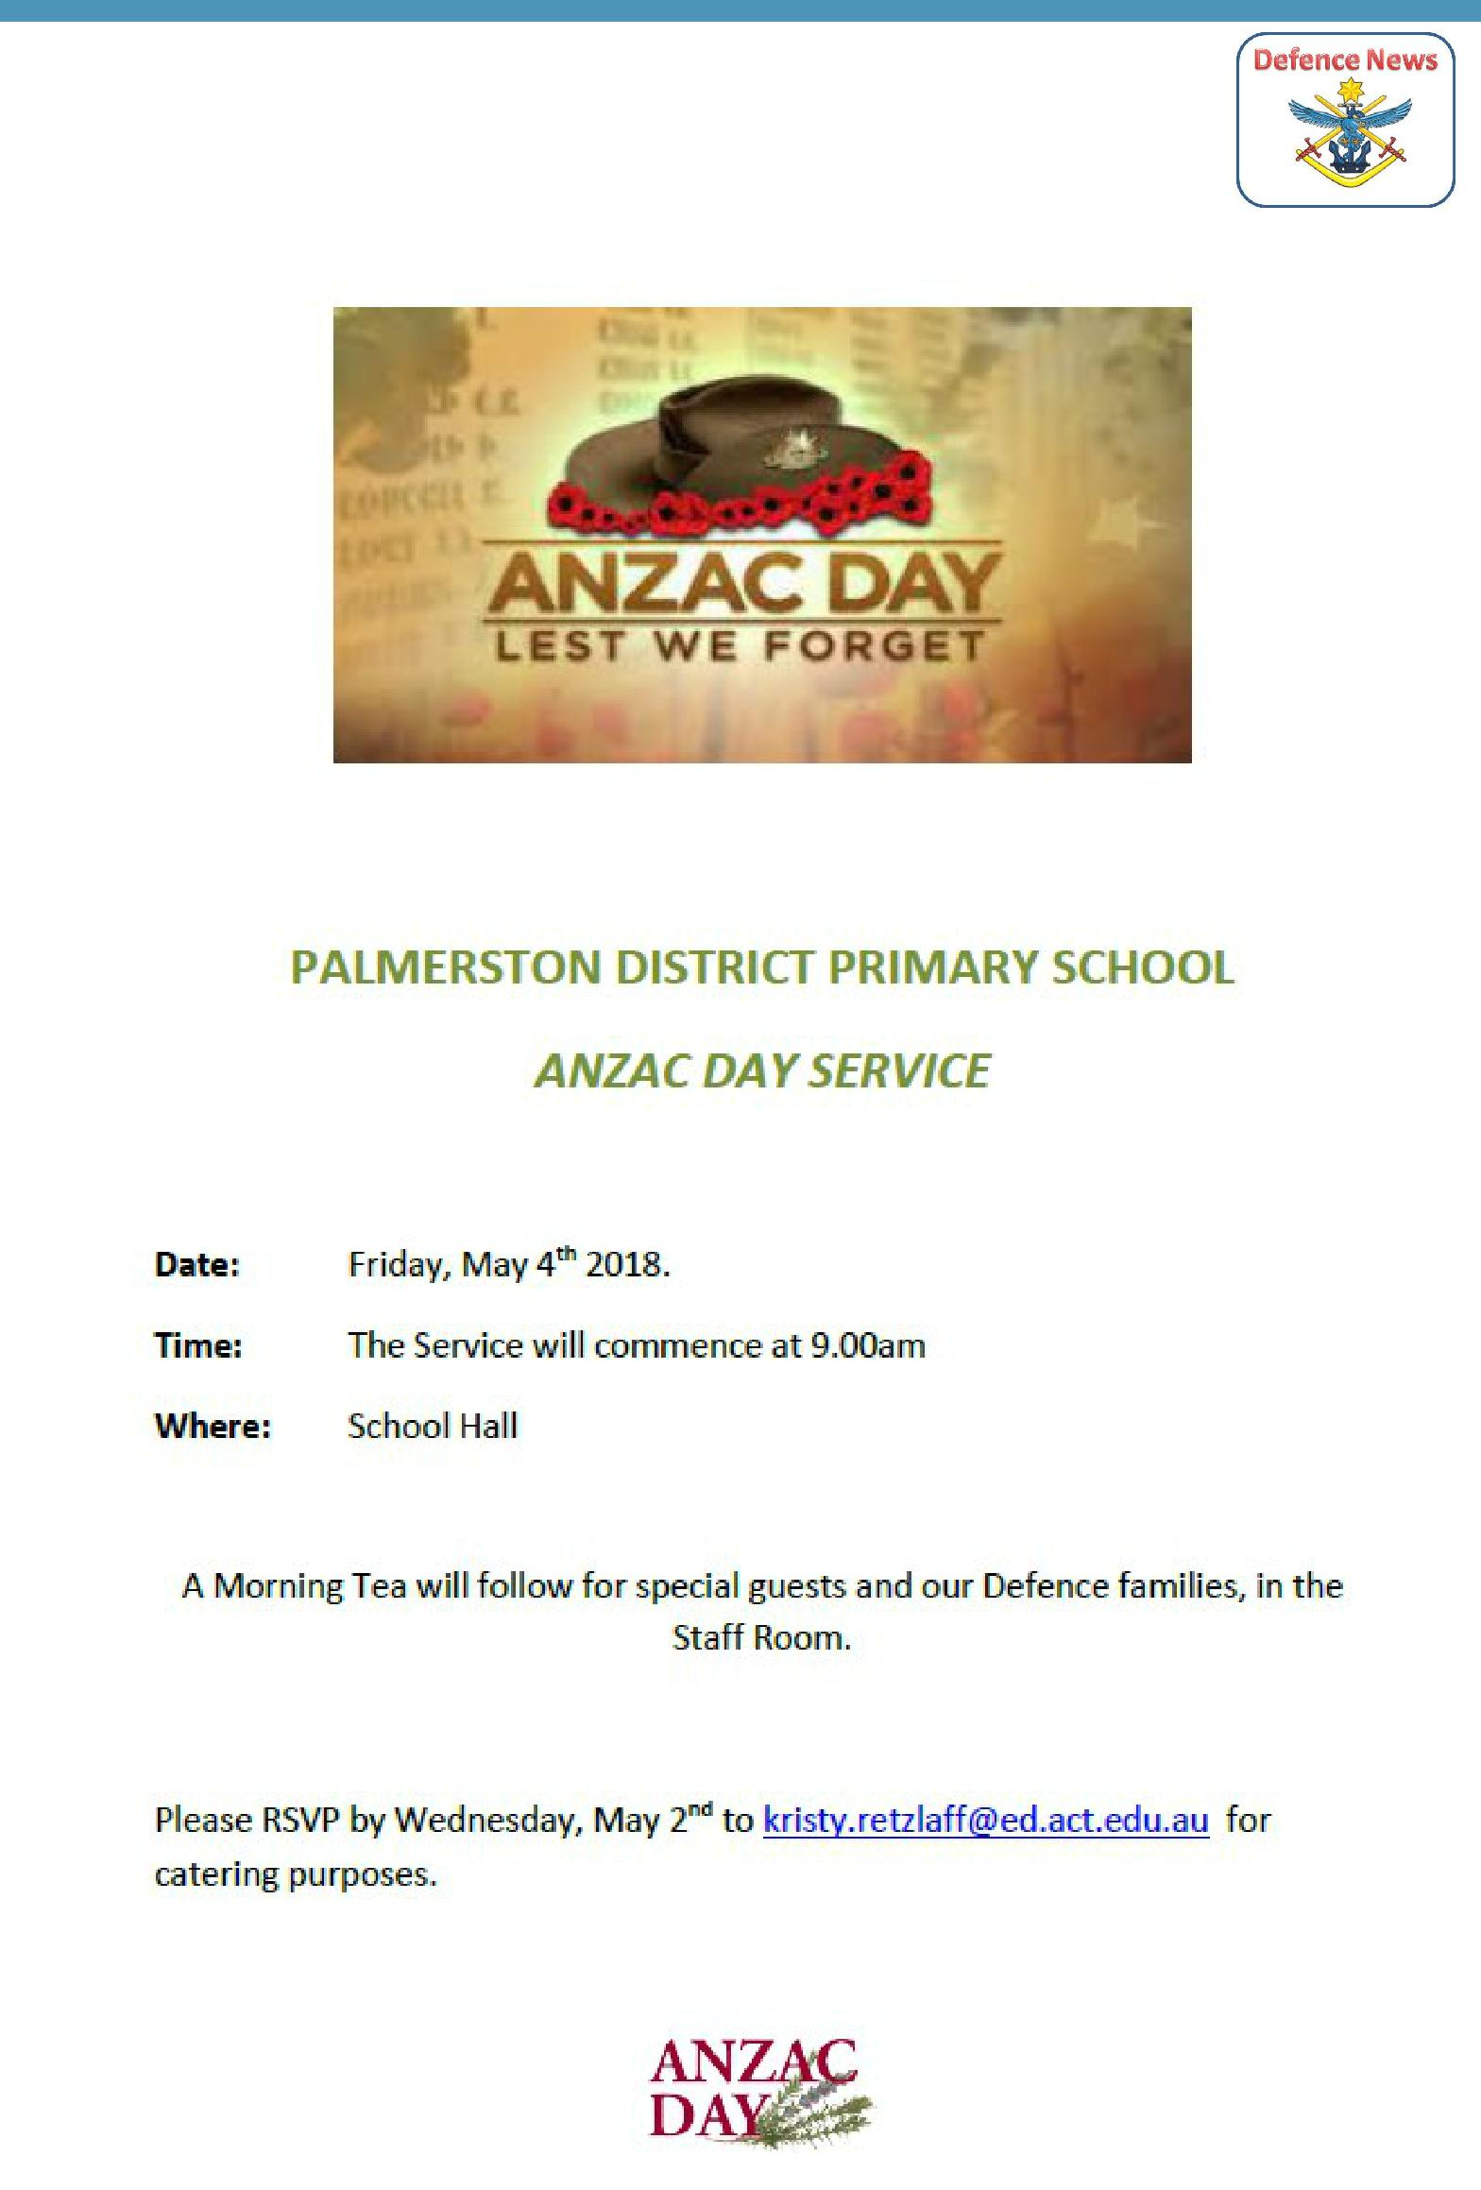

DSTA NEWS

Together, we learn from each other

Palmerston Post Page 6

Together, we learn from each other

Palmerston Post Page 7

P&C NEWS

The Parking Action Group sent the attached flyer with the following message to its members early this week

Dear Parking Action Group members,

The attached flyer is targeted at motorists who continue to park on Kosciuszko Avenue outside (or near) the school, and who may be liable to parking infringement notice/s.
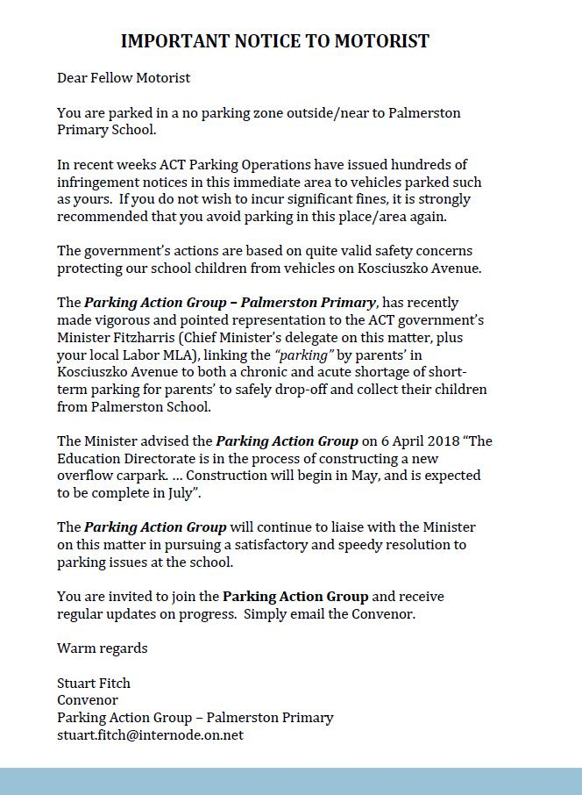

Together, we learn from each other

Palmerston Post Page 8
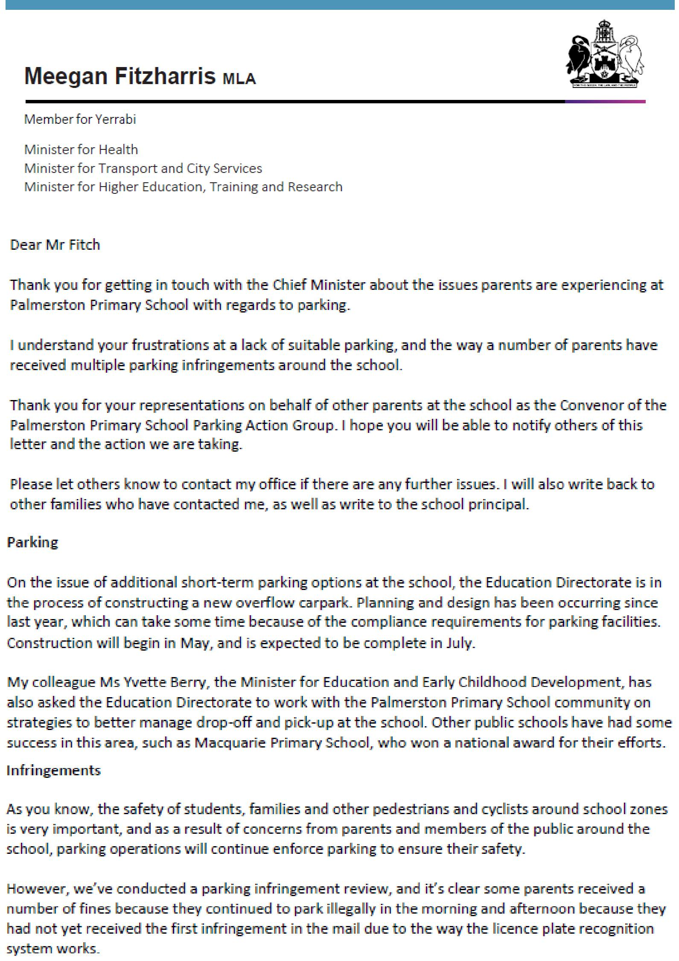

Together, we learn from each other

Palmerston Post Page 9
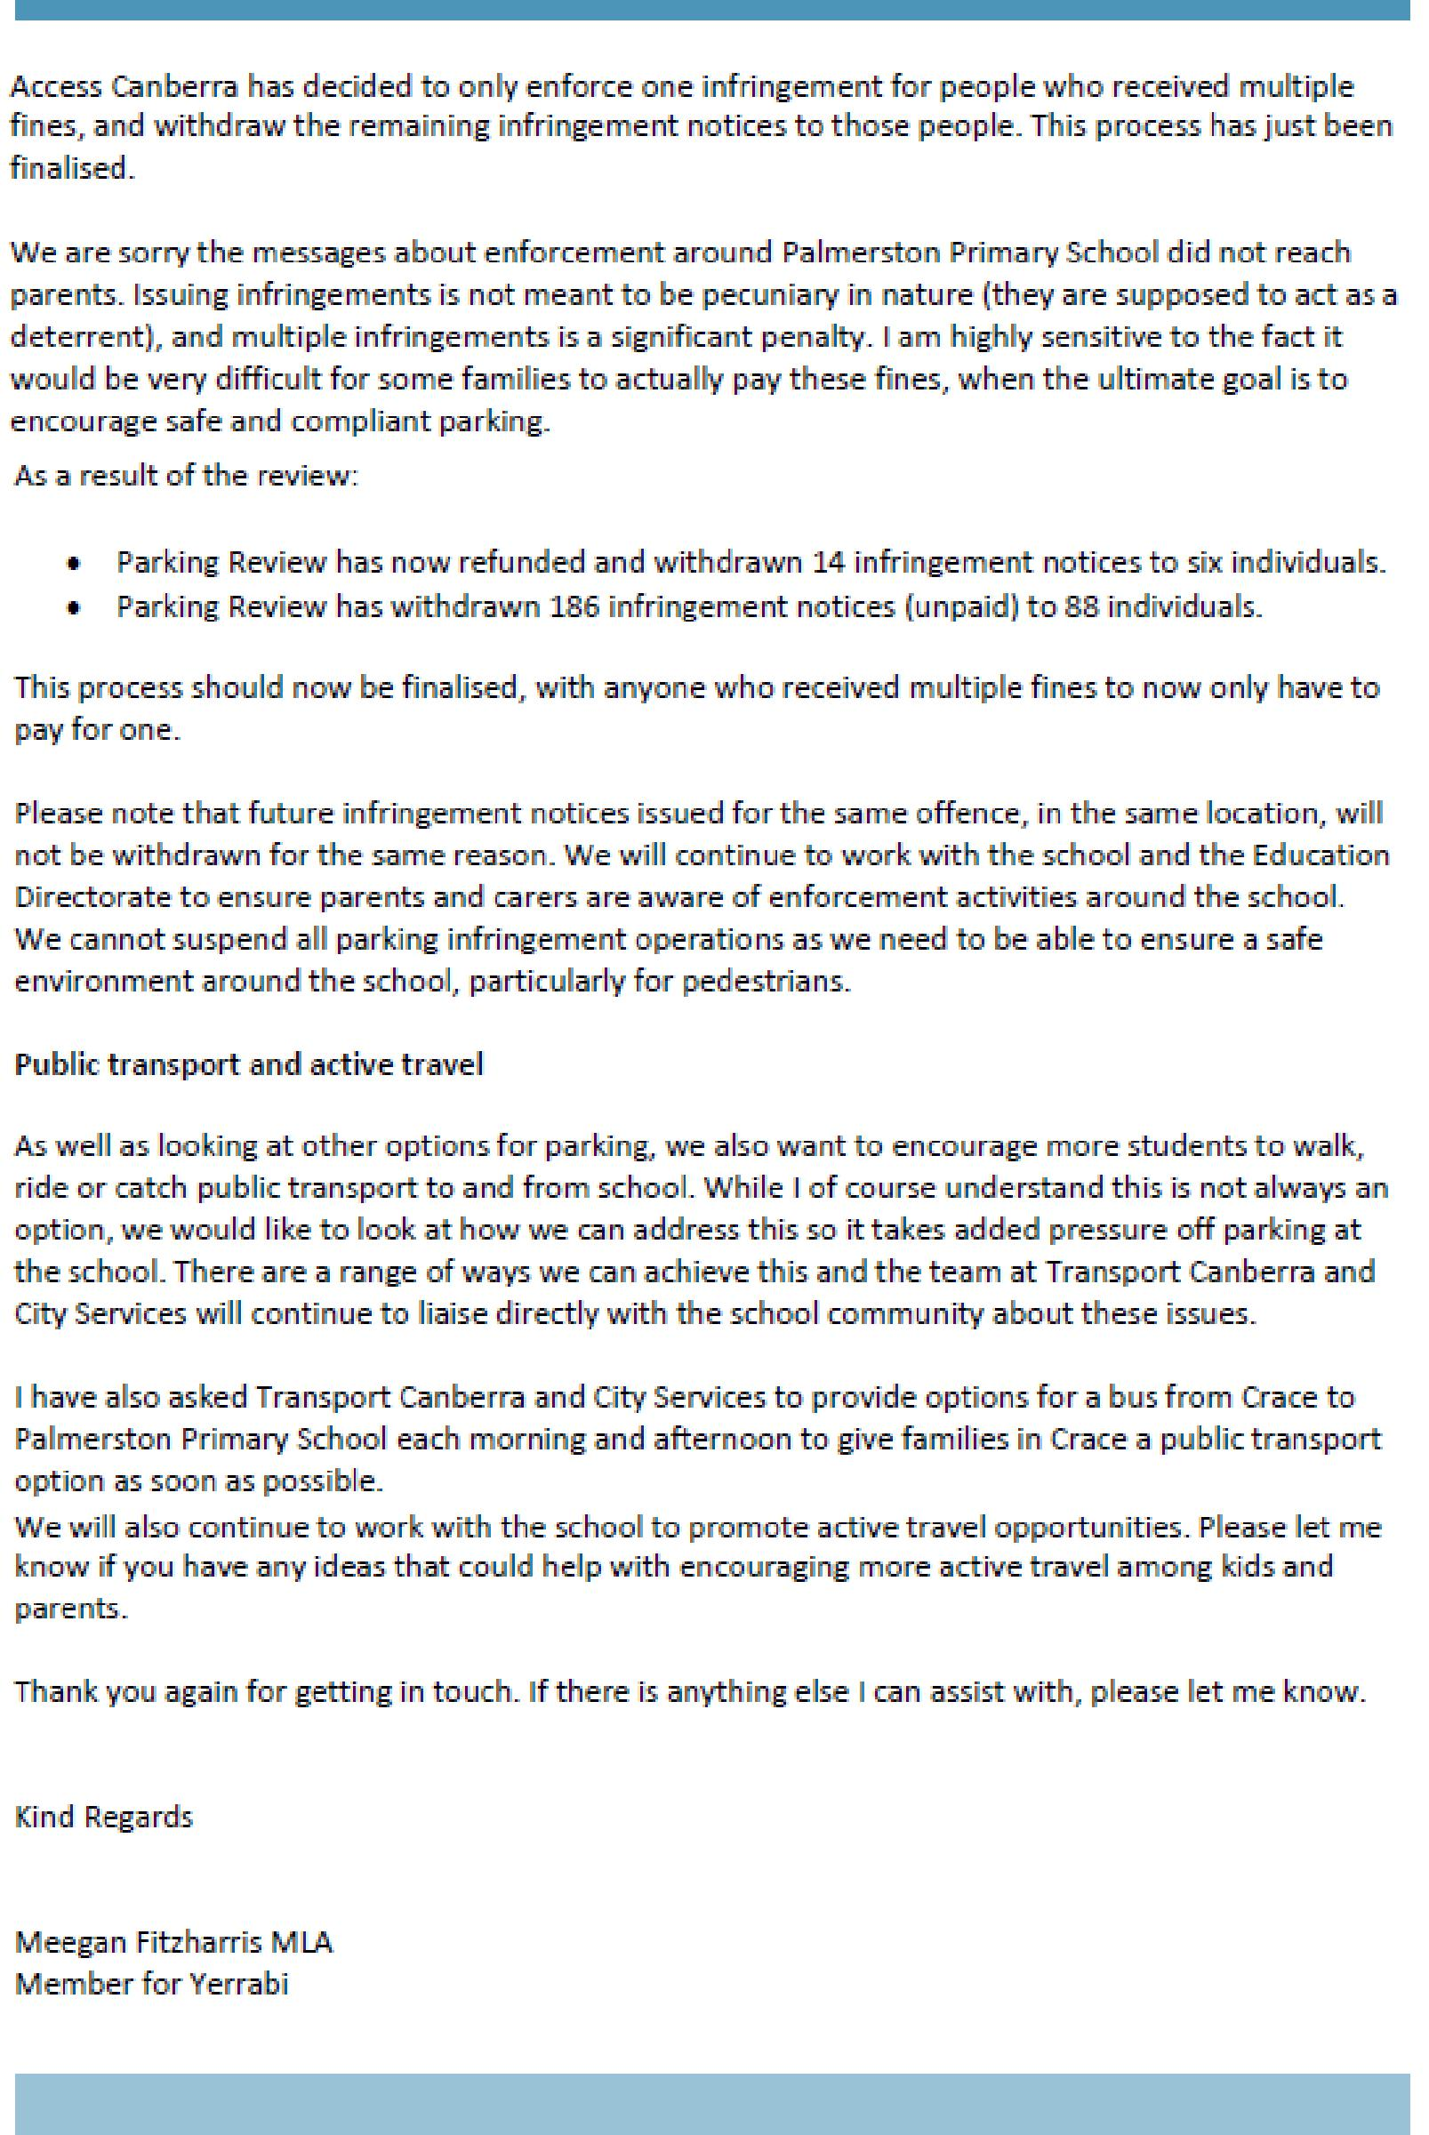

Together, we learn from each other

Palmerston Post Page 10

Year 7 School Open Days 2019
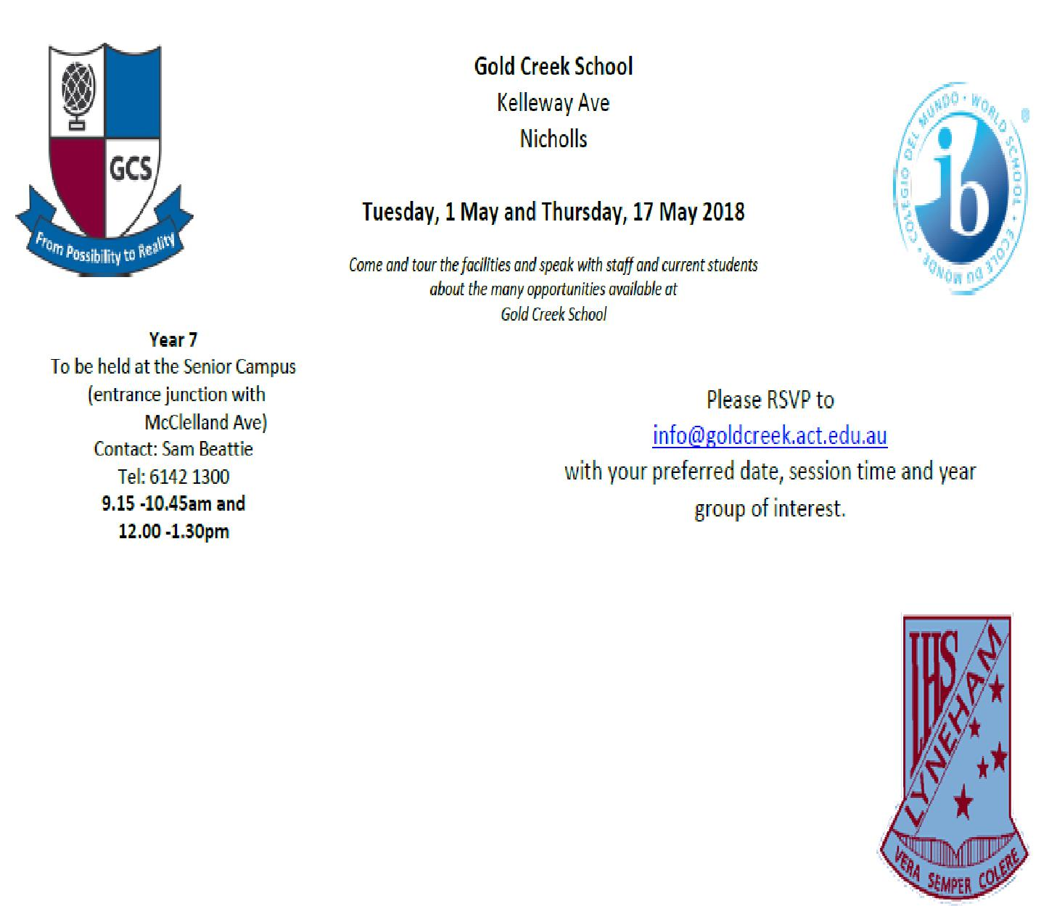

Lyneham High School

Tuesday 8 May 2018

Year 7 information session 6:30 -8:30pm in Hall

Band Information Session 5:30 – 6:30pm in IPAC building

Wednesday 9 May (tentative dates and times)

SEAL (Lyneham Enriched Academic Program) information session at 6:00pm in Library

LEAP (Sporting Excellence At Lyneham) information session at 7:00pm in Hall

For further details or information please contact Lyneham High School on 6142 1176 or email:LynehamHS@ed.act.edu.au

Kaleen High School

Tuesday 15 May 2018

6:00 – 8:00pm in the Library

On the evening of the 15th of May from 6-8pm we will be opening our school to the community for our annual Open Night. This is a fantastic evening for families to attend as they research which high school well best suit the needs of their child. The evening highlights the many wonderful opportunities on offer at UCHSK as well demonstrating exactly how we fulfil our mission of doing whatever it takes to ensure high levels of learning in every student.

Together, we learn from each other

Palmerston Post Page 11
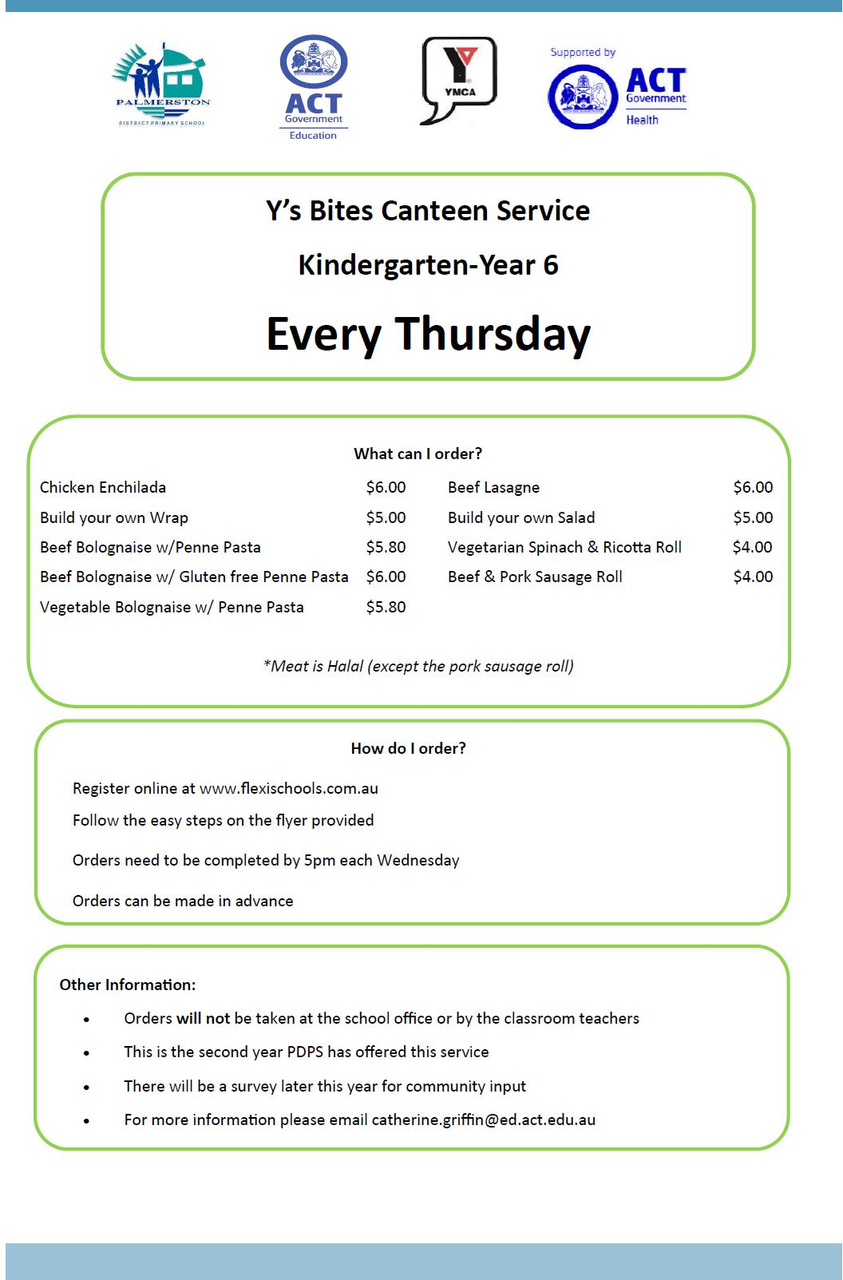

Together, we learn from each other

Palmerston Post Page 12
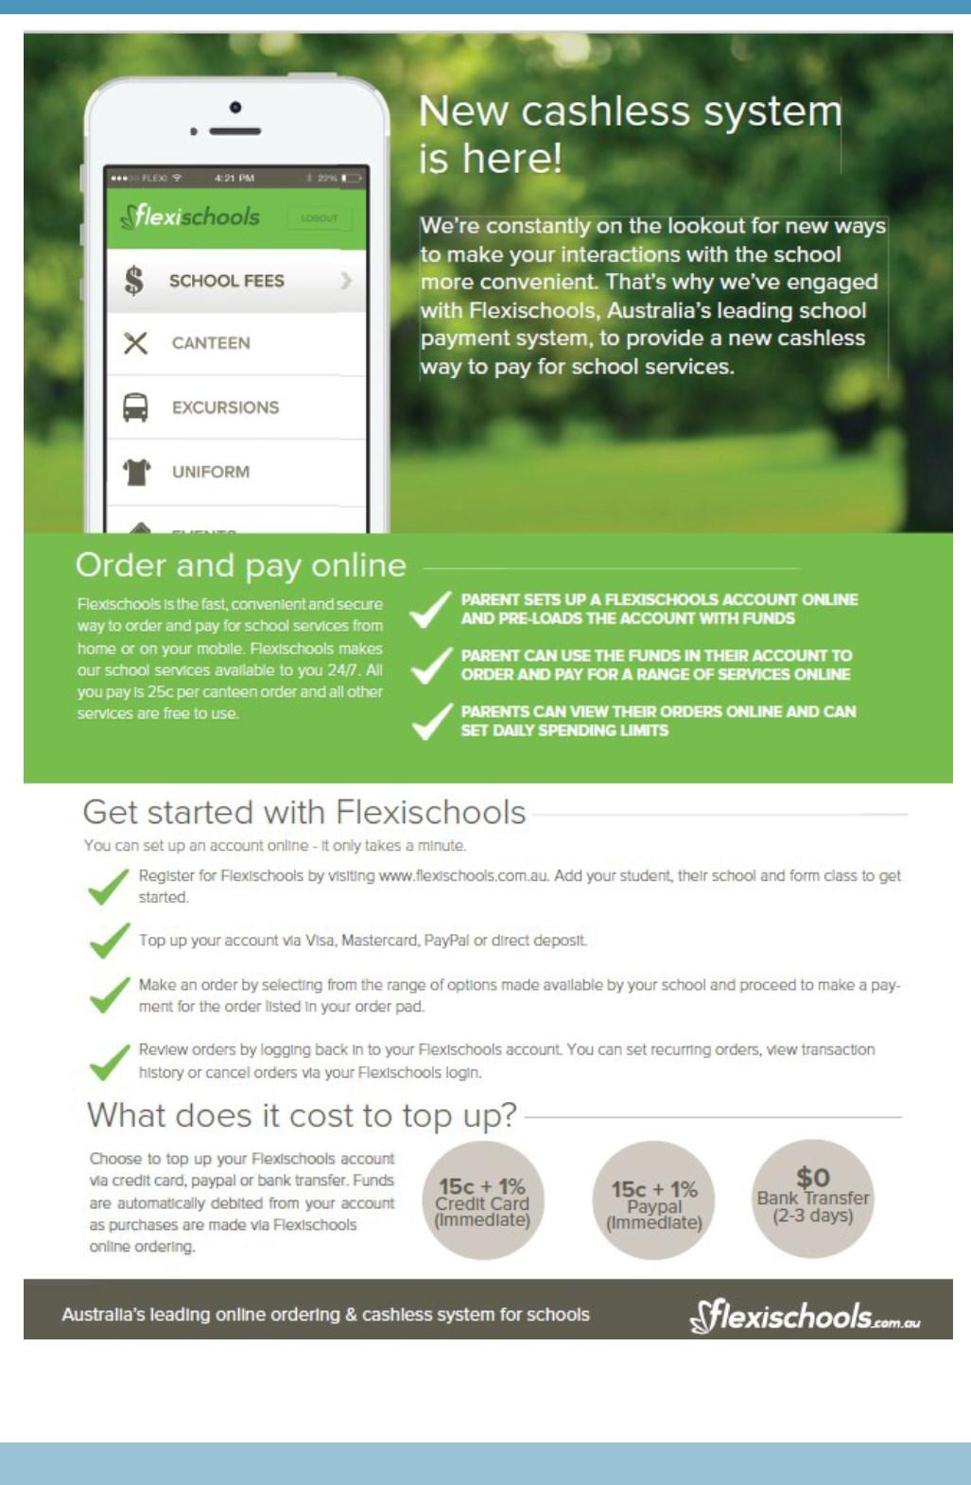

Together, we learn from each other

Palmerston Post Page 13

COMMUNITY NEWS
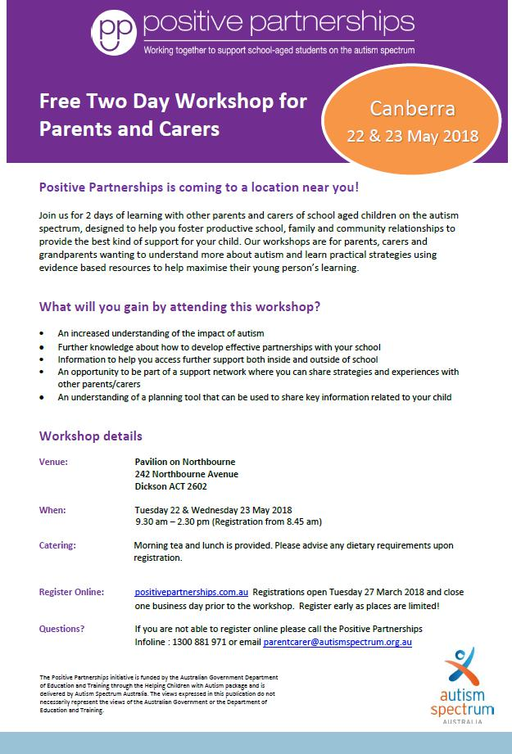

Together, we learn from each other

Palmerston Post Page 14
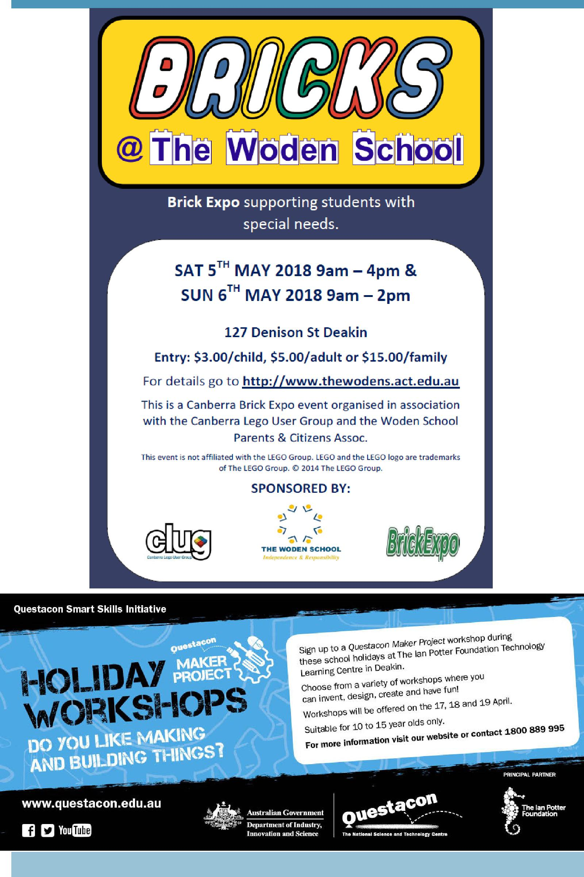

Together, we learn from each other

