Palmerston Post

6 December 2018

Week 8, Term 4

Board Chair: Lisa Fior Board Members: Parent Reps: Jesse Dang and George Villaflor

Teacher Reps: Jessica Lago and Maxine Green

P&C President: Lisa Fior

Principal: Melissa Travers Deputy Principal: Kate Flynn & Haeley Simms (acting)

Executive Teachers: Kylie Moller, Matt Gowen, Felicity McNeice, Catherine Griffin (acting)

ASSEMBLY:

7 Dec | No Assembly - Jump Off
14 Dec | Whole school - Music
DATES TO REMEMBER:
6 Dec | 5:30pm Carols
 | Evening
7 Dec | Yr2 AquaSafe
7 Dec | Jump Rope for
 | Heart - Jump Off
12 Dec | Volunteers’ Morning
 | Tea
10 - 14 Dec Kindy Swim &
 | Survive
11 Dec | P/S End of year
 | celebration (Brave,
 | Itchy & Noisy)
14 Dec | P/S End of year
 | celebration (Cranky,
 | Hungry & Sleepy)
14 Dec | P&C Lunch Order -
 | Sausage sizzle
17 - 21 Dec Yr1 Swim & Survive
19 Dec | Yr6 Graduation
20 Dec | K-Yr6 Fishing
 | incursion
21 Dec | Talent Quest

NOTES HOME:

- Carols Evening reminder

P&C BOARD NEWS P&C: 7:00pm 17 Dec

All P&C activities, meeting agendas and minutes are available from the school website at – Parent Corner

School Board:

EXECUTIVE TEACHER’S MESSAGE

In the past few weeks we have had preschool & kinder transition mornings. This is where preschool children have visited the Kindergarten pod for fun activities to get them used to being in the ‘big school’ ready for next year. This afternoon we have also had our whole school transition session where students completed activities in their next year level. For further information on the benefits of transitions please see the link below.

https://www.kidsmatter.edu.au/sites/default/files/public/ KM_SS_ThinkingAboutTransitionToSchool.pdf

Looking forward, we have our Christmas concert this evening beginning at 5:30pm. Children are welcome to sit and have a picnic tea with their families on the oval. Thank you to the P&C for their support in the hire of the sound equipment to make this possible. We are all looking forward to this wonderful community event.

Tomorrow morning is the Jump off for Jump Rope for Heart. It has been wonderful to see many students out on the black top trying side swing, scissors, cross over, double time and backwards skipping. Ask your students which ones they can do.

Year 2 swim school completes tomorrow and next week kinder will go swimming. Notes are due tomorrow. Please let your classroom teacher know if you do not wish them to participate.

Parent interviews are being held next week, please book a time with the front office if you wish to talk to your child/ren’s class teacher. Wednesday morning, we will have our volunteer’s morning tea. This will be held in the staff room and all are welcome to attend. A huge thank you to the many hands who have helped this year. We couldn’t keep our school running in the way we do without you. Volunteers have helped this year in a variety of ways from reading with students, covering books, working on the fete, banking, Father’s Day & Mother’s Day breakfast, second hand clothing pool and many other jobs. Did you know that … Volunteering helps counteract the effects of stress, makes you happy, increases self-confidence, provides a sense of purpose, helps you stay physically healthy. But most of all it builds community and benefits the students in our school. So, thank you.

Felicity McNeice
Together, we learn from each other

Palmerston Post

YEAR 2 NEWS
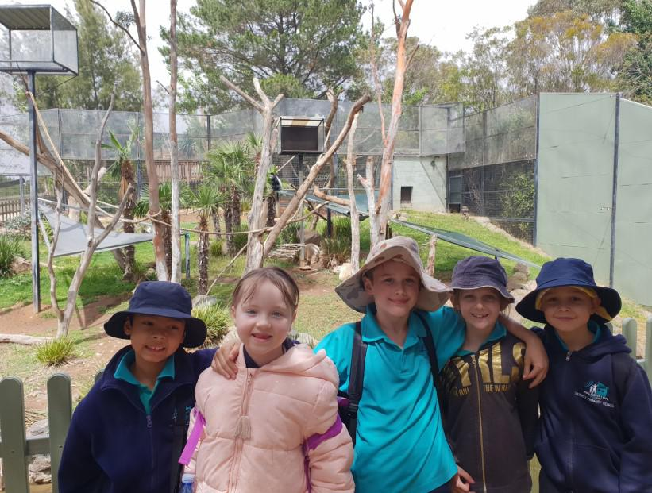

On Thursday 22nd November year two went to the zoo.

We saw:

A mob of meerkats

A pride of lions

A zeal of zebras

A crash of rhinoceros

And many more!

Along the way we engaged in a lot of experiences that

supported our learning in year 2. We explored the characteristics of living things, linking this to our prior knowledge in science about what living things need in order to survive. The staff at the zoo shared their knowledge about the individual needs of each animal and how the zookeepers support their needs.

Did you know:

A sumatran tiger at the National Zoo and Aquarium can smell all the way to Telstra Tower! An emu’s knees that look like they point backwards, but their ankles cause this shape. The horns on a giraffe’s head are called ossicones.
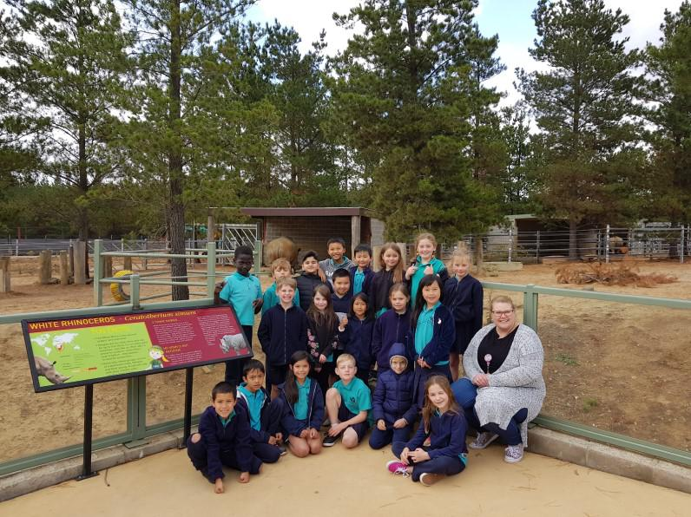

We were lucky to have lots of hands-on experiences at the zoo. We fed deer, had an emu peck an apple off our head and even held a snake.

The animals we saw came from countries all over the world. We discussed their habitat, where you might find these animals in the wild and where these countries are in relation to Australia.

In both geography and mathematics we have been learning about grid maps and following directions. The zoo provided us with an opportunity to put our navigation skills to the test.

- Why didn't the leopard cross the road?

- He didn't want to get spotted!

Together, we learn from each other

Palmerston Post

PALMERSTON PRIDE AWARDS

Congratulations to the following students who received a PRIDE Award at last week’s

assembly

PARTICIPATION – becoming involved, “having a go” and cooperating with others

Coen - KSH | Alisha - KKW | Seb - KKW | Joanna - KKW | Bezawit - KKW
Usman - KKW | Chanyai - KKW | Murray - KKW | Zayaan - KKW | Aaliyah - KFD
Lucia - KFD | Philopateer - KFD | Rhohan - 1PJ | Ayush - 1PJ | Jacqueline - 1PJ
Charli - 1MC | Maeve - 1MC | Hamish - 1AE | Zandar - 1AE | Madison - 1AE
Sophia - 1AE | Hannah - 2LM
RESPECT – having respect for self, others and their property
Yara - KSH | Marvin - KKW | Phone - 1MC
INTERGRITY - being honest, fair and responsible
Aaron - 1PJ | Zunaira - 1MC
DETERMINATION - being persistent and resilient
Andy - KSH | Huzaifa - KSH | Alaina - KSH | Vilai - KKW | Benjamin - KKW
McKenleigh - KKW | Alexis - KKW | Gunav - KFD | Chloe - KFD | Anne - 1PJ
Reign - 2MO | Harley - 2MO

EMPATHY - understanding and supporting others regardless of our differences

Dorjee - KSH Biar - KKW

WRITING AWARD

Emma - KSH

ARTIST OF THE MONTH

Dora - 1HD
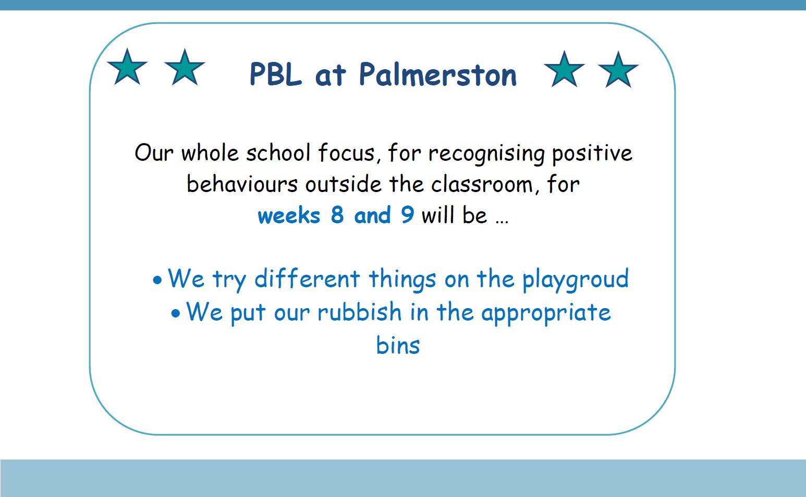

Together, we learn from each other

Palmerston Post

UPCOMING EVENTS

Carols Evening - TONIGHT

Date: 5:30pm Thursday 6 December 2018

Location: Palmerston Primary

Jump Rope for Heart “Jump Off”

Date: Friday 7 December 2018

Location: Palmerston Primary

Kindergarten Swim & Survive Swimming program

Date: Monday 10 December - Friday 14 December 2018

Location: Gungahlin Leisure Centre

Volunteers’ Morning Tea

Date: 9:30am Wednesday 12 December 2018

Location: Palmerston Primary - staff room

Year 1 Swim & Survive Swimming program

Date: Monday 17 December - Friday 21 December 2018

Location: Gungahlin Leisure Centre

Yr6 Graduation

Date: 9:15am Wednesday 19 December 2018

Location: Palmerston Primary

K - Yr6 Fishing Incursion

Date: Thursday 20 December 2018

Location: Palmerston Primary

Talent Quest

Date: Friday 21 December 2018

Location: Palmerston Primary

Date for your Diary: 2019 Swimming Carnival

The Palmerston District Primary School 2019 swimming carnival will be held on Wednesday 20 February 2019 (Term one, week three) at Dickson Pool. All K-6 students will be receiving permission notes next year and students wishing to compete in races will be asked to nominate at this time. The cost of this carnival will be approximately $10.

SCHOOL BOARD 2019

Next year we will have 2 parent vacancies on the School Board. Nominations will open on the 4 February 2109 and close on 18 February. Please keep these dates in mind if you are interested in applying for one of these positions.

Together, we learn from each other

Palmerston Post
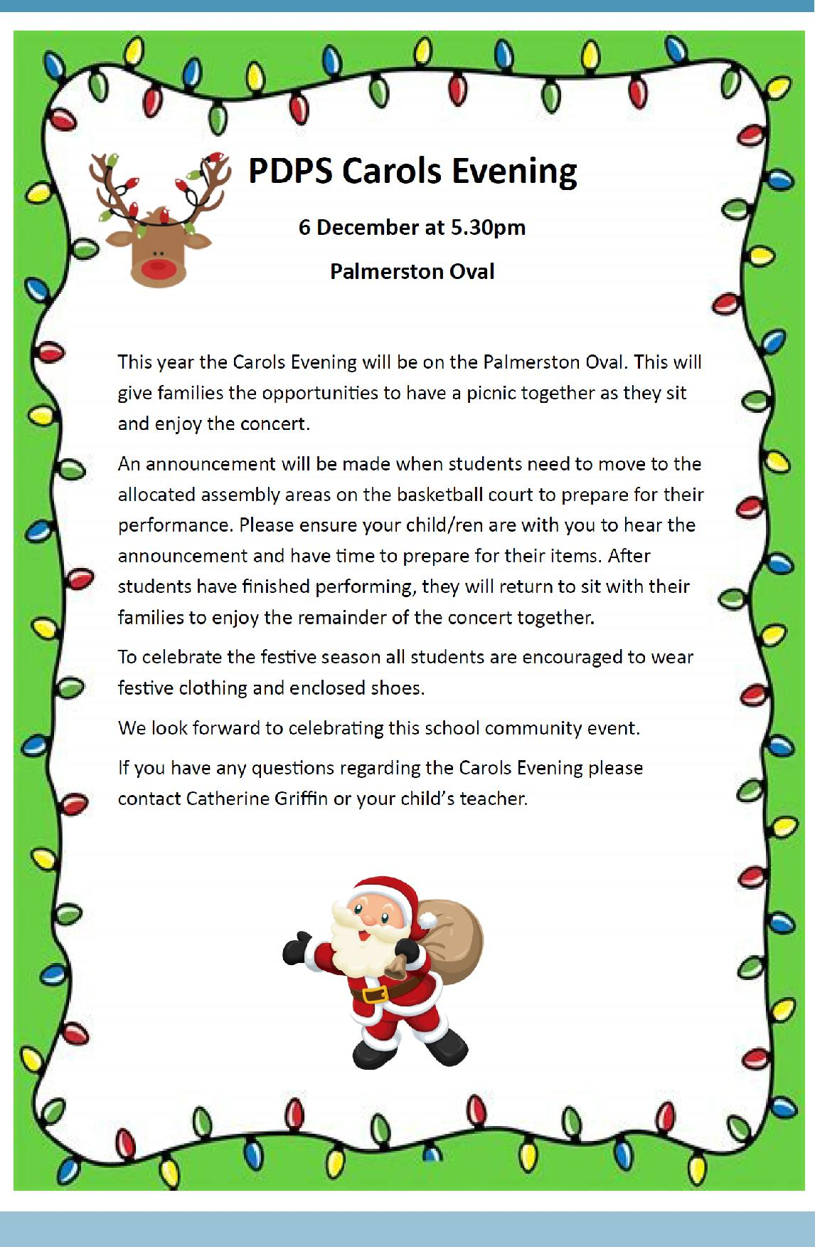

Together, we learn from each other

Palmerston Post

2019 BOOK PACK LISTS

Book Packs are ready! You can go online and order 2019 book packs.

Please refer to the website for book pack lists. Please follow the ordering instructions;

Go to the OfficeMax website OfficeMaxSchools.com.au

Search for Palmerston Primary School, Palmerston ACT and enter your school access key: 4TV8Q

Complete the student details and select the year level that your child will be in for 2019. Eg. If your child is in Yr.1 this year then you need to select the 2019 Yr. 2 list.

Review your requirements list and make any changes (if required). Please note that some items have been denoted as a requisite for the subject or year.

If you have more than one student at the school you will need to repeat the above steps, ordering the correct 2019 year level list.

Once completed, an order confirmation will be sent to your email address.

Order Deadlines and Delivery

Your order will be delivered to your home address. Please note: Orders will NOT be sent to the school.

Orders are delivered via Australia post’s eParcel service and you will receive an email with the Australia Post tracking ID Number. Post Offices Box addresses are NOT accepted.

Orders placed on or before 17 December will be delivered free of charge.

Orders placed after 17 December and on or before 31 December will incur a $12.95 delivery fee.

Orders placed after 31 December will incur a $12.95 delivery fee and all efforts will be made to deliver prior to the beginning of Term 1, 2019.

IMPORTANT

ALL Stationery packs need to be brought to school on the first day of Term 1, 2019 and given to the class teacher.

If you need any help placing your order, returns or refunds, delivery information or have a general enquiry please visit OfficeMaxSchool.com.au/help

Please DO NOT send any Stationery Lists or money to the school, ALL orders are through OfficeMax.

Together, we learn from each other

Palmerston Post
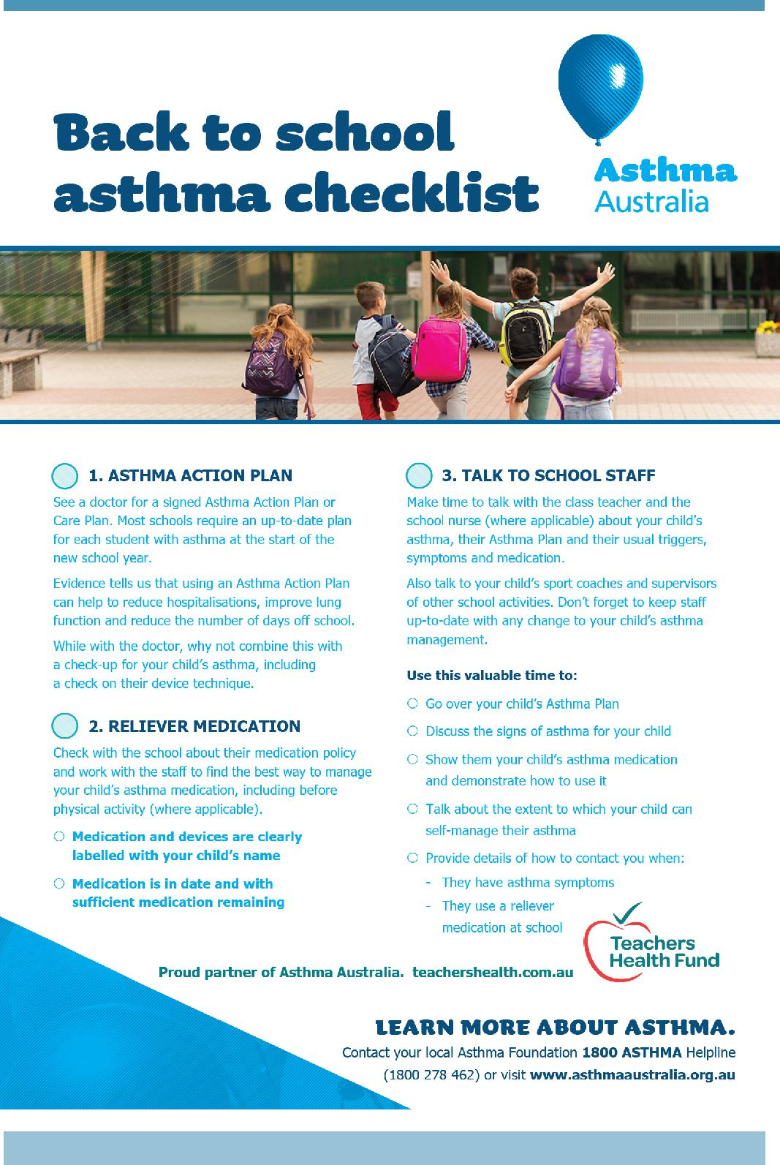

Together, we learn from each other

Palmerston Post

SCHOOL INTENTIONS 2019

School Leavers 2019

We have now reached the time in the year when we look at our school numbers and staffing arrangements for 2019. If your circumstances have changed and your child/ren will not be attending Palmerston District Primary School in 2019 can you please let the front office staff know as soon as possible.

My child/ren will not be returning to Palmerston in 2019.

Name Class

Last day at Palmerston:

My child/ren will be attending:

Another government school in the ACT:

A non-government school in the ACT:

Moving out of the ACT

Forwarding Address:

Phone number:

Parent’s name:

Together, we learn from each other

Palmerston Post
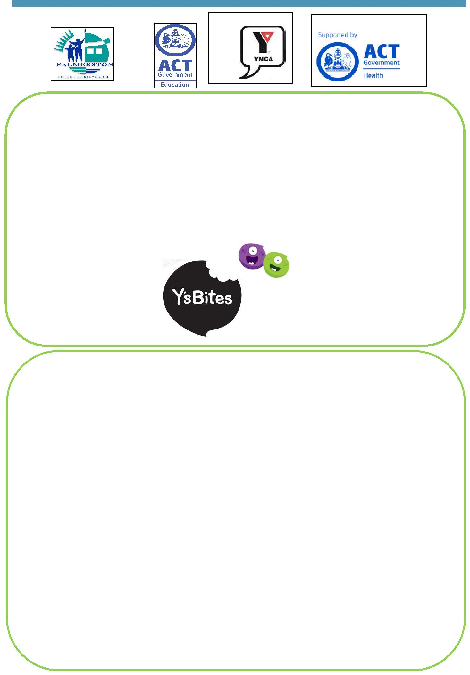

Y’s Bites Canteen Service

Kindergarten-Year 6

Thursday– Week 8 & 9

There will be no canteen service in week 10

MENU

Chicken Enchilada | $6.00
Build your own Wrap | $5.00
Beef Bolognaise w/Penne Pasta | $5.80
Beef Bolognaise w/ Gluten free Penne Pasta | $6.00
Vegetable Bolognaise w/ Penne Pasta | $5.80
Beef Lasagne | $6.00
Build your own Salad | $5.00
Vegetarian Spinach & Ricotta Roll | $4.00
Beef & Pork Sausage Roll | $4.00
*Meat is Halal (except the pork sausage roll)

Orders need to be placed on the Flexischools website flexischools.com.au by Wednesday 5pm.

Together, we learn from each other

Palmerston Post
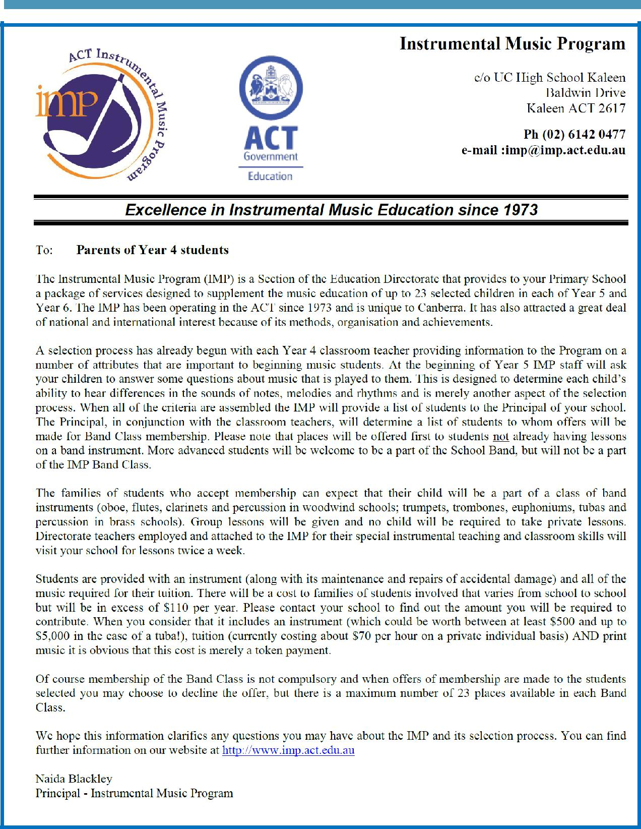

Together, we learn from each other

Palmerston Post

COMMUNITY NEWS

Chief Minister’s Canberra Gold Awards - Have you lived in Canberra for 50 years or more?

If you or someone you know has lived in Canberra for 50 years or more, then nominate now for a Chief Minister’s Canberra Gold Award. The Awards recognise long-term residents, businesses and groups that have made an important contribution to shaping our city and community through their long-term commitment to the ACT.

Nominations close in 8 February 2019 and can be made online at act.gov.au/cbrgold Canberra Citizen of the Year Award

Do you know someone who acts for the good of our community? Someone doing great things in their field, who is making a difference to the lives of Canberrans? Then nominate them for the 2019 Can-berra Citizen of the Year Award.

The Canberra Citizen of the Year is someone who makes an outstanding contribution to our commu-nity without expectation of remuneration or reward. They could be a researcher, a business leader, a journalist, artist, educator, an advocate for others in our community, or a leader in their field. Nominations close on Friday 11 January 2019 and can be made online at act.gov.au/cbrcitizen

A message from Access Canberra: Is your teen seeking to get their L’s or P’s around Christmas/New Year?

Access Canberra Service and Specialised Centres will be closed between Christmas and New Year, with most locations closed between 25 December 2018 and 1 January 2019 inclusive.

We apologise in advance if you have a teen with a birthday during that period and are eagerly awaiting their licence. We look forward to supporting them to get licenced in the New Year.

Also parents, if you need to pay a bill, renew your licence or rego over this time – don’t wait until we re-open! Save time and go online at www.act.gov.au/accessCBR

Wishing you and your family a safe and enjoyable festive season from Access Canberra.

Together, we learn from each other

