PALMERSTON POST
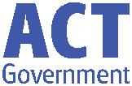

1 March 2018

Week 4, Term 1

Board Chair: Julian Fior, Board Members: Parent Reps: Jesse Dang and George Villaflor

P&C President: Lisa Fior

Principal: Melissa Travers Deputy Principal: Kate Flynn

Executive Teachers: Haeley Simms, Kylie Moller, Jacqui Warden, Matt Gowan, Catherine Griffin (acting)

ASSEMBLY:
2 Mar | No assembly
9 Mar | Junior - 2LM & 2EG
16 Mar | Senior - Yr4
DATES TO REMEMBER:
2 Mar | Clean Up Australia Day
7 Mar | Yr 3-6 Author visit
13 Mar | 9am Parent Info Session -
 | Reading (P/S - Yr1)
15 Mar | 9am Parent Info Session -
 | Reading (P/S - Yr1)
16 Mar | Harmony Day

NOTES HOME:

- Harmony Day - youngest

- Parent Information Session on Reading - P/S –Yr 1

P&C BOARD NEWS

P&C:

All P&C activities, meeting agendas and minutes are available from the School website at – Parent Corner

School Board Elections held in early 2018

PRINCIPAL’S MESSAGE

It is with sadness that we together mourn the loss of Riley Moon who passed away unexpectedly over the weekend. I would like to extend my condolences to Riley’s family and I extend my sympathy and thoughts to everyone in our school community at this time.

Over the last few days, I have witnessed many families, teachers and students support each other through this difficult time. I would like to acknowledge the sense of community you all bring to Palmerston District Primary School. I feel honoured to be part of such an amazing community.

DEPUTY PRINCIPAL’S MESSAGE

I too would like to start my newsletter item today by paying my respects to Riley Moon, a wonderful member of our school. This week we have spent time discussing his contributions to the Palmerston community.

The following link may assist you in talking with your child/ren about grief and loss.

https://www.parentlink.act.gov.au/__data/assets/ pdf_file/0003/405633/Grief-and-loss.pdf

Upcoming Events:

We have numerous events coming up over the term, which I have explained in detail below:

PIPS

This week our kindergarten children have been participating in the Performance Indicators in Primary Schools assessment (PIPS). This is an individual assessment that is carried out online. We look forward to this as we gain insight into what

Together, we learn from each other

Palmerston Post Page 2

literacy and numeracy skills the children currently possess. This information supports the teachers to develop an accurate program that targets the needs of the students. A report will come home towards the end of the term for parents to view their children’s results. This assessment will then be carried out again in term 4.

Clean Up Australia Day

Tomorrow, as a school community, we will be participating in Clean Up Australia Day from 2-2:30pm. Clean Up Australia Day is held each year. The Clean Up Australia organisation works with the community, government and business to provide practical solutions to help us all live more sustainably every day of the year. We encourage you to provide a gardening glove or two for your child.

Author Visit

On Wednesday 7 March our year 3-6 students will have a visit from author Harry Liang, who will take them on a awesome writing adventure.

Harmony Day

Harmony Day is an annual event where we come together as community to engage and participate in respecting cultural and religious diversity and foster a sense of belonging for everyone. At Palmerston, we will be acknowledging Harmony Day on Friday 16 March. We are also including Bullying No Way Day with our Harmony Day this year, as part of our Positive Behaviour Learning (PBL) initiative. On this day we encourage all children to wear orange clothing (Harmony Day colour) or a traditional costume.

Pathways

Next week our senior students will be participating in Pathways. This is a wonderful opportunity to support children in their career planning and during times of transition. This happens across ACT schools , with all children from year 5 invited to participate.

Emergency Evacuations

It is a requirement of the Directorate that we run practice fire drills and lock downs. This is to ensure we are able to keep children safe in case of an emergency and to ensure our procedures run smoothly and that both staff and students are aware of their roles and responsibilities. On Tuesday next week the whole school will be participating in a fire drill. On Thursday there will be a second fire drill just for preschool groups who don’t attend school on a Tuesday.
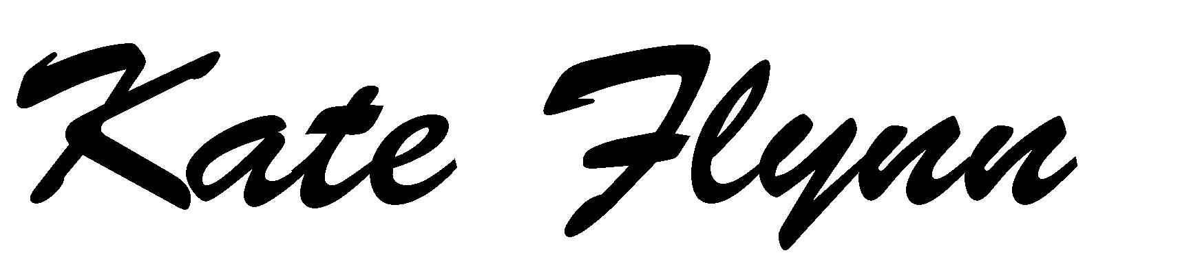

Together, we learn from each other

Palmerston Post Page 3

UPCOMING EVENTS

Clean Up Australia Day
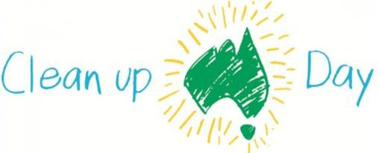

Date: Friday 2 March 2018

Location: Palmerston District Primary School

Yr 3-6 Author Visit
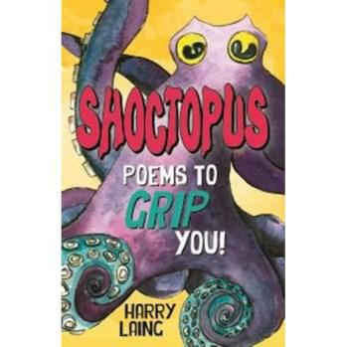

Date: Wednesday 7 March 2018

Location: Palmerston District Primary School

Harry Laing– Author Visit

Years 3-6 students will have the opportunity to attend a writing workshop on Wednesday 7 March with local author Harry Laing.
The event has been funded by the PDPS P&C to enrich our literacy program.

Parent Information Session on Reading - Preschool to Yr1

Date: 9:00 - 9:30am Tuesday 13 March & Thursday 15 March 2018

Location: Palmerston District Primary School, library
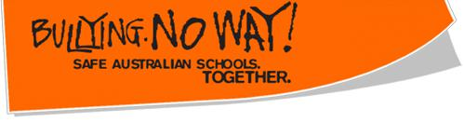

Date: Friday 16 March 2018

Location: Palmerston District Primary School

CLEAN UP AUSTRALIA DAY

Clean Up Australia Day is an event that is held each year. The Clean Up Australia organisation has evolved into an organisation that works with the community, government and business to provide practical solutions to help us all live more sustainably every day of the year.

Friday we will be participating in Clean Up Australia Day from 2:00-2:30pm.
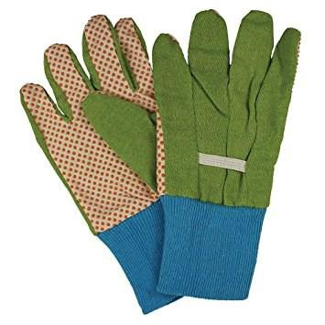

We encourage you to provide gardening gloves for your child.
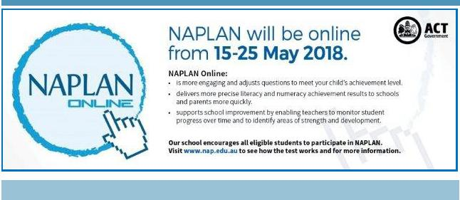

Together, we learn from each other

Palmerston Post Page 4

KINDERGARTEN HEALTH CHECK

The Kindergarten Health Check Program is conducted across ACT Government schools to assist children to have the best possible start at school. Forms were distributed to Kindergarten parents. The school nurses will visit Palmerston District Primary School during 2018 and, if you have provided consent, will conduct a health check with your child. Please return the completed forms to your child’s teacher if you haven’t already.
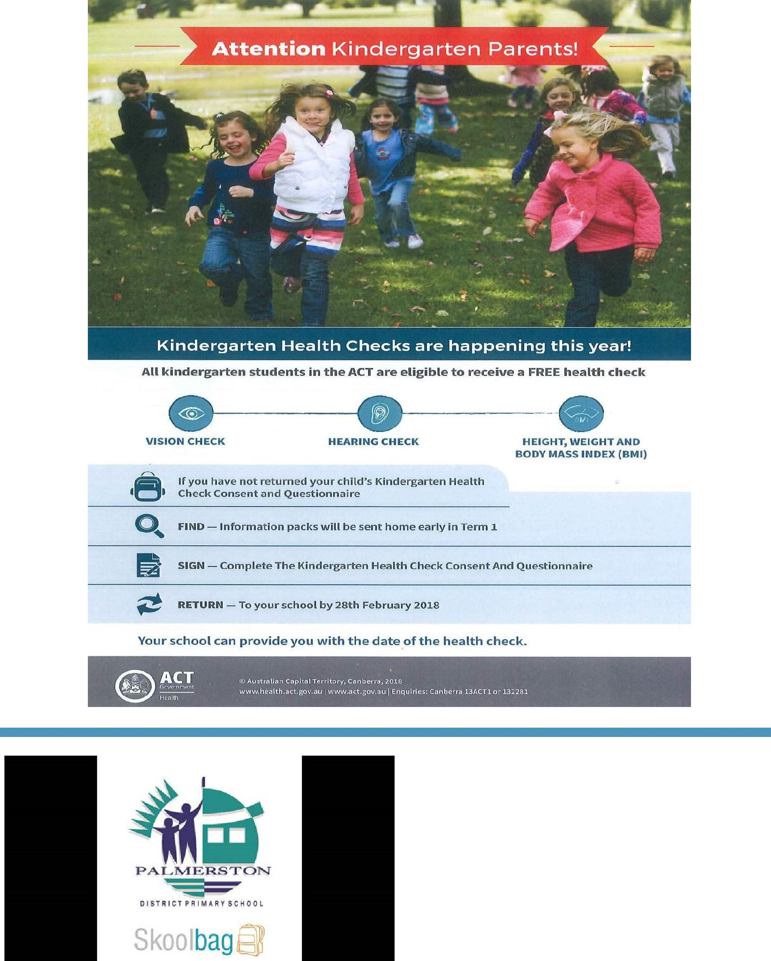

Did you know we have an app you can download to keep you up to date with what is happening at

Palmerston?

Together, we learn from each other

Palmerston Post Page 5

Think before you park…and keep our kids safe!

With school now back for the year we are encouraging all parents to make parking safety a priority!

This means:

- keep clear of ‘no stopping’ and ‘no parking’ zones

- don’t park in bus zones, on school crossings, across footpaths or driveways; and

- don’t double (or triple) park

Remember - it’s okay to park a little further away from the school and walk the rest of the way Consider - having a pre-determined meeting spot agreed with your kids. That way if you are a little late, they know where to wait.

Think – visibility around schools and if your car may be blocking the view of crossings for other motorists. Also be mindful when entering or leaving parking spots – look twice!

Be kind – to other road users and pedestrians and also if you see any parking officers in the area – they are doing their job and working to keep our kids safe!

Note - licence Plate Recognition (or electronic chalking) vans are now actively monitoring schools. Penalties range from $114 upwards to $600. Details at www.act.gov.au/accessCBR

SCHOOL BOARD 2018

In the first nomination period we had one nominee, we would like to congratulate Mr George Villaflor to our school board.

As we still had one position available after the first nomination period we extended the period. We now have two nominees for our one remaining position. You can read about the nominee in next week’s newsletter. You will then have the opportunity to vote for your school board representative. Voting period: Monday 9 March - 23 March 2018

Voting forms will be available from the front office.

Together, we learn from each other

Palmerston Post Page 6

Together, we learn from each other

Palmerston Post Page 7
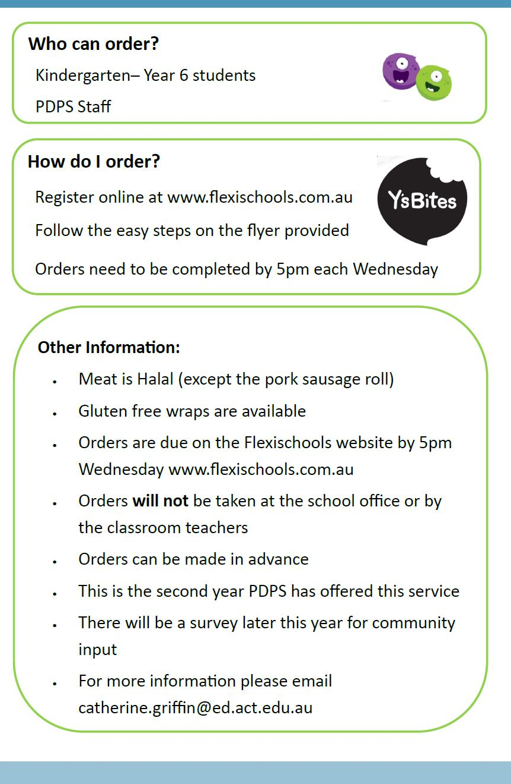

Together, we learn from each other

Palmerston Post Page 8

Together, we learn from each other

Palmerston Post Page 9
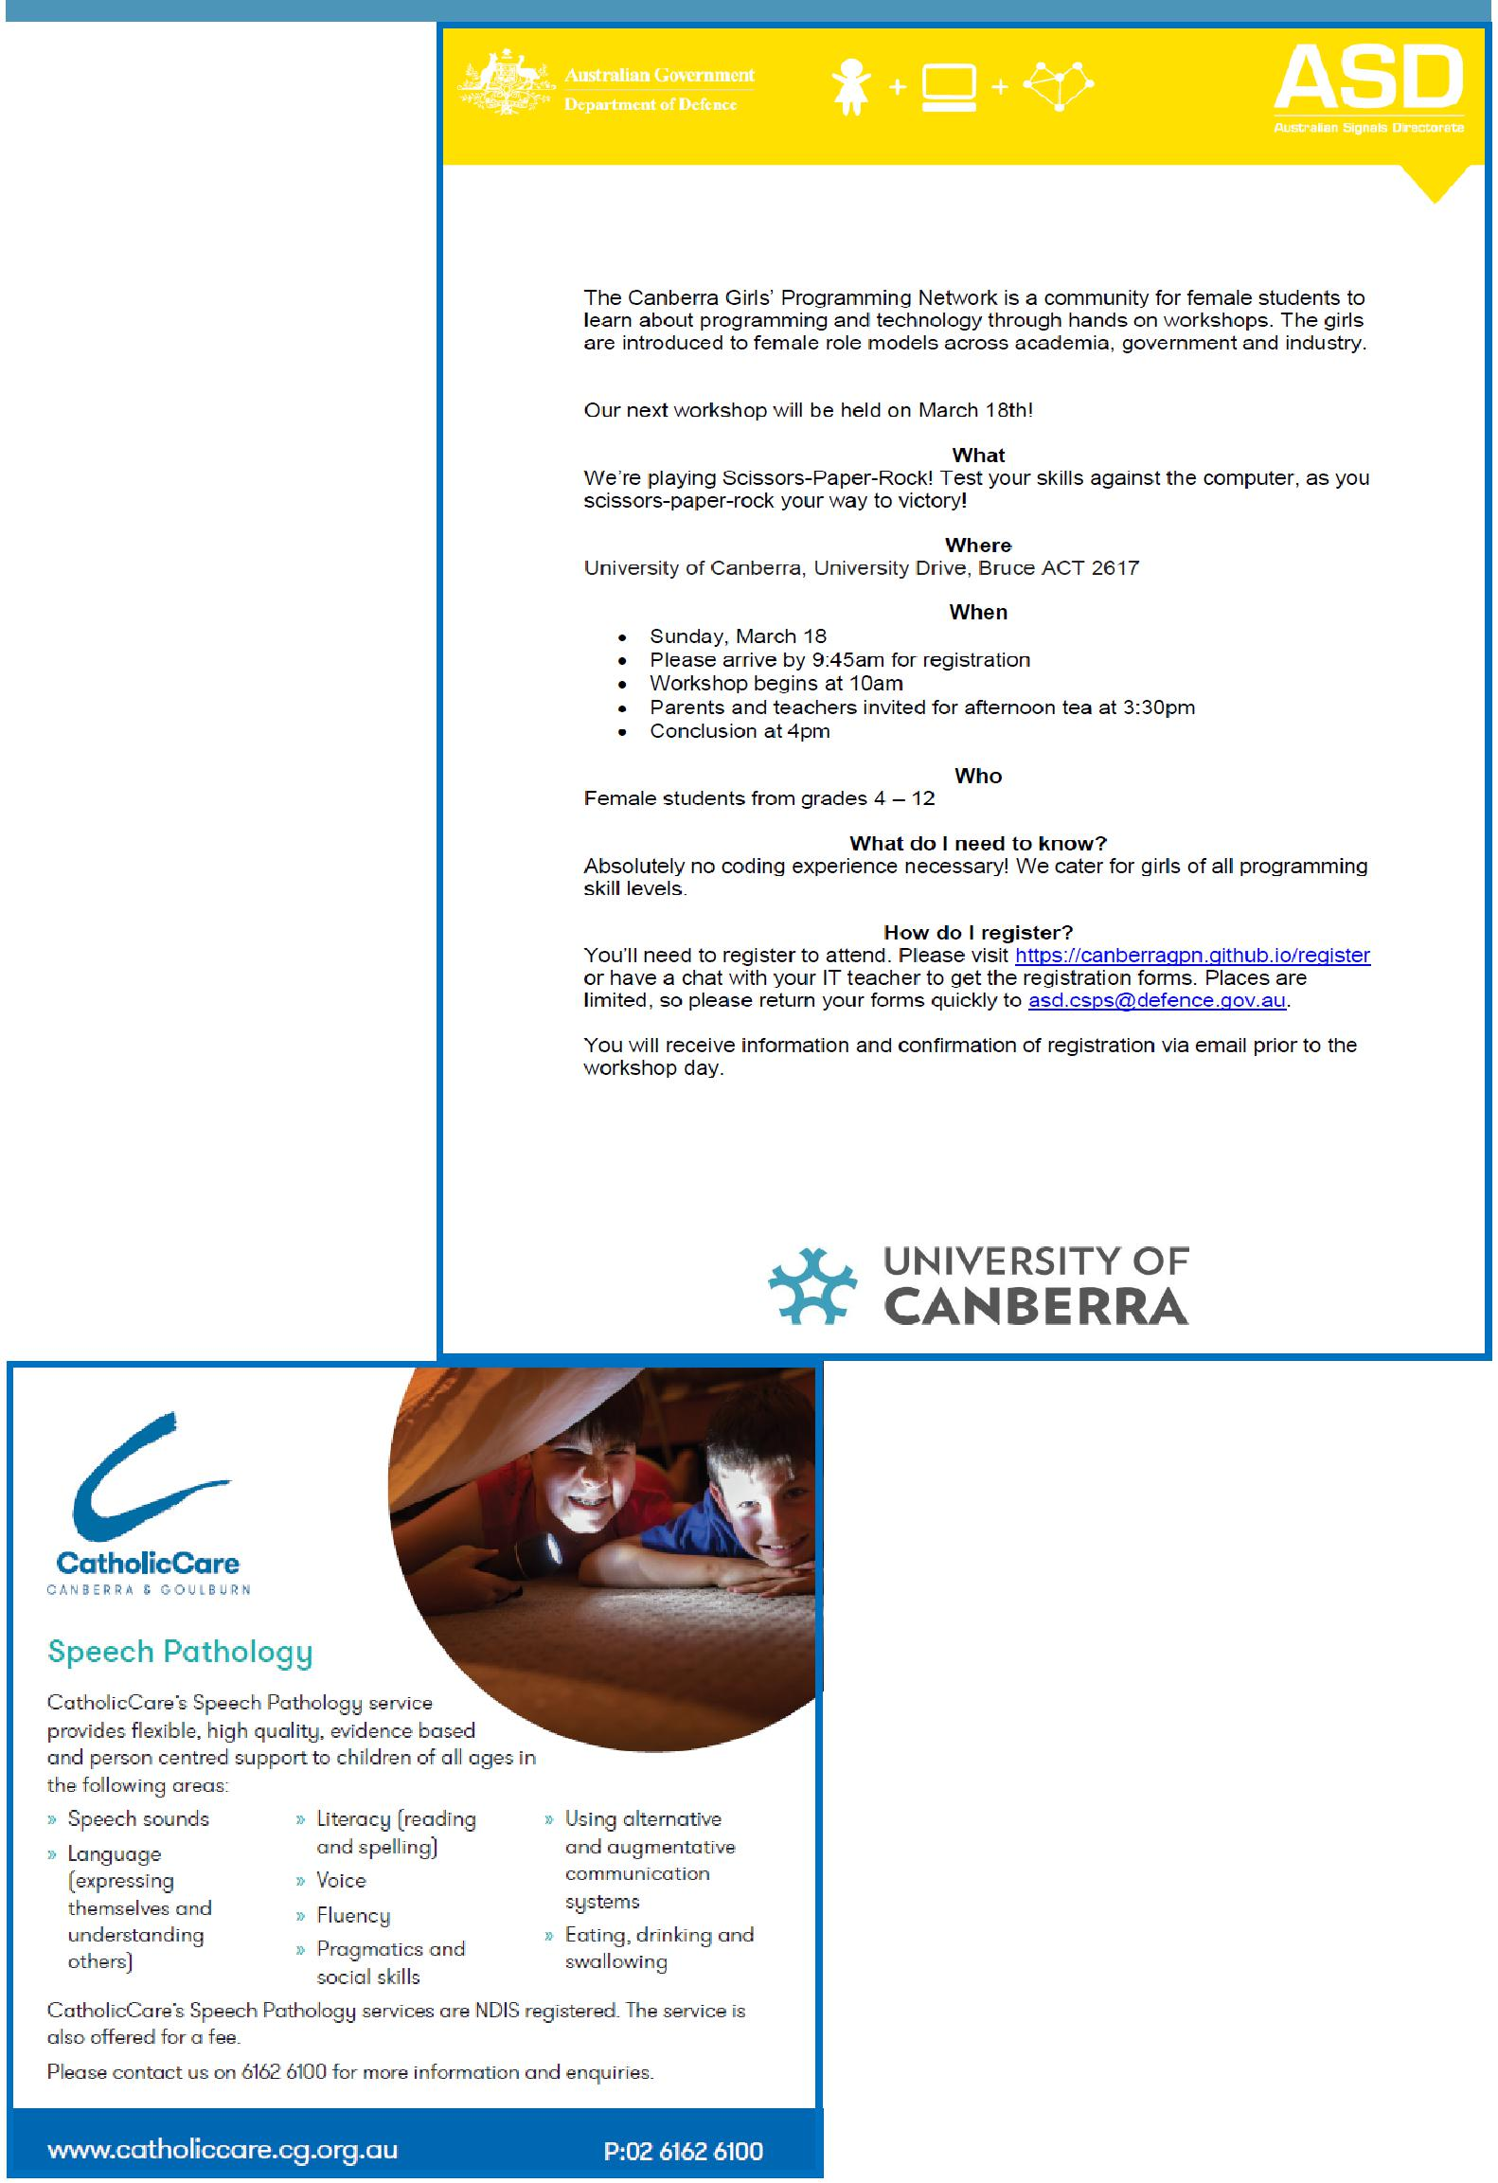

COMMUNITY NEWS

Together, we learn from each other

Palmerston Post Page 10
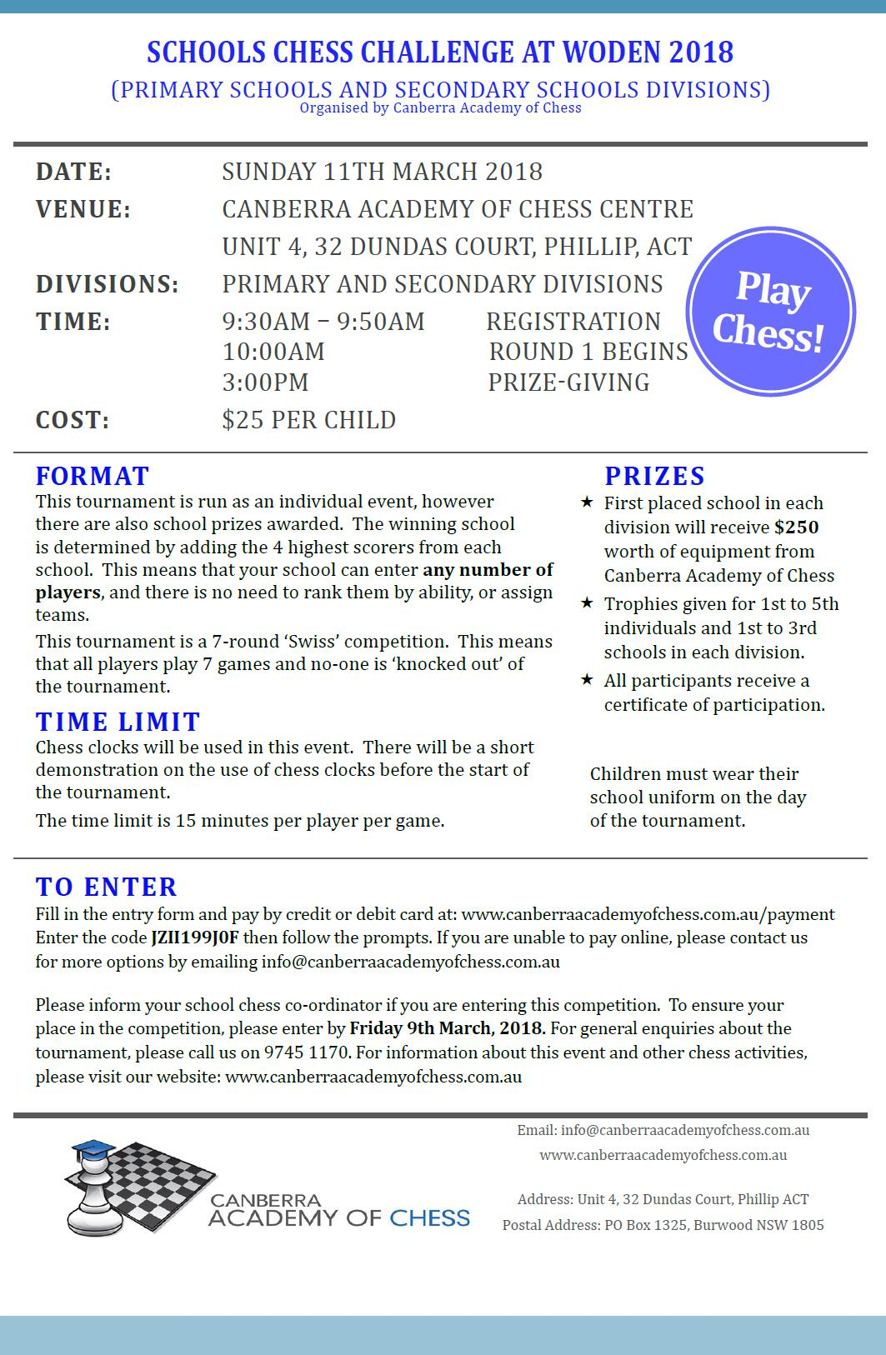

Together, we learn from each other

