Palmerston Post
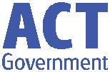

18 October 2018

Week 1 , Term 4

Board Chair: Lisa Fior Board Members: Parent Reps: Jesse Dang and George Villaflor

Teacher Reps: Jessica Lago and Maxine Green

P&C President: Lisa Fior

Principal: Melissa Travers Deputy Principal: Kate Flynn

Executive Teachers: Haeley Simms, Kylie Moller, Jacqui Warden, Matt Gowen, Felicity McNeice, Catherine Griffin (acting)

ASSEMBLY:

19 Oct |  | Junior - 2LM & 2EG
26 | Oct | Whole - Kindy
DATES TO REMEMBER:
23 | Oct | P/S & IEC Theatre
 |  | excursion
23 | Oct | Yr3/4 Soccer Carnival
25 | Oct | K - Gran’s Bag
26 Oct |  | CSIRO Science awards
29 | Oct | Jump Rope for Heart
 |  | Launch
30 | Oct - 2 Nov Book Fair
7 Nov |  | Whole school & Yr6 Grad
 |  | photos
7 Nov |  | 5pm P/S 2019 parent
 |  | info session
7 Nov |  | 5:30pm K 2019 parent
 |  | info session

NOTES HOME:

- Tombola - youngest

- 5c Challenge - youngest

- Grans Bag - Kindy

- Swim & Survive - K & Yr1

- Aqua Safe - Yr2

- Questacon - Yr3/4 & IEC

- Mr Tilley’s Leave - 5DT

- Aerosol cans - Yr5/6

- Yr6 Band - Bandstrav

P&C BOARD NEWS P&C: 7:00pm 29 Oct

All P&C activities, meeting agendas and minutes are available from the school website at – Parent Corner

School Board: 7:30am 29 Nov

PRINCIPAL’S MESSAGE

Welcome back to term 4. I hope you all had a relaxing break. As I walk around the school and talk to the children, they are refreshed and ready for a great term of learning. The staff are excited about the term as we have many great events on, so keep reading the newsletter, the app, See Saw, the website and any notes that come home. We have many ways to communicate what is happening at school.

Just a few of our events for this term are: swimming, graduation, excursions, Grandparents day in Kindy, transition visits, information evenings for preschool and Kindy, dancing, Jump Rope, Talent quest, fishing incursion, Bandstrav, and our TWILIGHT FAIR! And, of course we always have great learning at Palmerston, with wonderful lessons planned for all classes.

Have a great first week and enjoy the warmer weather,

Melissa Travers

DEPUTY PRINCIPAL’S MESSAGE

Like Melissa, I would also like to welcome you back to term 4. I have been sitting with the teachers this week discussing the exciting teaching programs planned for this term. More information around these will come home in the year group overviews next week.

As the weather warms, up I would like to remind you all about our commitment to being sun smart. Students are required to wear a hat each month of year except for June and July. Students are at school when UV radiation levels are at their highest (roughly 10am-3pm) so it is important that they are wearing the appropriate hats to protect them from the sun. Staff ask students to play in the shade when they do not have a hat at school, indoor clubs operate at lunchtime (outdoor clubs also run at this time) and the library is open for students to access as well. Enjoy the remainder of the week,
Kate Flynn

Together, we learn from each other

What’s On

UPCOMING EVENTS

Preschool (beginning) & IEC - Canberra Theatre excursion ‘The Gruffalo’

Date: Tuesday 23 October 2018

Location: Canberra Theatre

Yr3/5 Aldi Soccer competition

Date: Tuesday 23 October 2018

Location: Harrison Oval

5c Challenge for the Twilight Fair

Date: 22 October - 16 November

Location: Palmerston District Primary School

Kindergarten - Gran’s Bag

Date - Thursday, 9:30-11:00am 25 October 2018

We invite Grandparents of our Kindy students to come along to the performance of Gran’s Bag. Location: Palmerston District Primary School

Jump Rope for Heart Launch

Date: Monday 29 October 2018

Location: Palmerston District Primary School

Whole School & Yr6 Graduation Photo

Date: Wednesday 7 November 2018

Location: Palmerston District Primary School

2019 Preschool Parent Information Session

Date: Wednesday, 5pm 7 November 2018

Location: Palmerston Preschool

2019 Kindergarten Parent Information Session

Date: Wednesday, 5:30pm 7 November 2018

Location: Palmerston District Primary School

Yr6 Gold Creek School Transition

Date: Friday 9 November 2018

Location: Gold Creek School - senior site
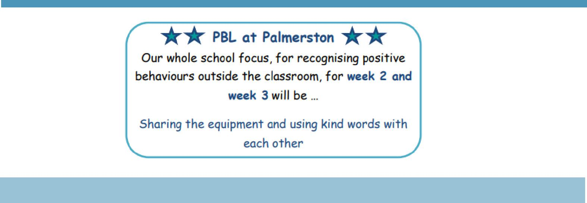

Together, we learn from each other

What’s On

Together, we learn from each other

What’s On

SKOOLBAG APP UPGRADE

As some community members have brought to our attention, there has been a high number of alerts and reminders. As of this term, community members will are to subscribe to year level groups on the PDPS SkoolBag app. This enables our community to personalise their app settings to receive only reminders they wish to see. Settings can be changed while logged onto the app in the ‘groups’ section on the home page.
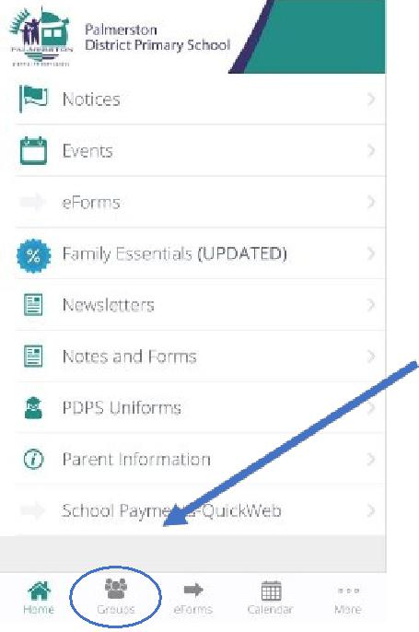

If you have any questions, please contact Catherine Griffin.

PALMERSTON PRIDE AWARDS

Congratulations to the following students who received a PRIDE Award at assembly at the end of term 3.

PARTICIPATION – becoming involved, “having a go” and cooperating with others

Tilo - 4VS

RESPECT – having respect for self, others and their property

Ava - 3/4JL Hope - 6AJ

INTEGRITY – being honest, fair, responsible and loyal

Dylan - 3/4JM Blake - 3/4JM

DETERMINATION - being persistent and resilient

Mylee - 3/4JL Lucas - 3/4JM

EMPATHY -

Daniel - 4VS Brody - 6AJ John - 6AJ Gus - 6AJ Brody - 6AJ

Surin - 6AJ

WRITING AWARDS

Niina - 5DT Poppy—5DT Toby - 5DT

Together, we learn from each other

What’s On
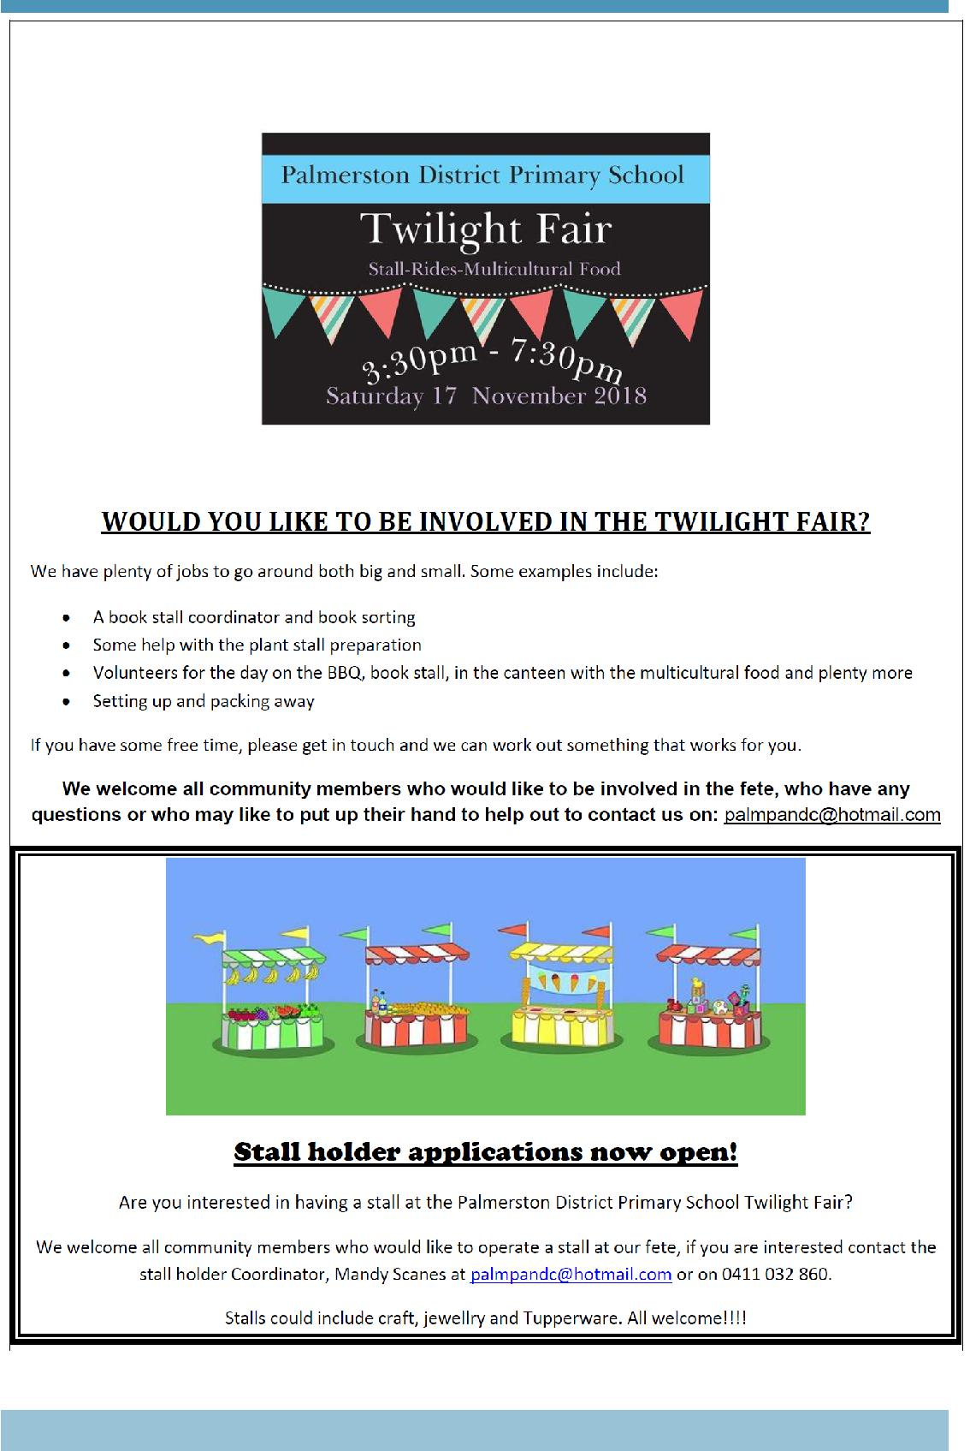

Together, we learn from each other

What’s On
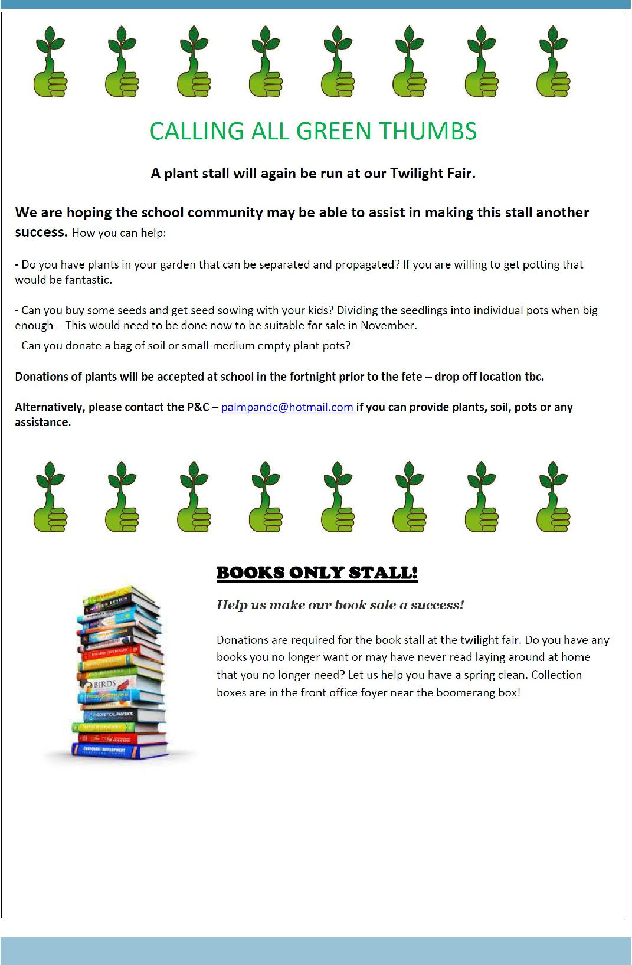

Together, we learn from each other

What’s On
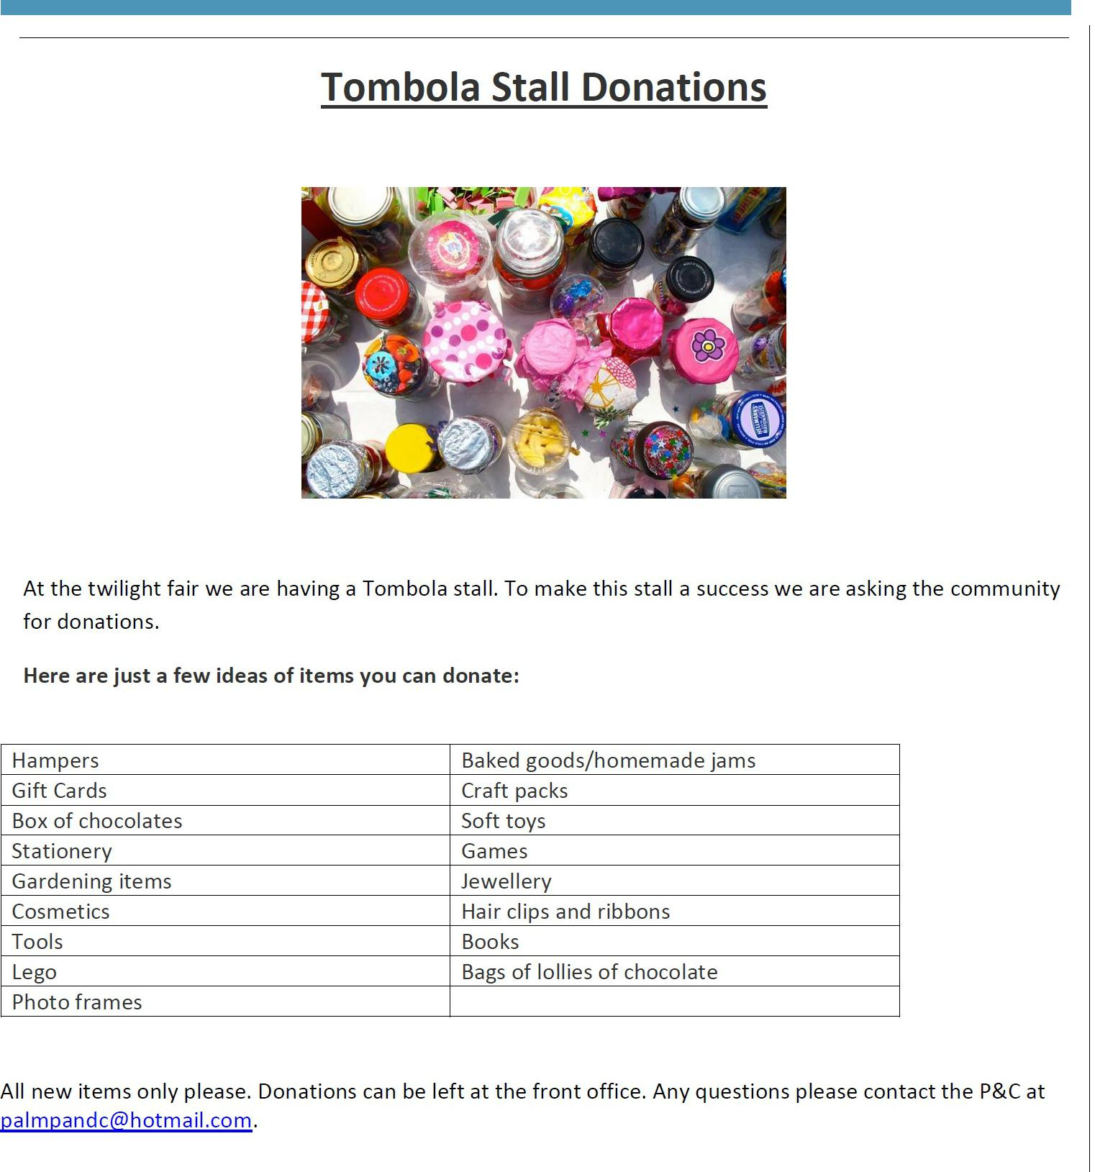

Together, we learn from each other

What’s On
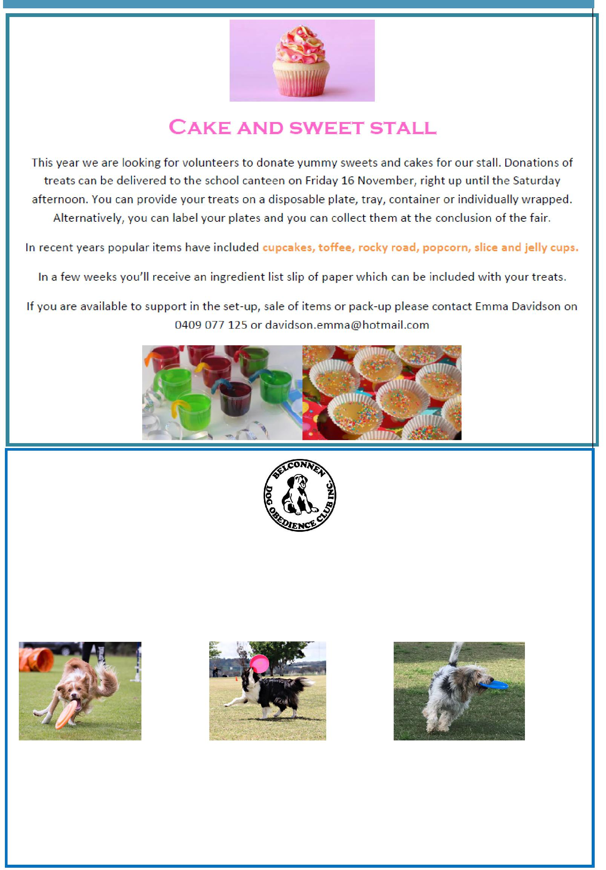

BDOC Disc Dogs Demonstration

Belconnen Dog Obedience Club will be showcasing a Disc Dog demonstration as part of the PDPS Twilight Fair. Disc Dogs is a series of disc (Frisbee) games played by a handler and their dog. Some activities include tunnels and/or jumps.

Come along as see various dogs participating in these sports including Miss Griffin’s dog Fergus.

Visit the Belconnen Disc Dogs Facebook page for more information: https://www.facebook.com/ BelconnenDiscDogs/

For further information please contact the stall co-ordinator Catherine Griffin by email catherine.griffin@ed.act.edu.au

Together, we learn from each other

What’s On

Together, we learn from each other

What’s On
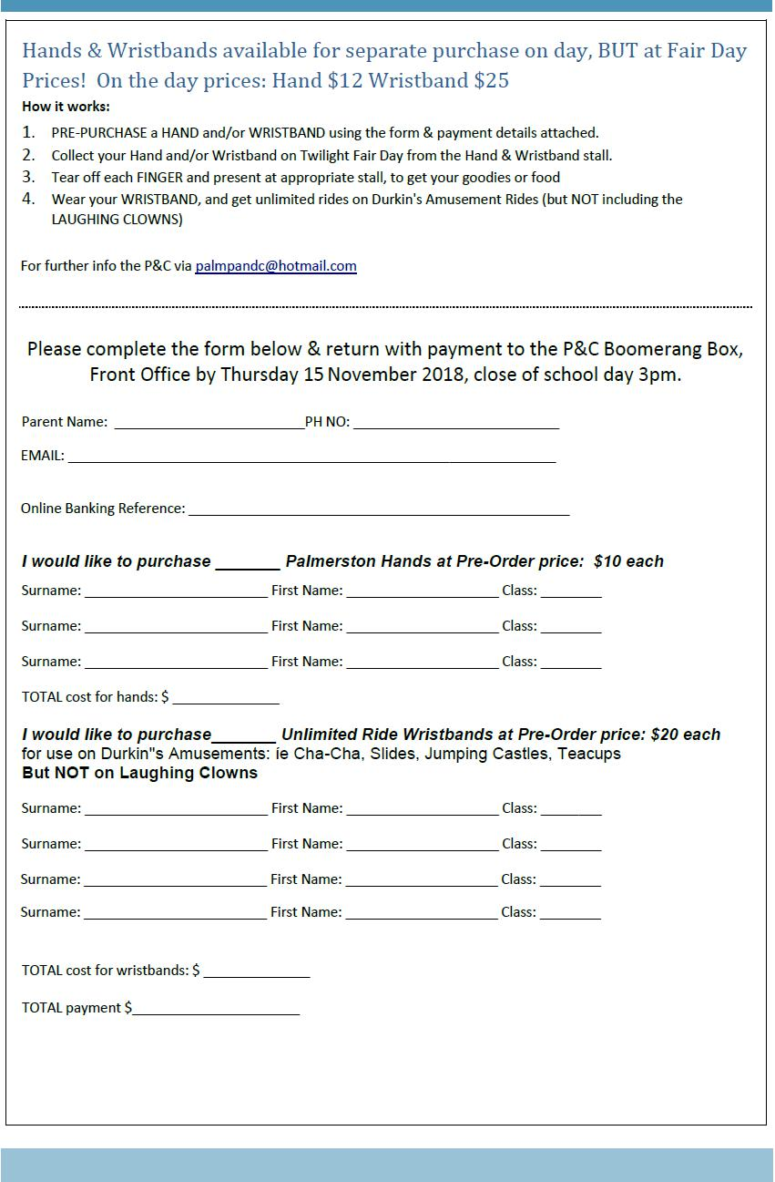

Together, we learn from each other

What’s On

SCHOOL INTENTIONS 2019

School Leavers 2019

We have now reached the time in the year when look at our school numbers and staffing arrangements for 2019. If your circumstances have changed and your child/ren will not be attending Palmerston District Primary School in 2019 can you please let the front office staff know as soon as possible.

My child/ren will not be returning to Palmerston in 2019.

Name Class

Last day at Palmerston:

My child/ren will be attending:

Another government school in the ACT:

A non-government school in the ACT:

Moving out of the ACT

Forwarding Address:

Phone number:

Parent’s name:

Together, we learn from each other

What’s On
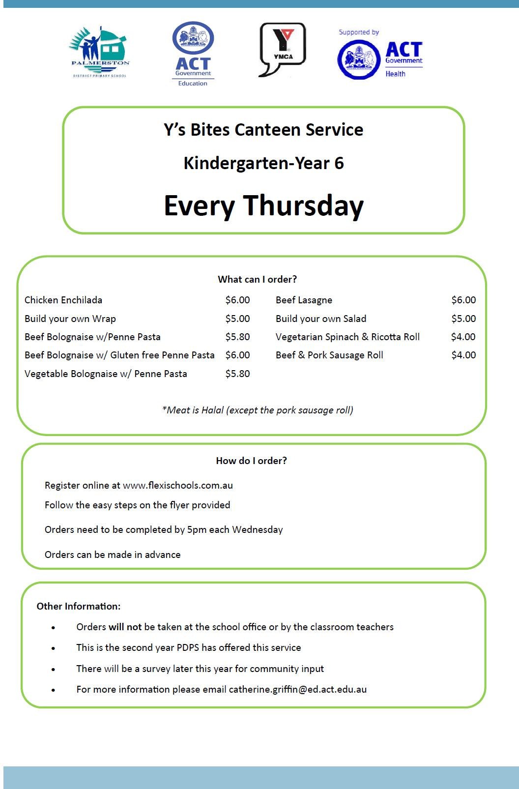

Together, we learn from each other

What’s On

Together, we learn from each other

What’s On

HIRERS
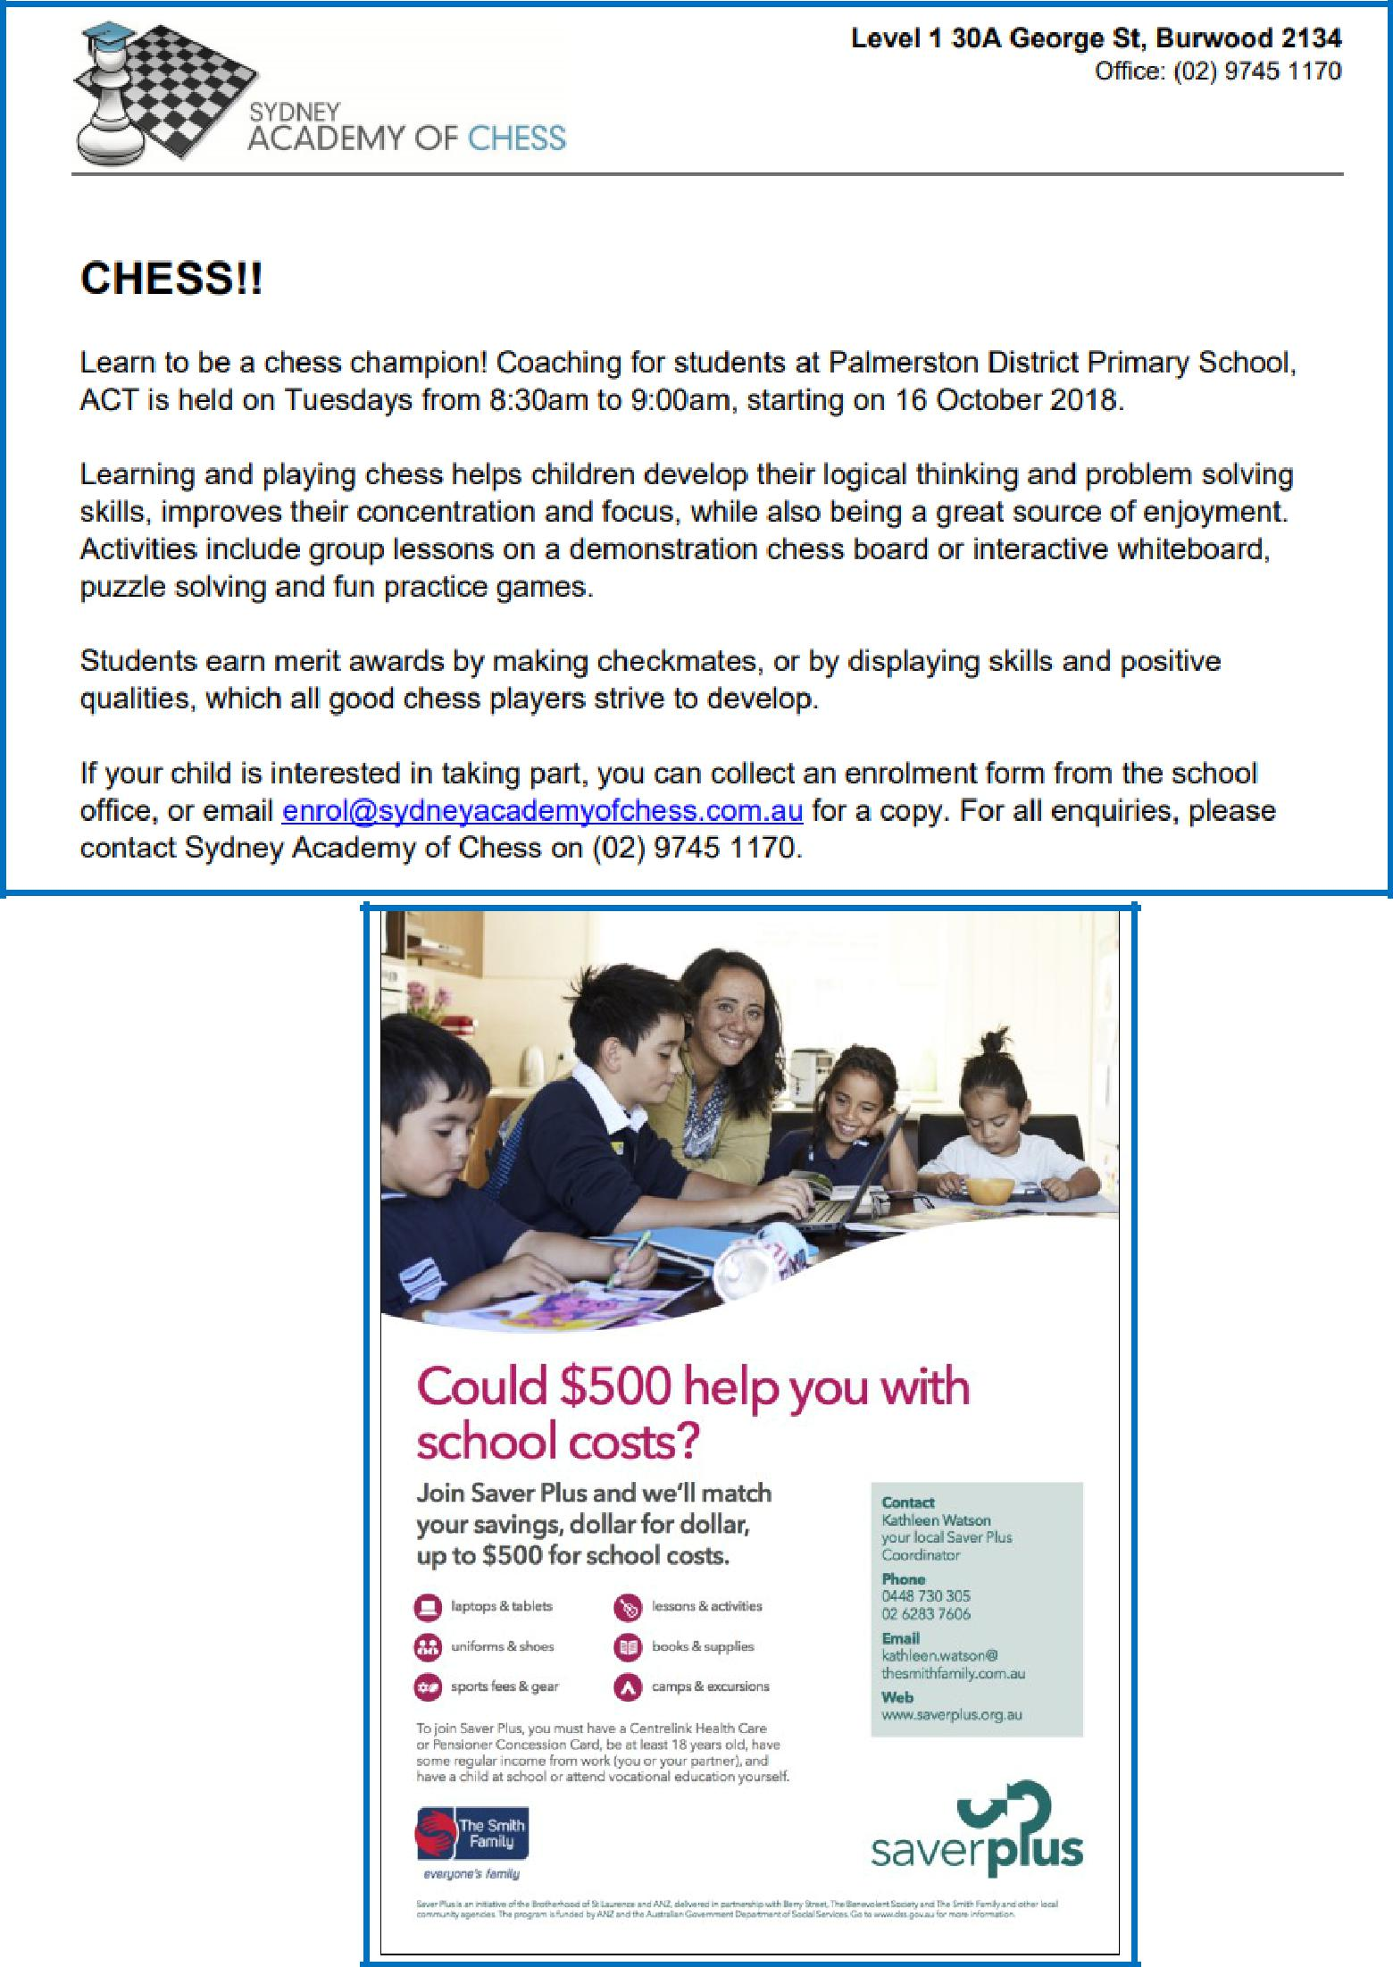

COMMUNITY NEWS

Together, we learn from each other

What’s On
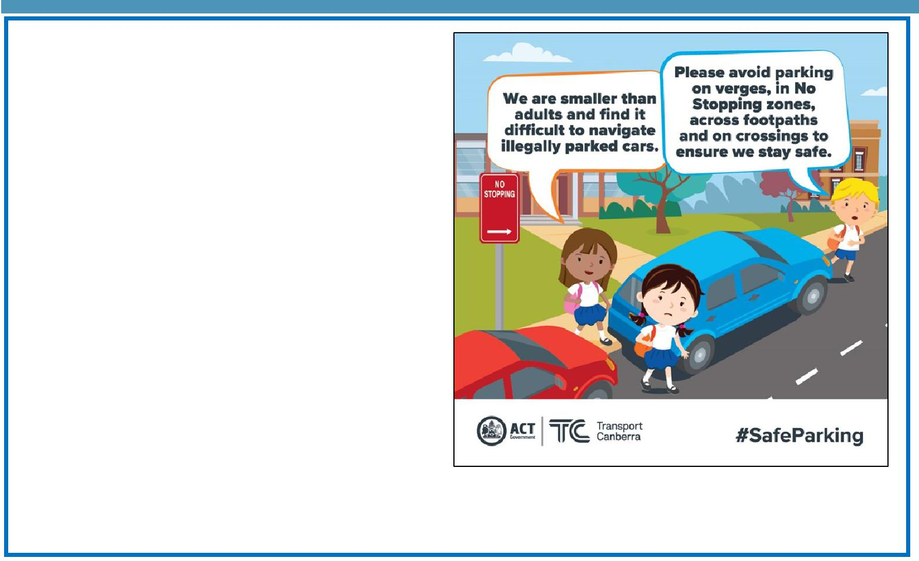

Safe parking behaviours

Unsafe driving and parking behaviours increase the potential road safety risk for children around schools. Road safety is a shared responsibility, it is important the road rules are followed near our school to ensure the entire school community feels safe.

Please remember children are more at risk than adults around schools because they are smaller and less visible to drivers. They are also less predictable and less experienced, which makes them more likely to make errors of judgement.

Failing to follow simple road rules like parking on the verge, in no stopping zones, in bus

stops, near children’s crossings, on footpaths or across driveways increases the risk to children around schools. Please do the right thing to create a safe environment around our school.
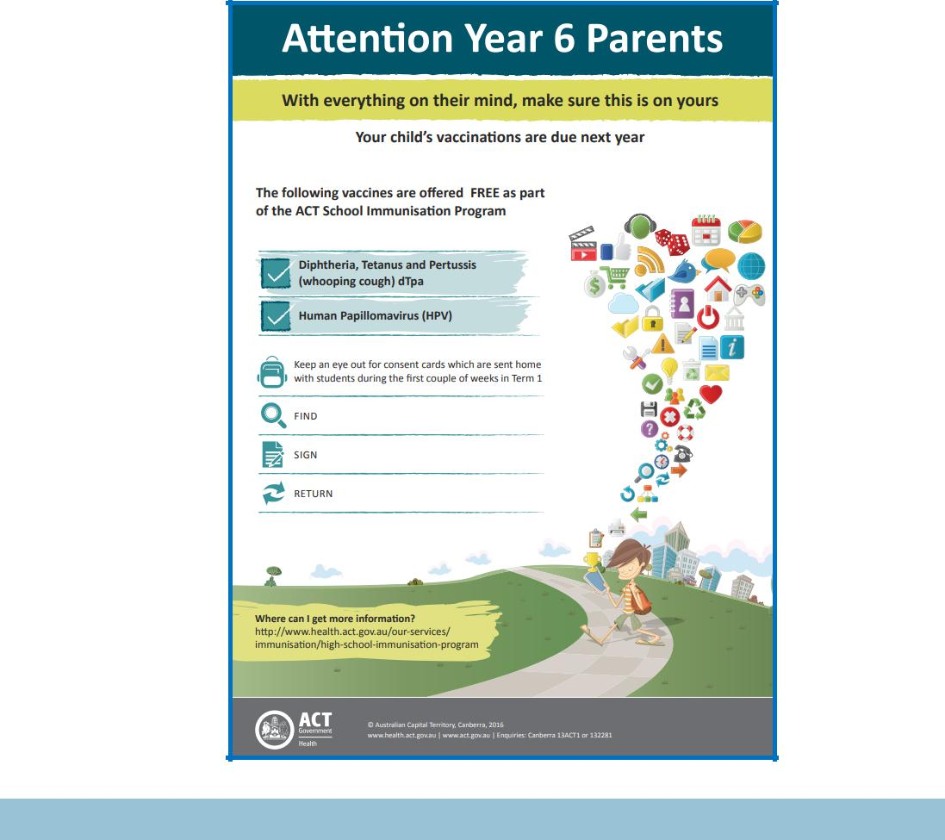

Together, we learn from each other

