Palmerston Post
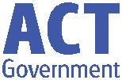

25 October 2018

Week 2 , Term 4

Board Chair: Lisa Fior Board Members: Parent Reps: Jesse Dang and George Villaflor

Teacher Reps: Jessica Lago and Maxine Green

P&C President: Lisa Fior

Principal: Melissa Travers Deputy Principal: Kate Flynn

Executive Teachers: Haeley Simms, Kylie Moller, Matt Gowen, Felicity McNeice, Catherine Griffin (acting)

ASSEMBLY:

26 Oct | Junior - Kindy
2 Nov | Senior - Yr3
DATES TO REMEMBER:
26 Oct | CSIRO Science awards
29 Oct | Jump Rope for Heart
 | Launch
30 Oct - 2 Nov Book Fair
7 Nov | Whole school & Yr6 Grad
 | photos
7 Nov | 5pm P/S 2019 parent
 | info session
7 Nov | 5:30pm K 2019 parent
 | info session
9 Nov | Yr6 Gold Creek Transition
12 Nov | Kindy Open morning
12 Nov | Yr3/4 & IEC Questacon
 | excursion
13 Nov | P/S Mufti Day
14 Nov | 5pm 2019 P/S Info
 | Session

NOTES HOME:

- Twilight Fair - wristband & hand order form

- Yr6 Graduation information

- 2019 Kindergarten information

P&C BOARD NEWS P&C: 7:00pm 29 Oct

All P&C activities, meeting agendas and minutes are available from the school website at – Parent Corner

School Board: 7:30am 29 Nov

EXECUTIVE TEACHER’S MESSAGE

Children’s Week

Students have been celebrating Children’s Week by sharing what they are passionate about. This is linked the United Nations theme of ‘all children have the right to be heard in regard to matters that impact them’. Some of our students have been sharing these passions at morning lines. Also, as part of the ACT Children’s week focus, ‘intergenerational activities’, Kindergarten students attended an incursion of Gran’s Bag with their grandparents. This was a great way to include our wider community.

Passion Project

Last night community members had the opportunity to come together to celebrate the achievements of students in the CAP classes. It was great to see such dedication in completing detailed and well-presented Passion Projects. Thank you to the CAP teachers providing this opportunity for the PDPS community.

Gruffalo Theatre Excursion

On Tuesday, Preschool and the IEC students attended a theatre excursion to see the Gruffalo. This was a great way to make connections with the award-winning book by Julia Donaldson. We have many copies of this book at the school for our community to borrow.
Aldi Soccer

Also, on Tuesday, selected 3/4 students represented the school at the Aldi Soccer Gala Day. Congratulations to those students on a fantastic effort, demonstrating our school PRIDE values.

World Teacher’s Day

Wednesday was World Teacher’s Day, a day to celebrate internationally the contributions teachers make to education. Thank you to the P&C for providing morning tea to celebrate the wonderful work our teachers do for the school.

Together, we learn from each other

Palmerston Post

5c Challenge

This week we launched the 5c Challenge to raise funds for PDPS Twilight Fair. Students are encouraged to bring along 5c coins. Each week classes tally up how much money they have raised so far. Updates will occur each Monday at morning lines.

Staffing 2019

Staffing for next year is currently being organised. Students will be given a slip of paper to nominate at least 5 friends who they would be happy to be with in their next year level. The school endeavours to place each child with at least one of the listed students. As there are over 700 students, we seek your understanding, that this is a difficult and complex process. Parent requests about child placements should be in writing, addressed to the principal and left at the front office. As our teachers have passed the ‘wonderful’ test, no teacher requests will be require required.

We look forward in being entertained by Kindergarten at junior assembly tomorrow.

Catherine Griffin
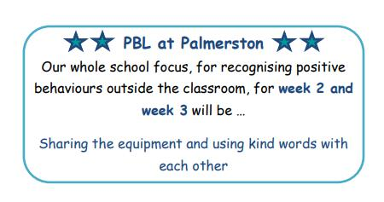

Together, we learn from each other

Palmerston Post

UPCOMING EVENTS

5c Challenge for the Twilight Fair

Date: 22 October - 16 November

Location: Palmerston Primary

Jump Rope for Heart Launch

Date: Monday 29 October 2018

Location: Palmerston Primary

Whole School & Yr6 Graduation Photo

Date: Wednesday 7 November 2018

Location: Palmerston District Primary School

2019 Preschool Parent Information Session

Date: Wednesday, 5pm 7 November 2018

Location: Palmerston Preschool

2019 Kindergarten Parent Information Session

Date: Wednesday, 5:30pm 7 November 2018

Location: Palmerston Primary

Yr6 Gold Creek School Transition

Date: Friday 9 November 2018

Location: Gold Creek School - senior site

2019 Kindergarten Open Morning

Date: Monday 12 November 2018

Location: Palmerston Primary

Yr3/4 & IEC Questacon Excursion

Date: Monday 12 November 2018

Location: Questacon

Together, we learn from each other

Palmerston Post

DEFENCE NEWS

PALMERSTON DISTRICT PRIMARY SCHOOL

REMEMBRANCE DAY SERVICE

Date: Friday, 9 November 2018.

Time: The Service will commence at 9:00am

Where: Black Top

A Morning Tea will follow for special guests and our Defence families, in the Staff Room.

Defence families, please RSVP by Wednesday, 7 November to kristy.retzlaff@ed.act.edu.au for catering purposes.

Together, we learn from each other

Palmerston Post

Together, we learn from each other

Palmerston Post
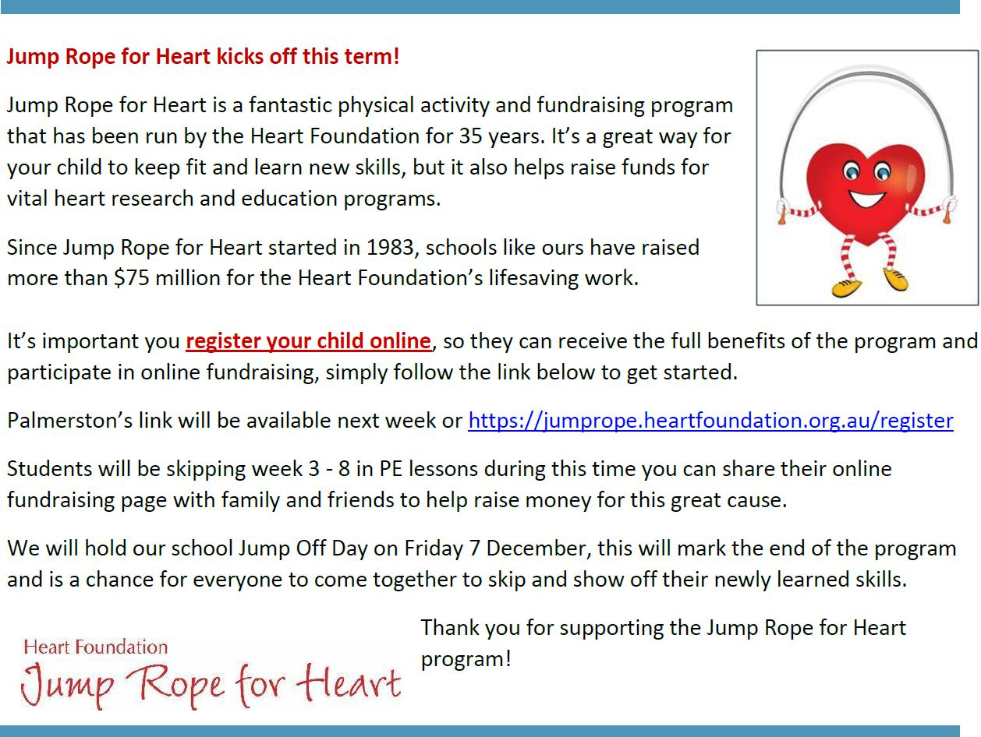

PALMERSTON PRIDE AWARDS

Congratulations to the following students who received a PRIDE Award at last week’s assembly

PARTICIPATION – becoming involved, “having a go” and cooperating with others

Luca - KFD Lara - KFD Lucas - KGS Olivia - 2EG Bach - 2EG

Eluney - 2MO Indy - 2MG Ela Rose - 2MG

RESPECT – having respect for self, others and their property

Cruz - 2EG Amira - 2MG

DETERMINATION - being persistent and resilient

Flynn - KSH Omar - KSH

STUDENT ACHIEVEMENTS

Mima - 2MO recently completed her preliminary piano and music theory Australian Guild of Music exams. She received a high distinction (98/100) and was recommended by the head examiner for a national award at a ceremony in Melbourne for piano; and a distinction for theory! Well done Mima!

Together, we learn from each other

Palmerston Post

P&C NEWS

Together, we learn from each other

Palmerston Post
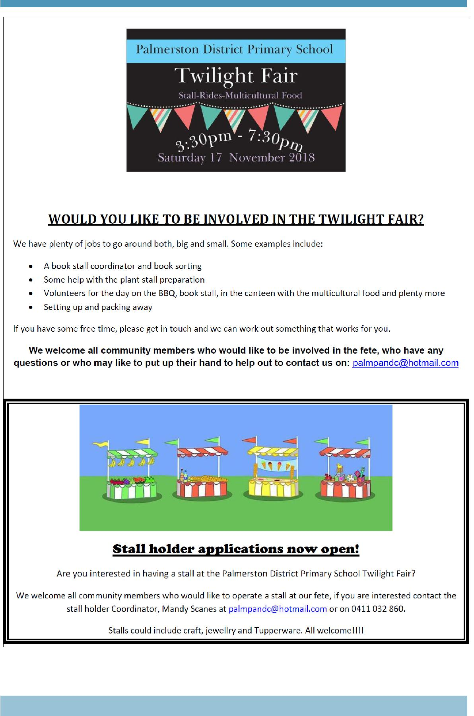

Together, we learn from each other

Palmerston Post
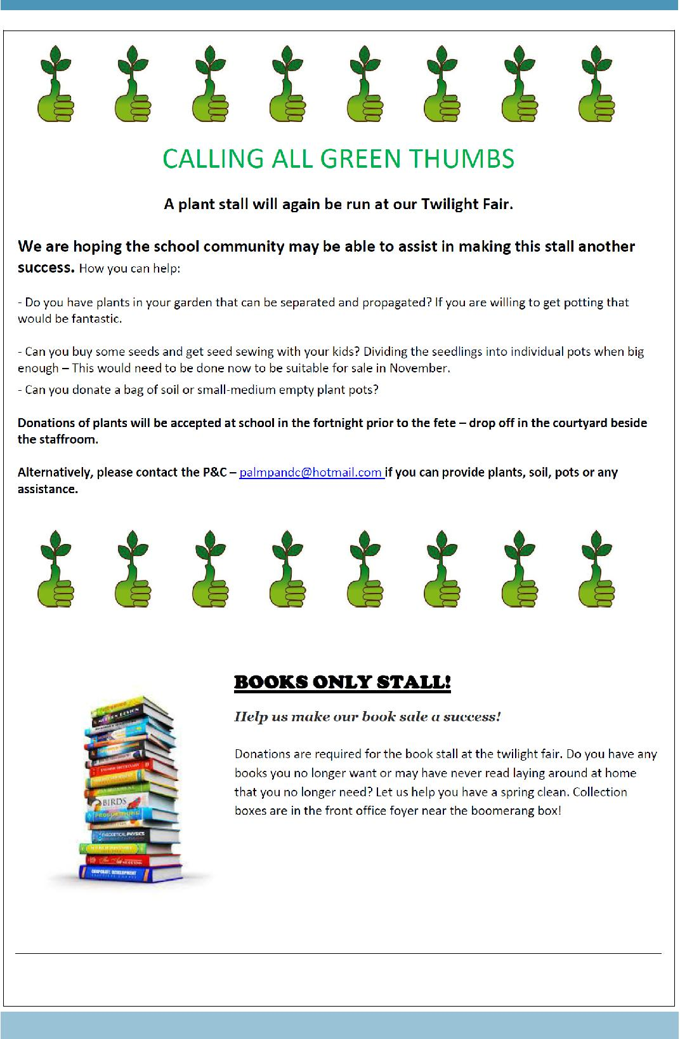

Together, we learn from each other

Palmerston Post
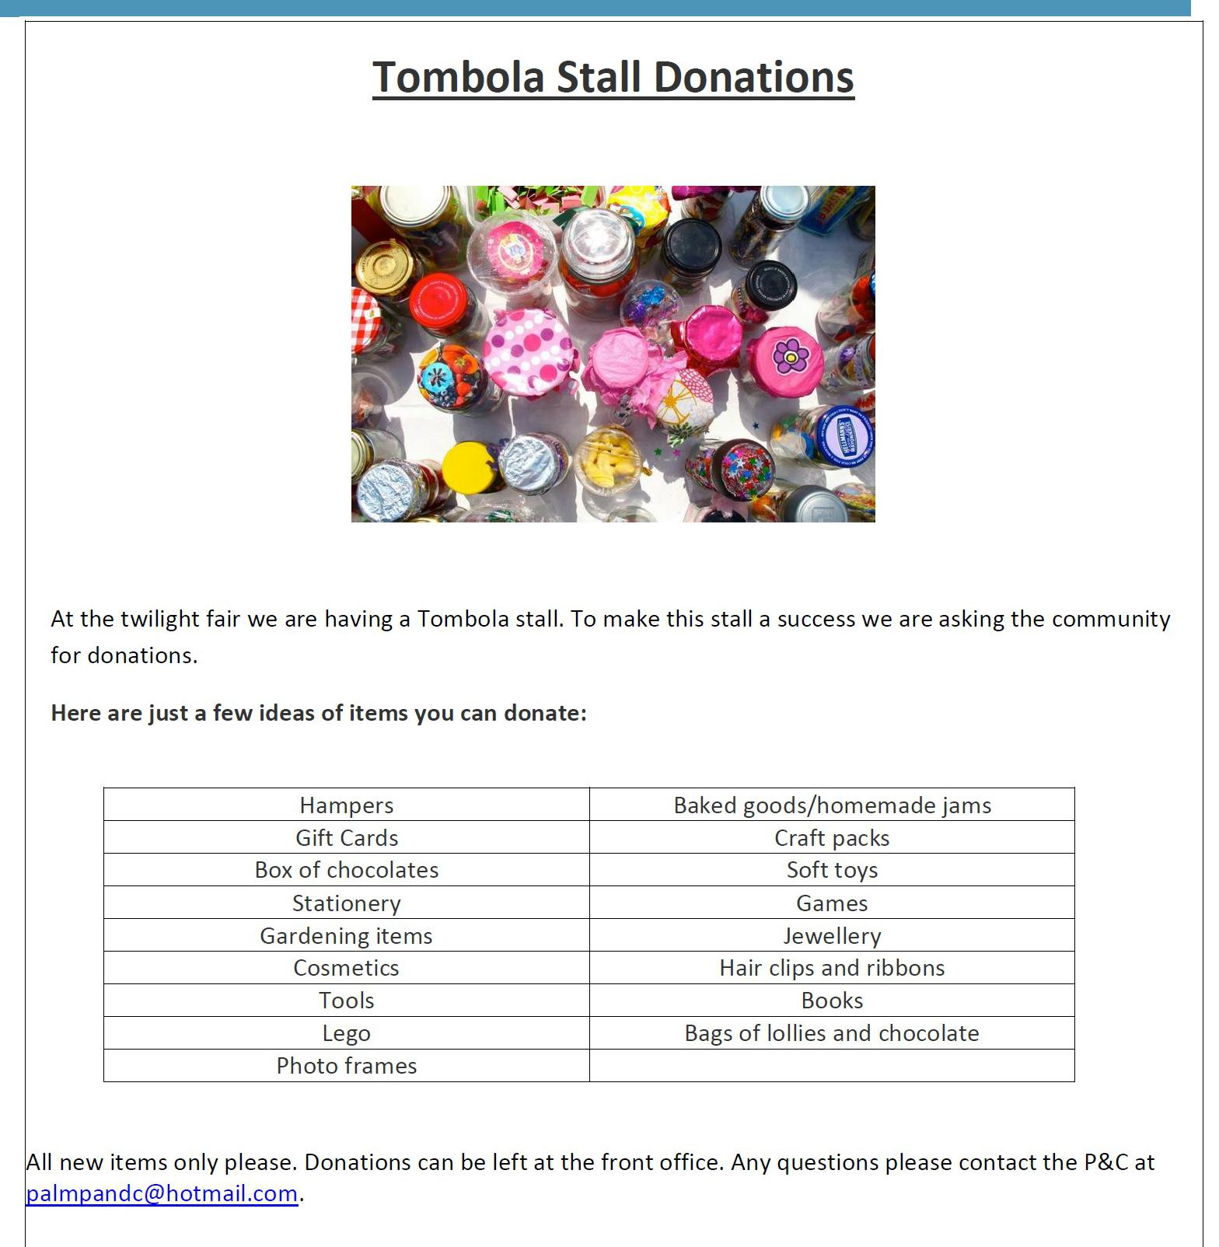

Together, we learn from each other

Palmerston Post
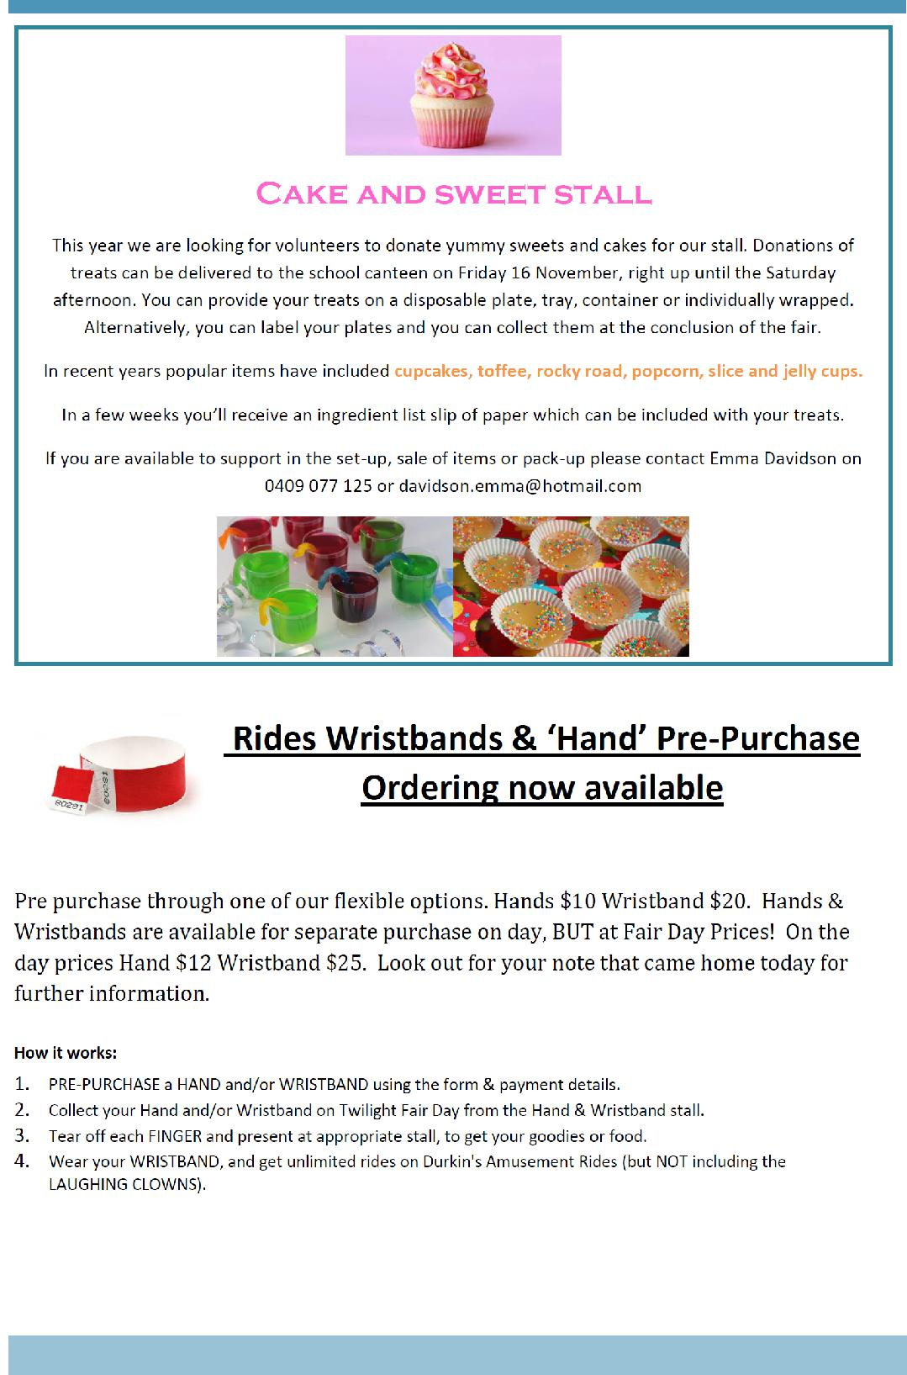

Together, we learn from each other

Palmerston Post
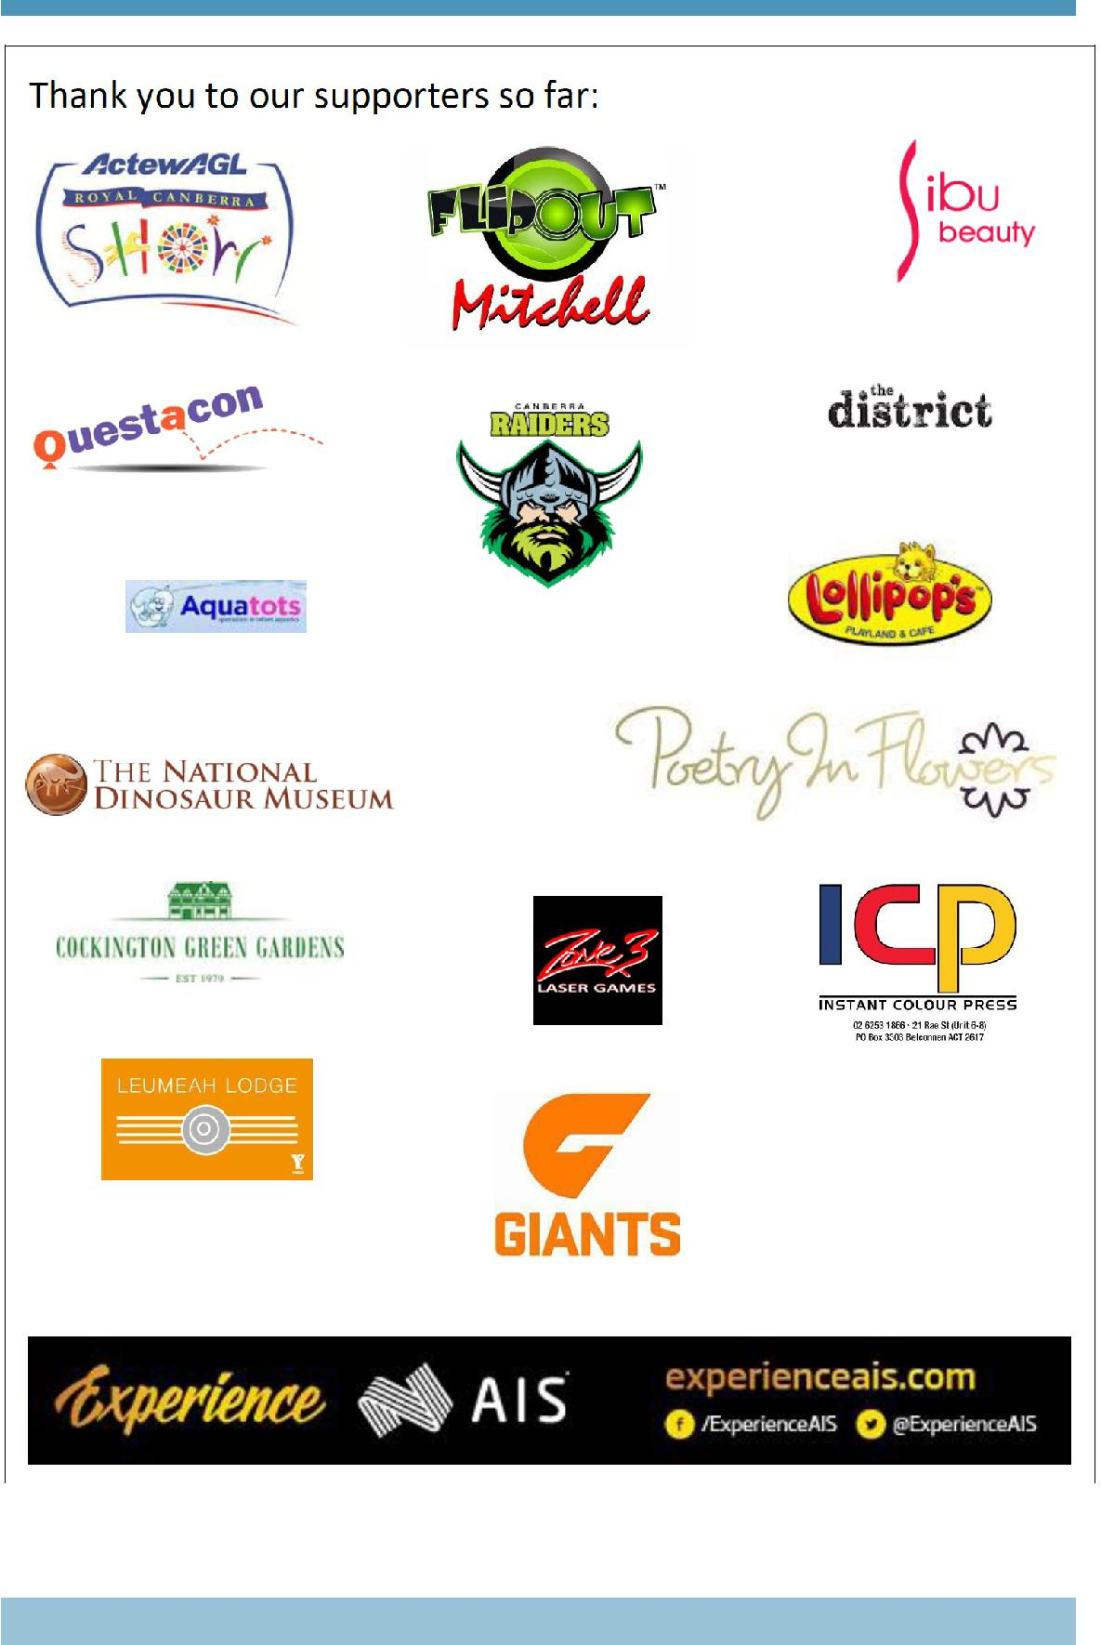

Together, we learn from each other

Palmerston Post
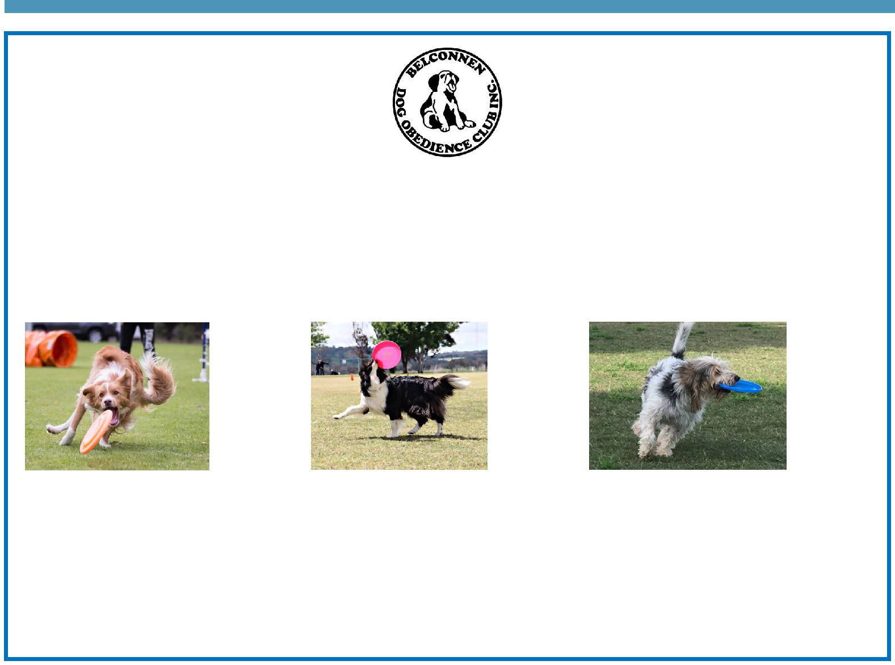

BDOC Disc Dogs Demonstration

Belconnen Dog Obedience Club will be showcasing a Disc Dog demonstration as part of the PDPS Twilight Fair. Disc Dogs is a series of disc (Frisbee) games played by a handler and their dog. Some activities include tunnels and/or jumps.

Come along as see various dogs participating in these sports including Miss Griffin’s dog Fergus.

Visit the Belconnen Disc Dogs Facebook page for more information: https://www.facebook.com/ BelconnenDiscDogs/

For further information please contact the stall co-ordinator Catherine Griffin by email catherine.griffin@ed.act.edu.au

Together, we learn from each other

Palmerston Post

SCHOOL INTENTIONS 2019

School Leavers 2019

We have now reached the time in the year when look at our school numbers and staffing arrangements for 2019. If your circumstances have changed and your child/ren will not be attending Palmerston District Primary School in 2019 can you please let the front office staff know as soon as possible.

My child/ren will not be returning to Palmerston in 2019.

Name Class

Last day at Palmerston:

My child/ren will be attending:

Another government school in the ACT:

A non-government school in the ACT:

Moving out of the ACT

Forwarding Address:

Phone number:

Parent’s name:

Together, we learn from each other

Palmerston Post
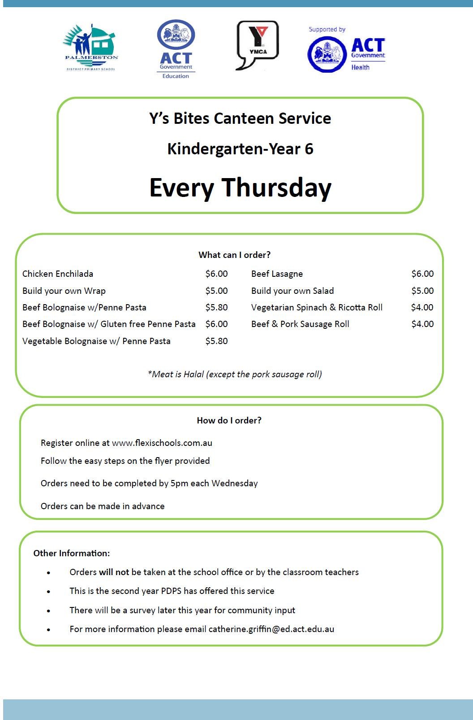

Together, we learn from each other

Palmerston Post

Together, we learn from each other

Palmerston Post

COMMUNITY NEWS
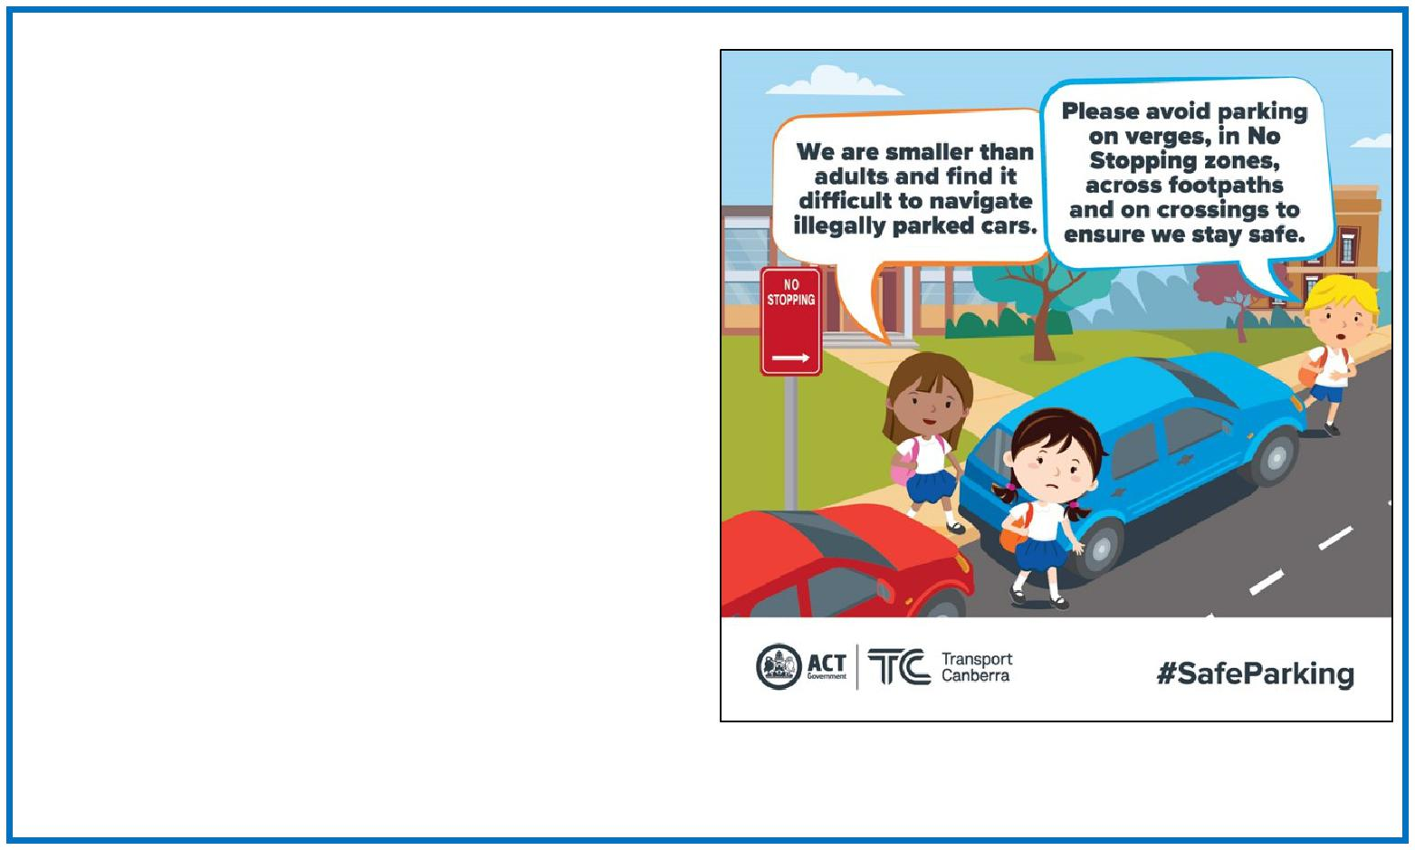

Safe parking behaviours

Unsafe driving and parking behaviours increase the potential road safety risk for children around schools. Road safety is a shared responsibility, it is important the road rules are followed near our school to ensure the entire school community feels safe.

Please remember children are more at risk than adults around schools because they are smaller and less visible to drivers. They are also less predictable and less experienced, which makes them more likely to make errors of judgement.

Failing to follow simple road rules like parking on the verge, in no stopping zones, in bus stops, near children’s crossings, on footpaths or across driveways increases the risk to children around

schools. Please do the right thing to create a safe environment around our school.
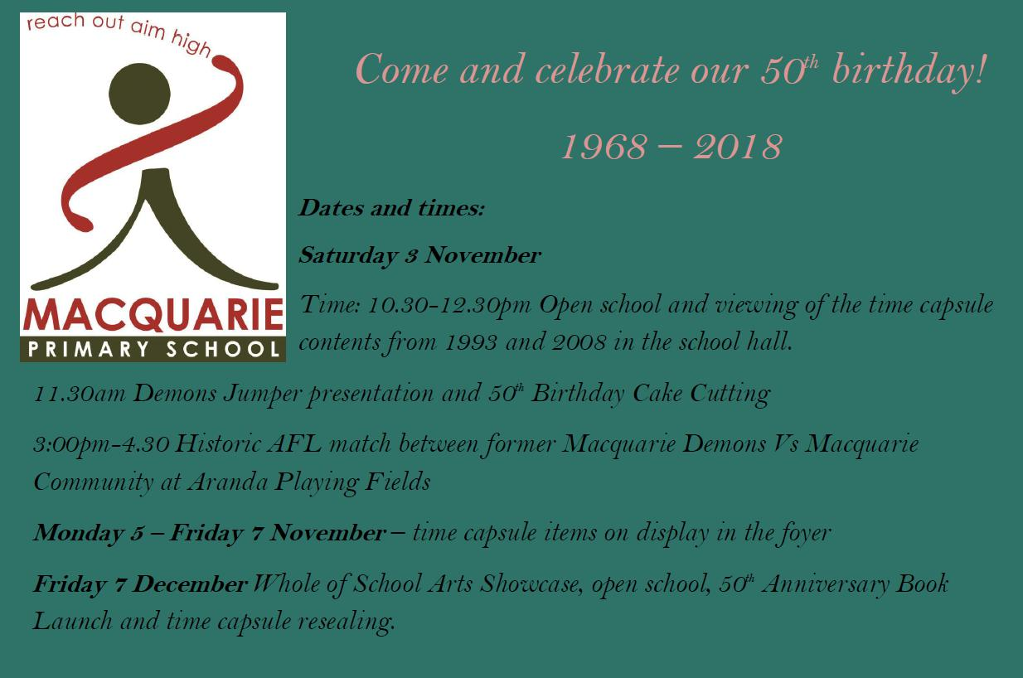

Together, we learn from each other

Palmerston Post

ACT Primary Concert Choir - 2019

The ACT Instrumental Music Program is seeking students who will be in Year 4 to Year 6 in 2019 to audi-tion for the ACT Primary Concert Choir (PCC). The PCC rehearses on Thursday afternoons from 4.30pm till 5.30pm during school terms at the IMP in Kaleen. The Primary Concert Choir is conducted by Katharine Finlayson. The choir is an extension and performance opportunity for students in ACT Educa-tion Directorate schools.

During its first four years the choir has been invited to perform in high profile events such as the nation-ally televised Australia vs New Zealand Brumbies game, Parliament House Open Day, Step Into the Lime-light, Wattle Day Citizenship Ceremonies, National Eisteddfod and IMP Concerts.

The choir is an excellent opportunity for talented, skilled and committed young singers to work together in an enriching environment. The PCC is a performance ensemble and the families of children audition-

ing will need to be prepared to make a strong commitment to rehearsal and performance attendance

for the year. Further details and information about how to apply for an audition are available from the Instrumental Music Program website at www.imp.act.edu.au. The application form can be accessed through this site or by clicking on the links below.

Information letters are available at your child’s school. These letters detail what is required during the audition and also further information about the audition process. If you do not have internet access please telephone the IMP on 61420477

https://goo.gl/forms/hKLIGHgO0ReTpXgD3

Applications are now open and close Friday 9 November.

Together, we learn from each other

Palmerston Post
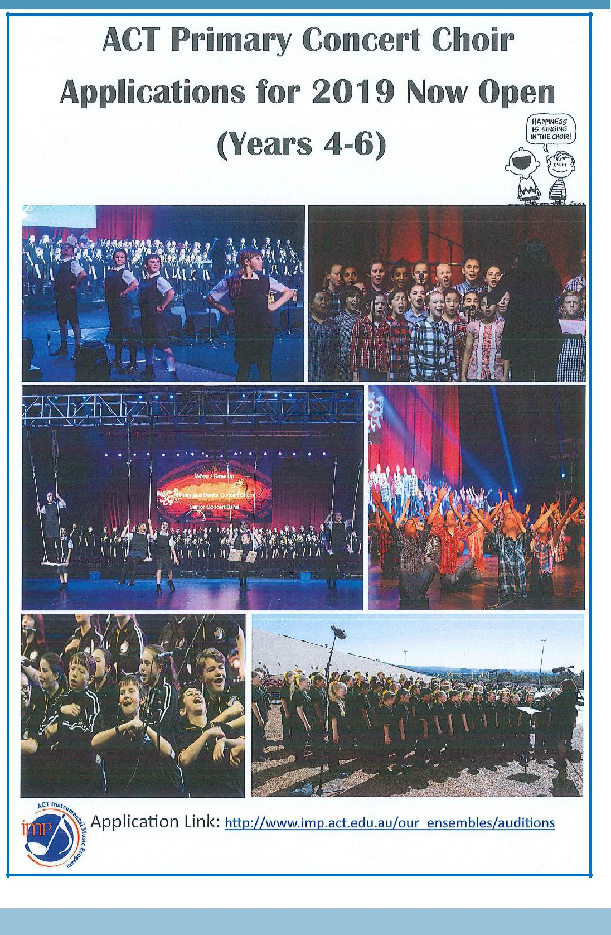

Together, we learn from each other

