 |  |  |  |  |  |  |  | What’s On
 |  |  |  |  |  |  |  | 22 February 2018
 |  |  |  |  |  |  |  | Week 3, Term 1
 |  | ASSEMBLY: |  |  |  |  |  | PRINCIPAL’S MESSAGE
 |  | 23 Feb |  | Junior - 2EG & 2LM |  |  |  | Parents and Citizens (P&C)
 |  | 2 Mar |  | Senior - Yr 5 |  |  |  | A big thank you to the parents who attended the P&C AGM and
 |  | 9 Mar |  | Junior - 2MO, 2MG & 2RK
 |  |  |  |  |  |  |  | 2018 meeting on Monday Evening. We have filled all our
 |  | DATES TO REMEMBER: |  |  |  |  |  | executive positions. My thanks go out to the outstanding
 |  | 26-28 Feb |  | Yr5/6 Camp - Borambola |  |  |  | contribution our P&C make to the School Community life. Lisa
 |  | 7 Mar |  | Yr3-6 Author visit
 |  |  |  |  |  |  |  | Fior is our P&C president for 2018. Her president’s report for
 |  |  |  |  |  |  |  | 2017 is attached to this newsletter and will be posted on the
 |  |  |  |  |  |  |  | school website soon. The P&C are already busy organising the
 |  | NOTES HOME: |  |  |  |  |  | term 1 events. (dates may vary, but we will keep you informed
 |  |  |  |  |  |  |  | through the newsletter).
 |  |  |  |  |  |  |  | Events

 |  |  |  |  | • Watermelon at the swimming carnival
 |  |  |  |  | • | Sausage sizzle
 |  |  |  |  | • | Disco
 |  |  |  |  | • | Mufti day
 |  |  |  |  | • Ice blocks for cross country
 |  |  |  |  | The P&C also run the second hand clothing pool, school
 |  |  |  |  | banking, extra special canteen days, book club and the Twilight
 |  |  |  |  | Fair. With the Assistance of the P&C 2017 fundraising, we will
 |  |  |  |  | be purchasing an audio visual set up for the school hall and an
 |  |  |  |  | enhanced speaker system for the morning assembly area. We
 |  |  |  |  | acknowledge that at times it is difficult to hear our
 |  |  |  |  | announcements, so an upgrade will greatly assist.
 |  |  |  |  | School Board
 |  |  |  |  | The School Board has an integral part in the governance of the
 |  |  |  |  | school. They have a minimum of 4 meetings a year and
 |  |  |  |  | Palmerston chooses to have one meeting in term 1 and two
 |  |  |  |  | meetings a term for terms 2,3,& 4. We meet at 7.30am on a
 |  |  |  |  | Thursday morning in weeks 1 and 7. The Board oversees the
 | P&C BOARD NEWS
 |  |  |  |  | design and implementation of the School Plan, annual Action
 | P&C: 26 March 2018 |  |  |  | Plans, the finances and any other issues that may arise. You
 | All P&C activities, meeting agendas and
 |  |  |  |  | can request to sit in on a meeting of non confidential matters
 | minutes are available from the School
 |  |  |  |  | or write to the board on any matter that you would like
 | website at – Parent Corner
 |  |  |  |  | discussed. The board is your link with the Directorate.
 | School Board Elections held in early 2018
 |  |  |  |  | We currently have one space open to fill for the School Board. I
 |  |  |  |  | encourage you to nominate for the board as it is a great way to
 |  |  |  |  | participate in the school, find out what is happening and be
 |  |  | Together, we learn from each other

What’s On Page 2

part of the decision making. Please feel free to contact me if you would like further information.

Nomination forms are at the front office.
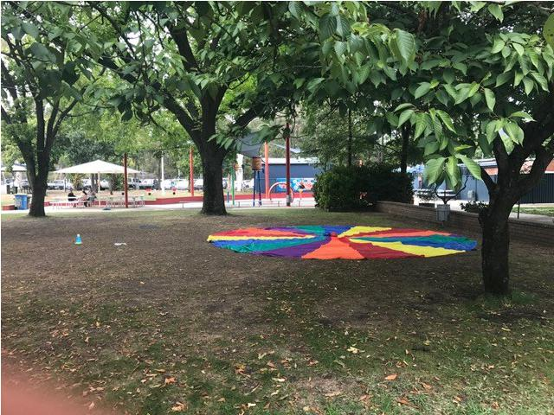

Swimming Carnival

At the time of writing this, we are still preparing for the swimming carnival. We have put on additional staff for the event and I would like to thank the team of teachers & staff who have put in additional hours so the
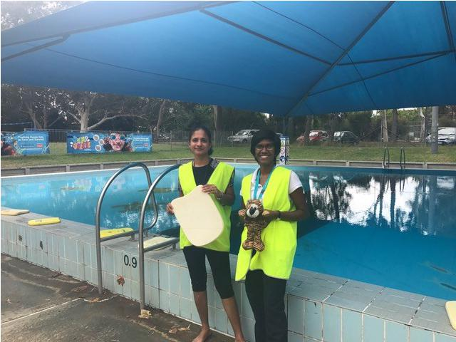
event can go smoothly. We thank all the families and children for being sun smart today by applying sunscreen, wearing broad brim hats and

applying sunscreen throughout the day.

Parking

I have had a few inquiries about our car parking. To assist with the flow of driving through the school and parking, the school has worked with and is continuing to work with the Directorate, Walk and Ride and with the Transport section of ACT Government to best meet most people’s needs. Work is underway with the building of a gravel carpark for staff at the preschool end of the school. This will supply 17 car spaces for staff and free up 17 spaces for parents and community. We have asked any trades people to not park over numerous car spaces and to alter work hours to not clash with our peak pick up and drop off times. Preschool pick up and drop off is 15 minutes before the main school so that the carpark can be used in a better manner. We encourage you to consider walking or riding to school, especially if you have older children or like to stroll in the sunshine. Our bike enclosure has been upgraded so it is covered and we have a large fixed bike pump available. A number of families are now using nearby parking around the area in streets, the shops carpark and the community hall carpark. Maybe you could consider car pooling with another family at convenient times. This is a great way to get to know others in our community. Every bit assists.

Student Leadership

On Wednesday morning we announced the 2018 school captains and vice captains as well as our

sporting house captains and vice captains. These people are:
School captains: | Caitlin | Isaac
School vice captains: | Niina | Toby
Murrumbidgee captains: | Meesha | Billy
Murrumbidgee vice captains: | Bridie | Mason
Gudgenby captains: | Evie | Si Thu
Gudgenby vice captains: | Aidan | Ava
Snowy captains: | Summer | Dominic
Snowy vice captains: | Sianna | Cadel
Cotter captains: | Anh-Minh | Raafi
Cotter vice captains: | Sonya | Zac

We congratulate all these people and know they will fulfil their leadership positions admirably this year.

Together, we learn from each other

What’s On Page 3

School Uniforms

Palmerston encourages you to dress your child in the school uniform. There are a number of reasons why we support this. The school board endorse our school uniform policy under the Directorate’s policy on School Uniforms. Wearing the uniform assists your child in being Sun Smart (types of material and longer sleeves on the shirt), saves on wear and tear of ‘good clothes/weekend wear’, supports Palmerston Pride and a sense of belonging and provides appropriate clothing for play and sport.

Have a great week,

Melissa Travers

UPCOMING EVENTS

Yr 5/6 Camp - Borambola

Date: 26-28 February 2018

Location: Borambola, NSW Sport & Recreation

Yr 3-6 Author Visit

Date: Wednesday 7 March 2018

Location: Palmerston District Primary School

Harry Laing– Author Visit

Years 3-6 students will have the opportunity to attend a writing workshop Wednesday 7 March with local author Harry Laing.

The event has been funded by the PDPS P&C to bring community members into our school. Students are encouraged to bring a gold coin donation for this event

TWILIGHT FAIR REFUNDS

If you requested a refund (due the rides being cancelled) from the Twilight Fair, please collect it at the front office.
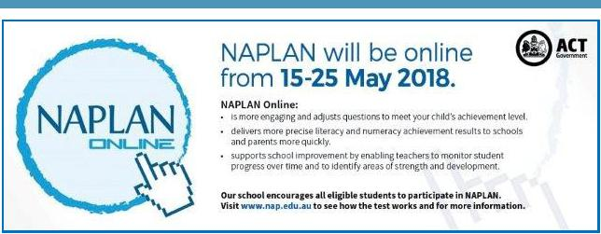

Together, we learn from each other

What’s On Page 4

YEAR 5 /6 PATHWAYS
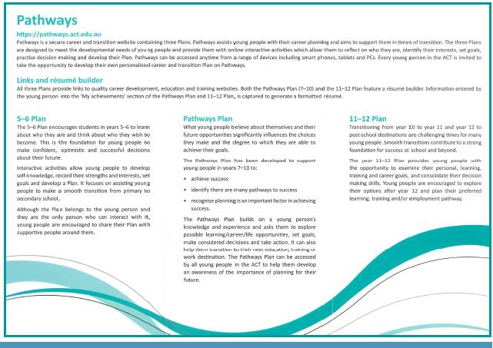

CLEAN UP AUSTRALIA DAY

Clean Up Australia Day is an event that is held each year. The Clean Up Australia organisation has evolved into an organisation that works with the community, government and business to provide practical solutions to help us all live more sustainably every day of the year.

Next Friday we will be participating in Clean Up Australia Day from 2-2:30pm We encourage you to provide a plastic glove for your child on this day.

Did you know we have an app you can download to keep you up to date with what is happening at Palmerston?

Together, we learn from each other

What’s On Page 5

Think before you park…and keep our kids safe!

With school now back for the year we are encouraging all parents to make parking safety a priority!

This means:

- keep clear of ‘no stopping’ and ‘no parking’ zones

- don’t park in bus zones, on school crossings, across footpaths or driveways; and

- don’t double (or triple) park

Remember - it’s okay to park a little further away from the school and walk the rest of the way Consider - having a pre-determined meeting spot agreed with your kids. That way if you are a little late, they know where to wait.

Think – visibility around schools and if your car may be blocking the view of crossings for other motorists. Also be mindful when entering or leaving parking spots – look twice!

Be kind – to other road users and pedestrians and also if you see any parking officers in the area – they are doing their job and working to keep our kids safe!

Note - licence Plate Recognition (or electronic chalking) vans are now actively monitoring schools. Penalties range from $114 upwards to $600. Details at www.act.gov.au/accessCBR

SCHOOL BOARD NOMINATIONS 2018

School Board elections will be held in early 2018

Membership of the School Board is a wonderful opportunity for parents to participate in the ongoing management of the school and to contribute to the determination of the school’s future directions. There is one (1) vacancy for a parent representative on the Palmerston District Primary School Board for the period 1 April 2018 to 31 March 2020. Election of the parent representative will be undertaken in the first few weeks of the 2018 school year. Nomination period:

Closes – 11:00am on Monday 26 February 2018

Voting period (if election is required):

Opens – 11:00am on Monday 5 March 2018

Closes – 11:00am on Monday 19 March 2018

The position for election will be:

One (1) - Parent Representative Position. Elected positions run for a two (2) year term.

The successful candidate will be announced by Monday, 26 March 2018.

If you are interested in being a member of the Palmerston District Primary School Board for 2018-2020 and would like more information about the roles and responsibilities of School Board members, please contact the Principal, Melissa Travers on 6142 1440. A copy of the School Board Manual is also available for perusal at the front office. Nomination forms will be available from the school front office from Monday, 5 February 2018. If you would like to have a form before that date, please contact the school front office on 6142 1440.

Together, we learn from each other

What’s On Page 6

P&C NEWS

The P&C AGM was held on Monday the 19 February and we are pleased to report that we have a new P&C executive in place for 2018. A big thank you to everyone who has volunteered to take on the executive roles and assistant positions.

2018 P&C Executive Positions are held by the following:

President |  | Lisa Fior
Vice President |  | Sharley Pavier-Jones
Secretary |  | Emma Davidson
Assistant Secretary |  | Mandy Scanes
Treasurer |  | Jenni Palombi
Assistant Treasurer |  | Helen Ritchie
Fundraising Officer |  | Helen Ritchie
2018 Assistants:
Public Officer |  | Marina Zwangobani
Assistant Returns Officer |  | Sonya Campbell
Auditor |  | TBA
Fundraising team members (x2) |  | Janelle Hunter, 1 x Vacant
Second Hand Clothing Shop Coordinator |  | Vacant
Student Banking Coordinator |  | Vacant
Book Club Coordinator |  | Edwina Samuelson

As the continuing P&C President I look forward to spending time getting to know many more families at Palmerston Primary School. The P&C and all of its volunteers have many events planned in 2018 and we look forward to the year ahead.

We welcome and warmly encourage new parents to the P&C. Being a member is a great way to contribute to and be part of your child’s schooling. Meetings are held in weeks 3 and 9 of each term. Please come along and find out what the P&C is all about.

If you can help in any way or would like more information on them then please see one of the P&C executive or email palmpandc@hotmail.com.

Lisa Fior

P&C President

Together, we learn from each other

What’s On Page 7

Have any spare time up your sleeve? Then we could use you. The P&C currently have a number of opportunities available to be part of our Palmerston team.

Second-hand Uniform Shop Coordinator

This role can be as little or as much as you want to make of it. All we do ask is that you open one morning a week in the hall outside the canteen from 9:00 - 9:15am. The assistant currently opens on Mondays 9:00 - 9:15 am and the current coordinator 9:00 - 9:15am on Fridays. Days are flexible around what
suits you. If this sounds like something you could do please give me (Lisa Fior) a call on 0407 107 595 to discuss further. You will receive a thorough handover from the current coordinator if you take up this role.

School Banking Coordinator

School banking is undertaken every Wednesday morning and takes approximately 1.5 hours. If you have another day that would suit you better this can be considered with the role. We need a committed volunteer who is

keen to support school banking to continue in our school community. If this sounds like something you could do please give me (Lisa Fior) a call on 0407 107 595 to discuss further. You will receive a thorough handover and information from the current coordinator if you take up this role.

Y’S Bites Lunch Assistants (multiple required to go on a roster)

Do your children like ordering lunch orders? Help us keep these coming to Palmerston Primary School. Lunch assistant roles can be filled on a rotating roster so you may

only need to help once a term, if that’s all you can do. Approximately 12:30 - 12:50pm every Thursday you open the canteen, meet the YMCA and take the delivery of the food and assist to sort food into class groups. Senior students come up and take the baskets to classes, return the baskets and you lock up the canteen. If this sounds like something you could do please give me (Lisa Fior) a call on 0407 107 595 to discuss further. Full training will be provided on Thursday the 1 March or any subsequent Thursday this term.

Together, we learn from each other

What’s On Page 8

School Banking:

Every Wednesday 9am-10.30am in the staff room.

Bank books can be left at the front office by 9.30am or handed to your child’s teacher in the morning.

Joanne from Commonwealth Bank will be at school from 8.30am on Wed 7 March (Week 5) to assist with questions and information about school Banking.

We will also be offering 2 account opening information sessions at preschool on Thursday 8 March (week 5) and Tuesday 13 March (week 6)

If you would like to open a new account, a Youthsaver account can be opened online by all parents. Visit commbank.com.au/schoolbanking and click on the link to open the Youthsaver account. Parents will need their child’s birth certificate or similar identification as well as their own to complete the process and generate an account.

Or you can visit any Commonwealth Bank branch with identification and open an account. **************** NEWS FLASH **************NEWS FLASH *********************

Urgently Calling for Volunteers…Mums, Dads, Gandparents or Carers WE NEED YOU!
Our students really enjoy participating in the Commonwealth Bank School Banking program and learning important skills on savings and safe spending habits.

To run the program we need the help of at least 2 volunteers to help us process the deposits every Wednesday at the school.

All training is provided and no experience necessary and it takes just a little bit of time each week.

Plus you will meet some other parents and little people are welcome to come too.

Please contact the Front Office or our School Banking Coordinator Edwina on 0422 006 142 for more information.

Book Club :

Issue 1 Book Club closes this Friday 23 Feb.

If you are paying by cash or cheque, all orders need to be received into the Boomerang Box (front office foyer) by Friday 23 Feb. (please double check you include your child’s name and class on the paperwork and also the correct money in a sealed envelope or snap lock bag)

If you are ordering via the LOOP system, then you do not need to return any paperwork. Just sit back, relax and wait for the books to arrive!

Books take approximately 1-2 weeks to be received and distributed out to classes.

Thanks,

Edwina

0422 006 142

Together, we learn from each other

What’s On Page 9

Palmerston District Primary School P&C

President’s Report for Annual General Meeting 2018

Monday February 19 2018

President - Lisa Fior

I would like to start with a big thank you to all of our hard working volunteers for their work throughout the 2017 year. In particular, I’d like to acknowledge the committee members, volunteers and school community that all contribute in many different ways creating a positive impact at Palmerston Primary School every day.

I would also like to acknowledge the support the P&C, the students and families receive from the amazing school staff. We are very lucky to be part of a school environment with staff that never fail to show their continued, relentless dedication and commitment to our children more often than not, going above and beyond what happens day to day in the classrooms. This support comes from all areas across the school. The administration and maintenance staff, teaching staff, executive staff and of course from our wonderful leaders Deputy Principal Kate Flynn and Principal Melissa Travers. Without this dedicated support and approach the Community would not be the flourishing environment that it is today. I talk to many children and families at Palmerston and a key message that I receive is how lucky they are to be at our school. What more can we ask for than that? It is certainly something to be very proud of and something we all work hard together to achieve. In 2017 we focused on:

Supporting the school/community

The parents of Palmerston and the P&C contribute to supporting the school community in many different ways. We have volunteers who assist at sports days, provide catering for a number of events through the year, take up roles in the P&C, and volunteer their time in classrooms as well as undertaking many other everyday tasks. In 2017 we again held our World Teachers Day celebration, Twilight Fair, supported the Mother’s Day and Father’s Day stalls, provided watermelon at the swimming carnival, ice blocks at many sporting events, numerous mufti days, lunch days and held 2 school discos.
Providing services

In 2017 the P&C continued to provide a number of services to the Palmerston Primary School community. These included:

- The Y’s bites trial for the canteen in partnership with the YMCA and the school. This is continuing one day a week this year with an increase in menu options available.

- School banking

- Second hand uniform shop

- Book club

- Library bags

Fundraising

This year saw our energy focussed on targeted and specific fundraising activities for the school. Our major fundraiser for 2017 was again the school Twilight Fair, which despite some major challenges to tackle on the day was still a success both financially and for the community.

Together, we learn from each other

What’s On Page 10

The P&C also held fundraising through:

- School Years photo frames

- Christmas Trees

- Mangos

- Discos

- Cup Cake day

Spending funds

Through our continued fundraising efforts we were able to provide a donation of $10,000 that went towards various school activities as well as teachers professional development. We also got to see the preschool playground revamp come to life, made possible by our $10,000 Twilight Fair donation in 2016.

Overall it has been another successful year for the P&C working in partnership with the school to enhance the Palmerston Primary School Community. Thank you to everyone who has made all of this possible to achieve.

Finally I would like to say that being involved in the P&C is an enriching and rewarding way to play another role in the education of your children. I strongly encourage anybody who has considered this or is thinking about it to come and join. Any contribution is a valuable one both big and small.

Thank you,

Lisa Fior

P&C President

18 February 2018

Together, we learn from each other

What’s On Page 11

Together, we learn from each other

What’s On Page 12
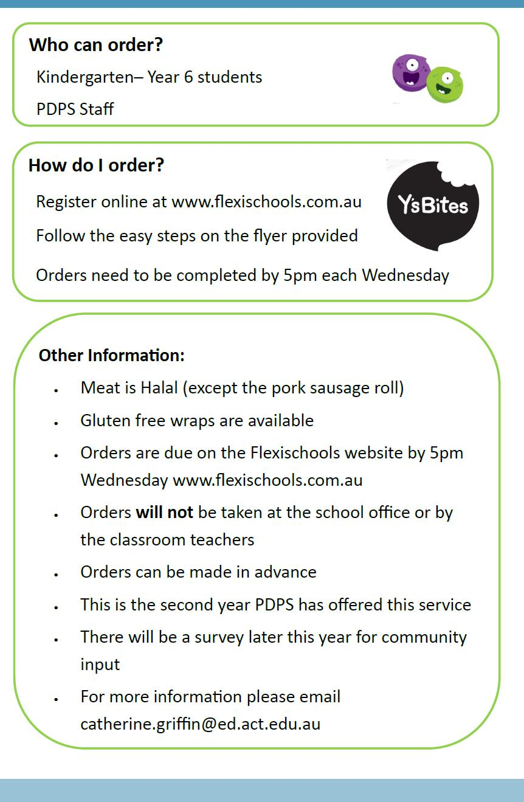

Together, we learn from each other

What’s On Page 13
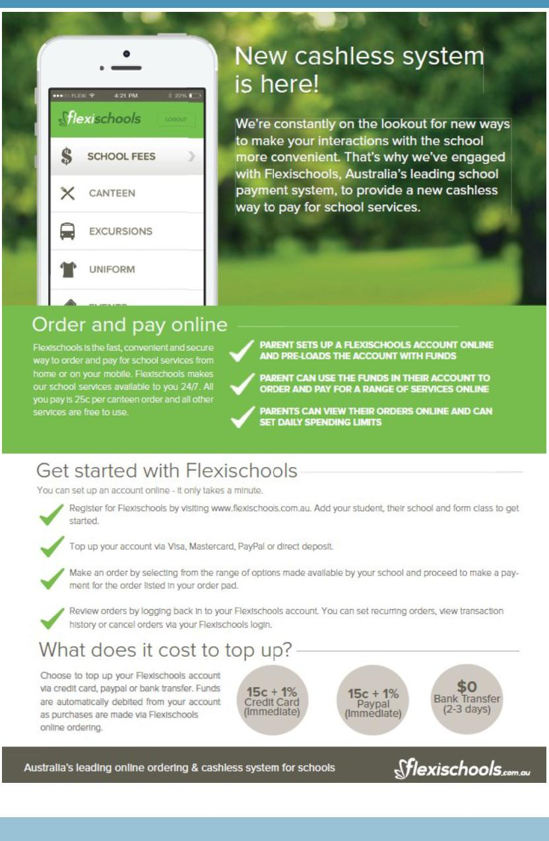

Together, we learn from each other

What’s On Page 14

COMMUNITY NEWS

Together, we learn from each other

What’s On Page 15
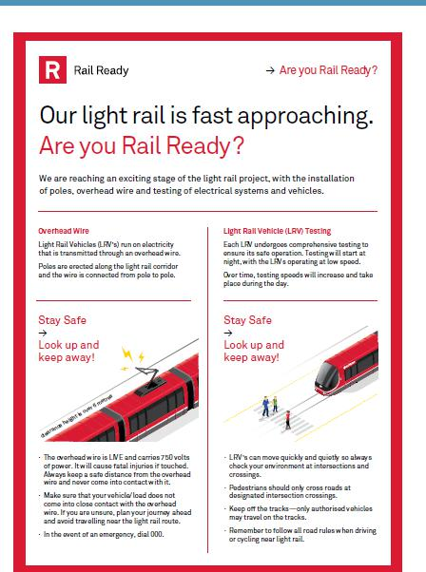

Together, we learn from each other

What’s On Page 16
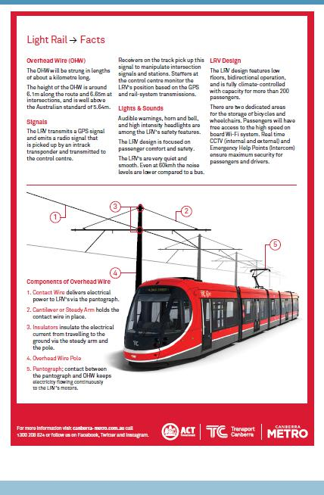

Together, we learn from each other

